For the SDK version problem showed in today’s help session(change the SDK version with each project properties to 10.0.15063.0), you can solve it with adding earlier SDK version into the visual studio.
First of all, you have to start visual studio installer. If you do not have one, you can find it here. https://www.visualstudio.com. Then start it.
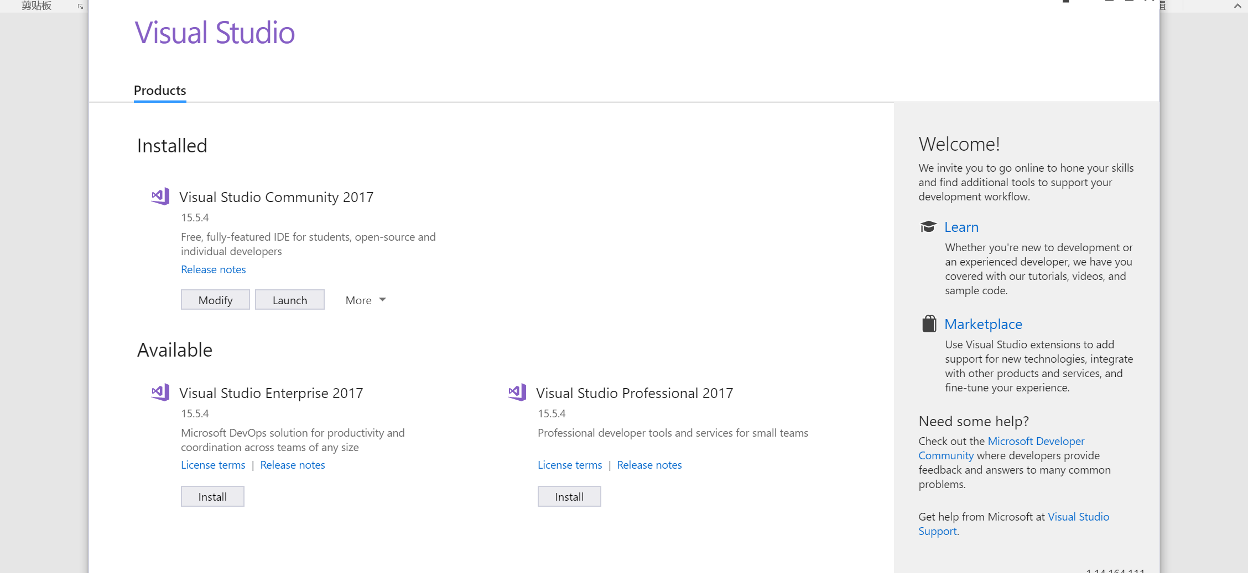
In this page just click “modify”. If there is no modify, you can find it in the red circle.
This will lead to the modify page where you can add or delete visual studio components.
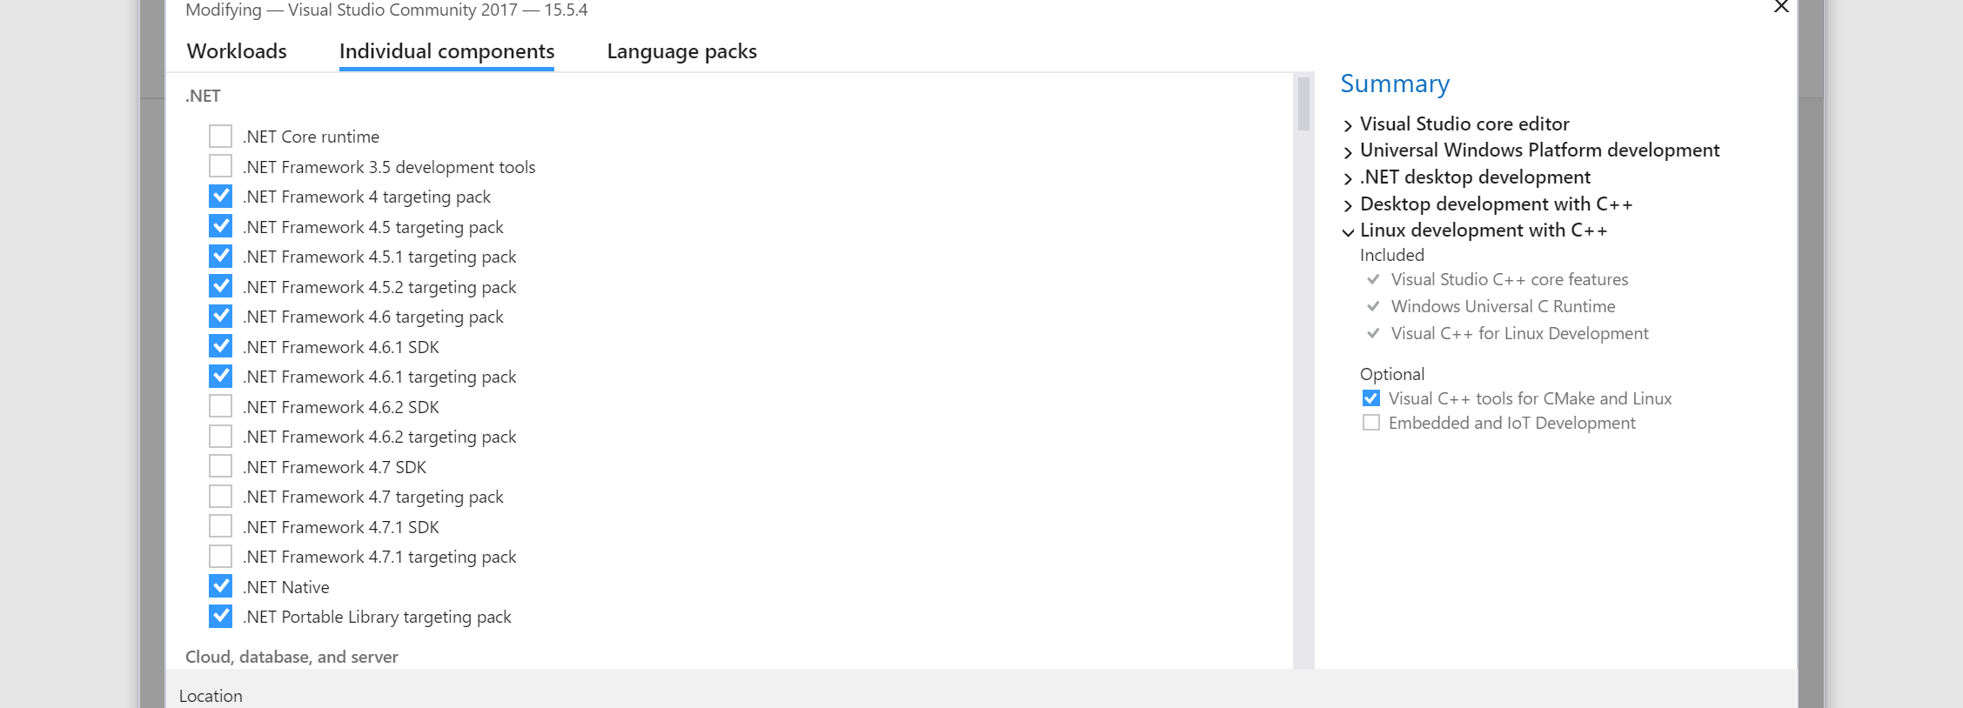
Here you may have to move to the individual components to find the target version.
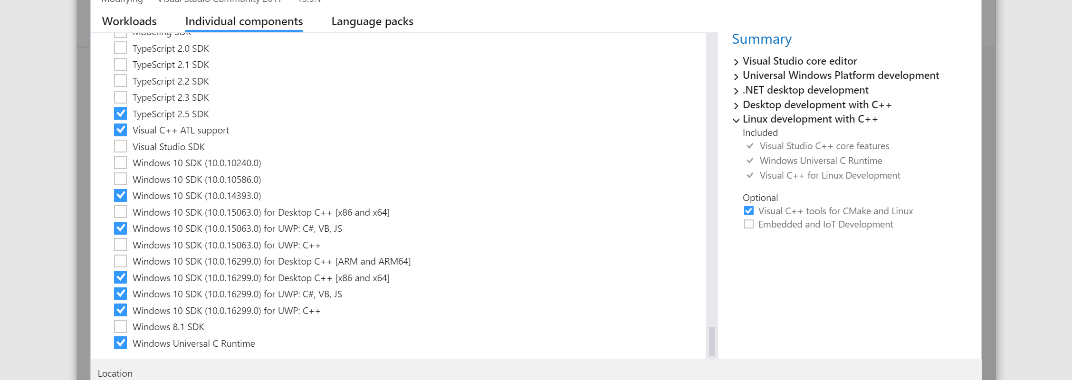
Then click the modify button.

This way should work for the version problems as I and my couple of friends all succeed. When I now build the solution I do not have to change the SDK version with each projects.

Created by Hao

