Relationship | Diagram | Code | Explanation
Inheritance  D “is-a” B | 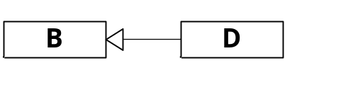 | public class D : B { … } | Derived class D is a specialization of the Base class B. D inherits all the members of B except constructors
Composition  Ownership, P is “part-of” C | 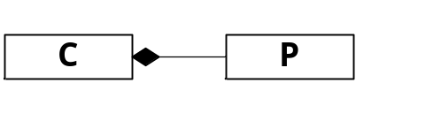 | public class C {  …  private double p = 3.142;  } | Composite class C owns, or contains, a part value type P. P is created and destroyed with C. The interface of P is visible only to C, not its clients. Example: P is a double.
Aggregation  Ownership, P is “part-of” A | 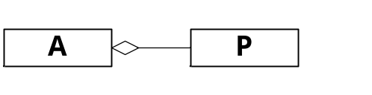 | public class A {  …  private P p = new P();  } | The Aggregator class A owns a part class P. P is created by a member function of A, and so its lifetime is strictly less than that of A. Example: P is any reference type.
Using  Referral:  U uses R through a reference | 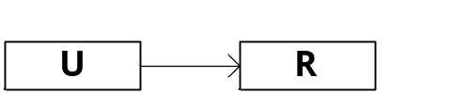 | public class U {  …  public void register(R r)  // use r  }  } | A class U uses instance of class R, to which it holds a reference. R is created by some other entity and a reference to it is passed to some member function of class U.

