Dependency Analysis
Operational Concept
Jim Fawcett
CSE681 – Software Modeling and Analysis
Fall 2010

Table of Contents
Executive Summary 3
Introduction 3
Usage 4
Structure 4
Package Responsibilities 5

Executive Summary

Introduction
This document is concerned with the concept for a Dependency Analyzer tool. The purpose of the tool is to find compilation dependencies between files in a set of file specifications defined at startup. In the form of its first release, it will successfully analyze dependencies between source code files for C#, provided that the code compiles without errors.
File dependencies are based on dependencies between user-defined types. File A depends on File B if it declares an instance or uses an existing instance or calls static methods on a type defined in File B. Types include classes, interfaces, structs, enums, and delegates. Analysis is based on an informal parsing process that is required to recognize a very small part of the C# language, e.g., just the types described above.
Analysis is carried out in two passes: the first finds all types and their namespaces in each file and saves the type name, filename, and namespace in a type table.
The concept for this phase is to start analysis of each file by tokenizing and collecting meaningful groups of tokens into a collection call semi-expressions. These are simply sequences of tokens that end in “{”, “}”, or “;”. Type recognition then is a simple matter of detecting each semi-expression that ends in “{“ and holds one of the tokens “class”, “interface”, or “enum” and also detecting semi-expressions then end in “;” and contain the token delegate, Action, or Func. The type name occurs immediately following the type token. Note that the analysis does not need to detect anonymous delegates as their use is encapsulated within a single file.
The second pass finds dependencies by matching tokens in the current analysis file with types stored in the type table.
In this pass, a file being analyzed is tokenized and the analysis looks for a match for each token against a type name key in the type table. If found it checks the using statements and namespace qualifiers, e.g., NS.T, against the namespace stored for the matching type. If there is a match, then the file stored in the table is returned as a child of the current analysis file in the file set’s dependency graph.
This analysis process uses several data models: FileModel containing file specifications for analysis, TypeModel containing the type table, UsingModel containing a tokenized version of the using statements for each file, and a DependencyModel that contains the dependency relationships, e.g., a list of files with, for each file, a child list of files on which it depends. There are also several views that may be important to users: FileView that lists all of the file specifications for analysis, TypeView that shows all of the discovered types, and DependencyView that shows the dependency relationships.
The analyzer has, as cited above, a significant amount of structure to be managed, we’ve chosen to use a Model-View-Controller architecture to provide a robust maintainable configuration for this tool.

Usage
Commercial and industrial software projects are composed of packages, e.g., files with prologues, comments, and construction test drivers, to support efficient construction and maintenance. Typical development projects will consist of hundreds or perhaps a few thousand packages. Thus, an analysis tool like Dependency Analyzer will have two distinct sets of users:
- Developers need to analyze a few files – their own project code and that code of other teams on which their code depends. Developers need a simple tool, easy to use, and will typically select manually files for analysis.
- Software Architects and Quality Assurance personnel will need to analyze large sets of packages, often the entire current software baseline. These users will need a batch mode of operation that does not require manual selection of files. The input file sets can be defined as a set of paths where analysis searches the entire directory tree rooted at that path for files matching a source code pattern, e.g., “*.cs”. It may be convenient for these users to provide an auxiliary tool that searches a path set, perhaps defined in an XML file, for files that have entered the tree or been modified, so enabling an incremental analysis that does not have to reprocess unchanged files. Quality Assurance will be particularly interested in mutual dependencies that are a sign of defective structure and inefficient testing. We will discuss this point further in the Critical Issues section.
- Tester’s needs for this tool are similar to Quality Assurance, but they need one additional feature. In order to test efficiently, we need to test first those packages that depend on no others in our baseline. Once those are tested we test those that only depend on already tested code. The reason for this is that testing often identifies code that must be changed. If other code depends on a package that is changed they must be tested along with the changed code. One obvious difficulty is with sets of packages that are mutually dependent. If we change any file in a mutually dependent set, we must retest them all. This indicates a need for a sorted listing that groups code into layered sets, based on the dependency graph of the file set. This too we will discuss further in the critical issues section.
We do not expect that managers, marketing, or customers will use this tool, except possibly through the agency of the Software Architect.

Tasks
The Dependency Analyzer has four main tasks: get file references, for each file find defined types, for each file find dependencies by comparing tokens with defined types, and display results. These are shown in Figure 1, below.

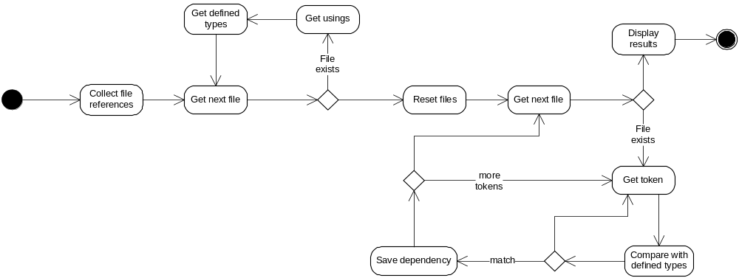

Figure 1 - Dependency Analyzer Activities

Structure
A package diagram for the Dependency Analyzer concept is shown below. The Model-View-Controller structure is evident from the names and layout used in Figure 1. Each of the models declares its internal data structures to be static. That way any part of the code that needs to access the data can, simply by declaring a new instance of the model, and thus sharing the static data with every other declared instance. Sharing always needs care and discipline in handling, but the models encapsulate all access to the data through member functions, and thus, can validate changes and control access.

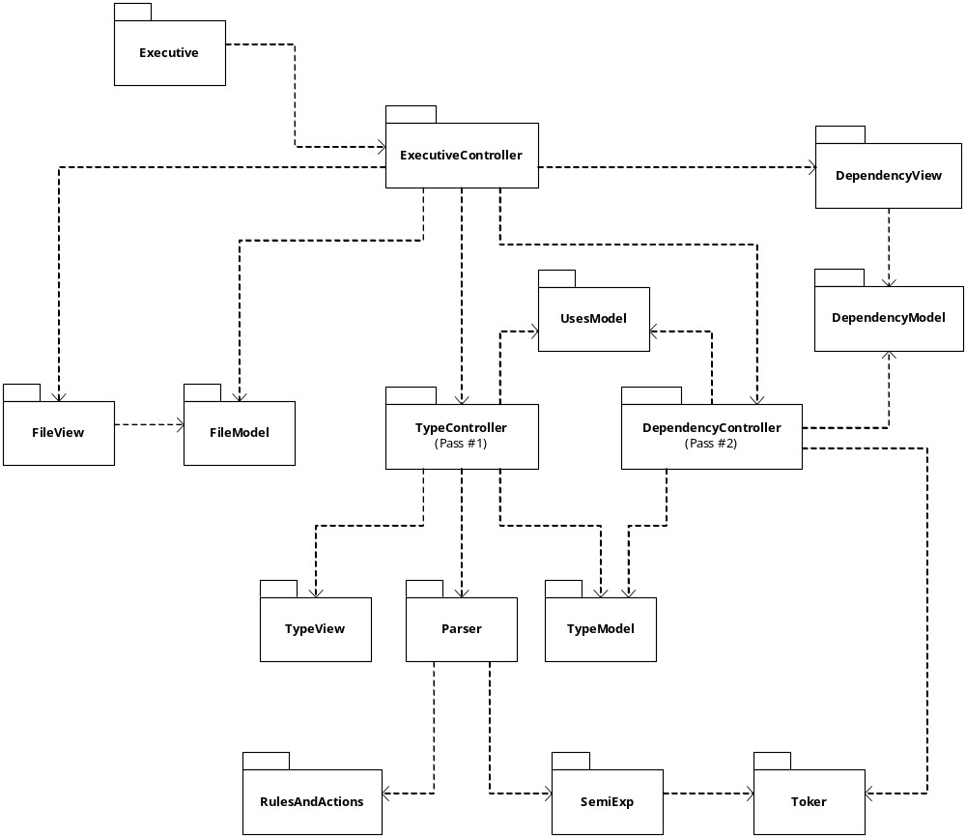
Figure 2 - Dependency Analyzer Packages

Package Responsibilities
The packages have the following responsibilities:
- ExecutiveController manages the tools activities by delegating responsibilities of each task to lower level packages.
- FileModel is passed a set of paths and its parameters determine whether the trees rooted at each path are to be searched and the file specifications made unique. When done with its initial analysis it contains a static list of all the files (using fully qualified filenames) that are subject to analysis.
- FileView displays the working file set.
- TypeController carries out the type analysis of Pass #1. It’s job is to find all of the types that are defined in each file, and save their type names, namespace, and file in which they are defined in the type table held by TableModel. While analyzing each file it also stores, in the UsingModel, tokens representing the using statements in each file.
- Parser is a container of rules and actions. It requests semi-expressions from the scanner, composed of SemiExp and Toker. It passes each of these to each of its rules in turn. Each rule defines a grammatical construct detector. The rules contain lists of actions that execute when the rule matches its current semi-expression. The actions are responsible for saving type information in the TypeModel and using information in the UsingModel.
- TypeView is used during construction to verify the operation of the TypeController.
- TypeModel stores the type names, the namespaces in which they are defined, and the name of the file where the type is defined.
- UsesModel stores, for each file, a tokenized list of using namespaces.
- DependencyController constructs the dependency results. It does this by tokenizing each file in the analysis set and matching with the TypeTable and UsesModel. If it finds a type name token that matches one in the TypeModel and has a match in the uses for the matched namespace then a dependency is declared on the file held in the TypeModel for that token.
- DependencyModel holds, for each analyzed file, a list of the names of files it depends upon.
- DependencyView is responsible for displaying dependency information in a manner useful for its users. Note that this may be quite different for the identified classes of users.

