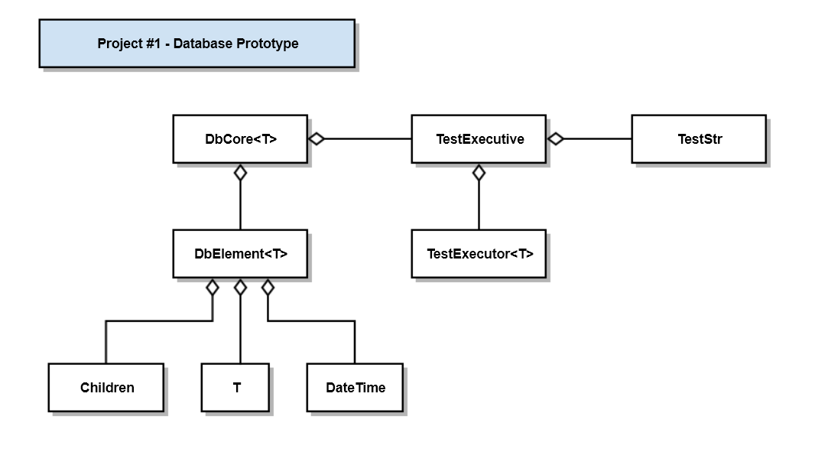

Class | Responsibility
DbCore<T> | Implements core database functionality
DbElement<T> | Value part of a { key, value } db record
T | Payload type
Children | std::vector<std::string>, holds a collection of keys, e.g., dependencies
DateTime | Manages date-time stamps, creates current time strings
TestExecutive | Holds a collection of TestStr instances, executes them using TestExecutor<T>
TestExecutor<T> | Executes a single test in the context of a try-catch block
TestStr | Struct { name, test (callable object) }

