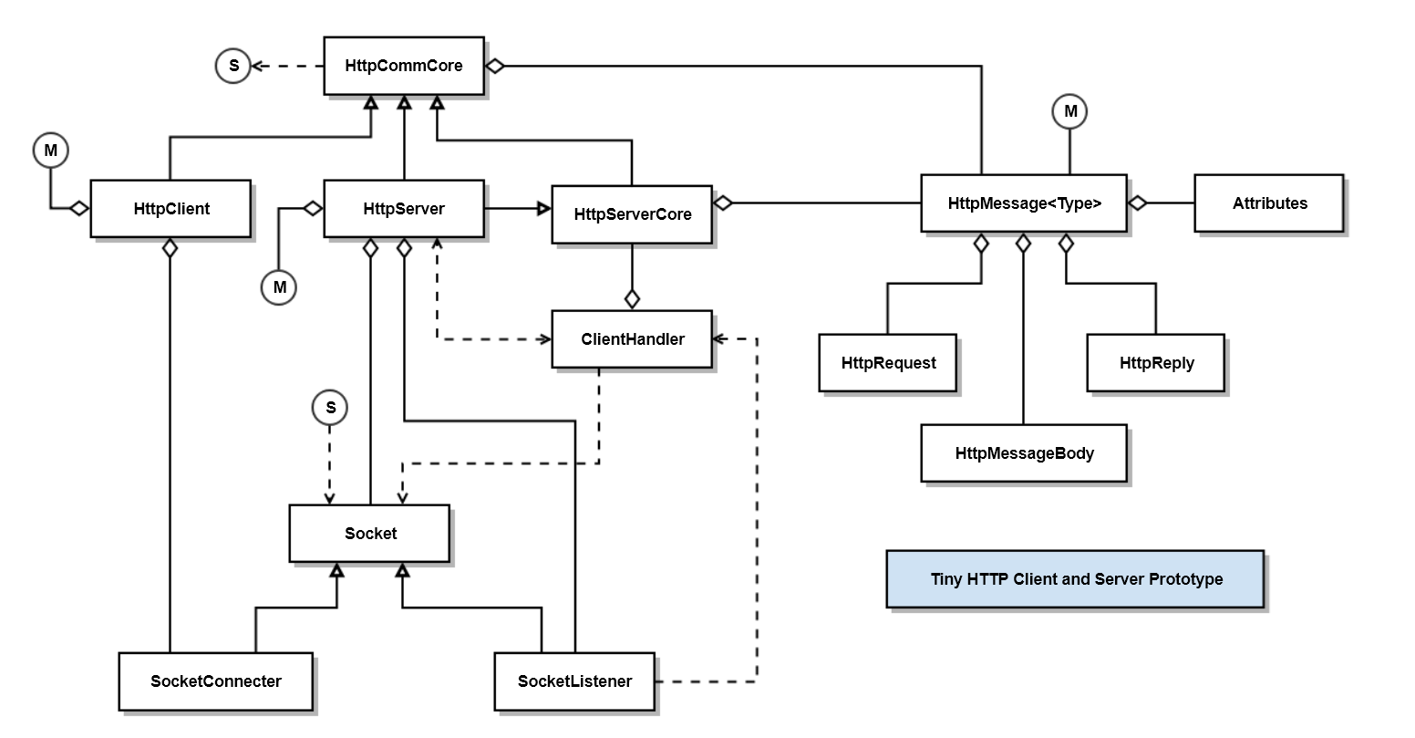

Class | Responsibility
HttpCommCore | Implements core HTTP Communication functionality
HttpClient | Sends HttpMessage<HttpRequest> and receives HttpMessage<HttpRely> messages.
HttpServer | Listens for HttpMessage<HttpRequest> messages and sends HttpMessage<HttpReply> reply messages.
HttpMessage<Type> | Creates and parses HttpMessage<Type> instances, where Type is either HttpRequest or HttpReply.
HttpRequest | Manages command line for request messages, e.g., GET, PUT, POST, DELETE, or HEAD
HttpReply | Manages command line for reply messages, e.g., status and status text.
HttpMessageBody | Reads and writes an ordered collection of bytes.
Attributes | A map of key:value string pairs
Socket | Used by ClientHandler thread to communicate with client
SocketConnecter | Used by client to connect to SocketListener -> Socket
SocketListener | Used by server to listen for connections and return connection as Socket.

