**User Control to Set File Dependencies**

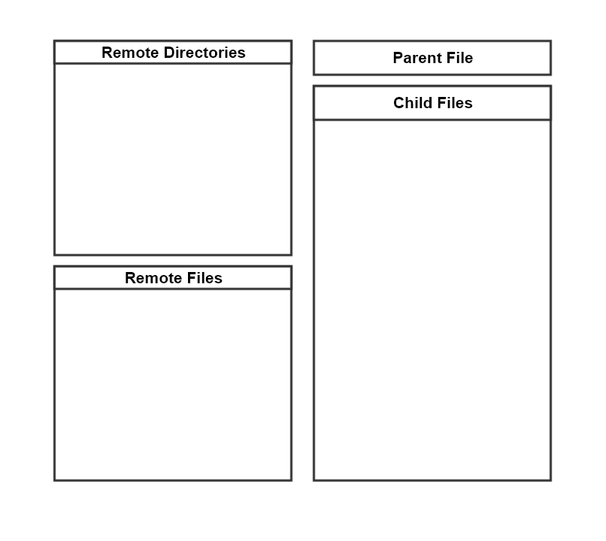

Double-click to remove child from list

Right-click to set parent file

Double-click to navigate through directories

Double-click to populate child files list