Steps to set up an azure account
1. Create a Microsoft Account for Azure and subscribe to it.
https://signup.live.com/
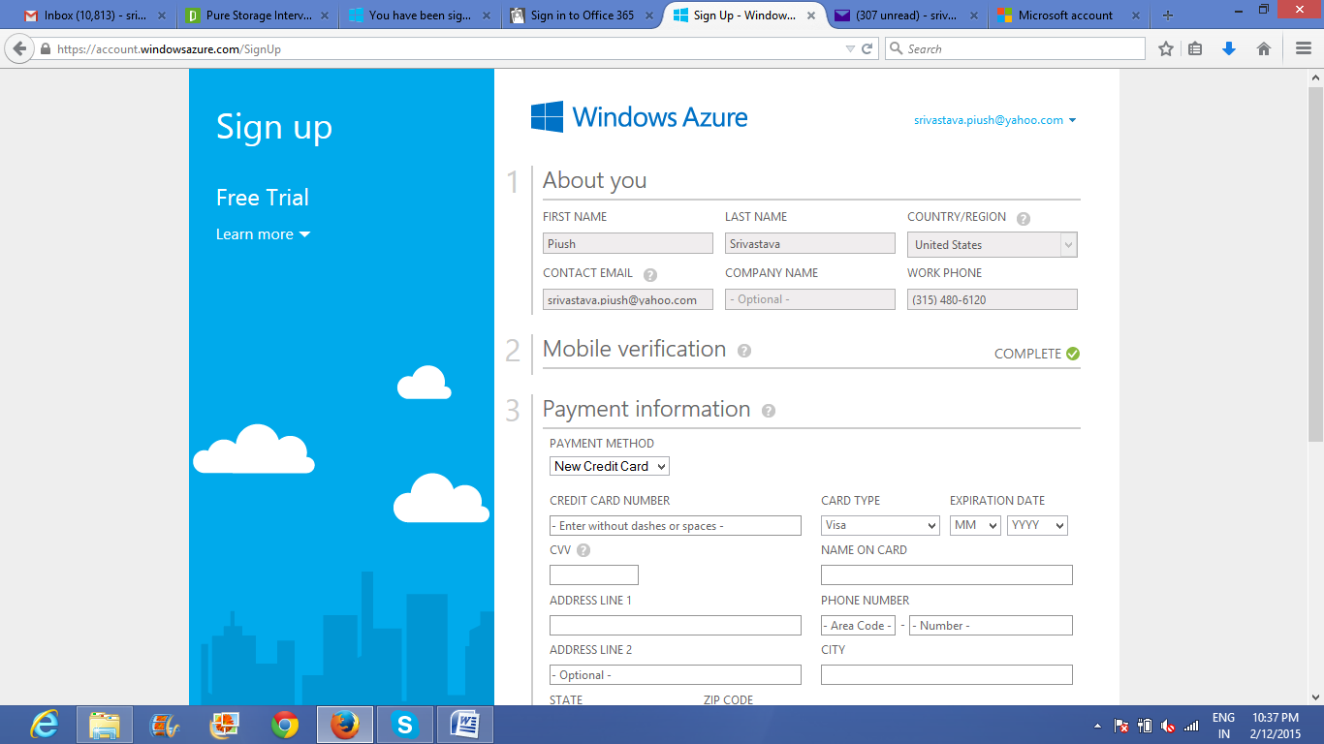

2. After creating account an selecting a trial period of 30 days
http://azure.microsoft.com/en-us/account/
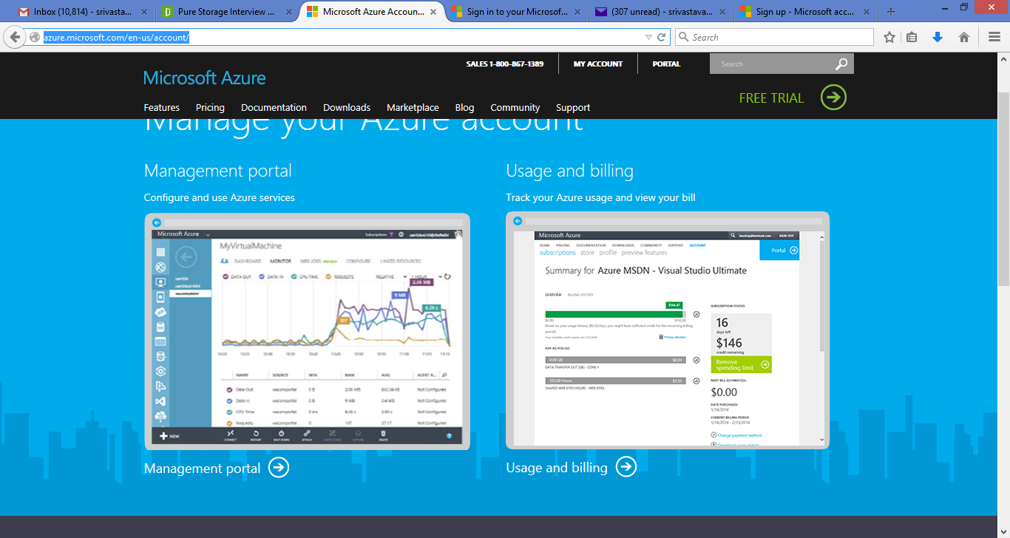
3. Select manage portal
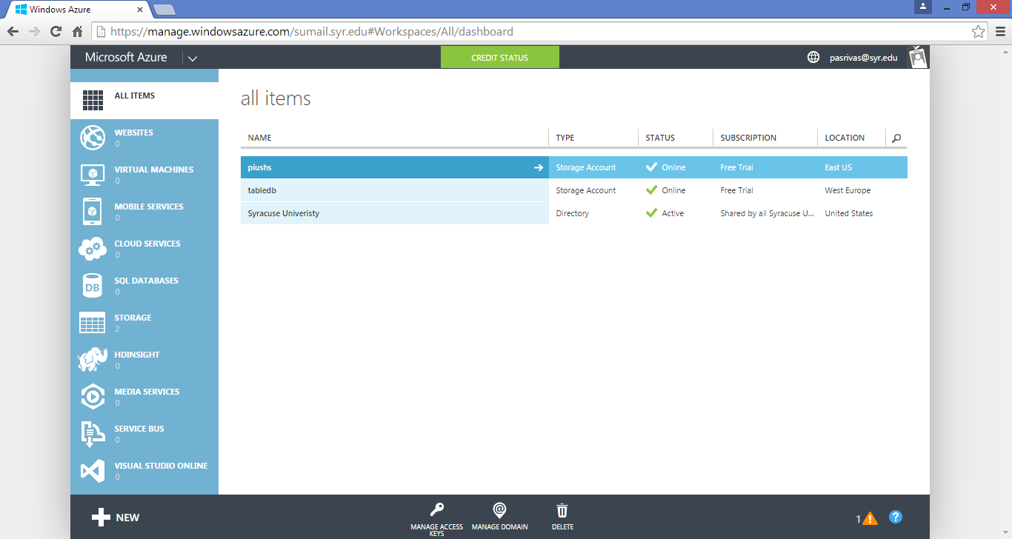

4. To create storage account select Storage from the left
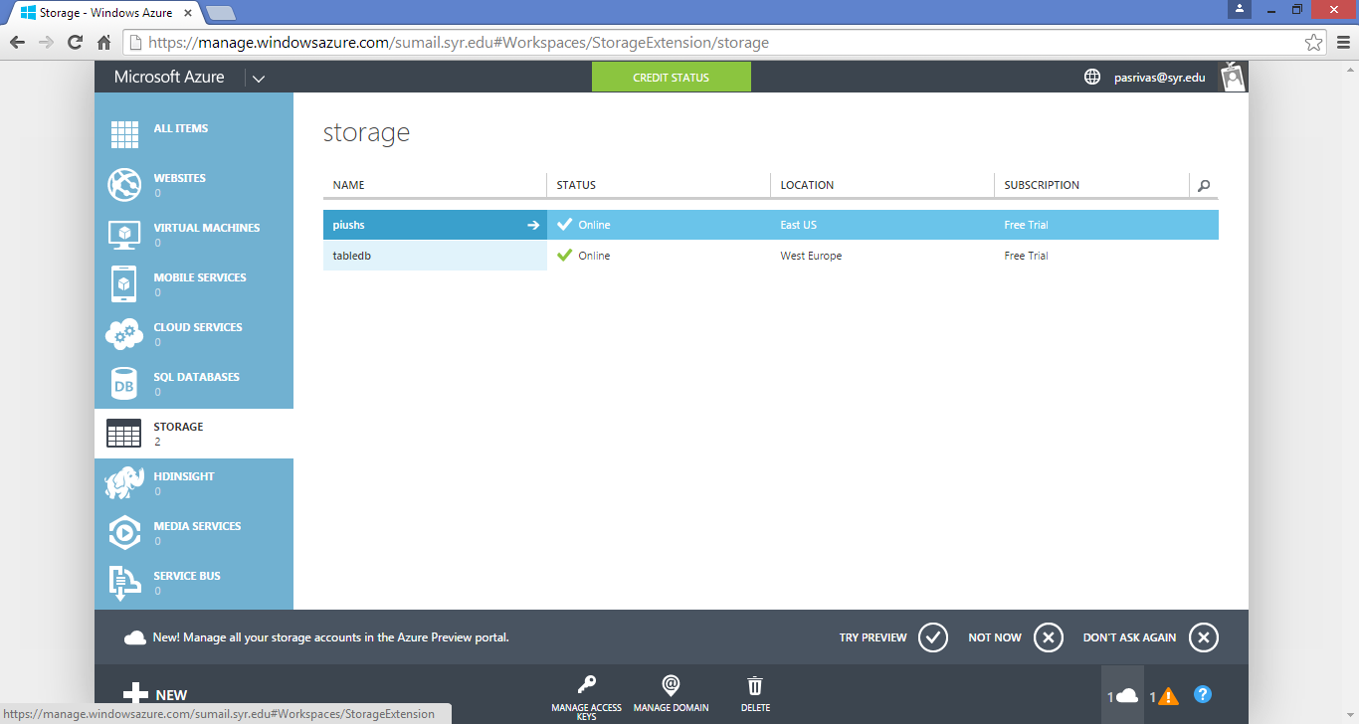
5. Select quick create and select a unique name in the url part
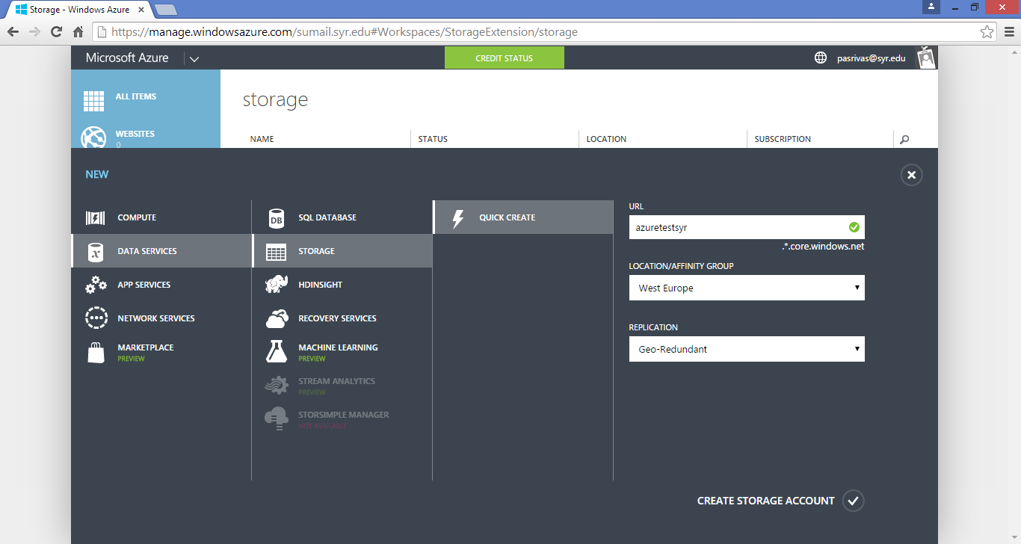
6. Select create storage account
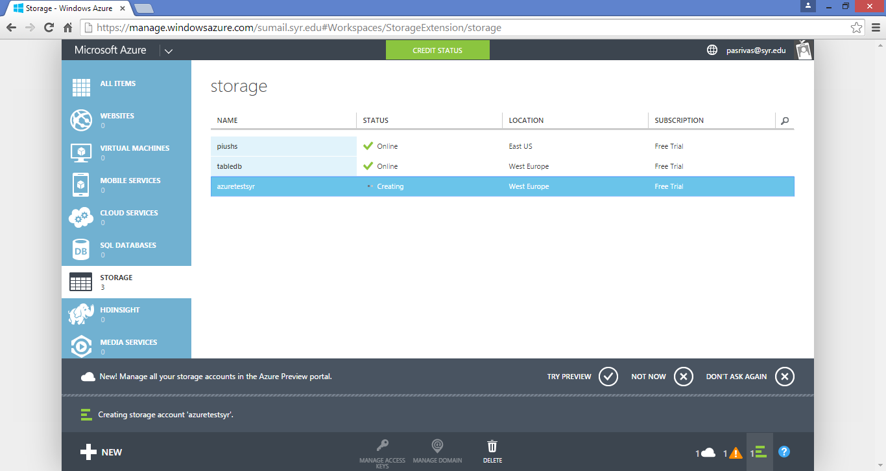

7. The blobs (files) are created in the container (Currently there are no containers)
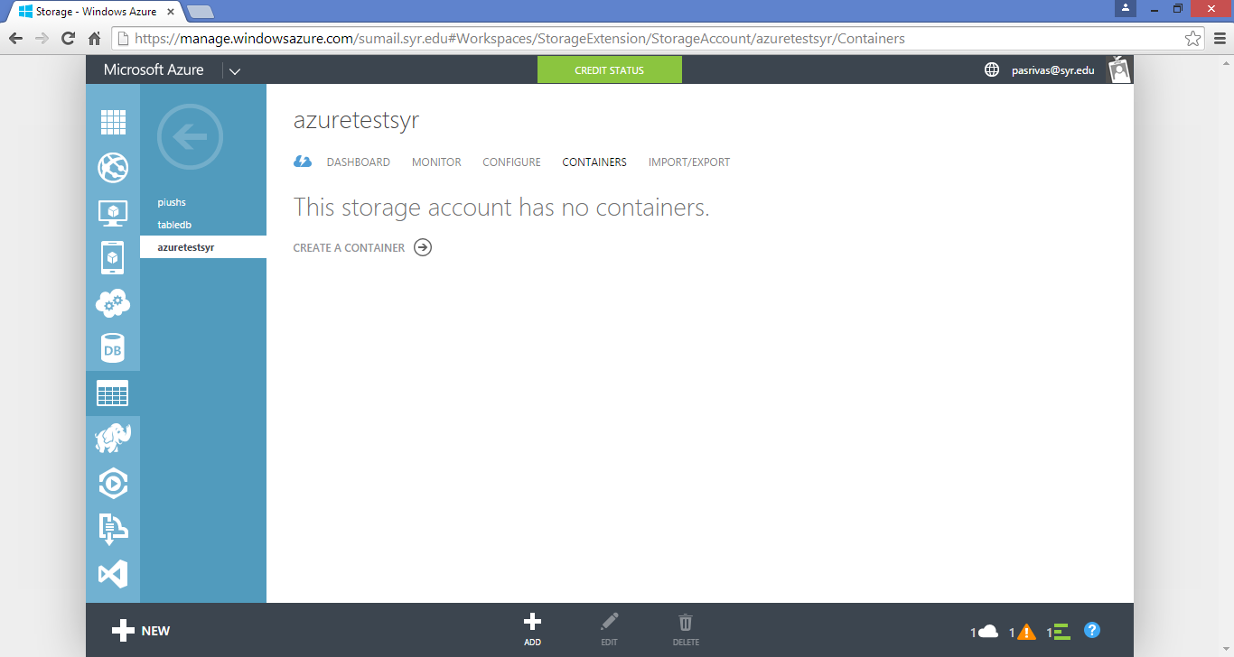

8. Create a container
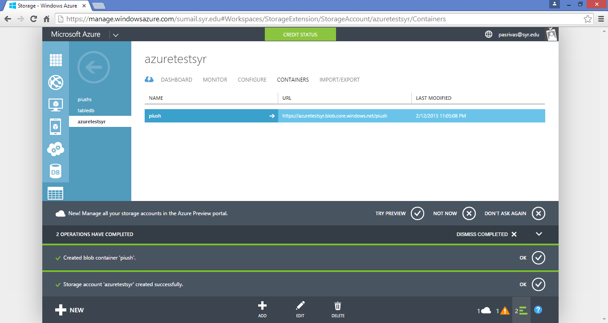

9. Setting up azure in Visual Studio (Open Visual Studio as an Administrator )
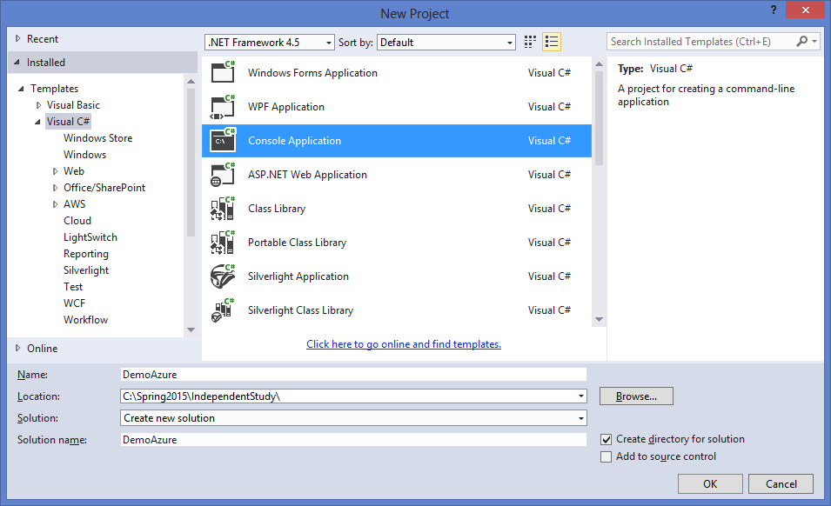
10. Right click on the Project and Select Manage NuGetPackages option
Note: The NuGetPackages might not be able to show azure packages in case Visual Studio is not running as an administrator. Make Sure Visual Studio runs as an administrator
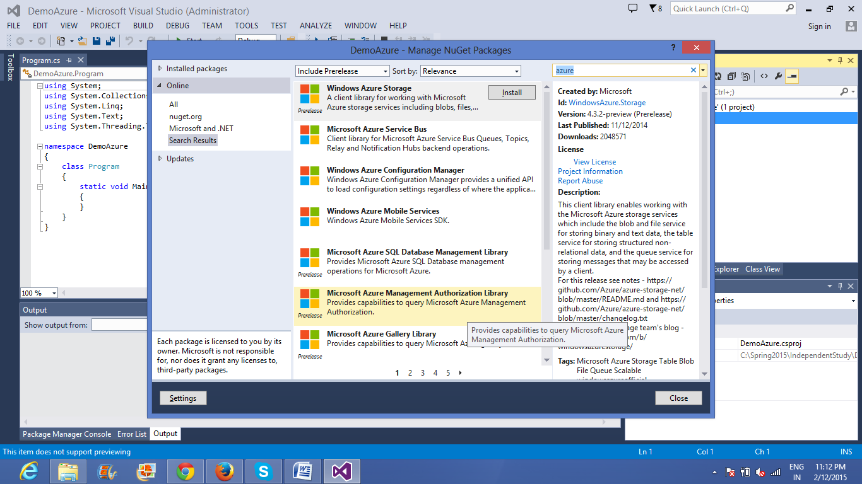

11. You might get the below error while installing
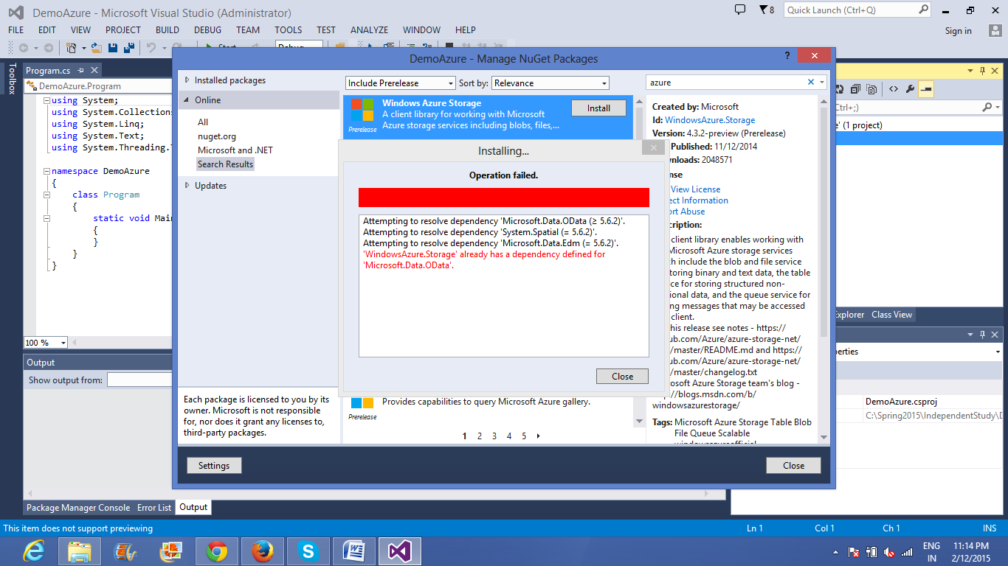

Solution:
a)Open the package Manager console
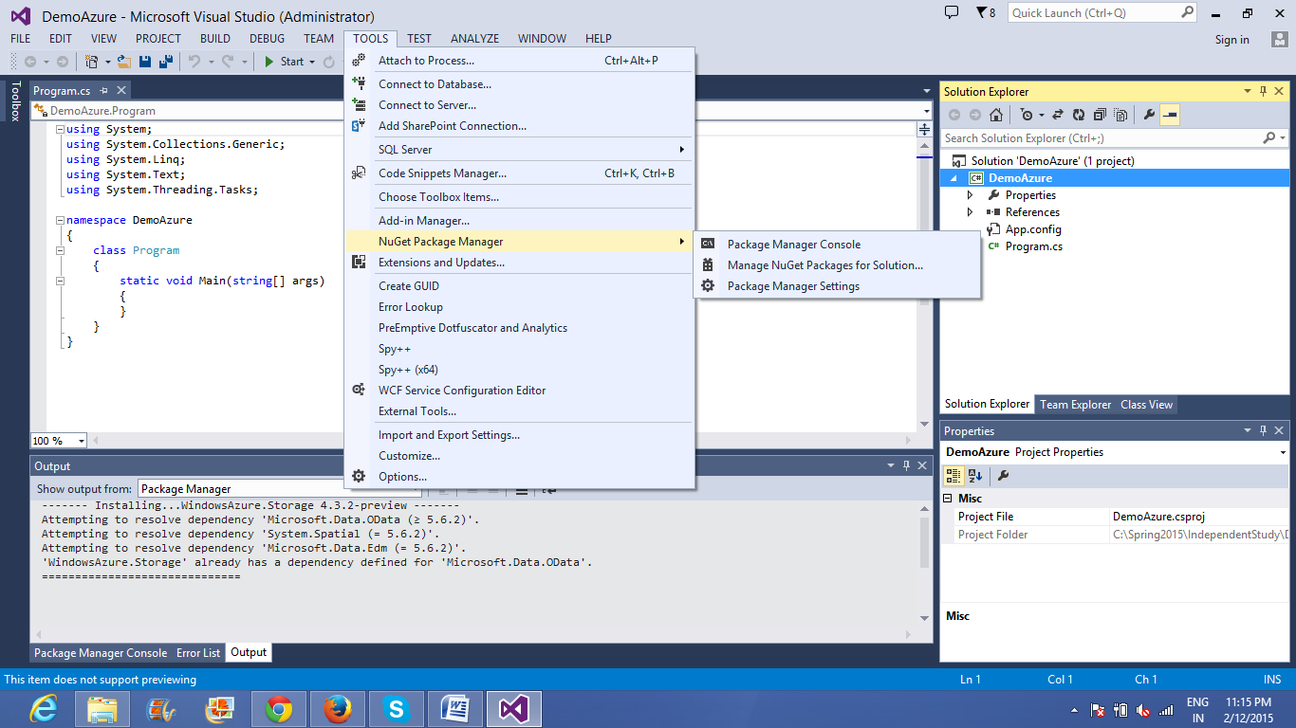

b)
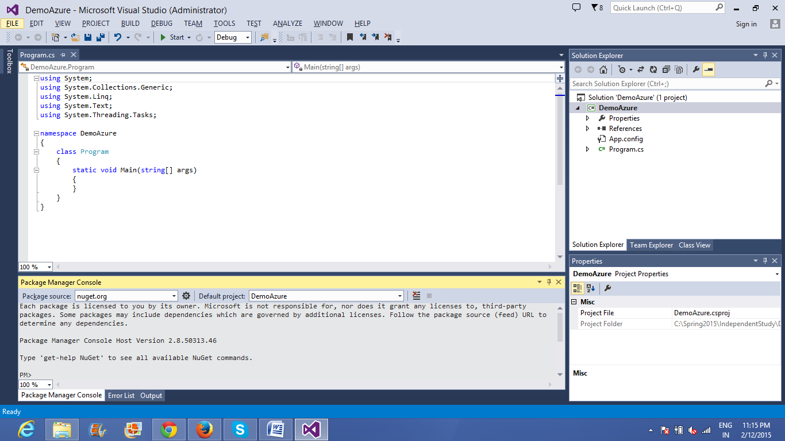
c) Type the command on the command prompt
Install-Package WindowsAzure.Storage -Version 4.3.0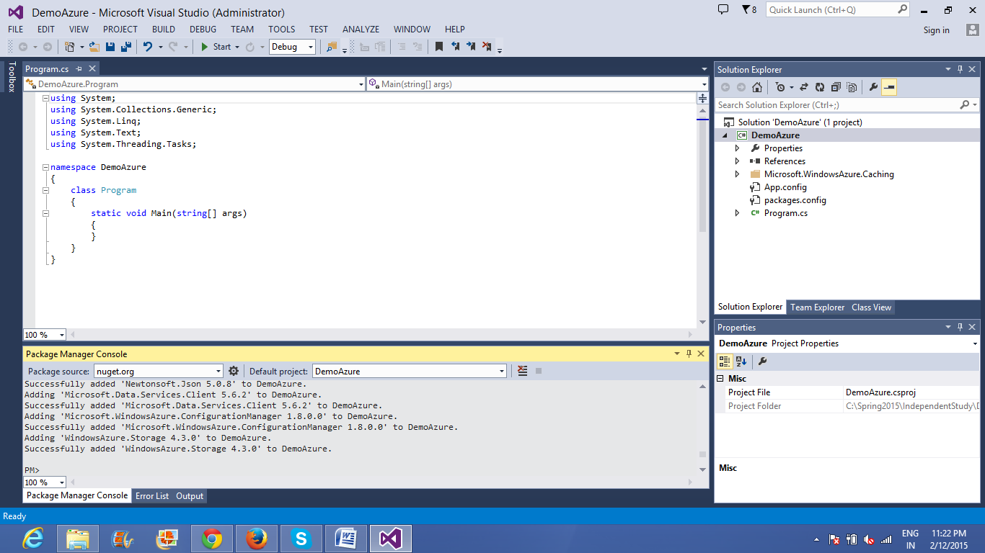
d) Check the reference section
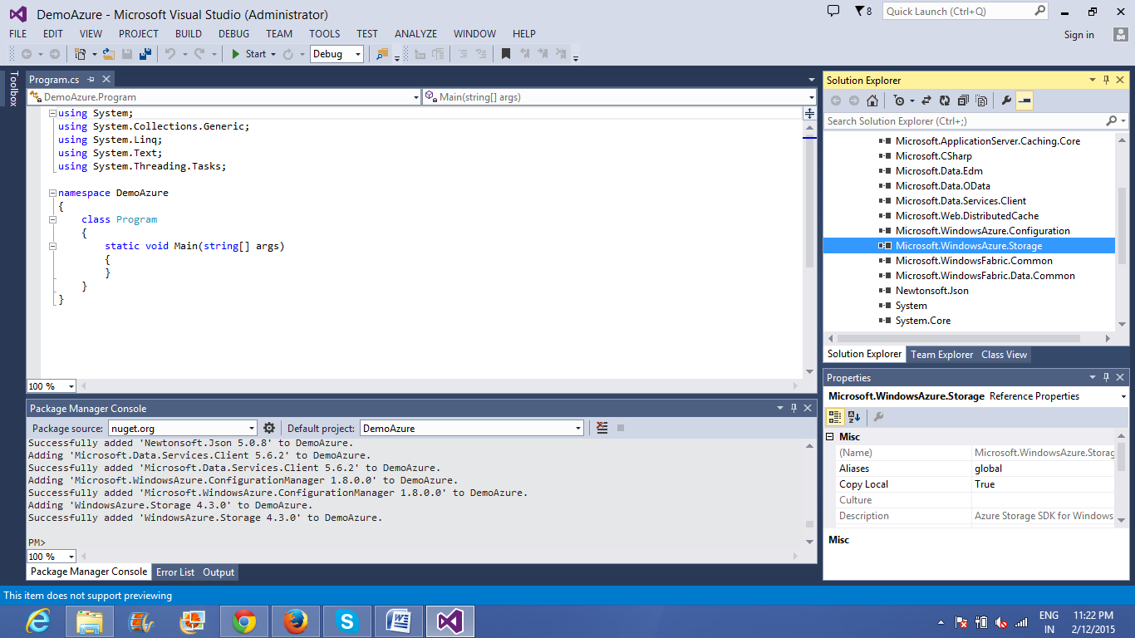

=====================================================================================
Uploading a blob to the azure account created
Steps
1. Connect to the azure account
Add the part highlighted in yellow to the app.config file. In order to prevent hardcoding of the key and account details in the source code you can put in the app.config file so that it is unreadable to the outside world
Modify the app.config file as below
<configuration>
<startup>
<supportedRuntime version="v4.0" sku=".NETFramework,Version=v4.5" />
</startup>
<connectionStrings>
<add name="AzureStorageAccount" connectionString=
"DefaultEndpointsProtocol=https;AccountName=piushs;
AccountKey=y2DXMCD2HlQaJLvPOUvX+6WVoMdEzPk/n3RLnYpVY+Y3vhOMoPTHY6abTfFaDbAaIIb1wLMny4e5XE5YHx10Bw==" />
</connectionStrings>
<appSettings>
<add key="sourceFolder" value="c:\LocalBlobs" />
<add key="destContainer" value="demoblobs" />
<add key="ClientSettingsProvider.ServiceUri" value="" />
</appSettings>
<system.web>
</configuration>
2. Accessing the connection string, source and destination folder parameters from app.config

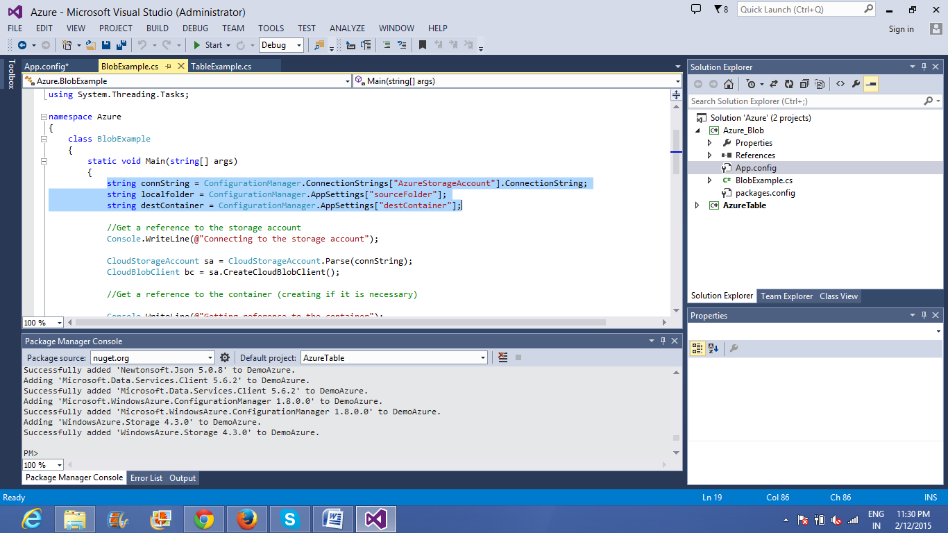
3. Create a CloudStorageAccount object using the connection string and CloudBlobClient object
//Created using the connection string
CloudStorageAccount sa = CloudStorageAccount.Parse(connString);

//Created using the above object
CloudBlobClient bc = sa.CreateCloudBlobClient();
4. You can create a container using the CloudBlobClient object
CloudBlobContainer container = bc.GetContainerReference(
destContainer);

//Create this conatainer if it doesn't exist
container.CreateIfNotExists();

5.Using the container object you can get reference to CloudBlockBlob object
//Get a blob reference to write this file to
CloudBlockBlob b = container.GetBlockBlobReference(key);
6. Use the below code to upload file contents as a stream to the cloud
//write the file
using (var fs = System.IO.File.Open(fileName, FileMode.Open, FileAccess.Read, FileShare.None))
{
b.UploadFromStream(fs);
}

7. Code Snippet to download blob and store as filestream
CloudStorageAccount storageAccount = new CloudStorageAccount(new Microsoft.WindowsAzure.Storage.Auth.StorageCredentials("piushs", "y2DXMCD2HlQaJLvPOUvX+6WVoMdEzPk/n3RLnYpVY+Y3vhOMoPTHY6abTfFaDbAaIIb1wLMny4e5XE5YHx10Bw=="), false);

CloudBlobClient blobClient = storageAccount.CreateCloudBlobClient();
CloudBlobContainer container = blobClient.GetContainerReference(username);
String dir = !isFromRcvd ? "Sent" : "Received";
CloudBlobDirectory Directory = container.GetDirectoryReference(dir);
Directory.Container.CreateIfNotExists();
CloudBlockBlob blob = Directory.GetBlockBlobReference(fileName);
//Blob Trannsfer client

using (var fileStream = System.IO.File.OpenWrite(ClientFileLocation))
{
blob.DownloadToStream(fileStream);
}

=========================================================================================
Upload data to tables in azure
Specify the data to be uploaded in a class
e.g. I need to upload customer details into a table userinfo in the storage
we create a class customer with fields
public class CustomerEntity : TableEntity
{
public CustomerEntity(string username, string password)
{
this.PartitionKey = username;
this.RowKey = password;
}

public CustomerEntity() { }

public string Email { get; set; }

public string PhoneNumber { get; set; }
}

1. After this the steps 1-2 are same as that for the blob
2. This will create a table client using the CloudStorageAccount object and using the table client object you can create or use the existing tables in the cloud storage account

CloudStorageAccount storageAccount = CloudStorageAccount.Parse(ConfigurationManager.ConnectionStrings["TableStorage"].
ConnectionString);

// Create the table client.
CloudTableClient tableClient = storageAccount.CreateCloudTableClient();

// Create the table if it doesn't exist.
CloudTable table = tableClient.GetTableReference("Users");
table.CreateIfNotExists();
3. To perform insert operation
// Create the TableOperation that inserts the customer entity.
TableOperation insertOperation = TableOperation.Insert(customer1);

// Execute the insert operation.
table.Execute(insertOperation);
4. To perform query operation
// Construct the query operation for all customer entities where PartitionKey="Smith".
TableQuery<CustomerEntity> query = new TableQuery<CustomerEntity>().Where(TableQuery.GenerateFilterCondition("PartitionKey", QueryComparisons.Equal, "piush"));

// Print the fields for each customer.
foreach (CustomerEntity entity in table.ExecuteQuery(query))
{
Console.WriteLine("{0}, {1}\t{2}\t{3}", entity.PartitionKey, entity.RowKey,
entity.Email, entity.PhoneNumber);
}
Note: Azure storage currently does not support displaying table info
In order to view tables you can download Azure Storage Explorer
https://azurestorageexplorer.codeplex.com/downloads/get/891668
