IEnumerable Interface – (Extension) members
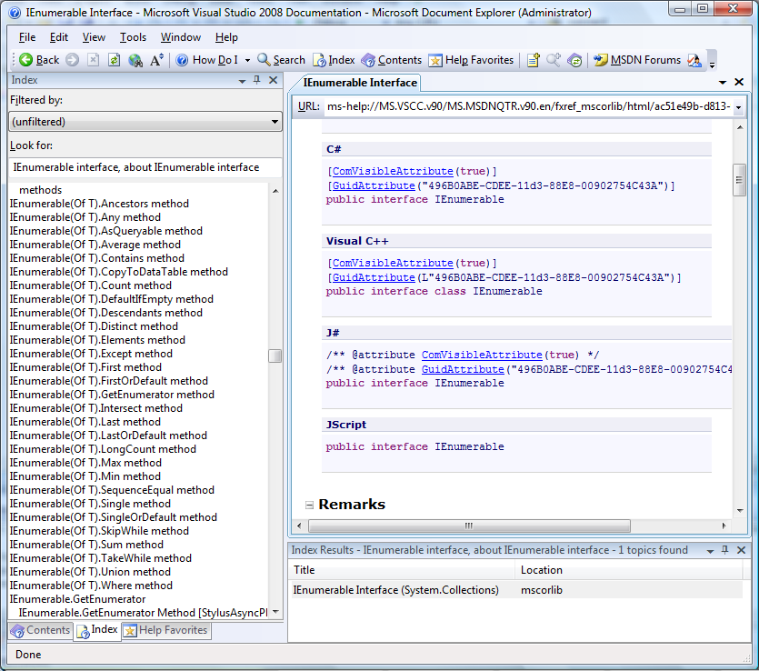

IQueryable Interface (Extension Methods)
