CSE 784 - Final Project

Collaboration Server

Jim Fawcett
version 1.0
23 September 2007

Instructions:
This is a cooperative project requiring the combined efforts of everyone in the class. Participants will be assigned roles in the project, and grades will be based on:

- how well each of your carries out your assigned role, as measured by products you generate.
- quality of the final product.
- conduct of a series of specification, design, and test reviews leading up to the final product qualification test

An Architectural description is provided on the next page, along with additional notes and comments. Also included are job descriptions for each of the roles to be assigned.

The project will be completed and a qualification test conducted on Friday, December 8th. Final product delivery of updated specifications and code will be on Monday, December 11.

Collaboration Server System

Preliminary Architectural Concept
version 1.0

Jim Fawcett
23 September 2007
Purpose of the Project:
The goal of the Collaboration Server System (CSERV) is to support conduct of shared work activities of software development teams, which may be separated in both space and time. The primary function of CSERV is to support project management activities, rather than project products. That is, the goal of CSERV is to manage people, tasks, and information about software development projects that are registered with it.

The Collaboration Server will support multiple projects, and provide role-based and team-based access to information about each project. The intent is that most project information is viewable by everyone with a Collaboration Server account, but the ability to modify a stored item is, by default, awarded only to the responsible individual for that item. Any project administrator may override that default, and an item’s responsible individual may grant permission to modify it to other project members.

The CSERV provides a set of tools for working with a common set of project data for: technical collaboration, documentation, disclosure, scheduling, notification, and monitoring progress against schedule. Since all tools share the same information, they work together to provide a diverse, but consistent view of a project’s management information. A change in project data made by one tool is immediately visible by any other tool that accesses the same information.

The main functions provided by the Collaboration Server are:

- Record and disclose project team structures and staffing
  - Organization chart with contact, job description, and biography information for each project member attached
  - Announcements of new additions and changes of responsibility
- Support development, recording, disclosure, and assignment of work packages to teams and people.
  - Work packages define specific activities, start and completion dates, and responsible individuals (RIs).
  - Each package provides links to issues statements and completed work.
  - Each package has an associated list of zero or more action items with responsible individuals and creation dates. Usually, the responsible individual will be the package RI, but additional people may be assigned co-responsibility for action completion.
  - Completed action items have resolution statement and date.
- Provide scheduling support for each project, team, and individual.
  - Work schedules, e.g., start, duration, and completion of each work package
  - Alerts for scheduled reviews and collaboration events
  - Specialized schedules for reviews, deliveries, and meetings.
- Support daily communication between teams.
  - Project and team whiteboards
  - Project and team Wikis
  - Notification service
- Document management:
  - Web-based document management system
  - All documentation is available via webpages, except for correspondence with customers
- Project Progress Monitor:
  - Evaluate and display progress of work package completion versus schedule for any registered project
  - Evaluate and display a set of progress metrics for each team
    - List of task completions with completion time relative to scheduled completion, in percent of project time ahead of schedule (+) or behind schedule (-).
    - Reviews assigned/completed
    - Tests assigned/completed
    - Documents assigned/completed
- Browsing Service:
  - Supports the role-based examination of all data stored on the Collaboration Server.
- Distributed Clients:
  - CSERV Clients provide access to the CSERV server information.
  - Each Client supports local project communication tools, e.g., whiteboard, access to Wikis, notification client, and support for digital meetings.
- Communication System based on message-passing through sockets and web services:
  - Supports client/Collaboration Server communication and Client/Client communication.
  - Supports notifications.
- Data Management:
  - Supports storage of all shared data, as described above, on the Collaboration Server.
  - The unit of storage is an item, and every item has one, and only one, responsible individual.
Figure 1. – Collaboration Server System Context

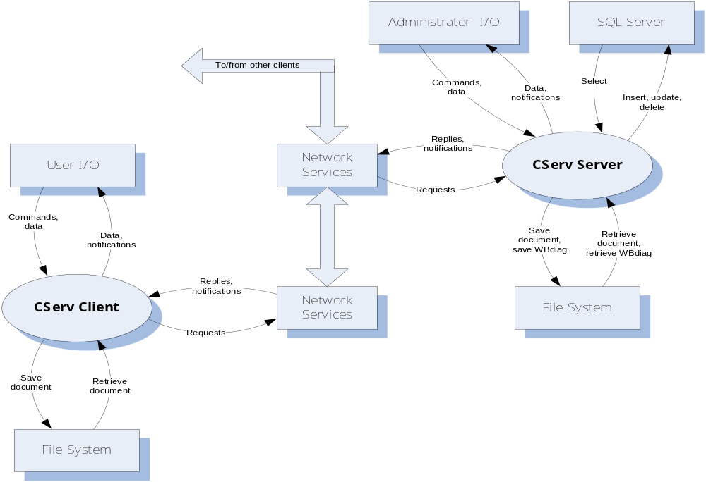
Figure 2. – Collaboration Server System Client Packages

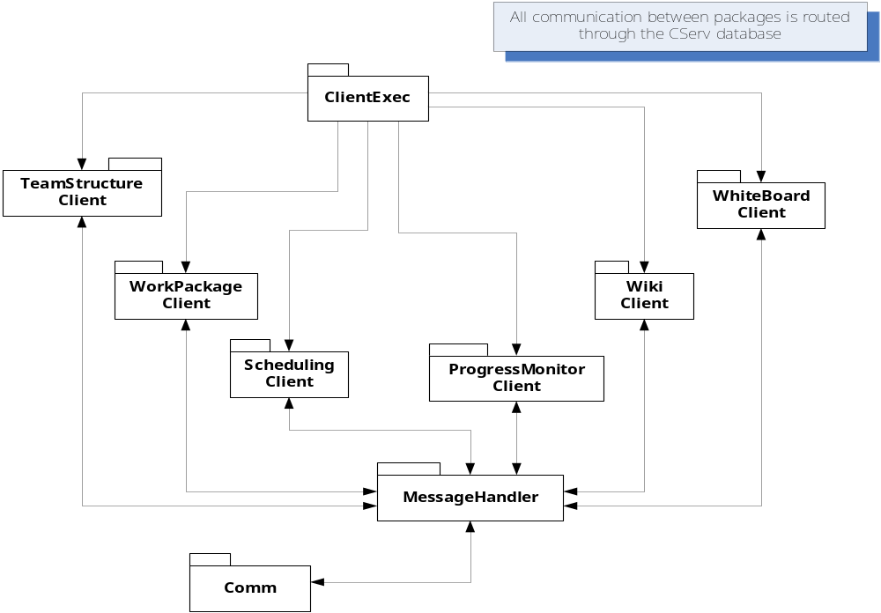
Figure 3. – Collaboration Server System Server Packages

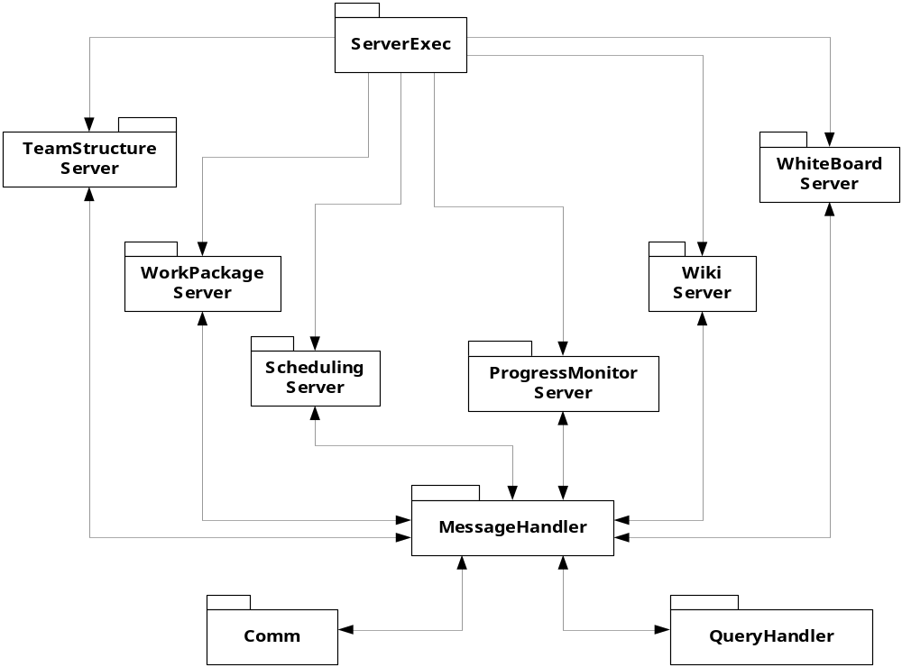

Preliminary Partitions and Their Functions:
Processing required to support the Collaboration Server System’s activities is divided into the following subsystems:
- CSERV Client and Server Executives
A local process, initiated by a user, that supports:
- Opening splash screen, with some helpful information about CServ
- Login facility
- On login, displays a list of available tools with help information
- On selection, starts the selected tool. Never terminates execution of a tool.
- Provides on-demand help for the tool set. Specialized help is provided by each of the tools.
- Data Manager
A facility that supports:
- Mapping messages into queries and query results into messages.
- Establishing and ending database connections.
- Provides, as a separate executable, an installation package that installs the database and all the tools on local machine.
- Communicator
A facility that supports, using the same code on client and server:
- Message-passing communication over sockets and web services.
- Registration of components that wish to receive specific messages.
- Dispatching messages of a designated type to each registered component.
- Facilities for construction and parsing of messages.
- Team Structure Tool
A tool that supports all the client and server activities for:
- Creating, editing, and displaying the team organization for an arbitrary number of projects.
- Displaying team member biographies in a specified structured format, including name, title, photo, job description, work history, work email and phone, and optional cell and home phone numbers.
- A form-based interface that supports selection of project, display of project organization, and, by clicking on relevant parts of the organization, display of individual information.
- All information is sent to, or retrieved, from the CServ database via messages.
- Work Package Tool
A tool that supports all the client and server activities for:
- Creating, editing, and displaying a hierarchy of work packages. Each project has a top level work package that is composed of lower-level work packages for each of its major partitions. The hierarchy may be extended with an arbitrary number of lower levels.
- Each package has at least the following information: name, start date, planned completion data, actual completion date, key words, description, and Responsible Individual (RI).
- A form-based interface that supports selection of project and creation, display, and editing of work-package information.
- Generation of web pages that display the same information, or some selected subset of this information.
- Printing work package information rooted at some specific work package.
- Scheduling Tool
A tool that supports all the client and server activities for:
- Displaying and printing schedules from information drawn from Work Package information.
- Semi-automatic replanning by adjusting individual work package schedules, based on changes in schedule of higher-level work packages.
- Scheduling of project reviews and customer meetings.
- Sending notifications for pending meetings and schedule changes to RIs of all the affected work packages.
- Progress Monitor Tool
A tool that supports all the client and server activities for:
- Creating, editing, and displaying and printing progress reports. A progress report is prepared for each work package by its RI on a specified schedule. The report includes at least work package id, work package start date and planned completion date, a title, RI name, date of creation, a reference to an action item list, and text describing the author’s view of progress against schedule.
- Reports are published periodically in a project progress report, including each package report and indicating at the top of each package report, a statement showing that the report was, or was not, updated since last publication.
- Action item lists, one for each work package. Contains a list of actions assigned to the package RI, with the assignment date, requested completion date, a text description of the action required, and, when closed, a statement of the actions taken. The creation of action items is role-based. The Project Manager can levy an action item on any project member, but usually does so only for immediate reports. A team leader can levy actions on any member of that team.
- Wiki Tool
A tool that supports all the client and server activities for:
- Collaborative creating, editing, and displaying web pages. Modifications are role-based. Anyone may create and modify a new page and read any exisiting page. Only the author can modify a page, unless the author specifically allows specific team members to have modification privileges.
- Providing an index, with categories determined for each project, linking to each wiki page.
- The categories are read from an XML file at startup and are specific to each project.
- The intent of Wiki pages is to support simply structured quick communication between collaborators in different locations.
- Whiteboard Tool
A tool that supports all the client and server activities for:
- Collaborative creating, editing, and displaying UML diagrams, and displaying existing documents.
- Adding free-form (scribble style) annotations to UML diagrams.
- Each client has a Whiteboard display, can access diagrams created locally and remotely, as well as documents, through the CServ Server.
- Two or more clients can collaborate on a single diagram, interactively. Diagrams support symbols, connections, and property views, where each property view contains information relevant to a particular symbol, e.g., a class view would show, on click, members, fields, properties, and events associated with a particular class. Activity views would show text for an activity, etc.
- Text-based chatting.
- The intent of the Whiteboard is to support quick technical communication between collaborators in different locations.

Collaboration Server System

Preliminary Project Organization
version 1.1

Jim Fawcett
28 September 2007

Software Project Manager
The SPM will manage the Collaboration Server System project, with the help of the Software Architect, Test Manager, and all the Team Leaders.

Software Architect
The Software Architect is responsible for the Collaboration Server System’s architectural concept and A Specification. A preliminary A-Specification is provided as part of this package, but will evolve as the team and customer negotiate system structure and capabilities. The SA will also provide support for qualification testing.
Software Development Teams
Collaboration Server System development will be carried out by teams, defined in this document. There will also be a test team, responsible for developing and executing Qualification Test. Each team, with the exception of test team, will:
- produce its own behavior specification, design description, and code
- present their specifications and design during Collaboration Server System specification and design reviews
- conduct unit test on their code
- integrate their software with that of the other teams
- participate in final qualification testing

Test Team
The test team will prepare a test plan which contains at least the following:
- A schedule of key milestones and their contents.
- A schedule for integration testing and qualification testing. The integration test schedule will be phased and clearly describe when each team’s software must be available for integration.
- A set of qualification test descriptions, procedures, and definition of all instrumentation, logs, and analyses needed to conduct qualification testing.
- Definition of a process for baselining and accessing test code, including a class build directory structure and error reporting mechanism.
Integration testing is the joint responsibility of the development team leaders and test team leader. Qualification testing is the responsibility of the Software Project Manager, supported by the test team and its manager. Each development team will be responsible for developing qualification tests, in collaboration with the Test Team member assigned to them, which implement the tests described in the test plan in for their software, under the joint direction of their team leader and the test team leader.
Team Assignments:
- Software Project Manager Dhaval Trivedi
- Software Architect Sreevatsa Lakshmanan
- Test Team Prashanth Vijayaraghavan
- Sunny Gupta (also Comm)
- Estepan Meliksetian (also WBrd)
- Vijay Reddy
- Falgun Shah
- Team Structure Tool Abhishek Allen
- Vijay Agarwal
- Priyanka Salvi
- Work Package Tool Kimberly Lang
- Aliasgar Gulamhuseinwala
- Sagnak Tasilar
- Scheduling Tool Aditya Damani
- Kamarish Shrivastava
- Progress Monitor Tool Abhinav Bose
- Shashank Muthyala
- Prashanth Sundararaman
- Wiki Tool Kedar Joshi
- Prudhvi Bongarala
- Naresh Salguti
- Whiteboard Tool Anirudhha Gore
- Shrenik Dedhia
- Estepan Meliksetian
- Communication Rajesh Thummalapally
- Vipul Dudani
- Sunny Gupta
- Data Manager Heidi Salapong
- Vikram Bedekar

Attachment #1 - Job Descriptions

Job Description: Software Project Manager (SWPM)

The Software Project Manager organizes the teams so that each team owns part of the B-Spec, C-Spec, and software integration. He/She conducts weekly meetings to stay on top of any problems that arise, and manages all the reviews.

The SWPM is expected to know most of the design and the critical code details. The SWPM, Software Architect, and Team Leaders establish the architecture and B-Specs; and they control the design, implementation, and test processes so that the final product is robust and meets specifications.

Finally, the Software Project Manager directs the Test Leader and Architect to prepare a Software Test Plan and conducts qualification tests based on the plan.

Responsibilities:
- Organize teams
- Prepare program schedule including Architecture Review, Specification Review, Design Review, and Qualification test. Present the schedule at the Architecture Review and at each succeeding review.
- Manage B-Spec process with team leaders.
- Provide the opportunity for each team leader to be a hero, but:
- Takes full responsibility for success of the project.
- Conducts specification review on date specified in program schedule.
- Conducts design review on date specified in program schedule.
- Prepares, with Test Leader and Software Architect, a Test Plan. Conducts qualification test with the help of Test Leader, Architect, and Team Leaders.

Evaluation:
The Project Manager's grade is based on:
- meeting program schedule
- Software Test Plan and success of qualification
- an oral examination.
Job Description: Software Architect (SA)

The Software Architect is responsible for the architectural concept, effectiveness and ease of use of the user interface, modularity and robustness of the design. He/She supports the team leaders in developing elegance and quality in the final product.

The SA is required to know the entire design and provides support for team leaders during major reviews. He/She has responsibility for consistency and integrity of all requirements with special focus on the user interface. The SA is also responsible for the top-level physical structure, organizing principles, and built in test. Built in test should directly support qualification testing.

SA participates in all weekly meetings, spending at least some time with each team, making sure they understand the architecture and testbed, and helps with problem solving as needed by each team. The SA is responsible for ensuring that the requirements are sensibly allocated to individual teams and that each team understands their allocation.
Responsibilities:
- Prepare an Architectural Concept Document which includes:
  - Organizing principles for project including processing partitions for each team
  - Definition of user interface
  - Definition of, and logical model for, top level processes and data flows, e.g., one DFD per team (worked out with respective Team Leader)
  - Updated to include definition of, and logical model for, each module in the Collaboration Server System design, including key classes.
  - This work will be presented at the architecture review.
- Support SW integration process.
- Provide technical support to teams during Specification Review, Design Review, and Qualification test.
- Help with design and implementation when needed.
- Assist SWPM and Test Leader with final product Qualification Test

Evaluation:
The Software Architect's grade is based on:
- Architectural Concept Document
- Success of reviews
- Support provided to teams during integration so that subsystems behavior reflects architectural goals and the subsystem interfaces are understood by all teams.
- Support provided to SWPM and Test Leader during Qualification
- An oral examination.
Job Description: Test Manager (TsM)

The Test Manager is the technical lead for integration and qualification test. Does whatever is needed to detect and locate latent errors in project code.

The TsM is required to know the entire design and provides support for team leaders during integration testing. He/She shares responsibility for qualification test with the Software Project Manager, assisted by the SA. The Test Leader:
- prepares a test plan, including qualification test descriptions and procedures
- reports status of unit testing, solicited from the Team Leaders.
- coordinates integration test schedule and supports team leaders in integration
- provides qualification test templates
- conducts the mechanics of qualification test while the Software Project Manager leads the test and signs off on tests with the customer
- manages a test bed which includes all released codes which are shared between teams or modules within a team. The test bed is built around a directory structure established by the Test Leader with the Software Architect and ECS cluster system administrators.

TsM participates in all weekly meetings, spending at least some time with each team, making sure they understand the test process and testbed, and helps with problem solving as needed by each team.

Responsibilities:
- Prepare a Test Plan Document which includes:
  - test schedule
  - priorities for integration test, based on dependency analysis of each team’s code base.
  - definition of qualification test templates
  - qualification test descriptions and test procedures (about 90% of the Test Plan)
- Provide technical support to teams during integration and qualification test.
- Manage the testbed used for the project.
- Help with design and implementation when needed.
- Help team leaders plan and conduct integration test.
- Plan and share responsibility with the Software Project Manager for final product Qualification Test.

Evaluation:
The Test Leader's grade is based on:
- Test Plan Document
- Success of qualification testing
- Integrity of the final product
- An oral examination.

Job Description: Team Leader (TL)

The Team Leader is the technical lead for one specific part of the system. Does whatever he/she has to make that part successful. The TL prepares the B-Spec for his/her assigned part of the system with the help of the Software Architect and presents that part at Specification Review. He/She organizes the team to produce the C-Spec, conduct design review, produce code, test drivers, and conduct unit testing. TLs share responsibility with the Test Manager for software integration. They are directly responsible for running all integration tests and preparing any required modifications to their team’s code.

Responsibilities:
- Reviews Architectural Concept and prepares assigned part of B-Spec.
- Presents team's part of B-Spec at Specification Review.
- Assigns classes/modules to individual team members.
- Guides the team in preparation of design and C-Spec.
- Assigns team members to present during design review.
- Insures that all requirements are traceable to the process and function level.
- Provides opportunity for each team member to be a hero, but:
- Takes full responsibility for success of team.
- Shares responsibility for software integration with TsM and other TLs.
- Helps team members with design and/or implementation problems.

Evaluation:
Grade based on:
- B-Spec for assigned part of system
- Presentation during B-Spec Review
- Meets allocated specifications
- Has adequate derived specifications and meets them
- Success of team's design and implementation, e.g.,
- Robustness of Team’s code.
- an oral examination.
Job Description: Team Member (TM)

Concentrates on one specific part of the system. Does whatever necessary to make assigned parts successful. TM has primary responsibility for assigned classes/modules including design, implementation, and test. He/She prepares C-Spec for assigned functionality, presents that part at the design review, develops code, and conducts unit test. The TM supports the Team Leader in conducting integration if requested by TL.

Responsibilities:
- Reads B-specification
- Prepares assigned part of the C-Spec and design.
- Presents that part at Design Review.
- Implements assigned part, paying attention to complexity, size, robustness, understandability.
- Develops unit test drivers.
- Tests every function and allocated requirement as early as possible
- Takes full responsibility for assigned part of subsystem.

Evaluation:
Grade based on:
- C-Spec Review presentation
- quality of assigned code and test
- robustness of code.
- "reasonable" size and complexity
- good understandability
- success of team's assigned part
- willingness to support team leader in documentation, design, implementation, and test

Final Project

Collaboration Server System

Statement of Work
version 1.0

Jim Fawcett
23 September 2007
- Introduction:
The Collaboration Server System is designed to support managing people and activities in a large project. Collaboration Server has facilities for:
- Defining Jobs, Work Packages and Schedules
- Collaborative communication via Wikis and Whiteboards.
- Monitoring progress.
- Reporting results in all these areas.
- Providing access to all Collaboration tools and information from remote locations.
- Customer Furnished Equipment:
The operating environment for Collaboration Server System will be Windows XP, as provided in the ECS clusters. The Collaboration Server System software must compile and link using Visual C# or C++, as provided by Visual Studio.Net 2005. This environment is available in the ECS clusters in 010 Link, 202 Link, and 2-122 in CST, Syracuse University.
- Reference Documents:
- Collaboration Server System Preliminary Architectural Concept, 23 September 2007, or latest version.
- Collaboration Server System A-Level Specification, 23 September 2007, or latest version.
- Visual C#, C++, and Class Libraries on-line documentation
- Preliminary Schedule – Fall 2007:
Project start date | 24 September
Program and Architecture Review | 08 October
B Specification Review | 15 October
Design and Prototypes Review | 29 October
Design and Implementation Meetings | 05 November
Design and Implementation Meetings | 12 November
Test Readiness Review | 26 November
Qualification Test | 07 December
Final Products Delivery | 10 December

Final Project

Collaboration Server System

A-Level Specification
version 1.0

Jim Fawcett
23 September 2007
Collaboration Server System (RTS)

- Introduction:
The Collaboration Server System is designed to help manage people and activities in large software development projects. Collaboration Server has facilities for:
- Selecting one or more collaboration tools to run to manage schedules, work packages, describe the project team relationships, collaborate on UML diagrams and Wiki documents, and monitor progress against schedule.
- Store all persistent data in a Collaboration Server database.
- Display selected results in web pages

Figure 1 - Collaboration Server Context

The Collaboration Server System Architecture consists of the partitions:
- CSERV Client and Server Executives
A local process, initiated by a user, that supports:
- Opening splash screen, with some helpful information about CServ
- Login facility
- On login, displays a list of available tools with help information
- On selection, starts the selected tool. Never terminates execution of a tool.
- Provides on-demand help for the tool set. Specialized help is provided by each of the tools.
- Data Manager
A facility that supports:
- Mapping messages into queries and query results into messages.
- Establishing and ending database connections.
- Provides, as a separate executable, an installation package that installs the database and all the tools on local machine.
- Communicator
A facility that supports, using the same code on client and server:
- Message-passing communication over sockets and web services.
- Registration of components that wish to receive specific messages.
- Dispatching messages of a designated type to each registered component.
- Facilities for construction and parsing of messages.
- Team Structure Tool
A tool that supports all the client and server activities for:
- Creating, editing, and displaying the team organization for an arbitrary number of projects.
- Displaying team member biographies in a specified structured format, including name, title, photo, job description, work history, work email and phone, and optional cell and home phone numbers.
- A form-based interface that supports selection of project, display of project organization, and, by clicking on relevant parts of the organization, display of individual information.
- All information is sent to, or retrieved, from the CServ database via messages.
- Work Package Tool
A tool that supports all the client and server activities for:
- Creating, editing, and displaying a hierarchy of work packages. Each project has a top level work package that is composed of lower-level work packages for each of its major partitions. The hierarchy may be extended with an arbitrary number of lower levels.
- Each package has at least the following information: name, start date, planned completion data, actual completion date, key words, description, and Responsible Individual (RI).
- A form-based interface that supports selection of project and creation, display, and editing of work-package information.
- Generation of web pages that display the same information, or some selected subset of this information.
- Printing work package information rooted at some specific work package.
- Scheduling Tool
A tool that supports all the client and server activities for:
- Displaying and printing schedules from information drawn from Work Package information.
- Semi-automatic replanning by adjusting individual work package schedules, based on changes in schedule of higher-level work packages.
- Scheduling of project reviews and customer meetings.
- Sending notifications for pending meetings and schedule changes to RIs of all the affected work packages.
- Progress Monitor Tool
A tool that supports all the client and server activities for:
- Creating, editing, and displaying and printing progress reports. A progress report is prepared for each work package by its RI on a specified schedule. The report includes at least work package id, work package start date and planned completion date, a title, RI name, date of creation, a reference to an action item list, and text describing the author’s view of progress against schedule.
- Reports are published periodically in a project progress report, including each package report and indicating at the top of each package report, a statement showing that the report was, or was not, updated since last publication.
- Action item lists, one for each work package. Contains a list of actions assigned to the package RI, with the assignment date, requested completion date, a text description of the action required, and, when closed, a statement of the actions taken. The creation of action items is role-based. The Project Manager can levy an action item on any project member, but usually does so only for immediate reports. A team leader can levy actions on any member of that team.
- Wiki Tool
A tool that supports all the client and server activities for:
- Collaborative creating, editing, and displaying web pages. Modifications are role-based. Anyone may create and modify a new page and read any exisiting page. Only the author can modify a page, unless the author specifically allows specific team members to have modification privileges.
- Providing an index, with categories determined for each project, linking to each wiki page.
- The categories are read from an XML file at startup and are specific to each project.
- The intent of Wiki pages is to support simply structured quick communication between collaborators in different locations.
- Whiteboard Tool
A tool that supports all the client and server activities for:
- Collaborative creating, editing, and displaying UML diagrams, and displaying existing documents.
- Adding free-form (scribble style) annotations to UML diagrams.
- Each client has a Whiteboard display, can access diagrams created locally and remotely, as well as documents, through the CServ Server.
- Two or more clients can collaborate on a single diagram, interactively. Diagrams support symbols, connections, and property views, where each property view contains information relevant to a particular symbol, e.g., a class view would show, on click, members, fields, properties, and events associated with a particular class. Activity views would show text for an activity, etc.
- Text-based chatting.
- The intent of the Whiteboard is to support quick technical communication between collaborators in different locations.
Figure 2. – Collaboration Server System Client Packages

Figure 3. – Collaboration Server System Server Packages

Reference Documents:
- Collaboration Server System Preliminary Architectural Concept, 23 September 2007.
- Collaboration Server System Statement of Work, 23 September 2007.
- Requirements:
The Collaboration Server System System is a tool designed to help manage people and activities in large software development projects. The requirements are allocated below, to each of the major partitions described in Section 1.
  - Functional Requirements
    - Team Structure Tool (TST)
The Team Structure client and server components provide facilities to record, edit, and display a project’s staffing, in the form of an organization model.
      - TST clients shall accept user inputs in a form for constructing, editing, and displaying all members of a project team.
      - A means shall be provided to enter the name, photo, title, job description, work history, email and office addresses, phone number, and optional home address and phone number.
      - Means shall be provided to display the information concerning each project member, individually.
      - Means shall be provided to display the entire project team structure, and to zoom down to expose more detail.
      - Shall provide the ability to print an organization chart and individual biographies.
      - All data shall be sent to the TST server component for persistent storage of its information.
      - TST clients shall provide the means to generate web page representations of their client displays.
    - Work Package Tool (WPT)
The Work Package client and server components provide facilities to create, edit, and display work information in a collection of packages and a hierarchy of package containers.
      - The WPT client shall provide a WinForm interface that accepts the following information for creating or editing work package descriptions: name, start date, planned completion date, actual completion date, key words, multi-line text description, of arbitrary length, Responsible Individual (RI), and a list of all work packages on which it depends.
      - The Client shall provide a means to connect each package description into a project-wide dependency network and to display views of this network at different zoom levels.
      - The WPT client shall provide means to define package containers. A package container holds packages, and possibly other containers, which serve to group work packages into work groups.
      - Shall provide means to print a representation of the Work Package network and to print information about individual packages.
      - All data shall be sent to the WPT server component for persistent storage of its information.
      - WPT clients shall provide means to generate web page representations of their client displays.
    - Scheduling Tool (ST)
The Scheduling client and server components provide facilities to create, edit, and display project and work package schedule information.
      - The ST client shall provide means of displaying Work Package schedule information for any collection of packages and work group containers.
      - The ST client shall provide the facility to display schedules for any time period from on or after the project start to before or on the projected completion date. These schedules may be as long as the entire project duration to as short as one week.
      - Shall display work package name and duration, and the names and durations of work group containers.
      - The ST client shall support replanning by entering a new duration and start date for a package. Each of its dependent packages shall be rescheduled by changing its start time so that it starts at the latest completion date of all the packages on which it depends.
      - The ST client shall support an additional replanning operation by entering a new duration and start date for a work group container. The durations of all work packages in the container are changed to keep their duration as a fraction of the container’s duration the same as it was before the change. Each of their start times is adjusted accordingly.
      - Shall provide means to print a representation of the schedule for any work package or container for any specified time from one week to the duration of the project.
      - All data shall be sent to the ST server component for persistent storage of its information.
      - ST clients shall provide means to generate web page representations of their client displays.
    - Progress Monitor Tool (PMT)
The Progress Monitor client and server components provide facilities to create, edit, and display progress reports for each work package.
      - The PMT client shall provide the means to create, edit, and display progress reports for each work package.
      - It shall provide a WinForm interface that accepts at least the following information: work package id, start date, projected completion date, title, Responsible Individual name, date of report creation, a reference to an action item list, and text describing the author’s view of progress against schedule.
      - The client shall provide the capability to display individual project reports for a selection of work packages or containers.
      - It shall also support the creation of a project report that displays progress reports of all work packages, and, for each package report, shows whether that report was updated since publication of the last project report.
      - Shall provide means to print a collection of work package reports or the entire project report.
      - All data shall be sent to the PMT server component for persistent storage of its information.
      - PMT clients shall provide means to generate web page representations of their client displays.
    - Wiki Tool (WT)
The Wiki client and server components provide facilities to create, edit, and display web pages as a collaboration of multiple team members at, possibly, more than one location.
      - The WT client shall provide the means to collaboratively create, edit, and display web pages with structures defined by one or more XML templates.
      - It shall provide a WinForm and/or WebForm interface to supply whatever information the collaborators deem appropriate.
      - The client shall support role-based access for reading and editing. All project members are, by default, given read access. Only the author is given, by default, write access.
      - The tool shall support allowing the author to change these defaults by selecting one or more project members for specific priviledges.
      - All data shall be sent to the WT server component for persistent storage of its information.

    - WhiteBoard Tool (WBT)
The Whiteboard client and server components provide facilities to create, edit, and display UML diagrams, documents, and text chats.
      - The WBT client shall provide the means to create, edit, and display at least the following UML diagrams: package, class, and activity diagrams.
      - It shall provide a WinForm interface that provides a drawing panel, document display, and text chat, in windows that may be tabbed in a single frame, or displayed as separate pop-up windows.
      - The client shall provide the capability to add, delete, rename, and move symbols representing packages, classes and activities.
      - The client shall also provide the capability to link these symbols with connectors representing aggregation, inheritance, using, dependency, and transfer operations in class, package, and activity diagrams, respectively.
      - It shall support the creation pop-up property sheets that contain the following information about class symbols: name, methods, properties, fields, and events.
      - It shall provide pop-up property sheets that contain activity information about each activity symbol.
      - It shall provide pop-up property sheets that contain information about the responsibilities of each package symbol.
      - Shall provide means to print a UML diagram with all its property sheets.
      - All data shall be sent to the WBT server component for persistent storage of its information.
      - WBT clients shall provide means to generate web page representations of their client displays.
    - Data Manager (DM)
The DM client and server components provide facilities to map client requests to messages, and back again to queries, and to reverse that process for responses.
      - The DM client shall provide the means to build messages, using the services of COMM, to request a query into the CServ database.
      - The DM server shall accept messages and transform them into queries into a SQL Server database.
      - It shall provide the capability to map query results back into messages for transmission to a requesting client.
      - The Data Manager shall provide an installation tool that will detach the CServ database, and archive the CServ client and server sites for installation on other machines.
      - The client shall support registration of one or more event handlers with the component for subsequent notification when messages of a specified type are received.

    - Communication (COMM)
The COM client and server components are expected to be identical, and provide facilities to send XML messages between processes on the same machine, and between two machines on the local network, using sockets, and between machines anywhere with access to the internet, supported by a web service.
      - The COMM component shall provide means to send XML messages between processes, machines, or networks.
      - The COMM receiver shall support registration of one or more event handlers for subsequent notification when messages of a specified type are received.
      - The receiver shall support the dispatching of messages to registered handlers of each specific message type.
      - The COMM sender shall provide facilities to build messages from predefined text.
      - It shall provide notifications to all registered handlers when a message of the specified type arrives.
      - COMM shall support building and parsing of messages as a service to the Executives and tools.

    - Client and Server Executives (CSC and CSS)
The client and server Executive components provide facilities to create instances of, and start, each of the tools provided by CServ.
      - The CSC client shall provide the means display names and brief information about each of the CServ tools, and to accept selection of a specific tool for starting.
      - It shall provide facilities for logging in to the CServ client and server. On login users are identified with a role, that supports a fixed set of permissions for actions.
      - The client shall support on-line help, augmented by tool specific help authored by the tool creator.

  - Process Requirements
These requirements specify the physical structure of delivered code and the environment where it must operate.
    - Physical Structure
      - The Collaboration Server source code shall be composed of modules.
      - The Collaboration Server source builds shall be composed of managed or unmanaged executables and dynamic link libraries.
      - The user interfaces shall delegate all operations, not directly associated with providing the user controls and views to server modules, e.g., communication, data management, and all operations specified in this document.
      - All modules shall be provided with manual pages and correct maintenance pages.
      - Code that implements services shared by two or more components of the Collaboration Server shall be provided by one set of source code, with the possible exception of configuration files.
    - Development
      - The Collaboration Server development process shall use the SA Repository and Testbed for Qualification testing.
      - The Collaboration Server System shall build and operate in the ECS clusters, e.g., 010, 202, 270, and 274 Link, and CST 2-122.
      - The Collaboration Server System shall be developed subject to the conditions specified in the Collaboration Server System Statement of Work, of the latest edition.

Start and completion dates are associated with each work package. The schedule accesses this information for editing and display.
Documentation includes specifications, design documents, code (production, test, and prototypes), schedules, and all other project planning documents. Specifications, design documents, and code are usually held in a repository, but the tools to create specifications and design documents as web pages are provided by CServ. Also, CServ provides the tool or tools to create webpage representations of code.
This implies that individual tools may not directly bind to the CServ database, but must go through the Data Manager by sending and receiving messages.
By local machine, we mean that the installer does not have to work over the network. An administrator may simply logon to a machine with no CServ facilities and install either a CServ Client or Server.
It would be interesting, but not required, to investigate audio communication with a separate ip channel to the CServ. Several open-source projects support this form of communication.
The form of behavior and design descriptions will be as cited above in the Preliminary Architectural Concept.
Each subsystem should have means to test the validity of its operations.
This is a technical support role, not a managerial role.
Team leaders conduct the integration process, as scheduled by the Test Manager. This schedule should be negotiated with everyone agreeing that it can be met. Should this be difficult, please consult the customer.
The test bed starts out as a set of directories globally accessible to the development teams, with permissions established to control the evolving product. As Qualification Test approaches the test bed typically contains a number of tools designed by the test team to support qualification testing.
The Team Leader should assign presentation responsibilities and introduce each speaker on his/her team, but should ensure that team members each get a major part of the presentation.
This implies that individual tools may not directly bind to the CServ database, but must go through the Data Manager by sending and receiving messages.
By local machine, we mean that the installer does not have to work over the network. An administrator may simply logon to a machine with no CServ facilities and install either a CServ Client or Server.
It would be interesting, but not required, to investigate audio communication with a separate ip channel to the CServ. Several open-source projects support this form of communication.
What model means is to be defined by the team, with help from the customer.
This display is not required to be graphical.
All the work packages in a sub-system would be collected into a group. The entire project would be represented by a work group of all the sub-system work groups.
This uses Vector Markup Language (VML).
This is intended to allow Project Management to select either C++ or C# or both as implementation languages.

