Final Project

Collaboration Server System

A-Level Specification
version 1.3

Sreevatsa Lakshmanan
11 October 2007
Collaboration Server System (RTS)

- Introduction:
The Collaboration Server System is designed to help manage people and activities in large software development projects. Collaboration Server has facilities for:
- Selecting one or more collaboration tools to run to manage schedules, work packages, describe the project team relationships, collaborate on UML diagrams and Wiki documents, and monitor progress against schedule.
- Store all persistent data in a Collaboration Server database.
- Display selected results in web pages

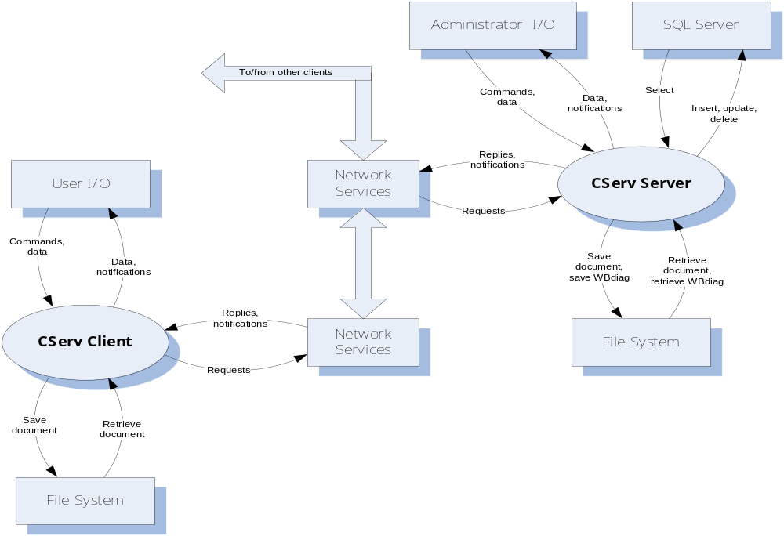

Figure 1 - Collaboration Server Context

The Collaboration Server System Architecture consists of the partitions:
- CSERV Client and Server Executives
A local process, initiated by a user, that supports:
- Opening splash screen, with some helpful information about CServ
- Login facility
- On login, displays a list of available tools with help information
- On selection, starts the selected tool. Never terminates execution of a tool.
- Provides on-demand help for the tool set. Specialized help is provided by each of the tools.
- Data Manager
A facility that supports:
- Mapping messages into queries and query results into messages.
- Establishing and ending database connections.
- Provides, as a separate executable, an installation package that installs the database and all the tools on local machine.
- Communicator
A facility that supports, using the same code on client and server:
- Message-passing communication over sockets and web services.
- Registration of components that wish to receive specific messages.
- Dispatching messages of a designated type to each registered component.
- Facilities for construction and parsing of messages.
- Team Structure Tool
A tool that supports all the client and server activities for:
- Creating, editing, and displaying the team organization for an arbitrary number of projects.
- Displaying team member biographies in a specified structured format, including name, title, photo, job description, work history, work email and phone, and optional cell and home phone numbers.
- A form-based interface that supports selection of project, display of project organization, and, by clicking on relevant parts of the organization, display of individual information.
- All information is sent to, or retrieved, from the CServ database via messages.
- Work Package Tool
A tool that supports all the client and server activities for:
- Creating, editing, and displaying a hierarchy of work packages. Each project has a top level work package that is composed of lower-level work packages for each of its major partitions. The hierarchy may be extended with an arbitrary number of lower levels.
- Each package has at least the following information: name, start date, planned completion data, actual completion date, key words, description, and Responsible Individual (RI).
- A form-based interface that supports selection of project and creation, display, and editing of work-package information.
- Generation of web pages that display the same information, or some selected subset of this information.
- Printing work package information rooted at some specific work package.
- Scheduling Tool
A tool that supports all the client and server activities for:
- Displaying and printing schedules from information drawn from Work Package information.
- Semi-automatic replanning by adjusting individual work package schedules, based on changes in schedule of higher-level work packages.
- Scheduling of project reviews and customer meetings.
- Sending notifications for pending meetings and schedule changes to RIs of all the affected work packages.
- Progress Monitor Tool
A tool that supports all the client and server activities for:
- Creating, editing, and displaying and printing progress reports. A progress report is prepared for each work package by its RI on a specified schedule. The report includes at least work package id, work package start date and planned completion date, a title, RI name, date of creation, a reference to an action item list, and text describing the author’s view of progress against schedule.
- Reports are published periodically in a project progress report, including each package report and indicating at the top of each package report, a statement showing that the report was, or was not, updated since last publication.
- Action item lists, one for each work package. Contains a list of actions assigned to the package RI, with the assignment date, requested completion date, a text description of the action required, and, when closed, a statement of the actions taken. The creation of action items is role-based. The Project Manager can levy an action item on any project member, but usually does so only for immediate reports. A team leader can levy actions on any member of that team.
- Wiki Tool
A tool that supports all the client and server activities for:
- Collaborative creating, editing, and displaying web pages. Modifications are role-based. Anyone may create and modify a new page and read any existing page. Only the author can modify a page, unless the author specifically allows specific team members to have modification privileges.
- Providing an index, with categories determined for each project, linking to each wiki page.
- The categories are read from an XML file at startup and are specific to each project.
- The intent of Wiki pages is to support simply structured quick communication between collaborators in different locations.
- Whiteboard Tool
A tool that supports all the client and server activities for:
- Collaborative creating, editing, and displaying UML diagrams, and displaying existing documents.
- Adding free-form (scribble style) annotations to UML diagrams.
- Each client has a Whiteboard display, can access diagrams created locally and remotely, as well as documents, through the CServ Server.
- Two or more clients can collaborate on a single diagram, interactively. Diagrams support symbols, connections, and property views, where each property view contains information relevant to a particular symbol, e.g., a class view would show, on click, members, fields, properties, and events associated with a particular class. Activity views would show text for an activity, etc.
- Text-based chatting.
- The intent of the Whiteboard is to support quick technical communication between collaborators in different locations.

Figure 2. – Collaboration Server System Architecture

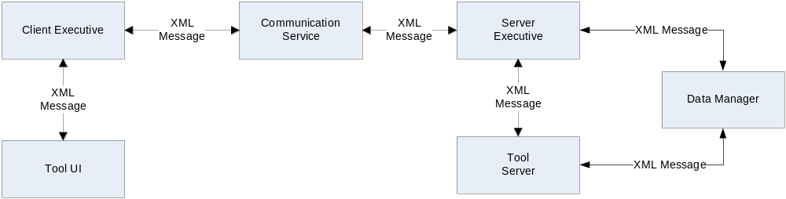

Figure 3. – Collaboration Server System Client Packages

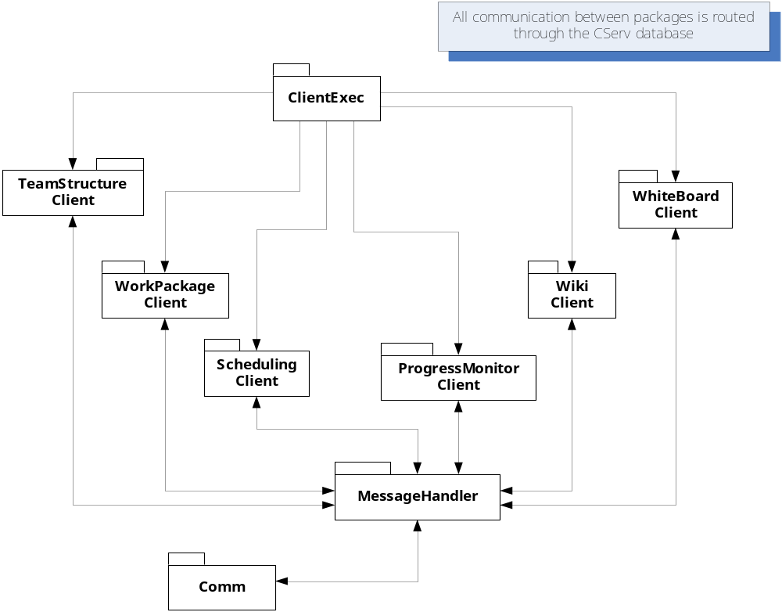
Figure 4. – Collaboration Server System Server Packages

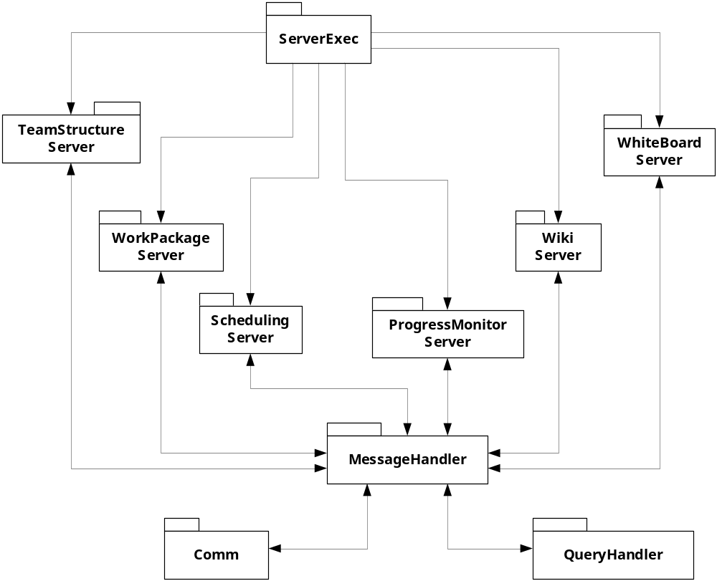
Reference Documents:
- Collaboration Server System Preliminary Architectural Concept, 23 September 2007.
- Collaboration Server System Statement of Work, 23 September 2007.
- Collaboration Server System A Level Specification Version 1.0, 23 September 2007.
- Collaboration Server System A Level Specification Version 1.1, 01 October 2007.
- Collaboration Server System A Level Specification Version 1.2, 08 October 2007.
- Requirements:
The Collaboration Server System System is a tool designed to help manage people and activities in large software development projects. The requirements are allocated below, to each of the major partitions described in Section 1.
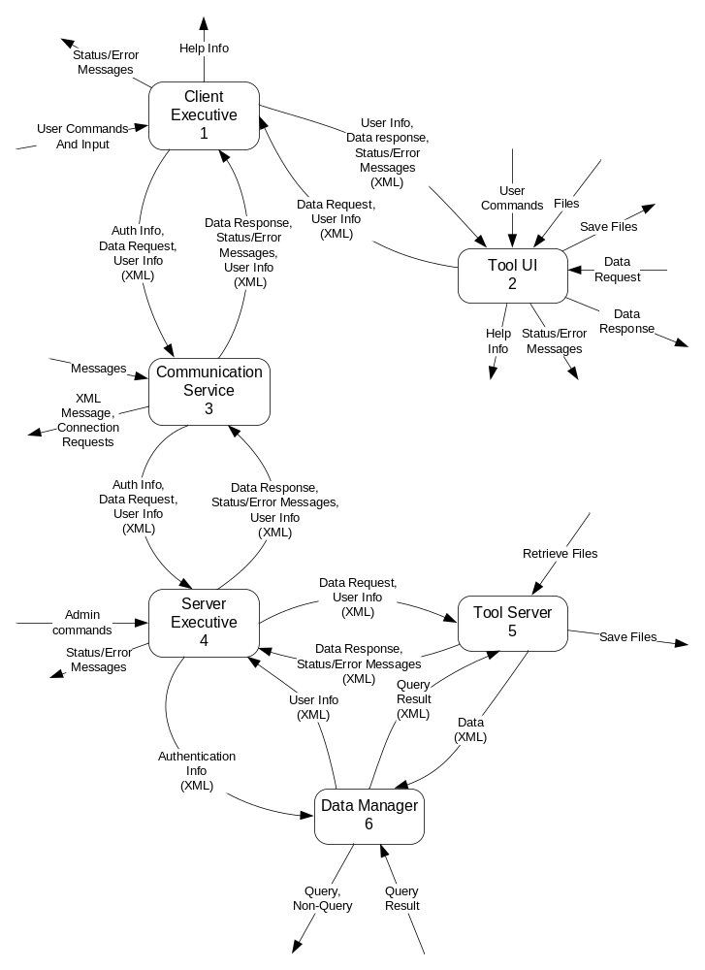
Figure 5. - Top Level Data Flow Diagram
  - Functional Requirements

    - Team Structure Tool (TST)
The Team Structure client and server components provide facilities to record, edit, and display a project’s staffing, in the form of an organization model.
      - TST clients shall accept user inputs in a form for constructing, editing, and displaying all members of a project team.
      - A means shall be provided to enter the name, photo, title, job description, work history, email and office addresses, phone number, and optional home address and phone number.
      - Means shall be provided to notify new user additions to the wiki tool.
      - Means shall be provided to display the information concerning each project member, individually.
      - Means shall be provided to display the entire project team structure, and to zoom down to expose more detail.
      - Shall provide the ability to print an organization chart and individual biographies.
      - All data shall be sent to the TST server component for persistent storage of its information.
      - TST clients shall provide the means to generate web page representations of their client displays.
    - Work Package Tool (WPT)
The Work Package client and server components provide facilities to create, edit, and display work information in a collection of packages and a hierarchy of package containers.
      - The WPT client shall provide a WinForm interface that accepts the following information for creating or editing work package descriptions: name, start date, planned completion date, actual completion date, key words, multi-line text description, of arbitrary length, Responsible Individual (RI), and a list of all work packages on which it depends.
      - The Client shall provide a means to connect each package description into a project-wide dependency network and to display views of this network at different zoom levels.
      - The WPT client shall provide means to define package containers. A package container holds packages, and possibly other containers, which serve to group work packages into work groups.
      - A Responsible Individual (RI) shall be assigned to each work group.
      - By default, only the RI of the root work group shall be given edit permissions for all work groups and work packages under his/her work group.
      - The WPT client shall support allowing the RI of the root work group to change these defaults by giving edit permissions to RI of work groups or work packages belonging to the root work group.
      - The work package tool shall notify the wiki tool about changes made to a work package or work group.
      - Shall provide means to print a representation of the Work Package network and to print information about individual packages.
      - All data shall be sent to the WPT server component for persistent storage of its information.
      - WPT clients shall provide means to generate web page representations of their client displays.
    - Scheduling Tool (ST)
The Scheduling client and server components provide facilities to create, edit, and display project and work package schedule information.
      - The ST client shall provide means of displaying Work Package schedule information for any collection of packages and work group containers.
      - The ST client shall provide the facility to display schedules for any time period from on or after the project start to before or on the projected completion date. These schedules may be as long as the entire project duration to as short as one week.
      - Shall display work package name and duration, and the names and durations of work group containers.
      - The ST client shall support replanning by entering a new duration and start date for a package. Each of its dependent packages shall be rescheduled by changing its start time so that it starts at the latest completion date of all the packages on which it depends.
      - The ST client shall support an additional replanning operation by entering a new duration and start date for a work group container. The durations of all work packages in the container are changed to keep their duration as a fraction of the container’s duration the same as it was before the change. Each of their start times is adjusted accordingly.
      - Modification of schedules of work packages or work groups shall be supported only for RI’s of the corresponding work group or work package with edit permissions.
      - The ST Client shall support the scheduling of project reviews and customer meetings.
      - The ST client shall send notifications for pending meetings and schedule changes to RIs of all the affected work packages.
      - If a schedule is changed for a work package, the ST client shall notify the corresponding RI by email.
      - The ST client shall also send notifications of schedule changes to the wiki tool.
      - Shall provide means to print a representation of the schedule for any work package or container for any specified time from one week to the duration of the project.
      - All data shall be sent to the ST server component for persistent storage of its information.
      - ST clients shall provide means to generate web page representations of their client displays.
    - Progress Monitor Tool (PMT)
The Progress Monitor client and server components provide facilities to create, edit, and display progress reports for each work package.
      - The PMT client shall provide the means to create, edit, and display progress reports for each work package.
      - It shall provide a WinForm interface that accepts at least the following information: work package id, start date, projected completion date, title, Responsible Individual name, date of report creation, a reference to an action item list, and text describing the author’s view of progress against schedule.
      - The client shall provide the capability to display individual project reports for a selection of work packages or containers.
      - It shall also support the creation of a project report that displays progress reports of all work packages, and, for each package report, shows whether that report was updated since publication of the last project report.
      - It shall provide a list of available work packages to select, from the work package database.
      - It shall also support the creation of action items.
      - Each action item shall contain a list of actions assigned to RI, with the assignment date, requested completion date, a text description of the action required, and, when closed, a statement of the actions taken.
      - The creation of action item shall be role-based.
      - Shall provide means to print a collection of work package reports or the entire project report.
      - All data shall be sent to the PMT server component for persistent storage of its information.
      - PMT clients shall provide means to generate web page representations of their client displays.
    - Wiki Tool (WT)
The Wiki client and server components provide facilities to create, edit, and display web pages as a collaboration of multiple team members at, possibly, more than one location.
      - The WT client shall provide the means to collaboratively create, edit, and display web pages with structures defined by one or more XML templates.
      - It shall provide a WebForm interface to supply whatever information the collaborators deem appropriate.
      - The client shall support role-based access for reading and editing. All project members are, by default, given read access. Only the author is given, by default, write access.
      - The tool shall support allowing the author to change these defaults by selecting one or more project members for specific privileges.
      - All data shall be sent to the WT server component for persistent storage of its information.

    - WhiteBoard Tool (WBT)
The Whiteboard client and server components provide facilities to create, edit, and display UML diagrams, documents, and text chats.
      - The WBT client shall provide the means to create, edit, and display at least the following UML diagrams: package, class, and activity diagrams.
      - It shall provide a WinForm interface that provides a drawing panel, document display, and text chat, in windows that may be tabbed in a single frame, or displayed as separate pop-up windows.
      - The client shall provide the capability to add, delete, rename, and move symbols representing packages, classes and activities.
      - The client shall also provide the capability to link these symbols with connectors representing aggregation, inheritance, using, dependency, and transfer operations in class, package, and activity diagrams, respectively.
      - It shall support the creation pop-up property sheets that contain the following information about class symbols: name, methods, properties, fields, and events.
      - It shall provide pop-up property sheets that contain activity information about each activity symbol.
      - It shall provide pop-up property sheets that contain information about the responsibilities of each package symbol.
      - Shall provide means to print a UML diagram with all its property sheets.
      - All data shall be sent to the WBT server component for persistent storage of its information.
      - WBT clients shall provide means to generate web page representations of their client displays.
    - Data Manager (DM)
The DM client and server components provide facilities to map client requests to messages, and back again to queries, and to reverse that process for responses.
      - The DM client shall provide the means to build messages, using the services of COMM, to request a query into the CServ database.
      - The DM server shall accept messages and transform them into queries into a SQL Server database.
      - It shall provide the capability to map query results back into messages for transmission to a requesting client.
      - The Data Manager shall provide an installation tool that will detach the CServ database, and archive the CServ client and server sites for installation on other machines.
      - The client shall support registration of one or more event handlers with the component for subsequent notification when messages of a specified type are received.

    - Communication (COMM)
The COM client and server components are expected to be identical, and provide facilities to send XML messages between processes on the same machine, and between two machines on the local network, using sockets, and between machines anywhere with access to the internet, supported by a web service.
      - The COMM component shall provide means to send XML messages between processes, machines, or networks.
      - The COMM shall also support the transfer of files in the form of XML messages.
      - The COMM shall also support base64 encoding for lossless transmission of data.
      - The COMM receiver shall support registration of one or more event handlers for subsequent notification when messages are received.
      - The receiver shall support the dispatching of messages to registered handlers of each specific message type.
      - The COMM sender shall provide facilities to build messages from predefined text.
      - It shall provide notifications to all registered handlers when a message of the specified type arrives.
      - COMM shall support building and parsing of messages as a service to the Executives and tools.

    - Client and Server Executives (CSC and CSS)
The client and server Executive components provide facilities to create instances of, and start, each of the tools provided by CServ.
      - The CSC client shall provide the means display names and brief information about each of the CServ tools, and to accept selection of a specific tool for starting.
      - It shall provide facilities for logging in to the CServ client and server. On login users are identified with a role that supports a fixed set of permissions for actions.
      - Support shall be provided to identify each user as belonging to a team.
      - It shall provide facilities for creating, deleting and modifying projects.
      - Each project shall be associated with its own database on the same server or different servers.
      - The server executive shall notify the RI of a work package to publish progress reports if the report was not published at scheduled date and time.
      - The client shall support on-line help, augmented by tool specific help authored by the tool creator.

  - Process Requirements
These requirements specify the physical structure of delivered code and the environment where it must operate.
    - Physical Structure
      - The Collaboration Server source code shall be composed of modules.
      - The Collaboration Server source builds shall be composed of managed or unmanaged executables and dynamic link libraries.
      - The user interfaces shall delegate all operations, not directly associated with providing the user controls and views to server modules, e.g., communication, data management, and all operations specified in this document.
      - All modules shall be provided with manual pages and correct maintenance pages.
      - All modules shall be provided with working test stubs.
      - Code that implements services shared by two or more components of the Collaboration Server shall be provided by one set of source code, with the possible exception of configuration files.
    - Development
      - The Collaboration Server System shall build and operate in the ECS clusters, e.g., 010, 202, 270, and 274 Link, and CST 2-122.
      - The Collaboration Server System shall be developed subject to the conditions specified in the Collaboration Server System Statement of Work, of the latest edition.

- Changes
  - On October 1st 2007, Version 1.1
- Added the following requirements:
  - 3.1.2.4
  - 3.1.2.5
  - 3.1.2.6
  - 3.1.3.6
  - 3.1.3.7
  - 3.1.3.8
  - 3.1.9.3
  - 3.1.2.5
- Modified the following requirement:
  - 3.1.5.2
In Version 1: It shall provide a WinForm and/or WebForm interface to supply whatever information the collaborators deem appropriate.
In Version 1.1: It shall provide a WebForm interface to supply whatever information the collaborators deem appropriate.
- Removed requirement 3.2.2.1.
- Added Top level DFD diagram
- Added CSERV architecture diagram
- Added critical issues.

  - On October 8th 2007, Version 1.2
- Added the following requirement:
  - 3.1.4.5
  - 3.1.4.6
  - 3.1.4.7
  - 3.1.8.2
  - 3.1.8.3
  - 3.1.9.4
  - 3.1.9.5
  - 3.1.9.6
- Modified the following requirement:
  - 3.1.8.3 in Version 1.1 (3.1.8.4 in Version 1.2)
In version 1.1: The COMM receiver shall support registration of one or more event handlers for subsequent notification when messages of specific types are received.
In version 1.2: The COMM receiver shall support registration of one or more event handlers for subsequent notification when messages are received.

  - On October 11th 2007, Version 1.3
- Added the following requirements:
  - 3.1.1.3
  - 3.1.2.7
  - 3.1.3.9
  - 3.1.3.10
  - 3.1.4.5

- Critical Issues:
  - Running more than one instance of the client
Issue: Allowing multiple instances of the local executive to run on the same client machine might raise issues while using web services. Since web services uses just one for communication when a messages is received from server executive, there is no information as to which instance of the local executive has to receive the message.
Solution: This issue can be solved by allowing only one instance to be executed on the client machine.
  - Conflicts in Wiki tool
Issue: When two users at different locations with edit permissions are modifying the contents of the same web page, conflicts might occur when they each try to save their modified contents. This mainly occurs because merging of contents failed.
Solution: Reporting the conflict to the user and providing an option to retrieve the latest copy of the contents and taking a snapshot of the local changes.
  - Locking objects in whiteboard tool
Issue: The main purpose of whiteboard tool is to allow collaborative creation and editing of UML diagrams. When two users are editing the same objects in a diagram, one user might not see his/her changes as the other users changes overwrites them without any notification.
Solution: To provide locking of objects in a diagram when a user is editing the object. This prevents the other users to edit the same object. Once the user saves all his modifications, the lock is removed and other users see the new changes.
  - Chunking of data sent over network
Issue: Some tools like the Wiki or Whiteboard might send and receive huge amounts of data. This can slow down the system or congest the network.
Solution: To chunk the messages when the message size exceeds some threshold.
  - Avoiding overwriting of new data with old data
Issue: Two users at different locations can be editing the same copy of some contents, resulting in the possibility of one user overwriting the changes made by the other user.
Solution: While updating the modified contents, the local modified date and time and remote modified date and time of the contents is compared. If there is a difference, the user will be alerted and the latest copy of the contents will be extracted from the database.

This implies that individual tools may not directly bind to the CServ database, but must go through the Data Manager by sending and receiving messages.
By local machine, we mean that the installer does not have to work over the network. An administrator may simply logon to a machine with no CServ facilities and install either a CServ Client or Server.
It would be interesting, but not required, to investigate audio communication with a separate ip channel to the CServ. Several open-source projects support this form of communication.
What model means is to be defined by the team, with help from the customer.
This display is not required to be graphical.
All the work packages in a sub-system would be collected into a group. The entire project would be represented by a work group of all the sub-system work groups.
This uses Vector Markup Language (VML).
This is intended to allow Project Management to select either C++ or C# or both as implementation languages.

