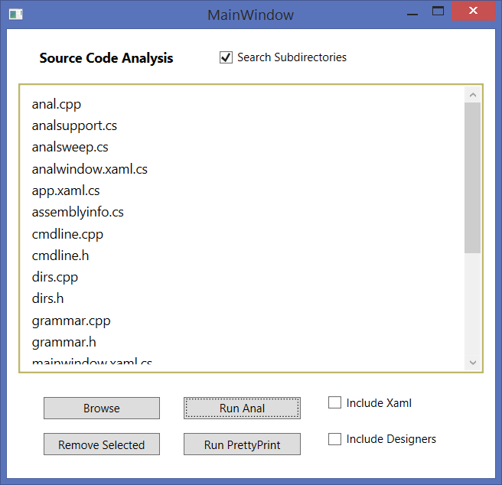
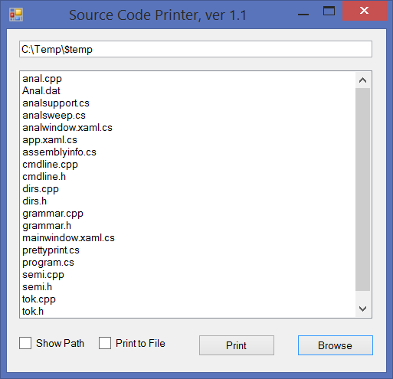
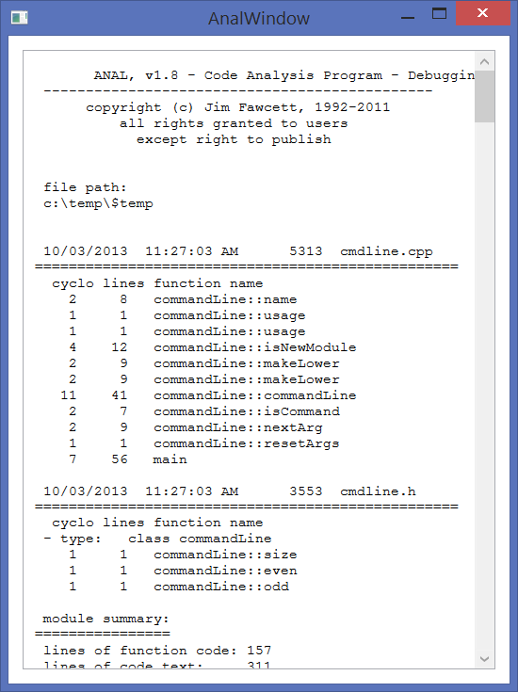
SweepAnal Facade
Simplify, Integrate, Organize, Encapsulate
Overcome limitations of Subsystems
SweepAnal Façade
Sweep dir tree
Find files
Copy to temp dir
PrettyPrint
Print Selected Results
Analyzer
Compute code metrics

