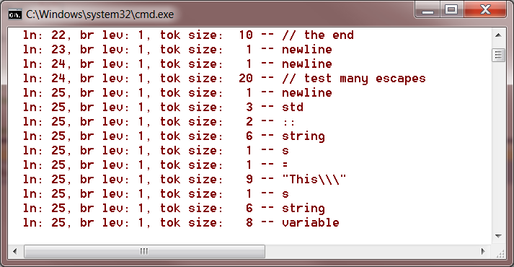

// testBraceBug.cpp

/* ver 1.3 - braces in quotes and comments caused increment bracecount
* ver 1.4 - eliminated by adding:
* enum state { default_state, comment_state, quote_state }
* and incrementing only if in default_state
*/

#include <string>
using namespace std;

void test()
{
std::string tok;
char ch = 'a';

if(tok == "{")
;
if(ch == '{')
;
// {{{
/* }} */
// the end

// test many escapes
std::string s = "This\\\"s string variable";
}

