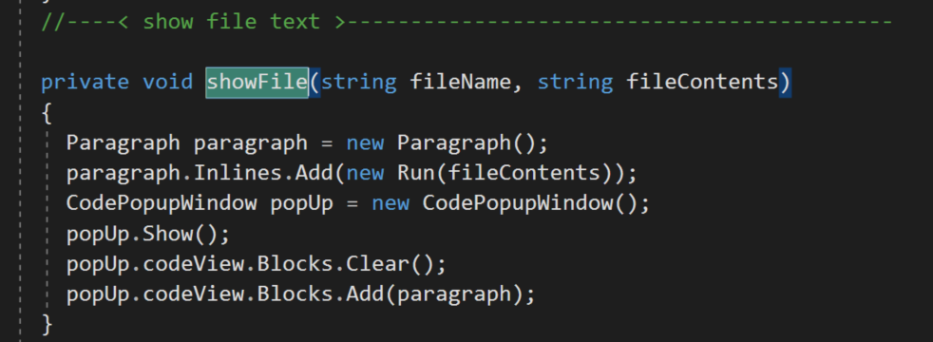

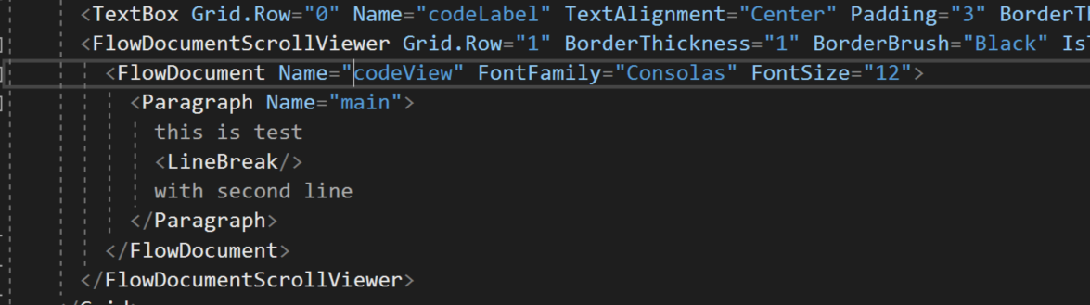
Steps to show code in popup window:
Comm provides SendFiles and SaveFiles folders on each end (for two different machines).
- Add Window to GUI – named CodePopUpWindow perhaps
- Add FileList mouse double-click event handler
  - Build “sendFile” message including the selected item and relative path
  - Post to server
- Add ServerProc sendFile
  - Extract name of file and relative path from request message
  - Build reply message that has “file” attribute with filename value and path attribute
  - Copy the specified file to the SendFiles folder
  - Post to the client
    - The “file” attribute causes Comm to send the file from SendFiles folder
- Add ClientProc sendFile
  - Extract filename from message
  - Read file text as one string from file in SaveFiles folder
  - Call show showFile(fileName, fileContents)

