CSE687 Midterm #2

Name: __________________________________ SUID: _____________

This is a closed book examination. Please place all your books on the floor beside you. You may keep one page of notes on your desktop in addition to this exam package. All Exams will be collected promptly at the end of the class period. Please be prepared to quickly hand in your examination at that time.
If you have any questions, please do not leave your seat. Raise your hand and I will come to your desk to discuss your question. I will answer all questions about the meaning of the wording of any question. I may choose not to answer other questions.
You will find it helpful to review all questions before beginning. All questions are given equal weight for grading, but not all questions have the same difficulty. Therefore, it is very much to your advantage to answer first those questions you believe to be the easiest.
- State the Single Responsibility Principle. How have you used it in Project #2? Please be specific.

- Draw a package diagram for your design of Project #3.

- Assume that a Project #3 test request consists of a list of one or more dynamic link libraries to load and execute, perhaps encoded in a string. Write a lambda that dispatches a test request message from one of the Process Pool’s Host queues to an appropriate child tester process. Now write a thread that, using the lambda, dispatches test requests messages as they arrive. You may treat the test request as a string without examining it’s details. For this question, I’ve attached a block diagram for Project #3, including a Process Pool, at the end of this exam packet.

- What are the main elements of Object Oriented Software Design, and how did you use them for Project #2?

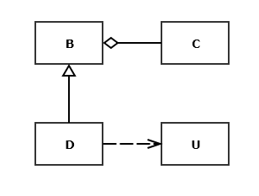
- Write a move constructor for the class D in the diagram given here.
You may assume that all of the bases and members of each class
are shown in the diagram. When will that method be called?

- Write a class declaration for a table to hold file dependency information. The table should hold, for each file, a collection of the files on which it depends. That information will be accessed using the file name. Please also store, for each file, an instance of an unspecified type used to hold application specific information.

- When you define a class, under what conditions will you chose to implement copy, assignment, and destruction operations? When would you decide not to provide those? If you don’t, what happens if code using your class attempts to copy or assign instances?

