CSE687 Midterm #1

Name: __________________________________ SUID: _____________

This is a closed book examination. Please place all your books on the floor beside you. You may keep one page of notes on your desktop in addition to this exam package. All Exams will be collected promptly at the end of the class period. Please be prepared to quickly hand in your examination at that time.
If you have any questions, please do not leave your seat. Raise your hand and I will come to your desk to discuss your question. I will answer all questions about the meaning of the wording of any question. I may choose not to answer other questions.
You will find it helpful to review all questions before beginning. All questions are given equal weight for grading, but not all questions have the same difficulty. Therefore, it is very much to your advantage to answer first those questions you believe to be the easiest.
- State the Dependency Inversion Principle. Describe how you did, or could, use it in Project #2. Please be specific.

- Write code for a thread that receives messages in the Core Test Harness of Project #3. Please provide all the code to dequeue messages from the Process Pool Host’s Comm instance, and deposit them in appropriate Host queues, using a lambda to define the thread’s processing. For this question, you will find a block diagram for Project #3, including the Process Pool, attached at the end of this exam packet.

- What relationships between classes does C++ support, and how did you use them for Project #2?

- Draw a class diagram for a design for your implementation of Project #3. Please guide your design by the Single Responsibility Principle.

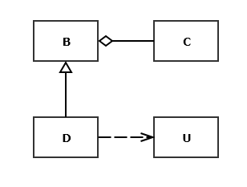
- Write all the code for a copy constructor for class D shown in the
class diagram given here. You may assume that all of the bases
and members of each class are shown in the diagram. When will
this method be called?

- What is a virtual function pointer table? When are its contents defined and when is it used?

- Write a class declaration for a container for test results. Assume that the ITest interface declares name and author functions, in addition to its test method, which each test driver implements. The container will store results using the test driver name as a key and the value associated with the key will be the author, time-date, test result, and an instance of an unspecified type which is test specific. The container will also provide a means to persist the test results collection to an XML string.

The date-time is passed as a string, probably generated by the DateTime class.
You may assume that the unspecified type provides a toXml method.

