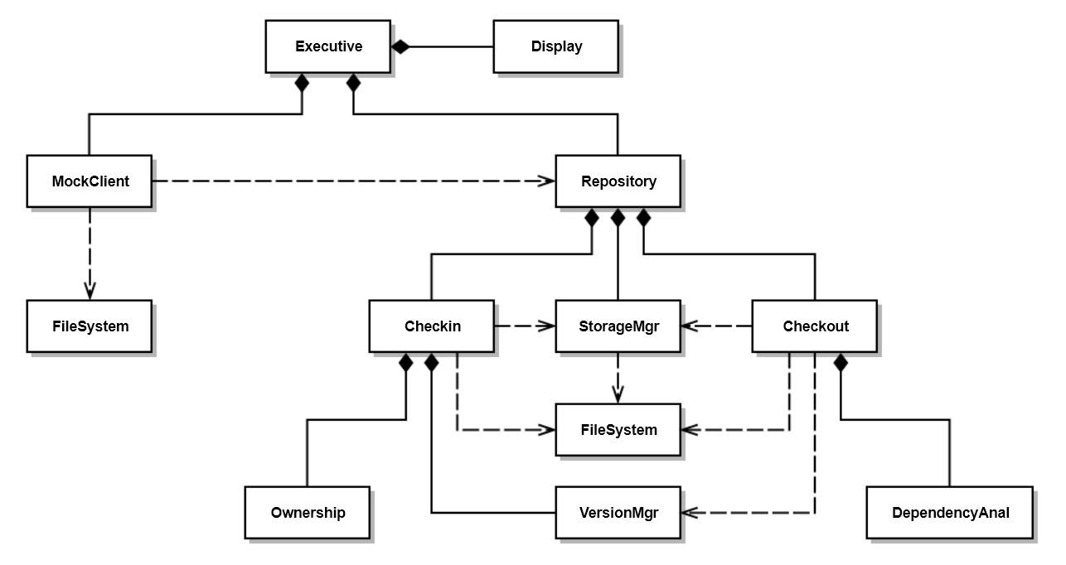
Class | Responsibility
Executive | Create MockClient and Repository and start execution
Display | Writes demonstration messages to console
MockClient | Initiate Checkin and Checkout operations
Repository | Create Checkin, Checkout, and StorageMgr  Respond to MockClient requests
Checkin | Respond to checkin request, using Ownership rules and VersionMgr
Checkout | Respond to checkout request using DependencyAnal, VersionMgr
StorageMgr | Manages Repository Folders and placement of files
VersionMgr | Creates new versions and finds latest versions
Ownership | Validate checkin
DependencyAnal | Evaluate transitive dependency relationships
FileSystem | Provide directory and file management utilities

