FRIDAY HELP-SESSION (3rd Feb 2017)

Project Debug Helper

- For this help session professor used HelpSessionDemo.zip(-V2) http://ecs.syr.edu/faculty/fawcett/handouts/CSE687/code/Project1HelpS17/HelpSessionDemo-V2/
- And from that we used NoSqlDb project
- Pressing F10(Step Over) after selecting this project as Startup Project gets us to the first executable line from the main
- This screenshot shows that after pressing F10 several times we get to the line 23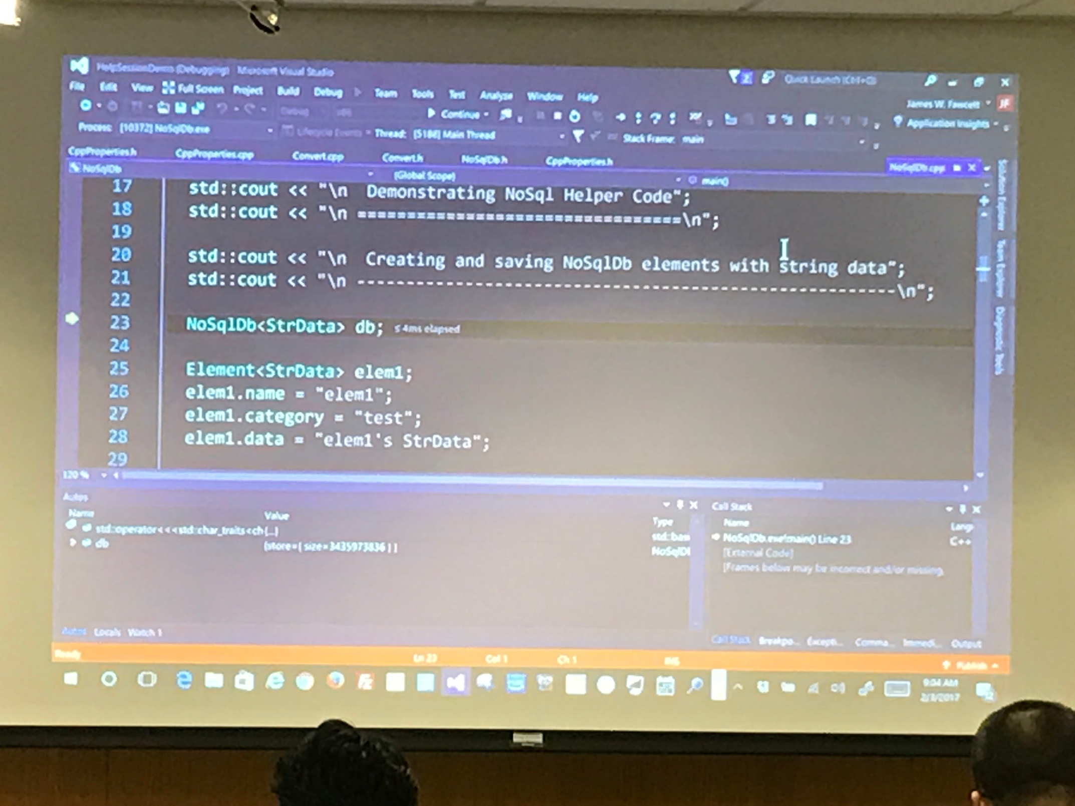

- Here we tried pressing F11(Step Into) which takes us inside the function being called but, on line number 23 as we have not defined any constructor we didn’t step into it

- We can get inside any function by pressing F11 if the function is called at the current line

- When we have an object defined we can look at its data in Autos and Locals window as shown in image below

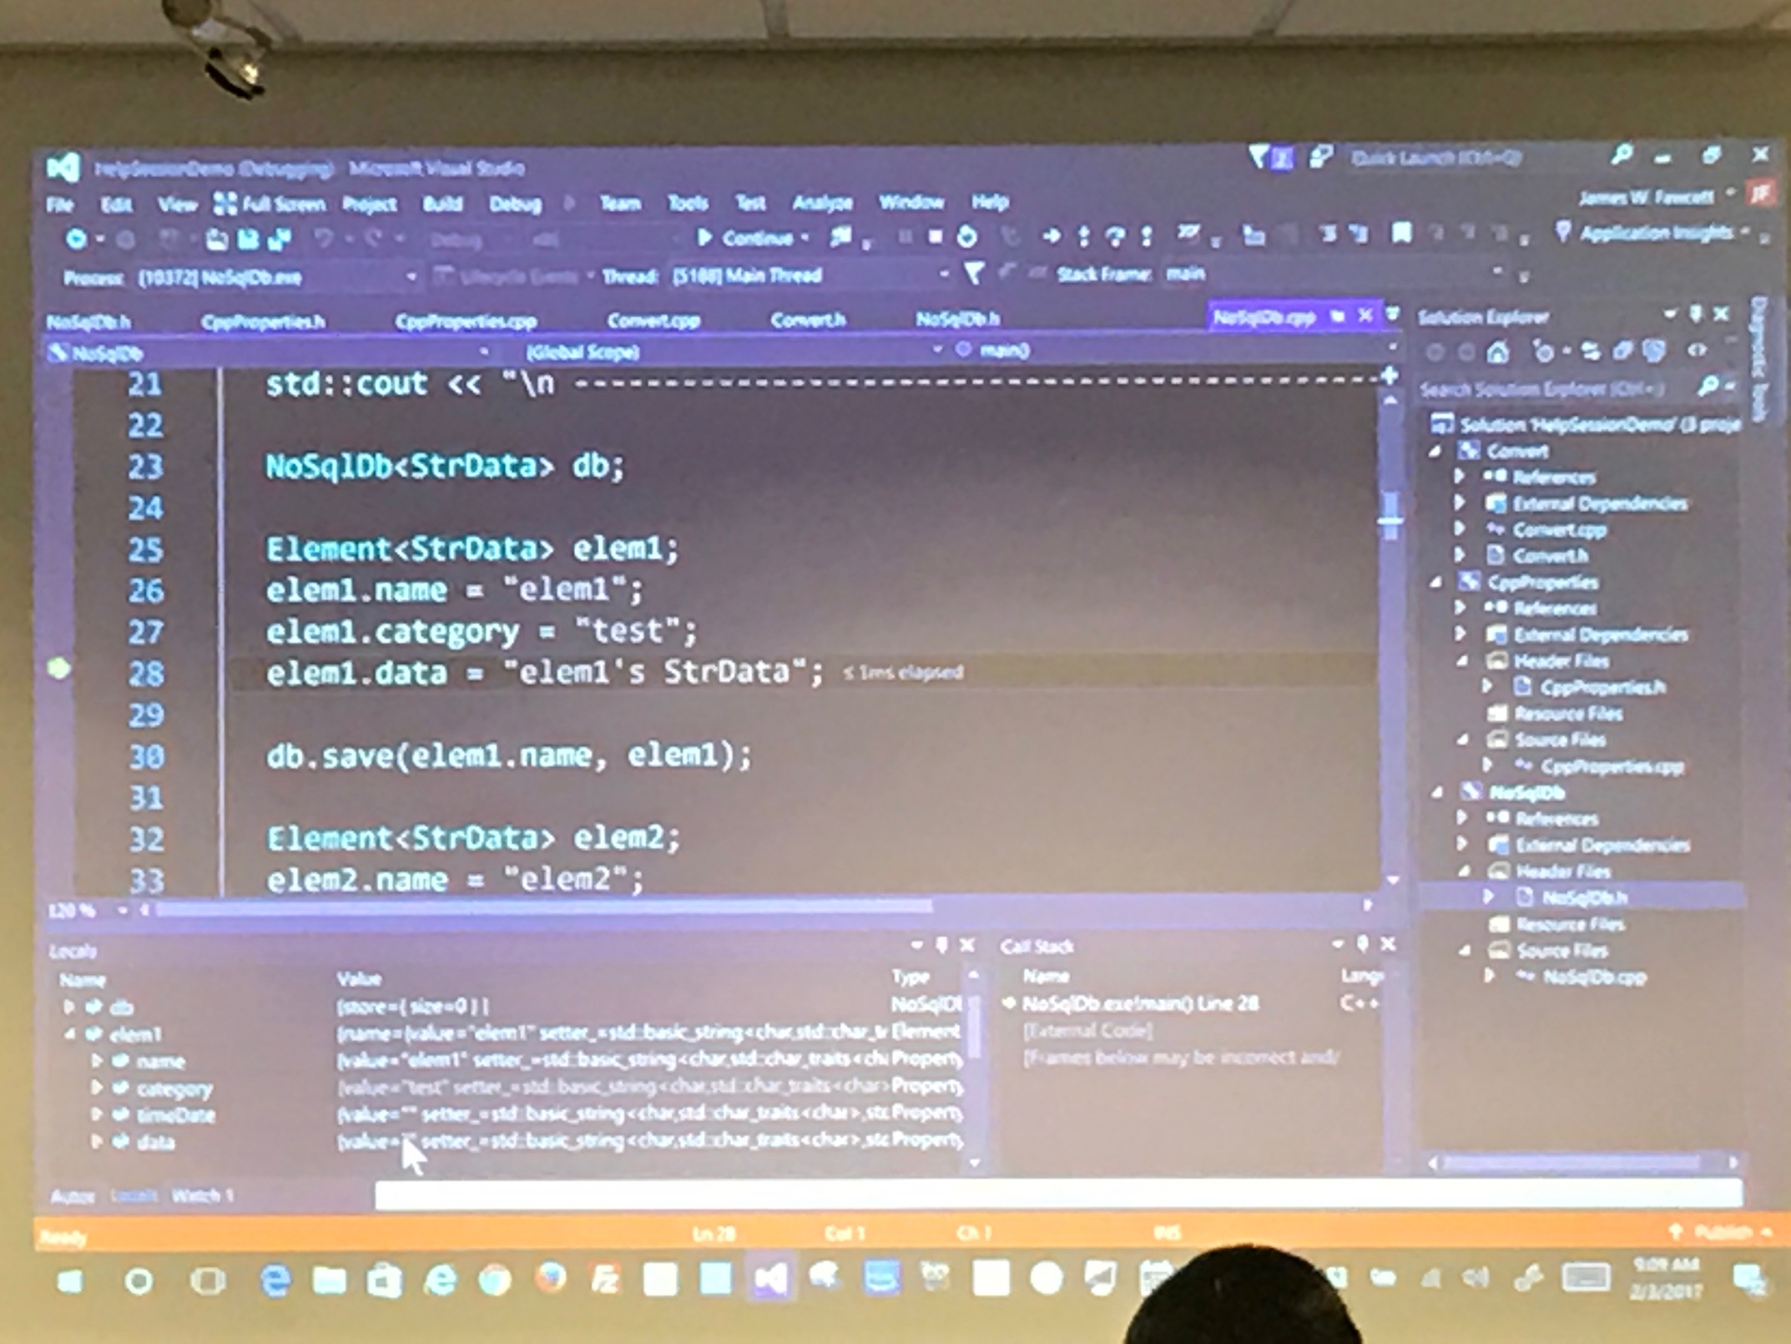

- Left clicking on the border at the left of line number creates a break point
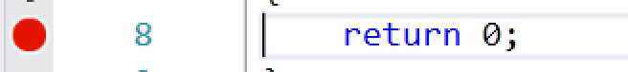

- We can choose various conditions to break at that point by right clicking on that break point and pressing on Conditions from menu
- While in debug mode pressing F5(Continue) gets us to the next available break point
- We can even put new breaking points and remove them when we are already in the debug mode

For additional help please refer to https://msdn.microsoft.com/en-us/library/sc65sadd.aspx

