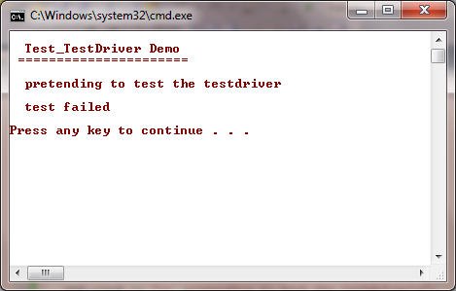
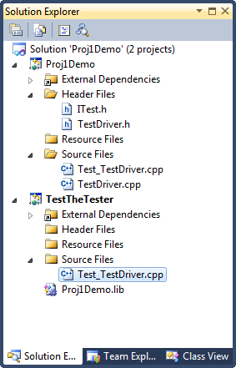
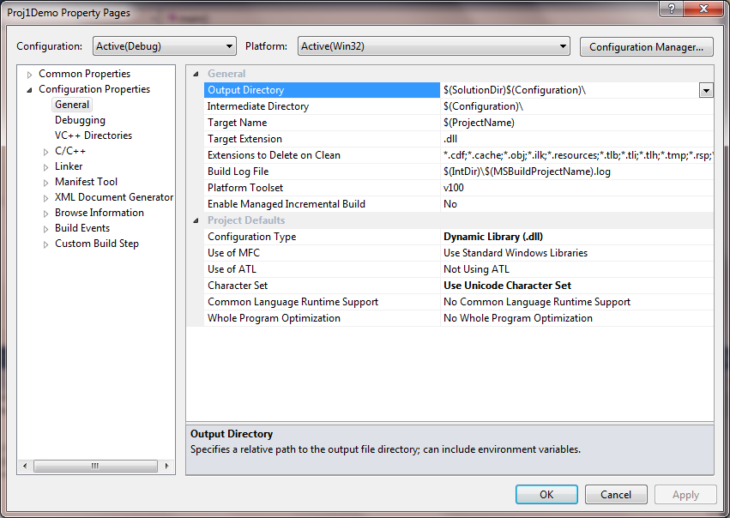

For initial testing you can add the Test_TestDriver code to the Proj1Demo project and build as a console application as shown below. When that works, change back to a dll build, compile the dll, then compile the Test_TestDriver client, with the dll Lib file part of the project.
