Create Virtual Directory for Mvc Application
- Run Visual Studio 2012 in Administrator mode
- Add the child element <modules runAllManagedModulesForAllRequests=”true” /> to the <system.webServer> element in the top-level Web.Config file.
- Add the statement:
System.Data.Entity.Database.SetInitializer( … ) as shown in the MvcState demo in Global.asax.cs file in the Application_Start method.
- Right click on the solution and select properties and set as shown below, then click on Create Virtual Directory.
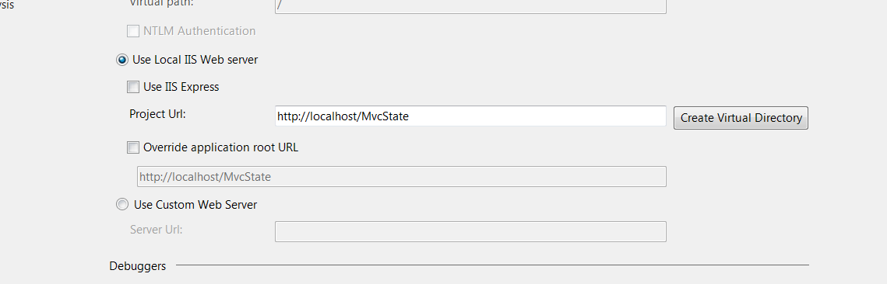
- Open Windows Explorer in Administrator mode. Navigate to the application folder
- In the Security tab select everyone and edit permissions to full control
- Now the application should run from either Internet Explorer or Visual Studio
- You may need to run Visual Studio 2012 as administrator after these changes.

