Create Virtual Directory
Vista – IIS 7.0

Jim Fawcett
CSE686 – Internet Programming
Summer 2009
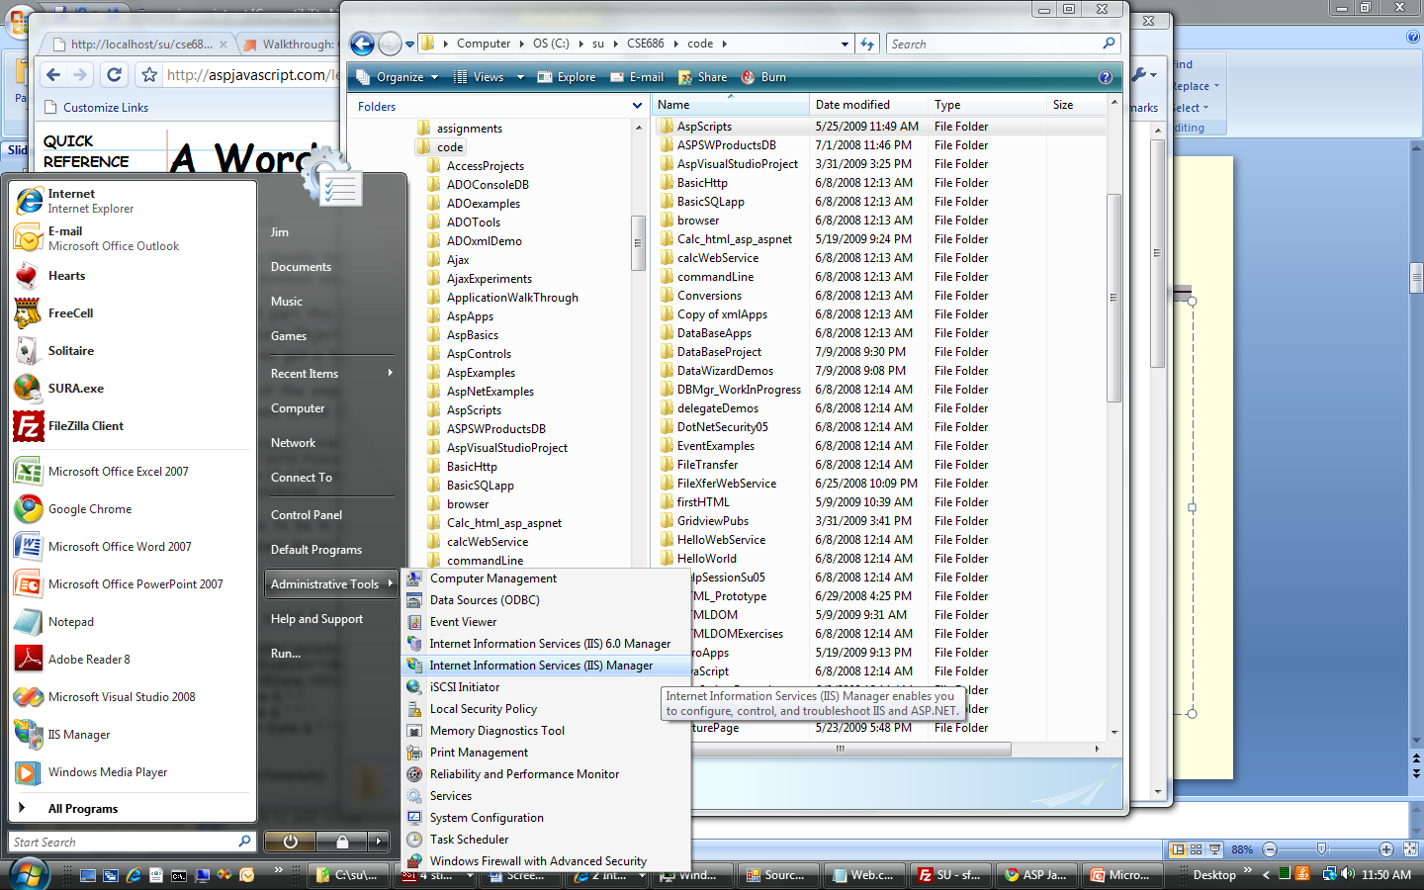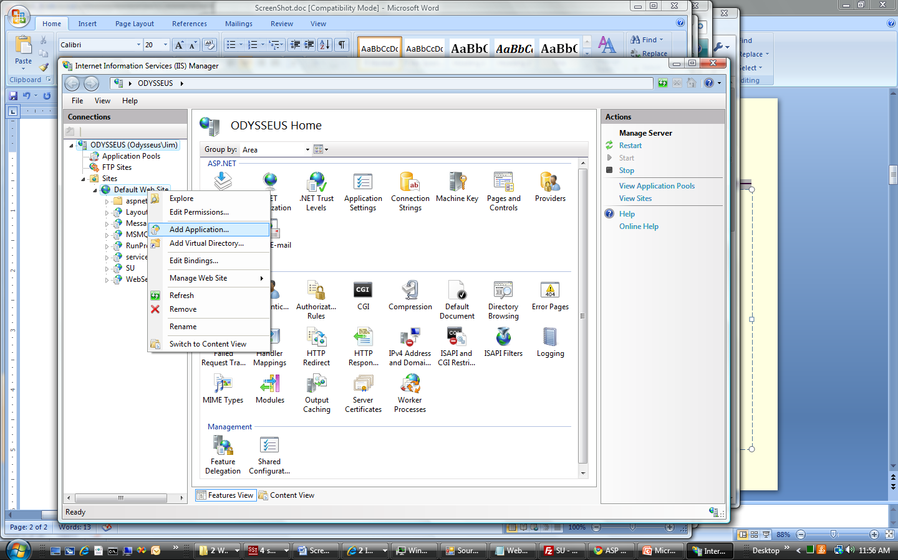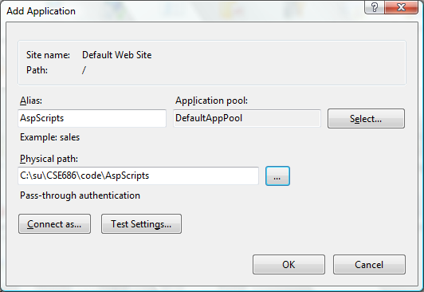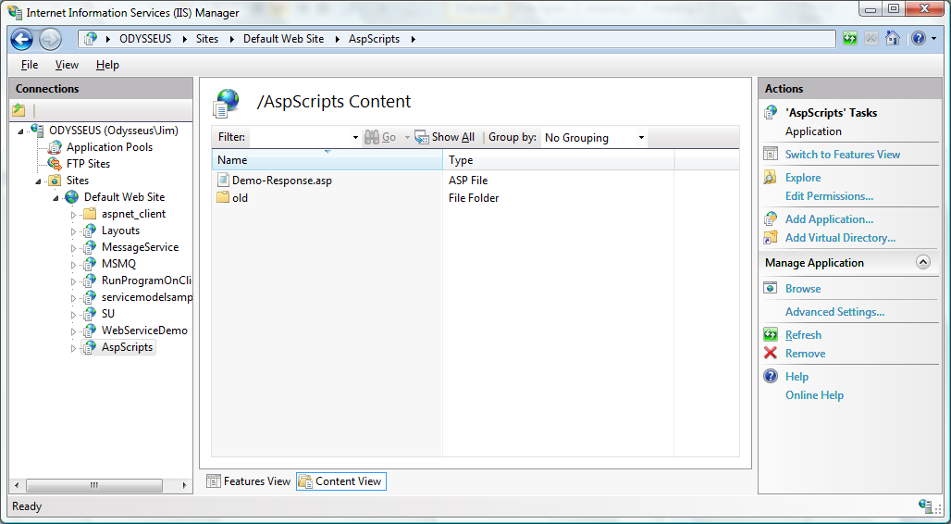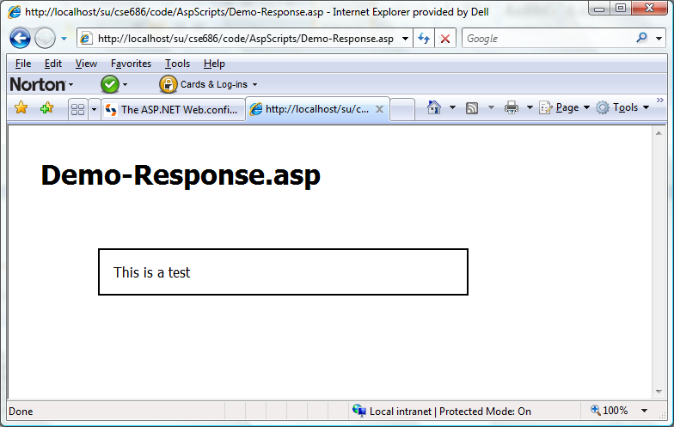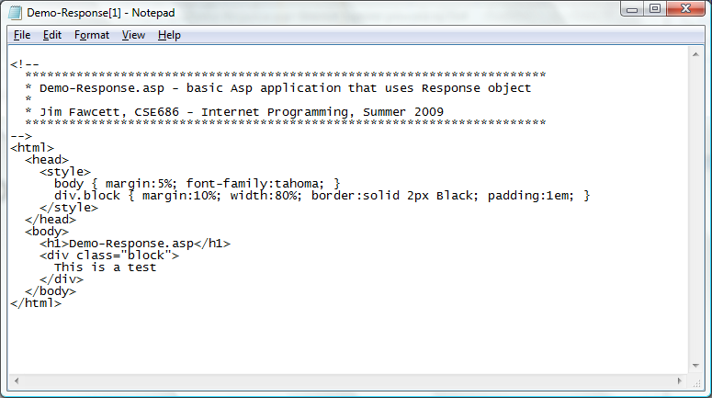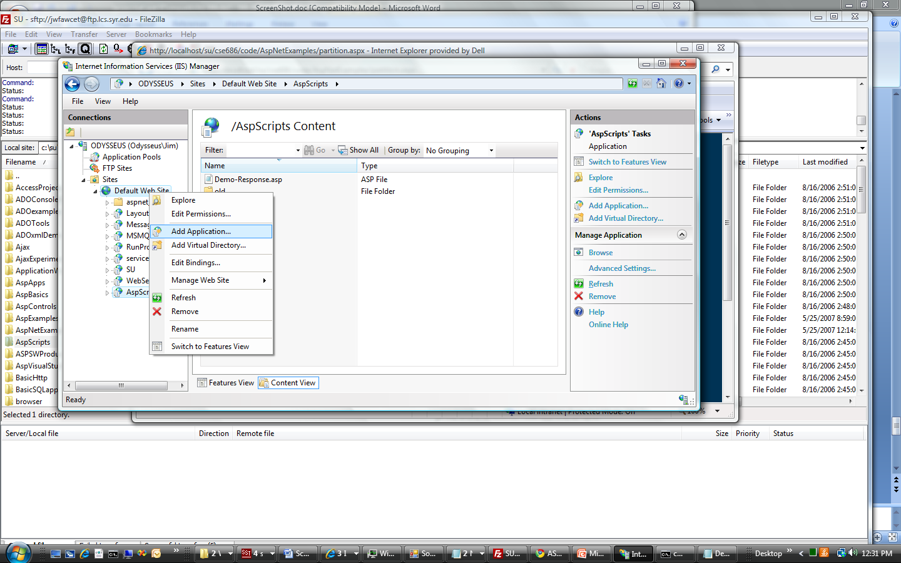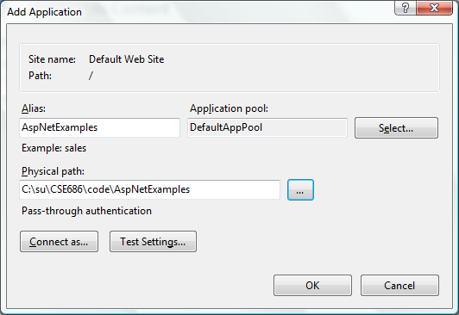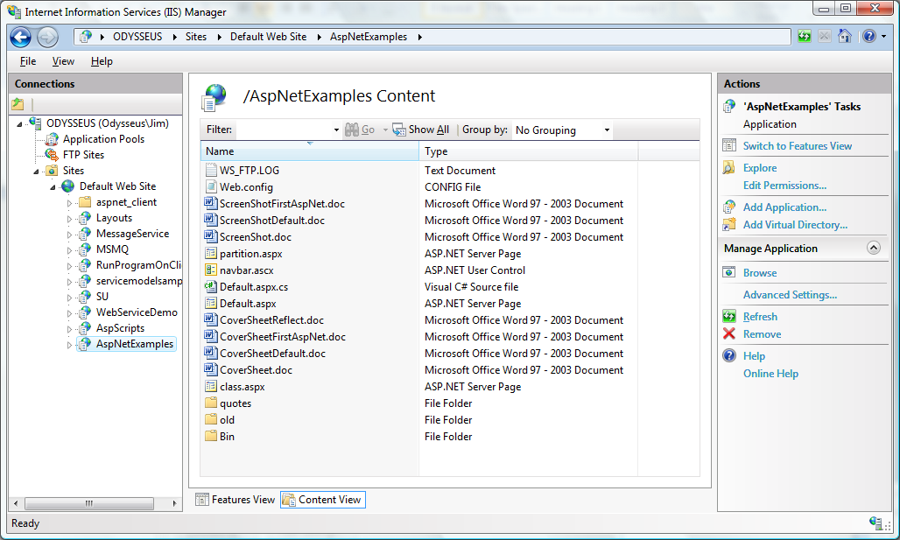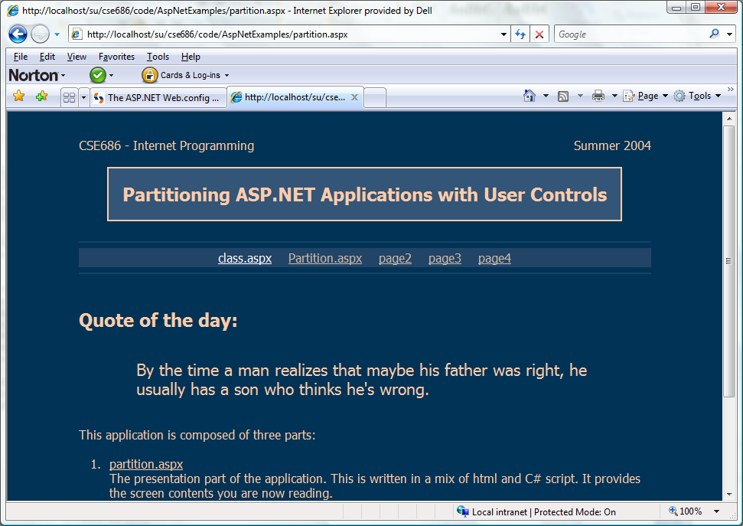
To begin creating virtual directory, open IIS 7.0 manager.
Expand sites, right click on Default Web Site and Add Application.
Now, you have a virtual directory. You may need to edit its access permissions – see Actions sidebar on right.
Now, we’re serving up an asp file from the new virtual directory.
Here, we create another virtual directory for a set of applications copied from another machine. These happen to be Asp.Net.
Here is one of the Asp.Net applications being served from the new virtual directory.


