Example Web Application
Using ASP.Net
Programming Model

Jim Fawcett
CSE686 – Internet Programming
Summer 2003

Note:
If you take the defaults for starting a Web Application in Visual Studio it will create a new virtual directory under c:\inetpub/wwwroot named WebApplicationN and put the Solution and Project Files in:

Documents and Settings\UserID\My Documents\Visual Studio Projects\WebApplicationN

You can move the solution and project files to the virtual directory if you want. You may also browse to an existing virtual directory when you create the project.

The next few pages show you how to set up a virtual directory. Starting on page 11 we start building the application.
Step #1 – Create Virtual Directory, part a.

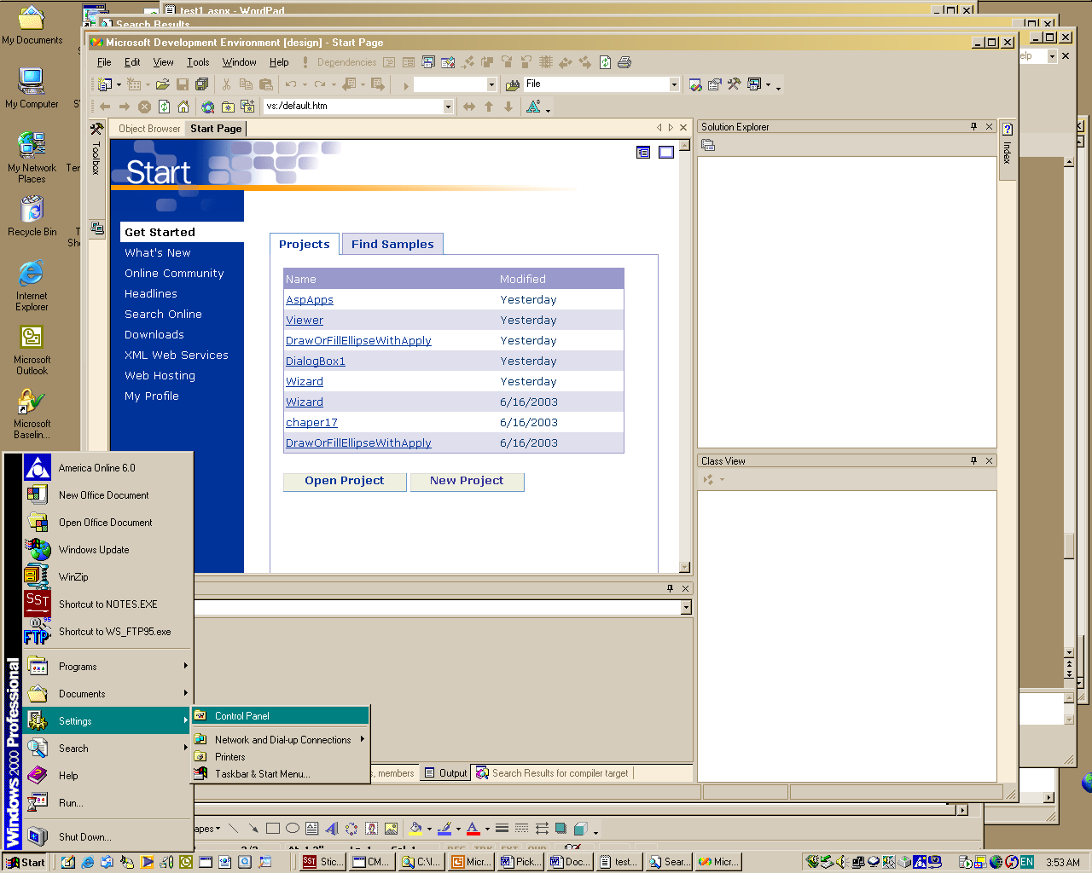
Step #1 - Create a Virtual Directory, Part b.

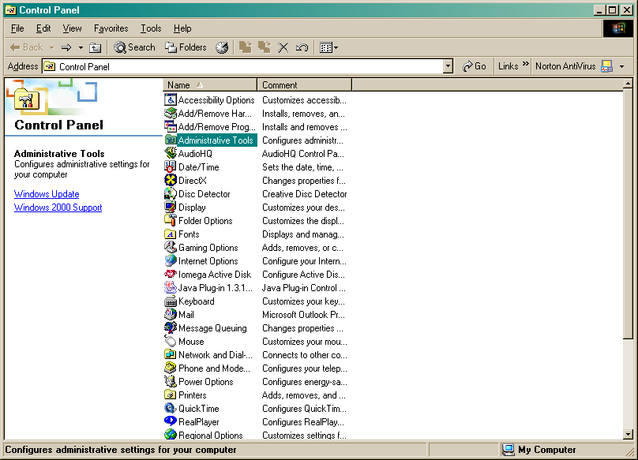
Step #1 – Create Virtual Directory, Part c.

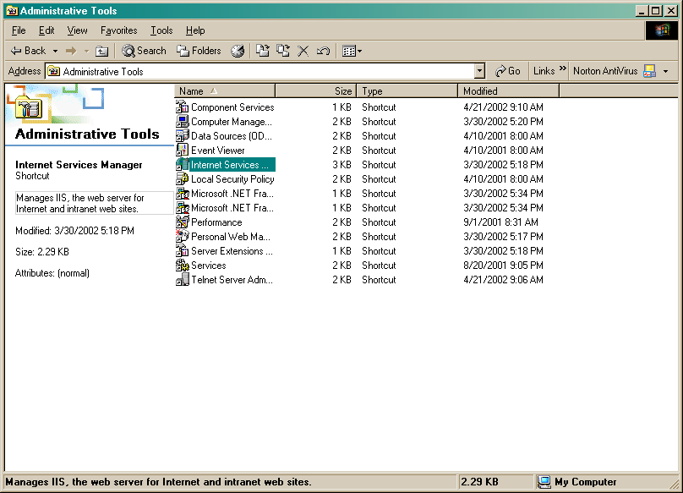
Step #1 – Create Virtual Directory, Part d.

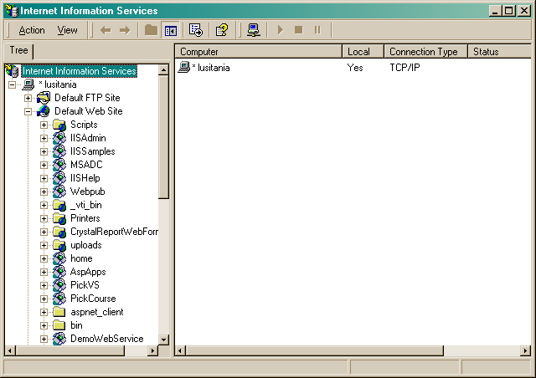
Step #1 – Create Virtual Directory, Part e.

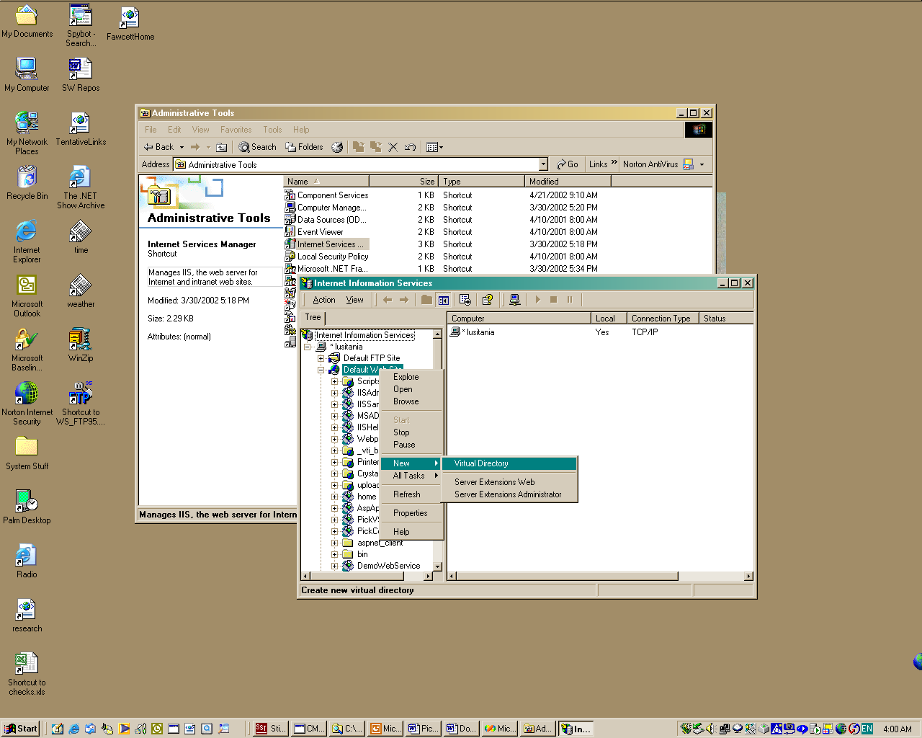
Step #1 – Create Virtual Directory, Part f.

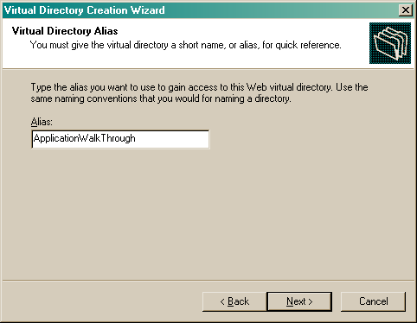
Step #1 – Create Virtual Directory, Part g.

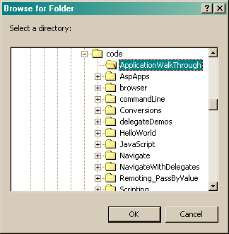
Step #1 – Create Virtual Directory, Part h.

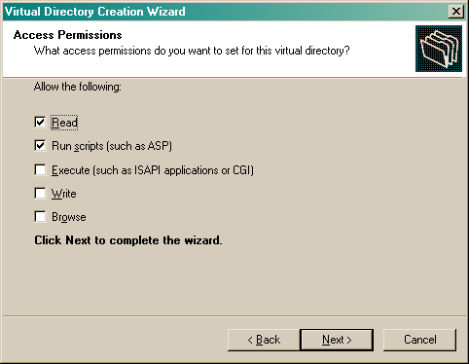
Step #1 – Create Virtual Directory, Part i.

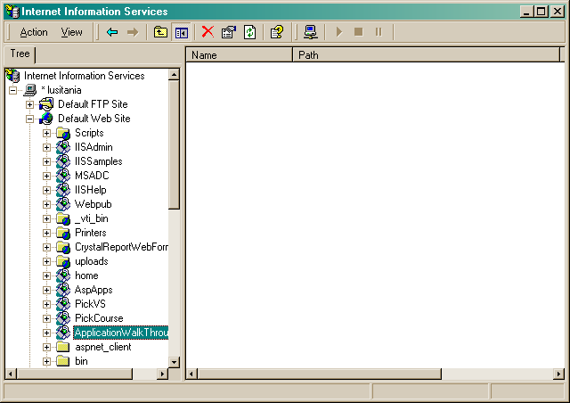
Step #1 – Create ASP.NET Web Application

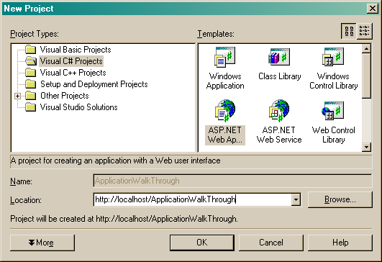
Step #2 – Create Web Application

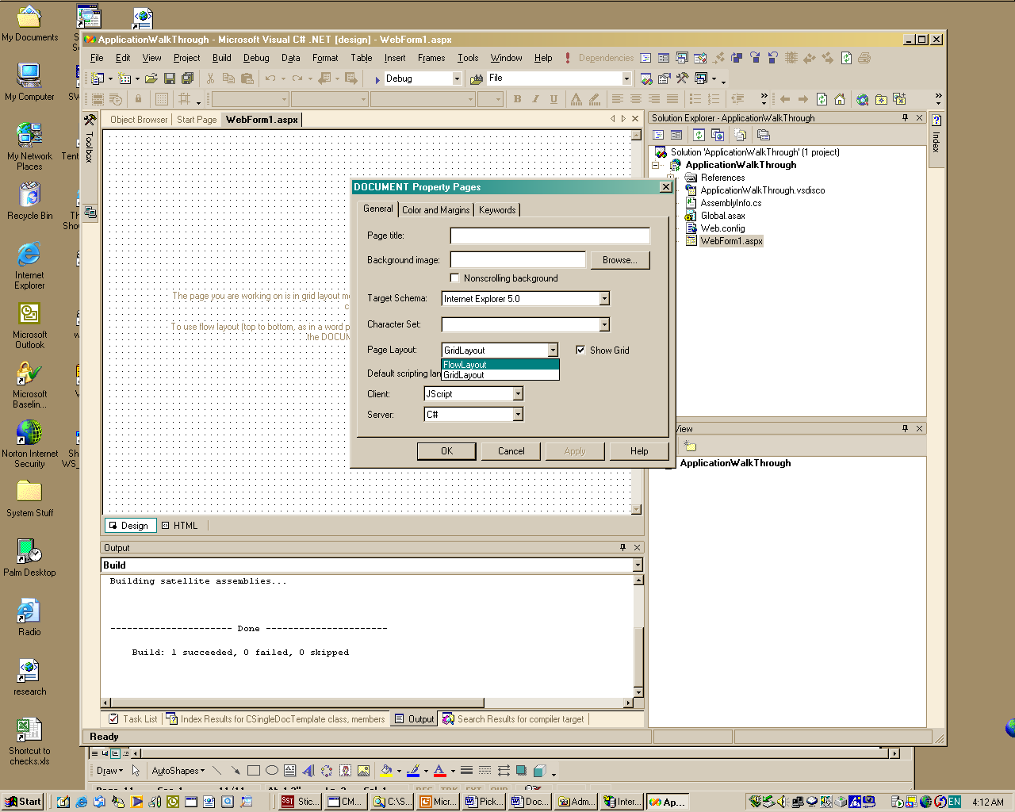
Step #3 – Add Controls to Web Form

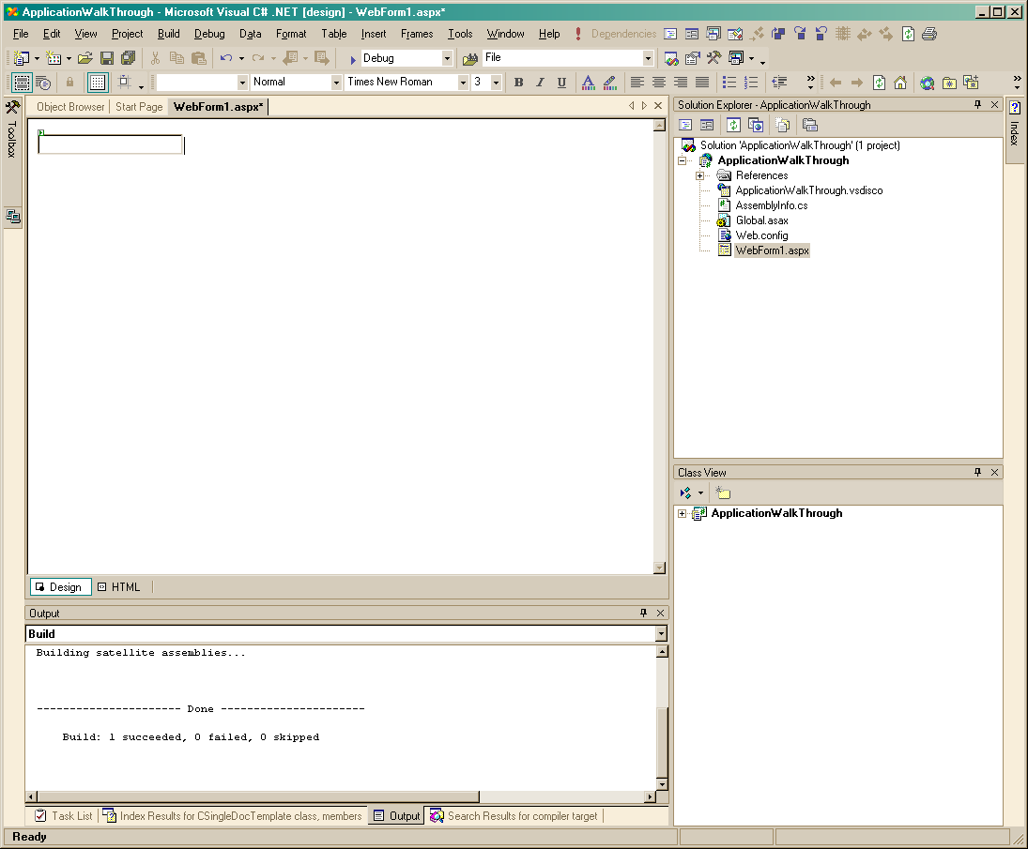
Step #3 – Add Controls to Web Form

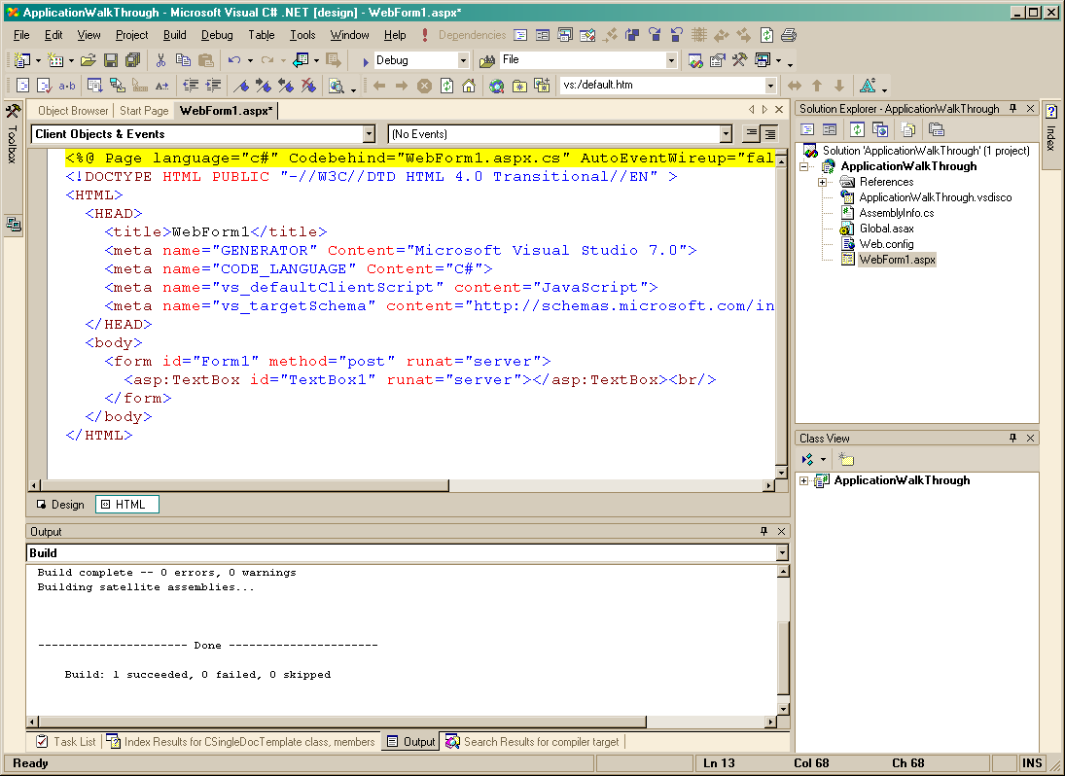
Step #3 – Add Controls to Web Form

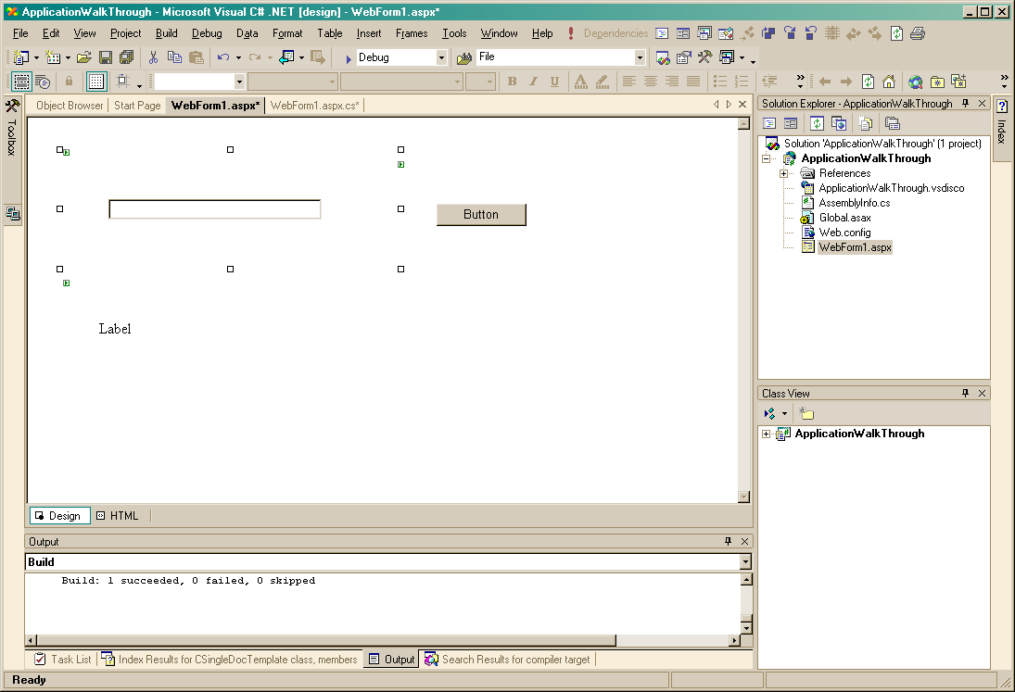
Step #3 – Add Controls to Web Form

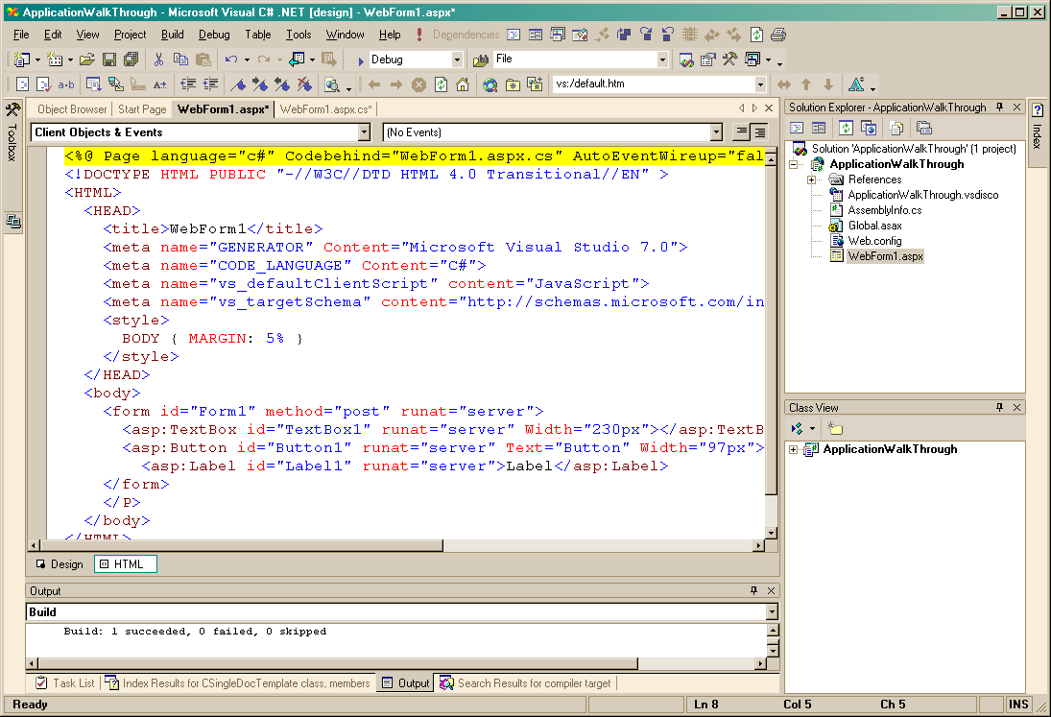
Step #3 – Add Controls to Web Form

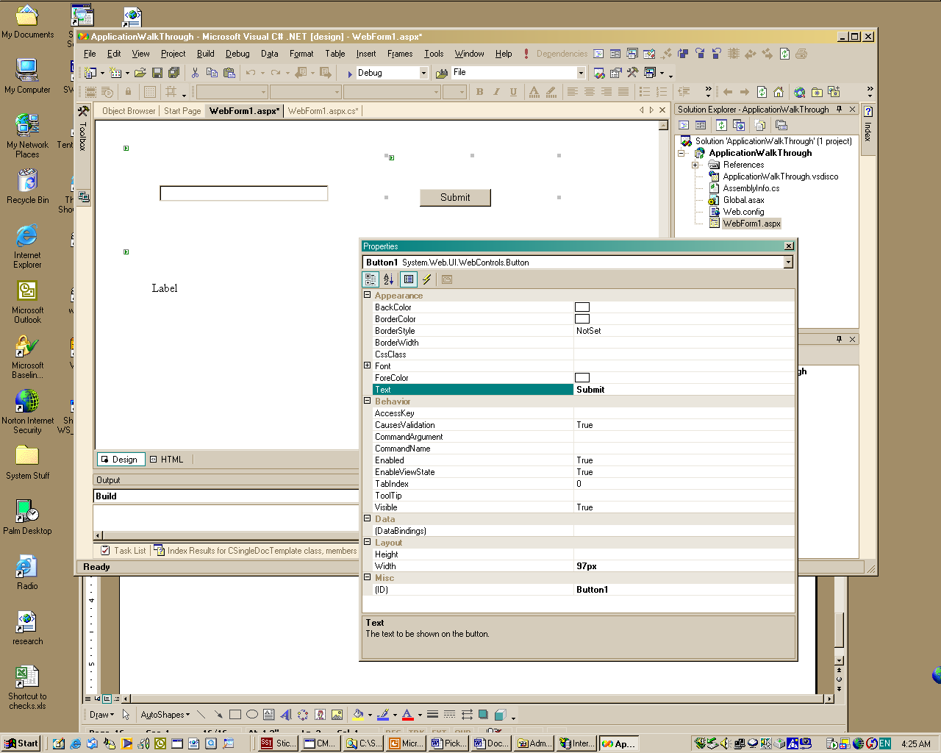
Step #4 – Add Code to Page_Load Event

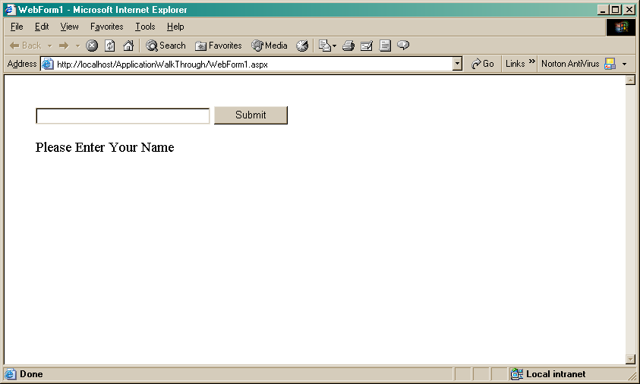
Step #5 – Add Code to Button Click Event

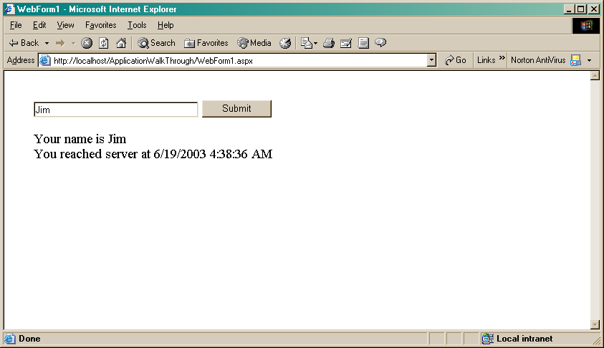

Congratulations – You’ve just completed a new Web Form!

