Steps to Build WinForm Demo

- Open VS.Net, select New Project, C# Project, Windows Application
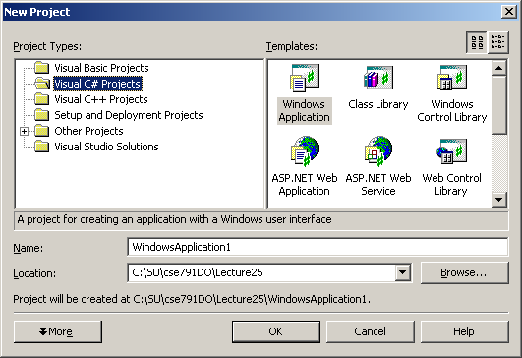
- In the resulting Design View open the toolbox and select a textbox and pull onto the Form:
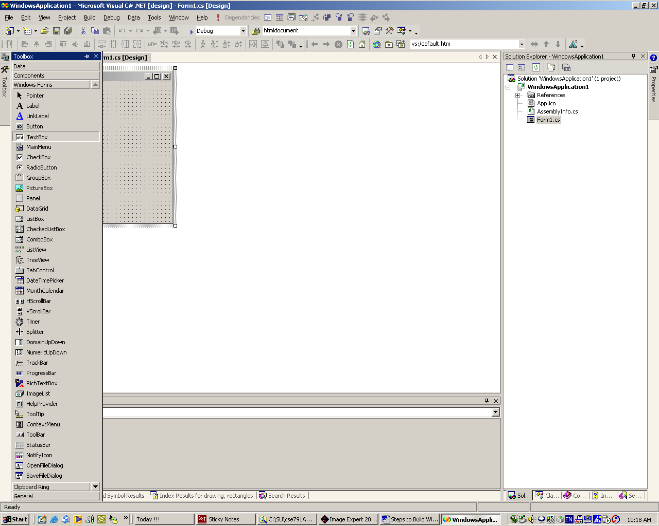
- Switch to class view (tab on IDE lower right), expand the tree view until you see Form1 and right click on it. Select add.
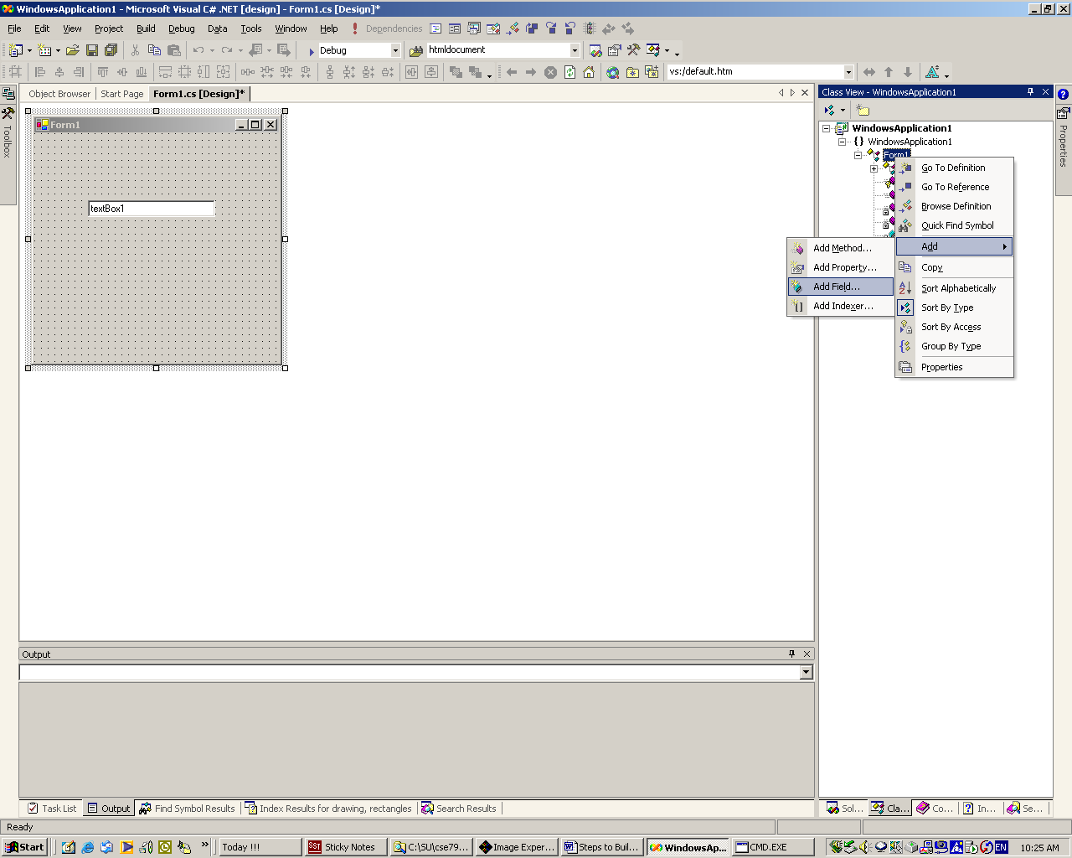

- Add a private field of type Image. Double click on the Form in Design View. That will create an event handler for the Form_Load event.
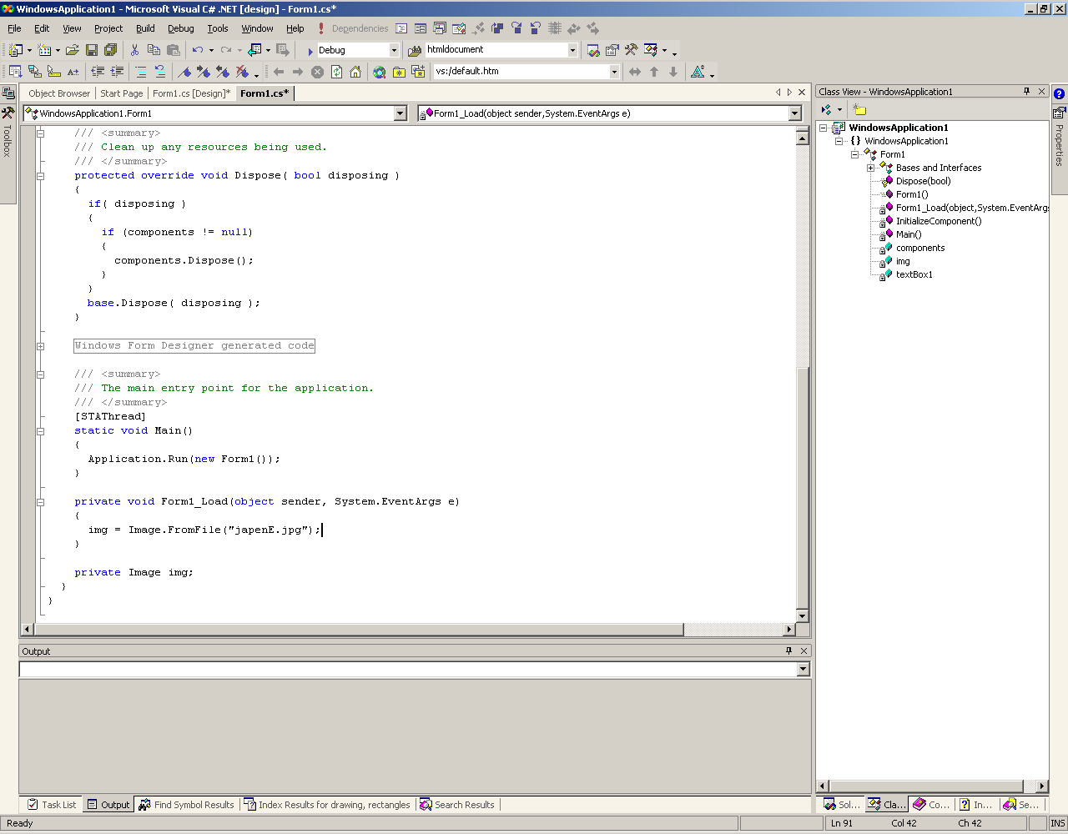
- Override this Form’s base class method: Form::OnPaint. You do that by expanding the Form1 tree element to see its base Form class. Expand its Bases and Interfaces element to see the OnPaint method. Right click on that to bring up an override selection, as shown below. Make that selection.
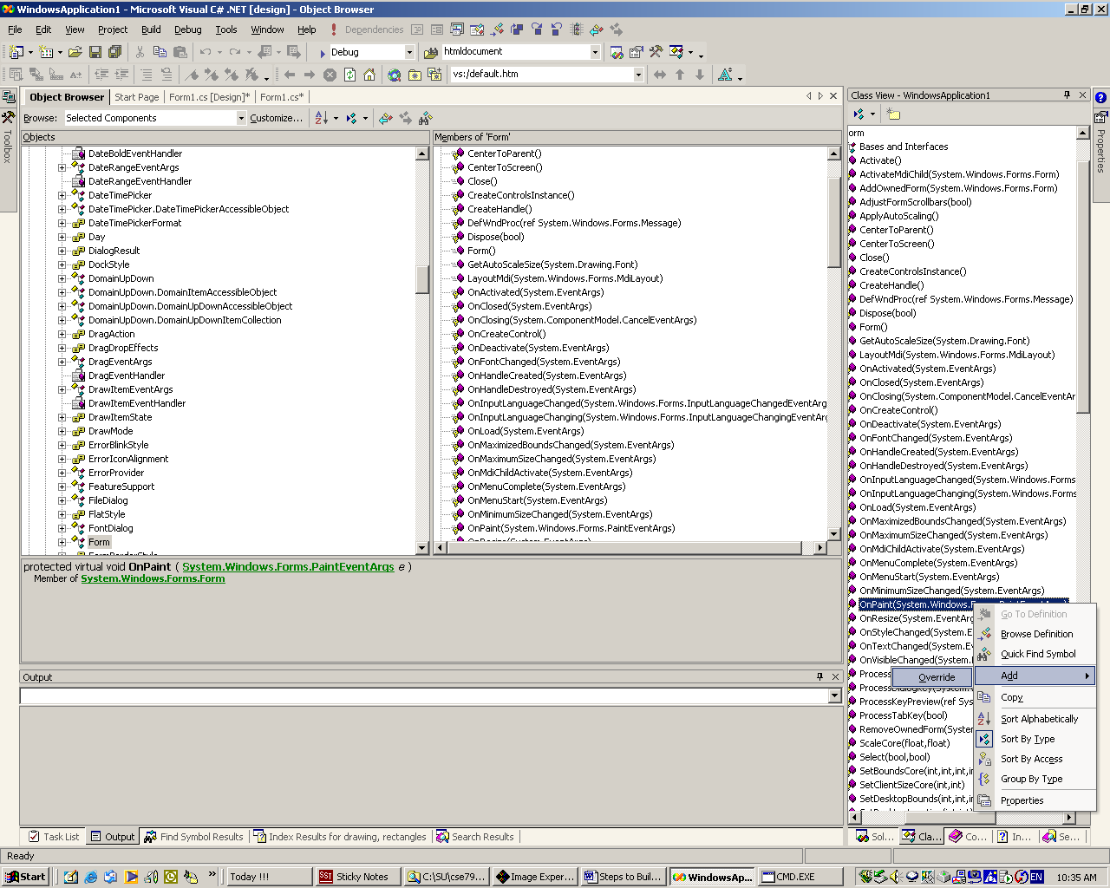

- You will fill in the OnPaint method with code to do what ever drawing you want. For this demo I drew some text, a line, and added code to allow one end of the line to be repositioned.
- To add a MainMenu selection, go to the Design View, open the toolbox, and select MainMenu
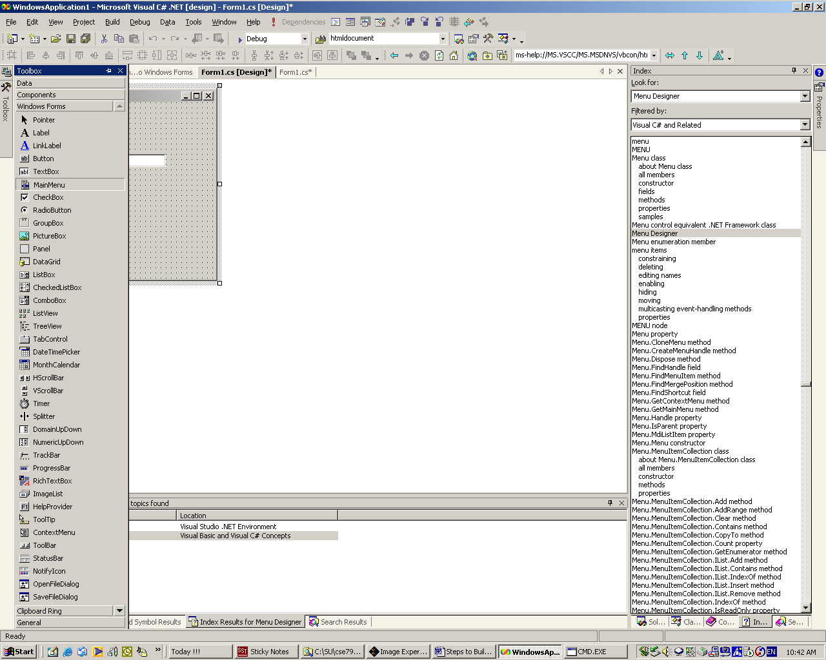
- Pull the MainMenu item to the upper left corner of the form and type in some text. Then, in the Design View, select the menu item and click the properties tab on the IDE far right.
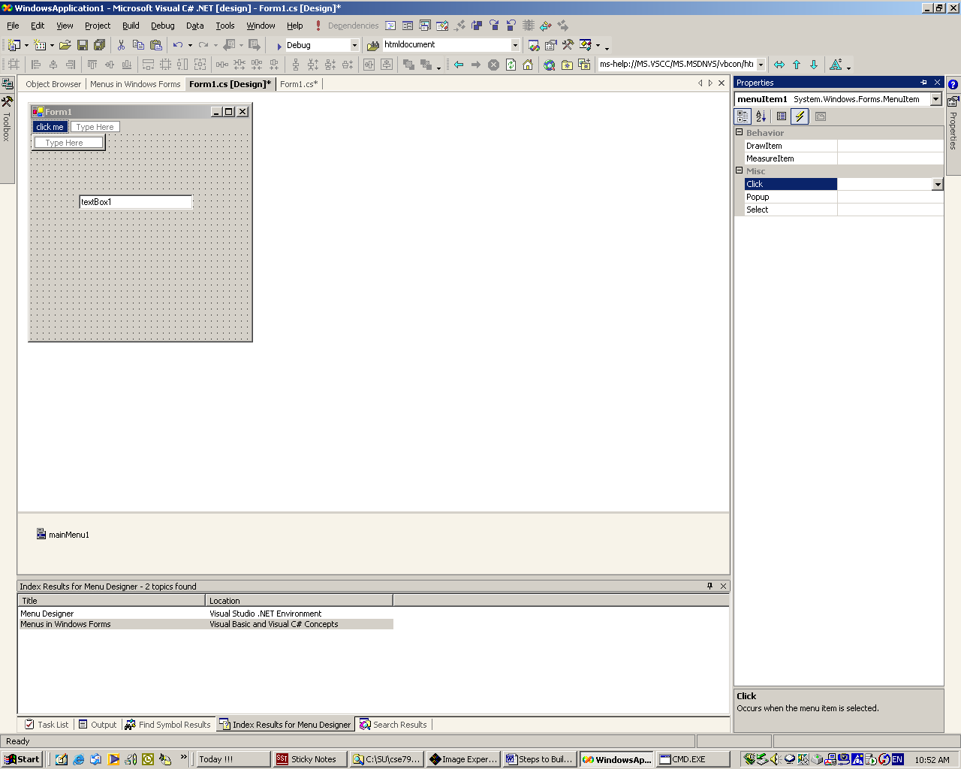
- Select the events view (lightning bolt) and double click on the click item. This creates an event handler for a click on the menu. Put whatever you need in that handler.
- To provide mouse event handlers you can select the form in Design View, open the properties tab, select events, and double click on the event you want to handle, say a mouse down event.
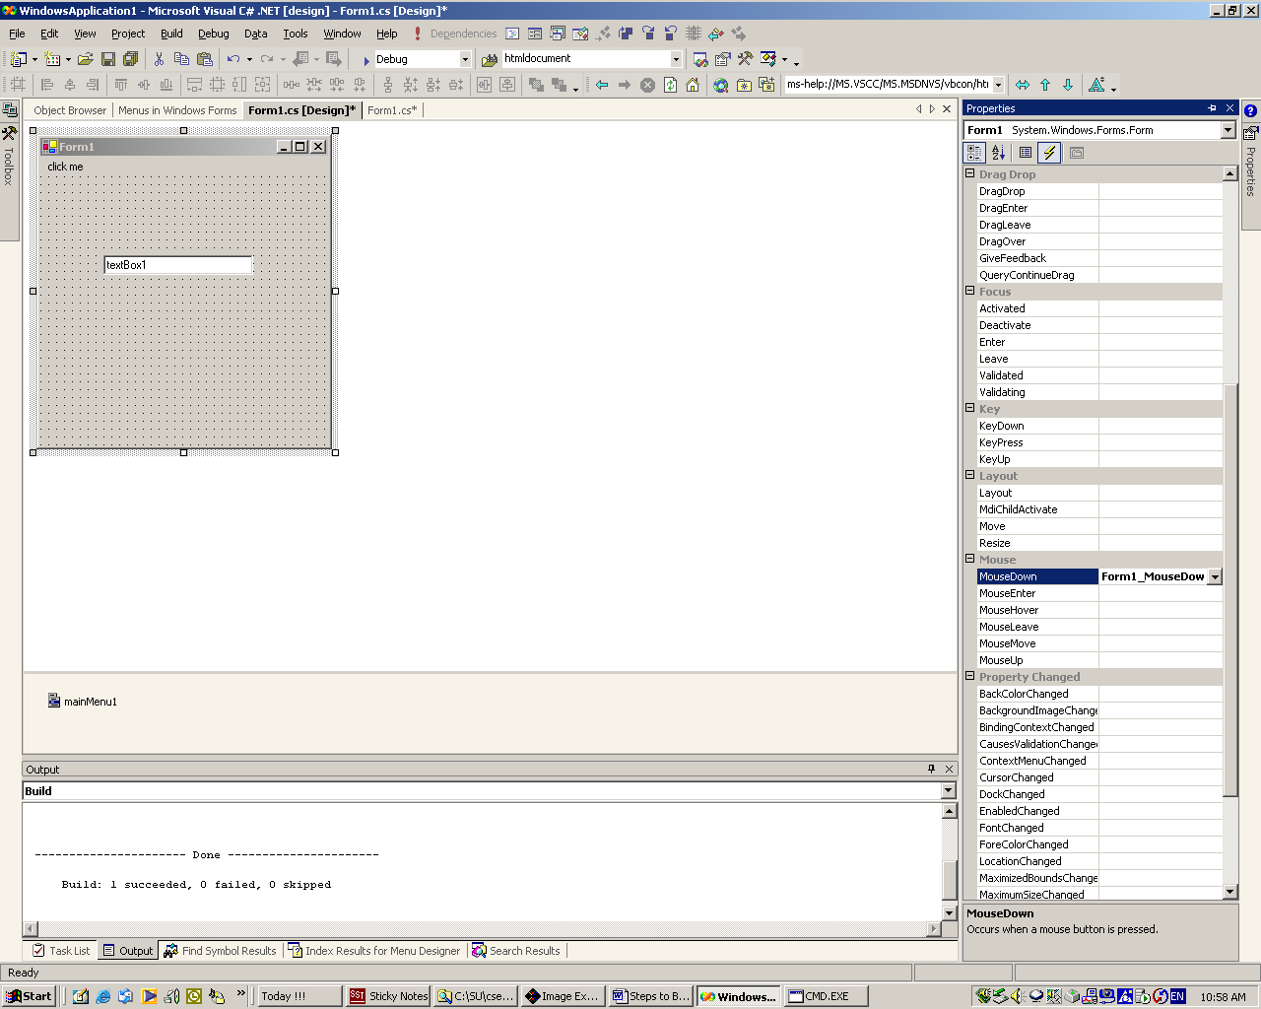
- The rest is just adding suitable code in these event handlers. Take a look at the WinForm Demo for some examples of how to do this.

