Role Management & Validation Demo

Vijay Ramakrishnan
CSE686 – Internet Programming
Spring 2012

Reference: Role Demo and Validation demo – Prateek Maloo, TA CSE 686, spring 2011
STEP 1: Create a new ASP.Net MVC2 Web Application
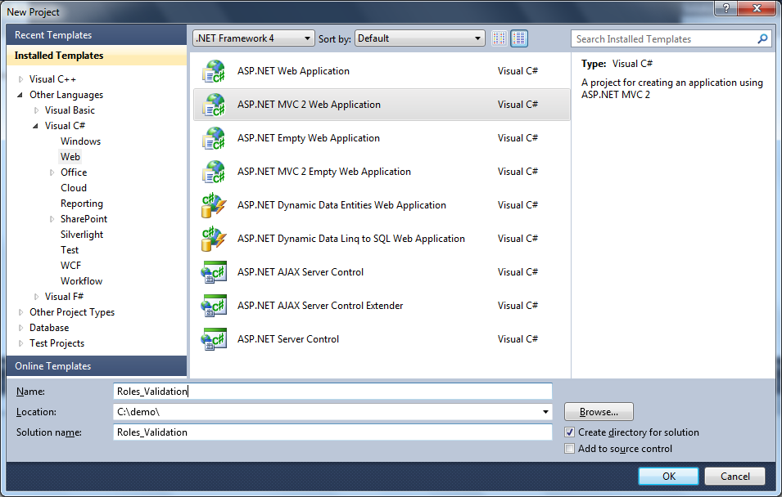

STEP 2: Run the application and click on [Log On] button, then click Register
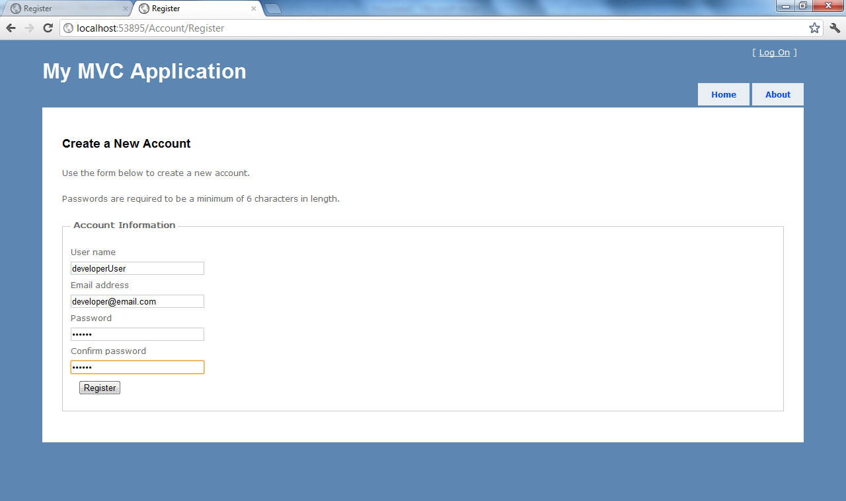
Create the following userid’s
- developerUser
- managerUser
- customerUser

STEP 3: Start the ASP.Net configuration manager
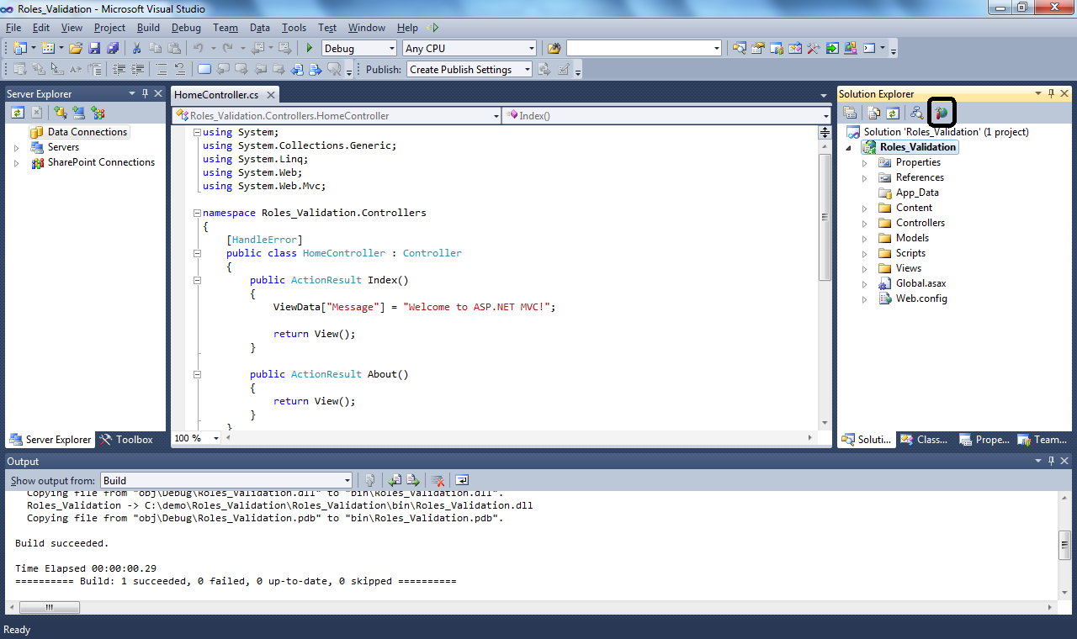

STEP 4: Click on Security
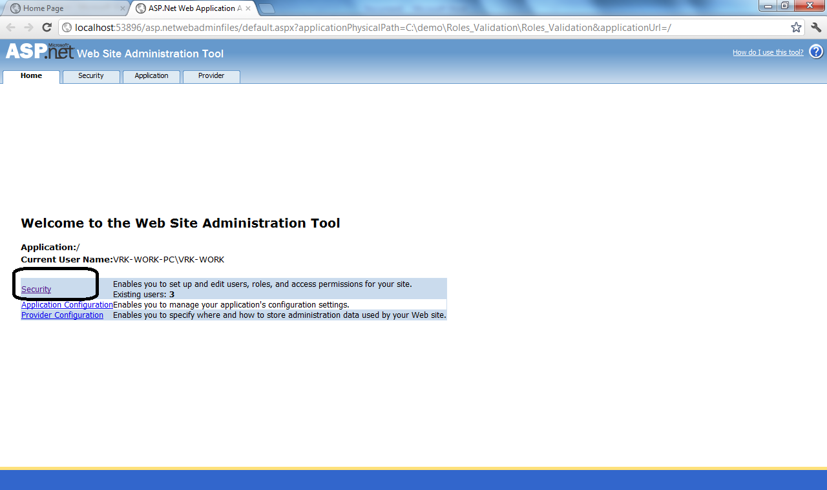

STEP 5: Click on Enable Roles
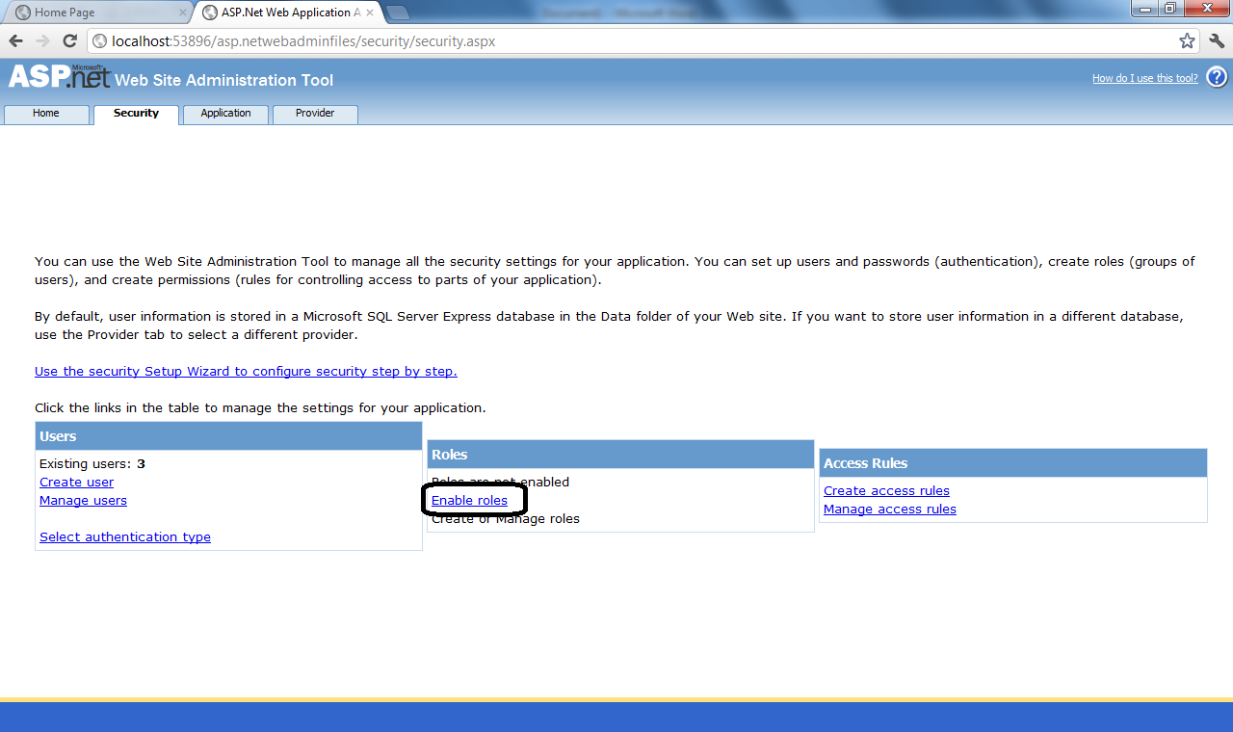

STEP 6: Click on Create or Manage roles
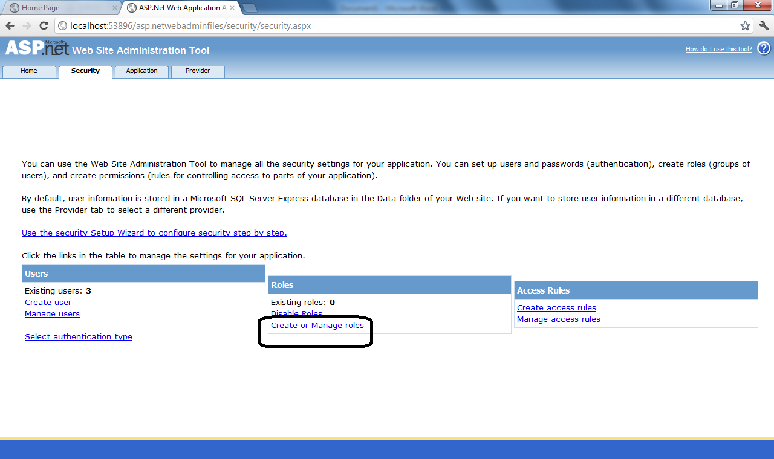

STEP 7: Add 3 roles – developer, manager and customer
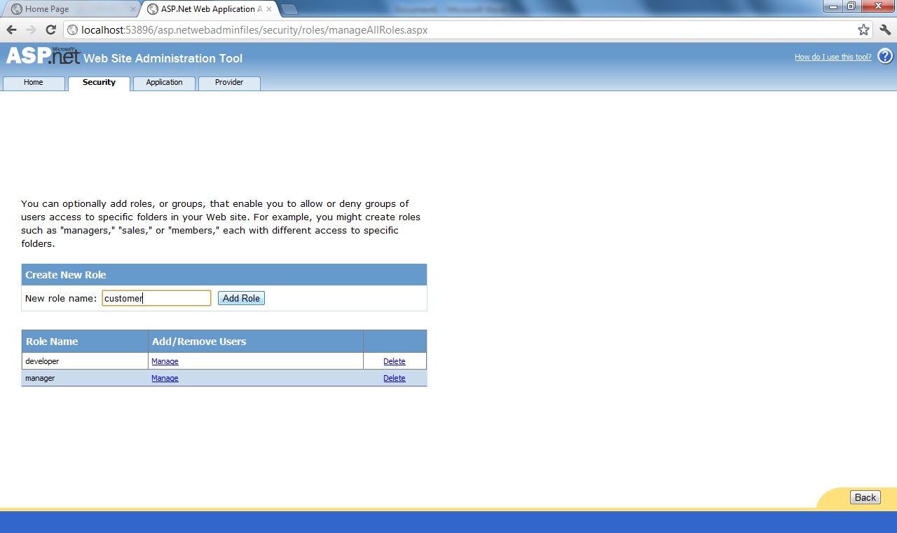

STEP 8: Click on manage for a specific role
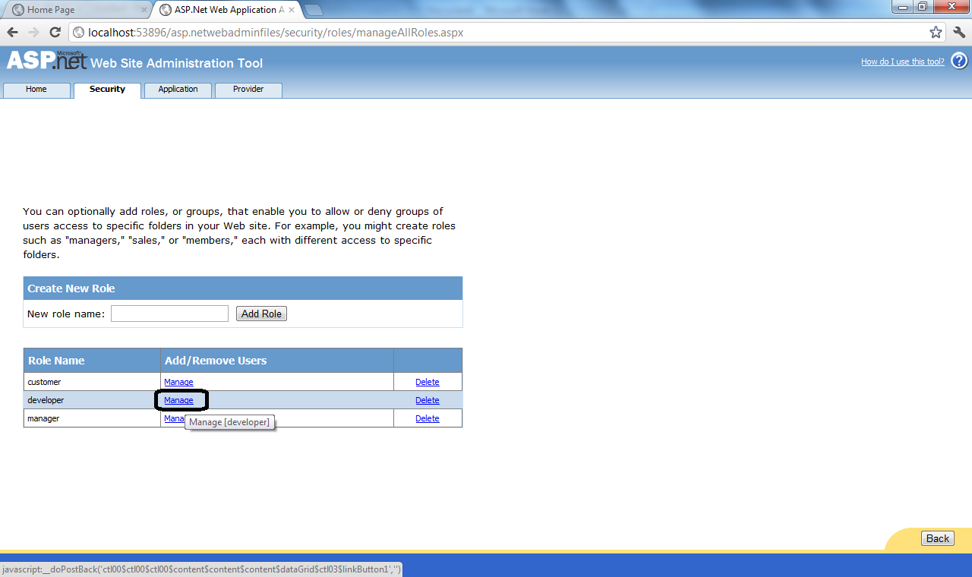

STEP 9: Search for all users and assign the role to single user or multiple users

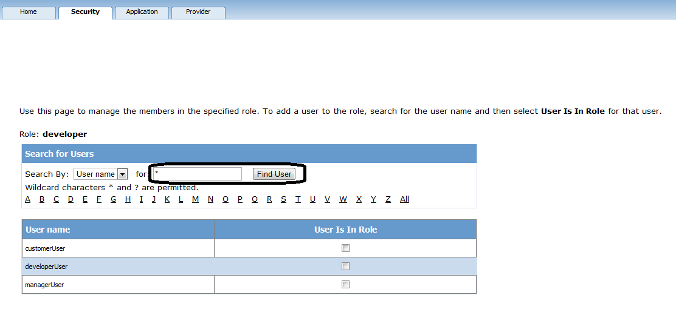

STEP 9: Alternatively, go to Security tab and click manage users
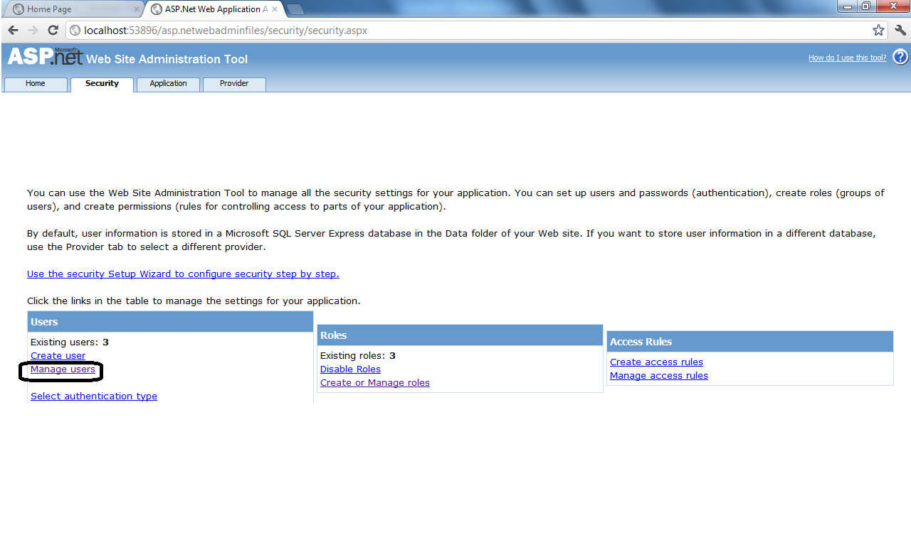

STEP 10: Assign roles to each of the users

