These notes demonstrate how to download and get Murat’s demonstation working.

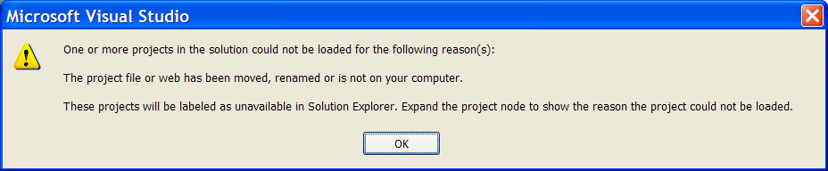

When you’ve copied a website folder with its sln file, when you click on the solution, you get this message. All you need to do is to click ok, remove the website project, and then add an existing website at the location of this folder, as shown below.
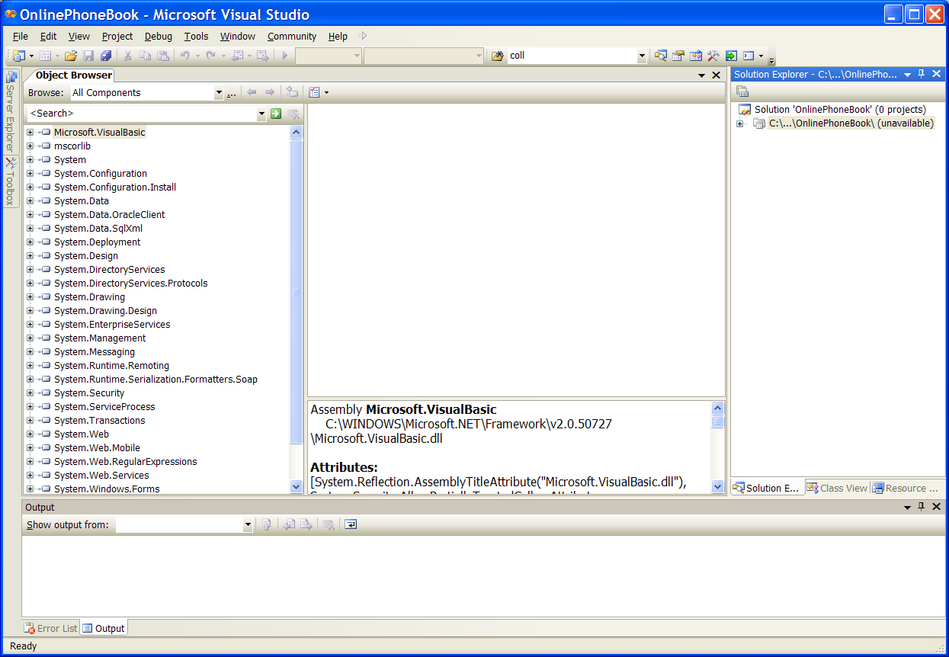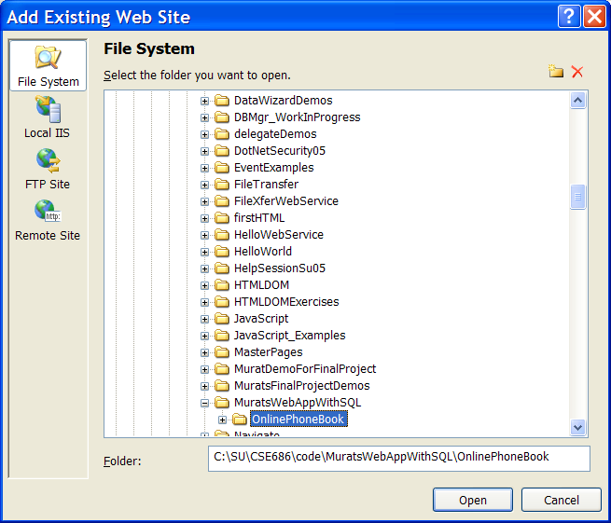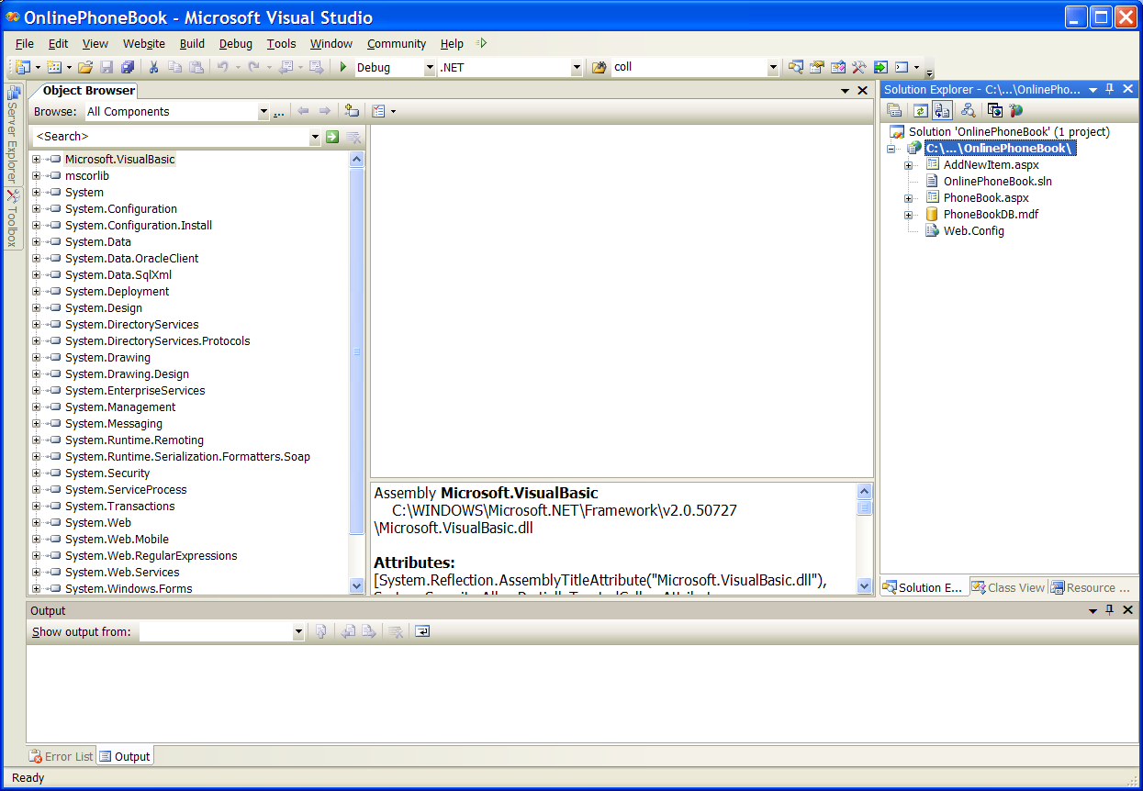
Remove this unavailable project.

Now, change connection string in Web.Config to relect the physical location of the database file, PhoneBookDB.mdf. Now, the project works.



