Operational Concept Document
Pluggable Code Repository

Jim Fawcett
CSE681-OnLine
Software Modeling and Analysis
June 3, 2017

- Executive Summary
- Concept
  - Store large evolving software baseline
  - Adapt to Engineering Organization’s processes
- Uses
  - Developer’s activities
  - Quality Assurance work flow
  - Manager’s need for progress information
  - Customer Code Maintenance
- Structure
  - Packages
    - Concept
    - Packages
    - Responsibilities
    - Package diagrams
  - Operations and Activity diagrams
    - Concept
    - Activities
    - Sequencing
    - Activity diagrams
- Critical Issues
  - Integrity
  - Ease of use
  - Size of the working set
  - Defining interfaces rich enough language vs. simplicity
  - Conflicting user activities
- Risks
  - External attacks
    - Integrity
    - Loss of proprietary value
  - Internal attacks
    - Integrity
    - Loss of proprietary value
- Conclusions

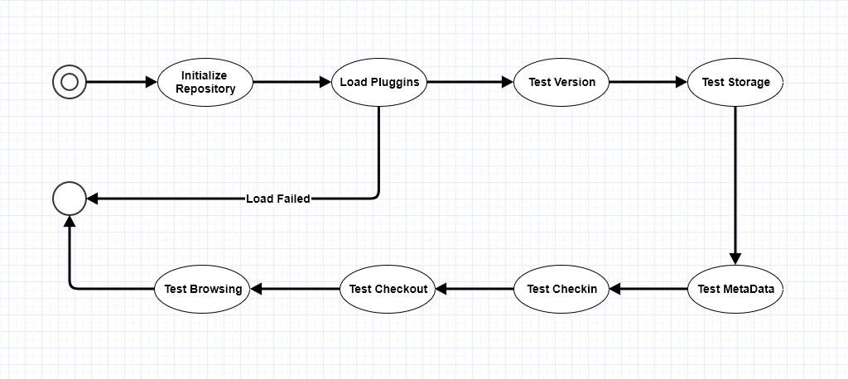
Figure 2 – Pluggable Repository Activity Diagram – First and Second Projects
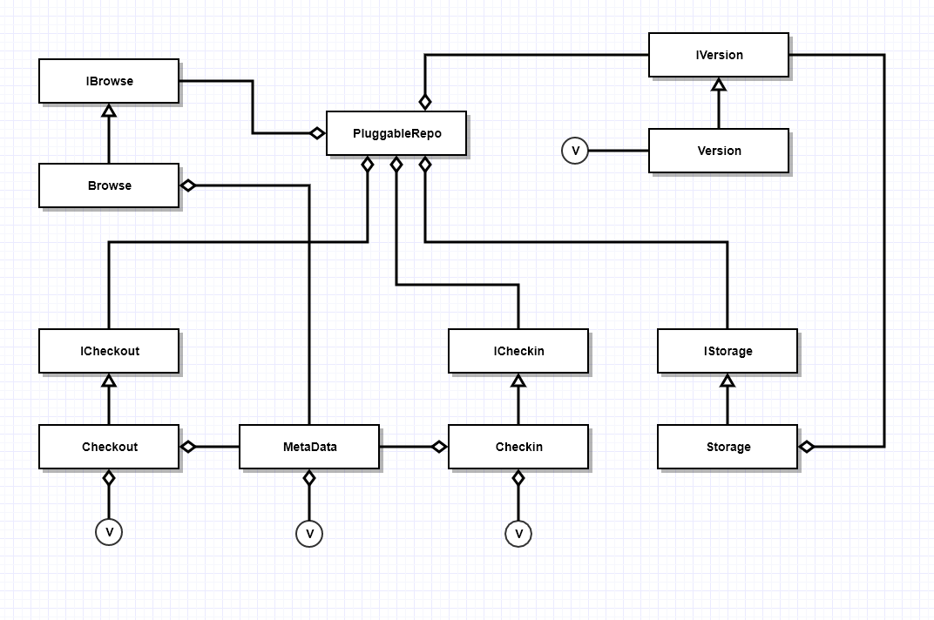
Figure 3 – Pluggable Repository Class Diagram – First and Second Projects

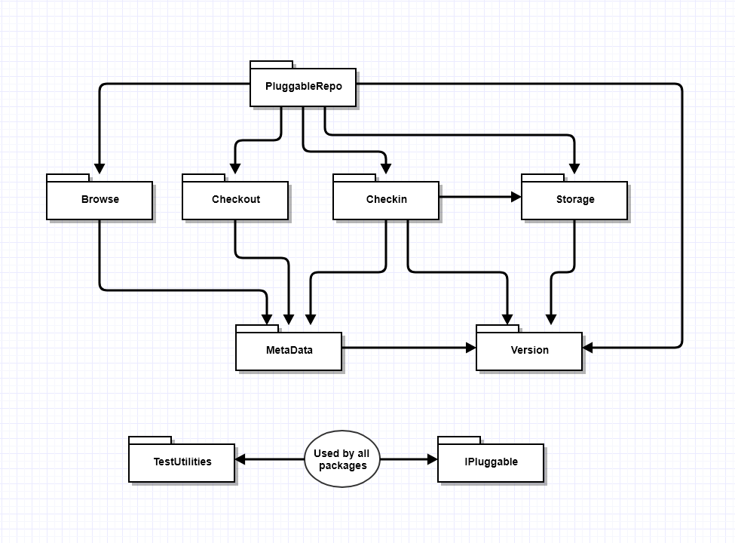
Figure 1 – Pluggable Repository Package Diagram – First and Second Projects

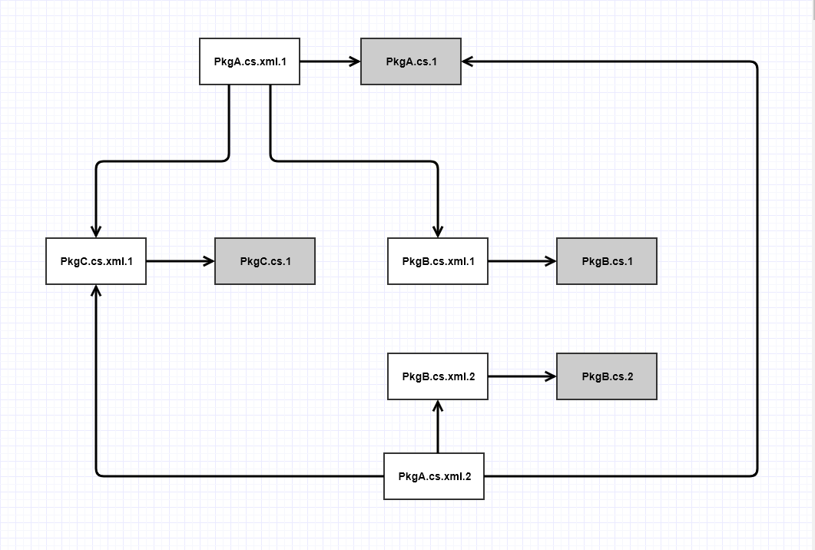
Figure 4 – Storage Structure with Versioned MetaData

