Instructor’s Solution
CSE687 – Object Oriented Design
Project #1
Jim Fawcett, February, 28 2010

Purpose:
Evaluate the design of XmlProcessor project with respect to partitioning, complexity, reusability, and use of Design Patterns.

- Partitioning:
XmlProcessing has 8 packages, including an interface package and a package used only for testing.
  - Packages are reasonably balanced in size and complexity, as shown in the diagrams, below.
  - The worst metrics for individual functions are 68 lines of code and cyclomatic complexity of 11 – almost all are within recommended limits of 50 lines and 10 cc.
  - Application specific processing is nicely balanced between XmlNode, XmlDocument, and XmlElementParts.

- Reusability:
Three of the 8 packages are reusable, e.g., Tokenizer, MTree, and MNode. No application specific code appears in any of these packages.
- Use of Patterns:
Two well-known patterns are used here:
  - Composite Pattern:
Represents a tree structure with nodes drawn from an inheritance hierarchy. Derived classes refer to other elements in the tree using the base type, as shown in the class diagram below.
  - 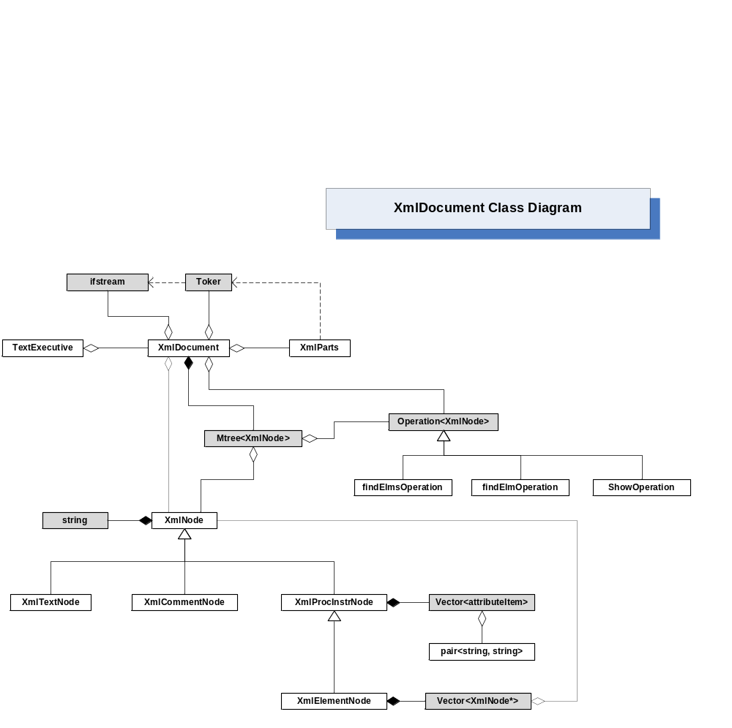Hook Pattern:
A reusable package provides a base class for application specific code to derive from. Classes in the reusable part invoke base class functions through pointers that are bound, by a registration or factory process, to derived objects.
Here, the MTree uses an instance of a class derived from Operation by invoking its operator() on every node it visits during a walk. The application registers its derived instance with the tree’s setOperation() function. The XmlDocument uses classes derived from Operation() for finding elements and for display through node’s ToString() methods.
Hook
Composite

