Create a Web Service with Notepad In Ten Minutes
- Copy Calc.asmx from WebService_Calc to an empty folder. Don’t copy anything else. Note that you could create this file with notepad in about 10 minutes.
- I named the folder TestWebService.
- Make that directory a virtual directory with the IIS manager as shown in the screen shot below.
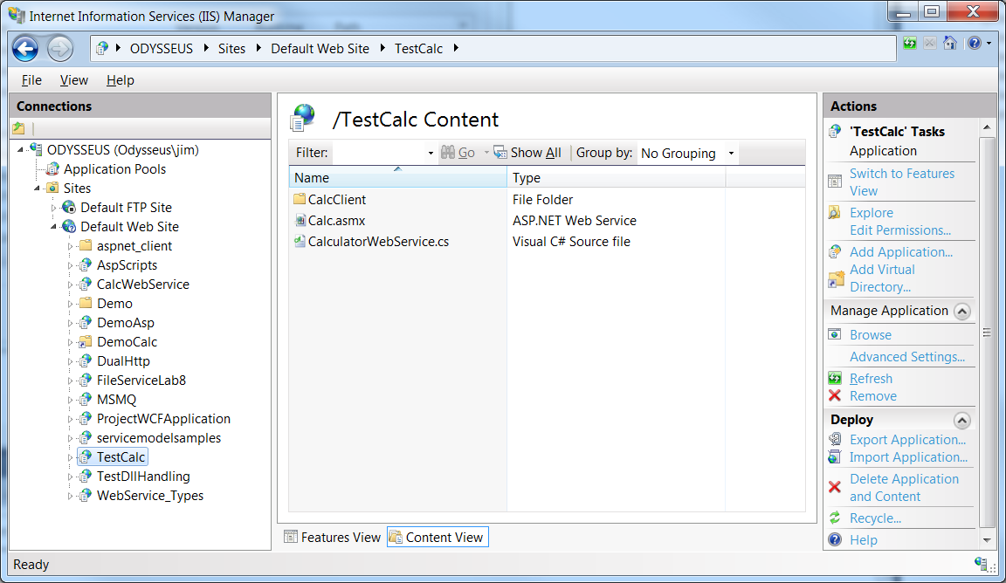
- Now open Visual Studio command prompt (I’m using in administrator mode, but you may not need to do that) and invoke the WSDL tool to create a proxy for the notepad Calc webservice, as shown in the screen shots below.
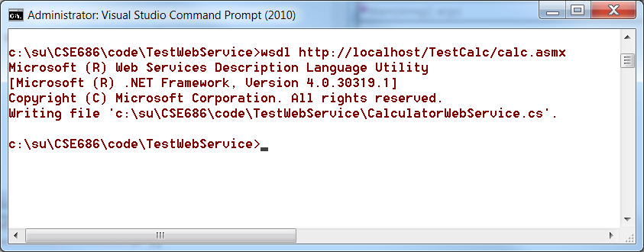
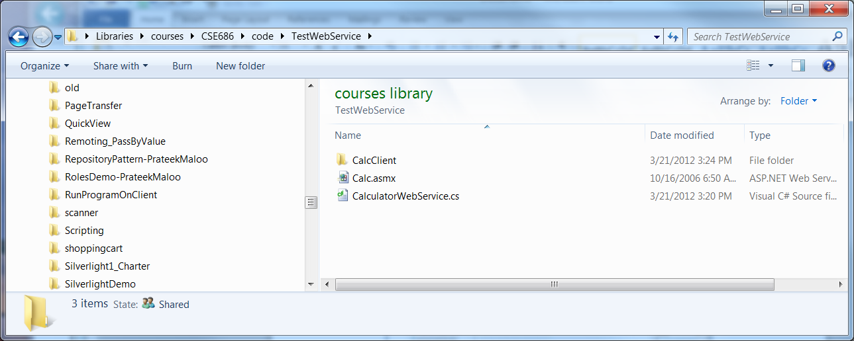

- Now, create a C# console application in the same folder, e.g., TestWebService, and add a reference to System.Web.Services, as shown in the screen shot below
- Add code to create the proxy and use it to access the service as shown in the second screen shots, below.
