Installing Kubuntu on Windows 7 Machine

- Make System Repair Disk
- Download Kubuntu iso image
- Burn iso image to DVD
- Install

Make System Repair Disk
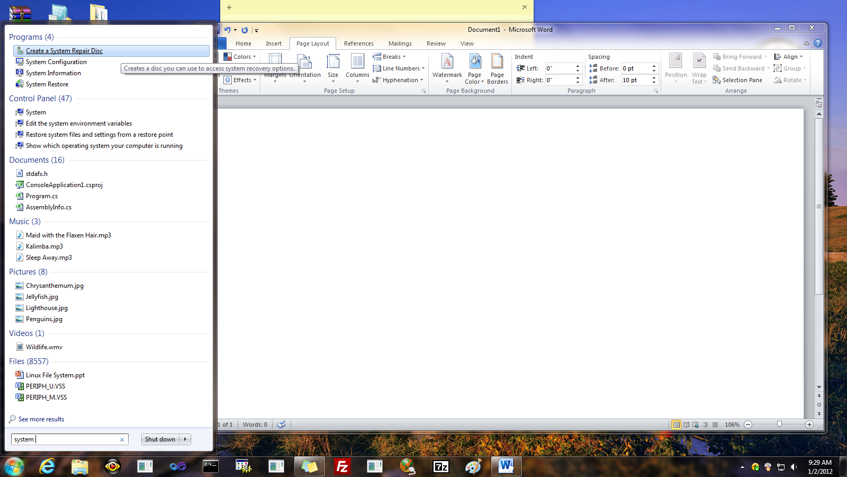
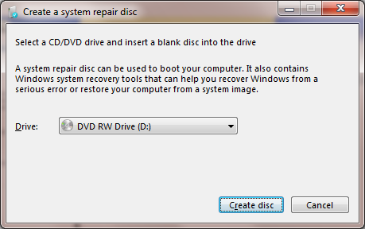

Download Kubuntu
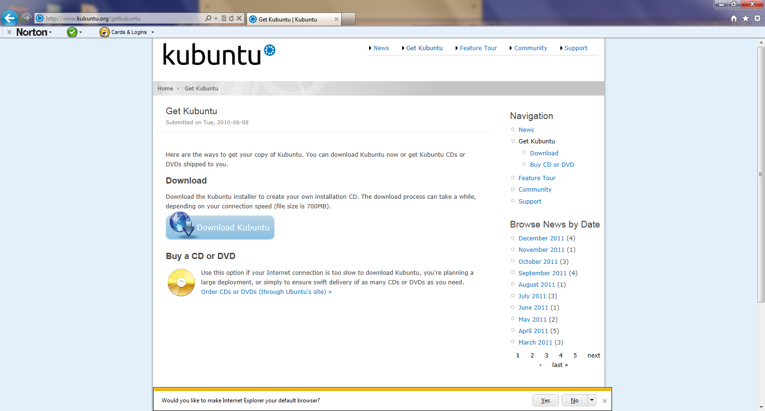

Make install DVD from iso image
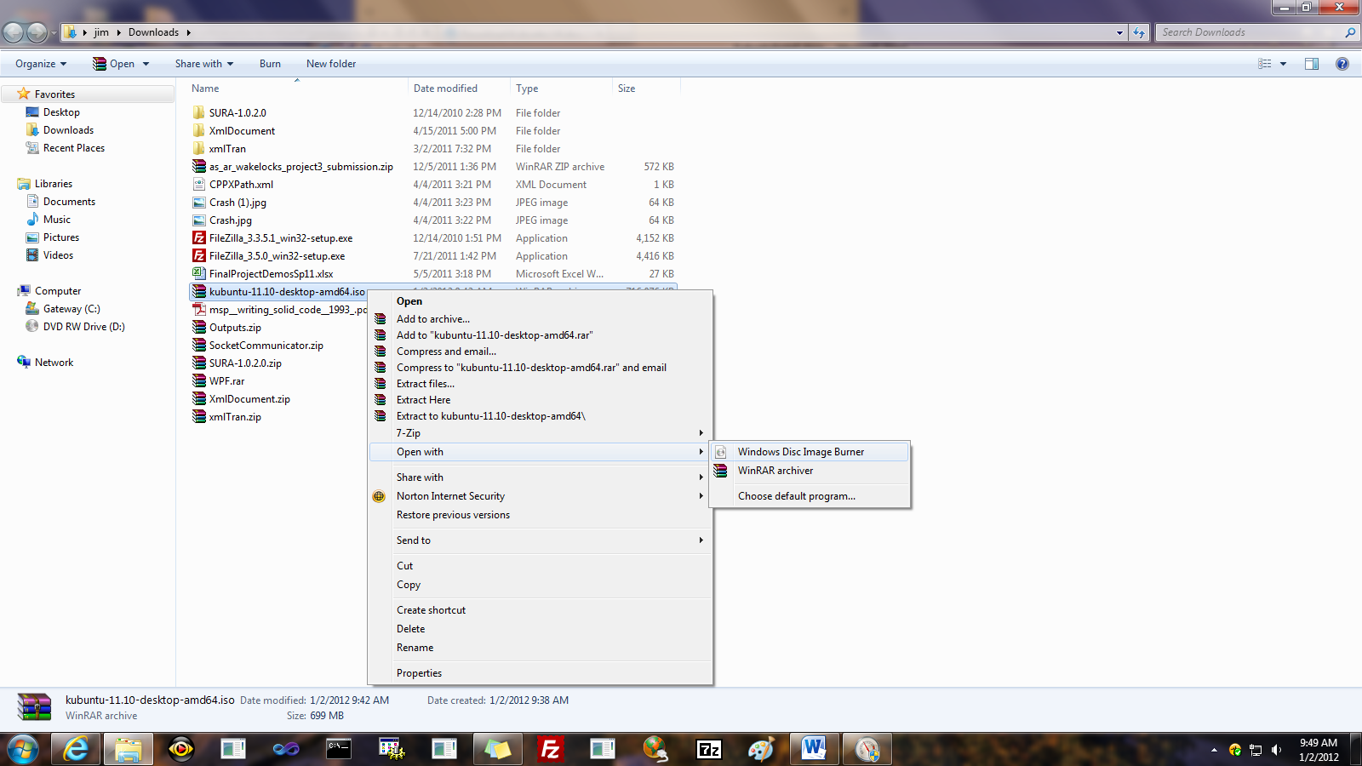
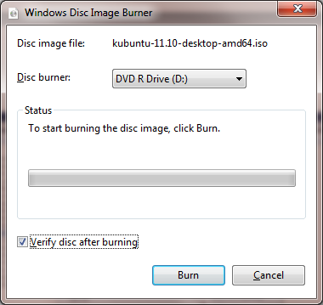

Install Kubuntu
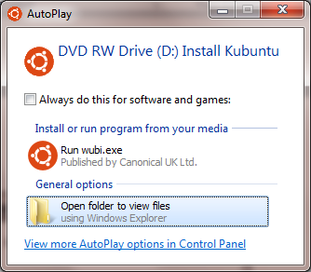

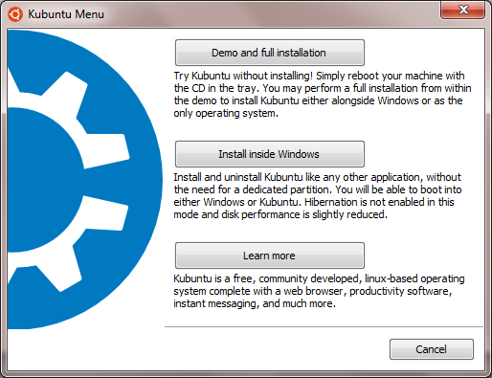

Take the “Install inside Windows” option. With that you do not need to use the installer’s partition manager, always a risky operation unless you know EXACTLY what you are doing. This builds Kubuntu in a virtual partition, e.g., a file – unreadable by Windows – in C:\ubuntu\disks. From Windows you cannot see the Kubuntu files, but in Kubuntu you can see the Windows directories and you can copy files from your kubuntu directories into whatever directory you want in the windows directory system. You will find a folder /Root/host which is the Windows directory system entry point.
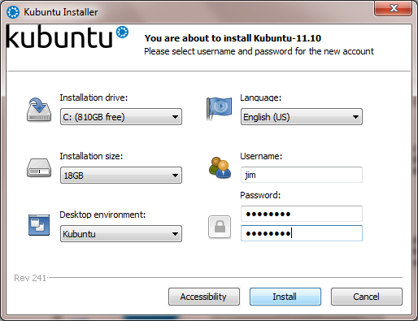

O.K., now we’ve booted into kubuntu!


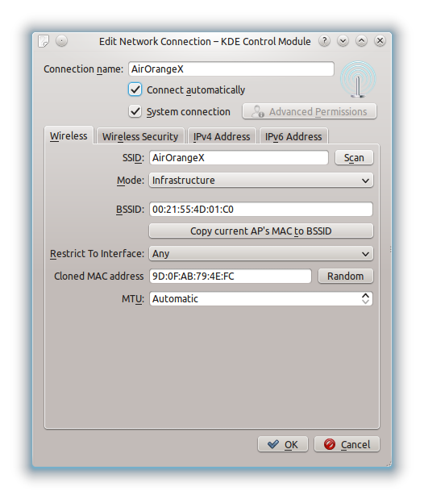
Now we’ll set up wireless networking so we can connect to AirOrangeX

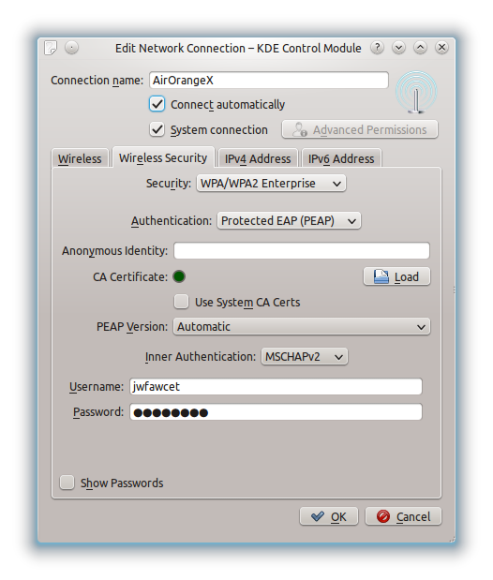
Now, we’re going to install Eclipse with support for g++
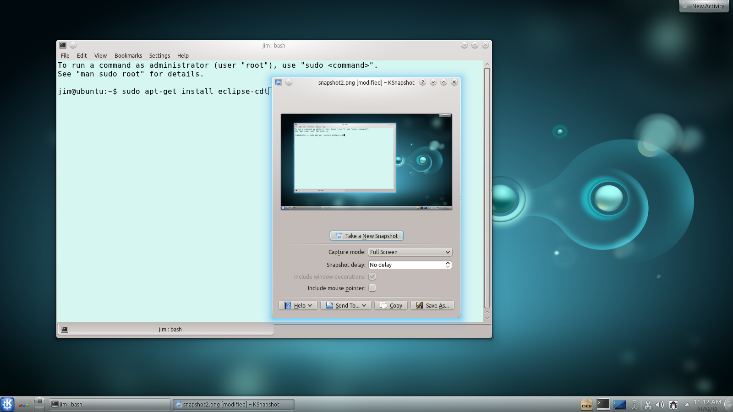
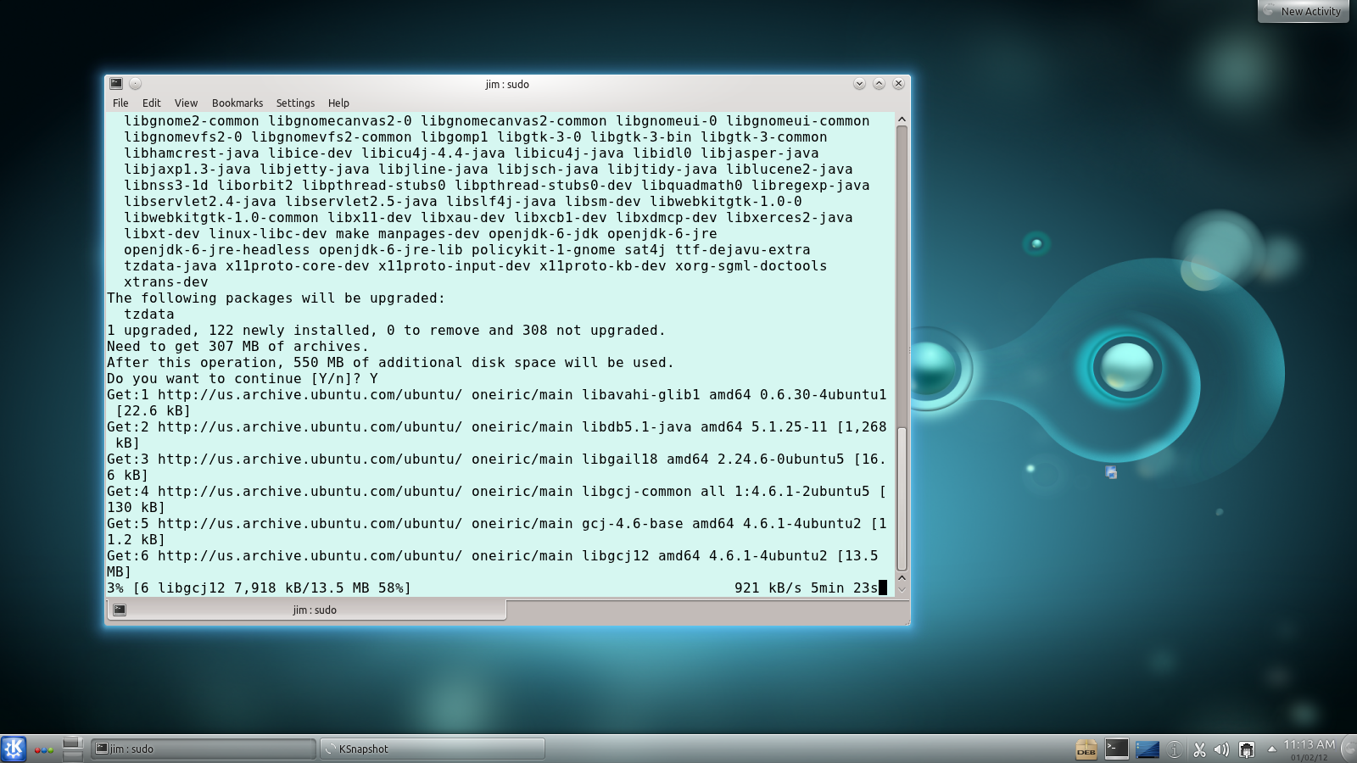

And finally, we need to install g++ itself:
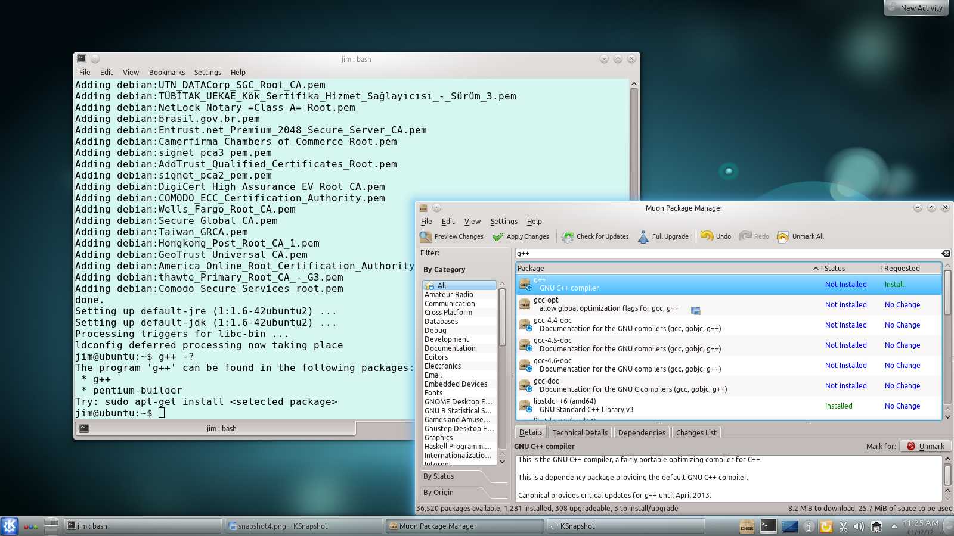

Here, I’m using Muon, the kubuntu package manager to install g++. It’s easier, and just as effective to simply give this command in the Konsole window:
sudo apt-get install g++

Here you see g++ help info
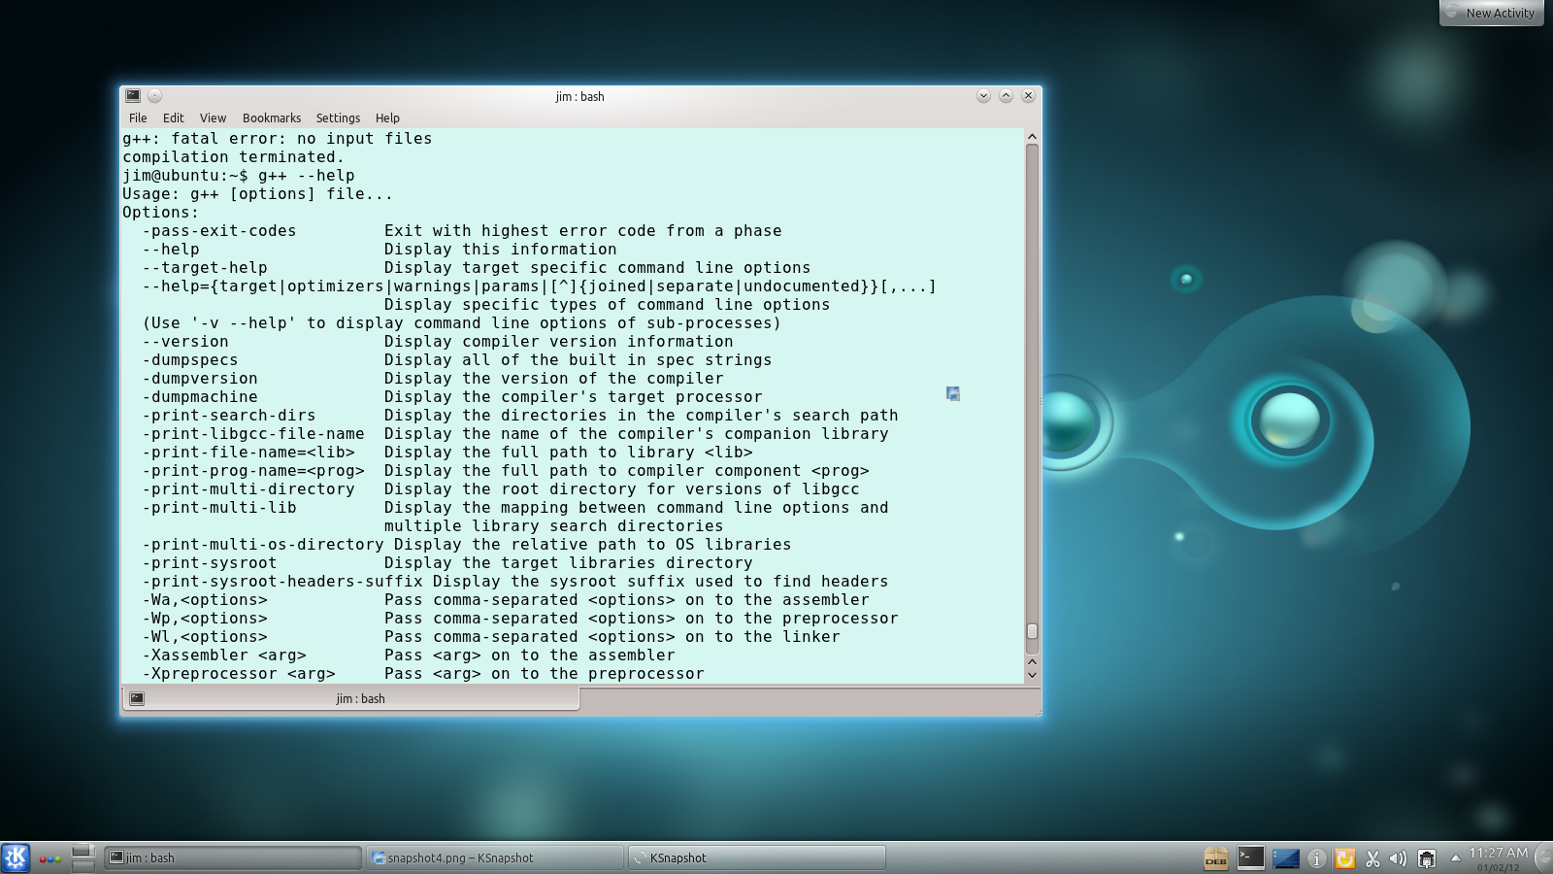

Finally, here’s some Eclipse screen shots:
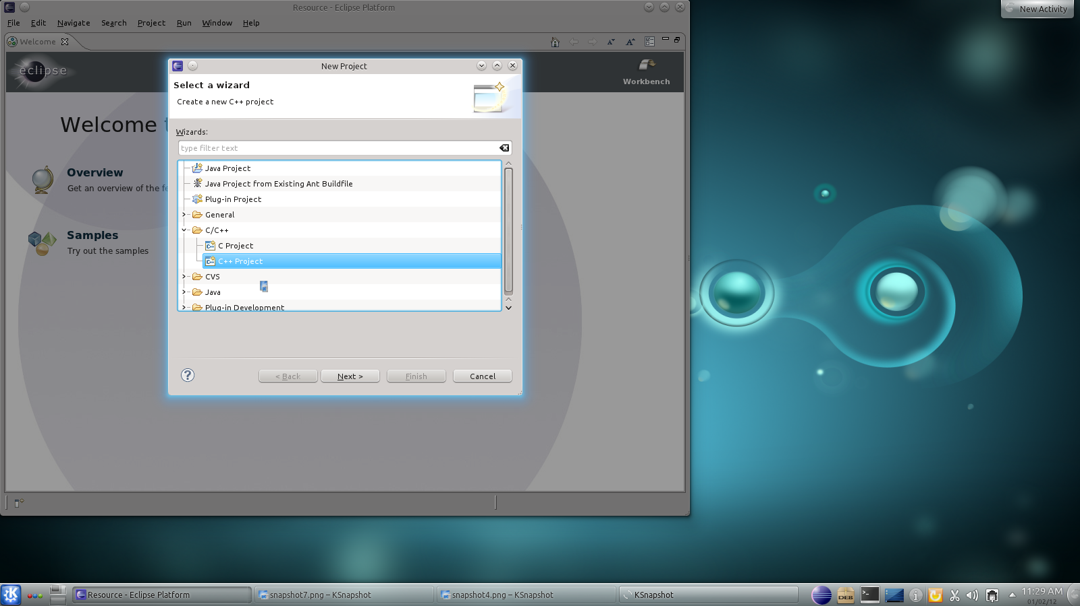

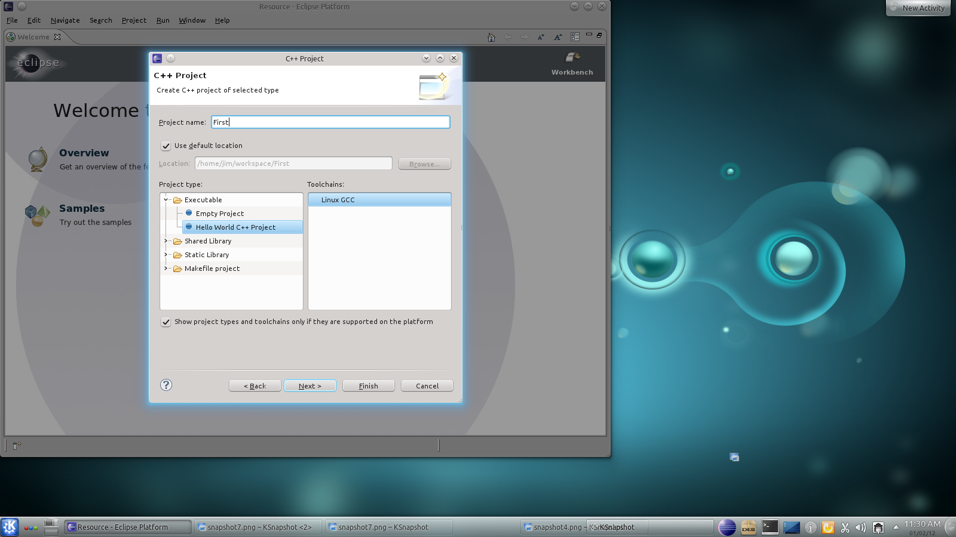

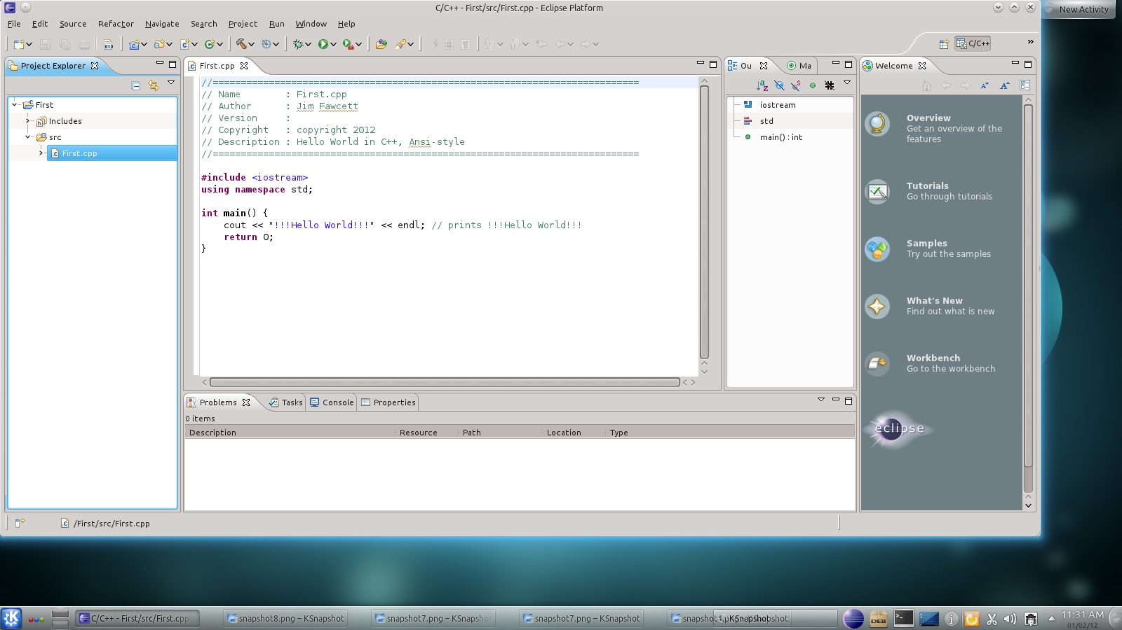

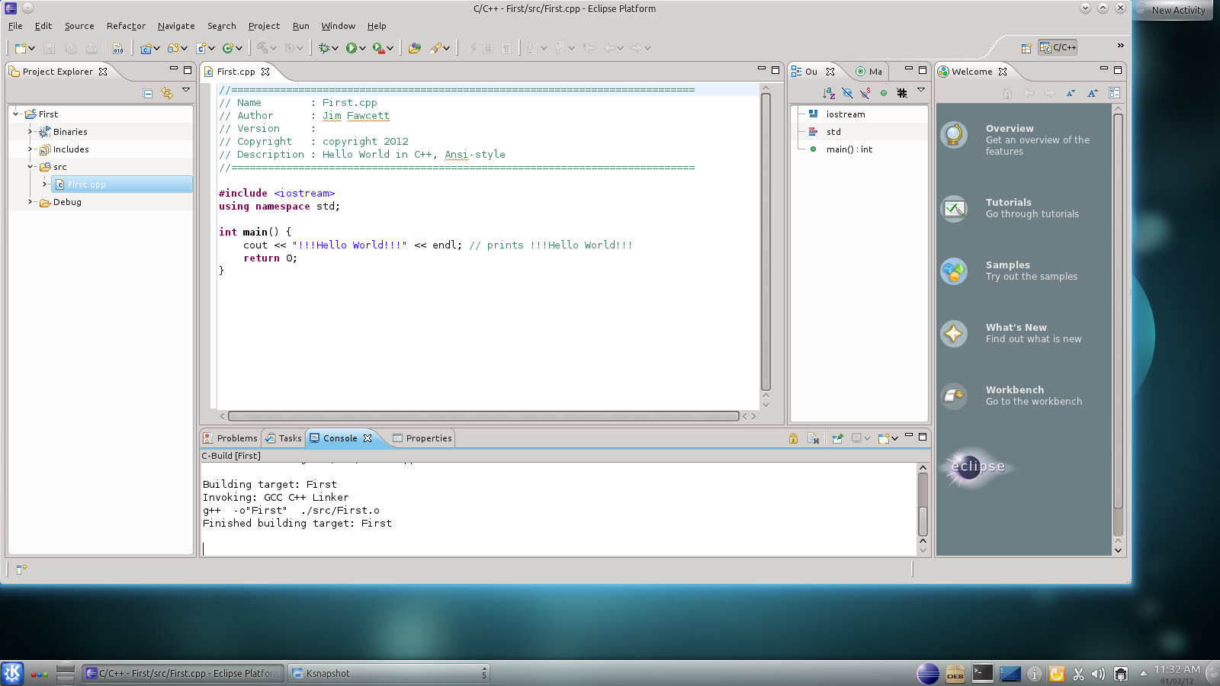

You see successful compiler output in the console window at the bottom of the screen.

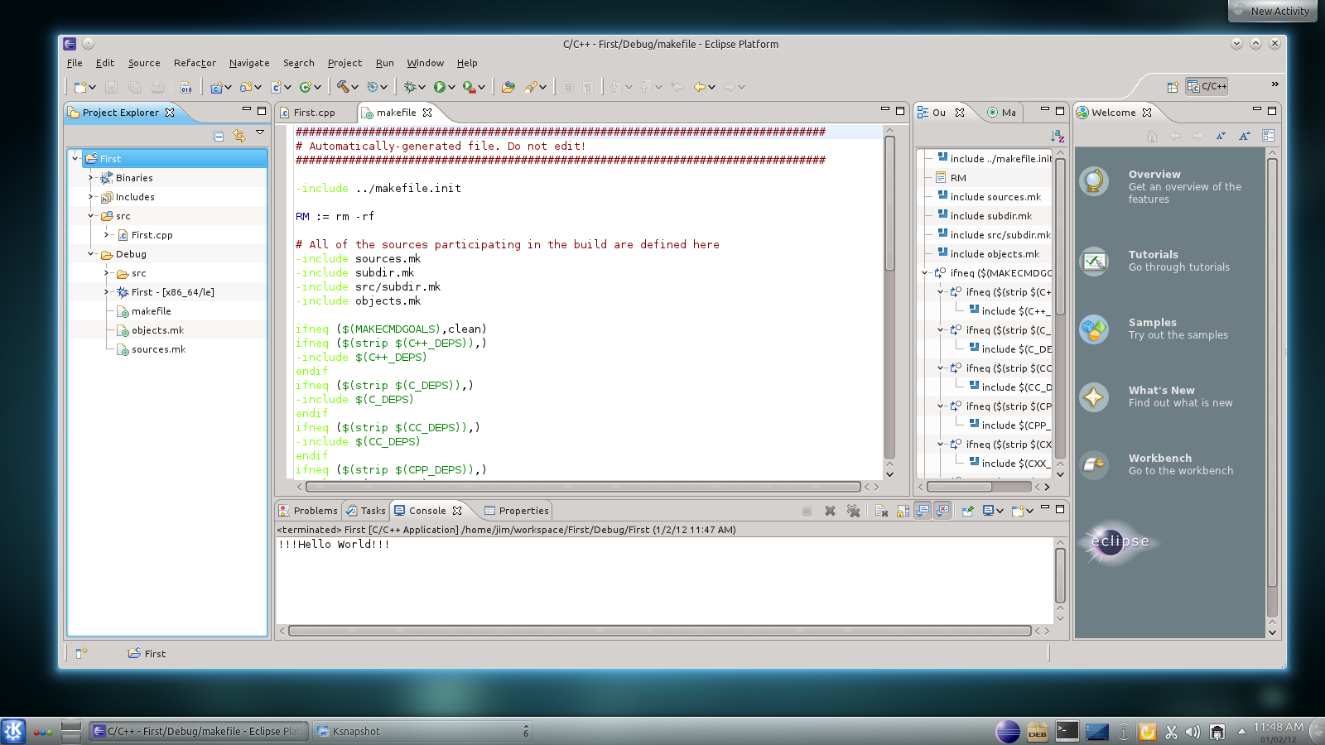
See output of the hello world program in the console window at the bottom. You see the project’s make file in the editor screen in the middle.

