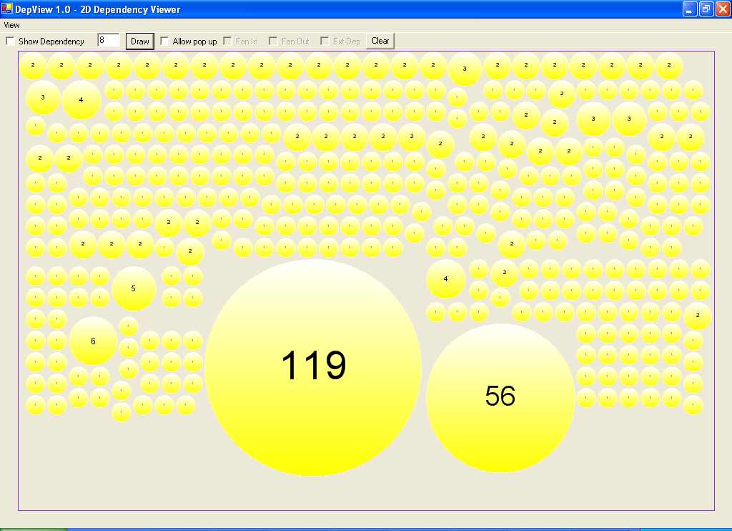
Mozilla dependency structure is shown here, for its GKGFX library (responsible for rendering). Each disk is a set of mutually dependent files. Disks of size two are conventional modules. Huge disks, like the two shown here, are sources of major problems when making changes.
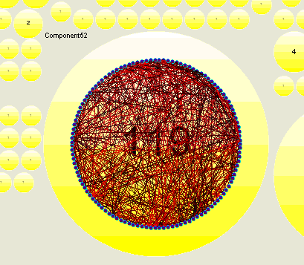
Internal dependencies in the largest set of mutully dependent files. Imagine trying to make a change to one of these files. Think of how much breakage that may cause.
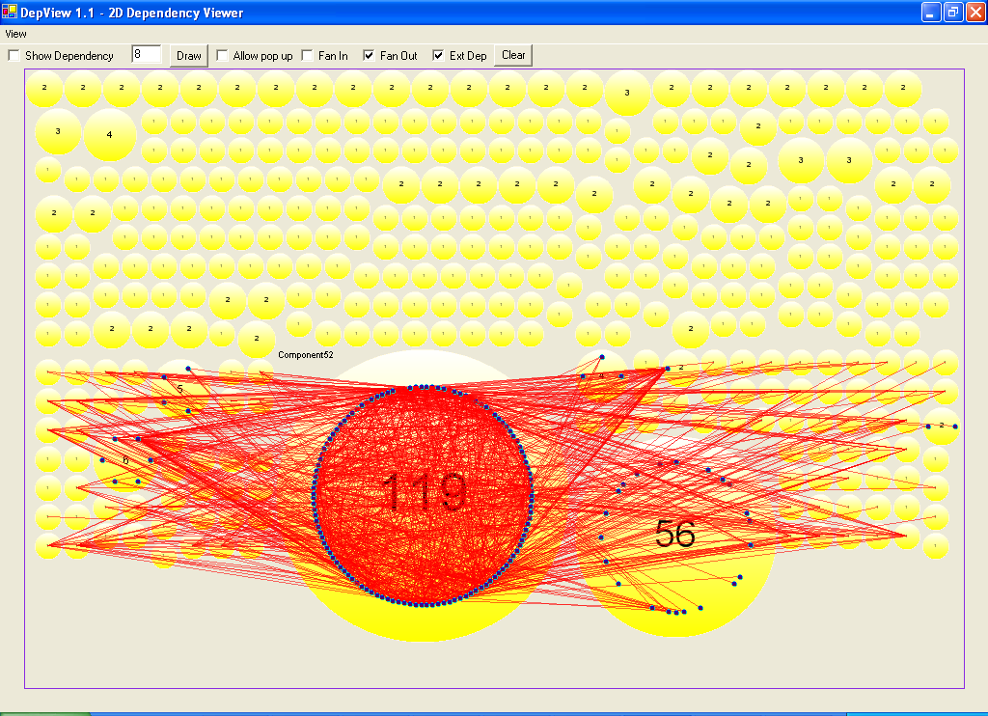
Here we show the dependencies of files outside this set of mutual dependencies on files within.

Clearly change control will be almost impossible to manage well.

