Build COM Component with ATL
Step-by-Step

Jim Fawcett
CSE775 – Distributed Objects
Spring 2013

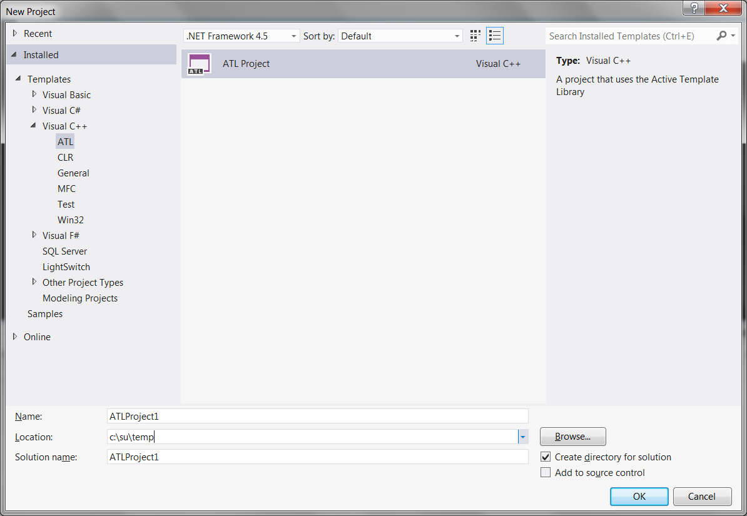

Create ATL Project
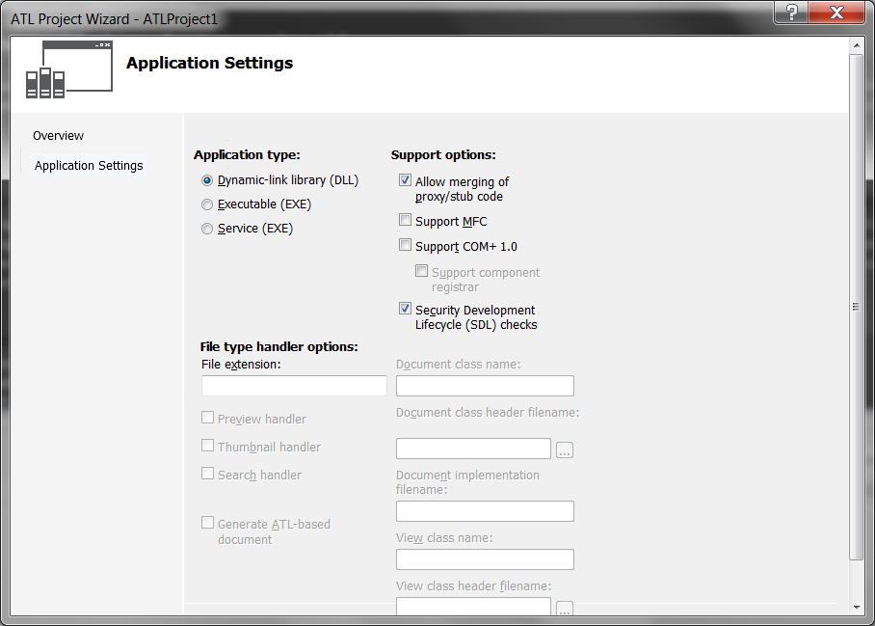

An In-Process (inproc) COM component is built as a dynamic link library. Mergin proxy/stub code makes things tidy. This creates a COM server, which does not yet have an object to support.

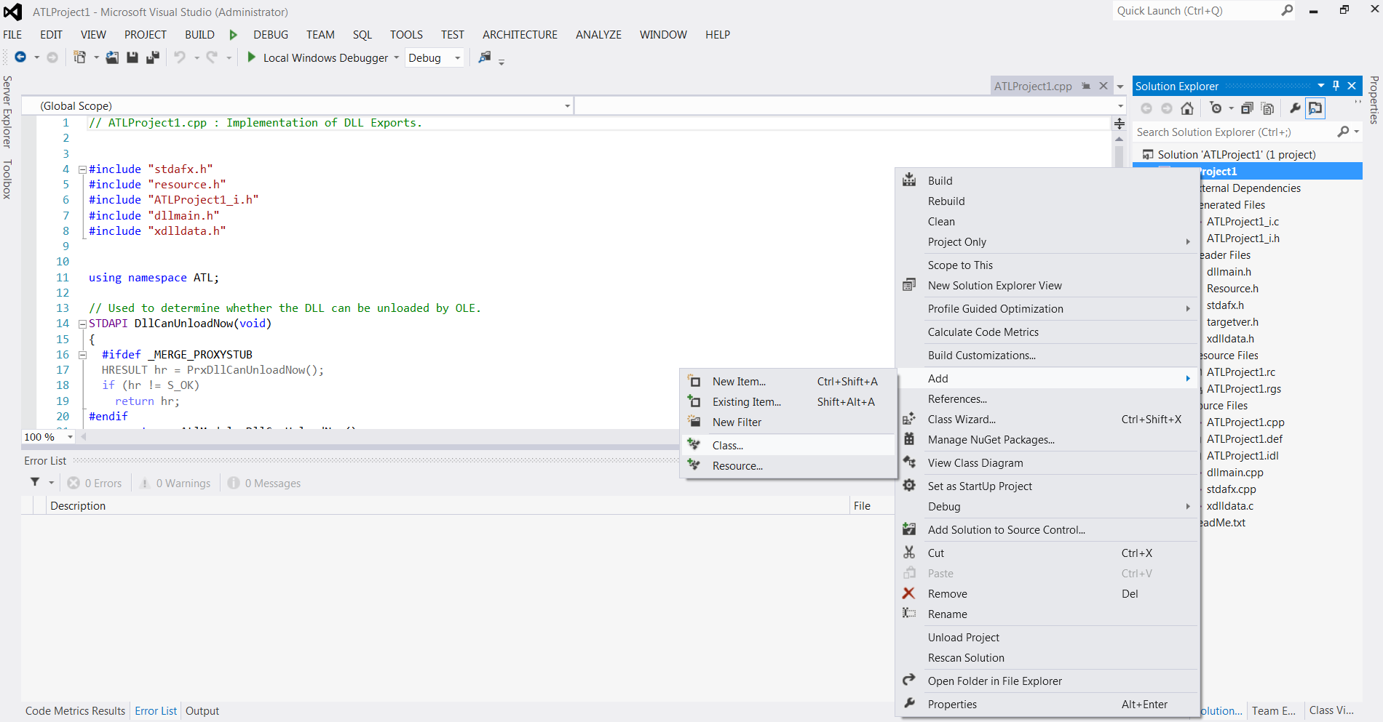

You add an internal object this way, starting with a right-click on the Project name.
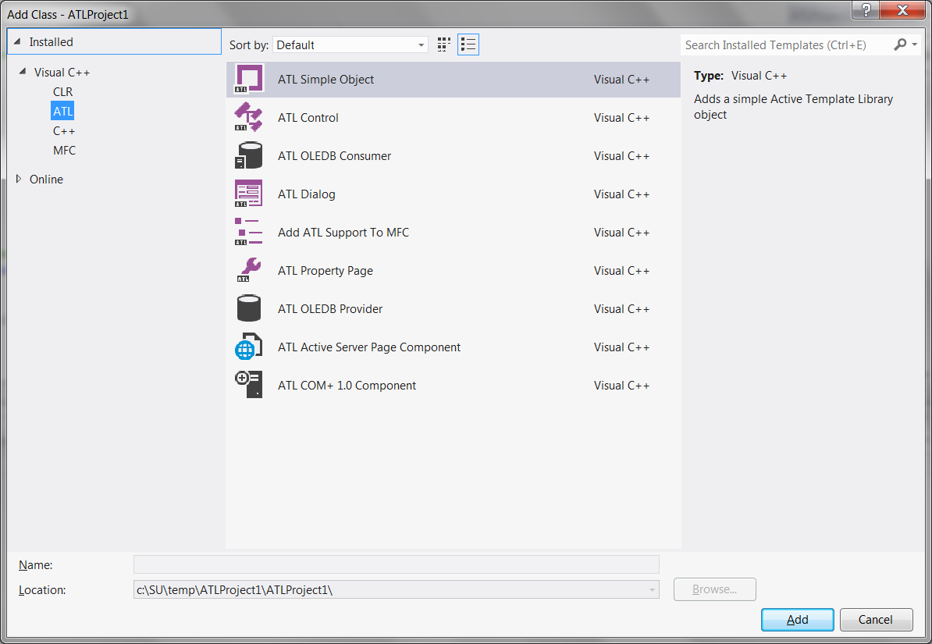

You want an ATL Simple Object.
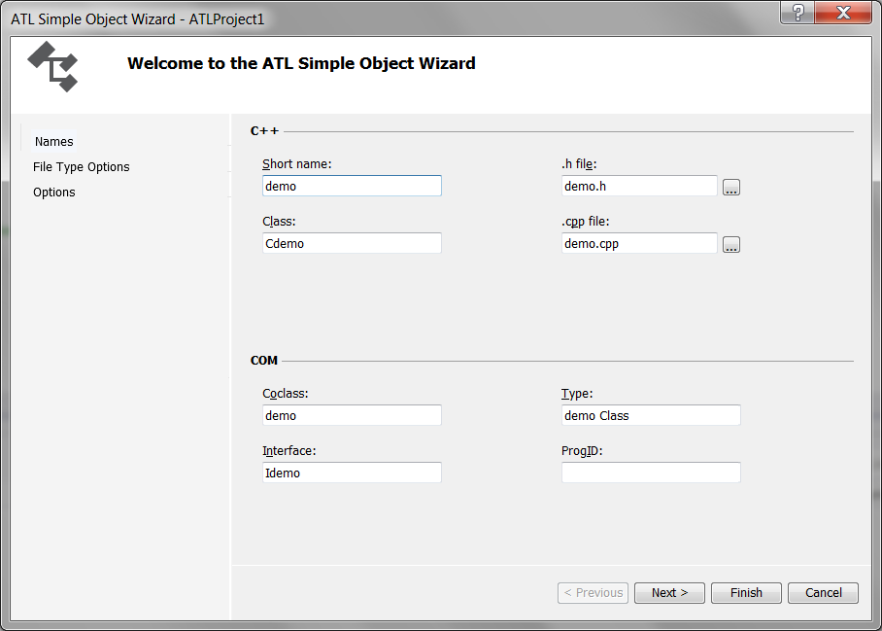
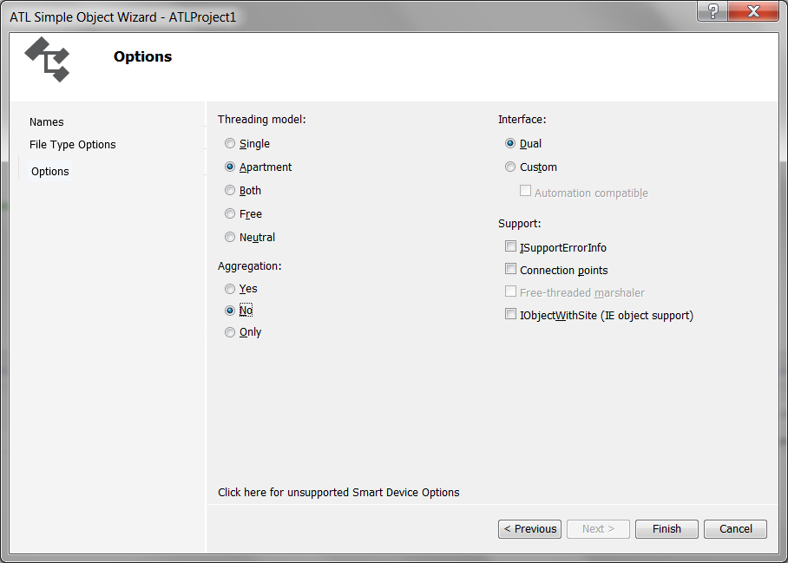

We will discuss Apartments and Dual interfaces and the other options too, in a week or so.

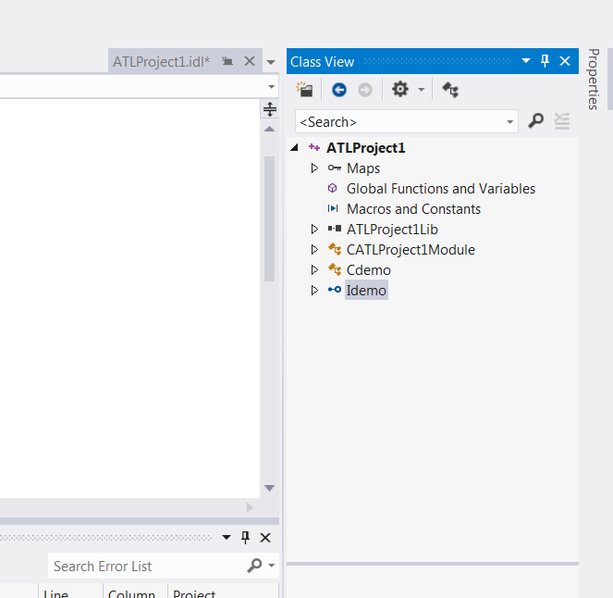

Now, we need to add methods to the Simple Object’s interface. So, right-click on the Idemo interface.

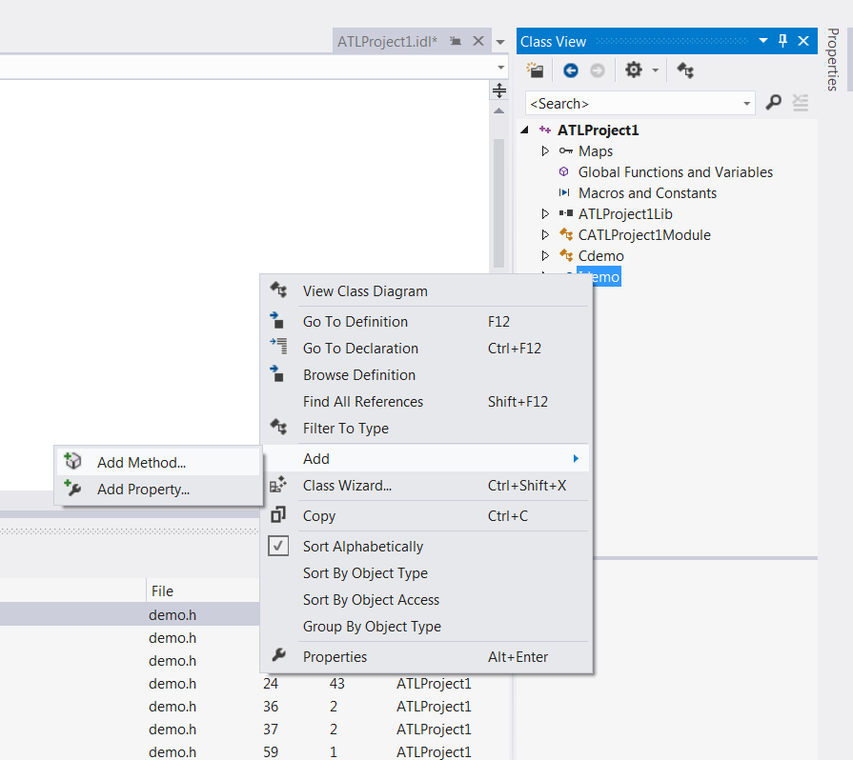
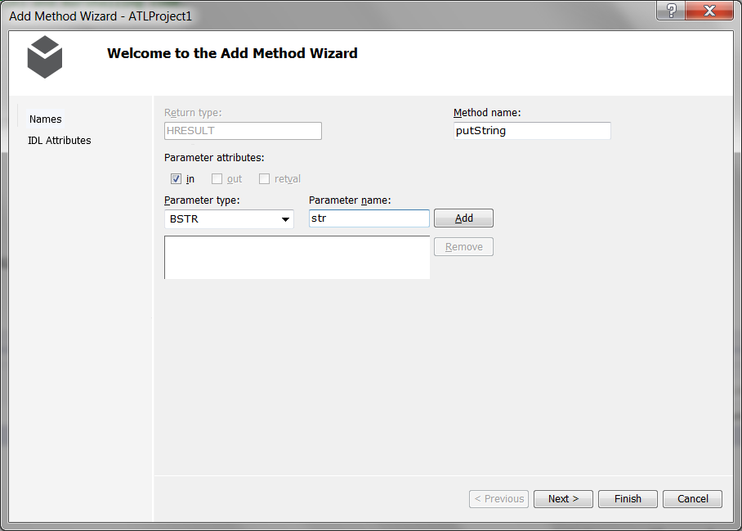

This component will have two simple methods, putString sends a string from client to server, and getString retrieve’s a string from the server. We will use the BSTR COM type to do that.

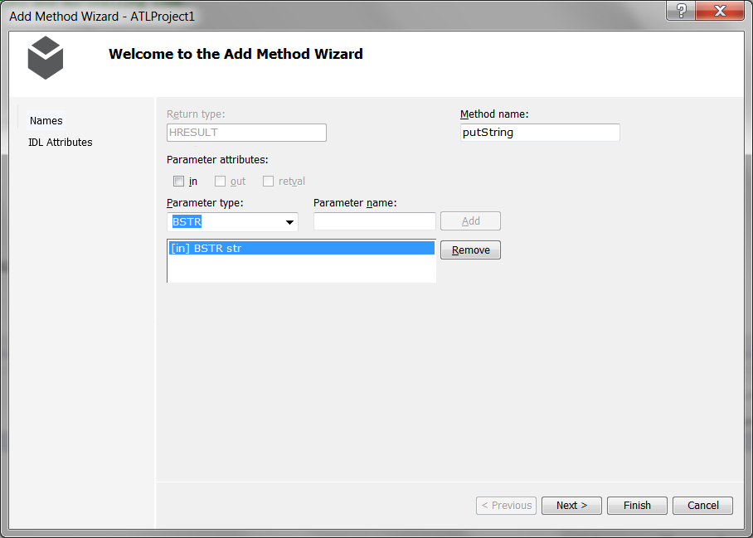

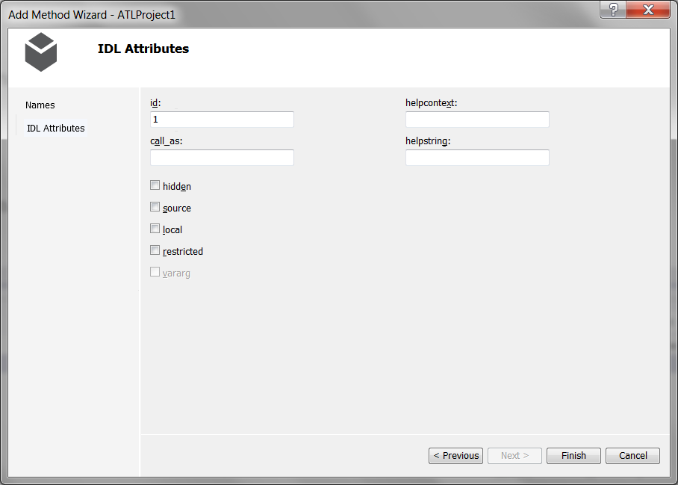
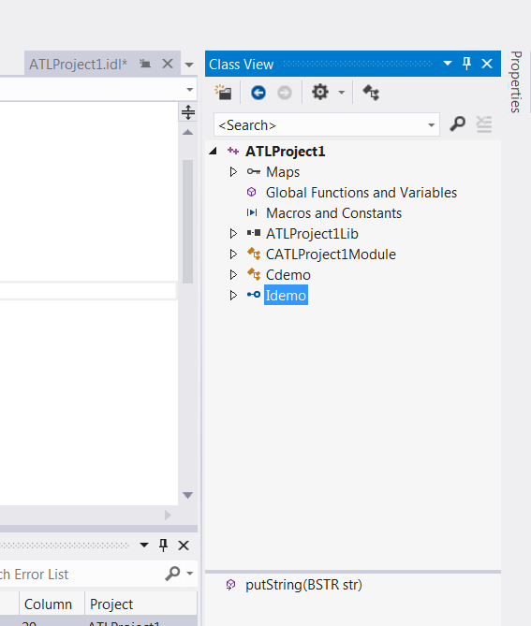
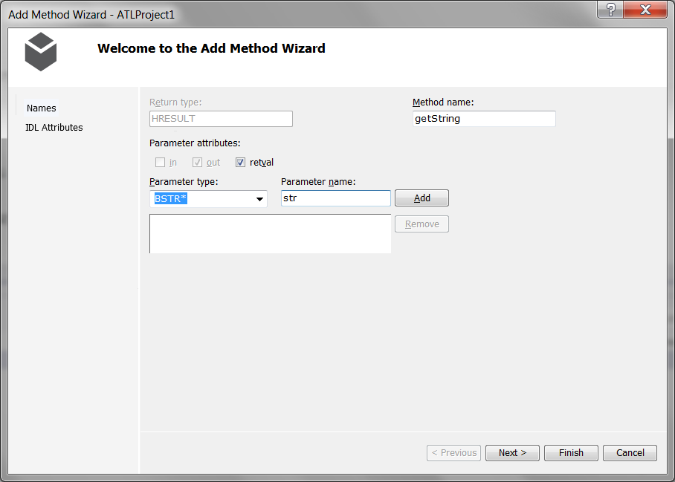
All COM components return values from the server via pointers. We will discuss this at length shortly.

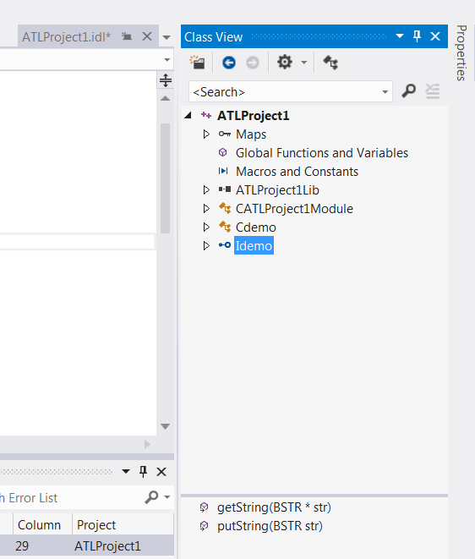

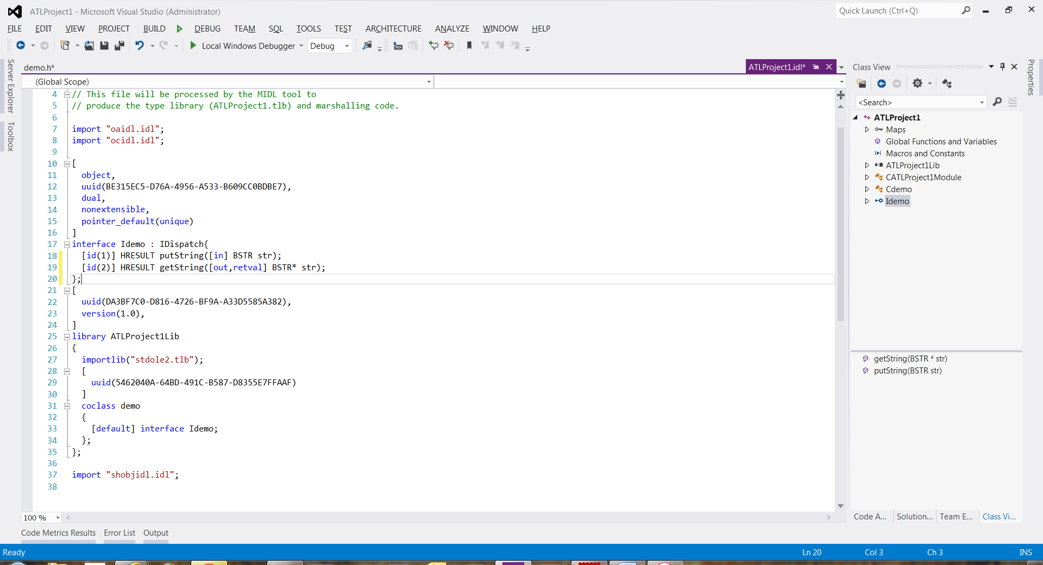

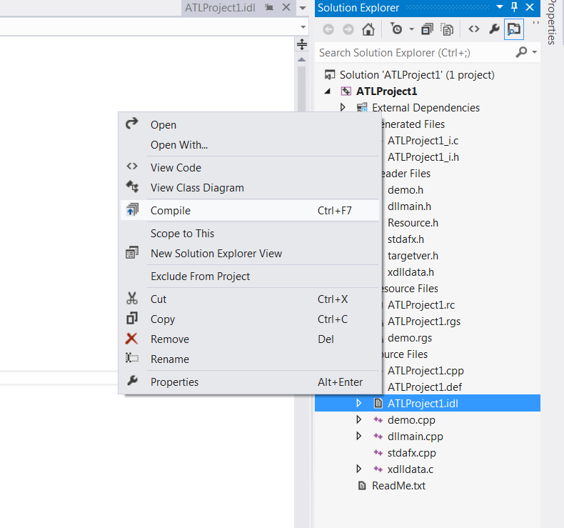
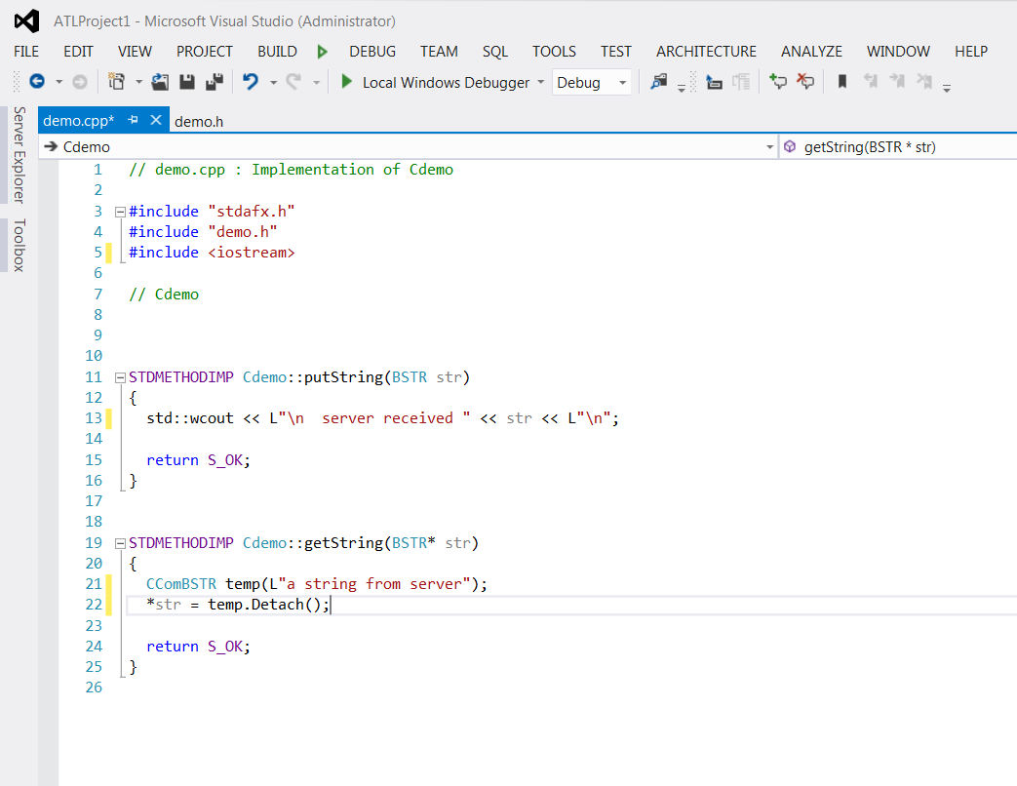

Here’s one way to implement the two object methods. The CComBSTR is an ATL wrapper class for BSTRs that makes using them significantly easier. Here we are using the CComBSTR to make it easy to supply the BSTR, for which CComBSTR provides a cast operator. The Detach() method transfers ownership of the CComBSTR memory to the stub for marshaling back to the client.
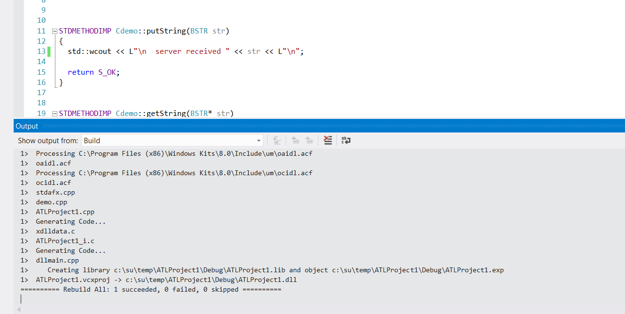

Now, we can build the COM component. That’s all folks!

