Reference for std::iostream Library

Jim Fawcett
CSE687 – Object Oriented Design
Spring 2010
istreams <iostream>
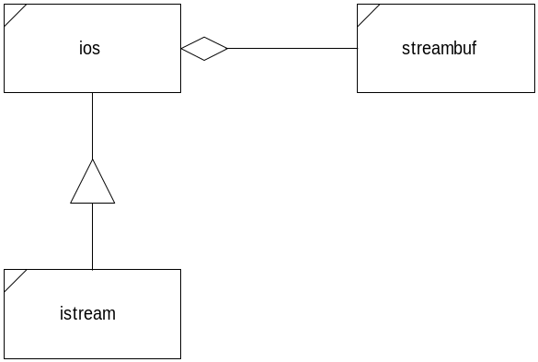

istream | ios | streambuf
Istream(streambuf*) | ios(streambuf*) | streambuf( )
~istream( ) | ~ios( ) | streambuf(char*, int)
istream& seekg(streampos); | streambuf* rdbuf( ) | ~streambuf( )
istream& seekg(streamoff, seek_dir) | long flags( ) | streambuf* setbuf(char*, int)
streampos tellg() | long flags(long) | int sgetc( )
istream& get(char*, int, char) | long setf(long, long) | void stossc( )
istream& read(char*, int) | long unsetf(long) | int sbumpc( )
istream& getline(char*, int, char) | int width(int) | int sputc(int)
istream& get(streambuf&, char) | char fill(char) | int out_waiting( )
istream& get(char&) | int precision(int) | streampos seekpos(streampos, int)
int get( ) | istream* tie(istream*) | streampos seekoff(streamoff, ios::seek_dir, int)
int peek( ) | int eof( )
int gcount( ) | int good( )
istream& putback(char) | void clear( )
istream& ignore(int, int) | int operator!( )
istream& operator>>(xxx) | static void sync_with_stdio( )

Formatting flags <iostream>
skipws | left | right | Internal | dec | oct
hex | showbase | showpoint | Uppercase | showpos | scientific
fixed | unitbuf | stdio
io_state <iostream>
 | goodbit | eofbit | Failbit | badbit
open_mode <iostream>
in | out | ate | App | trunc | nocreate
noreplace | binary
seek_dir <iostream>
 | beg | cur | End
Manipulators <iostream> or <iomanip>
dec | oct | hex | endl | ends | flush
ws | (re)setiosflags | setbase | Setfill | setprecision | setw
(no)boolalpha | (no)showbase | (no)showpoint | (no)showpos | (no)skipws | (no)uppercase
internal | left | right | fixed | scientific

ostreams <iostream>

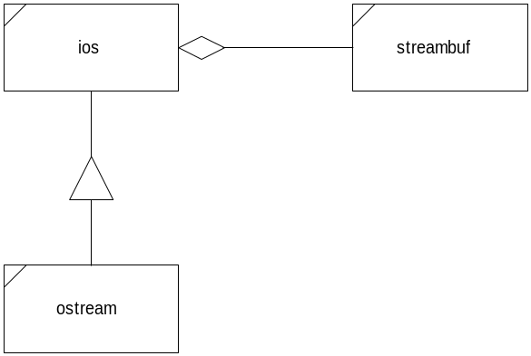

ostream | ios | streambuf
ostream(streambuf*) | ios(streambuf*) | streambuf( )
~ostream( ) | ~ios( ) | streambuf(char*, int)
ostream& seekp(streampos); | streambuf* rdbuf( ) | ~streambuf( )
ostream& seekp(streamoff, seek_dir) | long flags( ) | streambuf* setbuf(char*, int)
streampos tellp() | long flags(long) | int sgetc( )
ostream& put(char) | long setf(long, long) | void stossc( )
ostream& write(char*, int) | long unsetf(long) | int sbumpc( )
ostream& flush( ) | int width(int) | int sputc(int)
ostream& operator<<(xxx) | char fill(char) | int out_waiting( )
 | int precision(int) | streampos seekpos(streampos, int)
 | ostream* tie(ostream*) | streampos seekoff(streamoff, ios::seek_dir, int)
 | int eof( )
 | int good( )
 | void clear( )
 | int operator!( )
 | static void sync_with_stdio( )

ifstreams <fstream> and <iostream>

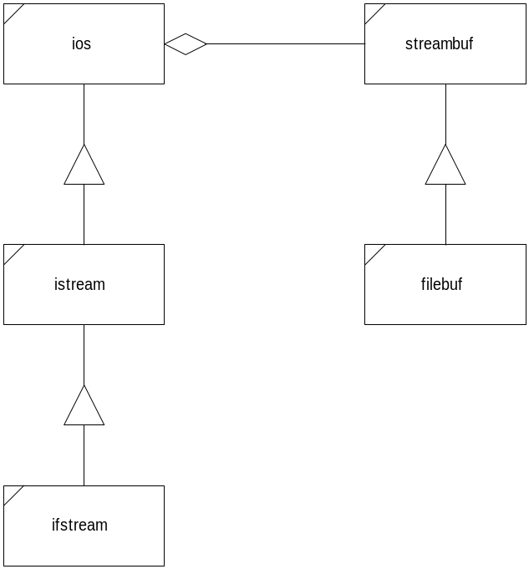

ifstream |  | filebuf
ifstream( ) |  | filebuf( )
ifstream(char*, int, int) |  | filebuf(int)
ifstream(int) |  | filebuf(int, char* int)
ifstream(int, char*, int) |  | ~filebuf( )
~ifstream( ) |  | int is_open( )
filebuf* rdbuf( ) |  | int fd( )
void open(char*, int, int) |  | filebuf* open(char*, int, int)
void attach(int) |  | filebuf* close( )
void close( ) |  | filebuf* attach(int)
int fd( ) |  | streambuf* setbuf(char*, int)
int is_open( ) |  | streampos seekoff(streamoff, ios::seek_dir, int)
ofstreams <fstream> and <iostream>

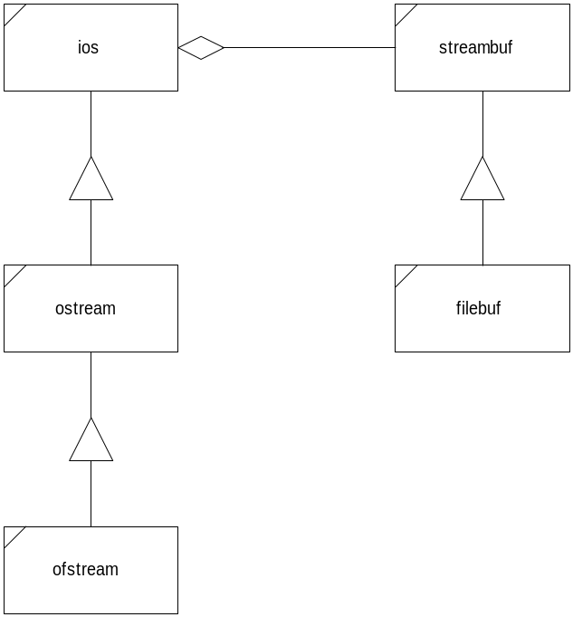

ofstream |  | filebuf
ofstream( ) |  | filebuf( )
ofstream(char*, int, int) |  | filebuf(int)
ofstream(int) |  | filebuf(int, char* int)
ofstream(int, char*, int) |  | ~filebuf( )
~ofstream( ) |  | int is_open( )
filebuf* rdbuf( ) |  | int fd( )
void open(const char*, int, int) |  | filebuf* open(char*, int, int)
void close( ) |  | filebuf* close( )
streambuf* setbuf(char*, int) |  | filebuf* attach(int)
int setmode(int) |  | streambuf* setbuf(char*, int)
void attach(int) |  | streampos seekoff(streamoff, ios::seek_dir, int)
int fd( )
int is_open( )
istringstreams <sstream>

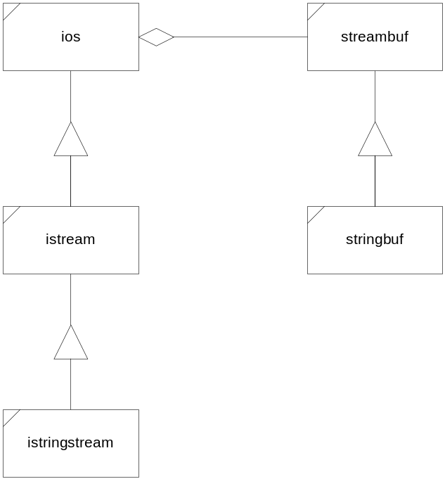

istringstream |  | stringbuf
istringstream(ios::openmode mode = ios::in) |  | stringbuf(ios::openmode mode=ios::in | ios::out)
istringstream(const string &s, ios::openmode mode = ios::in) |  | stringbuf(const string &s, ios::openmode mode =  ios::in | ios::out)
~istringstream( ) |  | ~stringbuf()
stringbuf *rdbuf() |  | string str()
string str() |  | void str(const string &s)
Void str(const string& s)
ostringstreams <sstream>

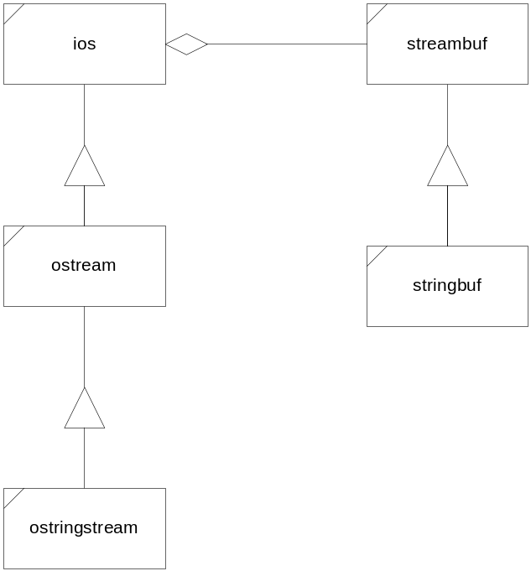

ostringstream |  | stringbuf
ostringstream(ios::openmode mode=ios::out) |  | stringbuf(ios::openmode mode=ios::in | ios::out)
ostringstream(const string &s, ios::openmode mode=ios::out) |  | stringbuf(const string &s, ios::openmode mode =  ios::in | ios::out)
~ostringstream( ) |  | ~stringbuf()
stringbuf* rdbuf() |  | void str(const string &s)
string str() |  | string str()
Void str(const string& s);

