IIS Demo – Setup and Use
- Open Control Panel > Programs and Features > Turn Windows features on or off
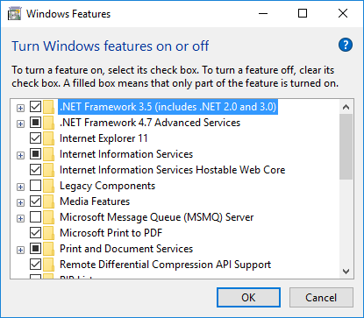

- Open Internet Information Services, expand, and make sure that IIS Management Console and Static Content are checked.
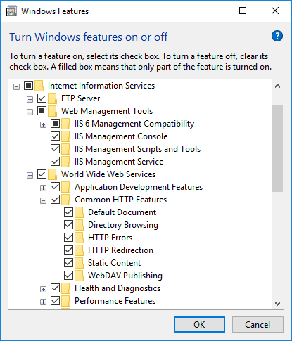
If any of these boxes were unchecked, then Windows will add new IIS features.

- Search for IIS. That brings up the management console:
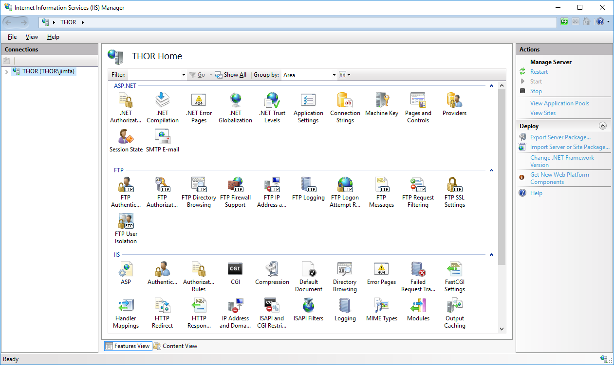

- Expand the local machine tree view in the left panel and right click on Sites:
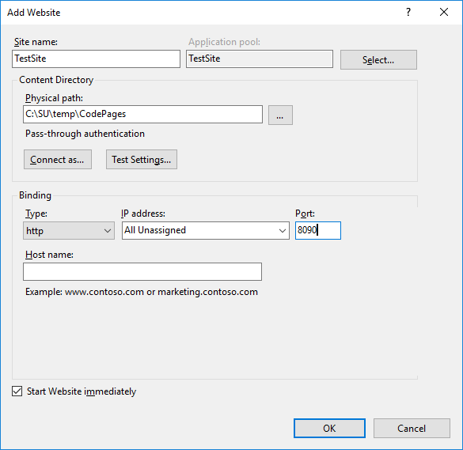

- Now you will see the TestSite in the Sites list.. Open File Explorer and add folder CodePages to C:\SU\Temp. Now, in IIS Manager, right click on TestSite and Add Application:
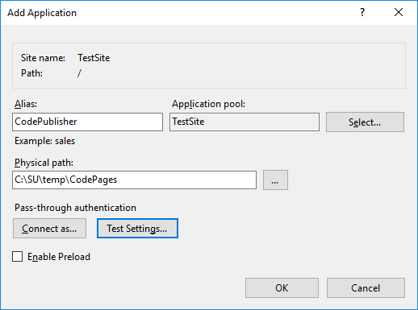

- Now Browse to http://localhost:8090/CodePublisher
