Demo Service Construction
- Run Visual Studio 2010 as Administrator
- Select File > New > Project > Visual C# > Console Application
- Provide Name and Location
- Hit OK
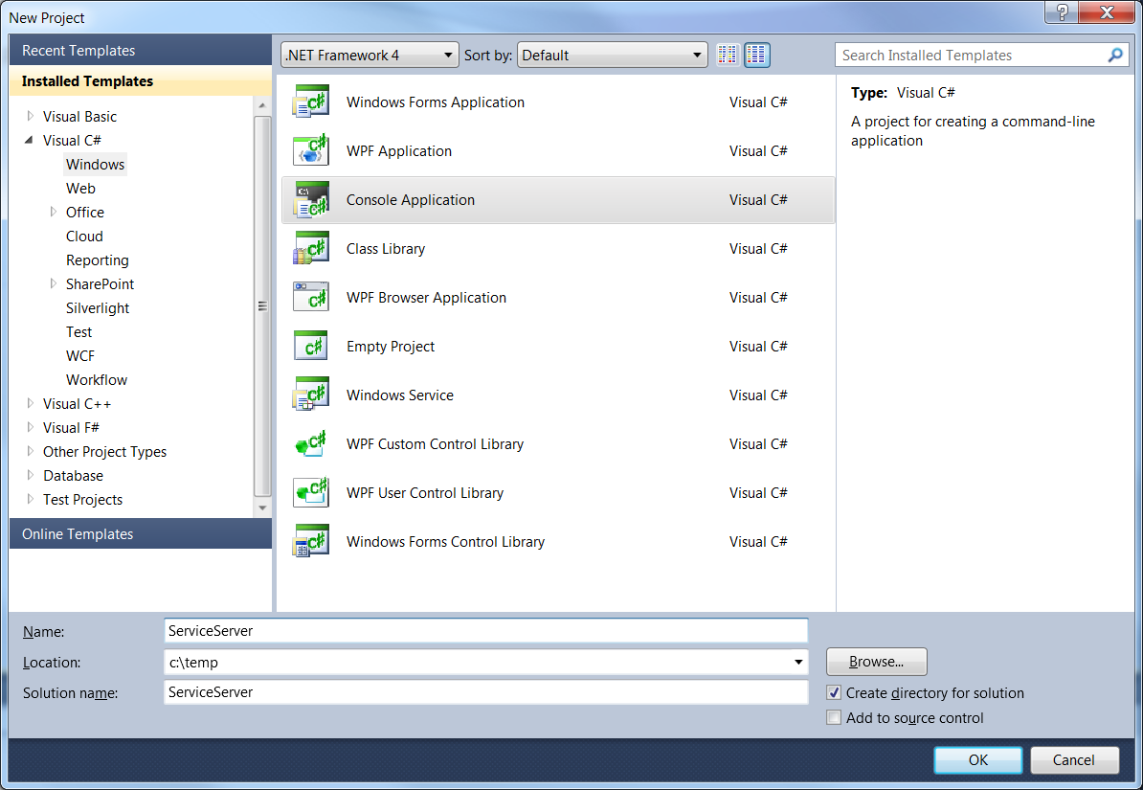
- Rename the file from Program.cs to Server.cs
- Right-click on ServiceServer project and select add > class.
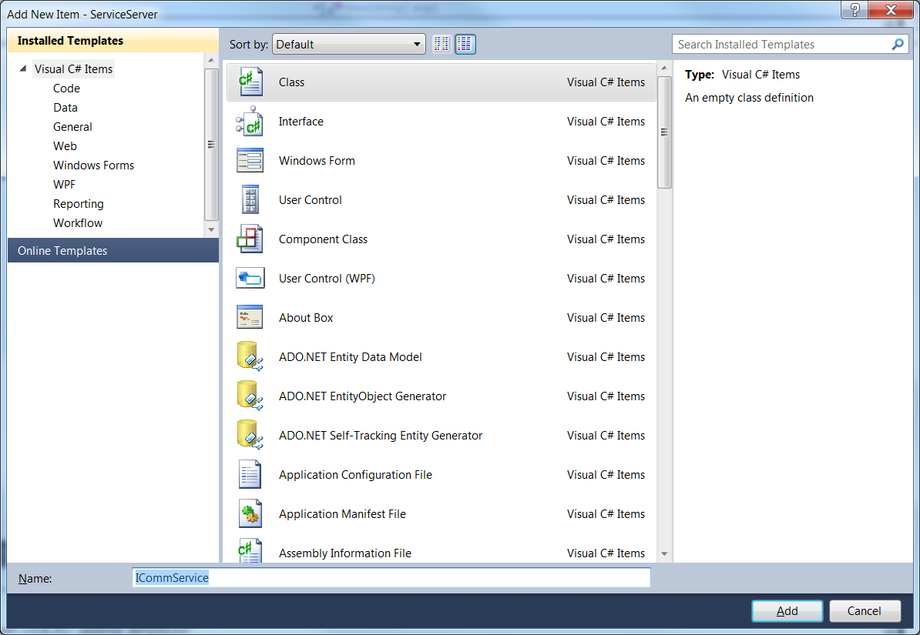
- Using HandCrafted Programmatic Basic Service (HCPBS) as a guide, write the interface code for your service with methods:
void PostMessage(string) and string GetMessage()
- You will need to add a reference to .Net System.ServiceModel and add usings for System.ServiceModel and System.Runtime.Serialization
- Go back to the Server.cs file
- Based on the code in HCPBS, add a CreateChannel function that returns a reference to an instance of ServiceHost.
- Add code for the service methods. See the attached code for an example.
- In the main function create an instance of the ServiceHost using the function you wrote in 10.
- Now block on a Console.ReadKey() to keep the server process alive so the client can use it.
- Now create a WPF client application.
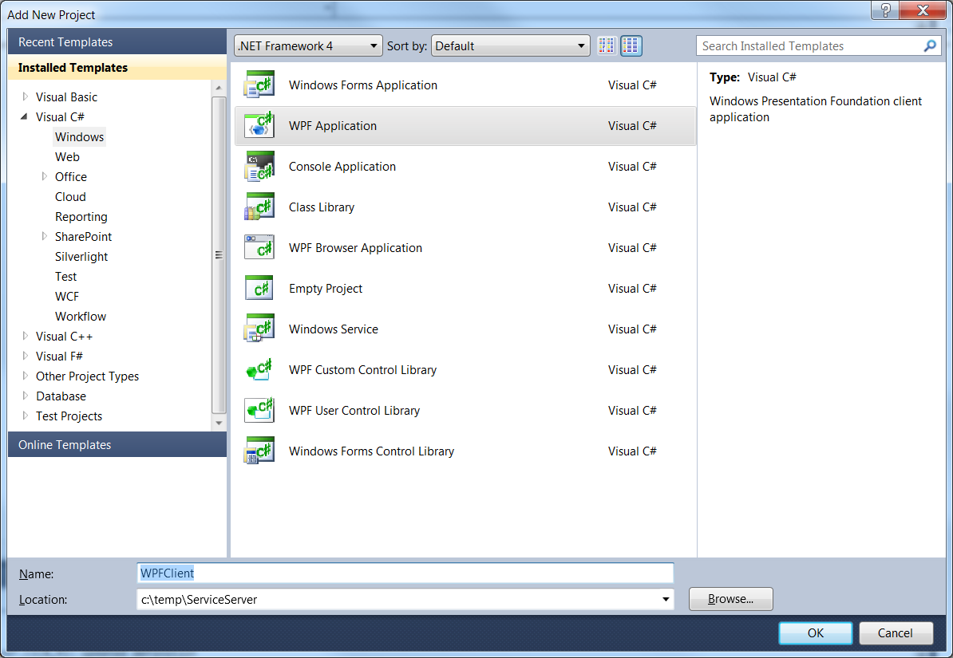
- Add a reference to System.ServiceModel and the same using statements you added to the Server console application.
- Add the ICommService interface you generated for the Server to this Client project.
- Add a ListBox to the window.
- Add a Button labeled connect and a Button labeled call.
- Double click the connect button and add service connection code (see attached code).
- Double click the call button and add service call code (again, see attached code).
- Notice what we didn’t do. We did not use the WCF wizard, we didn’t make any service references. We don’t have any app.config or web.config files.
- Right-click on the solution and select Set Startup Projects
- Click the radio button for multiple startup projects and set the Server and WPFClient to run.
- Now you should be able to connect and send messages.

