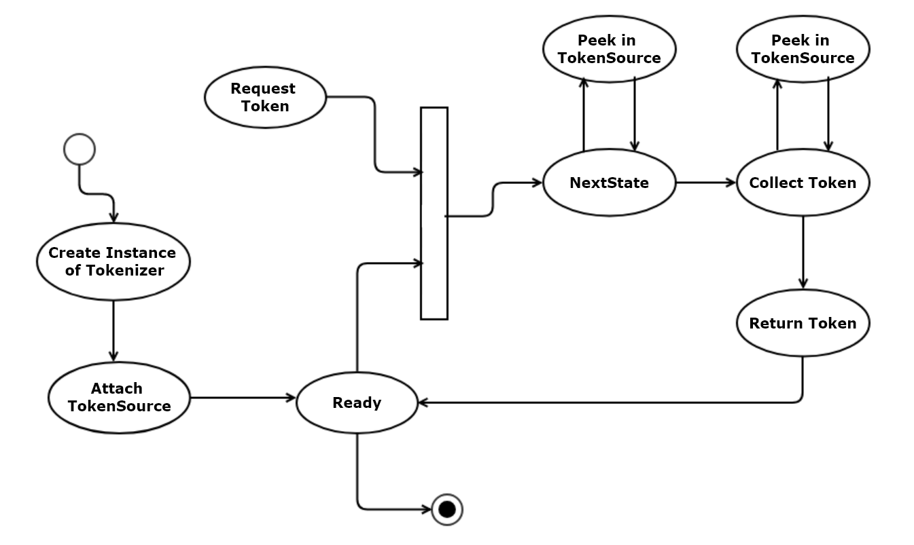
State-Based Tokenizer Activities

