Jim Fawcett
CSE681 – Software Modeling and Analysis
Summer 2003

This set of notes show you how to build a Graphical User Interface based program that delegates all its computational activities to a set of server modules. The demonstration uses a WinForm executive module and a Console server module. Both modules have a Main function defined. The server’s Main is intended to test the server’s functionality, and is compiled whenever you build the server. However, the server contains compilation constants that prevent its Main from being compiled when it is part of a larger program, as in the GUI project.

While, for this simple demonstration, it may seem that this is a lot of unnecessary work, when you build large complex programs, this modular construction style becomes essential. Almost every useful program that you may develop professionally or build to support your research activities should be structured this way.

CSE681 – Software Modeling and Analysis
Fall 2003

I’ve added a console application to demonstrate that the process is the same for both. Screen shots and source code are attached in the next few pages.

In order to build ConsoleUI, MainUI, or the test stub ComputationalEngine you simply select the desired project, right click to bring up a context menu, and select Set as StartUp Project. Then run.

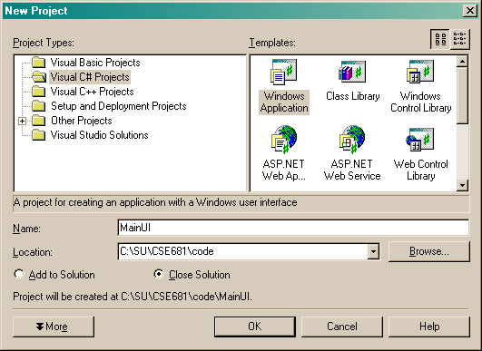
Create a C# WinForm Application. This will be the main GUI.
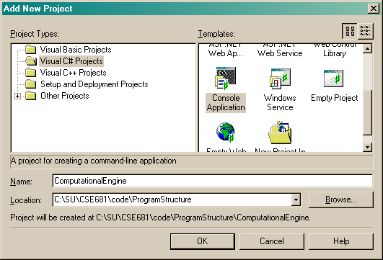
Add another Console application for each server module.

Work on each server module until it’s test stub, e.g., Main, shows that it is working correctly.

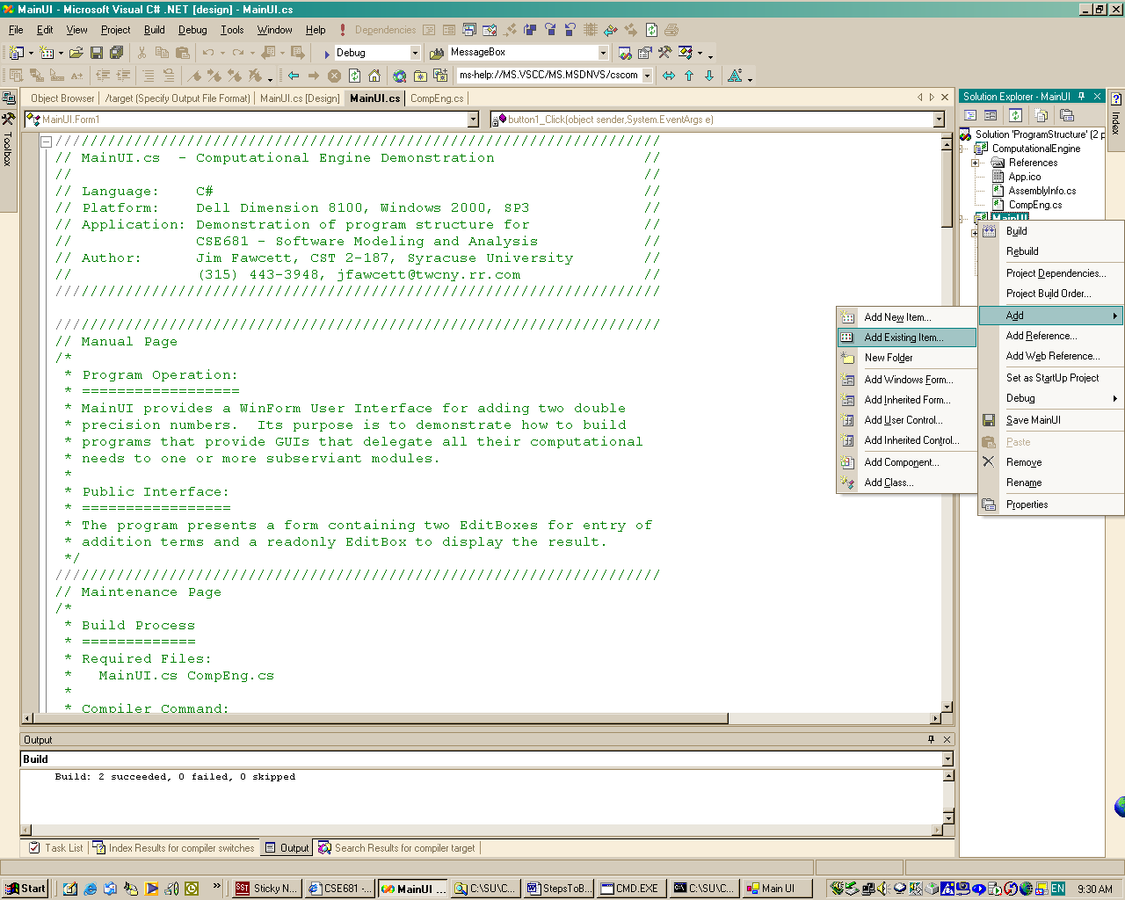
Here is how you add the server’s source code to the GUI project.
Now, add the server module’s source code to the GUI project.
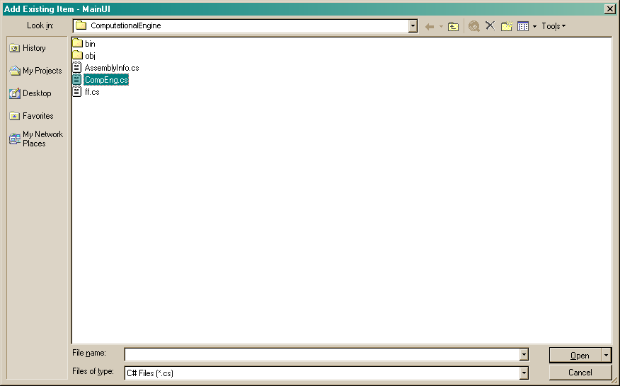
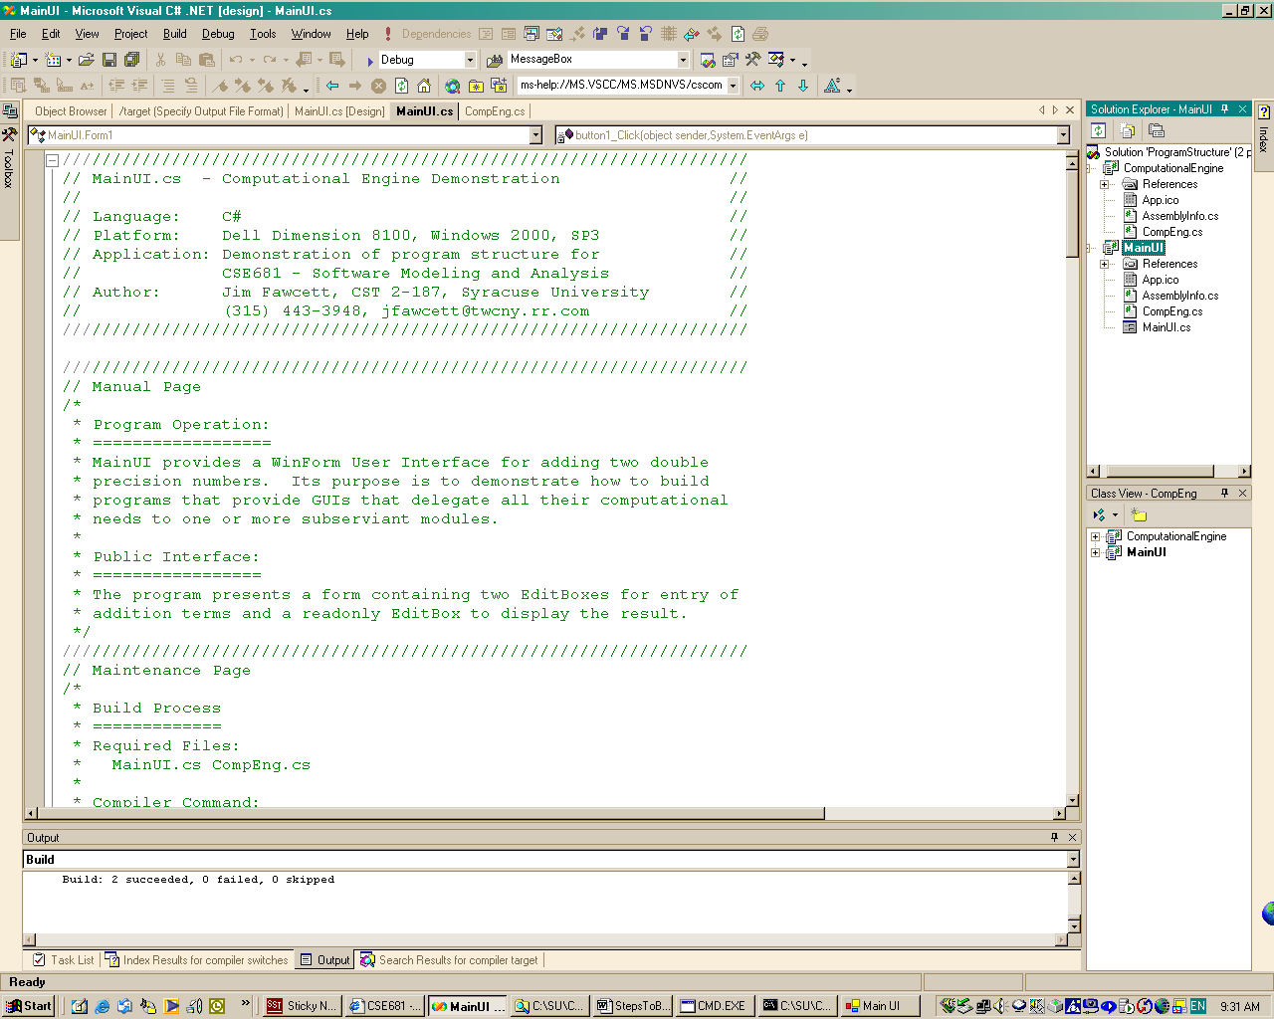
Now, you can work on the GUI executive until your program works correctly.
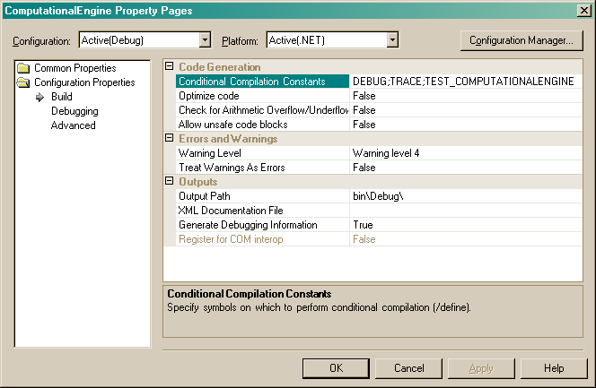
Once you add a server module to the GUI project you need to add compilation constants that surround its Main, like this:
#if(TEST_COMPUTATIONALENGINE)
static void Main(string[] args) { … }
#endif

If you define this Compilation Constant in the server’s project properties, but not in the GUI properties, then the server project will rebuild its test stub main, perhaps to fix a latent error, but the GUI project will not attempt to compile it while compiling the GUI.
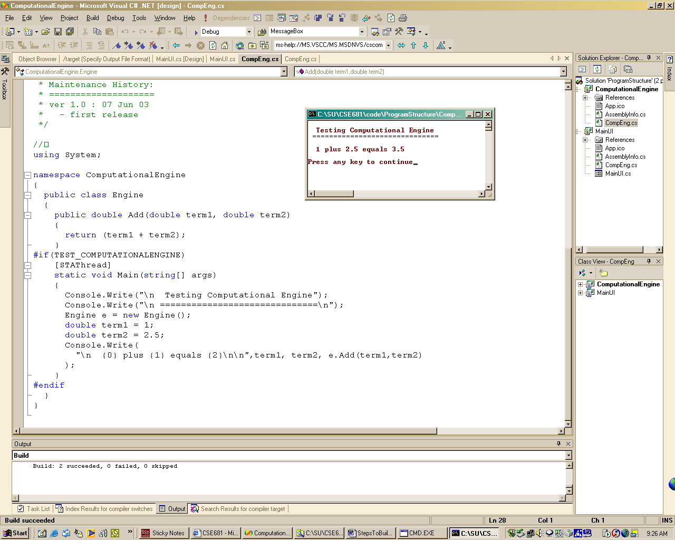
Server module running in stand-along mode.
Here’s the server module running stand-alone.
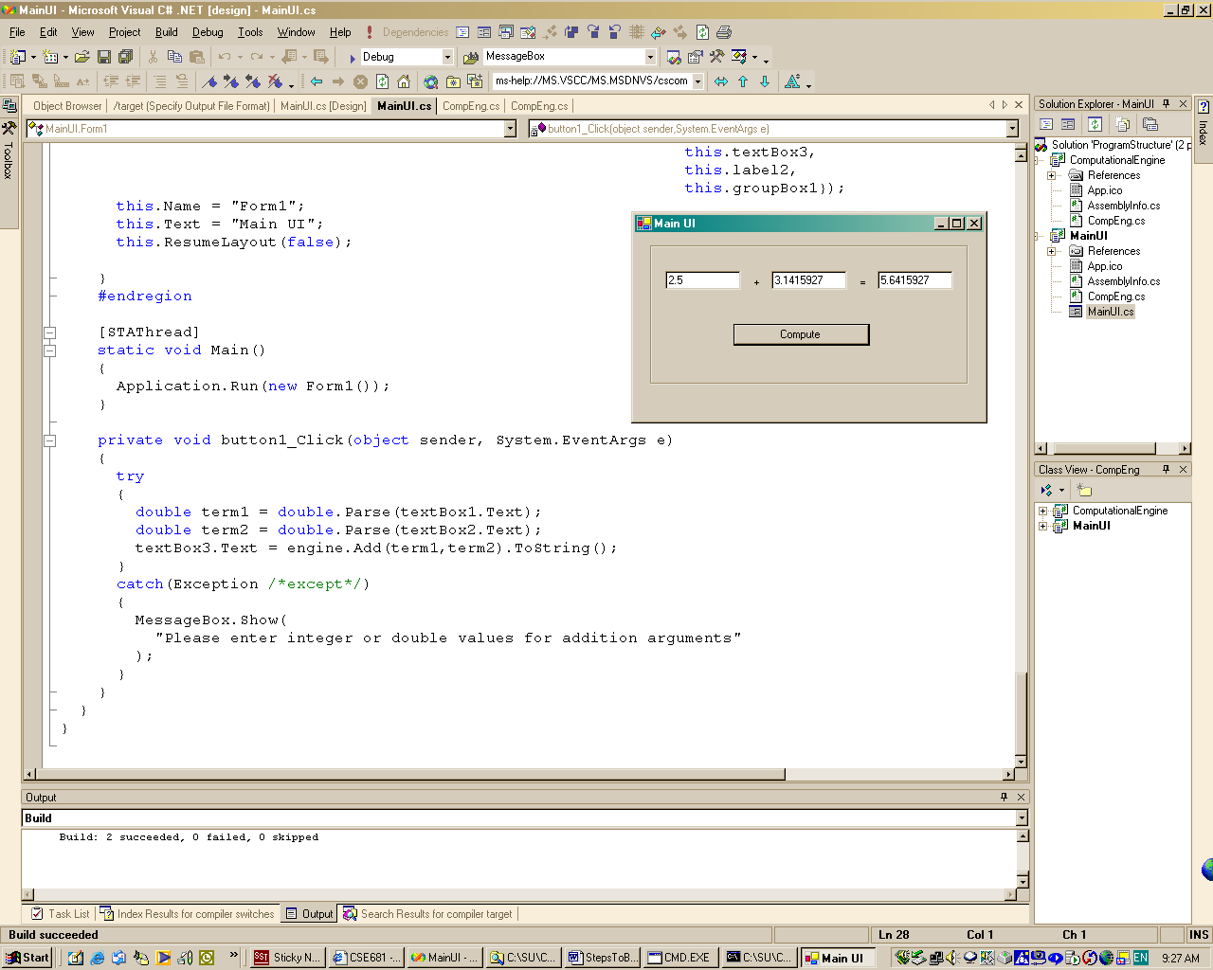
GUI running and using server module’s services.
Here’s the GUI running and using the services of the server.
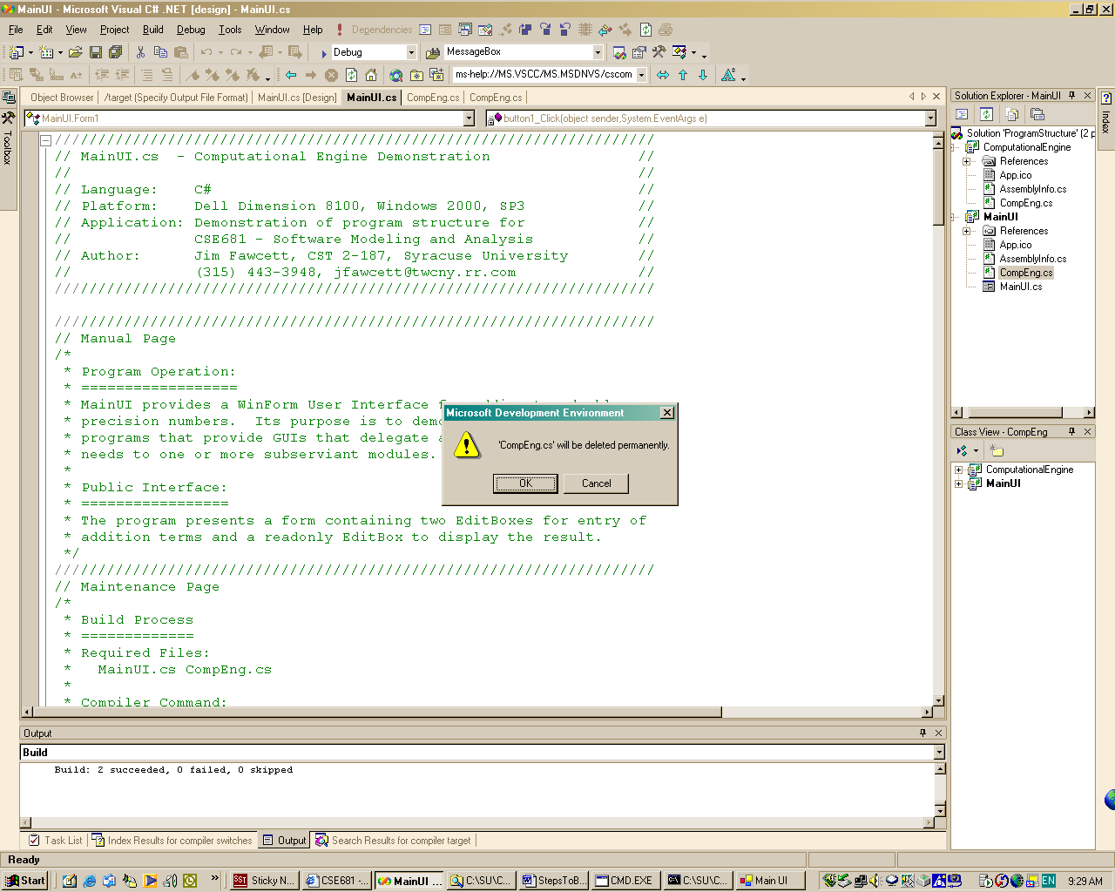
If you update the server you will need to delete, and re-add the server to the GUI project.

You must do this as the GUI project holds a copy, not the original server source file.

