CSE 681 Software Modeling and Analysis
Project 1

C# Class Relations Analyzer
Operational Concept Document

S. Kanat Bolazar

Table of Contents

1. Goal 2
2. Definitions 2
2.1. Classes 2
2.2. Detected Relationships 3
3. Critical Design Issues and Decisions 4
3.1. Memory Usage and Disk Access 4
3.2. Namespace Resolution 5
3.3. Output Size Issues 5
3.4. Interactivity and Statistics 7
3.5. Directory and File Change During Processing 9
3.6. C# Full Parse vs. Partial Parse 10
3.7. Buy vs. Build 10
3.8. Libraries and Reuse 10
3.9. Inverse Relations Output (to File and Console) 10
3.10. Crash Recovery 11
3.11. Prototype for GUI 11
4. Uses and Use Cases 12
4.1. Uses 12
4.2. Use Cases 13
5. Activities 14
5.1. Top-Level Activies 14
5.2. Get User Input 16
5.3. Get Files List 16
5.4. First Pass: Get Classes 16
5.5. Second Pass: Find Relationships 17
5.6. Post-Process the Relationship Tables Created 17
5.7. Save the Output to a File 17
5.8. Display Namespaces and Classes 18
5.9. Display Relationships of Selected Class 18
5.10. Jump to Related Class 18
6. Modules and Classes 19
6.1. CRA Module (CRA: Class Relationships Analyzer) 20
6.2. ClassRelInfo Module 20
6.3. GUI Module 20
6.4. OutputLogger Module 21
6.5. FileFinder Module 21
6.6. Grammar Module 21
6.7. Semiexpression Module 21
6.8. Tokenizer Module 22
7. Events 22
8. Views 23
9. Summary 26
Appendix. Suggested XML Structure for Output File 26

1. Goal

The C# Class Relationships Analyzer (CRA) shall analyze the relationships between the classes of a set of C# files. The C# files to be analyzed may be spread across multiple directories. For each directory, the program shall automatically traverse its descendent subdirectories recursively, retrieve all files matching a pattern, and analyze them to discover all the classes defined in these files as well as the relationships between these classes.

The CRA shall specifically look for four types of relationships between these C# classes:
- Inheritance
- Composition
- Aggregation
- Using

The relationships detected shall be saved in an xml file, and shall also be displayed on the user console.

2. Definitions

CRA, the C# Class Relationships Analyzer detects "relationships" between "classes". These two terms are defined in full detail in the subsections below.

2.1. Classes

CRA shall detect these classes and class-like constructs:
- Abstract classes
- Non-abstract classes
- Interfaces
- Structs

The following classes and class-like constructs shall be ignored by the CRA:
- Nested Classes
- Delegates

2.1.1. Abstract Classes, Non-Abstract Classes, Interfaces and Structs

In C#, we have abstract classes, non-abstract classes, interfaces, structs, delegates (and possibly other similar constructs that are not yet known by this developer).

Abstract classes differ from non-abstract classes by being allowed (but not required) to contain abstract methods (equivalent to pure virtual methods in C++) that don't have implementations. At one extreme, abstract classes could be made equivalent to non-abstract classes, by having implementations for all the methods in the class. At the other extreme, abstract classes could be made equivalent to interfaces, by having no implementations for the methods in the class. Due to these cases of "vanishing borders" between these constructs, CRA shall treat non-abstract classes, abstract classes and interfaces in exactly the same way, together with structs.

All the following discussion in this document about "classes" apply to non-abstract classes, abstract classes, interfaces and structs.

2.1.2. Nested Classes and Delegates:

A nested class' dependencies on and relationship with its enclosing class is somehow complicated. Nested class itself is a complicated concept. Due to these reasons, nested classes are not used very often for public class declarations. Nested classes shall be ignored by CRA.

Delegates are significantly different and specialized in syntax, and shall be ignored by the CRA. Note that struct declarations without explicit constructor-call initializations nevertheless create struct instances, and this special case should be handled carefully, and separately from the class declarations without initializations (that just create a null reference).

2.2. Detected Relationships

Inheritance: A subclass inherits from its superclass
Composition: A composer class declares and constructs a composed class, in its member variable initializers or its constructors.
Aggregation: An aggregator class declares and constructs an aggregated class, at some point after its (aggregator's) initialization and construction, in a member function.
Using: A user class gets passed a used (usee) class that is constructed outside the user class. The user class may hold reference to the used class beyond the method call that passes the reference.

For CRA, classes, structs and interfaces are considered the same; any "class" mentioned in these definitions could as well be a struct or an interface.

The roles in these relationships shall be called:
- Inheritance: Superclass – Subclass
- Composition: Composer – ComposedPart
- Aggregation: Aggregator – AggregatedPart
- Using: User - UsedClass

The latter role names are defined as seen above to allow for plural usage such as ComposedParts, AggregatedParts, UsedClasses (rather than "Composeds", "Aggregateds", "Useds" or "Usees").

3. Critical Design Issues and Decisions

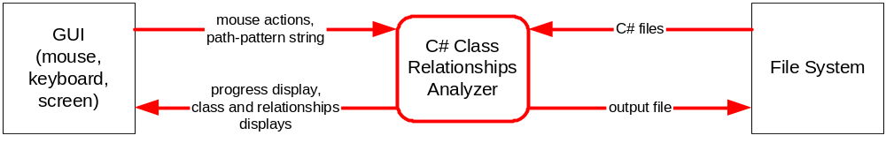
CRA is a very simple system that interacts with the user through a graphical user interface (GUI), by allowing the user to enter the input through keyboard (in a text entry box) and mouse (by clicking buttons, selecting tabbed pane to display, interacting with the dialogs), and see the results on the screen.

The CRA (Class Relationships Analyzer) program interacts with the file system to read the directories and the C# files to analyze, and writes the relationships detected in an output XML file.

3.1. Memory Usage and Disk Access

A project may contain thousands of files spread over many directories, with each one defining a few public classes, interfaces and structs. CRA needs to balance the memory requirement with time requirement. There are two main alternatives:
- Use two passes through the files. First pass gets all the class names (fully qualified) and the second pass finds the relationships between these and only these classes (dependencies on external classes are ignored).
- Use a single pass through the files, detecting both the class declarations and all the relationships between classes.

The advantages of each (compared to the other) approach are as follows:
- Two passes:
  - Does less computation and data structure manipulation per file: Only detects relationships between classes in the files analyzed; we can ignore relationships with other classes (thanks to the exhaustive class list we have after the first pass).
  - Needs less memory.
  - Uses simpler mechanism; does not have to parse partially while reading the files, and more later, when the class list is known.
- Single pass:
  - Does about half as much disk read access (ignoring the possible extra disk accesses for more swap-space usage due to using more memory). As disk space is considerably slow compared to memory access, the savings is significant, especially for large projects.
  - Could display all relationships of these classes to all classes (including those outside this list of classes), because all that information would have to be collected already as we don't know ahead of time the list of classes defined in these files.

Because of significant efficiency improvement due to reading files only once (the total number and size of the files may be quite large), single pass with more complicated algorithms and data structures were going to be preferred in this project.

But another issue preempts this analysis and leaves having two passes as the only truely feasible option (lest the program get significantly more complicated). This issue, namespace resolution, is discussed in the next section.

Decision: Deferred; see end of section 3.2.

3.2. Namespace Resolution

For each reference to a class name in code (such as member variable declaration and initialization, function parameter list declaration, function implementation), CRA needs to resolve which namespace this reference of a class is referring to.

CRA can not run all its processing in a single pass because namespace resolution is practically impossible without a list of all the existing classes, with their fully qualified names. To attempt doing this in one pass, CRA would have had to:
- Store every reference to a class name together with all the namespaces this section of the file is "using" (which is the list of all possible namespaces this class might exist in).
- Resolve the fully qualified names for each class usage after all the files are read and processed and all the classes are known together with their fully qualified names (and hence, the namespaces they are defined in).
- Extract the relationships according to these discovered fully qualified names of the classes.

This means most of the processing will have to be deferred: While reading and analyzing the files, most information will be stored in a large and complicated "partially analyzed" format by the system, to be further analyzed later, after all the files are read.

Decision: CRA shall process the file contents using two passes, as defined above in section 3.1.

3.3. Output Size Issues

A project could contain 2000 files (or more). What follows is an average bad case per file to understand worst case for a project that is analyzed. Due to averaging effect, we need not add up the worst case per file 2000 times; that is extremely unlikely to happen.

- There could be 2000 files to analyze
- Each file could define an average of 2 - 3 "classes" (classes, structs and interfaces).
- Each class (total: 14 – 26 relationships):
  - could also have one superclass
  - could implement zero or one (or more) interfaces.
  - could be composed or aggregated of 3 - 4 classes total.
  - could be using 10 - 20 other classes.

The number of files is somehow conservatively estimated as 2000 in the worst case. There could be more but probably 90% - 95% of the projects analyzed with this tool will fall below 1000 - 1500 files range, and 2000 is sufficient for this project.

Take 25 relationships with other classes as the average number per class in the worst case (of a project). For 2000 files, each defining three classes, with 25 relationships each, we have 2000x3x25 = 150,000 relationships for 6000 classes.

3.3.1 Display Issues

In the analysis above, a worst case analysis (assuming 2000 files in the worst case) revealed possibility of having 150,000 relationships between classes. If we printed these 150,000 relationships in 150,000 lines, and the 6,000 classes in 6,000 lines , that would take 2365 pages (at 66 lines per page) to print.

This is practically unprintable. User would have to use the soft-copy on the computer, and skim through that to find the information he/she seeks.

To avoid burdening the user with the task of skimming through hundreds or thousands of pages of output to find what he/she is looking for, the output shall be displayed through an interactive graphical user interface.

This is the only feasible option that allows proper input scalability in this project.

Decision: CRA shall use a Graphical User Interface (WinForms in C#) to display its outputs (the relationships between the classes).

3.3.2. Output File Size Issues

The output file format is XML, and the only problem XML has is that it does not use disk space efficiently. As it will be all text, it could be compressed to about 30% of its original size, but that does not conform to the original requirement of having simple XML output, and it also makes random-access to the file harder and slow.

In the analysis above, if we estimate 50 characters to store the fully qualified class names and the class and relationship type XML tags, per relationship and per class, we would have a file that is about 50*156000 = 7,800,000 bytes.

This is a large output file, but it is acceptable considering today's hard disks and memory sized, and the fact that this large project analyzed probably warrants this much disk usage. For the purposes of CRA, to keep the output file format simple, XPaths shall not be used to make the file size smaller.

The GUI will be used more by the users, to browse the output. The output file will not be used as much (see the use cases), unless CRA output is fed into another program.

We have two options about this output file:
- a single file, overwritten each time.
- a new file each time.

As the file is not used by users as much, and to avoid filling up the directory with many files and wasting the disk space with possibly giant files (for example, a large project may be analyzed repeatedly, after minor changes in some of its files), CRA shall use a single file and overwrite it each time. But this should not happen silently, so that important file data won't be lost by accidentally clicking on a "Process Files" button.

Decision: CRA shall use a single XML output file that is overwritten each time, with user warning dialog before overwriting, to allow the user to cancel the process or move the file to a safe place where it won't be overwritten by the CRA.

3.4. Interactivity and Statistics

Interactivity is a desired feature of any GUI program, including those that do significant amount of computation before displaying their results. The statistics of processing could be used both to display the progress and to later summarize the amount of total processing done and amount of output produced.

3.4.1. Progress Display

CRA might process large amounts of data, and may take a significant amount of time (hours, possibly days). The user needs to know at what stage the processing is, so as to be able to:
- easily see when program gets unresponsive for some reason (infinite loop somewhere, for some unthought-of case of input, or a deadlock due to poor inter-thread synchronization),
- make decisions about stopping or killing the processing.

In the second case, user may decide processing is too slow to complete in acceptable amount of time, and decide to kill it, or just stop and see the results discovered so far. This could also be prompted by hardware replacement or downtime issues: If the CRA is almost done, it would be best to delay the scheduled "downtime" to let CRA complete its task.

Progress display necessitates that CRA has some way to quantize to know and display the level of progress. For the second pass that detects relationships between classes, we can use the number of classes discovered in the first pass, and show how many and what percentage of classes are analyzed to detect relationships so far.

For the purposes of CRA, progress displays shall not be required to measure the time taken and estimate the time left to complete processing in the current stage (first or second pass).

The first pass may also take significant amount of time, and we can use the number of files analyzed so far (to detect the namespaces and the classes in them) as the measure of degree of progress.

This necessitates finding the number of files before the first pass, and finding the number of files matching a file match pattern requires we discover every matching file.

Decisions:
- CRA shall go through all the directories and create a list of all files matching the file match patterns, before starting the first pass (of processing these files).
- CRA shall use the number of files analyzed as the level of progress in the first pass through the files (to detect the classes).
- CRA shall use the number of classes analyzed as the level of progress in the second pass through the files (to detect the relationships).
- CRA shall allow the user to stop the current phase (files detection, first pass, or second pass), and continue with the next phase, using a "STOP" button.

3.4.2. Statistics

As mentioned above, statistics that are displayed during the processing could also later be referred to as summary of processing done. So, the progress page should be persistent, and visible later to get an overview of the amount of processing done, the amount of inputs, and the amount of outputs.

This means that it is best not to show the progress in a dialog box that is later closed (by the nature of the dialog box or by user, accidentally).

Decision: The progress and the statistics shall be displayed in a Tabbedpane that allows the user to later view the statistics as needed.

3.4.3. Non-Blocking Information Dialogs

The user could be sitting in front of the terminal monitoring the processing for long periods of time. But the user may also be away from the terminal for long periods of time, especially for large processing tasks.

GUI has to keep updating the progress and the statistics, so that the user may monitor the progress at any time.

But the GUI should not stop and wait for user input (at least, not without a timeout) for every little warning or information to be displayed.

User decision making shall be allowed at any time during the processing, as mentione above, at the end of section 3.4.1, through the "STOP" button.

But user decision making shall not be required before the end of processing. This means that blocking warning dialogs shall not be used.

CRA shall create non-blocking information dialogs (running on their own threads) to display the problems encountered. CRA shall not wait for these dialogs to be closed or interacted with; it shall continue its processing on its own separate thread.

Note: If this is not possible within the WinForms user interaction processing paradigm, an alternative method would be to create a warning and information message output log and display it in a scrollable text box on the GUI.

Decision: CRA shall use non-blocking information dialogs for non-critical problems encountered.

3.5. Directory and File Change During Processing

CRA may be used to analyze a multi-user project, and freezing the files or making a separate sandbox copy may not be desireable or feasible (due to disk space or time constraints, especially for large projects).

Existing files and directories may be removed and/or renamed, and new files and directories may be added while CRA is processing them.

What is more, the file names may remain the same, but their contents might change.

CRA can't be tasked by caching all the files' contents as this might take significant disk space and would often not fit in the memory.

Locking the files by disabling write access may not be appreciated by developers, especially if CRA or the computer it is running on crashes or if CRA is killed before unlocking all the (possibly thousands of) files.

According to the decisions of section 3.4.1, CRA shall read all the file names before starting processing. This means that CRA shall ignore the files and directories added during CRA's processing.

For missing files, it is best to create a non-blocking dialog box for the first such file, and only report the count at the end of the current phase if there are more files missing.

One method for discovering possible change in file content is:
- Save the timestamp of the file when it is added to the files list
- Check this against the timestamp during processing the file (both in the first pass and the second pass)

But what shall CRA do if we discover a change in the second pass, in one file? In this case, the class list CRA had extracted in the first pass might not be correct, and all the relationships of newly added or newly removed classes would be incorrectly ignored or incorrectly detected. Shall CRA restart the first pass? This could easily cause CRA to run in loops forever for a project where the files keep changing, albeit slightly, every now and then, without letting CRA finish its processing.

Due to these complications, CRA shall not attempt to detect any change in content of the files.

Decisions:
- CRA shall ignore the newly added files.
- CRA shall display a non-blocking information dialog for the first missing (removed or renamed during CRA processing) file.
- CRA shall display the number of files missing in a non-blocking information dialog at the end of the current stage (first or second pass) if there are more files missing after the first.
- CRA shall ignore any changes in the files' contents

3.6. C# Full Parse vs. Partial Parse

Two alternatives in parsing the C# files are:
- Parse fully, using the BNF grammar, to be certain of the context and meaning of each C# construct.
- Parse only in part, only as much as is needed by the task at hand, using keyword search, regular expression and other string format matching methods.

This task is significantly simple and the detections needed depend in a large part on keywords such as "namespace", "class", "struct", "interface", "new". The remaining matching can easily be implemented on top of the semi-expression detector code supplied.

Decisions:
- CRA shall do partial C# parsing, only as much as needed to detect namespaces, classes and the relationships of inheritance, composition, aggregation and using.
- CRA shall not create a parse tree.

3.7. Buy vs. Build

The contract bans the developer to "buy" the solution or part thereof from the market.

Decision: No part of CRA shall be bought from a third party; it shall be built directly by the developer.

3.8. Libraries and Reuse

The contract and course notes make this decision:

Decision: CRA may reuse the contractor's (Dr. Fawcett's) code as well as the standard C# and .Net libraries, including WinForms for the GUI. CRA shall not reuse other code or other libraries.

3.9. Inverse Relations Output (to File and Console)

Any user that is interested in viewing a relationship in one direction (such as "superclass", for inheritance) is also interested in being able to view the same relationship in the opposite direction (such as "subclass", for inheritance).

A relationship, due to the two roles of the classes involved, can be seen as containing forward and inverse relations between these two classes.

What is more, the output XML file may be read by tools that could simply isolate and use information for a single class, and these tools may not be capable of finding the inverse relations by parsing all the other relationships in all the other classes listed in the output file. For example, if the output file only contained "superclass" relationships, the tool would have to look at all the classes to find out if one specific class, "Class1" has any subclasses. The parsing would be much more complicated and slow to handle such relationships in a file that does not directly store them.

Storing both directions of each relationship grows the output file by a factor of two, but makes parsing it easier. The file size analysis in 3.3.2 produced 7,800,000 bytes estimated worst case output file size, and this would now be doubled. Still, it is acceptable for a worst case file size, considering today's hard disk sizes, and the access to needed data is made significantly easier. In this worst case, a SAX-based XML parser could do binary search through classes and discover all its roles in all its relationships in one place rather than having to detect all the instances of the class in the whole file as would be needed in the case of storing only one direction of each relationship.

Decisions:
- CRA shall store both the forward and inverse relations (class as participant in a relationship in both roles) for each class, in the output XML file.
- CRA shall display both the forward and inverse relations for each class, in the GUI.

3.10. Crash Recovery

For a program running a long time, it is desireable to have crash recovery and robustness. But crash recovery comes at a cost of code complexity and could make the code more error prone, which would not be desired.

If CRA crashes during files list creation: Not much time is wasted; CRA could be restarted. Only the user inputs need to be saved so as to avoid typing it again.
If CRA crashes during classes detection and class list creation: CRA would have to save the files list, the classes list and the index into the file list showing the file that is about to be processed next.
If CRA crashes during relationships detection: CRA would have to save the files list, the classes list, and index into the files list showing the file that is about to be processed next.

If the crash recovery is not done immediately, some of the files processed might be changed. This issue, ignored for when it happens during CRA processing, is more probable between crash-recover sessions, and may not be ignored just as easily. This means that the timestamps for all the files may also have to be saved to recover properly from a crash, and the files list should be recreated and these files lists and the files' timestamps should be compared.

This is too complicated, and will not be attempted in this project, to keep the code simple, manageable, and error-free (at least, to a high degree).

Decision: CRA shall not save its processing state so as to be able to recover from a (hardware, OS or software) crash. Upon crash, the user shall restart processing from the beginning.

3.11. Prototype for GUI

As this developer was not comfortable with the WinForms, a prototype for the graphical user interface system was developed. It worked well.

Decision: The somehow complicated (for a beginner C# developer) GUI designed for this project (in section 8) shall be used as is, in CRA.

4. Uses and Use Cases

4.1. Uses

Four types of uses are considered in the following subsections:
- Browsing the class relationships
- Automatic UML static class diagram extraction
- Inheritance hierarchy and metrics
- Coupling between the modules and cohesion within the modules

4.1.1. Browsing the Class Relationships

The most common use of CRA is informally browsing the relationships between classes of a project to get an understanding of how these classes are connected to each other. This could help a new developer familiarize himself/herself with a new project he has to work on, especially if it does not contain proper technical documentation. This could also be used by a professor, for example, to examine his students' OOD and OOP practices. The first case is about understanding the program. The second is about understanding the programmer.

4.1.2. Automatic UML Static Class Diagram Extraction

CRA outputs information that could directly be converted into a basic UML static class diagram. This diagram would only contain inter-class relationships. It would not contain any details of the classes, because the CRA does not extract or display the static and member variables and functions of each of the classes.

The XML output file can be converted into an XMI (XML Metadata Interchange) format that keeps the UML (static class) diagram information in an industry-standard interchangeable XML format. This conversion requires making decisions about where each class will be placed on the UML diagram, so this will not be a trivial XSL transformation. Nevertheless, CRA handles the core task, and this conversion is needed to create attractive views into the information exracted by CRA.

For this use, "using" relationships might be ignored as there may be too many instances of those relationships, causing the UML diagram to get significantly complicated. Also, if there are too many classes and files, splitting the diagram into namespaces, modules, or directories may be needed to keep the UML diagram size at a manageable level.

4.1.3. Inheritance Hierarchy and Metrics

Using the CRA and ignoring all but the inheritance relationships, the user could analyze the class hierarchy in an inheritance graph. Inheritance is an important concept in object oriented programming and how much it is employed reveals the potential level (more detail is needed to discover the actual level) that object and feature polymorphism are employed.

But some experienced and well-respected developers in the object oriented community suggest using more composition and aggregation and less inheritance, so as to decrease the degree of coupling between classes. Many design patterns employ aggregation or composition beyond possibly using inheritance to split the interfaces from their implementations (in these cases, the superclasses are not full-fledged classes; they are merely interfaces). These practices may alter the desired level of inheritance mechanism usage in an OO system.

One could also use inheritance graph data to find the object-oriented metric "depth of the inheritance tree" (DIT) defined as the maximum distance on the inheritance graph between an ancestor superclass and a descendent subclass. A very high value correlates with error-proneness of the architectural design.

4.1.4. Coupling Between the Modules and Cohesion Within the Modules

The outputs o CRA could also be used to examine the level of cohesion within the modules or the level of coupling between the modules. By examining the number and types of intra-module relationships, the user can see the strength of cohesion within each module. A high degree of cohesion generally corresponds to a functionally coherent module, and is preferred. By specifically examining the number and types of inter-module relationships, the user can observe the degree of coupling between the modules. A low degree of coupling is preferred as it allows independent reusability of any one of the modules.

4.2. Use Cases

As this is a simple program, there are few user inputs before files processing and there is only one sequence of actions up until the viewing/processing the outputs. There are two use cases to differentiate the file output usage and the graphical user interface usage.

4.2.1. GUI Use Case

The steps in the GUI use case are as follows:
- User enters paths & file match pattern strings, clicks "Process Files". The user can interrupt processing by clicking the "STOP" button (works during stages (2), (3), (4), (5) below, and only interrupts that stage, to continue normal processing in the next stage).
- CRA gets all the file names. Throughout this step, as well as throughout (3) and (4) below, statistics on how the execution is proceeding is displayed to the user.
- CRA reads all these files and gets all the fully qualified class names.
- CRA reads all these files again, and detects the relationships.
- CRA saves all the namespace, class and relationship information in a file called "relationships.xml".
- CRA displays all the classes in a namespace-class tree.
- User may click on a namespace to see namespaces and classes under it.
- User may click on a class to see all the relationships it has with other classes (displayed in a separate tree).
- In relationships tree display, user may click on a relationship to see all the classes related to this class by this relationship.
- In relationships tree display, user may click on a class to jump to that class and see its relationships with other classes.
- User may repeat processing.

Errors and special cases:
After 1: If the XML output file exists, it will be overwritten during processing. A warning dialog box displays this fact and allows the user to take proper action or cancal processing, after (1) above.
During and After (3) and (4): If there are missing and/or unreadable files, non-blocking information dialog boxes come up to inform user about missing and unreadable files.

4.2.2. XML File Output Use Case

Steps (1) - (6) are exactly the same as those in section 4.2.1 (GUI use case).
- User copies or moves the output file "relationships.xml" to somewhere else and does further processing on it or views it with an XML viewer.
- User may repeat processing.

5. Activities

5.1. Top-Level Activies

Top-level activities of CRA are:
- Get user input
- Get files list
- First pass: Get classes
- Second pass: Find relationships
- Post-process the relationship tables created
- Save the output to a file
- Display namespaces and classes
- Display relationships of selected class
- Jump to related class

The relationships between these activities are shown in the activity diagram on the next page.

This diagram shows the three contexts of the graphical user interface in separate user action “join” points in the diagram. The top context is always available, and corresponds to user controlling the tabbed pane to view and start or restart processing. The one in the middle (to the right) is available only when namespace-class TreeView is displayed. When the user clicks on a class in this three, the relationships TreeView also gets displayed, and the third control becomes available.

Each of the next subsections (5.2 – 5.10) describes one top-level activity seen on this diagram and also seen in the list above.

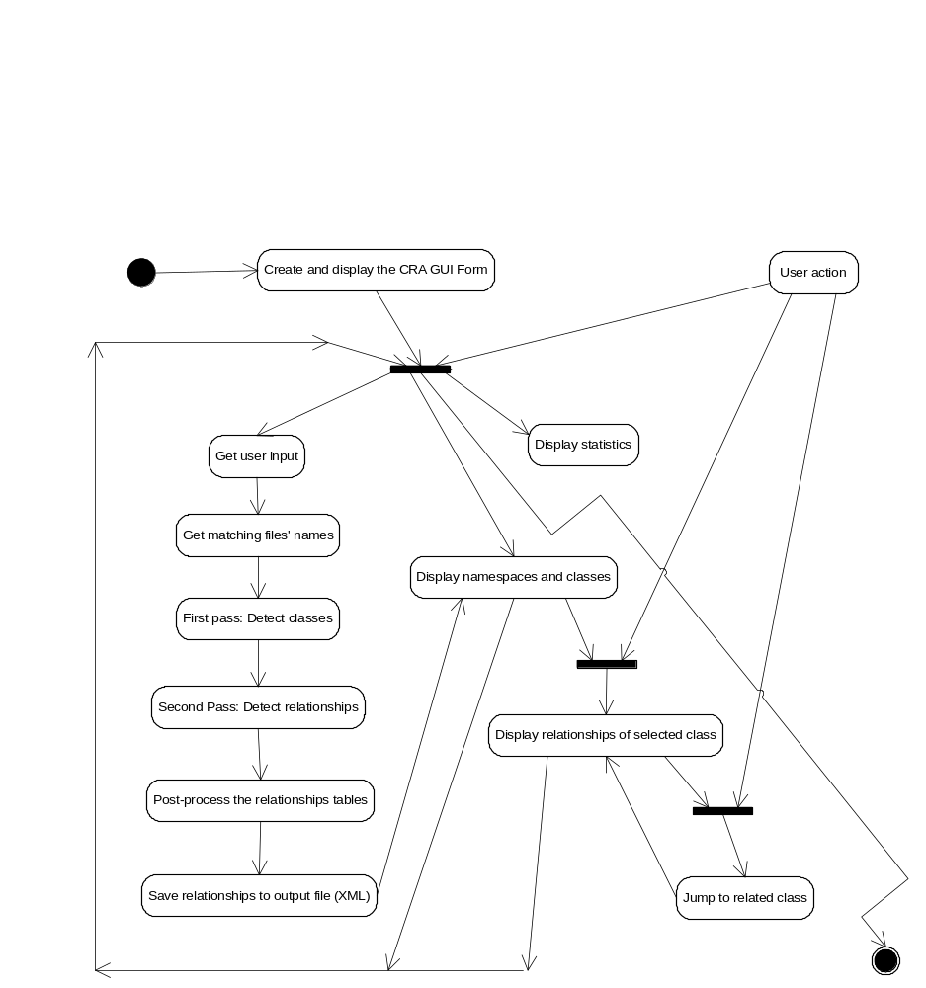

5.2. Get User Input

CRA starts processing when user clicks on the "Process Files" button.

The first top-level activity is to read the paths and file match patterns entered by the user on a textbox.

If the standard output file, "relationships.xml", exists, CRA displays a dialog box with the warning "output file exists; its contents will be overwritten", to allow the user to save a backup of that file before proceeding, or cancel processing altogether.

5.3. Get Files List

CRA creates a list of all files to be read and processed, before starting file processing, to allow interactivity (see 3.4) and consistency (see 3.5).

This list of all matching files is created by the following process:
- Parse each path + file match pattern string in user input, and for each each path and file match pattern:
- Descend to all the directories in the path, recursively, and for each directory:
  - Find all the files matching the file match pattern, and for each file:
    - Add the file name to the list of all matching files.

If no file ever matches the file match pattern, an error dialog displays this fact and stops further processing. In this case, the output file is not overwritten.

5.4. First Pass: Get Classes

In the first pass of processing (of all the matching files), CRA gets the fully qualified names of all the classes defined in these files.

The following activities are done for each file in the list of all matching files:
- Check file existence. No file? ==> Skip file; increment the count of missing files. If the count just became 1 (this is the first such file), display the file name and the fact that it must have been renamed or removed, in a non-blocking information dialog (see 3.4.3).
- Open the file. File can't be opened? ==> Skip file; increment the count of files that could not be opened. If this is the first such file, display the unreadable file's name in a non-blocking information dialog (see 3.4.3).
- Use the class detector parser to get fully qualified class names; add them to a running class names set (a mathematical "set"). Names will be sorted later, but for efficiency in adding items to the set, an unordered, Hashtable-based set could be used here. This detector also detects namespaces, and the namespaces are added to another set, to display the counts of.
- Close the file.
- Advance class detection progress bar and update the number of files analyzed, number of namespaces and number of classes displays.

After all the files are processed, if the missing files count or unreadable files count is larger than 1 (the first cases cause their individual dialogs to be opened), a non-blocking information dialog is opened to display these counts. CRA continues processing with its second pass without waiting for these dialogs.

If the counts are alarmingly high, the user may decide to use the "STOP" button to stop processing.

5.5. Second Pass: Find Relationships

In the second pass of processing all the matching files, CRA detects the four primary relationships (defined in 2.2) between the classes.

The following activities are done for each file in the list of all matching files (the first two steps are exactly the same as those steps in the first pass; see the details in 5.4, above):
- Check file existence. No file? Then, skip file.
- Open the file. File can't be opened? Then, skip file.
- Use relationships detector analyzer to get all the relationships; record them in ClassInfo's relationship fields that keep the set/list of classes that this class has relationship with.
- Close the file.
- Advance the relationships detection progress bar and update the number of classes analyzed and the (individual and total) number of relationships displays.

Similar to the first pass, after all the files are processed, if the missing files count or unreadable files count is larger than 1, a non-blocking information dialog (see 3.4.3) is opened to display these counts. CRA continues with its post-processing without waiting for these dialogs.

5.6. Post-Process the Relationship Tables Created

Create hierarchical namespace-class structure with the namespaces and classes sorted in alphabetical order.

Invert the relationships and add them to the ClassInfo's data structures as well. For example, take inheritance relationship: From the superclasses information gathered, we will now extract and record subclasses information as well. Each ClassInfo object will now keep all its superclasses as well as all its subclasses (if they exist).

See 3.9 for details on why this is desired, even though it requires twice as much memory.

5.7. Save the Output to a File

Save the user inputs, statistics, and the forward and inverse relations information to the file "relationships.xml" in XML format. A suggested format is given in the appendix.

5.8. Display Namespaces and Classes

Screenshots in section 8 show how CRA displays the outputs described here, in 5.8, 5.9, and 5.10. There are two TreeViews in the "Relationships" tabbedpane; the one on the left is to browse the namespaces and the classes, and the one on the right is to display the relationships of a selected class.

The activites performed to display the namespaces and classes in a tree are:
- Switch from progress and statistics display tabbed panel to the interactive output (class and relationships information) display tabbed panel.
- Fill in the WinForms namespaces-classes TreeView with the alphabetically sorted hierarchical namespace and class information, and display it.

After these activities, user input may prompt more activities:
On namespace click: Open up the namespace to display namespaces & classes defined under it. This activity will be left to be performed by the TreeView (rather than partially filling the tree and requiring callbacks from TreeView).
On class click: Display relationships (5.9, below) of this class with others.

5.9. Display Relationships of Selected Class

Whenever user clicks on a class (called "Class1" in the following), we have the following CRA activities:
- Create relationships tree for Class1 and display it, on the relationships TreeView.
- On relationship click: Open it up to display all related classes (this should be handled by the TreeView itself, through proper initialization of the tree data and structure by the CRA)
- On related class (called "Class2" here) click: Jump to Class2 (see 5.10).

5.10. Jump to Related Class

Whenever the user clicks on a class (called "Class2" in the following) while viewing the relationships of a class (called "Class1" below), the following activities are performed:
- Find Class2 in the namespace-class TreeView & have it selected
- Let the tree for the relationships of class1 be displayed as usual (5.9).
- Open up inverse relation folder & move mouse over Class1 there, ready to be selected, so that clicking takes us back to Class1.

If Class2 is a superclass of Class1, Class1 is a subclass of Class 2. Clicking the Class2 while the first relationship is being displayed

causes the inverse relation between the same two classes to be displayed, with Class2 in namespace-class TreeView, and Class1 under "Subclasses" relationship in the relationships TreeView.

Modules and Classes

CRA consists of eight modules:
- CRA Module (CRA: Class Relationships Analyzer)
- ClassRelInfo Module
- GUI Module
- OutputLogger Module
- FileFinder Module
- Grammar Module
- Semiexpression Module
- Tokenizer Module

As shown in the module diagram below, CRA Module is the executive main module that drives the CRA processing, and it depends on:
- FileFinder module to find the files
- ClassRelInfo module to store the class and relationships information detected
- GUI module to interact with the user
- OutputLogger module to store statistics, warnings and information throughout the processing of files.
- Grammar and Semiexpression modules to do the actual class and relationships (inheritance, composition, aggregation and using) detection.
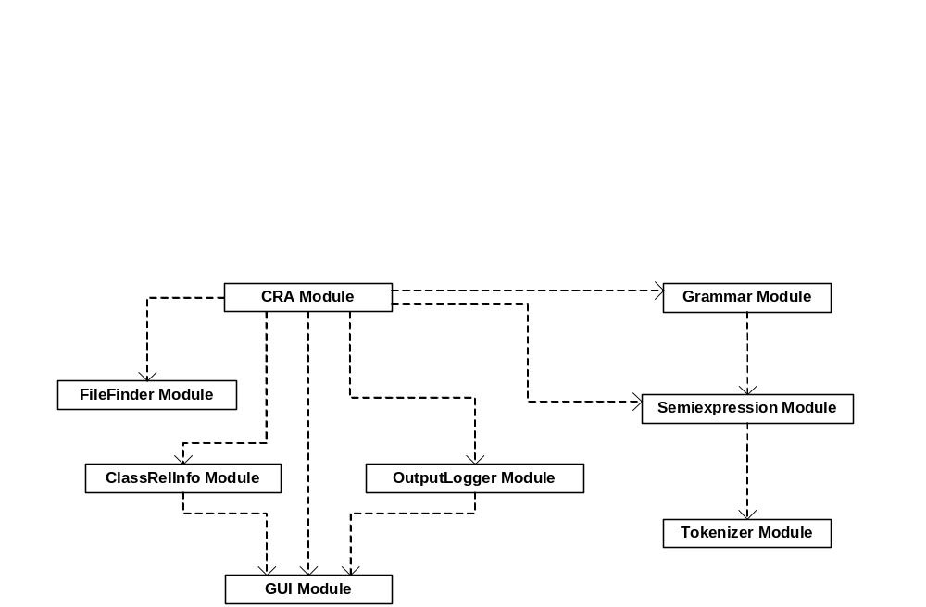

CRA uses the MVC (model-view-controller) pattern in its modules: ClassRelInfo and OutputLogger are the models for the data stored, GUI module is the view, and the CRA module is the controller. Accordingly, the model modules, OutputLogger and ClassRelInfo, need access to the GUI to change the data it displays. This dependency is also shown above.

Grammar module depends on the Semiexpression module and Semiexpression module depends on the Tokenizer module. Except for the addition of new detector classes in Grammar module, these three modules are used as written by the original author, Dr. Fawcett.

6.1. CRA Module (CRA: Class Relationships Analyzer)

This is the executive module. It contains the following classes:
- CRAMain: Main controller/executive
- FileParser: Handles parsing through a C# file
- ClassParser: Handles parsing one C# class encountered in the file
- FuncParser: Handles parsing one C# function encountered in the class
- RelsDetector: Handles detection and storing the information of the four types of relationships detected by the CRA. Uses the four individual relations detectors in Grammar module.
- UserInterruptedException: An exception thrown when a CRA phase stops due to user clicking on the "STOP" button. Caught by CRAMain top level function.

As different from Detector classes in the Grammar module, these classes are specific to CRA. Some of them may be quite small, only used to "glue together" the parts needed from other classes, and possibly delegate most processing to those other classes.

6.2. ClassRelInfo Module

This module has the classes that store the C# class and relationships information:
- NamespaceInfo: Information extracted for a C# namespace. May aggregate many NamespaceInfo and ClassInfo objects within. Fully qualified name (including aggregator parent NamespaceInfo's fully qualified name) is stored.
- ClassInfo: Information extracted for a C# class. May aggregate up to eight RelInfo objects (for forward and inverse relations). Fully qualified name is stored. A static Registry property of ClassInfo keeps all the ClassInfo classes created in a map to allow for searching a fully qualified class name in constant time (O(1)).
- ClassRelInfo: Information extracted for one type of relationship for one class. May aggregate any number of ClassInfo references.

6.3. GUI Module

This module handles the GUI of the CRA. It contains the following classes:
- CRAMainForm: Main window and WinForm Form of interaction with user.
- NonBlockingDialog: The implementation of the separate-thread non-blocking information dialog described in section 3.4.3.
- FileOverwriteWarningDialog: A simple warning dialog to warn user when the output XML file is about to be overwritten.

The screenshots in section 8 show all these components.

6.4. OutputLogger Module

This module has classes to store the output statistics, error and warning logs together so as to display them together at the end and write them to the/an XML file as needed.

During processing, these classes may be updated from time to time only (for each file processed, for example). At the end of processing, they shall be updated to contain the final values.

It has the following classes:
- FileStats: Stores the number of directories and files.
- ClassStats: Stores the number of files processed, number of namespaces and classes detected.
- RelStats: Stores the number of classes processed so far (to detect relationships, in the second pass), and the number of relationships detected for each type of relationship.

6.5. FileFinder Module

This module has a flexible delegate-based directory traversal and match pattern based file finder class. This class is based on directory navigation and command line argument parsing demonstration programs.
- FileFinder: This class has two functions: The findFiles function goes through all subdirectories under one directory and gets all the files matching a pattern string. The traverseDirectories function calls findFiles function for many path+pattern strings (as would be supplied by user).

6.6. Grammar Module

This module contains the classes that help detect C# language constructs.
It has the following classes:
- CSNSDet: C# namespace determiner
- CSClassDet: C# class determiner
- CSFuncDet: C# function determiner
- CSCreatDet: C# object creation determiner (using "new" keyword)

6.7. Semiexpression Module

This module contains the C# semiexpression detection class written by Dr. Fawcett. Semiexpression is a partial C# expression, and is operationally defined as a minimal sequence of tokens that end with open curly bracket '{', close curly bracket '}', or semicolon ';'.

It has one class:
- Semi: C# "semi-expression" parser.

6.8. Tokenizer Module

This module contains the C# tokenizer class written by Dr. Fawcett. This is a simple tokenizer that does not combine multi-character operators (such as "<<", "+=", "++") into single tokens.

It has one class:
- Toker: A simple C# tokenizer.

7. Events

The important events are captured by warning and non-blocking information dialogs throughout processing. They are listed here as well, for reference.

Non-critical events:
- No files to process: If the path and patterns string(s) supplied by the user don't match any files, a warning dialog gets displayed and CRA stops processing.
- File missing: Happens if a file or one of its parent directories get renamed or removed, during CRA processing. A non-blocking information dialog appears for first such file to warn the user and display the path to this file, and a summary of statistics non-blocking dialog appears at the end of the processing stage (first or second pass) if there is more than one such file.
- Unreadable file: Happens if file is not readable by the CRA process due to its protection settings or other disk (or network) hardware problems. Similar to missing file case, the first such incident causes a non-blocking information dialog box to be displayed with the path to the file, and a summary statistics non-blocking dialog appears at the end of the processing stage (first pass or second pass) if there is more than one such file.
- File not a C# file: If no classes are found in a file during the first pass, CRA reports this using a non-blocking information dialog (similar to above, one for the first file, and a final one for all the rest), and removes this file from the list of files to be processed by the second pass (relationships detection phase).

Standard GUI events such as closing the main form window, interact with the main form's GUI controls and with the dialogs are straightforward, and will not be defined in any detail here. One exception is pressing the "STOP" button during processing. This stops the current phase (files detection, first pass, second pass, GUI data structure creation and display) of CRA and moves on to the next phase with the partial information collected so far (a partial files list, a partial classes list, a partial list of relationships between the classes, a partially filled GUI tree, respectively).

Clicking "STOP" does not directly kill any threads as this could corrupt the data structures being manipulated by this thread. Instead, main CRA executive uses a boolean member variable (a flag) called "stopNow" that is checked at regular frequent intervals by the threads running the separate phases of CRA processing. The individual threads throw a UserInterruptedException if they see that this flag was raised, and this exception gets caught by the top-level executive function that calls other methods for the different phases.

UserInterruptedException is the only exception that CRA shall need.

8. Views

CRA shall have a graphical user interface, based on WinForms in C#.

CRA shall take as input a set of path + file match pattern strings:
- path is the directory to be recursively traversed
- file match pattern string matches the files to be analyzed (examples: *.*, *.cs, CRA*.cs)

When the user clicks on “Process Files” button, if the output file already exists, a warning dialog will be displayed:

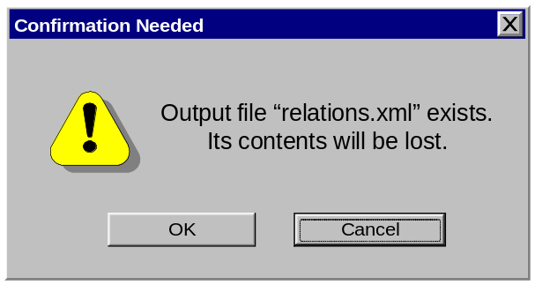

In this warning dialog, the user is warned that the output file will be overwritten. “Cancel” is the default option, because these output files may take a very long time to create, and should not be overwritten by accidental click of a button. The user could also choose to move or copy the file elsewhere before clicking on “OK” to proceed with CRA processing.

CRA goes through three stages of processing:
- Get the names of the matching files
- First pass: Detect all the classes defined in those files
- Second pass: Detect all the relationships between these classes

Each stage is associated with statistics, and the longer stages called “first pass” and “second pass” also display a progress bar.
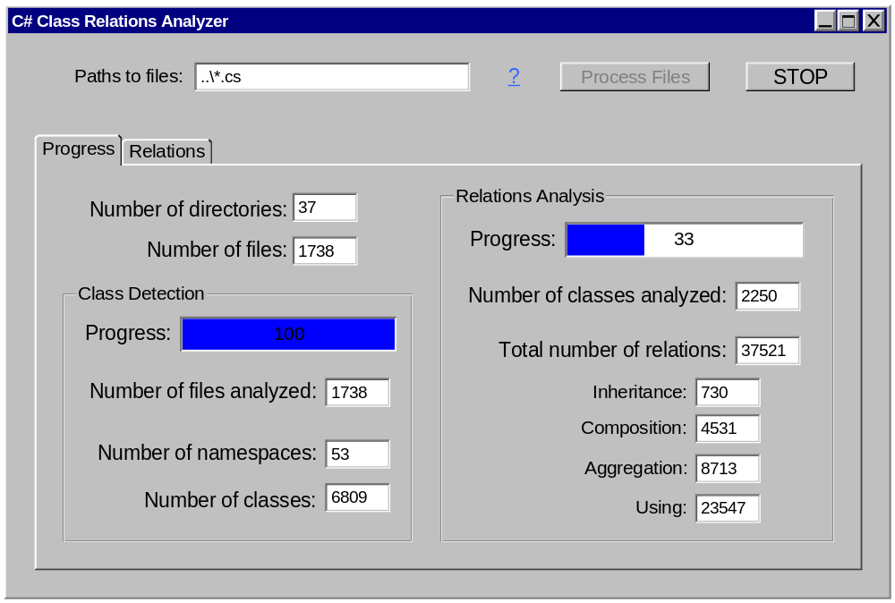

In the screen shot shown above, CRA has already found all the matching files, detecting all the classes in its first pass of processing, and is doing its second pass of processing. It has so far detected the relationships for 33% of the classes, and the detailed statistics can be seen for each type of relationship.

An optional set of inputs were considered but not included in this version. This could be included in a future version: A set of checkboxes for the relationships to analyze and extract.

During processing, CRA shall display statistics and degree of its progress.

CRA shall display as output:
- A sorted tree of hierarchy of namespaces and classes
- All the existing forward and inverse relations of any class selected by user, in relationships tree.

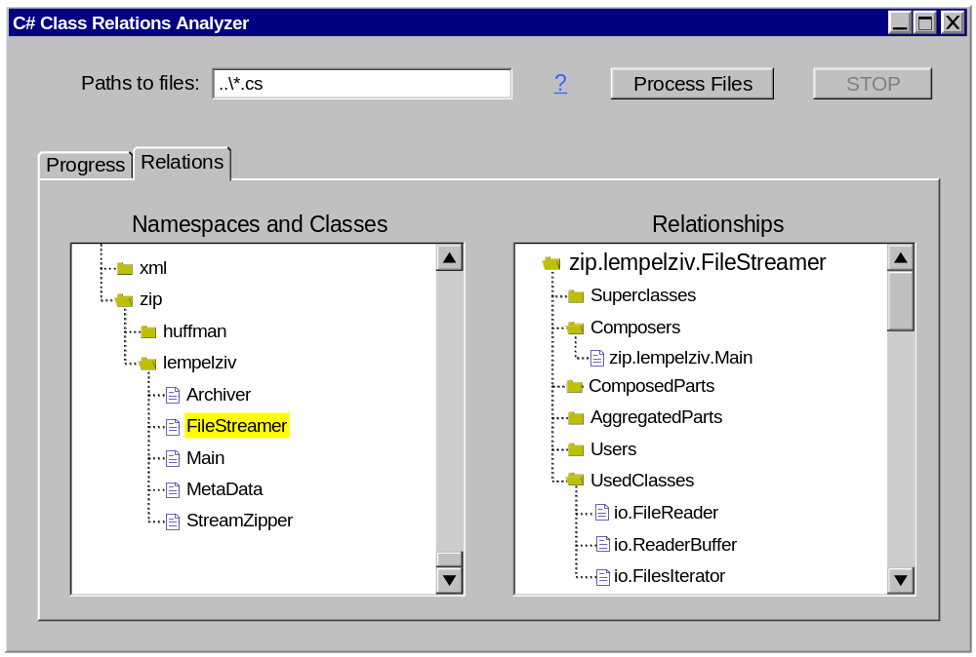

In this screenshot, we see the relations tabbed pane, with the namespaces and classes tree on the left, with the “FileStreamer” class selected, and the relationships tree to the right that displays the relationships of this class with other classes.

In the namespace-class tree, namespaces appear as folders (initially all closed), and the classes appear as documents (nested classes are not detected by CRA). A namespace can contain other namespaces and classes. Classes may be defined outside all namespaces. This tree does not show fully qualified names at each node; only the contextual names are displayed.

In the relationships tree, the top-level folder is always the fully qualified class name and it is open by default. Under it, there are folders (closed by default) for each relationship type this class has an instance of with any other class, out of the full set of eight forward and inverse relations:
- Superclass, Subclass
- Composer, ComposedPart
- Aggregator, AggregatedPart
- User, UsedClass

Clicking any relation type will open up that folder and display all the classes this class relates to, through the given relation. Specifically, Superclass will contain all the superclasses of this class. So, if the user is viewing class A and clicks on "User" and sees class B there, B is a User of A; "B uses A" (not "A uses B" -- that would require B to appear under the UsedClass folder).

CRA also displays a number of non-blocking information dialogs to inform user about problems with the files being processed. These dialog look very similar to the warning dialog seen earlier.

9. Summary

CRA is a very useful and highly interactive program to analyze and view the C# classes and their relationships with each other in a C# project of potentially thousands of files and classes.

The interactivity allows the user to easily browse the classes through the relationships between the classes. CRA serves both the user who is interested in all the relationships of one specific class, and the user who is interested in understanding the general overall architecture of the classes in a project.

The XML output allows the output of CRA to be fed into other programs that can do further processing on the relationships discovered by the CRA. A tool could also use the output produced to display these relationships in a UML static class diagram. All the classes of a large project would produce too large a UML diagram, and displaying all using relationships could significantly coplicate the diagram, but such a tool could easily use standard XML parsers to limit its attention to a subset of classes and a subset of relationships stored in the XML output file.

With proper implementation and use of ClassInfo.Registry map (see section 6.2), CRA should run efficiently, waiting for disk I/O (the task is disk access intensive) much more often than waiting for CPU time.

CRA is designed to run without requiring human supervision. Its interface is information-packed and yet simple to use. CRA is not designed to be able to recover after crash, but all other non-critical events are handled and the relevant information gets displayed to user through non-blocking dialogs.

Appendix. Suggested XML Structure for Output File

This format is not designed to be space-saving. It is designed for easy localized parsing, as could be done through a SAX parser (so that the whole DOM tree would not have to be kept in the memory). An example output file with the suggested format is shown below.

<cra>
<input>../proj1/*.cs ../proj2/server/*.cs</input>
<timing>
<duration>2:14:28</duration>
<start>Sept 9, 2003 Tue 11:32:13 PM GMT+05</start>
<end>Sept 10, 2003 Wed 1:46:41 AM GMT+05</end>
</timing>
<stats>
<numfiles>1317</numfiles>
<numclasses>5273</numclasses>
<numrelationships>87561</numrelationships>
<numinheritance>7318</numinheritance>
<numcomposition>8915</numcomposition>
<numaggregation>10019</numaggregation>
<numusing>61309</numusing>
</stats>
<classes-relations>
<namespace name="torro">
<class name="Runner">
<superclass name="torro.Controller"\>
<subclass name="torro.TextRunner"\>
<subclass name="torro.GuiRunner"\>
<composedpart name="os.thread.TThread"\>
<composedpart name="torro.CmdOptions"\>
<aggregator name="torro.BullRuns"\>
<aggregatedpart name="torro.OverrunError"\>
<user name="torro.RunnerTeam"\>
<usedclass name="edit.CommandParser"\>
</class>
<class name="Controller">
<subclass name="torro.Runner">
...
</namespace>
</classes-relations>
</cra>

