

CSE 681 - Software Modeling and Analysis

Project #1 - Fall 2003

Hierarchy Analyzer
Architectural Concept

Prepared by

Arunpriyaa Nachimuthu
Graduate student, Computer engineering
Syracuse University.

Version 1.0
10 Sep 2003

Table of Contents

1. Introduction ……………………………………………………………3

2. Use Case Analysis…………………………………………………….3

3. Context Diagram for Hierarchy Analyzer………………………….10

4. Hierarchy Analyzer Modules………………………………………..11

5. Hierarchy Analyzer Activities………………………………………..14

6. Hierarchy Analyzer Classes…………………………………………15

7. Critical Issues………………………………………………………….17

8. Summary……………………………………………………………….22

References…………………………………………………………….23

1. Introduction

Part decomposition and, conversely, the construction of composite objects out of individual parts have long been recognized as ubiquitous and essential mechanisms involving abstraction. A relationship between different classes helps a user to understand the structure of a system. This document details the architecture for a Hierarchy Analyzer program. Hierarchy Analyzer is a tool to analyze the relationships between classes in C# programs.

Inheritance and Composition are two powerful techniques that enable software reuse. Hierarchy Analyzer tool is intended to extract the type or types of relationships that exist between classes. A class may hold any of the following relationships with another class.
- Inheritance
- Composition
- Aggregation or
- Using

Inheritance models an “is-a “ semantic relationship. The derived class object is a base class object with an extended behavior. A class X composes a class Y, when it holds a reference to Y and constructs Y in its constructor. A class X has an aggregation relationship with class Y, either when it holds a reference to Y and constructs Y in any of the non-constructor member functions, or when it creates a local instance of Y in its member functions. A class X holds a using relationship with class Y, when X accepts a reference to Y and uses it in some member function.

Analyzing these relationships between the classes has many advantages. It helps the end-user visualize the structure of a system and navigate through the code, which is vital for restructuring and reengineering existing software. It comes handy when trying to comprehend a complex system.

2. Use Case Analysis

Developing reusable software involves analysis of requirements with the perception of a broad range of users. Users and their roles are imperative for any application. As

per this hidden protocol, the architectural concept of Hierarchy Analyzer discusses the principal users and the ways they control and interact with the system.

Principal Users
The following are the principal users of this system:

Program Manager:
A Program Manager is responsible for coordinating and integrating various tasks within the scheduled time and budget while developing software. He/She might use this tool to assign or to delegate modules to developers, particularly, when a new developer replaces an old developer.

Software Architect :
A Software Architect ‘s primary job is to analyze and design the architecture for a system. He/She will probably use this tool either when framing the architecture for a new system that uses some other system as a subsystem or when restructuring an existing system.

Software Developer :
A Software Developer is considered as the key user of this system as he/she may be obligated to develop modules for an existing system that needs a thorough understanding of the system. This tool will help him/her to get a good picture of what is going on and to develop the dependent modules accordingly.

Maintenance team members :
Reengineering and refactoring an existing system is inevitable at times due to changing requirements and due to other factors that change along with time and circumstances. Maintenance team members might require this tool during the maintenance phase to refactor an existing system.

Customer :
An ordinary customer might want to take a peek at how a system is developed. This tool provides him/her with a basic view, just outlining the relationships between classes.

Views
There are two views that are applicable with this tool.
- Basic View
- Comprehensive view
This is an interesting subtle distinction. If an actor is an ordinary client or a program manager, they might want to look at just classes and the relationships. So, it would suffice to offer a basic view using class rectangles and relationship connectors.

On the other hand, a developer or a team member might need more details that justify the relationships. Comprehensive view could be a table or grid with ProjectNames, Module names, Class names, relationships, function names and so on. This sort of comprehensive view would help the developers to modify code or to build code on top of it.

Use Cases
Use cases depict the communication between the user and the system. Following use cases are identified for this system.

Use Case: Specify the target path and file patterns
The user has to specify the target path and file patterns to do an analysis of relationships between the classes contained in the files.

Use Case: View error messages
The User might view error messages produced as a result of his/her action. Error handlers are provided to handle inappropriate input or action.

Use Case: View the directory structure chosen
The user is allowed to see the directory structure chosen for the hierarchy analysis.

Use Case: Run the Analyzer
The user runs the analyzer program by clicking on the option provided by the
User Interface.

Use Case: View the basic class graph
The user gets to see the output in the form of a class graph. The basic view of the class graph just outlines the relationships between classes.

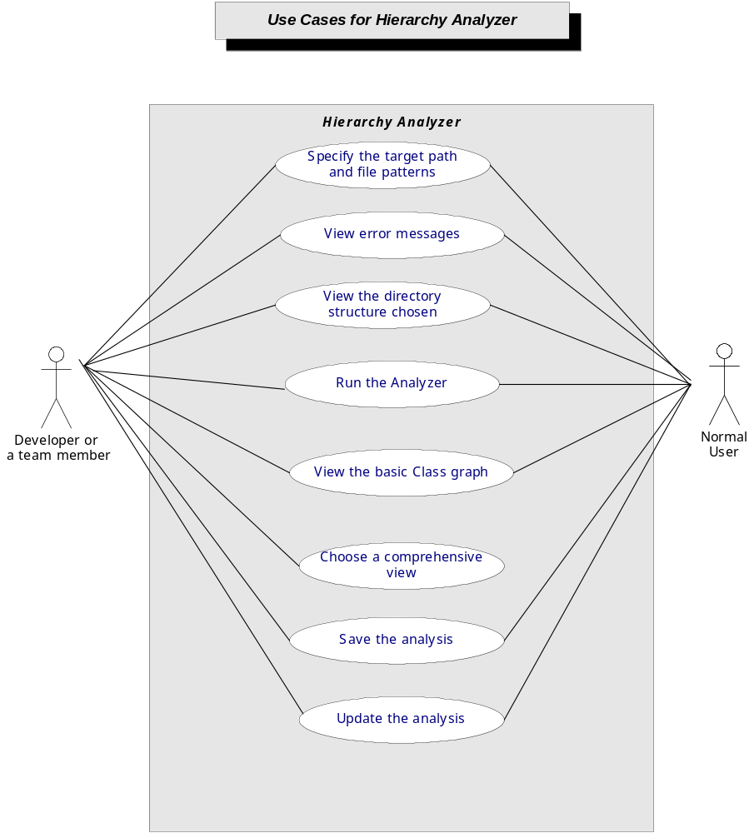

Use Case: Choose a comprehensive view
The user gets to see a comprehensive view of the class graph in the form of a table. This is a more detailed view, which will be helpful for the developer. The user can check the developer tab to get a comprehensive view.

Use Case: Save the analysis report
The user can save the analysis report in the form of an XML file, text file or as a word file in the specified location using the Save As button.

Use Case: Update the analysis
The user can remain in the same directory structure chosen and update the analysis by inputting file patterns. This use case might occur when a user want to choose a different file pattern for the same target path. Changes would have been made to some files that might alter the analysis. The user can update the analysis for the same input path and pattern using the update button.

User Interface

Based on the use case analysis, the following User Interface is proposed.

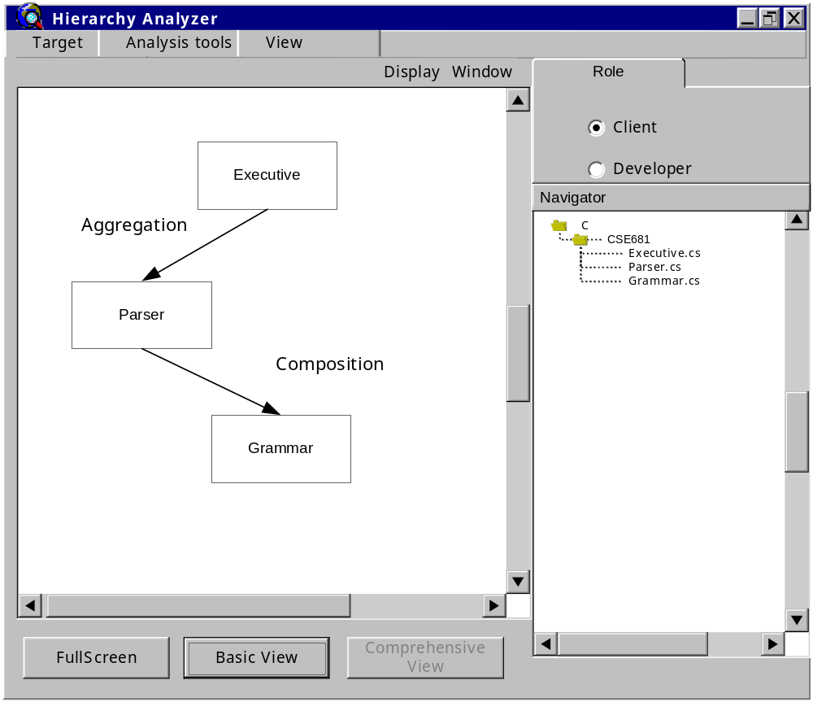

User Interface for Hierarchy Analyzer offers various features

- Target Menu allows a user to provide the input or to exit the system. When the user clicks on the New Target option, it opens up a dialog allowing the user to browse and select the path and then enter the file pattern. The user might choose to cancel this task or click on Ok to proceed.
- Analysis menu provides three options. Run starts the analyzer and displays the class graph. Save As allows the user to save the analysis report in the

specified format in a specified location with the help of a dialog box. Update enables the user to run the analyzer again on the same input or on the same path with a different file pattern.
- Navigator on the right hand side of UI displays the directory structure of the current path chosen.
- Role panel tab on the top allows the user to switch between basic and comprehensive views by choosing the appropriate roles. It offers a basic view designated for the client by default. If a user chooses the developer option, then the comprehensive view is displayed.

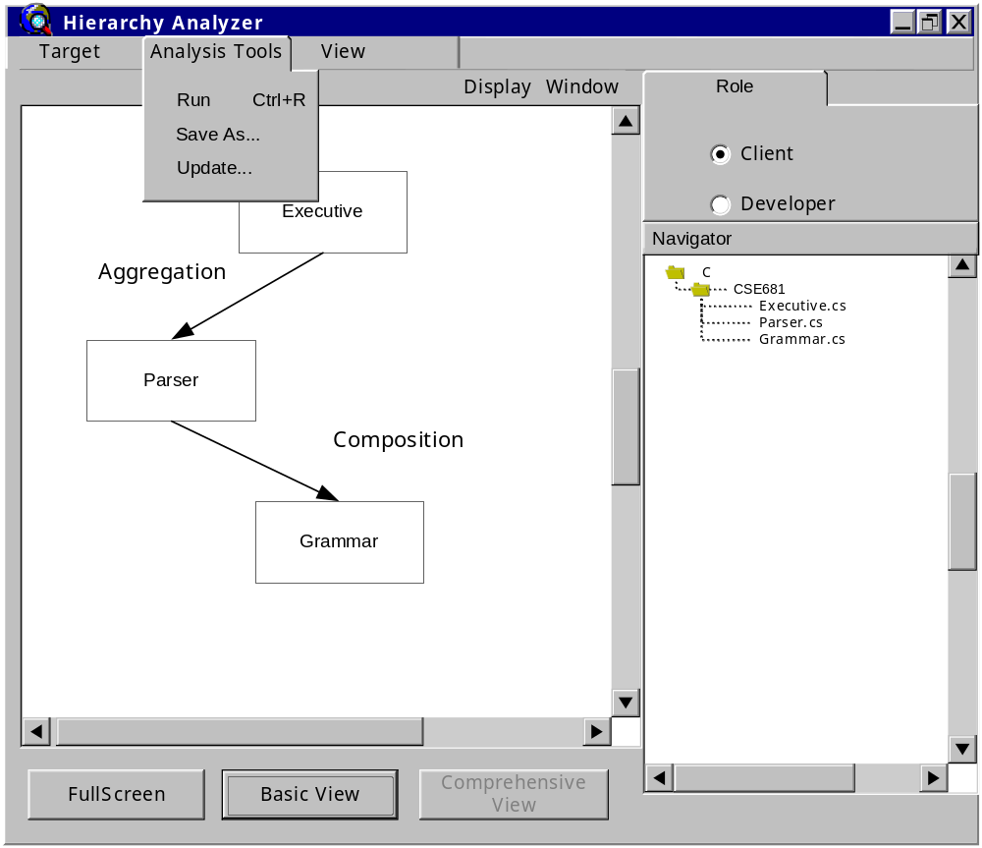

- Display Window enables the user to view the class graph. Full Screen button offers a full screen view of the results. Comprehensive view button is enabled

when the user chooses the role of a developer and it allows the user to view a detailed class graph. Basic view allows the user to switch back to the normal view.
- View menu offers the same functionality as the three view buttons with three options.

3. Context diagram for Hierarchy Analyzer

The context diagram below represents the interaction of Hierarchy Analyzer with its external environment. The user provides inputs through the GUI.The result of an analysis is also displayed on GUI.Hierarchy Analyzer generates error messages as and when necessary and responds to error conditions with the help of suitable error handlers. It utilizes the services of file system to handle file operations.

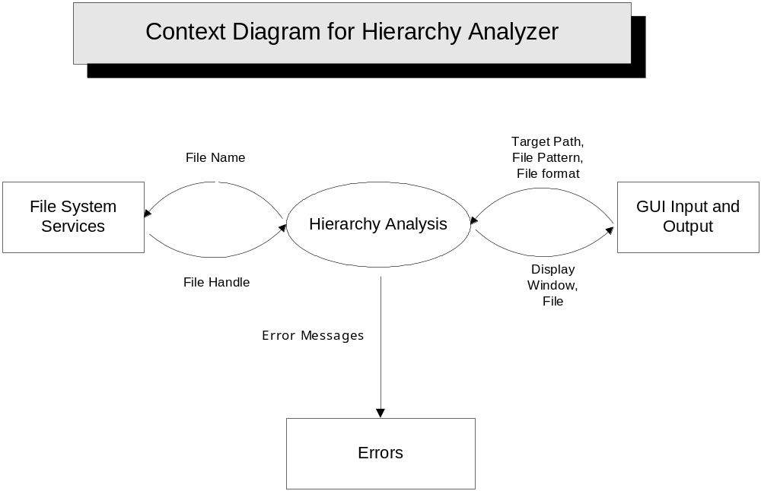

4. Hierarchy Analyzer Modules

Hierarchy Analyzer can be partitioned into the following modules:

- HierarchyAnalExec
- HierarchyAnalUI
- HierarchyStore
- DirNav
- DisplayGraph
- Parser
- SymbolTable
- Grammar
- SemiExpressionAnalyzer
- Tokenizer

HierarchyAnalExec :
This is the top-level module that integrates all the activities of the system. It generates the main form at the startup and initiates the main form’s displays.

HierarchyAnalUI :
This module defines all the user controls through which a user can interact with the Hierarchy Analyzer. It uses the services of HierarchyStore, DirNav and DisplayGraph modules to provide event handlers for user actions like providing the input, running the analyzer, and clicking a view.

HierarchyStore :
The responsibility of this module is to save the analysis report in the format and in the location as specified by the user. It uses the results from the analysis performed by the Parser module to store them in a file.

DirNav :
DirNav Module processes the user input .It searches a directory structure for a given file pattern. When the user provides the input, HierarchyAnalUI invokes methods provided by this module, to display the directory structure.

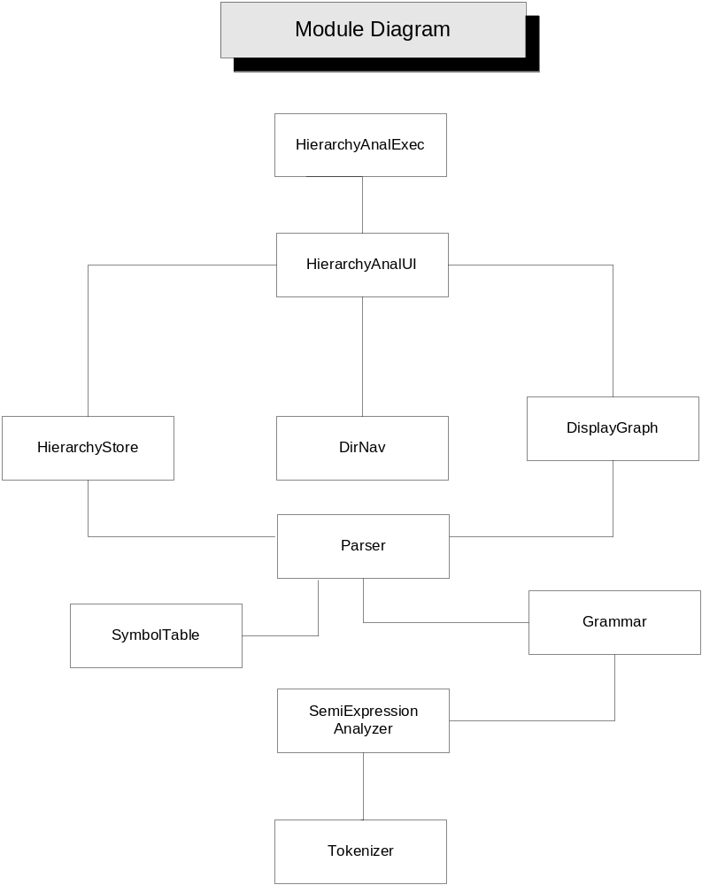

DisplayGraph :
This module handles the display of graphical representation of inter-class relationships. It retrieves the result from the Parser Module and uses it as an input to display the relationship graph. It offers two views namely basic view and comprehensive view. Basic view uses rectangles to represent classes and connectors for relationships. Comprehensive view displays a detailed view in the form of a table or grid.

Parser :
The primary function of Parser is to analyze the relationships between classes. The results of an analysis are stored in a Hierarchy store. The DisplayGraph module is used by the Parser to generate the analysis report graphically. It uses the Grammar module to capture object types. It uses the SymbolTable module to store the types required for processing.

SymbolTable:
SymbolTable module essentially provides the data structures required for storing the types while doing the type analysis. It provides an interface for the parser module.

Grammar :
Grammar module provides an IDetector interface to identify grammatical constructs. It defines a protocol to validate a semi expression using the services of SemiExpressionAnalyzer.

SemiExpressionAnalyzer :
This module provides methods to build lists of tokens called semi expressions. Tokens are extracted from the tokenizer module.

Tokenizer :
Tokenizer serves as a tool to extract tokens from a file stream. It presents an interface for SemiexpressionAnalyzer module to build semi expressions.

5. Hierarchy Analyzer Activities

Hierarchy Analyzer spawns a list of following activities from the start of the application.

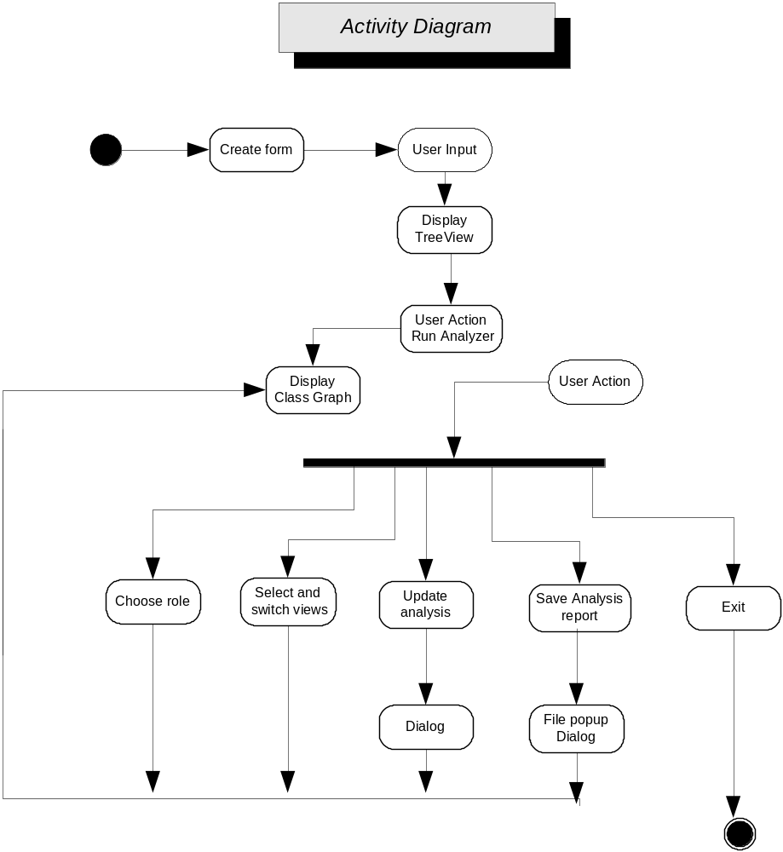

The main form is created and it waits for the user to provide input. Once the input is given, it displays the tree view structure. The user has to click on Run to start the analysis process. Consequently a class graph is displayed on the display window. It again waits for a user action as below:
- Choose role : User could click on the developer role to look at a comprehensive view.
- Select and switch views: User could switch between views with the buttons provided.
- Update analysis: User could update the analysis popup dialog appears when user clicks on update option asking for a file pattern. User could choose a different pattern or the same pattern to update the analysis.
- Save Analysis report: User could save the report in a text file or as an xml file by choosing to do so.
- Exit: User exits the application by clicking exit from the Target Menu.

6. Hierarchy Analyzer Classes

The following diagram illustrates the structure of Hierarchy Analyzer.

HierarchyAnalUI class handles the events resulting from the actions of the user. It enables a user to select the target and uses DirNav Module to perform pattern expansion. A user can save the results of the analysis in a desired file format and in the desired location with the help of HierarchyStore class. It handles the user events like running the analyzer and updating the analysis results with the help of DisplayGraph interface.

DirNav class uses the services of DefProc interface, fileinfo and wildcard class to do a depth first traversal of the directory structure. DisplayGraph class defines an interface to generate a graphical representation of the results. BasicView class and ComprehensiveView class inherits from DisplayGraph interface to offer different output views for a user.

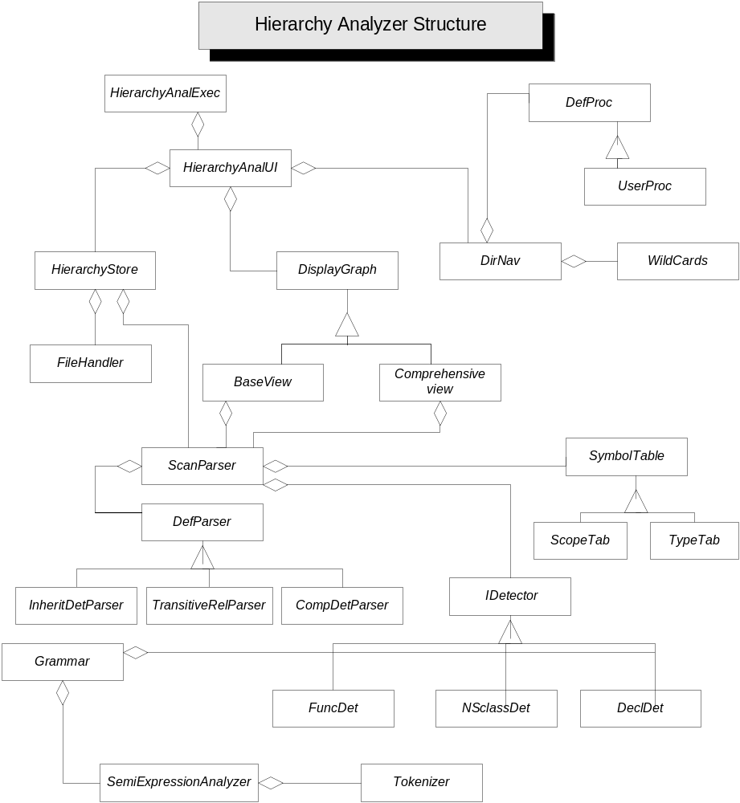

HierarchyStore class is triggered by the UI when the user wants to save the analysis information in a file. It uses the FileHandler class to locate, open, write and close a file.

ScanParser class is responsible for scanning the files. InheritDetParser CompDetParser and TransitiveRelParser classes inherit from an abstract DefParser class. ScanParser uses IDetector interface while scanning a file to perform type analysis. The type information is extracted and the relationships are established using InheritDetParser and CompDetParser.TransitiveRelParser is used to establish indirect relationships.

SymbolTable class provides an interface for the ScanParser class to store the types and do scope processing using a stack. ScopeTab and TypeTab classes inherit from
the SymbolTable interface.

FuncDet, NSClassDet, DeclDet classes inherit from IDetector interface. They use the methods of the grammar class to match semi expressions and consequently detect functions, classes and namespace names.

SemiExpressionanalyzer class forms semi expressions with a sequence of tokens using the tokenizer class. The tokenizer class accepts input from a file stream and generates tokens.

- Critical Issues

Achieving widespread use of a tool and reusability of complex software components requires a concerted focus on the critical factors that might be potential blocks during the analysis of the architecture. Identifying the critical issues allows a good understanding of any major pitfalls that might occur during the design, development and maintenance of the system. The following are some of the critical issues:

Performance and Implementation Issues

- Load on the system: The system’s file handling capacity is a major concern since the developer, who is the key user, deals with millions of lines of code.

When a user inputs a path that contains thousands of files, performance degradation occurs though it might depend on the machine the user is working. However, the design should ensure that the system doesn’t fail on such huge loads and provide appropriate error handlers.

- Scanning: The system should perform a rational scan of the input directory. The architecture proposes parsing a file twice, as C# involves namespaces and classes with same names could be differentiated by their qualified names. But the design should consider the consequences of parsing a file twice, given a directory with a huge number of files.

- Bad code: The system’s reaction to files containing bad code is a significant issue. This risk raises concerns like whether to stop the file containing the bad code and to proceed to the next file, if so what will happen to unresolved or unestablished relationships during the analysis, that really exists? The architecture proposes appropriate error handlers that should be provided when a file or files in a component contain bad code.

- Follow-up tool: A user might change something in a file, which may or may not affect the other components. Then the user runs an update analysis on the same directory. The design should consider appropriate design measures to preserve state and to render an optimum performance.

- Transitive relationships: A complete analysis of relationships includes both direct and transitive relationships. The proposed system considers this subtlety and uses a transitive relationship detector in the Parser module.

- Unused objects: When an object is instantiated to be used inside a function and if its not used, is it a using relationship? The system should appropriately categorize these kinds of relationships.

- Display: The display of the output plays a significant role in the assessment of the quality of the system. The proposed architecture offers a nice graphical representation of the relationships between classes.

Design Issues – A few thoughts

A good design dictates software reuse. Envisioning the set of users, who might want to use the system differently, a few design issues are discussed. Different ways of user interaction with the system are as below:
- A developer might want to use this system as a subsystem.
- A user might want to give the console input or
- A sensor might want to use the output from this system for some purpose.

In order to make the system prevalent and flexible, a tight coupling of the components should be avoided as much as possible during the design of the system. The use of following design patterns is recommended.

- Façade Design Pattern

The façade design pattern provides a unified interface to a set of interfaces in a subsystem. The modular architecture of Hierarchy Analyzer contains Tokenizer, Semiexpression Analyzer and Grammar modules. These modules collaborate to render a good functionality, which could be used by a number of clients above them. For instance, complex systems like code generator, dependency analyzer will have components that act as clients to this subsystem. A diagrammatic illustration is given below.

Introducing a façade above this subsystem comprising of tokenizer, semiexpression analyzer, SymbolTable and grammar modules will help to shield the subsystem from the clients. It reduces compilation dependencies to a large extent and it makes the subsystem easier to use.

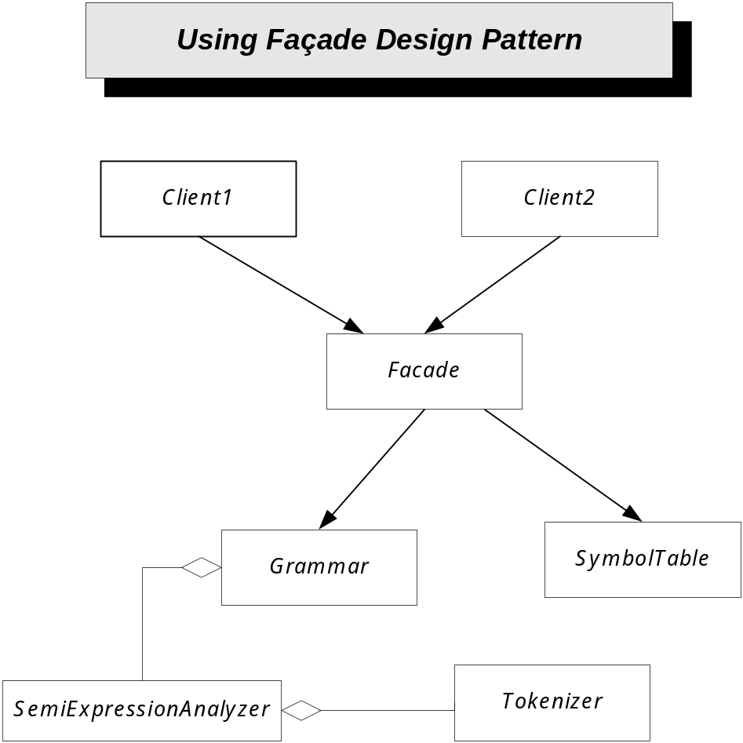

- Flyweight Pattern

Objects used throughout the design could turn out to be prohibitively expensive. Many instances of the tokenizer class of this system are produced when the tool is used on a large set of files. The Flyweight design pattern provides an approach for reducing the number of tokenizer instances, as they are fundamentally the same except for a few parameters. If these parameters (extrinsic data) are moved outside the class instance and passed as part of a method call, the number of individual instances could be greatly reduced by sharing them. In all, flyweight objects are sharable instances of a class.

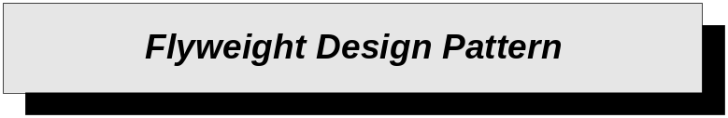

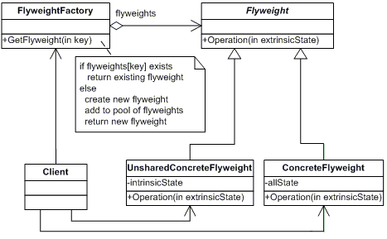

Fig: Courtesy http://www.dofactory.com/Patterns/PatternFlyweight.aspx

Intrinsic and extrinsic data need to be identified. A Tokenizer flyweight interface is defined through which flyweights can receive and act on extrinsic state. A Tokenizer flyweight factory interface is defined to create and manage the pool of flyweight tokenizer instances. Storage savings could be achieved with the flyweight design pattern.

8. Summary

Hierarchy Analyzer is a simple tool intended to analyze relationships between classes in C# files. The types of relationships analyzed are: inheritance, composition, aggregation, using, and transitive relationships.

It supports an effective user interface that provides various features for a user to interact with the tool: The user has to provide input, the user views a graphical representation of the output, the user could save the analysis report in a XML or a text file, the user could update the analysis and so on.

This application program is partitioned into ten modules at the architectural level. The top-level modules delegate the functionality among the lower level modules whenever an event is triggered. Parser module handles the key function of the system. HierarchyStore is used to make the analysis results persistent. DisplayGraph is used to provide a graphical representation of the output.

The potential critical issues and risk abatements were discussed .A few thoughts on the design of the system that could possibly make the system more reusable were outlined.

The implementation of the laid out architecture is feasible with no major difficulties. However, the critical issues should be considered while developing the system.

References

- Relationship definitions -
http://www.ecs.syr.edu/faculty/fawcett/handouts/CSE681/code/Pr2Help/GrammarIssues.doc

- Design Patterns –

ο http://www.dofactory.com/Patterns/PatternFlyweight.aspx
ο http://www.dofactory.com/Patterns/PatternFacade.aspx

