Windows 10 – Method #1 – type into search box “vs2015”
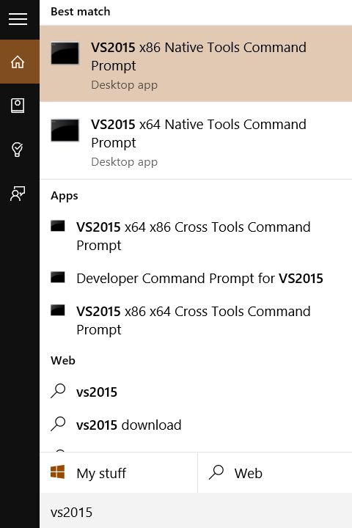
Windows 10 – Method #2 – Navigate to folder using File Explorer
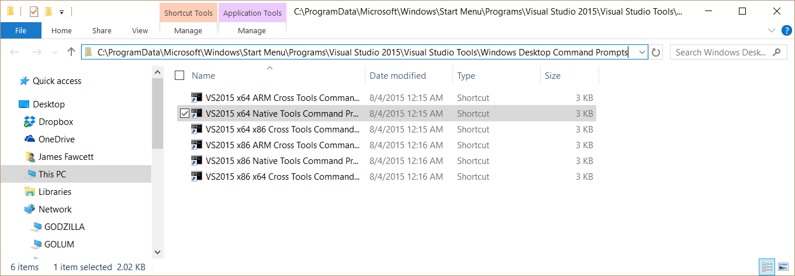
Windows 8: Method #1 - Swipe from right to show charms, then type into the search box
Developer’s Command Window

Windows 8: Method #2 - Navigate to Command Window using Windows Explorer
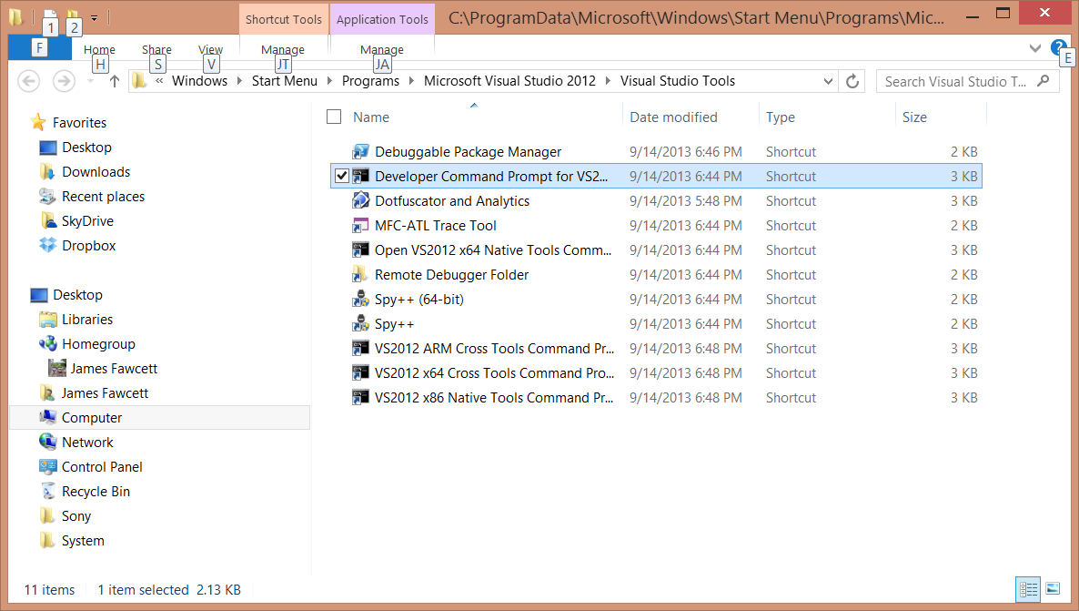

Windows 7: Method #1 - type “Visual Studio” into start button’s search box
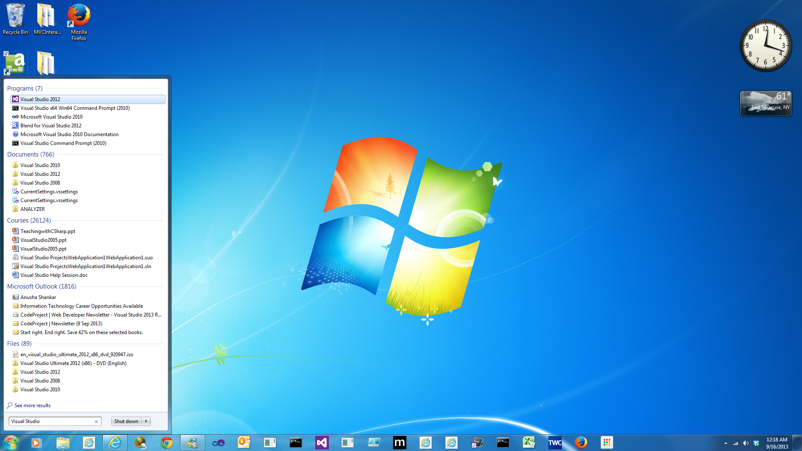
This is the developer’s command window

Windows 7: start > all programs - then scroll down as shown below
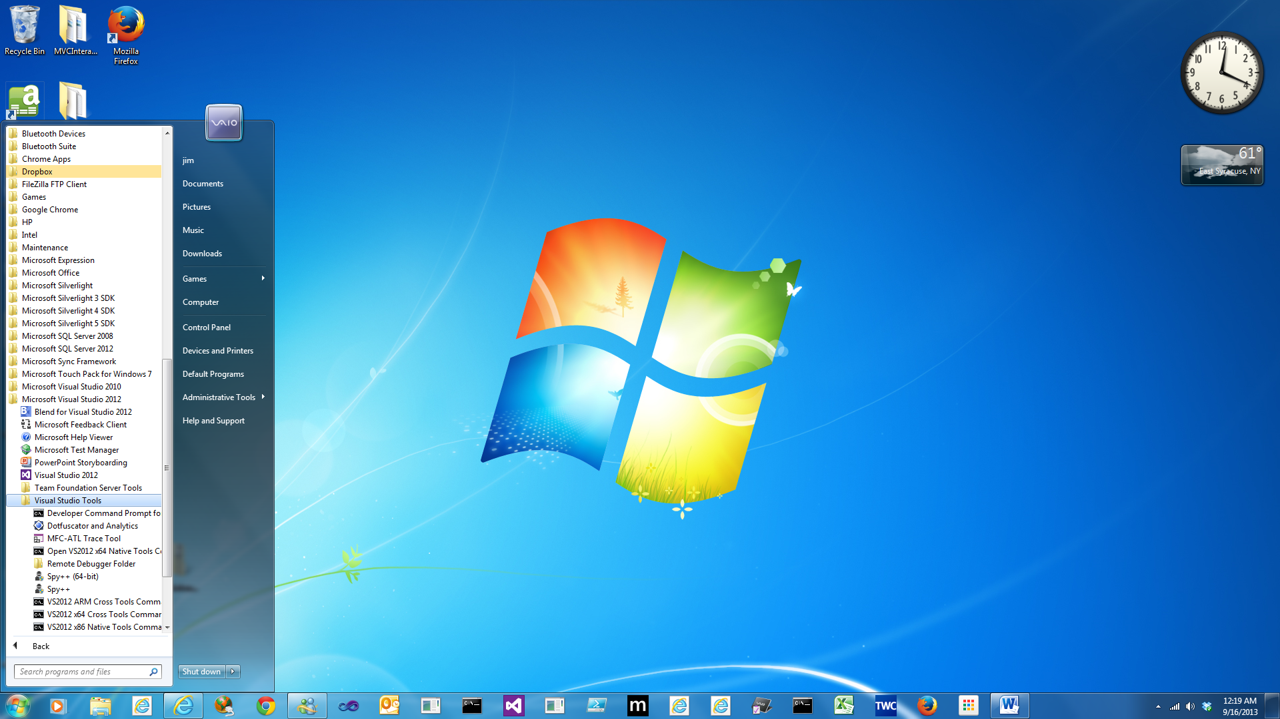
Developer’s Command Window

