.NET
in
Samples

Jan Šeda
jan.seda@skilldrive.com


Foreword
Learning and using technologies is sometimes very boring and reading books takes too much time. Many developers use MSDN but there is a big issue - that there are too many articles and other sources that this huge quantity is not possible to absorb and consfusing (maybe this is the reason why Russian search engine started a special indexer on MSDN itself, see http://msdn.rambler.ru). This is the reason why I don’t like reading technical books or MSDN articles like they would be bestsellers and searching on MSDN is terrifying experience at least for me).
That is why in December 2003 I have decided to write my own book (just for personal usage) with samples, descriptions and explation of technologies – just short samples and many images where principles could be seen immediately so learning curve could be as short as possible. Later I’ve provided this book to my friends and they told me that it can be useful for other developers who want to learn fast and see results in a very short time.

So far I have been writing samples on „as-needed“ basis, many chapters are unfinished and cover specific topic just basicaly. Also my English translation has not beeing checked by a professional translator and I want to excusse myself for not being able to write perfect English expressions but I hope this book will be helpful to developers.

Besides of it I’m searching for co-authors and experts on specific topics. I want to build large ebook with many samples but I can’t work on all technologies just by myself. That si why if anybody would like to participate on this ebook with me, please contact me on my email.

Terms of Use
© 2004 by Jan Šeda, Skilldrive
All rights reserved. Information in this document, including URL and other Internet Web site references, is subject to change without notice. Unless otherwise noted, the example companies, organizations, products, people and events depicted herein are fictitious and no association with any real company, organization, product, person or event is intended or should be inferred. Complying with all applicable copyright laws is the responsibility of the user. Without limiting the rights under copyright, no part of this document may be reproduced, stored in or introduced into a retrieval system, or transmitted in any form or by any means (electronic, mechanical, photocopying, recording, or otherwise), or for any purpose, without the express written permission of the author.
The information in this book is distributed on an “as is” basis, without warranty. While every precaution has been taken in the preparation of this book, the author shall not have any liability to any person or entitle with respect to any liability, loss or damage caused or alleged to be caused directly or indirectly by instructions contained in this book or by the computer software or hardware products described herein.
Microsoft may have patents, patent applications, trademarks, copyrights, or other intellectual property rights covering subject matter in this document. Except as expressly provided in any written license agreement from Microsoft, the furnishing of this document does o
Active Directory, ActiveX, Authenticode, BizTalk, DirectX, IntelliSense, JScript, Microsoft, MSDN, Visual Basic, Visual C++, Visual J++, Visual SourceSafe, Visual Studio, Windows, Windows Media, Windows NT and Windows Server are either registered trademarks or trademarks of Microsoft Corporation in the United States and/or other countries.
All other product names and company names mentioned herein are the property of their respective owners.
Contents
1. Foreword 2
2. Terms of Use 3
3. Windows Security 11
4. Security Concepts in .NET environment 12
4.1. Basic layout of .NET Framework – Security parts 12
4.2. Assembly 13
4.2.1. Runtime security policy 13
4.2.2. Types of security context for assemblies 17
4.2.3. Generate key pair with sn.exe tool 17
4.2.4. Give an assembly a strong name 18
4.2.5. Delayed signing of assembly 18
4.2.6. List of permissions for current assembly 18
4.2.7. List of declarative permissions of assembly 19
4.2.8. Output assembly evidence list to XML file 19
4.2.9. List policy levels and code groups where current assembly belongs 20
4.3. Type safety, metadata and code verification 21
4.3.1. Get info about types in assembly 23
4.4. Application domains 25
4.4.1. Application domain boundaries and objects 25
4.4.2. Create application domain programmatically 27
4.4.3. Shadow copy enabled for application domain 28
4.5. Security tools available in .NET 28
4.6. Code Access Security 30
4.6.1. Stack-walk 30
4.7. Role-based Security 33
4.7.1. Identity classes (also Whidbey) 33
4.7.2. Principal policy 33
4.7.3. Principal classes 36
4.7.4. Get list of groups for current thread’s identity 36
4.7.5. Get current user name 37
4.7.6. Impersonate as another user 38
4.7.7. Declarative principal permissions for Windows roles 39
4.7.8. Declarative principal permissions for custom roles 40
5. Cryptography & Security 41
5.1. Buffer Overrun 41
5.1.1. CodeRed Worm, Buffer Overrun attack 42
5.1.2. SQLSlammer 43
5.2. Algorithms for Encryption 43
5.2.1. Well Known Algorithms for Symmetric Encryption 43
5.2.2. Well Known Algorithms for Asymmetric Encryption 43
5.2.3. Well Known Hash Algorithms 44
5.3. Digital Certificates 44
5.4. Secure Communication Standards 44
5.4.1. IPSec (Internet Protocol Security) 44
5.4.2. Kerberos 44
5.4.3. SSL (Secure Socket Layler) 44
6. Cryptography 48
6.1. Basic terms in cryptography 48
6.2. A little bit of history 49
6.2.1. Caesar cipher 49
6.2.2. Progress in cryptography 51
6.3. PKCS 52
6.4. CMV (Cryptographic Module validation) 53
6.4.1. Microsoft FIPS 140 certification 54
6.4.2. .NET classes and FIPS 140 54
6.5. Cryptography in .NET 54
6.6. Configuring .NET cryptography 55
6.7. Win32 Security API and .NET 55
6.8. Random number generators 56
6.8.1. Generating random values 56
6.8.2. Generating random nonzero values 56
6.8.3. Random number generator and other CSPs (Cryptographic Service Provider) 56
6.9. Hashing algorithms 57
6.10. Symmetric encryption 58
6.10.1. Block ciphers 59
6.10.2. Stream ciphers 59
6.10.3. Key distribution problem 60
6.10.4. Data Encryption Standard (DES) 60
6.10.5. Blowfish 66
6.10.6. Twofish 66
6.10.7. MARS 66
6.10.8. Rijndael 67
6.10.9. Ronald Rivest’s (RC) ciphers 67
6.10.10. Hash value using MD5 and SHA 67
6.10.11. Classes for symmetric algorithms in .NET 69
6.10.12. Deriving symmetric keys from passwords 69
6.10.13. Creating symmetric encryption classes 70
6.10.14. Symmetric encryption/decryption of plaintext using DES 71
6.10.15. Symmetric encryption/decryption of plaintext using RC2 72
6.10.16. Symmetric encryption/decryption of plaintext using Rijndael 72
6.10.17. Determining weak and semi-weak keys in DES 73
6.10.18. Deriving symmetric key from password using PBKDF1 74
6.10.19. Deriving symmetric key & IV from a password using PBKDF1 74
6.10.20. Deriving symmetric key from a password using PBKDF2 75
6.10.21. Check valid key size for symmetric encryption 75
6.10.22. Hashing of plaintext and encryption/decryption using DES 76
6.10.23. Keyed hash algorithm HMACSHA1 77
6.10.24. Keyed hash algorithm MACTripleDES 78
6.11. Asymmetric encryption 78
6.11.1. Certificates & Certification authorities 78
6.12. Assymetric encryption 79
6.12.1. Classes for asymmetric algorithms in .NET 80
6.12.2. Storing public and private RSA keys in XML file 80
6.12.3. Encryption of plaintext using RSA with XML-stored key 80
6.12.4. Encryption/decryption of plaintext using RSA 81
6.12.5. Encryption/decryption of plaintext using RSA with XML-stored key 82
6.12.6. Encryption of plaintext using RSAParameters 83
6.12.7. Encryption/Decryption of plaintext by RSA 83
6.12.8. How to encrypt/decrypt large data using RSA? 84
6.12.9. Calling RSA/DSA from a Web service, ASP or COM+ 84
6.13. Digital signatures 85
6.13.1. Sign and verify data with RSA I 85
6.13.2. Sign and verify data with RSA II 87
6.13.3. Sign and verify data with RSA using SignatureFormatter 87
6.13.4. Sign and verify data with DSA 88
6.14. Key exchange methods and classes 89
6.14.1. Exchange symmetric key between two clients using OAEP 89
6.15. Certificates 91
6.15.1. Create X509Certificate from file generated by makecert.exe 91
6.15.2. Create X.509 certificate from base64 encoded certificates 91
6.15.3. Source library with CryptoAPI certificate mappings 92
6.15.4. List of installed client’s certificates 92
6.15.5. List of installed intermediate certification authorities 93
6.15.6. List of installed root certificate authorities 93
6.16. Data Protection API 93
6.16.2. How DPAPI works? 95
6.16.3. Source library with DPAPI methods 96
6.16.4. Use DPAPI to encipher application data into file 101
6.16.5. Use DPAPI to decipher application data from file 102
6.16.6. DPAPI used to encrypt data in file in isolated storage 103
6.16.7. DPAPI used to decrypt data from file in isolated storage 103
6.16.8. Encrypt/Decrypt database connection string using DPAPI 104
6.16.9. Issues with user’s store and web services and COM+ 105
6.16.10. Managed DPAPI 106
6.17. XML Signatures 106
6.17.1. Sign XML 106
6.18. Isolated storage 107
6.18.1. Storeadm.exe – administration of isolated storage in .NET 109
6.18.2. Opening of isolated storages for current user and domain 109
6.18.3. Store data in file in isolated storage 111
7. Network Operations 111
7.1.1. Retrieve DNS computer name 111
7.1.2. Retrieve NetBIOS computer name 111
7.1.3. Obtain IP address and host 111
7.1.4. Send email in .NET environment 112
7.1.5. Retrieve email from POP3 mail server 112
8. File operations 114
8.1. General IO operations 114
8.1.1. Get executing application’s path with reflection 114
8.1.2. Get executing application’s path 114
8.1.3. Classes working with file and directory information 114
8.1.4. Change file & folder attributes 114
8.1.5. Recursive list of directories/subdirectories & files 115
8.2. Reading and writing from/to files 116
8.2.1. BufferedStream 116
8.2.2. Read from file using BufferedStream 116
8.2.3. Read text from file 117
8.2.4. Write text to file 117
8.2.5. Create file and write to it 118
8.2.6. Append text to file 118
8.2.7. Read from binary file 118
8.2.8. Write to binary file 119
8.2.9. Watch file system for changes 120
9. Text Manipulation & Internationalization 120
9.1. String operations 120
9.1.1. Append string 120
9.1.2. Inserting/Removing string 121
9.1.3. Replace string 121
9.1.4. Reverse string 122
9.1.5. Reverse string using recursion 122
9.2. Formatting numbers 123
9.2.1. Table with number formatting options 123
9.2.2. Formatting of numeric values to currency 123
9.2.3. Formatting of numeric values to currency with NumberFormatInfo 123
9.2.4. Formatting of floating point values to a scientific notation (exponential) 124
9.2.5. Formatting of floating point values to specific number of decimals (fixed-point) 124
9.2.6. Formatting of numeric value to local culture specific number 124
9.2.7. Formatting of floating point value to roundtrip (can be converted back to number) 125
9.2.8. Formatting of an integer value to a hexadecimal number 125
9.2.9. Formatting floating point values to a percentage 125
9.2.10. Formatting floating point values to a percentage with limited number of decimals 125
9.2.11. Formatting of floating point values to a percentage with NumberFormatInfo 126
9.3. Formatting date and time 126
9.3.1. Table with date&time formatting options 126
9.3.2. Formatting DateTime to the short date&time pattern (dddd, MMMM dd, yyyy, hh:mm) 127
9.3.3. Formatting DateTime to the full date&time pattern (dddd, MMMM dd, yyyy hh:mm:ss) 127
9.3.4. Formating DateTime to the short date numerical pattern (M/d/yyyy) 127
9.3.5. Formatting DateTime to the full date numerical pattern (dddd, MMMM dd, yyyy) 128
9.3.6. Formatting DateTime to the short date&time numerical pattern (M/d/yyyy hh:mm) 128
9.3.7. Formatting DateTime to the full date&time numerical pattern (M/d/yyyy hh:mm:ss) 128
9.3.8. Formatting DateTime to the month name pattern (MMMM dd) 128
9.3.9. Formatting DateTime to the short date pattern (MMMM, yyyy) 128
9.3.10. Formatting DateTime to the long time pattern (hh:mm:ss) 129
9.3.11. Formatting DateTime to the short time pattern (hh:mm) 129
9.3.12. Formatting DateTime to the RFC1123 pattern (ddd, dd MMM yyyy HH':'mm':'ss 'GMT') 129
9.3.13. Formatting DateTime to sortable pattern 129
9.3.14. Formatting DateTime to universal sortable pattern (yyyy'-'MM'-'dd HH':'mm':'ss'Z') 129
9.3.15. Formatting DateTime to full date&time using universal time 130
9.3.16. Formatting DateTime to custom format using DateTimeFormatInfo 130
9.4. Custom number formatting 130
9.4.1. Formatting of number to specific number of decimals 131
9.4.2. Formatting of number with adding zeros 131
9.4.3. Formatting of number to custom positive, negative and zero sections 132
9.4.4. Formatting of number using custom CultureInfo and custom format 132
9.5. Formatting strings 132
9.5.1. Simple string formatting with number parameter 132
9.6. Conversions 133
9.6.1. Convert string to integer 133
9.6.2. Convert string to double 133
9.6.3. Convert string to double using CultureInfo 133
9.6.4. Convert string to date 134
9.6.5. Converting string to DateTime using CultureInfo 134
9.6.6. Convert time_t to DateTime 135
9.6.7. Convert time_t to DateTime (shorter code) 135
9.6.8. Convert base64 encoded number to float 135
9.6.9. Convert file1/encoding1 into file2/encoding2 136
9.7. Internationalization 138
9.7.1. American Standard Code for Information Interchange (ASCII) 138
9.7.2. ISO 10646 & Universal Character Set 138
9.7.3. Unicode 138
9.7.4. Class CultureInfo 139
10. Collections 141
10.1.1. ArrayList 141
10.1.2. BitArray 141
10.1.3. HashTable 142
10.1.4. Queue 142
10.1.5. SortedList 143
10.1.6. Stack 143
11. Time Operations 144
11.1.1. Time measuring (TickCount and Ticks property) 144
11.1.2. Accurate time measuring 144
12. Messaging 145
13. Windows Management Instrumentation (WMI) 146
13.1. CIM Schema 147
13.2. WMI Architecture 148
13.3. WMI tools 148
13.3.1. WMI Object Browser 148
13.3.2. WMI CIM Studio 149
13.3.3. WMI Event Registration Tool 150
13.3.4. WMI Event Viewer 150
13.4. List of WMI Classes 150
13.4.1. Working with WMI on remote machine 150
13.4.2. Get computer info (domain, model etc.) 151
13.4.3. Get computer info (vendor, UUID, type) 151
13.4.4. Get data about operating system 152
13.4.5. Logoff, shutdown, reboot computer 156
13.4.6. Get user’s desktop info 157
13.4.7. Determine computer type (workstation, server, controller etc.) 159
13.4.8. Determine physical computer features 159
13.4.9. Rename computer name 162
13.4.10. Get processor info 163
13.4.11. Get memory info 171
13.4.12. Getting list of file shares on local machine 171
13.4.13. Get logical disk info 172
13.4.14. Get environment variables 173
13.4.15. Get CD-ROM/DVD information 173
13.4.16. Get boot configuration 176
13.4.17. Get list of running/stopped services 177
13.4.18. Getting partition info 177
13.4.19. Get list of user’s account from local machine/domain 179
13.4.20. Get list of user groups from local machine/domain 180
13.4.21. Get list of installed codec files 181
14. XML 184
14.1. Forward-only reading and writing XML 184
14.2. XmlTextReader 184
14.2.1. XML file “Sample.xml” used in following samples 184
14.2.2. XSD file “Sample.xsd” used in following samples 185
14.2.3. Load and read XML from URL 186
14.2.4. Load and read XML from file 186
14.2.5. Load and read XML from memory-stored data 187
14.2.6. Handle whitespaces in XML 187
14.2.7. Read specific attribute in XML 188
14.2.8. Step over attributes in XML 188
14.2.9. Write string data to XML file 189
14.2.10. Write characters to XML file 189
14.2.11. Write comments to XML file 190
14.2.12. Write processing instructions to XML file 190
14.2.13. Write attributes to XML file 190
14.2.14. Write namespace to XML file 191
14.2.15. Write namespace with prefix to XML file 191
14.2.16. Set format options when writing to XML file 192
14.2.17. Set a single quote as formatting option for XML file 192
14.3. Document Object Model (DOM) 192
14.3.1. Open XML document from URL 192
14.3.2. Open XML document from file 192
14.3.3. Open XML document with memory-stored data 193
14.3.4. Quering XML using XPath 193
14.3.5. Sum attribute values using XPath expression 194
14.3.6. Validate XML against XSD 194
14.3.7. Validate XML against DTD 195
14.4. Extensible Stylesheet Language for Transformation (XSLT) 196
14.5. XML Encryption 196
15. Computer environment 196
15.1.1. Local computer environment properties 196
16. Other features 197
16.1.1. Creating shortcut in special folders (Desktop, StartMenu, Startup) 197
16.1.2. Determine actual system power status 198
16.1.3. Enumerate installed printers on local machine 200
16.1.4. Set default printer on local machine 200
16.1.5. Enumerate network drives 200
16.1.6. Integration with Windows (Help, Shotdown, Suspend, Control Panels) 201
16.1.7. Open Control Panel items 202
16.1.8. Get folder items using Windows folder dialog 203
16.1.9. Handle events from other applications 203
16.1.10. Beep in application 204
16.1.11. Beep in application in Whidbey 205
16.1.12. Programming access to attributes 205
16.1.13. Get full-path & name of current process 205
16.1.14. Get topmost window title using Win32 API 206
17. ADO.NET 206
17.1. Architecture of ADO.NET 206
17.1.1. Connecting to SQL Server, Oracle, MySQL and others 208
17.1.2. Executing SQL command and reading data in SqlDataReader 209
17.1.3. Executing stored procedure and reading data in SqlDataReader 210
17.1.4. Executing stored procedure and reading data from multiple result sets in SqlDataReader 210
17.1.5. Executing stored procedure and getting data in DataSet 211
17.1.6. Updating database data with changes in DataSet 213
17.1.7. List available SQL servers 214
18. ADO.NET & System.Xml 2.0 (Whidbey) 214
18.1. Summary of new features in ADO.NET 2.0 214
18.1.1. Asynchronous Data Access 214
18.1.2. Batch Updates 214
18.1.3. DataSet Performance 214
18.1.4. MARS (Multiple Active Results Sets) 214
18.2. Summary of new features in System.Xml 215
19. Appendix A - Fast-track to C# language 216
19.1. Basic terms and definitions in .NET & C# 216
19.2. What is C#? 217
19.3. Hello world 217
19.4. Assemblies 218
19.4.1. Locating of assemblies 218
19.4.2. Assembly layout 218
19.5. Identifiers 218
19.6. Types 219
19.6.1. Hierarchy of types 219
19.6.2. Predefined types 220
19.6.3. Integral types 220
19.6.4. Floating-point types 222
19.6.5. Decimal type 222
19.6.6. Bool type 222
19.6.7. Object type 222
19.6.8. String type 223
19.6.9. Implicit conversions of numeric values 223
19.6.10. Boxing and unboxing 223
19.7. Variables & parameters 224
19.7.1. Types of variables & parameters 224
19.7.2. Default values 226
19.8. Expressions & Operators 227
19.8.1. Operators 227
19.8.2. Overflow check operators 227
19.8.3. Operator overloading 228
19.9. Statements 229
19.10. C# namespaces 232
19.11. Exceptions & exception handling 234
19.11.1. Throwing exceptions 235
19.11.2. Exception classes 235
19.11.3. Monitoring of exception performance 236
19.11.4. Checked & unchecked exceptions 237
19.12. Attributes 238
19.13. Multithreading & synchronization 238
19.13.1. Semaphores & mutexes 239
19.13.2. Thread architecture 240
19.13.3. Multithreading in C# 240
19.13.4. Lock statement 241
19.14. Garbage Collection 241
19.14.1. Collection of memory space 242
19.14.2. Garbage Collector’s methods explained 244
19.14.3. Hotspot JVM 244
19.15. Unsafe code 245
20. C# version 2.0 246
20.1. Partial types 247
21. Alphabetical bibliography 248
21.1. Security & Cryptography 248
21.2. .NET Environment 248
21.3. Interop 249
21.4. Others 249

Windows Security
The Windows Security is very important to understand to see other principles in .NET because .NET security stand above Windows security. Also till Whidbey many security concepts are provided just in unmanaged environment and many Win32 methods must be wrapped into the .NET environment (they are not provided in .NET framework 1.1 so far).

In Windows are system objects and those objects are connected to concept of token-based security. It means that any object in operating system has it’s own “lock” (in Windows terminology this “lock” is called as security descriptor) and when anybody wants to access this objects then must provide his “key” to open this lock. And user’s tokens are keys used to open “lock” to get access to some resource.

So what happens when user is logged into the system? When you type your password correctly and you authorize yourself as authorized user then system starts your session and creates user’s token together with its security ID (SID). This SID is located in domain controller (when user is a member of domain) or in a local SAM database (when accessing local computer).
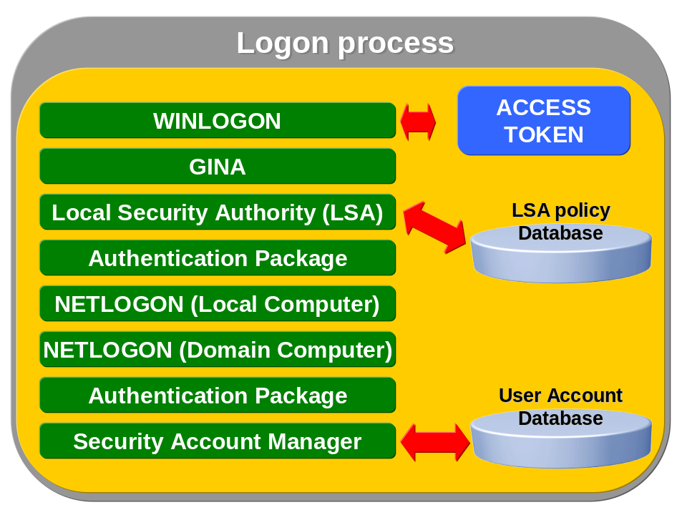
Then when user is logged and his session exist in operating system then there is always his access token with his SID.
Except SID access token contains other very important lists:

- Discretionary Access Control List (DACL)
- Security Access Control List (SACL)

SID, DACL and SACL forms user’s “key” that is used to open any lock of system resource when user is trying to access it.

Security Concepts in .NET environment

Basic layout of .NET Framework – Security parts
.NET Framework security is composed from many technologies and approaches like:
- Code-based security
- Role-based security
- Evidence-based security
- CLR verification & Application Domains
- Cryptography

The following figure presents basic layout of runtime environment and its security components.
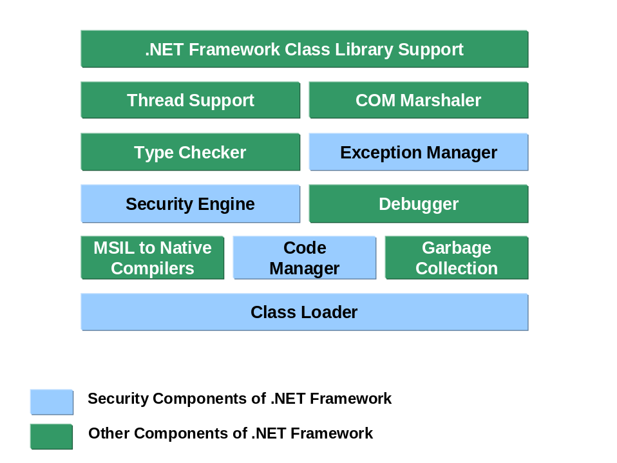
Generally, the .NET platform is very advanced from security point of view, it brings many new approaches and today its one of the best (maybe the best) technical solution even when looking at security concepts. Today’s problems with viruses, buffer overrun and more can be solved by .NET environment and typical advantages will be seen with migration of Microsoft Office into the .NET environment (primitive viruses like MyDoom or similar will not be easy to write as now, we can hope ☺ ).
The Microsoft .NET common language runtime (CLR) controls the execution of code, including just-in-time (JIT) compilation of Microsoft intermediate language code into native assembly code and garbage collection. Because of this CLR can prevent running code from inappropriate behavior and even to protect against security flaws.
As an assembly is loaded, JIT compiled, and executed, the security system verifies it for type safety and enforces code access security policy (see diagram).

Assembly
Assembly is a term used in .NET platform for a specific file generated by compilier after compilation. This file is similar to Windows binary files (at first sight with its extension .exe or .dll) and its layout is derived from standard PE file structure. But it is enhanced to support other features not included in native Windows binary files (for example assembly signature, version etc.).
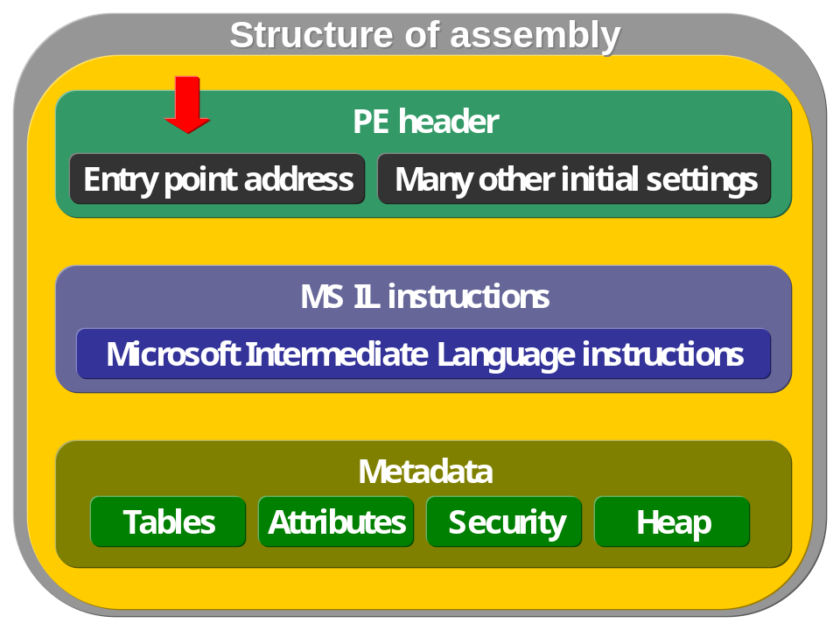

Runtime security policy
Runtime security policy is essential to .NET security, it affects all assemblies running in .NET environment. But these is nothing magical on it – all assemblies are asking for some permissions which are needed to run and all assemblies belond to specific groups depending on configured conditions. .NET environment sets 4 groups, in .NET terminology policy levels:

- Enterprise (configuration settings for enterprise administrators)
- Machine (for local administrators)
- User (for users)
- Application domain (similar to Win32 processes)

.NET security is similar to Windows security provided by operating system. User must provide his password and username, when he his authenticated against SAM database and access token is created and this token is used by process and threads to access system resources.

Similar approach is in .NET, when assembly is loaded it provides its evidences and asking for permissions based on those evidences. They are evaluated by runtime security policy management for each code group where assembly belongs to as it is configured for .NET environement (on figure below is sample code group with Intranet zone belonging to machine level security policy).

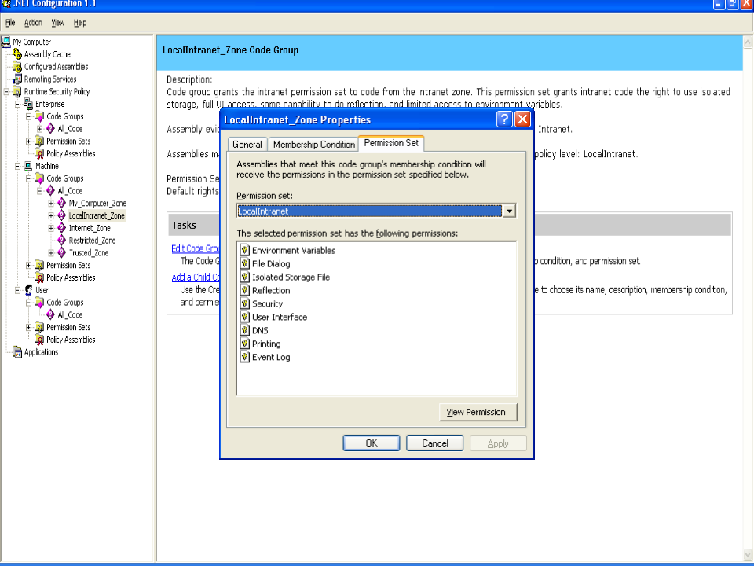

Finally assembly collects permissions from all code groups and when assembly is running and accessing any securable resource then those permissions are checked and access is granted or not.
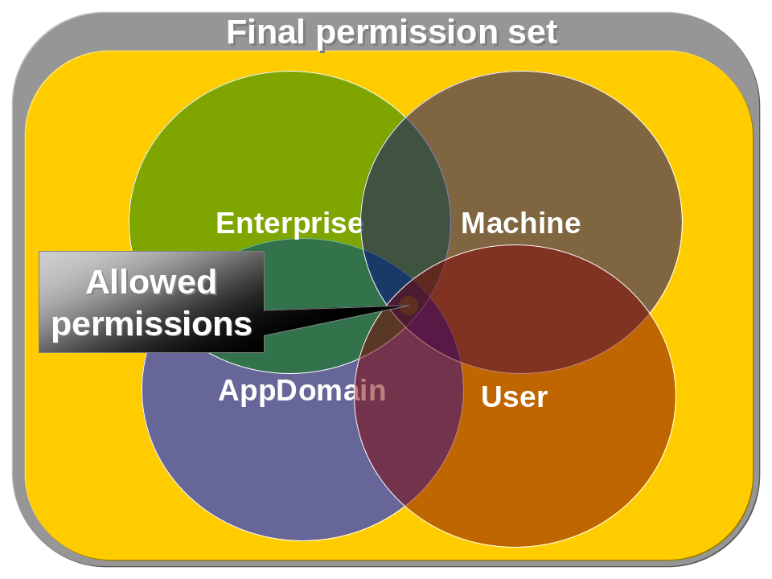
Beside policy levels it is important to realize importance of code groups where permissions are defined. Code groups finally hold permissions and they associate assemblies with their permissions according to defined conditions (by default it is primary zone). On figure below is presented basic principle how code group works:
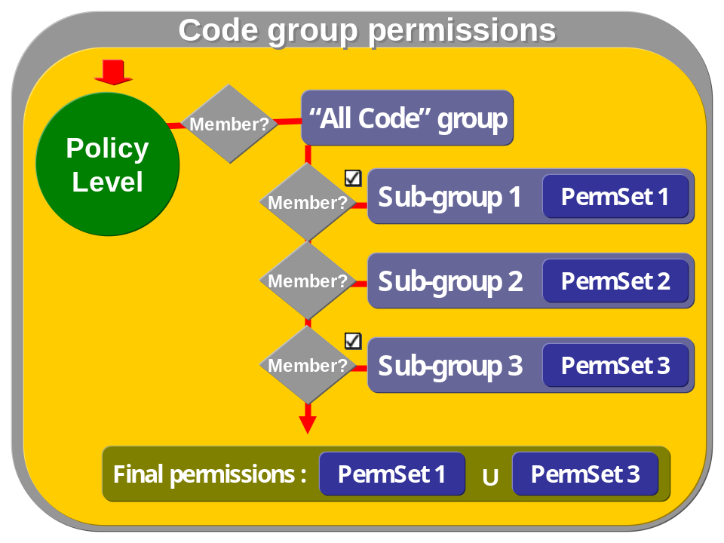
When policy levels work like an intersection of the same granted permissions, code groups join their permissions from one policy level.
Below is a sample with intranet application, when assembly is running in intranet environment (for instance run assembly from remote disk drive), then it is checked for all policy levels and assembly receives appropriate permissions (see figure).
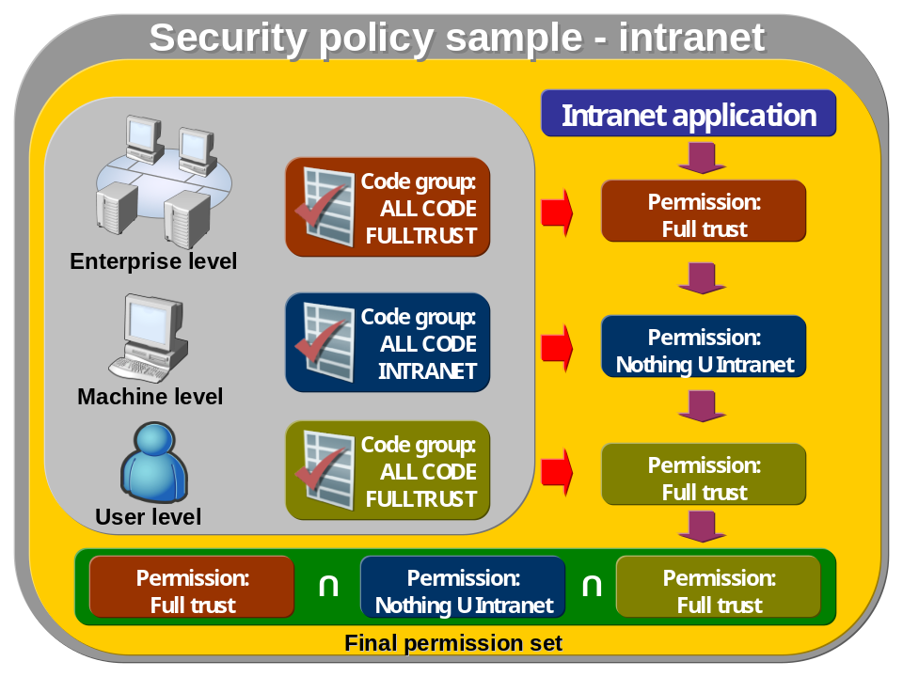
In figure above application has been started from intranet (guess g:\sampleApp.exe). This application has a strong name and when started it is mapped to each levels and appropriate code groups. On enterprise level just All Code group is defined (the same is user level) with full trust permissions. On machine level are other sub-groups limiting permittions:

Code group | Description
My Computer (local) | Code is running on local machine and has full trust permissions.
Intranet | Code is executed from share or URL on LAN (or trusted enterprise network). Code has limited but still high permissions to access system resources.
Internet | Code is executed from internet and has limited permissions to a few resources like isolated storage, printing, dialogs.
Restricted | Code belongs to untrusted sites, it has no permissions.
Trusted | Code is executed from trusted sites and has the same permissions as in Internet code group.

Sample intranet application belongs to code group Intranet and will receive permissions defined in that group (environment variables, file dialog, isolated storage file, reflection, security, user interface, dns, printing, event log).

Types of security context for assemblies
Assembly must always run in security context which depends on behavior of assembly, code zone and type of assembly. Generally assembly can be running in three types of security contexts:

- Security neutral – assembly is running on “as-is” basis, it desn’t request any permissions explicitly and it leaves all configuration and security settings on administrator. This is default bevaior and majority of applications is running in thic context.
- Controled security context – assembly is explicitly controlling its security context and reacts on it. Assembly can use attrbibutes to work in those two submodes:
  - Request permissions – assembly will request security permissions and if not successful it will refuses to run.
  - Assembly refuses assigned permissions. This can happen when assembly is controlling its permission set and when it receives more permissions then it needs then an exceptions is rised. It is because application can protect itself against malicious code misusing redundant permissions.

Generate key pair with sn.exe tool
First option is to generate file with keys which will be used to give a strong name to assembly:

- Switch to the .NET Framework’s command line (Start -> Programs -> Microsoft Visual Studio .NET -> Visual Studio .NET Tools -> Visual Studio .NET Command Prompt)
- Generate key file using sn.exe tool:

sn -k myKey.snk
- This will generate file with RSA private and public key file.

Second option is to store keys in CSP’s store, this is much more secure and recommended because keys are encrypted using DPAPI.
- Generate myKey.snk file as described in previous steps.
- Store keys in CSP store with command:
sn -i myKey.snk "SampleKeyStore"
- Keys are stored in secure container and file can be deleted.

Give an assembly a strong name
Assembly can be signed using file or CSP store, depending where keys are stored. If keys are stored in file then:
- Locate a key pair generated by sn.exe tool.
- Refere to key file in attribute in assembly with strong name:

[assembly: AssemblyKeyFile(@"c:\@samples\MyKeys.snk")]

If keys are located in CSP store then use following attribute:

[assembly: AssemblyKeyName("SampleKeyStore")]

Delayed signing of assembly
This is a modification of signing an assembly with a strong name in previous chapter. There is different usage of keys because private key is not distributed and is kept hidden till final build is prepared and can be finally signed.

- Locate a key pair generated by sn.exe tool.
- Exctract public key from myKey.snk file to new file myPublic.snk.

sn -p myKey.snk myPublic.snk

- Set following attributes in AssemblyInfo.cs file:

[assembly: AssemblyDelaySign(true)]
// use public key file to sign
[assembly: AssemblyKeyFile("myPublic.snk")]

- At the end of application development sign assembly with private key:

sn -r <assembly_name> myKey.snk

or

[assembly: AssemblyDelaySign(false)]
// use main key file to re-sign assembly with delay signing
[assembly: AssemblyKeyFile("c:\\signed\\myKey.snk")]

When assembly is not signed but AssemblyDelaySign is set to true, then in assembly is left enough space for latter signature. But problem is when assembly has to be installed into GAC (strong name is required). For this purpose is recommended to use a temporary private key and change it with final one when application is released.

List of permissions for current assembly
Namespaces:
using System;
using System.Security;
using System.Security.Policy;
using System.Collections;

Code:
static void Main(string[] args)
{
IEnumerator policy = SecurityManager.PolicyHierarchy();
while(policy.MoveNext())
{
PolicyLevel currentLevel = (PolicyLevel)policy.Current;
IEnumerator namedPermission = currentLevel.NamedPermissionSets.GetEnumerator();
while(namedPermission.MoveNext())
{
NamedPermissionSet permissionSet = (NamedPermissionSet)namedPermission.Current;
Console.WriteLine(permissionSet.Name);

IEnumerator psEnumerator = permissionSet.GetEnumerator();
while (psEnumerator.MoveNext())
{
Console.WriteLine("\t" + psEnumerator.Current);
}
}
}
}

List of declarative permissions of assembly
.NET Framework provides tool permview.exe that can be used to get declarative permission requests in assembly.
This tool can be used as follows:

permview.exe assemblyName.exe

Output will be list of permissions declared in assemblyName.exe file.

Output assembly evidence list to XML file
Code:
using System;
using System.IO;
using System.Collections;
using System.Reflection;

namespace SampleAssembly
{
class AsmEvidence
{
static void Main(string[] args)
{
// output file name
string fileName = "asmevidence.xml";
FileStream stream = new FileStream(fileName, FileMode.OpenOrCreate, FileAccess.Write);
StreamWriter writer = new StreamWriter(stream);

writer.WriteLine("<AssemblyList>", writer);

// output current assembly to xml file
outputAssembly(Assembly.GetExecutingAssembly(), writer);

foreach (AssemblyName asmn in Assembly.GetExecutingAssembly().GetReferencedAssemblies())
{
// output referencing assemblies to current assembly
outputAssembly(Assembly.Load(asmn), writer);
}

writer.WriteLine("</AssemblyList>");
// close stream
writer.Close();
}
static void outputAssembly(Assembly asm, StreamWriter writer)
{
writer.WriteLine("<Assembly name='{0}' version='{1}' codebase='{2}' culture='{3}'>", asm.GetName().Name, asm.GetName().Version,
asm.GetName().CodeBase, asm.GetName().CultureInfo);
IEnumerator it = asm.Evidence.GetEnumerator();
while (it.MoveNext())
{
// dont output all raw data to keep file small and readable!!!!
if (it.Current.GetType() != typeof(System.Security.Policy.Hash))
writer.WriteLine(it.Current);
}
writer.WriteLine("</Assembly>");
}
}
}

List policy levels and code groups where current assembly belongs
Namespaces:
using System;
using System.Reflection;
using System.Security;
using System.Security.Policy;
using System.Collections;

Code:
class PolicyGroups
{
static void Main(string[] args)
{
IEnumerator policy = SecurityManager.PolicyHierarchy();
while(policy.MoveNext())
{
PolicyLevel currentLevel = (PolicyLevel)policy.Current;
Console.WriteLine(currentLevel.Label);
CodeGroup group = currentLevel.ResolveMatchingCodeGroups(Assembly.GetExecutingAssembly().Evidence);
ResolveGroups(group);
}
}

static void ResolveGroups(CodeGroup parent)
{
Console.WriteLine("\t" + parent.Name);
if (parent.Children.Count > 0)
{
foreach (CodeGroup cp in parent.Children)
{
if (cp.Children.Count >0) ResolveGroups(cp);
// code is not optimazed to work with many levels in console displaying
else Console.WriteLine("\t\t" + cp.Name);
}
}
}
}

Type safety, metadata and code verification
One of the most important part of .NET is the verifier which is the part of JIT compiler. Verifier ensures that executing code is safe and does some very important checks.
Programmers sometime are using scripting languages like JavaScript or VBScript allowing to use variables without declaration, initialization or assigning them very different types. This can lead to unintended behavior and possible security implications when program mysteriously crashes.
In compiled languages such as C and C++ is possible to do direct memory allocations or to take a pointer and do copy of memory data anywhere. This is a very powerful technique but also this is a source for many bugs and majority of security problems are cased by this.
.NET is very strict on type usage and verifier ensures that all types are declared properly and are properly used. CLR does checks on following issues:

- Uninitialized variables
- Unsafe variable casting
- Out of bounds indexing of array
- Buffer overrun
- Bad use of pointers

Except type checking CLR is taking care of whole code when it loads it from assembly. But what is assembly? It is a package with PE (Portable Executable) format, where this format is similar to DLL structure. But this is extended with new areas like metadata, which has very useful data about classes, methods, fields, heaps, types contained in an assembly (more about PE format on MSDN).
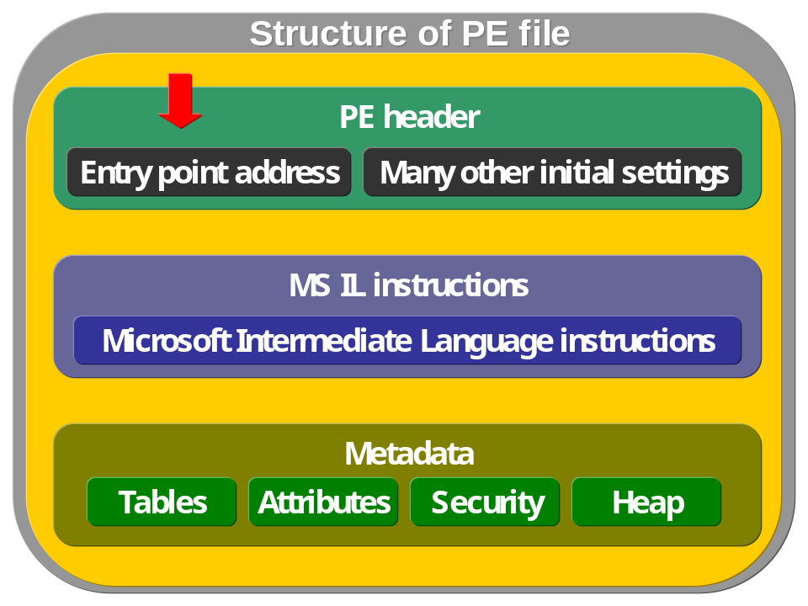
The metadata can be seen as a detailed information section with data about variables, objects, types, security settings etc. One of the most important section of metadata are tables with definition of classes in assembly, table with methods and to this table is related table with method arguments (see diagram bellow).
This is a sample of code in assembly

public class C
{
public void C1(string C11) {
// some code here
}
}

which is then compiled to MS IL code stored in assembly. The metadata of that code contains following tables with appropriate code objects when each row is idenfied by a four-byte number – metadata token.
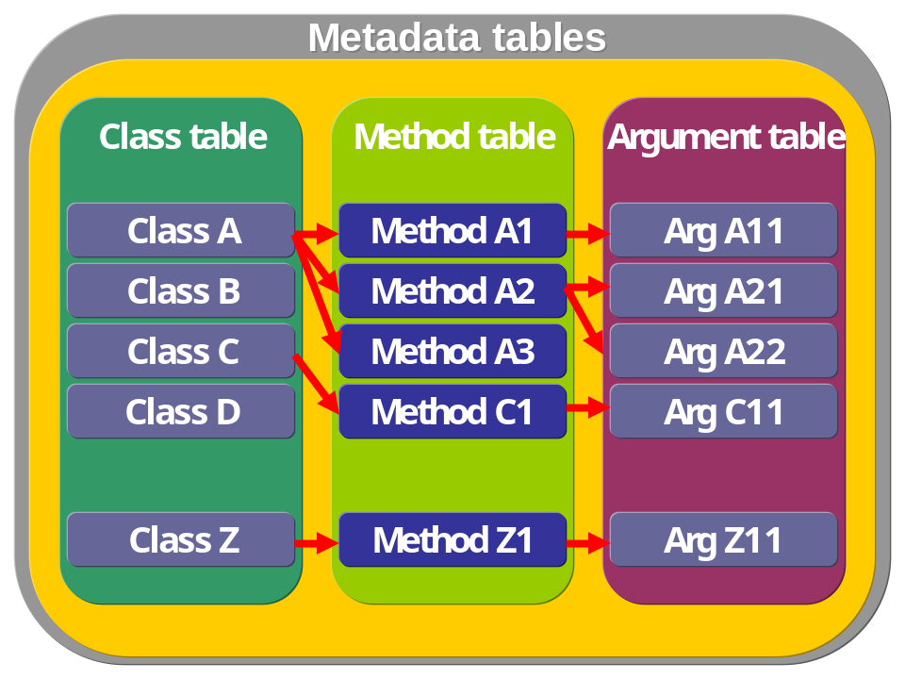
Type-safety verification is the cornerstone of .NET Framework security because it prevents access to unauthorized memory locations. This allows you to consistently enforce security policy. For example, code cannot overrun a buffer and cause execution to jump to an arbitrary memory location.

Metadata are very important to verify code – this process is called is code verification and occurs when assembly is being loaded. Those verifications are very important and should not be disabled (using SkipPermition

Get info about types in assembly
This is just simple sample about reflexion on assembly file and getting basic type info. For professional tool on reflexion use .NET Reflector (see http://www.aisto.com/roeder/dotnet).

Namespaces:
using System;
using System.IO;
using System.Reflection;

Code:
class AssemblyInfo
{
static void Main(string[] args)
{
// name of file with assembly information
string fileName = "AssemblyInfo.txt";
FileStream stream = new FileStream(fileName, FileMode.OpenOrCreate, FileAccess.Write);
StreamWriter writer = new StreamWriter(stream);

// use this to build large info file about assembly from .NET Framework
// name of assembly file to examine
// string asmFile = @"C:\Windows\Microsoft.NET\Framework\v1.1.4322\mscorlib.dll";
// Assembly asm = Assembly.LoadFrom(asmFile);

Assembly asm = Assembly.GetExecutingAssembly();

// basic assembly properties
writer.WriteLine("Location of assembly: " + asm.Location);
writer.WriteLine("Assembly name: " + asm.FullName);
writer.WriteLine("Entry point into assembly: " + asm.EntryPoint);
writer.WriteLine("Assembly loaded from GAC: " + asm.GlobalAssemblyCache);

writer.WriteLine("-------------- Resources --------------");
// get resouce names for current assembly
string[] names = asm.GetManifestResourceNames();
for (int i=0; i<names.Length; i++)
{
ManifestResourceInfo mri = asm.GetManifestResourceInfo(names[i]);
writer.WriteLine(mri.FileName + ", " + mri.ReferencedAssembly + ", " + mri.ResourceLocation);
}

writer.WriteLine("-------------- Types --------------");
foreach (Type types in asm.GetTypes())
{
// inpecting all classes, other types can be easily inspected with similar approach as demonstrated
if (types.IsClass)
{
writer.WriteLine("Class: "+types.Name);
BuildClass(types, writer);
}
}
// close file stream
writer.Close();
}

private static void BuildClass(Type types, StreamWriter writer)
{
writer.WriteLine("\t"+"-------Constructors-------");
foreach(ConstructorInfo ci in types.GetConstructors())
{
writer.WriteLine("\t"+(ci.IsAbstract?"abstract ":"")+(ci.IsPrivate?"Private ":"")+(ci.IsPublic?"Public ":"")
+(ci.IsStatic?"Static ":"")+(ci.IsFinal?"Final ":"")+types.Name+", Parameters: "+ci.GetParameters().Length);
}
writer.WriteLine("\t"+"-------Methods-------");
foreach(MethodInfo mi in types.GetMethods())
{
writer.WriteLine("\t"+(mi.IsPrivate?"Private ":"")+(mi.IsPublic?"Public ":"")
+(mi.IsStatic?"Static ":"")+(mi.IsFinal?"Final ":"")+mi.Name+", Parameters: "+mi.GetParameters().Length);
}
}
}

Application domains
Application domains are very important enhancement in .NET platform providing better configuration, security and performance features. Domains can be understood as “smaller processes” running inside of process’s address space. In each process can be many domains representing different applications (typically this can be seen in web applications running on ASP.NET platform where each application is running inside of its own application domain).

Application domain boundaries and objects
Domain’s address space is protected by CLR separated from each others and can’t be accessed directly. Following picture shows how domains are separated within process and within whole system.
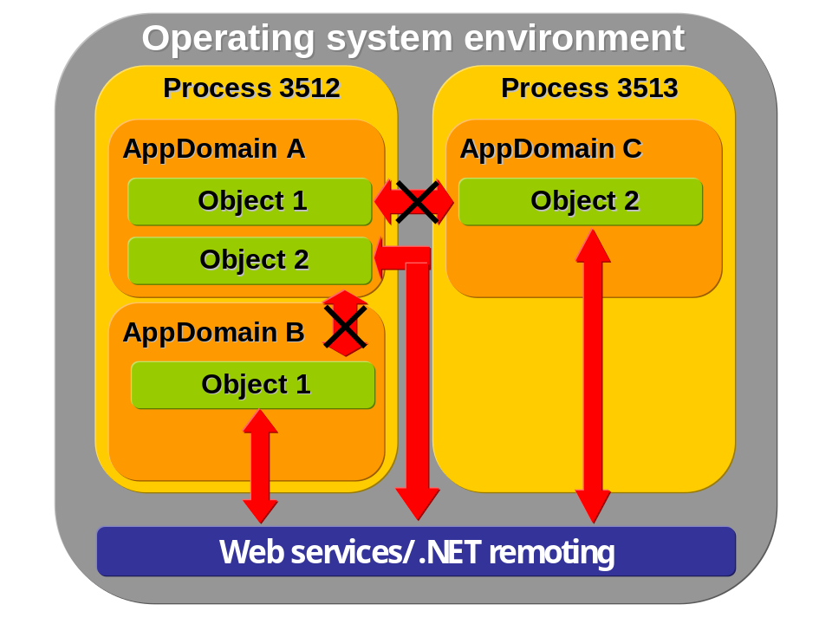
CLR protects every application domain and doesn’t allow them to access other domain’s address space. This can be done just by using web services, messaging or remoting (or by some direct memory operations around CLR environment).
When remoting is involved then there are two options how to pass objects between application domain boundaries:

- Marshal-by-value (MBV)
Objects that are passed as MBV are serializable type and when object is passed then current state of object is serialized and new object in other domain is created and initialized with serialized values. Then in both domains exist two the same objects, but two instances.
This can be achieved by this declaration:

[System.Serializable]
class PassingMBV
{
// here are member variables and properties
}

When working with MBV objects then copy instances are created and to create a new instance in another application domain, metadata with object’s type must be loaded. This means that another assembly must be loaded and can’t be unloaded till domain is closed. This can lead to performance problems and that is why wrappers can be used instead of standard object’s instances.
For that purpose is designed class System.Runtime.Remoting.ObjectHandler which wraps object’s type and is used as a “proxy” that can be called to when object is needed.

- Marshal-by-reference (MBR)
Objects that are passed as MBR are not cloned as MVB’s objects. First proxy of passed is created and this proxy is passed to other domain but still there is a connection with original object which is kept in first domain and the second one makes calls on this object using its proxy.
All MBR objects must be derived from System.MarshalByRefObject:

class PassingMBR : System.MarshalByRefObject
{
// here are member variables and properties
}
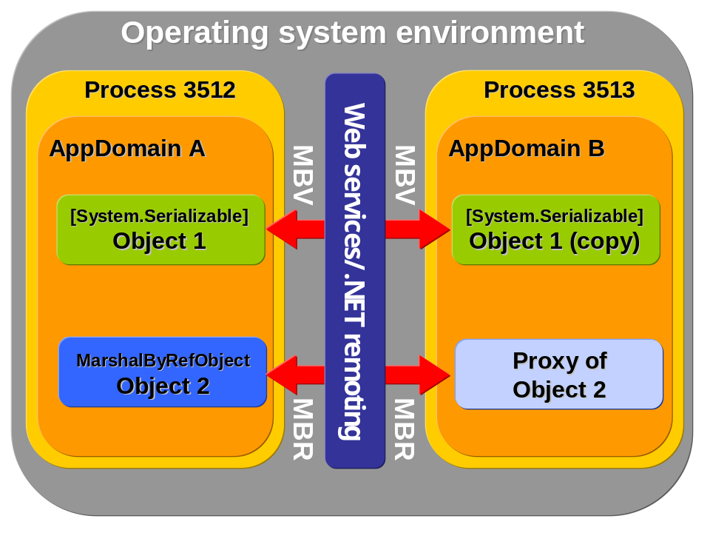
If objects are not MBV (serializable) or MBR (derived from MarshalByRefObject) then they can’t be passed between domain neither way.

Create application domain programmatically
Namespaces:
using System;

Code:
public static void Main(string[] args)
{
AppDomainSetup setup = new AppDomainSetup();
// setup path for a new appdomain, use base of current appdomain, runtime will use it to get private assemblies
setup.ApplicationBase = AppDomain.CurrentDomain.BaseDirectory;
// this is a appdomain configuration file
setup.ConfigurationFile = "app_domain.config";
// this is a list of directories with private assembly, it's relative to ApplicationBase
setup.PrivateBinPath = "first;second;third";
// download or not assemblies over the network (http)
setup.DisallowCodeDownload = false;
// if configuration file is provided then this enables to use policy section in config file
setup.DisallowPublisherPolicy = true;

AppDomain newDomain = AppDomain.CreateDomain(
"SecondAppDomain",
AppDomain.CurrentDomain.Evidence,
setup);
}

Shadow copy enabled for application domain
Sometimes it’s important to keep executable file unlocked (for instance when compiling or publishing new assembly version in real-time environment). To achieve this, application domain must be setup to enable shadow copy feature, then assembly is cached by a system and not locked. This feature is used extensively by ASP.NET and can be used in many scenarios like custom deploying and versioning system etc.

Namespaces:
using System;
using System.Diagnostics;

Code:
static void Main(string[] args)
{
// get current executable file name
string file = Process.GetCurrentProcess().MainModule.FileName;

// create setup for main domain (this will hold shadowed copy of assembly)
System.AppDomainSetup mySetup = new System.AppDomainSetup();
mySetup.ApplicationName = "ShadowingDomain";
// enable Shadowcopying, MUST be string!
mySetup.ShadowCopyFiles = "true";
// which directory will be shadowcopied
mySetup.ShadowCopyDirectories = AppDomain.CurrentDomain.BaseDirectory;
// where will go copied files
mySetup.CachePath = AppDomain.CurrentDomain.BaseDirectory;

// new application domain to be shadowed
AppDomain domain = AppDomain.CreateDomain(AppDomain.CurrentDomain.FriendlyName,
AppDomain.CurrentDomain.Evidence,
mySetup);

// if shadowing is not started yet
if (!AppDomain.CurrentDomain.ShadowCopyFiles) domain.ExecuteAssembly(file);
}

Security tools available in .NET
Here is alphabetical list of available security tools in .NET Framework 1.1.

Tool name | Description | MSDN reference
Certificate Creation Tool  (makecert.exe) | Generates X.509 certificates for testing purposes only. | Details
Certificate Manager Tool  (certmgr.exe) | Manages certificates, certificate trust list (CTLs) and certificate revocation list (CRLs). Works with local account and can help with local testing of security features using certificates. The same tool is available through Internet Explorer (Internet options->Content->Certificates). | Details
Certificate Verification Tool  (chktrust.exe) | Checks the validity of a file signed with an Authenticode certificate. | Details
Code Access Security Policy  (caspol.exe) | Enables users and administrators to modify security policy for the machine policy level, and the enterprise policy level. | Details
File Signing Tool  (signcode.exe) | Signs portable executable file (.dll or .exe) with an Authenticode digital signature and required permissions for code are added. This gives a control over security restrictions placed on executable files. | Details
Isolated Storage Tool  (storeadm.exe) | Lists or removes existing stores for the current user. Sample isolated storages for Windows XP are:  - Roaming enabled: <SYSTEMDRIVE>\Documents and Settings\<user>\Application Data  - Non-roaming: <SYSTEMDRIVE>\Documents and Settings\<user>\Local Settings\Application Data  See chapter 6.18. | Details
Permissions View Tool  (permview.exe) | This tool is used to view the minimal, optional, and refused permissions sets requested by an assembly. | Details
PEVerify Tool  (peverify.exe) | It helps to verify if generated MSIL code meets type safety requirements (generally this tool is not useful for application programmers but just the system ones, who write compilers or when developers wants to use compilers provided from third party and check the compiler’s output). | Details
Secutil Tool  (secutil.exe) |  | Details
Set Registry Tool  (setreg.exe) |  | Details
Software Publisher Certificate Test Tool  (cert2spc.exe) |  | Details
String Name Tool  (sn.exe) |  | Details

Code Access Security
Code access security is a basic part of .NET security concepts enabling to identify code privilege to run specific type of operation requiring some type of authorization to do it.
CAS divides code trust into different levels depending on where the code originates and also other aspects of its identity (like strong name etc.).
In .NET terminology this is called as permission and .NET defines three types of them:

- Code Access Permissions
Those types of permissions derive from System.Security.CodeAccessPermission abstract class. From that class are derived other classes representing different permissions like System.Data.Common.DBDataPermission (ensures that user has a security level adequate for accessing data), System.Security.Permissions.FileIOPermission (it controls the ability to access files and folders) and many others.
- Identity Permissions
Also identity permissions are classes derived from System.Security.CodeAccessPermission abstract class. However, those classes are used for a different purpose when compared with code access permissions. Identity permissions enable to securely run assemblies according to type of their origin. For instance, when assembly is downloaded from Internet, then it can be identified by System.Security.Permissions.ZoneIdentityPermission class.
- Other Permissions

Stack-walk
Stack walk is a basic part of .NET security. It checks calling queue for a specific system resource where are some security concerns. When code is accessing protected system resource and demanding a permission to accees it, then stack walk is performed.
When function is called then there is createded a frame in .NET security stack where all data related to this call are stored.
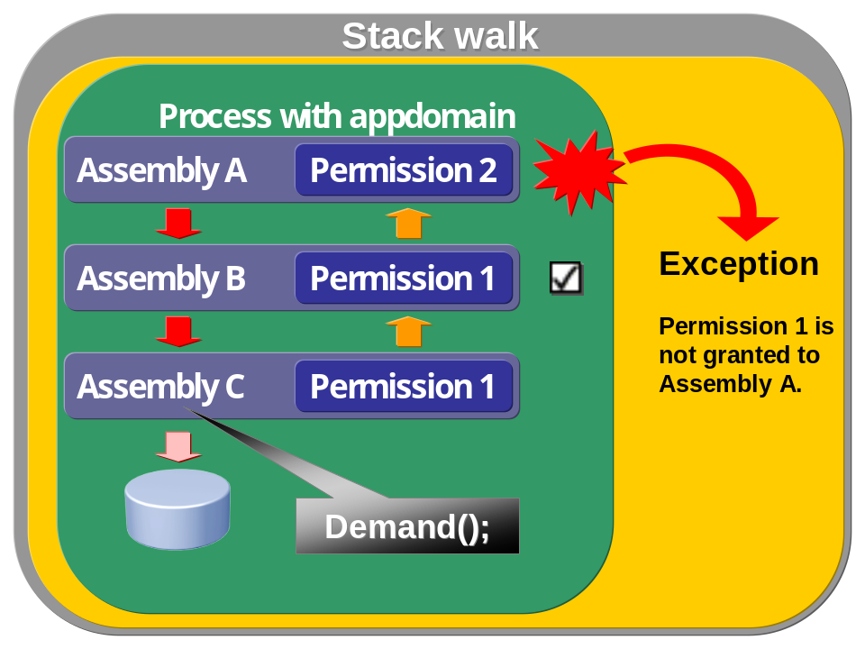
On figure above is presented situation when assemblies are nested with method calls finally asking for some system resource. Assembly C is calling Demand() casing to run through all stack frames in stack (there are two frames for methods from assembly A and B) and check their permission set for permission 1. If permission 1 is granted then it is ok, if not then SecurityException will be rised like in case of assembly A (there is just permission 2).
Stack walk is very important to protect against “luring attack” when some malicious applications takes advantage of some otherone with higher privileges and does something harmful. Stack walk is great to improve protection agains such type of attack but still there are many issues which must be considered like:

- Stack walk is limited to process and machine boundaries. When calling Demand when remoting or web services are involved then checking is not done on other machines, checking of user’s rights must be done using other techniques).
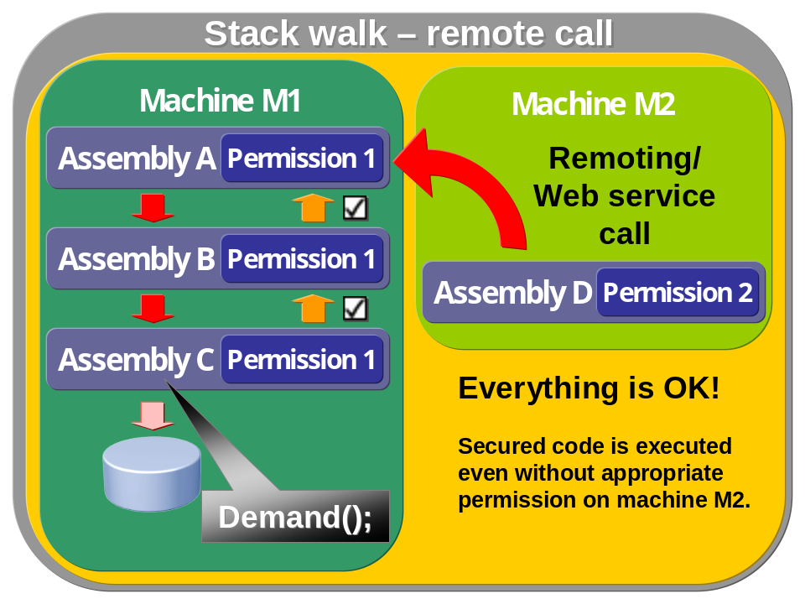
- Demand method is very expensive (it checks all related check frames to last method call). LinkDemand and Assert should be considered, but they can open holes to security.
- Last method call is not checked.

Role-based Security

Identity classes (also Whidbey)
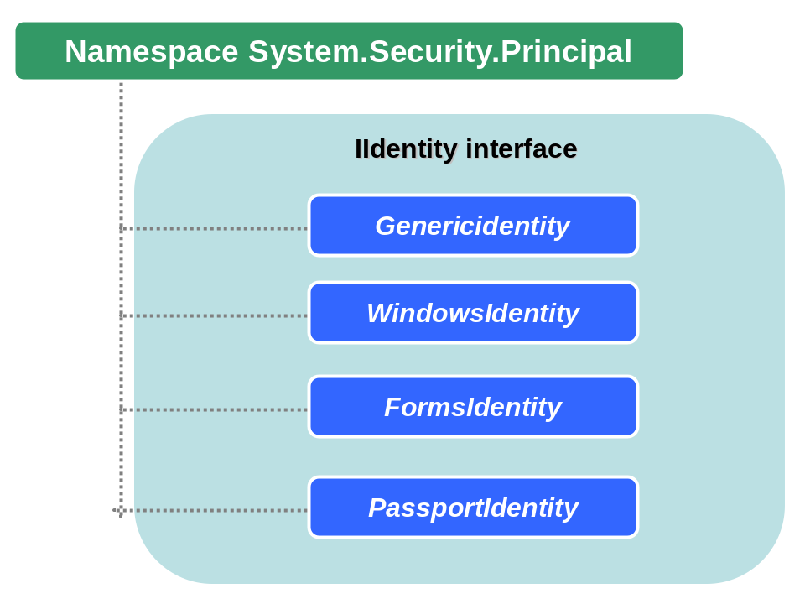

Principal policy
In .NET are recognized two types principals: windows principal and generic principal. The first one is related to Windows security context and when current Windows principal is associated with access token tight to each process under Windows. When generic principal is involved then this security context is independent from underlaying environment like Windows. By default .NET principal policy is set to generic identity and anonymous user. To change default settings call SetPrincipalPolicy() method on the beginning. See following samples where is described how principal policy can be set.
In first sample is presented code where on first two lines is accesed and initialized principal object of currect thread.

using System;
using System.Threading;
using System.Security;
using System.Security.Principal;

public static void Main(string[] args)
{
// get default principal - this will be GenericPrincipal
IPrincipal principal = Thread.CurrentPrincipal;
Console.WriteLine("Default principal: "+ principal.GetType());

// change default policy to Windows, this will not work!!! principal object has been activated already!!!

AppDomain.CurrentDomain.SetPrincipalPolicy(PrincipalPolicy.WindowsPrincipal);

// output will be a GenericPrincipal again
principal = Thread.CurrentPrincipal;
Console.WriteLine("Changed principal: "+ principal.GetType());
}

Output of this program will be always GenericIdentity because this principal has been bind to current thread with call Thread.CurrentPrincipal and setting other principal policy will be ineffective. But consider next code section:

public static void Main(string[] args)
{
// first change default policy to Windows principal
AppDomain.CurrentDomain.SetPrincipalPolicy(PrincipalPolicy.WindowsPrincipal);

// output will be WindowsPrincipal now!
IPrincipal principal = Thread.CurrentPrincipal;
Console.WriteLine("Changed principal: "+ principal.GetType());
}

Here is SetPrincipalPolicy() called first and it will be effective so console output will be WindowsIdentity class. If programmer needs to deal with different principals in application then new threads should be created and in ThreadStart delegate should be done their inicialization as shown in following sample:

using System;
using System.Threading;
using System.Security;
using System.Security.Principal;

class ManyPrincipalsSample
{

private static PrincipalPolicy pp;

public static void Main(string[] args)
{
// !!!!!!!!!!!!!!!!!!!!!!!!
// whe this code is uncommented then all CurrentPrincipal objects will be GenericPrincipal
// IPrincipal principal = Thread.CurrentPrincipal;
// Console.WriteLine(principal.GetType());

// set principal for thread t1 to WindowsPrincipal
pp = PrincipalPolicy.WindowsPrincipal;
// create a new thread
Thread t1 = new Thread(new ThreadStart(SetThread));
t1.Start();
t1.Join();

// set principal for thread t2 to UnauthenticatedPrincipal
pp = PrincipalPolicy.UnauthenticatedPrincipal;
Thread t2 = new Thread(new ThreadStart(SetThread));
t2.Start();
t2.Join();

// set principal for thread t3 to NoPrincipal, no principal object will be created!!!
pp = PrincipalPolicy.NoPrincipal;
Thread t3 = new Thread(new ThreadStart(SetThread));
t3.Start();
t3.Join();
}

// this is a delegate for newly created thread object (ThreadStart)
public static void SetThread()
{
// set principal policy of newly created thread
Thread.GetDomain().SetPrincipalPolicy(pp);
// get principal object
IPrincipal principal = Thread.CurrentPrincipal;
// output principal object's name
if (principal != null) Console.WriteLine(principal.GetType());
else Console.WriteLine("No principal object.");
}
}

Principal classes
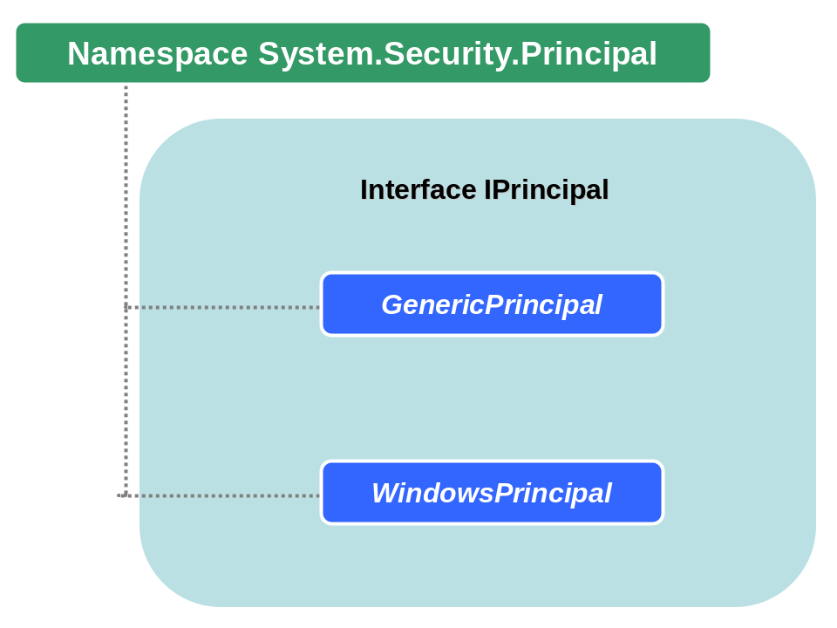

Get list of groups for current thread’s identity
Namespaces:
using System;
using System.Collections;
using System.Threading;
using System.Security.Principal;

Code:
static void Main(string[] args)
{
ArrayList array = new ArrayList();
// set appdomain to bind threads to windows identity objects, then windows security api can be used
AppDomain.CurrentDomain.SetPrincipalPolicy(PrincipalPolicy.WindowsPrincipal);
// WindowsPrincipal is default principal object
WindowsPrincipal wp = (WindowsPrincipal) Thread.CurrentPrincipal;

// create array of mapped Builtin groups provided by .NET FW
// there can be SecurityException when builtin group RID doesnt exist in all Windows systems
try
{
// if (wp.IsInRole(WindowsBuiltInRole.AccountOperator)) array.Add("Managed - Account Operator");
if (wp.IsInRole(WindowsBuiltInRole.Administrator)) array.Add("Managed - Administrator");
if (wp.IsInRole(WindowsBuiltInRole.BackupOperator)) array.Add("Managed - Backup Operator");
if (wp.IsInRole(WindowsBuiltInRole.Guest)) array.Add("Managed - Guest");
if (wp.IsInRole(WindowsBuiltInRole.PowerUser)) array.Add("Managed - Power User");
// if (wp.IsInRole(WindowsBuiltInRole.PrintOperator)) array.Add("Managed - Print Operator");
if (wp.IsInRole(WindowsBuiltInRole.Replicator)) array.Add("Managed - Replicator");
// if (wp.IsInRole(WindowsBuiltInRole.SystemOperator)) array.Add("Managed - System Operator");
if (wp.IsInRole(WindowsBuiltInRole.User)) array.Add("Managed - User");
}
catch (ArgumentException se)
{
Console.WriteLine(se.Message);
}

// user can check if account is in builtin roles by those command (they should be changed appropriatelly to reflect used builtint accounts)
if (wp.IsInRole(@"BUILTIN\Administrators")) array.Add("String - Administrators");
if (wp.IsInRole(@"BUILTIN\Guests")) array.Add("String - Guests");
if (wp.IsInRole(@"BUILTIN\Users")) array.Add("String - Users");
IEnumerator en = array.GetEnumerator();
while(en.MoveNext())
{
Console.WriteLine(en.Current);
}
}

Get current user name
This sample presents two different approaches to getting current user information.

Namespaces:
using System;
using System.Net;
using System.Security.Principal;

Code:
static void Main(string[] args)
{
// get info about current user using Environment class
Console.WriteLine(Environment.UserDomainName + @"\" + Environment.UserName);

// --------------------------

// get current user from WindowsIdentity class
WindowsIdentity user = WindowsIdentity.GetCurrent();
// output current user name
Console.WriteLine(user.Name.ToString());
}

Impersonate as another user
using System;
using System.Runtime.InteropServices;
using System.Security.Principal;

class ImpersonateUser
{
// this implementation doesn't handle GetLastError function to catch error messages, it should be implemented in standard application

// mapping of Win32 function to logon under another account
[DllImport("advapi32.dll", SetLastError = true)]
public static extern bool LogonUser(
String lpszUsername,
String lpszDomain,
String lpszPassword,
int dwLogonType,
int dwLogonProvider,
ref IntPtr phToken);

// this will duplicate access token based on current user's one
[DllImport("advapi32.dll", CharSet = CharSet.Auto, SetLastError = true)]
public extern static bool DuplicateToken(
IntPtr ExistingTokenHandle,
int SECURITY_IMPERSONATION_LEVEL,
ref IntPtr DuplicateTokenHandle);

[DllImport("kernel32.dll", CharSet = CharSet.Auto)]
public extern static bool CloseHandle(IntPtr handle);

static void Main(string[] args)
{
const int LOGON32_LOGON_INTERACTIVE = 2;
const int LOGON32_PROVIDER_DEFAULT = 0;
const int SecurityImpersonation = 2;
// handle of access token of current user
IntPtr token = IntPtr.Zero;
// new token based on the old one
IntPtr duplicateToken = IntPtr.Zero;

// this method returns handle to access token of user we want to use to logon, user is check just in local database
if (LogonUser("TestUser", ".", "Test1234]", LOGON32_LOGON_INTERACTIVE, LOGON32_PROVIDER_DEFAULT, ref token))
{
// token is duplicated according to the token of impersonated user
if (DuplicateToken(token, SecurityImpersonation, ref duplicateToken))
{
Console.WriteLine("Current user name: " + WindowsIdentity.GetCurrent().Name);
// new identity is created
WindowsIdentity newIdentity = new WindowsIdentity(duplicateToken);
// !!!! This is the impersonation !!!!
WindowsImpersonationContext impersonatedUser = newIdentity.Impersonate();
Console.WriteLine("Current user name: " + WindowsIdentity.GetCurrent().Name);
// return to the old user
impersonatedUser.Undo();
Console.WriteLine("Current user name: " + WindowsIdentity.GetCurrent().Name);

// close handles to tokens
CloseHandle(token);
CloseHandle(duplicateToken);
}
else { Console.WriteLine("Error duplicate."); }
}
else { Console.WriteLine("Error logon."); }
}
}

Declarative principal permissions for Windows roles
This sample demonstrates usage of declarative principal permissions integrated with Windows groups. There is class MethodClass with MethodA and this class demands its callers to be members of group of administrators. To run it correctly, Thread line must be uncommented otherwise application will rise an exception because caller will not be authorized to use class MethodClass.

Namespaces:
using System;
using System.Security;
using System.Threading;
using System.Security.Permissions;
using System.Security.Principal;

Code:
class TestPrincipalPermission
{
static void Main(string[] args)
{
try
{
// -------- uncomment this to run app correctly, otherwise it will rise an exception!!!!
// -------- set appdomain to use windows principal!!!
// Thread.GetDomain().SetPrincipalPolicy(PrincipalPolicy.WindowsPrincipal);
MethodClass.MethodA();
}
catch (SecurityException se)
{
Console.WriteLine("You are not authorized to access MethodA! Change role name.");
Console.WriteLine(se.Message);
}
}
}

// caller must be in group of administrators
[PrincipalPermissionAttribute(SecurityAction.Demand, Role=@"BUILTIN\Administrators")]
class MethodClass
{
public static void MethodA()
{
Console.WriteLine("MethodA was called!");
}
}

Declarative principal permissions for custom roles
Namespaces:
using System;
using System.Security;
using System.Threading;
using System.Security.Permissions;
using System.Security.Principal;

Code:
class TestPrincipal
{
static void Main(string[] args)
{
try
{
GenericPrincipal gp = new GenericPrincipal(new GenericIdentity("Jan Seda"), new string[] {"SampleRole"});
// set generic principal object, this will be used to authenticate to MethodClass
Thread.CurrentPrincipal = gp;
// call method
MethodClass.MethodA();
}
catch (SecurityException se)
{
Console.WriteLine("You are not authorized to access MethodA! Change role name.");
Console.WriteLine(se.Message);
}
}
}

// caller must have "SampleRole"
[PrincipalPermissionAttribute(SecurityAction.Demand, Role=@"SampleRole")]
class MethodClass
{
public static void MethodA()
{
Console.WriteLine("MethodA was called!");
}
}

Cryptography & Security

Buffer Overrun
Buffer overrun is one of the most common and the most dangerous security risks. This vulnerability exists because of low level of memory management that exists in languages like C/C++. Generally, buffer overruns occurs when the size of a variable is not large enough to hold a given value and the memory buffer is overwritten with inappropriate values. There are three kinds of buffer overruns:
- Static buffer overrun
- Heap overrun
- V-table and function pointer overwriting
- Exception handler overwriting
So how buffer overrun works? The basic principle can be seen on the following diagram
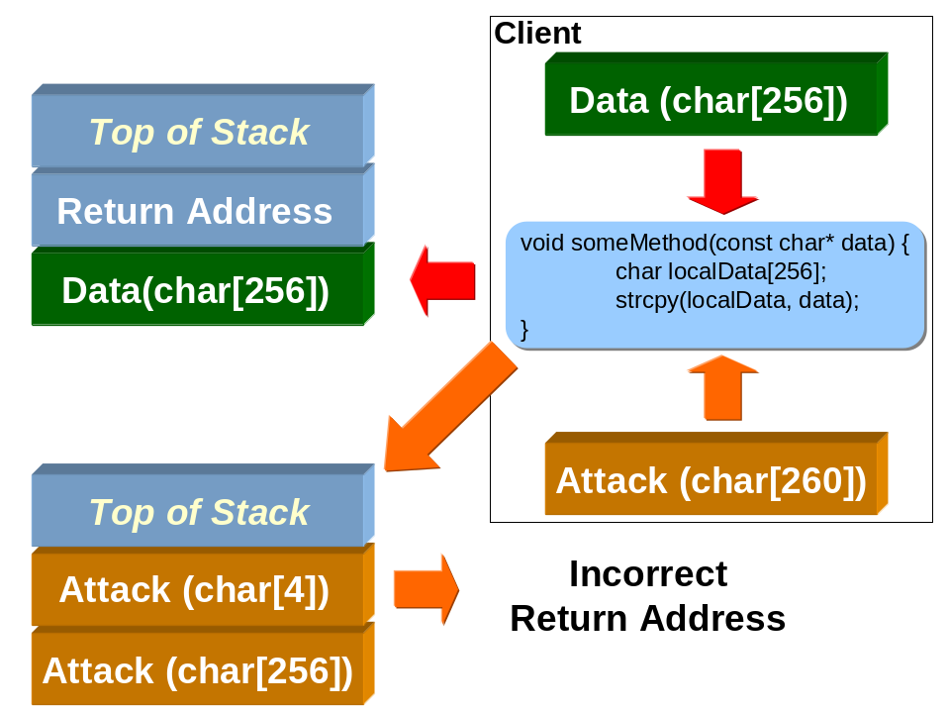
As can be seen on a diagram, green data panel is correct with its size. It holds 256 bytes and its stccpy()s to stack as appropriately. But because there is no size check in method someMethod, it is possible to send unlimited data, like in second example char[260]. The attacker can do some tests on buffer overflow and if he is lucky he can override system values and get weird results, in better case he gets just access violation error and process shuts down. In case hacker makes successful attack, he will be able to overwrite the method’s return address and execute some arbitrary code with the same privileges as the running process.

CodeRed Worm, Buffer Overrun attack
In July 2001 worm CodeRed started to propagate itself over the Internet and affected Microsoft IIS. The problem was cased by usage of Unicode and ANSI format, when developer writing a small part of code in IIS forgot to do a check on passed parameter and its size calculated to Unicode format (its two bytes long, not one byte as ANSI).
This is a sample of affected code:
...
// cchAttribute is a byte count of user input
WCHAR wcsAttribute[200];
if (cchAttribute >= sizeof wcsAtrribute)
THROW (CException(DB_E_ERRORSINCOMMAND));
DecodeURLEscapes((BYTE*) pszAttribute, cchAttribute,
wcsAttribute, webServer.CodePage());
...
As been seen, first two rows are the reason for existence of CodeRed worm. There is a check on cchAttribute size, where sizeof is calculated on ANSI size of wcsAttribute. But WCHAR is Unicode and that is why it is two time bigger that developer was expecting it should be. With this error hacker has 200 bytes available for attack.
This error can be fixed by a following check:
...
// cchAttribute is a byte count of user input
WCHAR wcsAttribute[200];
if (cchAttribute >= sizeof wcsAtrribute / sizeof WCHAR)
THROW (CException(DB_E_ERRORSINCOMMAND));
...
When wcsAttribute is divided by size of WCHAR, then we get a correct value and check is fine. If code should be absolutely correct we should make division by a first array member:
...
// cchAttribute is a byte count of user input
WCHAR wcsAttribute[200];
if (cchAttribute >= sizeof wcsAtrribute / sizeof wcsAttribute[0])
THROW (CException(DB_E_ERRORSINCOMMAND));
...
and not by using WCHAR because value of WCHAR can be changed and our code would be again insecure. With this approach we are fine for all times (we can hope for some time ☺).

SQLSlammer
Another type of very dangerous worm is SQLSlammer that used a security hole in Microsoft SQL Server 2000, but this attack used buffer underrun when UDP packets were sent to port 1433 with length of 376 bytes. This cased buffer underrun and worm was loaded as resident program and started to scan and send other internet addresses.

Algorithms for Encryption

Well Known Algorithms for Symmetric Encryption
Algorithm | Description
Data Encryption Standard (DES)  (see chapter 6.10.4) | Relatively slow, key - 56 bits, not suitable for high-security encryption
Triple DES | Performs three DES roundtrips, equivalent of 168-bit key, relatively slow, widely used
Advanced Encryption Standard (AES) | 128-, 192-, 256-bit keys, current standard used by U.S. government
International Data Encryption Algorithm (IDEA) | 128-bit key, requires licensing for commercial use
RC2 | 8- to 128-bit keys, stream cipher

Well Known Algorithms for Asymmetric Encryption
Algorithm | Description
RSA | 384 – 16384 bit keys, used to encrypt data and generate digital signatures, de-facto standard for asymmetric encryption
Diffie-Helman | 768 – 1014 bit keys, fast asymmetric algorithm
ElGamal
DSA | 512 – 1024 bit keys, only supports digital signatures

Well Known Hash Algorithms
Algorithm | RFC | Description
Message Digest 4 (MD4) | RFC 1320 | 128 bits, very fast, appropriate for medium security usage
Message Digest 5 (MD5) | RFC 1321 | 128 bits, fast, more secure then MD4
Secure Hash Standard (SHA-1) | FIPS PUB 180-1 | 160 bits, slower then MD5, standard for U.S. government

Digital Certificates
A digital certificate is an item of information that binds the details about individual or organization to the individual’s or organization’s public key. Digital certificates can be used to verify the identity of both clients and servers.
A digital certificate is a binary structure that contains information about the holder of a public key. The most common form of certificate is the X.509 certificate. There are three versions of this certificate:1, 2 and 3.

Secure Communication Standards

IPSec (Internet Protocol Security)
IPSec is a framework of open standards you can use to ensure secure, private communication over IP networks by using a combination of cryptography security services that are negotiated between client and server. IPSec is build by using other encryption standards, including symmetric algorithms such as DES, 3DES and RC5 and hashes such as MD5 and SHA-1.

Kerberos
Kerberos is one of the most important security protocols. His name is derived from mythological three-headed dog guarding entrance into the Hades. But this is mythology but in computer sciencie Kerberos means a new standard developed by MIT to keep primary network authentication secure and prevent sending passwords as plaintext over the network.

SSL (Secure Socket Layler)
SSL (Secure Sockets Layer) is a protocol for session-based encryption and authentication. The advantage of is that it lends itself to applications that require a trust relationship between client and server and want to defeat themselves from eavesdropping, tampering and message forgery.
SSL can be thought of as a pipeline between a client and server protecting transferred data.

History of SSL
SSL protocol was developed by Netscape in 1994 and now it is widely accepted as a secure standard for internet communication (today it’s implemented in nearly all web servers and browsers). The protocol comes in three versions:

- SSLv2
- SSLv3
- TLSv1 (SSLv3.1)

SSL version 3 is the predominant protocol used worldwide as an secure standard. This version solves many issues like requesting a new handshake from client or from server in any time to change keys used to encipher client-server communication.

Description of SSL
In TCP stack of protocols SSL is at the transport layer and is idependent of the application protocol. That is why application protocols can use SSL as it is shown in figure bellow.

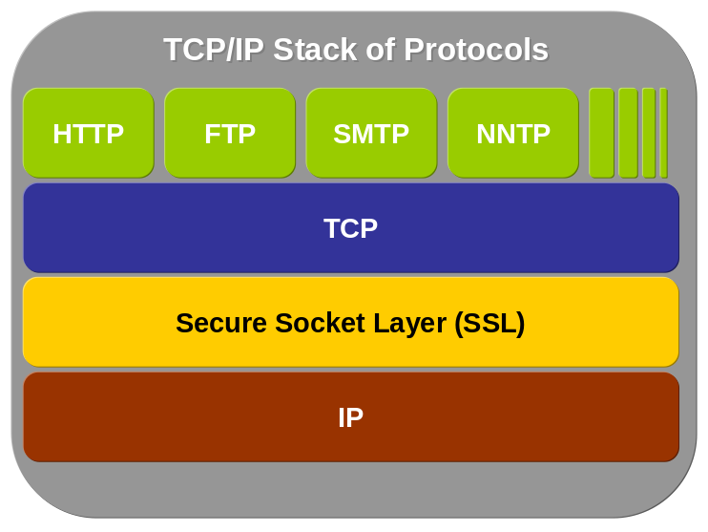

SSL encryption relies on the server’s public key and private key. The private key exists only on the Web server and is used by the Web server to encrypt and decrypt secure messages. The public key exists on any client computer that has installed a certificate for that Web server. After the public key is installed, the user can send encrypted messages to, and decrypt messages received from, the Web server.
When SSL is used, the following occurs:
- The user browses to the secure Web server’s site.
- 2. The browser creates a unique session key and encrypts it by using the Web server’s public key, which is generated from the root certificate. Each session key that the Web server’s certificate generates is unique. Therefore, even if a hacker has the same certificate installed on their browser, the hacker cannot decrypt the message. The browser where the encrypted message originated cannot decrypt the message. Only the Web server with the appropriate private key can decrypt the message.
- The Web server receives the message and decrypts it by using its private key. This phase of SSL communication is often called the SSL handshake. A hacker may intercept a message protected with SSL. However, the hacker cannot decrypt the message, because the hacker does not have the Web server’s private key.
- After the connection is established, all communication between the browser and the Web server is secure.
- When the session ends, the session key is destroyed.

SSL Handshake
But thse steps are a very short and brief description of what happens when SSL is getting involved. But sometimes (primary when calling from application other services like .aspx pages and we want to use SSL from application).
That is why deeper knowledge is essential. One of the most asked question on SSL is regarding the SSL Handshake when connection is established. That is why there are the steps of handshake to understand this process:

- The client sends the server client’s SSL version number, proposed type of cipher, session specific data and other data required by server to communicate with the client.
- The server sends to client the same request with the same type of data: the server’s SSL version, type of cipher, session specific data and other data required by client to communicate with the server. The server also sends the server’s certificate and client can send its own client certificate if it’s required by server to access some resources.
- The client uses data sent by server to authenticate the server according to process in figure below (more details on Microsoft’s web site):
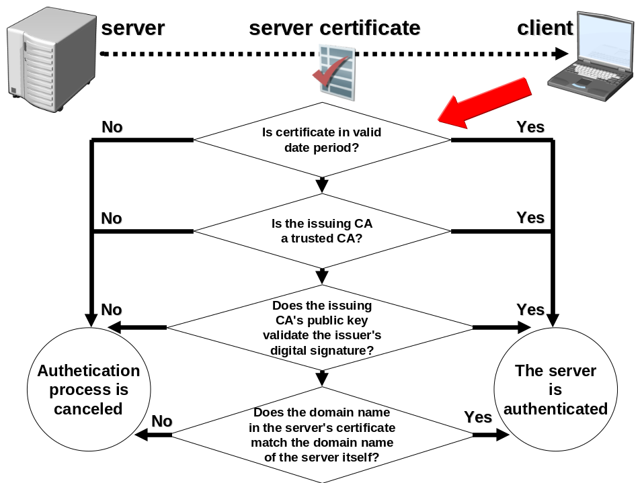
- The client uses all data generated in handshake up to now to create pre-master secret for current session (pre-master secret is 48 bytes large). This “pre-master” is encrypted by the server’s public key from server’s certificate (see step 2) and sends it to the server. The pre-master secret is
- This is an optional step in handshake – client authentication. In case that server has requested client’s authentication to access some resources and in such a situation the client’s certificate is used. The clients signs data known to both client and server and together he sends the client’s certificate along with the pre-master secret. When client’s authentication is required then server runs according to following diagram:
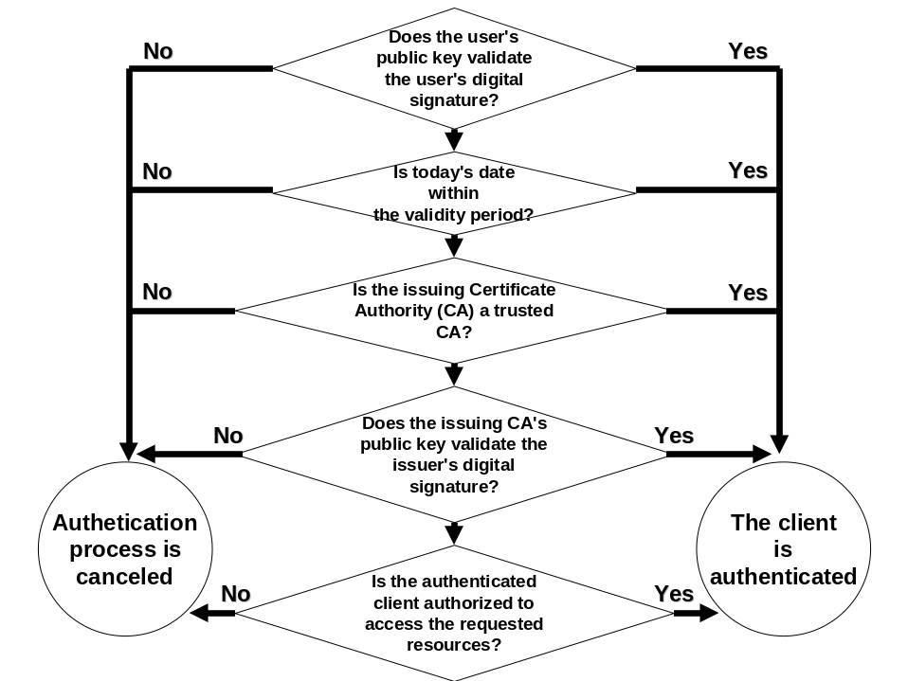
- When client is authenticated (when required) server uses its private key to decipher the pre-master secret from and then generates master secret. This happens on both sides – on the client and the server simultaneously:
"master_secret =
MD5(pre_master_secret + SHA('A' + pre_master_secret +
ClientHello.random + ServerHello.random)) +
MD5(pre_master_secret + SHA('BB' + pre_master_secret +
ClientHello.random + ServerHello.random)) +
MD5(pre_master_secret + SHA('CCC' + pre_master_secret +
ClientHello.random + ServerHello.random));"
- Both the client and the server use the master secret to generate session keys, which are used for symmetric encryption used during the SSL’s session.
- Finally the client sends to server a message informing that future messages will be encrypted by symmetric key.

Cryptography

Basic terms in cryptography
Cryptography – is the science concerting ciphering and deciphering of some data to protect it from unauthorized access.
Steganography – this is a collection of techniques hiding data (for instance encrypted data) into some medium carrying them (like microfilm, images etc.). Generally steganography isn’t difficult to break (when compared with cryptography), but it hides data that could become a target for attack. Generally steganography is used together with cryptography to cover the encrypted data by some unimportant wrapper (like image) and not to show them to possible attacker to use on them some cryptoanalytic attacks.
Cryptoanalysis – this is the science related to cryptography, but its purpose isn’t to protect data but to find ways how to decrypt data without knowledge of secret key used for encryption.
Plain text – this term defines data, that are clear before encryption (generally readable text or similar form of data).
Cipher text – when plain text is encrypted, then cipher text is created. Input data (plain text) are now transformed to cipher text form, which is unreadable to unauthorized person.
Symmetric algorithms – A symmetric algorithm uses the same key for encryption and also for decryption of the same data.
Asymmetric algorithms – An asymmetric algorithm is based on research of Diffie and Hellman in 1976, when they published the first publication on this topic. The basic principle is presence of private and public keys when data can be encrypted and decrypted just by the adequate pair of those keys.
Confusion – is a method of mixing-up input data so it’s difficult to “mix” them back (decipher), this process is based on substitution when letter or a bit array is exchanged by another.
Diffusion – is a principle when every change in a plain text cases many changes in cipher text and this is based on transposition when letter or a bit array order is changed. Together with confusion, diffusion is a basic part of cryptographic algorithms because together they create too many alternatives when used (just imagine that 26 characters in alphabet used for substitution of plain text N characters long give (26^{n})! of cipher text modifications).
Initialization vector – when using block ciphers like DES encrypt/decrypt data in blocks when for block n is used defined encryption operation together with key and n-1 block. This prevents from finding any patterns in encryption process. But problem is with first block where is no previous block. That is why initialization vector is defined and it is block with random data giving higher secrecy.
Salt – salt is a term used for non-secret bits which are added to data before encryption. When salt is used then ttacks with precomputed databases or plain-text attacks are much harder.

A little bit of history

Caesar cipher
Cryptography is the word derived from Greek words kỳptus (hidden) and gráphein (write). The first use of cryptography has been identified to 1900 BC in Egypt. Since them cryptography made a big progress in its algorithms and techniques, but the purpose is always the same. One of the most famous ciphers is Caesar cipher, which has been extensively used by Julius Ceasar who even developed it. This cipher is very easy but efficient, it is based on character rotation, when each character is mapped to another one according to a number of rotation steps (see figure below)
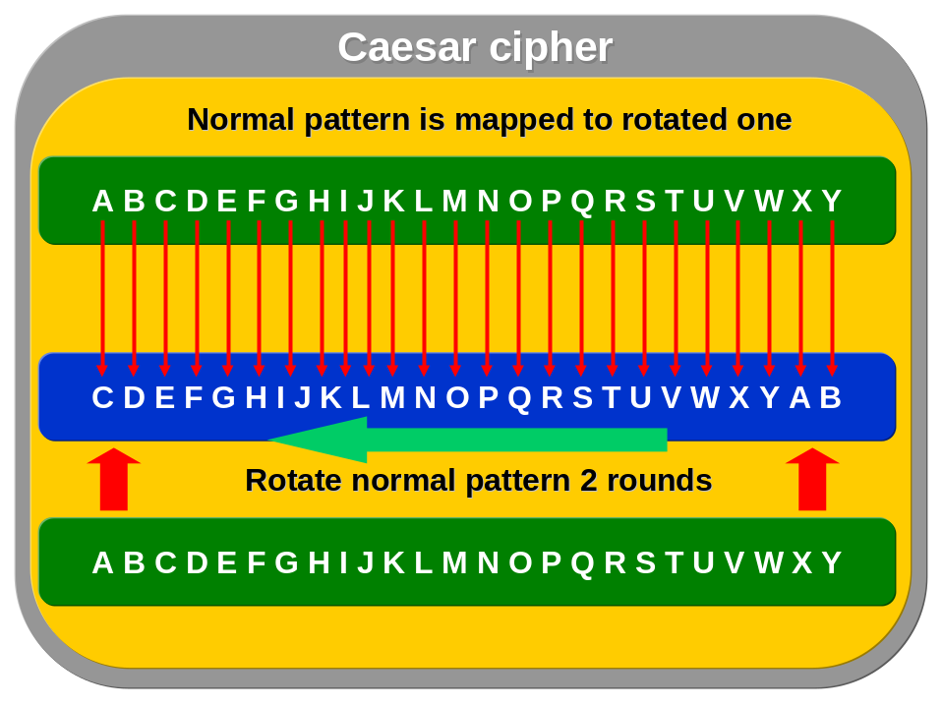
When rotation is finished, then there are two patterns available. The first one is the normal with alphabet as we know it (the green pattern). The second one (blue pattern) is the pattern after 2 round of shifting. It’s obvious how cipher works now.

Here is a code representing Caesar cipher (code is not optimized, but it is easy to reduce its size):

using System;
using System.Text;

class CaesarCipher
{
static void Main(string[] args)
{
string ciphertext = encrypt(".NET in Samples", 2);
Console.WriteLine("Ciphertext: " + ciphertext);
Console.WriteLine("Plaintext: " + decrypt(ciphertext, 2));
}

public static string encrypt(string plaintext, int key)
{
StringBuilder ciphertext = new StringBuilder();
// for simplicity this implementation works just with uppercases
char[] c = plaintext.ToUpper().ToCharArray();

for (int i = 0; i < c.Length; i++)
{
if (c[i] < 'A' || c[i] > 'Z') ciphertext.Append(c[i]);
else
{
// shift the character accoring to key and add it to cipher text
ciphertext.Append(shift((int)c[i], key));
}
}
return ciphertext.ToString();
}

public static string decrypt(string ciphertext, int key)
{
StringBuilder decipher = new StringBuilder();
// for simplicity this implementation works just with uppercases
char[] c = ciphertext.ToUpper().ToCharArray();

for (int i = 0; i < c.Length; i++)
{
if (c[i] < 'A' || c[i] > 'Z') decipher.Append(c[i]);
else
{
// now minus is used with key to invert the reverted values
decipher.Append(shift((int)c[i], -key));
}
}
return decipher.ToString();
}

// !!! algorithm is not optimized and could be written in one line, this is JUST for sampling purposes
private static char shift(int iC, int key)
{
// subtract value of the lowest character in ASCII, it is 'A'
iC = iC - 'A';
// add key to shift the character as is needed
iC = iC + key;
// check if it is out of bounds, then return a reminder which represents shift character to a new possition
iC = iC % 26;
// add ASCII value of 'A' character to make correct representation as on the beginning
iC = iC + 'A';
return (char)iC;
}
}

Caesar cipher is quite easy to brake because there are only 26 possible permutations before finding intelligible word. That is why its practical usage is zero, but it’s important to understand it and to know the historical development of cryptography.

Progress in cryptography
The substitution ciphers are just the beginning of development of cryptography algorithms. Major progress has been made during World Wars, when cryptography and cryptanalysis played a very important role. Notoriously known is decoding of message sent from German Foreign Minister Arthur Zimmerman to German Minister to Mexico offering Mexico United States’ land in exchange for support to Germany over the World War I. When Americans deciphered the message, they joined the war thereafter against Germany.
Second historically known case of cryptography importance is during World War II, when Germans used special machine called Enigma (developed by Arthur Scherbius), to encrypt their communication with U-boats. When Enigma cipher was broken, nearly all U-boats had been destroyed and this was very important for survival of United Kingdom and destruction of Bismark.
All of these algorithms were sophisticated and hard to brake and their mechanism was not so simple as Caesar cipher or similar ones.
But modern cryptography can be dated from 1952, when the National Security Agency was established and this organization played a key role during the Cold War. The most famous work of NSA is their research based on “Feistel ciphers” (according to Dr. Horst Feistel who establish this cryptographic concept) and published as FIPS PUB-46, but it’s more known under the name DES (see chapter 6.10.4).

Milestones in cryptography
Year | Event
1379 | Compilation of first European manual on cryptography by Gabriele de Lavinde of Pharma.
1466 | First cipher disk was described by Leon Battista Alberti.
1562 | A French diplomat Blaise de Vigenère invented special matrix 26x26 called “Vigenere square”.
1854 | Charles Babbage developed the method of statistical analysis that had been sucessfuly used to decrypt messages encrypted by Vigenere square.
1918 | German engineer Arthur Scherbius invented Enigma.
1930 | Japanese used the first rotor machine called “RED”.
1939 | Japanese introduced a new cipher machine with code name “PURPLE”.
1943 | German’s ENIGMA rotor setting could be rapidly found by “Bomba” machines and cipher texts could be decrypted.
1952 | NSA was established.
1976 | Diffie and Hellman published famous “New directions in cryptography”, as the beginning of asymmetric cryptography.  http://www.cs.rutgers.edu/~tdnguyen/classes/cs671/presentations/Arvind-NEWDIRS.pdf
1977 | DES (Data Encryption Standard) was adopted.
1977 | Ron Rivest, Adi Shamir and Leonard Adleman publish their proposal on public key cryptography concept known today as RSA and based on proposal from Diffie and Hellman.

PKCS
With development of cryptography methods software companies realized the impotance of standards to define how to deal with data in secure and standard manner. Sun Microsystem, Microsoft, Applet and others joined this process in RSA and together they defined PKCS standards (Public Key Cryptography Standards).
For application programmers working with any cryptographical functions it’s important to known them because they’re refered in any crypto-documentation and are essential terms. That is why here are listed active PKCS standards with basic introduction (but more can be found on RSA website).

Standard | Description
PKCS#1 | The RSA encryption standard. Defines mechanisms for encrypting and signing data using RSA system.
PKCS#3 | The Diffie-Hellman key agreement standard. It defines Diffie-Hellman key agreement protocol.
PKCS#5 | The password-based encryption standard (PBE).It defines a method to generate secret key on a password.
PKCS#6 | The extended certificate syntax standard. It’s going to be exchange in favour of X509v3.
PKCS#7 | The cryptographic message standard. It defines syntax of messages on which cryptography were used.
PKCS#8 | The privat- key information syntax standard. It defines how to store private key information.
PKCS#9 | It defines a selected attribute types for use with other PKCS.
PKCS#10 | The certification request syntax standard. It defines syntax of certification requests.
PKCS#11 | The cryptographic token interface standard. It defines technology independent programming interface for crypto devices as smartcards.
PKCS#12 | The personal information exchange syntax standard. It defines a portable format for storage and transportation of user private keys & certificates etc.
PKCS#13 | The elliptic curve cryptography standard. It defines mechanism how to encrypt and sign data using ECC.
PKCS#14 | The pseudo random number generation. It defines mechanism of pseudorandom number generation process.
PKCS#15 | The cryptographic token information format standard. It defines standard for the format of cryptographics credentials stored on cryptographics tokes.

CMV (Cryptographic Module validation)
Cryptographical algorithms are studied on mathematical basis but their implementation is the same important. If alrgorithms are not properly implemented than they are opened to attacks. That is why NIST (National Institute of Standards and Technology) has started program CMV which allows software vendors to demonstrate that they comply with the security standards and their implementations are certified as trustworthy (more details about CMV program can be found here: http://csrc.nist.gov/cryptval/).
This is very important for programmers because they have to prove their products are certified if they want to sell to the government or army.
By now there are two types of certification process when FIPS 140 define a framework and methodology for cryptographic standards.

- FIPS 140-1
- FIPS 140-2

Comparition of both models can be found here: http://csrc.nist.gov/publications/nistpubs/800-29/sp800-29.pdf.

Microsoft FIPS 140 certification
Microsoft is keen on FIPS certification because they are required by security agencies and governments (not just in USA) as FIPSs are becoming “de-facto” standard for implementation of cryptographic features.
More up-to-date details about certified Microsoft products are published on Microsoft’s website (http://www.microsoft.com/technet/security/topics/issues/fipseval.mspx).

.NET classes and FIPS 140
Only those classes are FIPS 140 certified (they are wrappers around CSP, primary CryptoAPI with FIPS 140 certification):

- RSACryptoServiceProvider
- DSACryptoServiceProvider
- SHA1CryptoServiceProvider
- DESCryptoServiceprovider
- TripleDESCryptoServiceProvider

So far managed .NET crypto classes are not certified and it seems there are no plans to do it in the future. This is not good for those who develop enterprise applications for government and army. The only solution is to use .NET classes provided by thirt party companies other then Microsoft like:

- Clarios Security Development Library (SDL)
- Security Builder Crypto-C#

Cryptography in .NET
Cryptography in .NET environment is based on CryptoAPI provided by Windows. But this doesn’t mean that .NET layer would be just a wrapper around this security feature in Windows. .NET’s namespace System.Security.Cryptography brings many new concepts and approaches to working with cryptography and other security related principles. There’re three primary characteristics:
- Very well organized classes with open approach to other implementation providers (as presented on figure below).
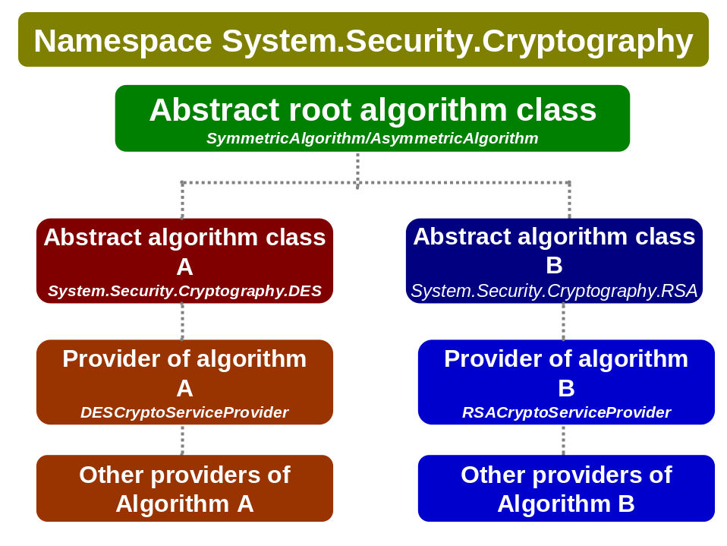
- .NET model is stream-based and you can see and understand what it means on the samples listed in other chapters below. But in short it means that all cryptographic operations are performed on streams (except asymmetric algorithms of course).
- Cryptography in .NET environment is highly configurable using by machine.config file.

Configuring .NET cryptography
Cryptographic namespaces in .NET can use XML configuration to setup the environment to work with appropriate classes and their implementations. Configuration is usually stored in machine.config in this way:

<configuration>
<mscorlib>
<cryptographySettings>

..........

</cryptographySettings>
</mscorlib>
</configuration>

Typically there can be setup mapping for Create methods of abstact classes.
This is shown in following sample configuration section:

Win32 Security API and .NET
GotDotNet provides excellent wrapping classes for security features in Windows API. The library can be obtained from http://www.gotdotnet.com/Community/UserSamples/Details.aspx?SampleGuid=e6098575-dda0-48b8-9abf-e0705af065d9 and it is refered by many samples here.

Random number generators

Generating random values
Namespaces:
using System;
using System.Text;
using System.Security.Cryptography;

Code:
static void Main(string[] args)
{
// array to be filled with strong random bytes
byte[] plaindata = new byte[16];
// abstract class represents specific RNG implementation
RandomNumberGenerator rng = new RNGCryptoServiceProvider();
// generate random value including zero values
rng.GetBytes(plaindata);
Console.WriteLine("This is a random value: "+Encoding.ASCII.GetString(plaindata));
}

Generating random nonzero values
Namespaces:
using System;
using System.Text;
using System.Security.Cryptography;

Code:
static void Main(string[] args)
{
// array to be filled with strong random bytes
byte[] plaindata = new byte[16];
// abstract class represents specific RNG implementation
RandomNumberGenerator rng = new RNGCryptoServiceProvider();
// generate random nonzero value
rng.GetNonZeroBytes(plaindata);
Console.WriteLine("This is a random value: "+Encoding.ASCII.GetString(plaindata));
}

Random number generator and other CSPs (Cryptographic Service Provider)
For RNG can be used other CSPs, as they are defined in wincrypt.h and are described in CryptoAPI documentation.

Namespaces:
using System;
using System.Text;
using System.Security.Cryptography;

Code:
static void Main(string[] args)
{
// constants are defined in wincrypt.h in VC SDK
const int PROV_RSA_FULL = 1;

// array to be filled with strong random bytes
byte[] plaindata = new byte[16];
CspParameters csp = new CspParameters(PROV_RSA_FULL);
RandomNumberGenerator rng = new RNGCryptoServiceProvider(csp);
// generate random value including zero values
rng.GetBytes(plaindata);
Console.WriteLine("This is a random value: "+Encoding.ASCII.GetString(plaindata));
}

The table bellow presents list of typical providers:

Constant | Wincrypto.h’s name | String name
1 | PROV_RSA_FULL | -
2 | PROV_RSA_SIG | Microsoft RSA Signature Cryptographic Provider
3 | PROV_DSS | Microsoft Base DSS Cryptographic Provider
4 | PROV_FORTEZZA | Not supported by .NET FW
5 | PROV_MS_EXCHANGE | Not supported by .NET FW
6 | PROV_SSL | -
12 | PROV_RSA_SCHANNEL | Microsoft RSA SChannel Cryptographic Provider
13 | PROV_DSS_DH | Microsoft Base DSS and Diffie-Hellman
18 | PROV_DH_SCHANNEL | Microsoft DH SChannel Cryptographic Provider
24 | PROV_RSA_AES | Microsoft Enhanced RSA and AES Cryptographic Provider

Hashing algorithms
Hashing algorithms are one-way functions. What it means? In general it’s that such an algorithm takes plaintext data on input and digests them to unique fixed-length output that is nearly impossible to be constructed back to plaintext.

Symmetric encryption
Symmetric encryption is very important for nearly all today’s activities. It uses a same key for encryption and decryption and that is why it faces a problem to distribution of keys and their number when many nodes are included and need to communicate securely.
Generally cryptography is facing a problem of brute-force attacks, but this is primary an issue for symmetric algorithms, where brute-force attacks are used more often.
Also symmetric algorithms are very fast and it takes very little time to try a key (when compared with asymmetric algorithms).
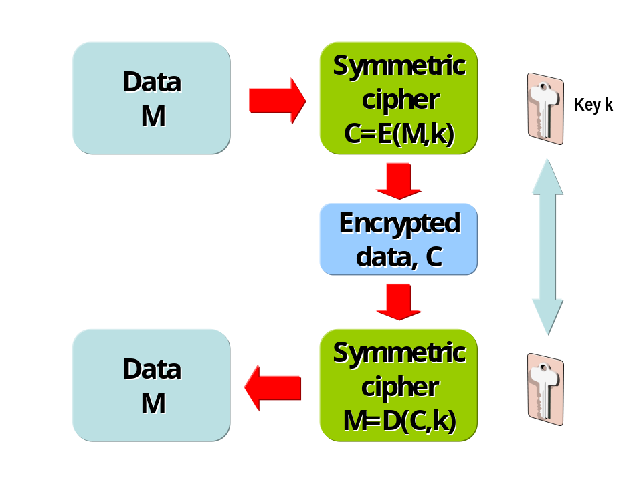
According to mathematical probability attacker should try half of all possible keys to get to big probability of finding a correct key. So how long should be a key? The answer depends on how long a secret should be kept safe. When we would use 40-bit keys, them key size is from 0 to about 1 trillion, what is a very low number of key to try and attacker will be successful when today’s modern computers would be used.
Currently, 128-bits keys are considered as secure and are the most commonly used. There can be expected that technology will be advancing and attackers will use stronger machines and better types of attacks. But when algorithms will be safe from mathematical point of view, then we can expect to use 512 bits keys as the largest ones (number of operations needed to do brute-force attack would need all atoms in universe as computers and even more time then this universe exists from Big Bang, about 2²⁴ millennia). But this is not the only type of attack, brute-forcing a key size, but there was encounter an attack on PRNG (pseudo-random number generator) and its seed.
Netscape was the inventor of SSL protocol and Netscape used it in its browser Netscape Communicator with custom PRNG using as a seed process ID, year, month, day, hours and seconds. On September 17, 1995, Goldberg and Wagner reported that they found the seed and also the key for SSL session in less then minute. It was not important if key size was 40 or 128 bits, it took only one minute to break it.

Block ciphers
Block cipher is a term used to symmetric algorithms that operate on a specific and defined block of data. It works with given data as with blocks, simply plaintext is divided into blocks (say 64 bits) and algorithm is working on them with strictly defined operations.

Advanced Encryption Standard
With ageing of DES, NIST started to work on a new security standard. This work began on January 2, 1997, when NIST asked for proposals on a new algorithm, which would be freely available. NIST named 15 candidates on August 20, 1998 and after one year in August 1999 this list was trimmed to 5 proposals.
Finally, on October 2, 2000, NIST named the winner algorithm called Rijndael (pronounced as “Rhine-doll”) developed by two Belgian researchers Joan Daemen and Vincent Rijmen.
This standard is now freely available and can be used, sold or developed by anybody.

Stream ciphers
Stream ciphers can be seen as very fast algorithms, faster then block ciphers. Stream ciphers are similar to concept called one-time pad, known in cryptography. Typically this technique was used in World War II, when headquarters gave to their spies one pad with printed numbers and the other copy was in headquarters. Then spy encrypted his message by a number corresponding to some number in the alphabet.
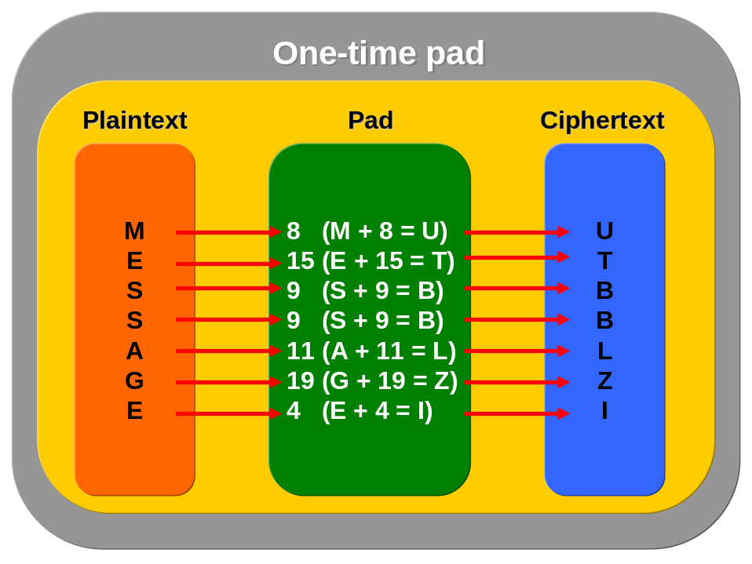
Stream ciphers work in similar way (but terms are different). In cryptography regarding stream ciphers the term pad is not used but instead of it key stream is more appropriate.
The steps of encryption are similar to one-time pad, when stream ciphers take usually one byte of plaintext and XOR it with one byte of key stream and throwing out one byte of ciphertext. Then used key stream byte is thrown away and key table is remixed.

Key distribution problem
When working with private keys, both side have to share the same key to communicate. The problem starts when keys must be distributed to another side and when many nodes are involved. Suppose that person A wants to securely communicate with person A, to encrypt their communication, but they have to exchange their keys securely. This is a paradox, because if they aren’t able to communicate securely, how could they make a secure exchange of keys? Of course in real life they could use a special agent to fly abroad and to carry their private keys in the protected package and make this “communication” secure. But imagine, when hundreds or thousands are involved (like when communicating over the Internet). Just use the following formula for some number of involved people in communication:

Number_of_keys = (n * (n-1))/2

where n represents number of people using private keys. As can be seen, this would be unacceptable expensive and even impossible to manage distribution of those keys when too much people are getting involved. The solution is asymmetric cryptography and concepts related to certification authorities (see chapter 6.11);

Data Encryption Standard (DES)
In 1970s IBM researchers started to work on the new encryption algorithm suited for computer age. This algorithm was based on scheme called LUCIFER and was developed by known and famous cryptographer Horst Feistel. Together with NSA they created the Digital Encryption Standard (DES).
DES is a block cipher using 56-bit key to build a key table. After researches introduced DES a new proposed standard, it became freely available and many other cryptographers started to study it. In 1980s DES was accepted as the standard because cryptographers agreed that has no weak parts and the only way how to break it is using of brute force attack (56-bit wide key can produce about 72 quadrillion of possibilities to try when brute force attack is applied).
The DES algorithm is defined in Federal Information Procession Standard (FIPS) 46-2 (or together with TripleDES in FIPS 46-3) and guidelines for its using are in FIPS 74.

DES modes
There are many different ways of using keys to cipher plaintext and this usage depends on application where algorithm is used. Here is a list of those modes as defined in FIPS 81 (see http://csrc.nist.gov/publications/fips/fips81/fips81.htm):
- Electronic Code Book (ECB)
Encryption is performed on 8-byte blocks and this mode produces the same cipher text whenever the same plain text is encrypted using the same key and initialization vector.
This mode depends on 8-byte blocks and when provided data is less then this size, then additional bytes must be added to form 64-bit block. This process is known as padding. Padding is one of the points to study in cryptanalysis because there could be found some optimizations how to brake the algorithm. Regarding padding RSA Data Security, Inc. defines its standard PKCS#5 (see http://www.rsasecurity.com/rsalabs/pkcs/pkcs-5/) which works as presents following figure:
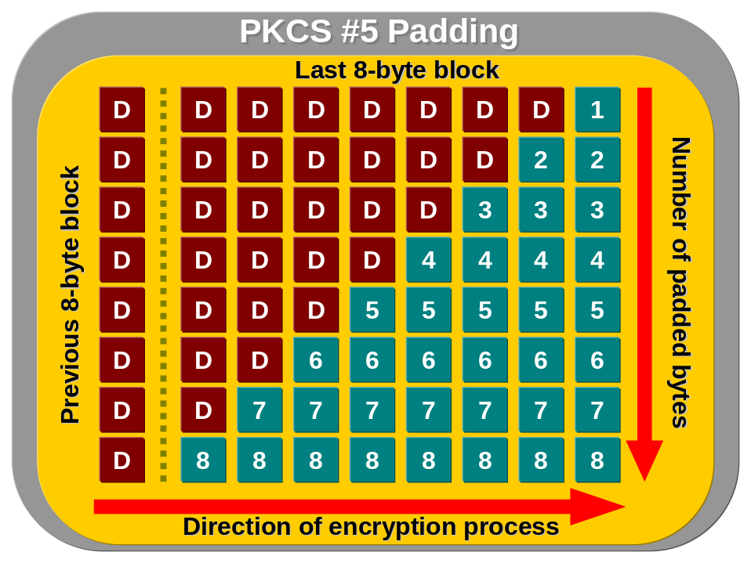
Figure presents, how padding works and it can be defined in two rules:
  - When bytes are padded, then number in padded byte represents number of all padding bytes (in figure this is represented by green squares with number).
  - If no additional bytes aren’t needed by be added, then 8 bytes are padded to last 8-byte block of data (this is the last line with number 8 in squares).
These two rules are the main principle of padding defined in PKCS#5 and they work very simple because when cipher text is decrypted, then on the end are always padding bytes with number representing number of padded bytes. Then it’s simple to remove date from padding bytes.
Back to ECB mode. The advantage of ECB is that 8-byte blocks are independent from each other. This means that when some of that block would be corrupted (for instance by transfer error) then this would not affect the other blocks. This is great when users want to keep higher reliability of data which can be transferred over not such a reliable medium. Then this can reduce a risk of data corruption.
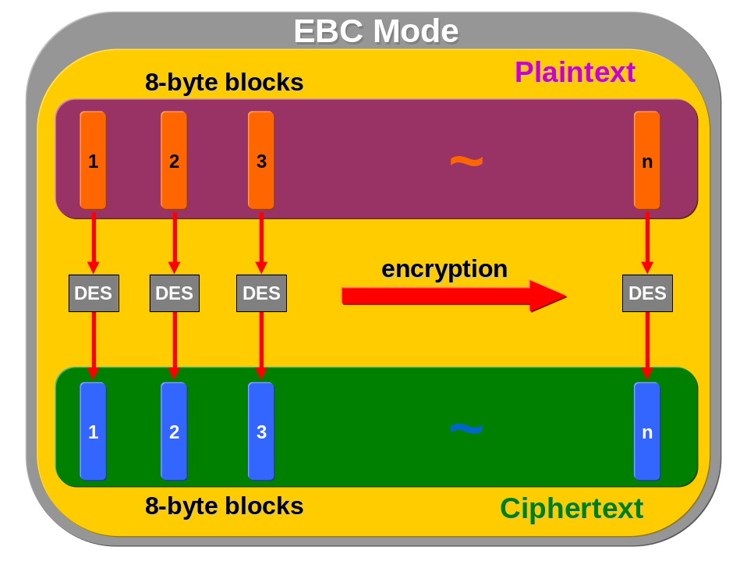
But also ECB has disadvantages, like when working with generally known format of data (like letters or some XML documents). Because in this mode the cipher text will be always the same for the same plaintext, then attacker can watch a communication and can map some special data that are repeated. For instance when application sends email starting by “Dear Mr. Smith”, then the cipher text will be always the same and this can be tracked by attacked and this communication can be them used for other types of attacks.
- Cipher Feedback Mode (CFB)
CFB is a stream method of encryption in which the DES is used to generate pseudorandom bits which are XORed with binary plain text to form a cipher text. This mode is typically designed for situation, when application is not able to provide 64-bit blocks and needs to react in “real-time” manner. For instance when user press key on terminal and wants to see a result of this action immediately (like banking terminal or similar) then CFB is appropriate mode.
Usually CFB works with 8-bits representing one byte information (like when sending key pressed code over the network) and this mode is called as CFB8.
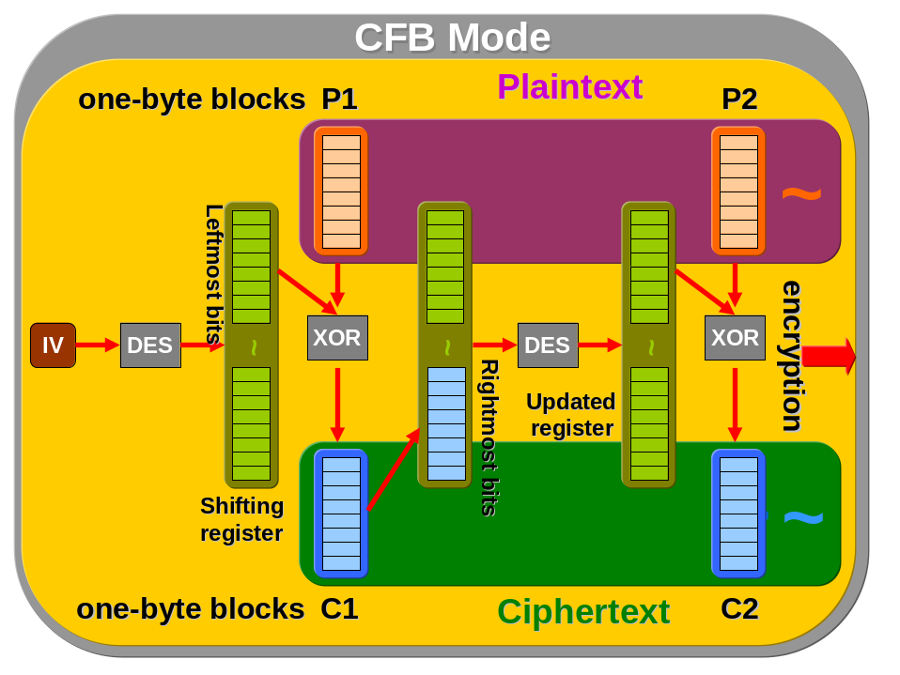
So what happens in CFB mode:
  - At first initial vector is created (IV).
  - IV is encrypted by DES and this produces shifting register 64-bits long.
  - The leftmost eight bits (P1 on figure) of shifting register are XORed with plaintext (8-bits) and this XOR operation produces 8-bits of ciphertext (C1).
  - Those bits of ciphertext are then moved to shifting register where they replace the rightmost eight bits of this register.
  - Then a whole this cycle is repeated, but except initial vector is used shifting register with shifted bits.
- Output Feedback Mode (OFB)
OFB mode is very similar to CFB mode, but there is one exception and this is that bits in shirting register aren’t replaced by ciphertext bits, but there is done a shifting of bits inside of this register (see figure bellow).
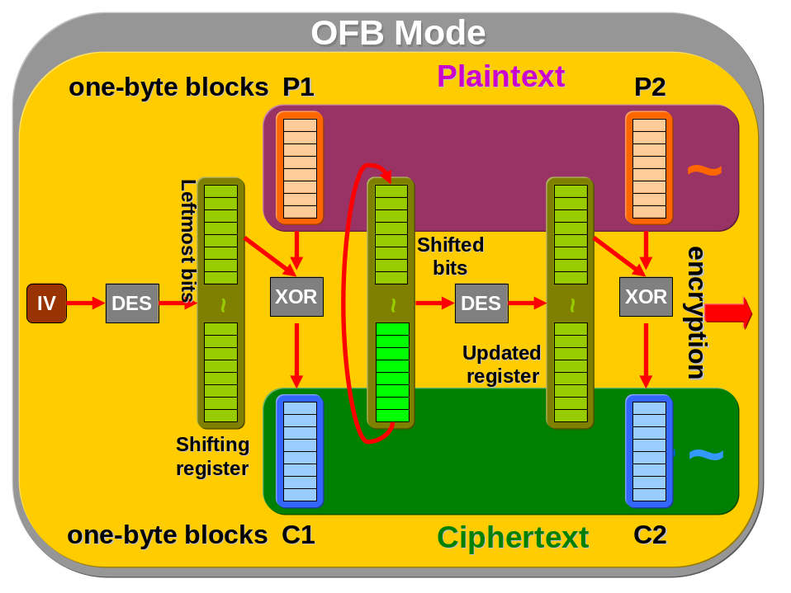
- Cipher Block Chaining (CBC)
Encryption is performed on 8-byte blocks and as against ECB mode, the first block of plaintext is XORed with initialization vector (IV) and encrypted. This will produce the first block of cipher text, which is then XORed with next plain text block and again and again till the last plain text block.
When encryption proceeds to the last plain text block, padding can be used and this is done in the same way as in the ECB mode.
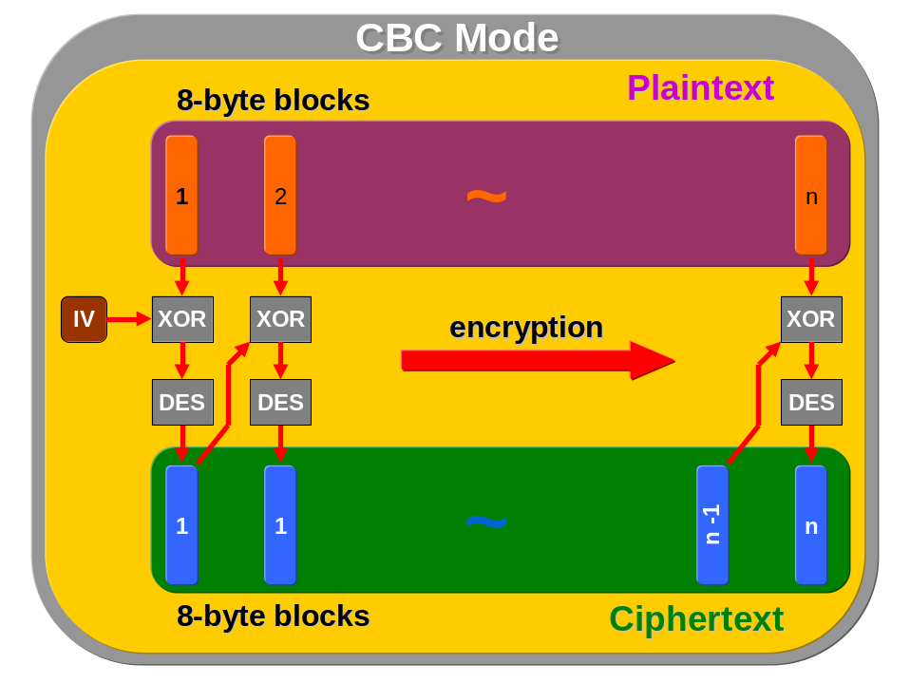
- Propagating Cipher Block Chaining (PCBC)
This is similar mode like CBC, but it differs just by adding plain text block to XOR operation. Today PCBC is very popular in use. The advantage of PCBC is that when error occurs, it’s propagated to all encrypted message and that is why attacker can’t make modifications to parts of message and change its content (for instance according to statistical analysis etc.).
The disadvantage is based on its advantage, because ciphertext can’t be decrypted on separated blocks but as a whole message. Then any error in encryption process cases incorrect message.
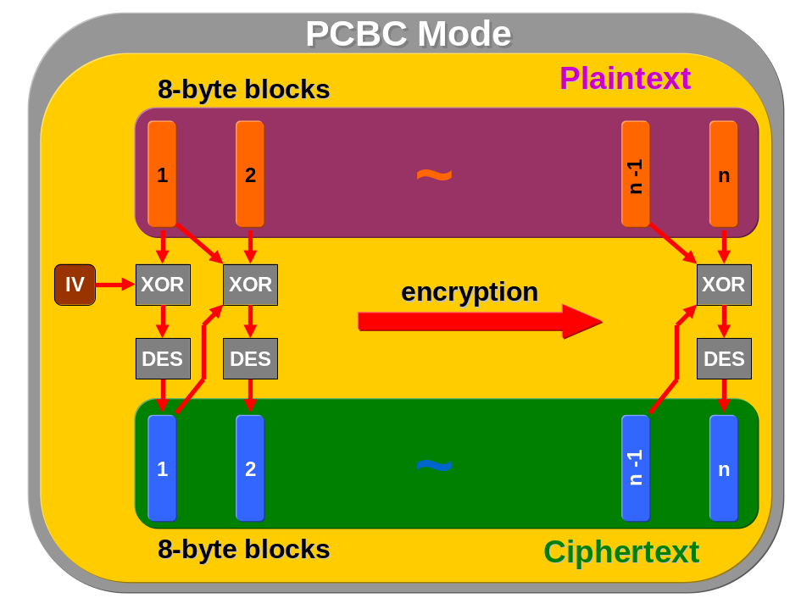

TripleDES
When DES started to be considered as obsolete algorithm, triple DES was introduced as the one widely used replacement. In its name is give a whole description of the enhancement – DES is performed three times at once with three different 56-bit keys (this will produce a result like a 168-bit key). But Triple DES is not as secure as it seems now. Cryptographers have found new ways how to reduce brute force attack to 108-bit key. Although this is still very secure key length, the problem is finding some workarounds how to reduce Triple DES key length and if this research can bring better results in brute force attacks area.
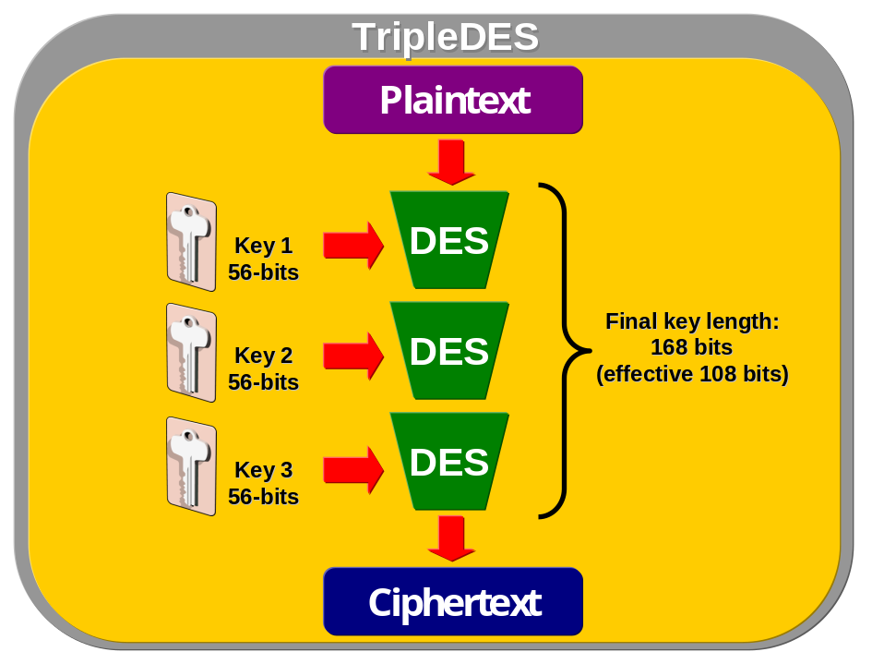

Blowfish
This algorithm was designed by Bruce Schneier, the author of the known book Applied Cryptography. Blowfish is not patented and it’s royalty free to use.
Blowfish is 64-bit block algorithm and was intended as a replacement for DES, because it’s faster and even more secure. Key length of this cipher is from 32 up to 448 bits.
More details on http://www.schneier.com/blowfish.html.

Twofish
This is Feistel algorithm designed by Bruce Schneier and its company Counterpane (colleges John Keisey, Dough Whiting, David Wagner, Chris Hall, Niels Ferguson). It was one of the five AES finalists. It’s 128-bit block cipher working with 128, 192 and 256-bits keys. Also like Blowfish, Twofish isn’t patented and it’s royalty free and source codes are available uncopyrighted.
It uses 16 rounds modified by one-bit rotation; the proposal uses different operations like multiplying in Galois element GF (2⁸), arithmetic addition, XOR and S-boxes (those are 8x8 S-boxes, which are created by composition of key and 4x4 S-boxes).
Twofish is theoretically vulnerable to timing and power attacks and primary this was criticized because of a large complexity of this algorithm making analysis of it too hard (according to NIST).

MARS
MARS is one of the five finalists in AES contest. This algorithm had been proposed by IBM researchers and was considered as a very secrete one and according the authors algorithm has no predecesor. MARS has variable key length 128, 192 and 256-bits keys, but in general it supports keys up to 448-bits large.
Though MARS is based on conventional cryptographic methods it brings a new ideas like thesis that middle of algorithm is more significant them beginning or end etc.
Finally MARS was rated as a very secure one even though it is very complex (primary because of two kinds of rounds).

Rijndael
Rijndael has SPN (Substitution-Permutation Network) structure because it is based on cipher Square, where has been used for a first time square attack (more details about attacks on Rijndael can be found here http://www.schneier.com/paper-rijndael.pdf).

Ronald Rivest’s (RC) ciphers
Ronald Rivest, one of the founders of RSA Data Security, is one of the very famous persons in modern cryptography. He is the co-inventor of RSA public key encryption algorithm and as well he worked on symmetric ciphers series called RCx (from RC1 to RC6) according to his name (Ron’s Code).
The ciphers RC1 and RC3 were never used too much and that is why they’re not covered here.

RC2
This is a proprietary symmetric cipher of RSA Data Security. It works with 64-bit blocks and has a variable key length. Its speed is much higher then DES.
Together with RC4, RC2 has been widely used because of less stringent export rules applied to these ciphers.

RC4
A proprietary symmetric stream cipher of RSA Data Security. It works with variable key length. It operates in OFB-like mode (see 6.10.4.1) and like RC2 it’s faster then DES.
This cipher has become known primary by its usage in SSL and export laws enabling RC to be used worldwide (not DES).

RC5
This is a patented block cipher of RSA Data Security. It can be used with variable key and block sizes and it uses data-dependent rotations.

RC6
RC6 was RSA’s candidate for the AES where it entered the final round (like Twofish by Counterpane, see 6.10.6). It is a Feistel block cipher based on RC5 and as well as RC5 it can use variable number of key and block sizes (RC6 is a derivative of RC5 and that is why it is based on many previous studies). RC6 is very well designed for high-end smartcard usage where 32-bit instructions are available (then the performance of RC6 is excellent) but when compared with other finalists, RC6 has a relatively low security margin.
RC6 is theoretically vulnerable to timing and power attacks.

Hash value using MD5 and SHA
Namespaces:
using System;
using System.IO;
using System.Text;
using System.Security.Cryptography;

Code:
static void Main(string[] args)
{
// data to be hashed
string cipherData = "This is a sample plaintext";

// data with hash value of plaintext
byte[] hashbytes;

// create MD5 provider to do hashing on plaintext
MD5CryptoServiceProvider md5 = new MD5CryptoServiceProvider();
// calculate hash value on plaintext to be encrypted
hashbytes = md5.ComputeHash(Encoding.ASCII.GetBytes(cipherData));
Console.WriteLine("MD5 Hash value: "+Encoding.ASCII.GetString(hashbytes));

// this is a 160-bit sha hash provider
SHA1CryptoServiceProvider sha = new SHA1CryptoServiceProvider();
hashbytes = sha.ComputeHash(Encoding.ASCII.GetBytes(cipherData));
Console.WriteLine("SHA 160-bit hash value: "+Encoding.ASCII.GetString(hashbytes));

// this is a 256-bit managed sha hash provider
SHA256Managed sha256 = new SHA256Managed();
// hashbytes = sha256.ComputeHash(Encoding.ASCII.GetBytes(cipherData));
Console.WriteLine("SHA 256-bit hash value: "+Encoding.ASCII.GetString(sha256.Hash));

// this is a 512-bit managed sha hash provider
SHA384Managed sha384 = new SHA384Managed();
// hashbytes = sha384.ComputeHash(Encoding.ASCII.GetBytes(cipherData));
Console.WriteLine("SHA 384-bit hash value: "+Encoding.ASCII.GetString(sha384.Hash));

// this is a 512-bit managed sha hash provider
SHA512Managed sha512 = new SHA512Managed();
hashbytes = sha512.ComputeHash(Encoding.ASCII.GetBytes(cipherData));
Console.WriteLine("SHA 512-bit hash value: "+Encoding.ASCII.GetString(hashbytes));
}

Classes for symmetric algorithms in .NET
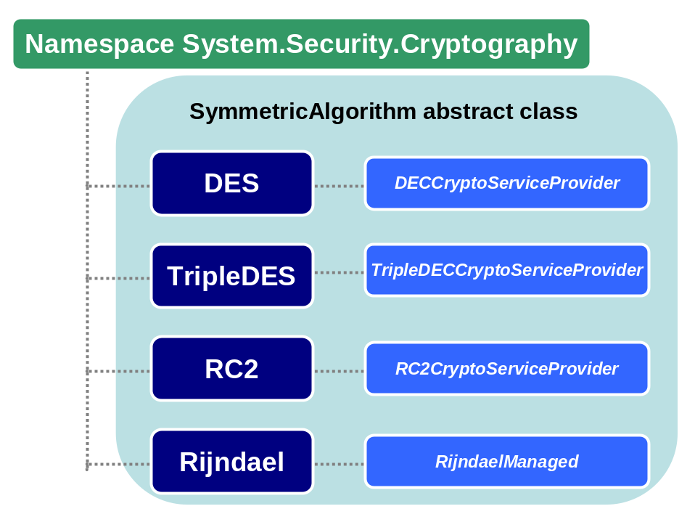

Deriving symmetric keys from passwords
Sometimes password is used to derive a key to encrypt data by symmetric encryption algorithm. For this purpose are defined standards that specify how to use passwords and derive from them correct symmetric key.
.NET provides two classes related to deriving keys from passwords (Rfc2898DerivedBytes is available only with Whidbey .NET version):
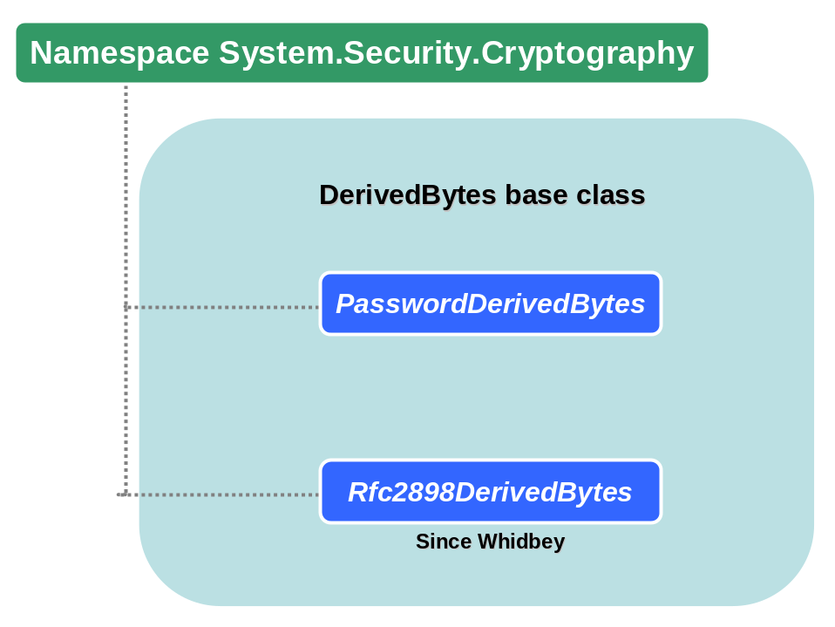
The first class, PasswordDerivedBytes, is based on PBKDF1 (see RFC2898 section 5.1) and this should be used just for compatibility purposes since it can produce smaller keys than it should be used when higher security is required. So what PBKDF1 defines? Here is a list of operations that PBKDF1 does:
- Password and salt are concatenated.
- The result of concatenation is hashed by specified algorithm and this is repeated so many times as IterationCount property specifies.
To this key can be used dictionary attacks and that is why there is salt which can improve security when using larger salt. Also number of iterations is very important and RSA recommends to set IterationCount to 1000.
Also PBKDF1 is bound to output size of hash algorithm but .NET implementation solves this issue so user needs not to care about it.

Second class, Rfc2898DerivedBytes, is available with Whidbey .NET Framework and provides better deriving mechanism for symmetric keys. It’s based on PBKDF2 (see
RFC2898 section 5.2). PBKDF2 makes a big improment when there isn’t bound to the size of hash algorithm. It’s recommended to use this class instead of PasswordDerivedBytes for higher security.

Creating symmetric encryption classes
In .NET Framework is available abstract base class SymmetricAlgorithm, which is able to provide general class to work with symmetric encryption classes. The code bellow shows how to use it to create each class:
Namespaces:
using System;
using System.Security.Cryptography;

Code:
static void Main(string[] args)
{
// call static method Create on SymmetricAlgorithm class
// create DES instance
SymmetricAlgorithm des = SymmetricAlgorithm.Create("DES");
// create TripleDES instance (can be used string '3DES'
SymmetricAlgorithm des3 = SymmetricAlgorithm.Create("TripleDES");
// SymmetricAlgorithm des3 = SymmetricAlgorithm.Create("3DES");
// create RC2 instance
SymmetricAlgorithm rc2 = SymmetricAlgorithm.Create("RC2");
// create Rijndael instance
SymmetricAlgorithm rdm = SymmetricAlgorithm.Create("Rijndael");
}

Here is a table with possible strings representing each cryptographic method as a parameter for Create() method:

Cryptographic algorithm | String
DES | "DES", "System.Security.Cryptography.DES"
TripleDES | "3DES", "TripleDES", "Triple DES", "System.Security.Cryptography.TripleDES"
RC2 | "RC2", "System.Security.Cryptography.RC2"
Rijndael | "Rijndael", "System.Security.Cryptography.Rijndael"

Symmetric encryption/decryption of plaintext using DES
Namespaces:
using System;
using System.IO;
using System.Text;
using System.Security.Cryptography;

Code:
static void Main(string[] args)
{
// data to be encrypted
string cipherData = "This is a sample plaintext";
// final encrypted data
byte[] cipherbytes;
// byte form of plaintext
byte[] plainbytes = Encoding.ASCII.GetBytes(cipherData);

// creating instance of DES class
SymmetricAlgorithm desObj = DES.Create();
// generating symmetric key
desObj.GenerateKey();
// generating vector
desObj.GenerateIV();
// choose other appropriate modes (CBC, CFB, CTS, ECB, OFB)
desObj.Mode = CipherMode.CBC;
// setting the padding mode
desObj.Padding = PaddingMode.PKCS7;

// --------------- ECRYPTION ---------------
// memory stream used as a target to write enrypted data
MemoryStream ms = new MemoryStream();
// transforms and encrypts plaintext data to memorystream object
CryptoStream cs = new CryptoStream(ms,
desObj.CreateEncryptor(),
CryptoStreamMode.Write);
cs.Write(plainbytes, 0, plainbytes.Length);
cs.Close();
// getting encrypted data from memorystream to bytes
cipherbytes = ms.ToArray();
ms.Close();

Console.WriteLine("Cipher result: "+Encoding.ASCII.GetString(cipherbytes));

// --------------- DECRYPTION ---------------
MemoryStream ms1 = new MemoryStream(cipherbytes);
CryptoStream cs1 = new CryptoStream(ms1,
desObj.CreateDecryptor(),
CryptoStreamMode.Read);
// allocate array of bytes equal on lenght with ciphertext array
plainbytes = new Byte[cipherbytes.Length];
// decrypt the ciphertext from previous section
cs1.Read(plainbytes, 0, cipherbytes.Length);
cs1.Close();
ms1.Close();
Console.WriteLine("Decipher result: "+Encoding.ASCII.GetString(plainbytes));
}

Symmetric encryption/decryption of plaintext using RC2
See sample “Symmetric encryption/decryption of plaintext using DES” and change line

SymmetricAlgorithm desObj = DES.Create();

with following line

SymmetricAlgorithm desObj = RC2.Create();

Change other settings appropriately.

Symmetric encryption/decryption of plaintext using Rijndael
See “Symmetric encryption/decryption of plaintext using DES” and change line

SymmetricAlgorithm desObj = DES.Create();

SymmetricAlgorithm desObj = Rijndael.Create();

Change other settings appropriately.

Determining weak and semi-weak keys in DES
This is a very specific to DES/3DES where have been found weak and semi-weak keys. This function checks these keys. But according to RSA this is not an issue, because the probability that such a key would be used is 2⁻⁵² and those keys can be safely ignored. But this test makes nearly no impact on performance.

Here is the list of weak and semi-weak keys:
Type of key | Key value (in hexadecimal)
weak | 00000000000000
weak | 0000000FFFFFFF
weak | FFFFFFF0000000
weak | FFFFFFFFFFFFFF
semi-weak | 01FE01FE01FE01FE
semi-weak | FE01FE01FE01FE01
semi-weak | 1FE01FE00EF10EF1
semi-weak | E01FE01FF10EF10E
semi-weak | 01E001E001F101F1
semi-weak | E001E001F101F101
semi-weak | 1FFE1FFE0EFE0EFE
semi-weak | FE1FFE1FFE0EFE0E
semi-weak | 011F011F010E010E
semi-weak | 1F011F010E010E01
semi-weak | E0FEE0FEF1FEF1FE
semi-weak | FEE0FEE0FEF1FEF1

Namespace:
using System;
using System.Security.Cryptography;

Code:
static void Main(string[] args)
{
// creating instance of DES class
DES desObj = DES.Create();
// generating symmetric key (this method will never generate a weak key, included just to compile a sample program)
desObj.GenerateKey();
// checking for a weak key
DES.IsWeakKey(desObj.Key);
// checking for a semi-weak key
DES.IsSemiWeakKey(desObj.Key);
}

Deriving symmetric key from password using PBKDF1
This sample uses CryptDeriveKey method which returns appropriate symmetric key.

Namespaces:
using System;
using System.Text;
using System.Security.Cryptography;

Code:
static void Main(string[] args)
{
const string password = "your password";

// salt used to be add to password to make the process more random and secure
byte[] salt = new byte[16];
byte[] iv = new byte[8];
RandomNumberGenerator rng = new RNGCryptoServiceProvider();
// salt for password
rng.GetBytes(salt);

PasswordDeriveBytes pdb = new PasswordDeriveBytes(password, salt);
pdb.IterationCount = 1000;
// initialization vector
rng.GetBytes(iv);
// generate key based on a password (change settings to other algorithms to get different keys)
byte[] rc2key = pdb.CryptDeriveKey("RC2", "MD5", 64, iv);

Console.WriteLine("This is a RC2 key: " + Encoding.ASCII.GetString(rc2key) + " for password: " + password);
}

Deriving symmetric key & IV from a password using PBKDF1
In this sample key and initialization vector is acquired using GetBytes method.

Namespaces:
using System;
using System.Text;
using System.Security.Cryptography;

Code:
static void Main(string[] args)
{
const string password = "your password";

// salt used to be add to password to make the process more random and secure
byte[] salt = new byte[16];
// initialization vector
byte[] iv;
// RC2 key
byte[] rc2key;
RandomNumberGenerator rng = new RNGCryptoServiceProvider();
// salt for password
rng.GetBytes(salt);

PasswordDeriveBytes pdb = new PasswordDeriveBytes(password, salt);
// this iteration value is recommended by RSA
pdb.IterationCount = 1000;
pdb.HashName = "MD5";
rc2key = pdb.GetBytes(16);
iv = pdb.GetBytes(8);

Console.WriteLine("This is a RC2 key: " + Encoding.ASCII.GetString(rc2key));
Console.WriteLine("This is a IV: " + Encoding.ASCII.GetString(iv));
}

Deriving symmetric key from a password using PBKDF2
Namespaces:
using System;
using System.Text;
using System.Security.Cryptography;

Code:
static void Main(string[] args)
{
const string password = "your password";

// salt used to be add to password to make the process more random and secure
byte[] salt = new byte[16];
// initialization vector
byte[] iv;
// RC2 key
byte[] rc2key;
RandomNumberGenerator rng = new RNGCryptoServiceProvider();
// salt for password
rng.GetBytes(salt);

// PBKDF2 is used with 1000 of iterations
Rfc2898DeriveBytes pdb = new Rfc2898DeriveBytes(password, salt, 1000);
rc2key = pdb.GetBytes(16);
iv = pdb.GetBytes(8);

Console.WriteLine("This is a RC2 key: " + Encoding.ASCII.GetString(rc2key));
Console.WriteLine("This is a IV: " + Encoding.ASCII.GetString(iv));
}

Check valid key size for symmetric encryption
Namespaces:
using System;
using System.Security.Cryptography;

Code:
static void Main(string[] args)
{
// this is a desired size of the key
int keysize = 64;

SymmetricAlgorithm rc2Obj = RC2.Create();
// array with legal key sizes for symmetric algorithm
KeySizes[] legalsize = rc2Obj.LegalKeySizes;
foreach (KeySizes ks in legalsize)
{
if (keysize >= ks.MinSize &&
keysize <= ks.MaxSize &&
keysize % ks.SkipSize == 0)
Console.WriteLine("This is a legal key size");
}
}

Hashing of plaintext and encryption/decryption using DES
Namespaces:
using System;
using System.IO;
using System.Text;
using System.Security.Cryptography;

Code:
static void Main(string[] args)
{
// data to be encrypted
string cipherData = "This is a sample plaintext";
// final encrypted data
byte[] cipherbytes;

// data with hash value of plaintext
byte[] hashbytes;
// decrypted hash value from ciphertext
byte[] dechashbytes;

// create MD5 provider to do hashing on plaintext
MD5CryptoServiceProvider md5 = new MD5CryptoServiceProvider();
// calculate hash value on plaintext to be encrypted
hashbytes = md5.ComputeHash(Encoding.ASCII.GetBytes(cipherData));
Console.WriteLine("Hash value: "+Encoding.ASCII.GetString(hashbytes));

// creating instance of DES class, use default keys and settings
DES desObj = DES.Create();

// --------------- ECRYPTION OF HASH VALUE---------------
MemoryStream ms = new MemoryStream();
CryptoStream cs = new CryptoStream(ms, desObj.CreateEncryptor(), CryptoStreamMode.Write);
cs.Write(hashbytes, 0, hashbytes.Length);
cs.Close();
cipherbytes = ms.ToArray();
ms.Close();

Console.WriteLine("Cipher result: "+Encoding.ASCII.GetString(cipherbytes));

// --------------- DECRYPTION OF HASH VALUE---------------
MemoryStream ms1 = new MemoryStream(cipherbytes);
CryptoStream cs1 = new CryptoStream(ms1,
desObj.CreateDecryptor(),
CryptoStreamMode.Read);
// allocate array of bytes equal on lenght with ciphertext array for hash value
dechashbytes = new Byte[cipherbytes.Length];
// decrypt the hash from previous section
cs1.Read(dechashbytes, 0, cipherbytes.Length);
cs1.Close();
ms1.Close();
Console.WriteLine("Decrypted hash: "+Encoding.ASCII.GetString(dechashbytes));
}

Keyed hash algorithm HMACSHA1
A keyed hash algorithm is a cryptographic method that is used to hash date. In case of HMAC is this mechanism used for message authentication using SHA algorithm, see RFC 2104.
Namespaces:
using System;
using System.IO;
using System.Text;
using System.Security.Cryptography;

Code:
static void Main(string[] args)
{
// data to be encrypted
string cipherData = "This is a sample plaintext";
byte[] cipherbytes = Encoding.ASCII.GetBytes(cipherData);
byte[] key = new byte[16];

HMACSHA1 hmac = new HMACSHA1(key);
CryptoStream cs = new CryptoStream(Stream.Null, hmac, CryptoStreamMode.Write);
cs.Write(cipherbytes, 0, cipherbytes.Length);
cs.Close();

Console.WriteLine("HMACSHA1 value is: "+Encoding.ASCII.GetString(hmac.Hash));
}

Keyed hash algorithm MACTripleDES
Namespaces:
using System;
using System.Text;
using System.Security.Cryptography;

Code:
static void Main(string[] args)
{
// data to be encrypted
string cipherData = "This is a sample plaintext";
PasswordDeriveBytes pdb = new PasswordDeriveBytes("your string", null, "SHA1", 10);
// MACTripleDES uses a key of length 8, 16 or 24 bytes
byte[] keybytes = pdb.GetBytes(16);

MACTripleDES mac3des = new MACTripleDES(keybytes);
byte[] result = mac3des.ComputeHash(Encoding.ASCII.GetBytes(cipherData));
Console.WriteLine("MACTripleDES method value is: "+Encoding.ASCII.GetString(result));
}

Asymmetric encryption

Certificates & Certification authorities
In Windows certificates can be seen using Internet Explorer or .NET tool certmgr.exe (see 4.3.1).
Here is the sample screenshot of what can be found by this tool; there is the list of all supported certification authorities (like Verisign, Thawte etc. as a root CAs). Also list of personal certificates is enlisted here on other tabpane.

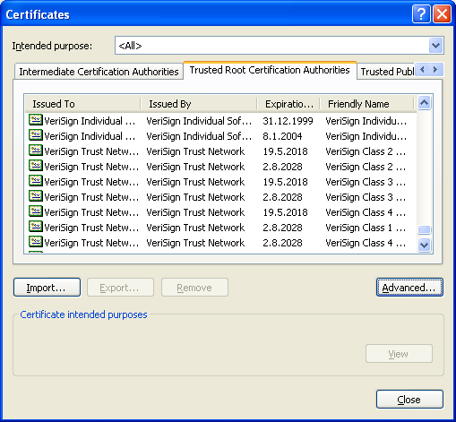

Assymetric encryption
In previous chapters we have dealed with symmetric encryption and secret keys. But secret kes face many problems primary with delivering those keys securily to the other side. This is a key distribution problem and public key encryption helps to solve it. But this isn’t the only one purpose of asymmetric encryption because it stands as another ecryption possibility to keep data safe.

Classes for asymmetric algorithms in .NET
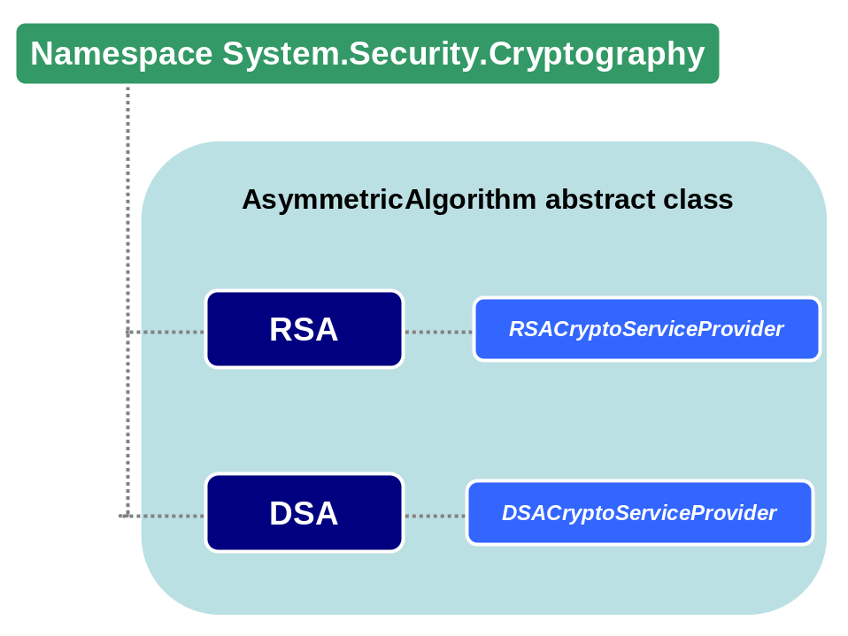

Storing public and private RSA keys in XML file
Namespaces:
using System;
using System.IO;
using System.Text;
using System.Security.Cryptography;

Code:
static void Main(string[] args)
{
// by default it will create RSA keys
RSACryptoServiceProvider rsa = (RSACryptoServiceProvider)RSA.Create();
// write to this file all rsa data
FileStream fs = new FileStream("rsaxmldata.xml", FileMode.OpenOrCreate,
FileAccess.Write);
// this will produce all RSA data, including private key
byte[] rsadata = Encoding.ASCII.GetBytes(rsa.ToXmlString(true));
fs.Write(rsadata, 0, (int)rsadata.Length);
fs.Close();
}

Encryption of plaintext using RSA with XML-stored key
This sample is able to be compiled by Visual Studio, but will throw an exception. This is cased by current version of RSACryptoServiceProvider, where method EncryptValue is not defined. This is because CryptoAPI doesn’t provide direct encryption/decription schema using RSA. Functional version follows in next chapter.
Namespaces:
using System;
using System.Text;
using System.Security.Cryptography;

Code:
static void Main(string[] args)
{
// this is a rsa key serialized by ToXmlString method, see chapter 'Storing public and private RSA keys in XML file'
const string rsakey = "<RSAKeyValue><Modulus>yf4I7PVef43rZ2NdPFA5FQFb/y/k/5Awqrwc+/VDUimthRg4C5K2P6EUhU5n2m4HUiz102LIuwsYDYuyHwG3VUbAb4zjqxiOwrSpsHfCvgOdLsb4DBrXFFGp5kMtoZrDzl84tnDlyYgy8v3o5Qp2eeQgDaau2PhYUxoco6IArHU=</Modulus><Exponent>AQAB</Exponent><P>74LA9574+jZbn2FoJ1QLqX1osXcUra/aKN9d58zO9XOexI+aPp9KEkOFifXVw3gQdSe4ZVv4UB/cEN4Z2X0pGw==</P><Q>1+YKCRr9I0K3/BA4ermfZaVrjAKPD1KGR+pfzf6vagMcZ0kUnRcug84oNu6WEfzYQhVfLfuZ7bqa0dgjGZjprw==</Q><DP>jZ9jOwhlcI5z3upaC+dGfhIJteYT9B/ngAOUI1yXg8u6NcA0FJNb2TDT5Z/Xpp14Hc4+2rBnQ/mSxuaNomy/wQ==</DP><DQ>sR8SgKHZpwHney27iEOc14E8mCLJRyLG81z+uDsHogtnU/0Kok4QZSXOrDJUf/FVYfGyokDV6ci7lwig0zE2FQ==</DQ><InverseQ>0rYiRKwxftLS8nR8STgqup+LtVjsfVRbfoZEFxiD6n1jhAweHRACPz6cF6uPI60b1QWYjBCz17EE/EdkTSvH9w==</InverseQ><D>JdLb+QM5XslEe2ev3ctn5PcMMwzU5MYrVs1C4CtdH9WOGI4gcIpYdjHDlfLIn65a0Jh6r8qfq+a36lFuWUAJBCmkT7uvU6RwuwkN5mkuLw54mtuEQCbR3Z0OXImdBtvj4uSL5t+YrJ+qezyhydCTKowtM8cLYMMrLkFxe2jlpUE=</D></RSAKeyValue>";

// this is a text to be encrypted
string plaintext = "This is a sample text.";
// create RSA class
RSA rsa = RSA.Create();
// Initialize RSA object with key
rsa.FromXmlString(rsakey);
// encipher plaintext by RSA
byte[] ciphertext = rsa.EncryptValue(Encoding.ASCII.GetBytes(plaintext));
Console.WriteLine("Value '"+plaintext+"' was encrypted to: ");
Console.WriteLine(Encoding.ASCII.GetString(ciphertext));
}

Encryption/decryption of plaintext using RSA
Namespaces:
using System;
using System.Text;
using System.Security.Cryptography;

Code:
static void Main(string[] args)
{
// this is a text to be encrypted
string plaintext = "This is a sample text.";
// create RSA class
RSACryptoServiceProvider rsa = (RSACryptoServiceProvider)RSA.Create();
// encipher plaintext by RSA with PKCS1 1.5 padding (lower security)
byte[] ciphertext = rsa.Encrypt(Encoding.ASCII.GetBytes(plaintext), false);
Console.WriteLine("Value '"+plaintext+"' was encrypted to: ");
Console.WriteLine(Encoding.ASCII.GetString(ciphertext));
Console.WriteLine("Decrypted text: "+Encoding.ASCII.GetString(rsa.Decrypt(ciphertext, false)));
}

Encryption/decryption of plaintext using RSA with XML-stored key
Namespaces:
using System;
using System.Text;
using System.Security.Cryptography;

Code:
static void Main(string[] args)
{
const string rsakey = "<RSAKeyValue><Modulus>yf4I7PVef43rZ2NdPFA5FQFb/y/k/5Awqrwc+/VDUimthRg4C5K2P6EUhU5n2m4HUiz102LIuwsYDYuyHwG3VUbAb4zjqxiOwrSpsHfCvgOdLsb4DBrXFFGp5kMtoZrDzl84tnDlyYgy8v3o5Qp2eeQgDaau2PhYUxoco6IArHU=</Modulus><Exponent>AQAB</Exponent><P>74LA9574+jZbn2FoJ1QLqX1osXcUra/aKN9d58zO9XOexI+aPp9KEkOFifXVw3gQdSe4ZVv4UB/cEN4Z2X0pGw==</P><Q>1+YKCRr9I0K3/BA4ermfZaVrjAKPD1KGR+pfzf6vagMcZ0kUnRcug84oNu6WEfzYQhVfLfuZ7bqa0dgjGZjprw==</Q><DP>jZ9jOwhlcI5z3upaC+dGfhIJteYT9B/ngAOUI1yXg8u6NcA0FJNb2TDT5Z/Xpp14Hc4+2rBnQ/mSxuaNomy/wQ==</DP><DQ>sR8SgKHZpwHney27iEOc14E8mCLJRyLG81z+uDsHogtnU/0Kok4QZSXOrDJUf/FVYfGyokDV6ci7lwig0zE2FQ==</DQ><InverseQ>0rYiRKwxftLS8nR8STgqup+LtVjsfVRbfoZEFxiD6n1jhAweHRACPz6cF6uPI60b1QWYjBCz17EE/EdkTSvH9w==</InverseQ><D>JdLb+QM5XslEe2ev3ctn5PcMMwzU5MYrVs1C4CtdH9WOGI4gcIpYdjHDlfLIn65a0Jh6r8qfq+a36lFuWUAJBCmkT7uvU6RwuwkN5mkuLw54mtuEQCbR3Z0OXImdBtvj4uSL5t+YrJ+qezyhydCTKowtM8cLYMMrLkFxe2jlpUE=</D></RSAKeyValue>";
// this is a text to be encrypted
string plaintext = "This is a sample text.";
// create RSA class
RSACryptoServiceProvider rsa = (RSACryptoServiceProvider)RSA.Create();
// inicialize RSA instance with key from XML data
rsa.FromXmlString(rsakey);
// encipher plaintext by RSA with PKCS1 1.5 padding (lower security)
byte[] ciphertext = rsa.Encrypt(Encoding.ASCII.GetBytes(plaintext), false);
Console.WriteLine("Value '"+plaintext+"' was encrypted to: ");
Console.WriteLine(Encoding.ASCII.GetString(ciphertext));
Console.WriteLine("Decrypted text: "+Encoding.ASCII.GetString(rsa.Decrypt(ciphertext, false)));
}

Encryption of plaintext using RSAParameters
Namespaces:
using System;
using System.Text;
using System.Security.Cryptography;

Code:
static void Main(string[] args)
{
// this text to encrypt
string plaintext = "Some text to be encrypted";

const string publickey = @"yf4I7PVef43rZ2NdPFA5FQFb/y/k/5Awqrwc+/VDUimthRg4C5K2P6EUhU5n2m4HUiz102LIuwsYDYuyHwG3VUbAb4zjqxiOwrSpsHfCvgOdLsb4DBrXFFGp5kMtoZrDzl84tnDlyYgy8v3o5Qp2eeQgDaau2PhYUxoco6IArHU=";
const string exponent = @"AQAB";

RSACryptoServiceProvider rsa = (RSACryptoServiceProvider)RSA.Create();

RSAParameters rsaKeyInfo = new RSAParameters();
rsaKeyInfo.Modulus = Encoding.ASCII.GetBytes(publickey);
rsaKeyInfo.Exponent = Encoding.ASCII.GetBytes(exponent);

rsa.ImportParameters(rsaKeyInfo);
byte[] ciphertext = rsa.Encrypt(Encoding.ASCII.GetBytes(plaintext), false);

Console.WriteLine("\nValue '" + plaintext + "' was enciphered to: ");
Console.WriteLine(Encoding.ASCII.GetString(ciphertext));
try
{
// this will rise an exception because private key is unknown
Console.WriteLine("\nDeciphered text: " + Encoding.ASCII.GetString(rsa.Decrypt(ciphertext, false)));
}
catch(Exception e)
{
Console.WriteLine(e.Message);
}
}

Encryption/Decryption of plaintext by RSA
Namespaces:
using System;
using System.Text;
using System.Security.Cryptography;

Code:
static void Main(string[] args)
{
// this is a text to be encrypted
string plaintext = "This is a sample text.";
// create RSA class
RSACryptoServiceProvider rsa = (RSACryptoServiceProvider)RSA.Create();
// encipher plaintext by RSA with PKCS1 1.5 padding (lower security)
byte[] ciphertext = rsa.Encrypt(Encoding.ASCII.GetBytes(plaintext), false);
Console.WriteLine("Value '"+plaintext+"' was encrypted to: ");
Console.WriteLine(Encoding.ASCII.GetString(ciphertext));
Console.WriteLine("Decrypted text: "+Encoding.ASCII.GetString(rsa.Decrypt(ciphertext, false)));
}

How to encrypt/decrypt large data using RSA?
There are too many questions on this topic and that is why here is the answer. Many people use RSA to encrypt large blocks of data and then they’re surprised why performance is low and they think that .NET Framework isn’t well implemented. But this is a very wrong explanation because problem don’t relates to problems in .NET FW but to knowledge of programmer.
By default RSA instance (RSACryptoServiceProvider) is created to work with 1024 bits large keys and in such a case RSA can work just with data 1024 bits large (128 bytes). But this is not correct answer because PCKS#1 defines how to work with padding and here goes 11 bytes off. So finally a programmer can work with just 117 bytes when 1024-bits key are involved. This is a reason why programmers divide their data into each blocks that RSA can handle and encrypte each block separately. But this is wrong and this makes many performance problems.
The solution is to combine using of asymmetric and symmetric cryptography together. RSA is able to handle all keys of current symmetric ciphers (even when just 1024 bits are used) and finally symmetric encryption is fast enough to process any type of data.

Calling RSA/DSA from a Web service, ASP or COM+
When RSACryptoServiceProvider/DSACryptoServiceProvider classes are called from Web service, ASP or COM+ application then CryptographicException will rise. This problem was presented by many times in newsgroups and even Microsoft created a specific “Q” on this (Q322371). When RSACryptoServiceProvider/DSACryptoServiceProvider classes are created keys are stored in key containers in user profiles (see chapter 6.15.3 about DPAPI). When those classes are called from Web service, ASP or COM+ then CryptographicException is rise because user profiles are not loaded in these scenarios (for performance reasons) and key container can’t be accessed. Solution is to set CspParameters as presents the following code:

Namespaces:
using System;
using System.Security.Cryptography;

Code:
static void Main(string[] args)
{
CspParameters cspParams = new CspParameters();
// this is important to set DPAPI not to use user profiles but machine store!!!
cspParams.Flags = CspProviderFlags.UseMachineKeyStore;
// create provider with custom settings
RSACryptoServiceProvider rsa = new RSACryptoServiceProvider(cspParams);

// then follows the code using RSA/DSA appropriately
// ....
}

Digital signatures
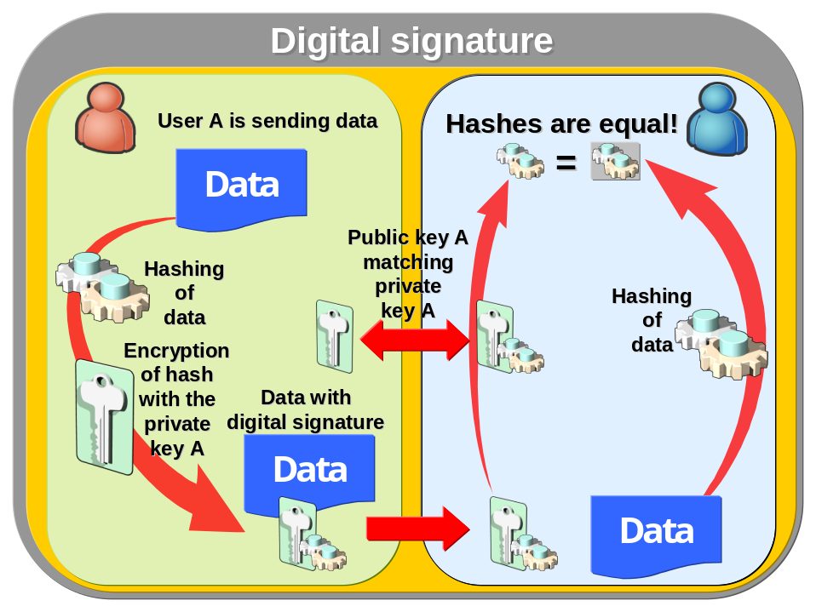

Sign and verify data with RSA I
RSA allows to define hash algorithm, this is a second parameter in SignData() method. For that example MD5 is used.
Namespaces:
using System;
using System.Text;
using System.Security.Cryptography;

Code:
static void Main(string[] args)
{
// public key to check valid signature
const string publickey = "<RSAKeyValue><Modulus>tlBhWUIdXAOQatzRKHnD+UFBQFMjZHEyMCUw3Z0zxAUyti1rPSKQBtpk3Si3j2pHt3bmKvLWThc7GOum8enSP2sdLWbcyOnYaV66UuR58g9DUdTR3QoXSTA0PcZIp6eXzyOVHSpIuhxeLQ836PvBto1NXUPvFeQedh7UCwQ/tDM=</Modulus><Exponent>AQAB</Exponent><P>7PEKBMcU4ehzmyNNFVk67G3t1R0emckztT9vcGGTUvAt/b5HpSUNftZZU8xvn+kaxdRhgFlo+cdLyeuAIQFzxQ==</P><Q>xPp7eyy7XejuR1rtUJ0bOTHC1b+rbw7TGVHjAoD3EPu63tAM145na1/quikdj9amT11Jbo/vzaDb3kwSp4pvlw==</Q><DP>N1RySntS3Q4zMN8leP7FS8C/8SxDoRXjBUgy9cNTa+K6Wq68fEwSwrO7WF49EtKUde4KdrZqVSm9AQIFga+dIQ==</DP><DQ>EPITiWcxv0R4qz7RR6wcWXFEd6sDjoxR8M2wn9iEaLufOefgEvM3Rm97/APpfSRULmOyG4badHAwOhGFUVCBhQ==</DQ><InverseQ>bWsonmY91jc1Zz+MWVEjudRKYi19ipgGsSsbH9BokrvdJPSw9Uxst5PT4Ev2kH0AGMxZwZfxnGPsYCgB+tnQ+g==</InverseQ><D>TqmN50pMiqgLBuCx6knnkcNjGRMGIU9p/TX+yJAMhtZLVClyrNUd2acfgAESenG78d/+XaebaeRCHnWG+bgOe41NbImIGcqa79Ldxx/HP11muaH12TZfig/AkNLSK2xIXjplJe8nicyjRbjCXgM/ER+6q45dxIP/8QjiaEoyQrk=</D></RSAKeyValue>";
// private key to sign signature
const string privatekey = "<RSAKeyValue><Modulus>tlBhWUIdXAOQatzRKHnD+UFBQFMjZHEyMCUw3Z0zxAUyti1rPSKQBtpk3Si3j2pHt3bmKvLWThc7GOum8enSP2sdLWbcyOnYaV66UuR58g9DUdTR3QoXSTA0PcZIp6eXzyOVHSpIuhxeLQ836PvBto1NXUPvFeQedh7UCwQ/tDM=</Modulus><Exponent>AQAB</Exponent><P>7PEKBMcU4ehzmyNNFVk67G3t1R0emckztT9vcGGTUvAt/b5HpSUNftZZU8xvn+kaxdRhgFlo+cdLyeuAIQFzxQ==</P><Q>xPp7eyy7XejuR1rtUJ0bOTHC1b+rbw7TGVHjAoD3EPu63tAM145na1/quikdj9amT11Jbo/vzaDb3kwSp4pvlw==</Q><DP>N1RySntS3Q4zMN8leP7FS8C/8SxDoRXjBUgy9cNTa+K6Wq68fEwSwrO7WF49EtKUde4KdrZqVSm9AQIFga+dIQ==</DP><DQ>EPITiWcxv0R4qz7RR6wcWXFEd6sDjoxR8M2wn9iEaLufOefgEvM3Rm97/APpfSRULmOyG4badHAwOhGFUVCBhQ==</DQ><InverseQ>bWsonmY91jc1Zz+MWVEjudRKYi19ipgGsSsbH9BokrvdJPSw9Uxst5PT4Ev2kH0AGMxZwZfxnGPsYCgB+tnQ+g==</InverseQ><D>TqmN50pMiqgLBuCx6knnkcNjGRMGIU9p/TX+yJAMhtZLVClyrNUd2acfgAESenG78d/+XaebaeRCHnWG+bgOe41NbImIGcqa79Ldxx/HP11muaH12TZfig/AkNLSK2xIXjplJe8nicyjRbjCXgM/ER+6q45dxIP/8QjiaEoyQrk=</D></RSAKeyValue>";

// this is a text to be signed
string plaintext = "This is a sample text.";
byte[] plainbytes = Encoding.ASCII.GetBytes(plaintext);
// RSA to sign a plaintext
RSACryptoServiceProvider rsasign = new RSACryptoServiceProvider();
// RSA checking valid signature
RSACryptoServiceProvider rsacheck = new RSACryptoServiceProvider();
MD5 md5 = MD5.Create();
rsasign.FromXmlString(privatekey);
// signing data
byte[] signature = rsasign.SignData(plainbytes, md5);

// validating signed data
rsacheck.FromXmlString(publickey);
if (rsacheck.VerifyData(plainbytes, md5, signature))
Console.WriteLine("Signature is correct.");
}

Sign and verify data with RSA II
This is a simpler form of previous sample, when keys are generated directly in code and not provided in variables (like it could be in some calling function in application).
Namespaces:
using System;
using System.Text;
using System.Security.Cryptography;

Code:
static void Main(string[] args)
{
// this is a text to be signed
string plaintext = "This is a sample text.";
byte[] plainbytes = Encoding.ASCII.GetBytes(plaintext);
// this instance represents keys used to signing and verification
RSACryptoServiceProvider rsakey = new RSACryptoServiceProvider();
// RSA to sign a plaintext
RSACryptoServiceProvider rsasign = new RSACryptoServiceProvider();
// RSA checking valid signature
RSACryptoServiceProvider rsacheck = new RSACryptoServiceProvider();
MD5 md5 = MD5.Create();
rsasign.FromXmlString(rsakey.ToXmlString(true));
// signing data
byte[] signature = rsasign.SignData(plainbytes, md5);

// validating signed data
rsacheck.FromXmlString(rsakey.ToXmlString(false));
if (rsacheck.VerifyData(plainbytes, md5, signature))
Console.WriteLine("Signature is correct.");
}

Sign and verify data with RSA using SignatureFormatter
Namespaces:
using System;
using System.Text;
using System.Security.Cryptography;

Code:
static void Main(string[] args)
{
// this is a text to be signed
string plaintext = "This is a sample text.";
byte[] plainbytes = Encoding.ASCII.GetBytes(plaintext);
// this instance represents keys used to signing and verification
RSACryptoServiceProvider rsakey = new RSACryptoServiceProvider();
// RSA to sign a plaintext
RSACryptoServiceProvider rsasign = new RSACryptoServiceProvider();
// RSA checking valid signature
RSACryptoServiceProvider rsacheck = new RSACryptoServiceProvider();

// setting private key to signing RSA class
rsasign.FromXmlString(rsakey.ToXmlString(true));
// setting public key to checking RSA class
rsacheck.FromXmlString(rsakey.ToXmlString(false));

// signature formatter used to sign a data
AsymmetricSignatureFormatter signform = new RSAPKCS1SignatureFormatter(rsasign);
signform.SetHashAlgorithm("SHA1");
// create hash instance
HashAlgorithm hashAlg = HashAlgorithm.Create("SHA1");
// signing data
byte[] signature = signform.CreateSignature(hashAlg.ComputeHash(plainbytes));
// deformatter is used to check signed data
AsymmetricSignatureDeformatter signcheck = new RSAPKCS1SignatureDeformatter(rsacheck);
signcheck.SetHashAlgorithm("SHA1");
// check signature
if (signcheck.VerifySignature(hashAlg.ComputeHash(plainbytes), signature))
Console.WriteLine("Signature is correct.");
}

Sign and verify data with DSA
DSA uses as a hash algorithm SHA, there is not possible to choose other hashing method.
That is why SHA is used in example bellow.

Namespaces:
using System;
using System.Text;
using System.Security.Cryptography;

Code:
static void Main(string[] args)
{
// this is a text to be signed
string plaintext = "This is a sample text.";
byte[] plainbytes = Encoding.ASCII.GetBytes(plaintext);
DSACryptoServiceProvider dsa = new DSACryptoServiceProvider();
DSASignatureFormatter dsaform = new DSASignatureFormatter();
SHA1 sha = new SHA1Managed();
dsaform.SetKey(dsa);
// sign data with hash and key
byte[] signature = dsaform.CreateSignature(sha.ComputeHash(plainbytes));

DSASignatureDeformatter dsadeform = new DSASignatureDeformatter(dsa);
// check signed data if correct
if (dsadeform.VerifySignature(sha.ComputeHash(plainbytes), signature))
Console.WriteLine("Signature is correct.");
}

Key exchange methods and classes
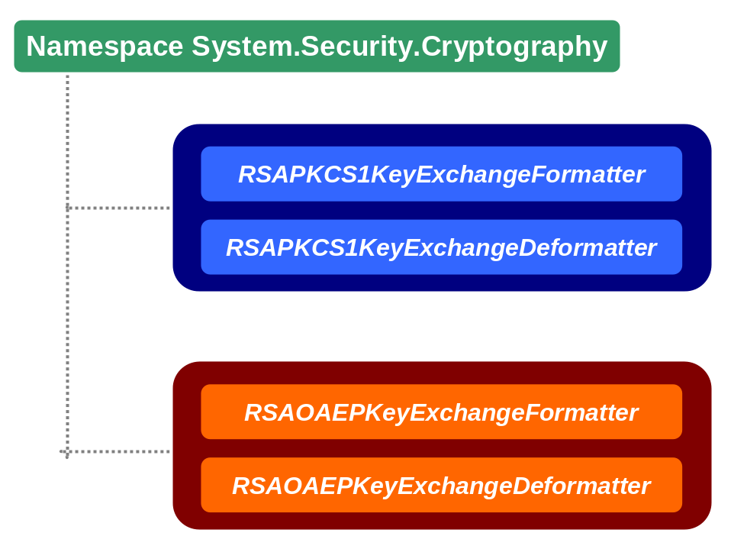

Exchange symmetric key between two clients using OAEP
Namespaces:
using System;
using System.Text;
using System.IO;
using System.Security.Cryptography;

Code:
static void Main(string[] args)
{
// this is a key pair for a second client B who will recieve symmetric key
RSACryptoServiceProvider rsaKeyB = new RSACryptoServiceProvider();
// create instance of symmetric key used by client A and send to client B
RC2 rc2A = RC2.Create();
// generate key to be sent to client B
rc2A.GenerateKey();
// this is a formatter for client A, it will be used for RC2 key from client A
RSAOAEPKeyExchangeFormatter formA = new RSAOAEPKeyExchangeFormatter();
// client A knows public key of client B, he can use it to encrypt his RC2 key
// client A creates object representing client B's public key
RSACryptoServiceProvider rsaPublicB = new RSACryptoServiceProvider();
// sets public key using XML (see chapter '')
rsaPublicB.FromXmlString(rsaKeyB.ToXmlString(false));
// set key to formatter
formA.SetKey(rsaPublicB);
// key for exchange to send it to client B
byte[] dataKeyA = formA.CreateKeyExchange(rc2A.Key);

// now use data recieved by client B
// first decrypt data encrypted by client A's public key
// use OAEP deformatter, deformatter must be always the same type (PKCS1 or OAEP)
RSAOAEPKeyExchangeDeformatter deformB = new RSAOAEPKeyExchangeDeformatter();
deformB.SetKey(rsaKeyB);
// decrypt symmetric key from recieved data
byte[] dataKeyB = deformB.DecryptKeyExchange(dataKeyA);

// create symmetric class instance
RC2 rc2B = RC2.Create();
rc2B.Key = dataKeyB;
//!!!! NOTE !!!!
// All other data related to symmetric cipher must be set, this is just principal
// sample but to make it functional vector, Mode and Padding must be set!
// for sampling purposes it's done here directly without any transmission

// see what happens when algorithm is not correctly set even with using correct key
check(rc2A, rc2B);

// now set other properties
rc2B.IV = rc2A.IV;
rc2B.Mode = rc2A.Mode;
rc2B.Padding = rc2A.Padding;

// test symmetric encryption of both clients A & B
check(rc2A, rc2B);
}

public static void check(RC2 rc2A, RC2 rc2B)
{
// data to be encrypted
string cipherData = "This is a sample plaintext";
// final encrypted data
byte[] cipherbytes;
// byte form of plaintext
byte[] plainbytes = Encoding.ASCII.GetBytes(cipherData);

// --------------- Client A encrypts plaintext ---------------
MemoryStream ms = new MemoryStream();
CryptoStream cs = new CryptoStream(ms,
rc2A.CreateEncryptor(),
CryptoStreamMode.Write);
cs.Write(plainbytes, 0, plainbytes.Length);
cs.Close();
cipherbytes = ms.ToArray();
ms.Close();

// --------------- Client B decrypts plaintext ---------------
MemoryStream ms1 = new MemoryStream(cipherbytes);
CryptoStream cs1 = new CryptoStream(ms1,
rc2B.CreateDecryptor(),
CryptoStreamMode.Read);
plainbytes = new Byte[cipherbytes.Length];
cs1.Read(plainbytes, 0, cipherbytes.Length);
cs1.Close();
ms1.Close();
Console.WriteLine("Cipher result: "+Encoding.ASCII.GetString(plainbytes));
}

Certificates

Create X509Certificate from file generated by makecert.exe
Microsoft provides tool called makecert.exe, which can be used for development purposes to generate certification file.
It can be used from command line in a following form:

makecert -n "CN=Skilldrive.com" sampleCertificate.cer

This will create certification file DER encoded and it can be directly used to create X509Certificate class instance. See sample code bellow:

Create X.509 certificate from base64 encoded certificates
.NET Framework provides classes to work with certificates, but those classes of version 1.0 and 1.1 are tight to DER encoding of .cer files. That is why base64 encoded certificates can’t be created and used. This is a workaround how to avoid this problem and to use base64 DER encoded certificates.
Namespaces:
using System;
using System.IO;
using System.Text;
using System.Security.Cryptography.X509Certificates;

Code:
public static void Main(string[] args)
{
StreamReader stream = File.OpenText("samplecertificate.cer");
String stringdata = stream.ReadToEnd();
stream.Close();

StringBuilder sb = new StringBuilder(stringdata);
// this part of certificate must be removed to be able to create X509Certificate
sb.Replace("-----BEGIN CERTIFICATE-----", "");
sb.Replace("-----END CERTIFICATE-----", "");

// convert base64 to bytes
byte[] certbytes = Convert.FromBase64String(sb.ToString());
X509Certificate cert = new X509Certificate(certbytes);
Console.WriteLine(cert.GetName());
}

Source library with CryptoAPI certificate mappings
public sealed class CertificateAPI
{
[DllImport("CRYPT32.DLL", CharSet = CharSet.Auto, SetLastError = true)]
public static extern uint CertOpenSystemStore(int hCryptProv, string storename);
[DllImport("CRYPT32.DLL", CharSet = CharSet.Auto, SetLastError = true)]
public static extern bool CertCloseStore(uint storeProvider, int flags);
[DllImport("CRYPT32.DLL", CharSet = CharSet.Auto, SetLastError = true)]
public static extern uint CertEnumCertificatesInStore(uint storeProvider, uint prevCertContext);
}

List of installed client’s certificates
Use CertificateAPI class.
Namespaces:
using System;
using System.Runtime.InteropServices;
using System.Security.Cryptography.X509Certificates;

Code:
static void Main(string[] args)
{
uint hStore = CertificateAPI.CertOpenSystemStore(0, "My");
uint hContext = 0;
// list client certificates in "My" store (current user)
// second parametr in method referes to previous context
while ((hContext = CertificateAPI.CertEnumCertificatesInStore(hStore, hContext)) != 0)
{
// create certificate instance
X509Certificate x509 = new X509Certificate((IntPtr)hContext);
// get client name
Console.WriteLine(x509.GetName());
// get certificate issuer name
Console.WriteLine(x509.GetIssuerName());
}
// store must be closed when used
CertificateAPI.CertCloseStore(hStore, 0);
}

List of installed intermediate certification authorities
The code for this sample is the same as in 6.15.4 but initialization of system store is different.

Code:
uint hStore = CertificateAPI.CertOpenSystemStore(0, "CA");

List of installed root certificate authorities
The code for this sample is the same as in 6.15.4 but initialization of system store is different.

Code:
uint hStore = CertificateAPI.CertOpenSystemStore(0, "ROOT");

Data Protection API
Data Protection API (DPAPI) provides is a password-based protection service integrated with Windows’s CryptoAPI (DPAPI is provided since Windows 2000) and DPAPI is intended to be used to protect some sensitive data like passwords, private keys or database connection strings. DPAPI is very easy to use and very strong because it uses cryptographic standards to protect data but it’s password-based and the user password is the only one weakness of this technology.
There’re two modes how DPAPI can be used:

- User mode
In this mode just logon user can access encrypted data and nobody else. In provided source library it’s set up by flag DataProtection.Store.USE_USER_STORE.
- Machine mode
When machine mode is used then data are encrypted for specific machine and every user that logs on to that machine can access them. In provided source library it’s set up by flag DataProtection.Store.USE_MACHINE_STORE.

When application calls DPAPI methods (like CryptProtectData or CryptUnprotectData) then DPAPI calls LSA (Local Security Authority) over the RPC and encrypts data.
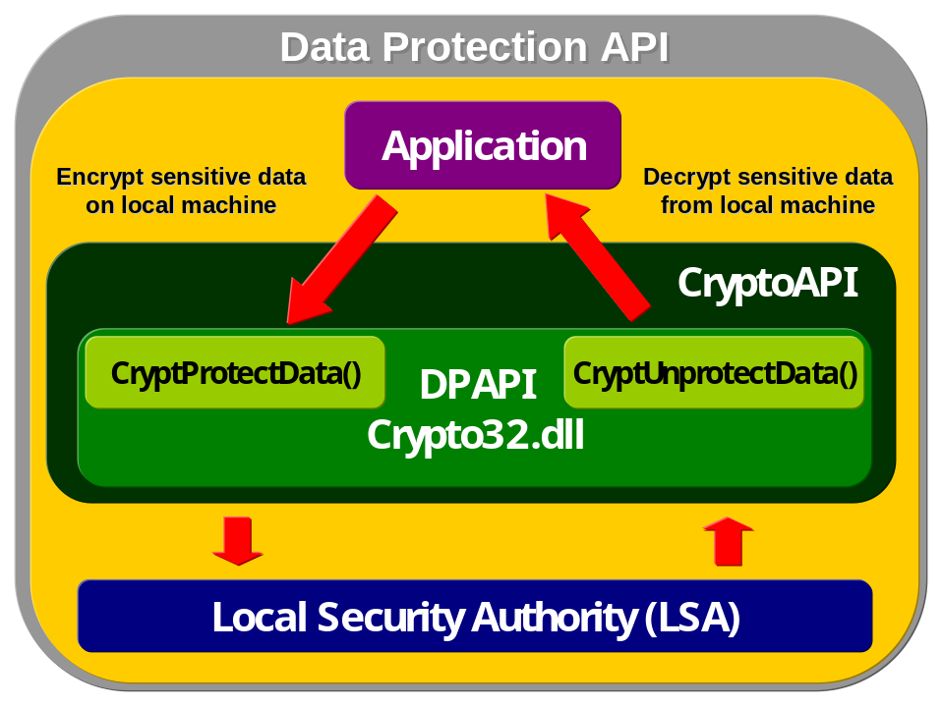
Also how data are encrypted differs from operating system (and on non-domain accounts this is extremely important), see list bellow:

Operating system/account | Encryption scheme
Non-domain accounts on Windows 2000 | DPAPI encrypts its master keys with the user password, and stores a backup copy encrypted with an LSA secret. The LSA secret in turn is encrypted with the syskey.
Domain accounts on Windows 2000 | DPAPI encrypts its master keys with the user password, and stores a backup copy encrypted with a domain secret.
Non-domain accounts on Windows XP | DPAPI encrypts its master keys with the user password, and stores a backup copy encrypted with the public key corresponding to the private key on the password reset disk.
Domain accounts on Windows XP | DPAPI encrypts its master keys with the user password, and stores a backup copy encrypted with a domain secret.

As can be seen, user’s passwords are the basic concept for encryption in DPAPI and also previous operating systems. This was the main issue in Windows till Windows 2000 because previous version were using primary LM Hash (or NTLM) to generate keys to encrypt data.

LM Hash
LM Hash was inveted by IBM (and not by Microsoft as many people think) in 70th to be used in IBM 360/370 series. Later Microsoft adopted it in its products in LAN Manager and started to call this technology LM Hash. LAN Manager was a technology used by IBM and Microsoft when those two companies was in alliance and latter when Microsoft droped this alliance LM Hash concept was kept in futher Windows versions to keep backward compatibility with previous ones (primary Windows 3.x).

How DPAPI works?
- First primary user’s key is generated from credentials as user’s password or some user’s data on smartcard.
- After that master key is generated and it is encrypted by primary user’s key.
- Whenever a call is made to DPAPI functions then session key is generated. Session key is derived from master key, random data and optionally from entropy provided to called function.
- Session key is used to encrypt data. This key is not stored anywhere, just random data and entropy is added to encrypted data and stored together.
- When user decrypts data using DPAPI it generates session key from master key and random data plus entropy stored with encrypted data.
- Master keys are usually regenerated after some time period (usually months) and those master keys are encrypted by primary user’s key and stored in user’s profile.
- When user’s password is changed (and primary key is derived from password) then master keys are re-encrypted using a new user’s key derived from a new password.
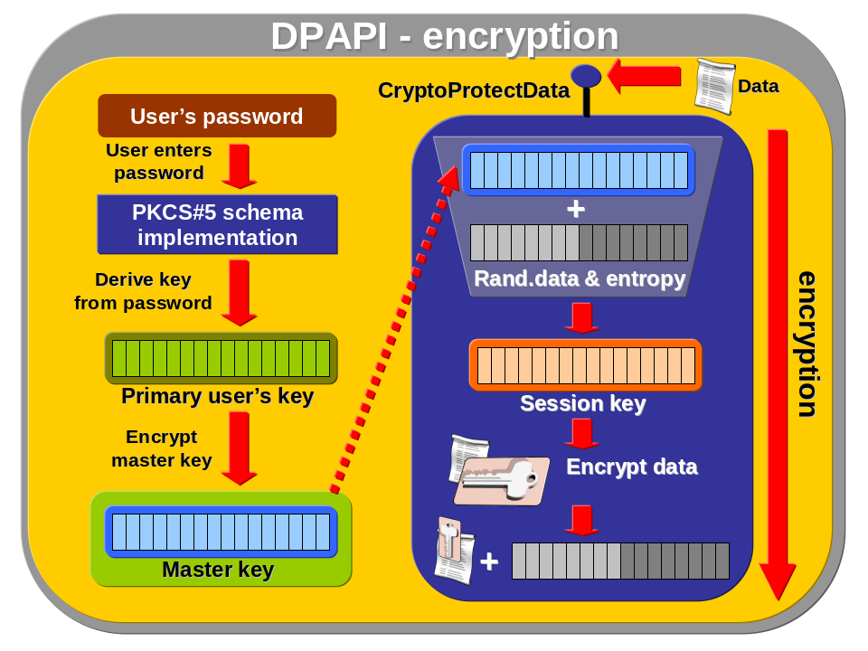

Source library with DPAPI methods
Here is the code that maps DPAPI methods to .NET environment and it can be used then by any .NET application. It’s important to mapped references to library crypt32.dll.
This code has been provided by J.D. Meier, Alex Mackman, Michael Dunner and Srinath Vasireddy on MSDN in this article. It’s very nicely written common library mapping DPAPI functions to .NET and it’s recommended to use. Here is just a copy for offline usage in other samples (more details on MSDN).

Code:
using System;
using System.Text;
using System.Runtime.InteropServices;
namespace dpapiLibrary
{
public class DataProtection
{
[DllImport("Crypt32.dll", SetLastError = true, CharSet = System.Runtime.InteropServices.CharSet.Auto)]
private static extern bool CryptProtectData(ref DATA_BLOB pDataIn, String szDataDescr, ref DATA_BLOB pOptionalEntropy, IntPtr pvReserved, ref CRYPTPROTECT_PROMPTSTRUCT pPromptStruct, int dwFlags, ref DATA_BLOB pDataOut);
[DllImport("Crypt32.dll", SetLastError = true, CharSet = System.Runtime.InteropServices.CharSet.Auto)]
private static extern bool CryptUnprotectData(ref DATA_BLOB pDataIn, String szDataDescr, ref DATA_BLOB pOptionalEntropy, IntPtr pvReserved, ref CRYPTPROTECT_PROMPTSTRUCT pPromptStruct, int dwFlags, ref DATA_BLOB pDataOut);
[DllImport("kernel32.dll", CharSet = System.Runtime.InteropServices.CharSet.Auto)]
private unsafe static extern int FormatMessage(int dwFlags, ref IntPtr lpSource, int dwMessageId, int dwLanguageId, ref String lpBuffer, int nSize, IntPtr * Arguments);
[StructLayout(LayoutKind.Sequential, CharSet = CharSet.Unicode)]
internal struct DATA_BLOB
{
public int cbData;
public IntPtr pbData;
}
[StructLayout(LayoutKind.Sequential, CharSet = CharSet.Unicode)]
internal struct CRYPTPROTECT_PROMPTSTRUCT
{
public int cbSize;
public int dwPromptFlags;
public IntPtr hwndApp;
public String szPrompt;
}
static private IntPtr NullPtr = ((IntPtr)((int)(0)));
private const int CRYPTPROTECT_UI_FORBIDDEN = 0x1;
private const int CRYPTPROTECT_LOCAL_MACHINE = 0x4;
public enum Store { USE_MACHINE_STORE = 1, USE_USER_STORE };
private Store store;
public DataProtection(Store tempStore)
{
store = tempStore;
}
public byte[] Encrypt(byte[] plainText, byte[] optionalEntropy)
{
bool retVal = false;
DATA_BLOB plainTextBlob = new DATA_BLOB();
DATA_BLOB cipherTextBlob = new DATA_BLOB();
DATA_BLOB entropyBlob = new DATA_BLOB();
CRYPTPROTECT_PROMPTSTRUCT prompt = new CRYPTPROTECT_PROMPTSTRUCT();

InitPromptstruct(ref prompt);

int dwFlags;

try
{
try
{
int bytesSize = plainText.Length;

plainTextBlob.pbData = Marshal.AllocHGlobal(bytesSize);
if (IntPtr.Zero == plainTextBlob.pbData)
{
throw new Exception("Unable to allocate plaintext buffer.");
}

plainTextBlob.cbData = bytesSize;
Marshal.Copy(plainText, 0, plainTextBlob.pbData, bytesSize);
}
catch (Exception ex)
{
throw new Exception("Exception marshalling data. " + ex.Message);
}
if (Store.USE_MACHINE_STORE == store)
{//Using the machine store, should be providing entropy.
dwFlags = CRYPTPROTECT_LOCAL_MACHINE | CRYPTPROTECT_UI_FORBIDDEN;

//Check to see if the entropy is null
if (null == optionalEntropy)
{//Allocate something
optionalEntropy = new byte[0];
}

try
{
int bytesSize = optionalEntropy.Length;

entropyBlob.pbData = Marshal.AllocHGlobal(optionalEntropy.Length);;
if (IntPtr.Zero == entropyBlob.pbData)
{
throw new Exception("Unable to allocate entropy data buffer.");
}

Marshal.Copy(optionalEntropy, 0, entropyBlob.pbData, bytesSize);
entropyBlob.cbData = bytesSize;
}
catch (Exception ex)
{
throw new Exception("Exception entropy marshalling data. " + ex.Message);
}
}
else
{//Using the user store
dwFlags = CRYPTPROTECT_UI_FORBIDDEN;
}

retVal = CryptProtectData(ref plainTextBlob, "", ref entropyBlob, IntPtr.Zero, ref prompt, dwFlags, ref cipherTextBlob);
if (false == retVal)
{
throw new Exception("Encryption failed. " + GetErrorMessage(Marshal.GetLastWin32Error()));
}
}
catch (Exception ex)
{
throw new Exception("Exception encrypting. " + ex.Message);
}

byte[] cipherText = new byte[cipherTextBlob.cbData];

Marshal.Copy(cipherTextBlob.pbData, cipherText, 0, cipherTextBlob.cbData);
return cipherText;
}
public byte[] Decrypt(byte[] cipherText, byte[] optionalEntropy)
{
bool retVal = false;
DATA_BLOB plainTextBlob = new DATA_BLOB();
DATA_BLOB cipherBlob = new DATA_BLOB();
CRYPTPROTECT_PROMPTSTRUCT prompt = new CRYPTPROTECT_PROMPTSTRUCT();

InitPromptstruct(ref prompt);
try
{
try
{
int cipherTextSize = cipherText.Length;

cipherBlob.pbData = Marshal.AllocHGlobal(cipherTextSize);
if (IntPtr.Zero == cipherBlob.pbData)
{
throw new Exception("Unable to allocate cipherText buffer.");
}

cipherBlob.cbData = cipherTextSize;
Marshal.Copy(cipherText, 0, cipherBlob.pbData, cipherBlob.cbData);
}
catch (Exception ex)
{
throw new Exception("Exception marshalling data. " + ex.Message);
}

DATA_BLOB entropyBlob = new DATA_BLOB();
int dwFlags;

if (Store.USE_MACHINE_STORE == store)
{//Using the machine store, should be providing entropy.
dwFlags = CRYPTPROTECT_LOCAL_MACHINE | CRYPTPROTECT_UI_FORBIDDEN;

//Check to see if the entropy is null
if (null == optionalEntropy)
{//Allocate something
optionalEntropy = new byte[0];
}

try
{
int bytesSize = optionalEntropy.Length;

entropyBlob.pbData = Marshal.AllocHGlobal(bytesSize);
if (IntPtr.Zero == entropyBlob.pbData)
{
throw new Exception("Unable to allocate entropy buffer.");
}

entropyBlob.cbData = bytesSize;
Marshal.Copy(optionalEntropy, 0, entropyBlob.pbData, bytesSize);
}
catch (Exception ex)
{
throw new Exception("Exception entropy marshalling data. " + ex.Message);
}
}
else
{//Using the user store
dwFlags = CRYPTPROTECT_UI_FORBIDDEN;
}

retVal = CryptUnprotectData(ref cipherBlob, null, ref entropyBlob, IntPtr.Zero, ref prompt, dwFlags, ref plainTextBlob);
if (false == retVal)
{
throw new Exception("Decryption failed. " + GetErrorMessage(Marshal.GetLastWin32Error()));
}

//Free the blob and entropy.
if (IntPtr.Zero != cipherBlob.pbData)
{
Marshal.FreeHGlobal(cipherBlob.pbData);
}

if (IntPtr.Zero != entropyBlob.pbData)
{
Marshal.FreeHGlobal(entropyBlob.pbData);
}
}
catch (Exception ex)
{
throw new Exception("Exception decrypting. " + ex.Message);
}

byte[] plainText = new byte[plainTextBlob.cbData];

Marshal.Copy(plainTextBlob.pbData, plainText, 0, plainTextBlob.cbData);
return plainText;
}
private void InitPromptstruct(ref CRYPTPROTECT_PROMPTSTRUCT ps)
{
ps.cbSize = Marshal.SizeOf(typeof(CRYPTPROTECT_PROMPTSTRUCT));
ps.dwPromptFlags = 0;
ps.hwndApp = NullPtr;
ps.szPrompt = null;
}
private unsafe static String GetErrorMessage(int errorCode)
{
int FORMAT_MESSAGE_ALLOCATE_BUFFER = 0x00000100;
int FORMAT_MESSAGE_IGNORE_INSERTS = 0x00000200;
int FORMAT_MESSAGE_FROM_SYSTEM = 0x00001000;
int messageSize = 255;
String lpMsgBuf = "";
int dwFlags = FORMAT_MESSAGE_ALLOCATE_BUFFER | FORMAT_MESSAGE_FROM_SYSTEM | FORMAT_MESSAGE_IGNORE_INSERTS;
IntPtr ptrlpSource = new IntPtr();
IntPtr prtArguments = new IntPtr();
int retVal = FormatMessage(dwFlags, ref ptrlpSource, errorCode, 0, ref lpMsgBuf, messageSize, &prtArguments);

if (0 == retVal)
{
throw new Exception("Failed to format message for error code " + errorCode + ". ");
}

return lpMsgBuf;
}
}
}

Use DPAPI to encipher application data into file
Namespaces:
using System;
using System.IO;
using System.Text;
// this is a reference on namespace of the above provided library in chapter
using dpapiLibrary;

Code:
static void Main(string[] args)
{
// create new class instance from dpapiLibrary
DataProtection dp = new DataProtection(DataProtection.Store.USE_MACHINE_STORE);

// data to be encrypted
string cipherData = "This is a sample plaintext";

// final encrypted data
byte[] cipherbytes;

// byte form of plaintext
byte[] plainbytes = Encoding.ASCII.GetBytes(cipherData);

// encrypt data using DPAPI
// there isn't used and entropy, so the security level is smaller
cipherbytes = dp.Encrypt(plainbytes, null);

// store data in local file
StreamWriter writer = new StreamWriter(@".\Encrypted.txt");

writer.WriteLine(Convert.ToBase64String(cipherbytes));
writer.Close();
}

Use DPAPI to decipher application data from file
Namespaces:
using System;
using System.IO;
using System.Text;
// this is a reference on namespace of the above provided library in chapter
using dpapiLibrary;

Code:
static void Main(string[] args)
{
// encrypted data in file
string cipherData;

// byte form of plaintext
byte[] cipherbytes;

// create new class instance from dpapiLibrary
DataProtection dp = new DataProtection(DataProtection.Store.USE_MACHINE_STORE);
StreamReader reader = new StreamReader(@".\Encrypted.txt");

cipherbytes = Convert.FromBase64String(reader.ReadLine());
// decrypt data using DPAPI
// there isn't used and entropy, so the security level is smaller
cipherData = Encoding.ASCII.GetString(dp.Decrypt(cipherbytes, null));
Console.WriteLine(cipherData);
reader.Close();
}

DPAPI used to encrypt data in file in isolated storage
Namespaces:
using System;
using System.IO;
using System.IO.IsolatedStorage;
using System.Text;
// this is a reference on namespace of the above provided library in chapter
using dpapiLibrary;

Code:
static void Main(string[] args)
{
// data to be encrypted
string cipherData = "This is a sample plaintext";

// final encrypted data
byte[] cipherbytes;

// byte form of plaintext
byte[] plainbytes = Encoding.ASCII.GetBytes(cipherData);

// create new class instance from dpapiLibrary
DataProtection dp = new DataProtection(DataProtection.Store.USE_MACHINE_STORE);

// open isolated storage file
// create new file to store data
IsolatedStorageFile domStorage = IsolatedStorageFile.GetUserStoreForDomain();
IsolatedStorageFileStream isfs = new IsolatedStorageFileStream("Encrypted.txt", FileMode.Create, domStorage);
StreamWriter writer = new StreamWriter(isfs);

cipherbytes = dp.Encrypt(plainbytes, null);
writer.WriteLine(Convert.ToBase64String(cipherbytes));
writer.Close();
domStorage.Close();
}

DPAPI used to decrypt data from file in isolated storage
Namespaces:
using System;
using System.IO;
using System.IO.IsolatedStorage;
using System.Text;
// this is a reference on namespace of the above provided library in chapter
using dpapiLibrary;

Code:
static void Main(string[] args)
{
// encrypted data in file
string cipherData;

// byte form of plaintext
byte[] cipherbytes;

// create new class instance from dpapiLibrary
DataProtection dp = new DataProtection(DataProtection.Store.USE_MACHINE_STORE);

// open isolated storage file
// create new file to store data
IsolatedStorageFile domStorage = IsolatedStorageFile.GetUserStoreForDomain();
IsolatedStorageFileStream isfs = new IsolatedStorageFileStream("Encrypted.txt", FileMode.Open, domStorage);
StreamReader reader = new StreamReader(isfs);

cipherbytes = Convert.FromBase64String(reader.ReadLine());

// decrypt data using DPAPI from isolated storage file
cipherData = Encoding.ASCII.GetString(dp.Decrypt(cipherbytes, null));
Console.WriteLine(cipherData);
reader.Close();
domStorage.Close();
}

Encrypt/Decrypt database connection string using DPAPI
This sample demonstrates using of DPAPI to keep connection string secret.
The scenario is simplified but can be easily extended to real usage in applications and ASP.NET.
First get connection string (from application parameter, from WebForm in case of ASP.NET or any other custom source) . In this sample we work with sample connection string (server=(local);Integrated Security=SSPI;database=Northwind) in application configuration file applicationName.exe.config:

<?xml version="1.0" encoding="utf-8"?>
<configuration>
<appSettings>
<add key="connectionstring" value="AQAAANCMnd8BFdERjHoAwE/Cl+sBAAAAatVYYV9QZUSJOPI1kIBbWwQAAAACAAAAAAADZgAAqAAAABAAAACVYDurlVoXSld1tYV3Edi3AAAAAASAAACgAAAAEAAAAFWaEZK3Rv37Vut7Z8KwDe5A_u65 ?AAHjftc1NhxvZylAoKQshCXTiv3aGdCH3/1Gl5UQQwJbT+lvkspwIgvuz2uIFIZ2IFngbYPOUlv7wy3eJOglNtJBQAAAAUHl7qdEeucMlGMKi8CJm23iCCVQ==" />
</appSettings>
</configuration>

Don’t use this XML file, it contains just sample connection string encrypted on different computer with different encryption key. Just insert there your one encrypted with DPAPI as described in previous samples and update your own configuration file. Your configuration file keep in application directory and then run the following code:

using System;
using System.Text;
using dpapiLibrary;
using System.Configuration;

class ConnectionString
{
static void Main(string[] args)
{
// create new class instance from dpapiLibrary
// for better security use DataProtection.Store.USE_USER_STORE
DataProtection dp = new DataProtection(DataProtection.Store.USE_MACHINE_STORE);

// Encrypt connection string
string cipherData = ConfigurationSettings.AppSettings["connectionstring"];

byte[] cipherbytes = Convert.FromBase64String(cipherData);
string plaintext = Encoding.ASCII.GetString(dp.Decrypt(cipherbytes, null));
Console.WriteLine(plaintext);
}
}

Issues with user’s store and web services and COM+
User’s store is a good option with higher level of security when compared with machine store. It’s because data encrypted on machine level are accessible to all users who can access machine, but when USE_MACHINE_STORE flag is used then data can be encrypted and decrypted just by the only one user (specific user profile). User profile is important to encrypt/decrypt data and without this profile is impossible to get DPAPI data.
In case of web services and COM+ components (like Enterprise Services) user profile is not loaded to optimize performance and when programmer is calling DPAPI from them then exception is rised.
This can be solved by two solutions:
- Method LoadUserProfile
Win32 API provides method that can explicitly load user’s profile but this method requires administrator’s privileges to be called.
- Windows Service
When service is started than Windows Service Control Manager (SCM) loads user’s profile automatically. This service can encapsulate web services or COM+ components (Enterprise Services) or service can load those components under the same user’s account (with loaded user’s profile).

Managed DPAPI
With new version of .NET Framework will be brought the possibility to use managed DPAPI that will encapsulate DPAPI in CryptoAPI package. There will be two primary classes:
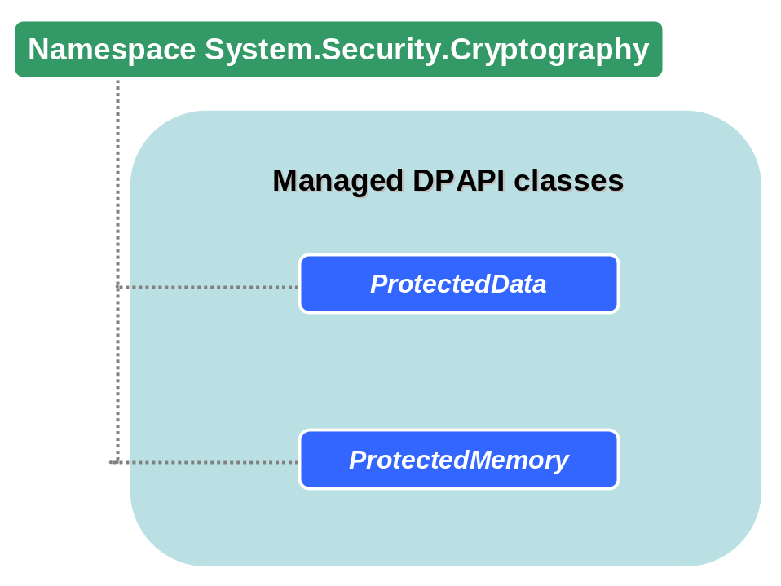
Those two classes provide DPAPI functionality in those methods:

XML Signatures

Sign XML
Add reference to your project to system.security.dll (go to Solution Explorer, right click on References tree item, from popup menu choose Add reference... and on table pane .NET select library system.security.dll).
XML signatures are applied to arbitrary data within or external XML document. Signed data can assure of:
- Whole document has not been changed or corrupted.
- Data originated from signer.
So what is a signed XML? It is XML document consisting of data objects that were hashed and encrypted into a digest, digest was then placed into an element together with other information. All that is signed by cryptographic methods.
XML signatures are represented by Signature element. Syntax of that element is following:

Isolated storage
Many applications stores data in files and their name and location must be carefully chosen with respect to protection of data from other applications (that could access those files and make data not consistent) or from security point of view. Also registry became popular one time and this idea was smart but also it caused many problems (like many problems with searching, backup and very confusing organization). That is why Microsoft introduced the idea of isolated storages which can be seen as a separate “file system and store” specific to each user and application domain (or other extending specifics) solving problems with separation of stored data by applications.
With isolated storage concept, data is always isolated by:

- User and assembly (Assembly evidence like strong name is used to create isolated storage, where only instances of that assembly will be able to access and modify)
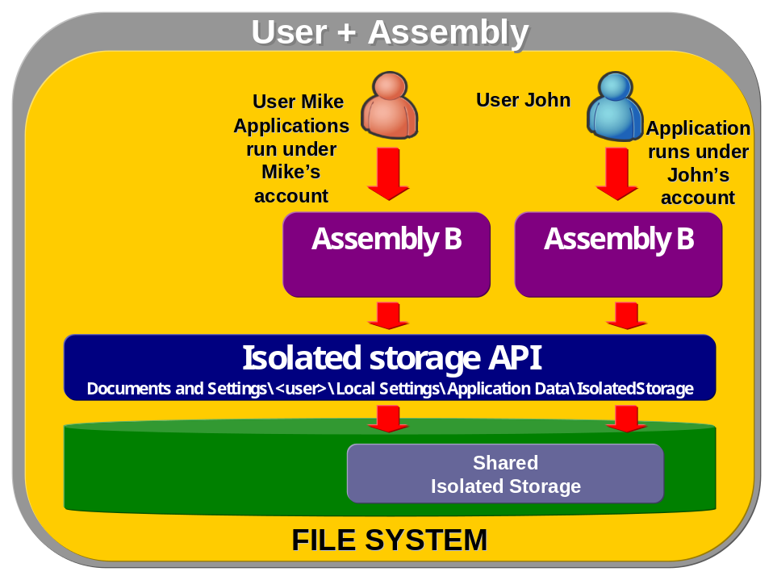
- User, application domain and by assembly (Identification is based on assembly instances running from a specific application domain (it can be assembly running from specific site). Just those instances from the same domain can access and modify data in that isolated storage context. Simply this means that this type of isolation is more restrictive then previous one and just code that created this isolation storage can access it.
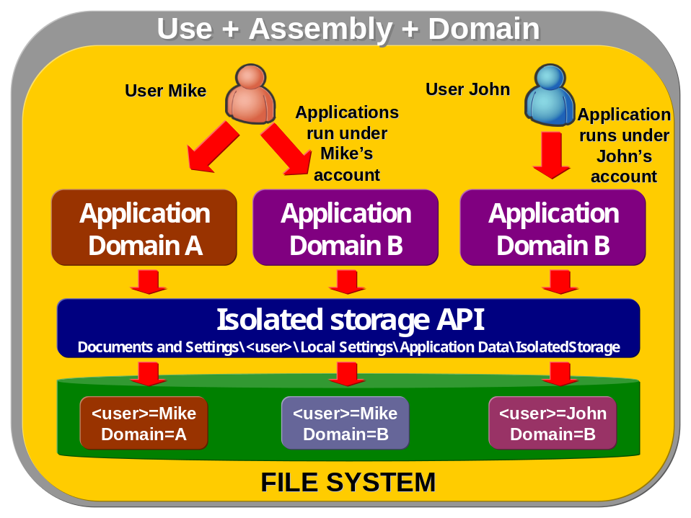
Isolated storages can be managed by administrators to enable access to them based on an appropriate trust level or administrators can remove all persisted user’s data. That access to isolated storage is based on permission carried by System.Security.Permissions.IsolatedStoragePermission class. Of course this is abstract class and is never instantiated there’s derived one (IsolatedStorageFilePermission) which specifies allowed usage of a private virtual file system.

Sometimes developers need to know location of isolated storage files. This location depends on operating system used by client and following table shows locations where are isolated storages created for some common Windows systems.
Operating system | Location in file system
Windows 98, Windows ME  - user profiles not enabled | Roaming = <SYSTEMROOT>\Application Data  Non-roaming = <SYSTEMROOT>\Local Settings\Application Data
Windows 98, Windows ME  - user profiles enabled | Roaming = <SYSTEMROOT>\Profiles\<USER>\Application Data  Non-roaming = Windows\Local Settings\Application Data
Windows NT 4.0 | <SYSTEMROOT>\Profiles\<USER>\Application Data
Windows NT 4.0  - Service Pack 4 | Roaming = <SYSTEMROOT>\Profiles\<USER>\Application Data  Non-roaming = <SYSTEMROOT>\Profiles\<USER>\Local Settings\Application Data
Windows 2000, Windows XP, Windows Server 2003  - upgrade from NT 4.0 | Roaming = <SYSTEMROOT>\Profiles\<USER>\Application Data  Non-roaming = <SYSTEMROOT>\Profiles\<USER\Local Settings\Application Data
Windows 2000  - clean install (and upgrades from Windows 98 and NT 3.51) | Roaming = <SYSTEMDRIVE>\Documents and Settings\<USER\Application Data  Non-roaming = <SYSTEMDRIVE>\Documents and Settings\<USER>\Local Settings\Application Data

Storeadm.exe – administration of isolated storage in .NET
This tool is shipped with .NET Framework SDK and it enables to work with isolated storage. It can list isolated storages and managed them like cleaning of their content.
Storeadm.exe is located in SDK directory in subdirectory <SDKDIRECTORY>\FrameworkSDK\Bin.

Cleaning of isolated storage
Explicit removing of stored files is very important because isolated storage doesn’t work like garbage collector reclaiming all unused memory back again. With isolated storage storeadm.exe must be used to clean those stores and limitations of such work must be known and realized. The most important is that cleaning of isolated storage by storeadm.exe can be done only on behalf of current user (not all users), when calling this tool from command line. But this can be solved by using of MSI files which are deployed via Group Policy affecting all users. This is a standard solution, when MSI includes storeadm.exe with flag /quiet keeping running it without any dialog box.

Listing of content of isolated storage

Opening of isolated storages for current user and domain
This sample presents how to start working with isolated storages using the basic class IsolatedStorageFile. Using it it’s possible to create directories, files and do other I/O operations in that virtual file system. The code will create sample directory as shows the figure bellow

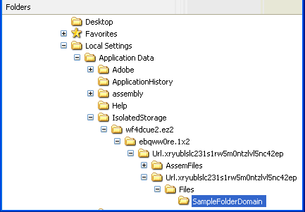

and then destroys it.
In the code are used two IsolatedStorageFile instances (domStorage and domStorageShort) presenting possible methods of their obtaining.

Namespaces:
using System;
using System.IO.IsolatedStorage;

Code:
static void Main(string[] args)
{
// application domain specific storage
IsolatedStorageFile domStorage = IsolatedStorageFile.GetStore(IsolatedStorageScope.Assembly | IsolatedStorageScope.Domain | IsolatedStorageScope.User, null, null);
// this is the same function as previous
IsolatedStorageFile domStorageShort = IsolatedStorageFile.GetUserStoreForDomain();
// create the directory in isolated storage
domStorageShort.CreateDirectory("SampleFolderDomain");
string[] dirs = domStorageShort.GetDirectoryNames("*");
// ensure that directory has been created
Console.WriteLine(dirs[0]);
// delete the directory using second instance of IsolatedStorageFile class
domStorage.DeleteDirectory("SampleFolderDomain");
// ensure that directory has been deleted
dirs = domStorageShort.GetDirectoryNames("*");
if (dirs.Length == 0) Console.WriteLine("There are no directory in isolated storage");
else Console.WriteLine(dirs[0]);
// close isolated store files
domStorageShort.Close();
domStorage.Close();
}

Store data in file in isolated storage
Namespaces:
using System;
using System.IO;
using System.IO.IsolatedStorage;

Code:
static void Main(string[] args)
{
IsolatedStorageFile domStorage = IsolatedStorageFile.GetUserStoreForDomain();
// create new file to store data in
IsolatedStorageFileStream isfs = new IsolatedStorageFileStream("SampleFile.txt", FileMode.Create, domStorage);
// now do it like in the sample in chapter 8.2.4
StreamWriter writer = new StreamWriter(isfs);
// write data to file
writer.WriteLine("This is a first line stored in isolated storage");
writer.Flush();
// close resources
isfs.Close();
domStorage.Close();
}

Network Operations

Retrieve DNS computer name
Code:
public static void Main(string[] args) {
Console.WriteLine(“DNS: {0}”, System.Net.Dns.GetHostByName(“LocalHost”).HostName);
}

Retrieve NetBIOS computer name
Code:
public static void Main(string[] args) {
Console.WriteLine(“NetBIOS: {0}”, System.Environment.MachineName);
}

Obtain IP address and host
Namespaces:
using System;
using System.Net;

Code:
static void Main(string[] args)
{
string host = Dns.GetHostName();
Console.WriteLine("Hostname is: {0}", host);
IPHostEntry entry = Dns.GetHostByName(host);
foreach (IPAddress ip in entry.AddressList)
{
Console.WriteLine("IP address: " + ip.ToString());
}
}

Send email in .NET environment
Namespaces:
using System;
using System.Web.Mail;

Code:
static void Main(string[] args)
{
MailMessage mailMsg = new MailMessage();
mailMsg.From = "jan.seda@skilldrive.com";
mailMsg.To = "jseda@microsoft.com";
mailMsg.Cc = "";
mailMsg.Bcc = "";
mailMsg.Subject = "Here goes a subject";
mailMsg.Body = "Here goes email body";
mailMsg.Priority = (MailPriority)1;
mailMsg.Attachments.Add(new MailAttachment("c:\\links.txt"));
SmtpMail.SmtpServer = "smarthost";
SmtpMail.Send(mailMsg);
}

Retrieve email from POP3 mail server
Namespaces:
using System;
using System.IO;
using System.Text;
using System.Net.Sockets;

Code:
public static void Main ()
{
const string host = "pop3.yourdomain.com";
const string user = "youruseraccount";
const string password = "yourpassword";

// tcp client for pop3
TcpClient tcp = new TcpClient();

// connect to host to port 110 (pop3)
tcp.Connect(host, 110);
NetworkStream netStream = tcp.GetStream();
StreamReader reader = new StreamReader(tcp.GetStream());

// allocate bytes for buffered read by TCP stream
string inBuffer = "";
// sent bytes to mail server
byte[] outBuffer;
// read data into the buffer
inBuffer = reader.ReadLine();

// output data read from server (usually name of mail server with welcome message)
Console.WriteLine(inBuffer);

// authorize to the server (USER userName)
outBuffer = Encoding.ASCII.GetBytes("USER " + user + "\r\n");
netStream.Write(outBuffer, 0, outBuffer.Length);

// response from server (OK)
inBuffer = reader.ReadLine();

// send password (PASS password)
outBuffer = Encoding.ASCII.GetBytes("PASS " + password + "\r\n");
netStream.Write(outBuffer, 0, outBuffer.Length);

// response from server (OK - login)
inBuffer = reader.ReadLine();

Console.WriteLine("---------------------- Authenticated to server ----------------------");

outBuffer = Encoding.ASCII.GetBytes("STAT" + "\r\n");
netStream.Write(outBuffer, 0, outBuffer.Length);

inBuffer = reader.ReadLine();
Console.WriteLine(inBuffer);

// retrieve first message from server (RETR messageNumber)
outBuffer = Encoding.ASCII.GetBytes("RETR 1" + "\r\n");
netStream.Write(outBuffer, 0, outBuffer.Length);

inBuffer = reader.ReadLine();
Console.WriteLine(inBuffer);
while (!inBuffer.Equals("."))
{
inBuffer = reader.ReadLine();
Console.WriteLine(inBuffer);
}

outBuffer = Encoding.ASCII.GetBytes("QUIT" + "\r\n");
netStream.Write(outBuffer, 0, outBuffer.Length);

// close tcp connection
tcp.Close();
}

File operations

General IO operations

Get executing application’s path with reflection
Code:
static void Main(string[] args)
{
string path;
path = System.IO.Path.GetDirectoryName(
System.Reflection.Assembly.GetExecutingAssembly().GetName().CodeBase);
Console.WriteLine(path);
}

Get executing application’s path
Code:
static void Main(string[] args)
{
// this shows application's path
Console.WriteLine(System.Windows.Forms.Application.StartupPath);
}

Classes working with file and directory information
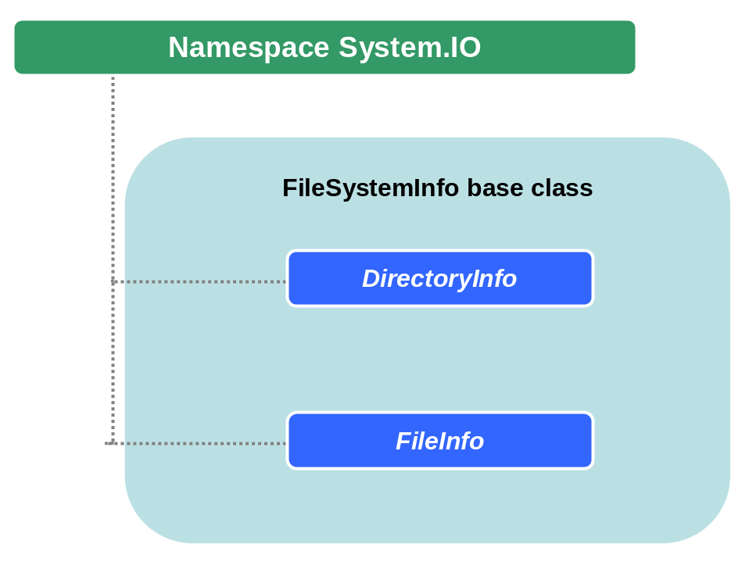

Change file & folder attributes
Code:
using System;
using System.IO;

class ChangeAttrib
{
static void Main(string[] args)
{
// arg[0] represent path to files and folder where attributes will be changed
ChangeAttributes(args[0]);
}

public static void ChangeAttributes(string path)
{
DirectoryInfo dirInfo = new DirectoryInfo(path);

// set directory attribute to appropriate
dirInfo.Attributes = FileAttributes.Normal;
foreach (FileSystemInfo file in dirInfo.GetFileSystemInfos())
{
// here set appropriate attribute for file
file.Attributes = FileAttributes.Normal;
}

foreach (DirectoryInfo dir in dirInfo.GetDirectories())
{
// do recursive calls to change attributes in subdirectories
ChangeAttributes(dir.FullName);
}
}
}

Recursive list of directories/subdirectories & files
Code:
using System;
using System.IO;

class Sample
{
static void Main(string[] args)
{
DirectoryInfo dirInfo = new DirectoryInfo("c:\\Sample_path");
RecursiveList(dirInfo);
}

private static void RecursiveList(DirectoryInfo dirInfo)
{
// first list all subdirectories
DirectoryInfo[] subDirs = dirInfo.GetDirectories();
foreach(DirectoryInfo subDir in subDirs)
{
RecursiveList(subDir);
}

// list all files in current directory (as RecursiveList method is called)
FileInfo[] dirFiles = dirInfo.GetFiles();
foreach(FileInfo fileInfo in dirFiles)
{
Console.WriteLine(fileInfo.FullName);
}
}
}

Reading and writing from/to files
Reading and writing to a file is done using a generic concept called a stream. The idea behind the stream lays a long time ago, when data are thought as a transfer from one point to another like a flow of data. In .NET environment you can find many classes representing this concept working with files or with memory data (see diagram bellow).
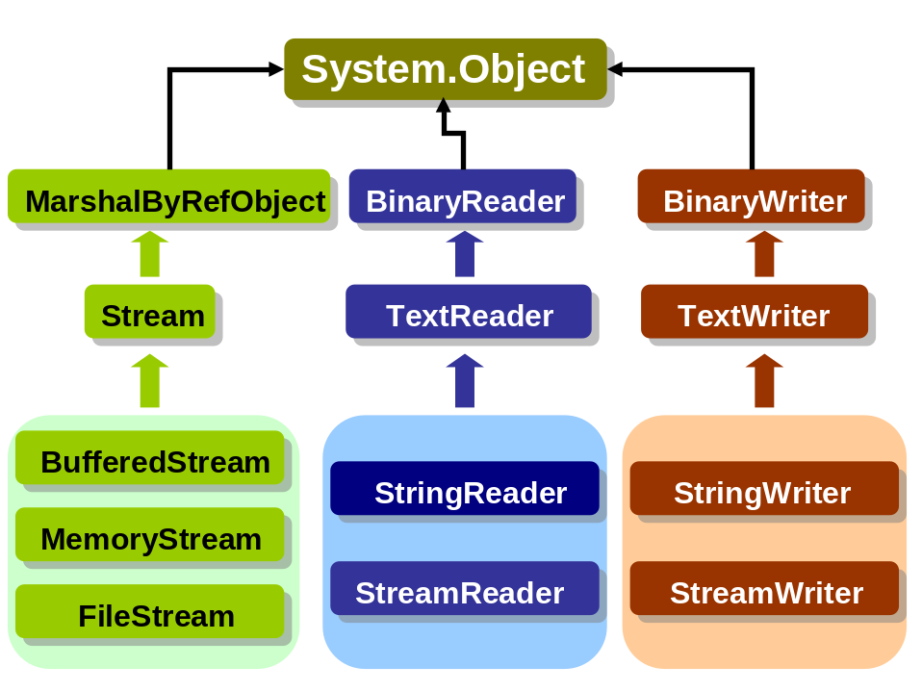
BufferedStream – this class is used to read and write to another stream. It is used for performance reasons, when caching of file data is used by underlying operating system.
MemoryStream -
The most important classes, regarding file operations, are

BufferedStream
Using of streams to do file IO is straightforward but slow with low performance (as was mentioned above). For that reason BufferedStream class exists and is more efficient. It can be used by any stream class. For file operations it’s possible to use FileStream, where buffering operations are already included.

Read from file using BufferedStream
Namespaces:
using System;
using System.Text;
using System.IO;

Code:
static void Main(string[] args)
{
string path = "c:\\sample\\sample.xml";
Stream instream = File.OpenRead(path);
// create buffer for open stream
BufferedStream bufin = new BufferedStream(instream);
byte[] bytes = new byte[128];
// read first 128 bytes of file
bufin.Read(bytes, 0, 128);
Console.WriteLine("Allocated bytes: "+Encoding.ASCII.GetString(bytes));
}

Read text from file
Namespaces:
using System;
using System.IO;

Code:
static void Main(string[] args)
{
string fileName = "temp.txt";
FileStream stream = new FileStream(fileName, FileMode.Open, FileAccess.Read);
StreamReader reader = new StreamReader(stream);

while (reader.Peek() > -1) Console.WriteLine(reader.ReadLine());
reader.Close();
}

Write text to file
Namespaces:
using System;
using System.IO;

Code:
static void Main(string[] args)
{
string fileName = "temp.txt";
FileStream stream = new FileStream(fileName, FileMode.OpenOrCreate, FileAccess.Write);
StreamWriter writer = new StreamWriter(stream);

writer.WriteLine("This is my first line in a file");
writer.Close();
}

Create file and write to it
This sample uses method CreateText() which creates a new file and returns StreamWriter object that writes to a file using UTF-8 encoding.
Namespaces:
using System;
using System.IO;

Code:
static void Main(string[] args)
{
string fileName = "temp.txt";
StreamWriter writer = File.CreateText(fileName);

writer.WriteLine("This is my newly created file.");
writer.Close();
}

Append text to file
Namespaces:
using System;
using System.IO;

Code:
static void Main(string[] args)
{
try
{
string fileName = "temp.txt";
// this appends text to existing file, if file doesn't exist it is created
StreamWriter writer = File.AppendText(fileName);
writer.WriteLine("This is the appended text.");
writer.Close();
}
catch
{
Console.WriteLine("Error");
}
}

Read from binary file
Namespaces:
using System;
using System.IO;

Code:
static void Main(string[] args)
{
try
{
string fileName = "temp.txt";
int letter = 0;
FileStream stream = new FileStream(fileName, FileMode.Open, FileAccess.Read);
BinaryReader reader = new BinaryReader(stream);

while (letter != -1)
{
letter = reader.Read();
// chars are converted according to current Encoding settings
if (letter != -1) Console.Write((char)letter);
}
reader.Close();
stream.Close();
}
catch
{
Console.WriteLine("Error");
}
}

Write to binary file
Namespaces:
using System;
using System.IO;

Code:
static void Main(string[] args)
{
try
{
string fileName = "temp.txt";
// data to be stored
int[] data = {0, 1, 2, 3, 4, 5};
FileStream stream = new FileStream(fileName, FileMode.Open, FileAccess.Write);
BinaryWriter writer = new BinaryWriter(stream);

for(int i=0; i<data.Length; i++)
{
// numbers are stored in UTF-8 format (4 bytes), try to read it
writer.Write(data[i]);
}

writer.Close();
stream.Close();
}
catch
{
Console.WriteLine("Error");
}

Watch file system for changes
.NET Framework provides class System.IO.FileSystemWatcher which listens to the file system changes. This sample presents how to use it.
Code:
using System;
using System.IO;
class WatcherSample
{
static void Main(string[] args)
{
// watch for changes in application's directory and on all files
FileSystemWatcher watcher = new FileSystemWatcher(System.Windows.Forms.Application.StartupPath, "*.*");

// watch for file name and size changes
watcher.NotifyFilter = NotifyFilters.FileName | NotifyFilters.Size;
watcher.Changed += new FileSystemEventHandler(OnChange);
watcher.Created += new FileSystemEventHandler(OnChange);
watcher.Deleted += new FileSystemEventHandler(OnChange);
watcher.Renamed += new RenamedEventHandler(OnChange);
watcher.EnableRaisingEvents = true;

// wait for key pressed to terminate the application
Console.ReadLine();
}
private static void OnChange(object sender, FileSystemEventArgs e)
{
Console.WriteLine("File: {0} - change type: {1}", e.FullPath, e.ChangeType);
}
private static void OnChange(object sender, RenamedEventArgs e)
{
Console.WriteLine("File: {0} renamed to {1}", e.OldName, e.Name);
}
}

Text Manipulation & Internationalization

String operations

Append string
When appending is running for repeated number of times, StringBuilder class has very good performance results when compared with String class. It is recommended to use it in such cases.
Namespaces:
using System;
using System.Text;

Code:
public static void Main(string[] args)
{
string sampleStr = "Some string to work with";
StringBuilder sb = new StringBuilder();
// append sample string, Append method is overloaded by many different layouts, see MSDN documentation
sb.Append(sampleStr.ToCharArray());
Console.WriteLine(sb.ToString());
// this will append 'A' character to string in StringBuilder, this is a very appropriate use for StringBuilder
sb.Append((char)0x41, 10);
Console.WriteLine(sb.ToString());
}

Inserting/Removing string
Namespaces:
using System;
using System.Text;

Code:
public static void Main(string[] args)
{
string textToInsert = "---Inserted text---";
// initiate StringBuilder instance with sample string
StringBuilder sb = new StringBuilder("Here goes the insertion: text continues...");
// insert sample string beginning on 24th possition in StringBuilder
sb.Insert(24, textToInsert.ToCharArray());
Console.WriteLine(sb.ToString());
// remove inserted text from StringBuilder
sb.Remove(24, textToInsert.Length);
Console.WriteLine(sb.ToString());
}

Replace string
Namespaces:
using System;
using System.Text;

Code:
public static void Main(string[] args)
{
string textToReplace = "---Replaced text---";
// initiate StringBuilder instance with sample string
StringBuilder sb = new StringBuilder("REPLACING! Text will be replaced by other string...");
// very simple replacing
sb.Replace("REPLACING!", textToReplace);
Console.WriteLine(sb.ToString());
}

Reverse string
.NET Framework still has not been providing built-in reversing functionality for strings. But this is usually done by chars as presents this sample.
Code:
public static void Main(string[] args)
{
string sampleStr = "Sample string to be reverted.";
char[] sampleChars = sampleStr.ToCharArray();
Array.Reverse(sampleChars);
Console.WriteLine("Original string: " + sampleStr);
Console.WriteLine("Reverted string: " + new string(sampleChars));
}

Reverse string using recursion
Recursive methods are sometimes used to reverse a string. But this consumes too much of system resources and that is why it is very slow when compared with Array.Reverse method provided by .NET Framework.
Code:
class ReversingString
{
public static void Main(string[] args)
{
int start = Environment.TickCount;

string sampleStr = "Sample string to be reverted.";
char[] sampleChars = sampleStr.ToCharArray();
for (int i = 0; i < 30000; i++)
{
// standard method to reverse a string through Array class
Array.Reverse(sampleChars);
}

int end = Environment.TickCount;
Console.WriteLine("Array reverse:" + (end - start));

start = Environment.TickCount;
for (int i = 0; i < 30000; i++)
{
// this recursion providing reversing of string value
reverse(sampleStr);
}
end = Environment.TickCount;
Console.WriteLine("Array reverse:" + (end - start));
}

public static string reverse(string revStr)
{
if (revStr.Length == 1) return revStr;
else return reverse(revStr.Substring(1)) + revStr.Substring(0,1);
}

Formatting numbers

Table with number formatting options
Parameter | Description | Link to a sample
‘c’/’C’ | Currency | Formatting of numeric values to currency
‘d’/’D’ | Decimal | General decimal format.
‘e’/’E’ | Exponential | Formatting of floating point values to a scientific notation (exponential)
‘f’/’F’ | Fixed point | Formatting of floating point values to specific number of decimals (fixed-point)
‘n’/’N’ | Number | Formatting of numeric value to local culture specific number
‘r’/’R’ | Roundtrip, ensures that numbers converted to strings will have the same value when they are converted back to numbers | Formatting of floating point value to roundtrip (can be converted back to number)
‘x’/’X’ | Hexadecimal | Formatting of an integer value to a hexadecimal number

Formatting of numeric values to currency
Numbers can be converted to currency, which depends on local culture settings.
Code:
public static void Main(string[] args)
{
// floating point value
double num = 150.4683;
Console.WriteLine(num.ToString("c"));
Console.WriteLine(num.ToString("C"));
// integer value
Console.WriteLine(170.ToString("c"));
Console.WriteLine(170.ToString("C"));
}

Formatting of numeric values to currency with NumberFormatInfo
Namespaces:
using System;
using System.Globalization;

Code:
public static void Main(string[] args)
{
// floating point
double num = 150679.4683;

// NumberFormatInfo will use 2 groups with one member
int[] group = { 1, 1 };
NumberFormatInfo numFormat = new NumberFormatInfo();

numFormat.CurrencyDecimalDigits = 1;

// default value for separator is '.'
numFormat.CurrencyDecimalSeparator = ",";

// set currency symbol to appropriate one
numFormat.CurrencySymbol = "US Dollars: ";

// group specifies each group that is separated
numFormat.CurrencyGroupSizes = group;

// groups are devided by '.' sign
numFormat.CurrencyGroupSeparator = ".";
// floating point conversion
Console.WriteLine(num.ToString("C", numFormat));
// integer value conversion
Console.WriteLine(170.ToString("C", numFormat));
}

Formatting of floating point values to a scientific notation (exponential)
Code:
public static void Main(string[] args)
{
double num = Math.PI;
Console.WriteLine(num.ToString("E"));
}

Formatting of floating point values to specific number of decimals (fixed-point)
This sample presents the option how to format floating point values to more readable form, with less number of decimals. Numbers are not truncated, but rounded.
Code:
public static void Main(string[] args)
{
double num = Math.PI;
// specify number of decimals, in this case 5 numbers
Console.WriteLine(num.ToString("F5"));
}

Formatting of numeric value to local culture specific number
Code:
public static void Main(string[] args)
{
int num = 255;
double num2 = 255.67;
// lower-case format
Console.WriteLine(num.ToString("n"));
// upper-case format
Console.WriteLine(num2.ToString("N"));
}

Formatting of floating point value to roundtrip (can be converted back to number)
Code:
public static void Main(string[] args)
{
double num = 255.456;
// lower-case format
Console.WriteLine(num.ToString("r"));
// upper-case format
Console.WriteLine(num.ToString("R"));
}

Formatting of an integer value to a hexadecimal number
Code:
public static void Main(string[] args)
{
int num = 255;
// hexadecimal value in lower-case format
Console.WriteLine(num.ToString("x"));
// hexadecimal value in upper-case format
Console.WriteLine(num.ToString("X"));
}

Formatting floating point values to a percentage
Floating point values can be formatted to percentage in two options. This is the first one where number of decimals is not specified.
Code:
public static void Main(string[] args)
{
double num = 0.4683;
Console.WriteLine(num.ToString("p"));
}

Formatting floating point values to a percentage with limited number of decimals
Number of decimals can be specified directly to the parameter.
Code:
public static void Main(string[] args)
{
double num = 0.4683;
// number of decimals is one
Console.WriteLine(num.ToString("p1"));
// number of decimals is five
Console.WriteLine(num.ToString("p5"));
}

Formatting of floating point values to a percentage with NumberFormatInfo
Namespaces:
using System;
using System.Globalization;

Code:
public static void Main(string[] args)
{
double num = 0.4683;
NumberFormatInfo numFormat = new NumberFormatInfo();
// number of decimals in percentage
numFormat.PercentDecimalDigits = 3;
// decimal separator, default is ","
numFormat.PercentDecimalSeparator = ".";
// there are three option for pattern used for percetage representation
numFormat.PercentPositivePattern = 2;
// Default symbol '%' can be changed to anything more appropriate
numFormat.PercentSymbol = "Percentage: ";
Console.WriteLine(num.ToString("p", numFormat));
}

Formatting date and time

Table with date&time formatting options
Parameter | Pattern | Link to a sample
‘f’ | dddd, MMMM dd, yyyy, hh:mm | tting DateTime to the short date&time pattern (dddd, MMMM dd, yyyy, hh:mm)
‘F’ | Dddd, MMMM dd, yyyy hh:mm:ss | Formatting DateTime to the full date&time pattern (dddd, MMMM dd, yyyy hh:mm:ss)
‘d’ | M/d/yyyy | Formating DateTime to the short date numerical pattern (M/d/yyyy)
‘D’ | dddd, MMMM dd, yyyy | Formatting DateTime to the full date numerical pattern (dddd, MMMM dd, yyyy)
‘g’ | M/d/yyyy hh:mm | Formatting DateTime to the short date&time numerical pattern (M/d/yyyy hh:mm)
‘G’ | M/d/yyyy hh:mm:ss | Formatting DateTime to the full date&time numerical pattern (M/d/yyyy hh:mm:ss)
‘m’/’M’ | MMMM dd | Formatting DateTime to the month name pattern (MMMM dd)
‘y’/’Y’ | MMMM, yyyy | Formatting DateTime to the short date pattern (MMMM, yyyy)
‘T’ | hh:mm:ss | Formatting DateTime to the long time pattern (hh:mm:ss)
‘t’ | hh:mm | Formatting DateTime to the short time pattern (hh:mm)
‘r’/’R’ | ddd, dd MMM yyyy HH':'mm':'ss 'GMT' | Formatting DateTime to the RFC1123 pattern (ddd, dd MMM yyyy HH':'mm':'ss 'GMT')
‘s’ | yyyy'-'MM'-'dd HH':'mm':'ss'Z' | Formatting DateTime to sortable pattern
‘u’ | yyyy'-'MM'-'dd HH':'mm':'ss'Z' | Formatting DateTime to universal sortable pattern (yyyy'-'MM'-'dd HH':'mm':'ss'Z')
‘U’ |  | Formatting DateTime to full date&time using universal time

Formatting DateTime to the short date&time pattern (dddd, MMMM dd, yyyy, hh:mm)
DateTime class instances can be formatted to specific local culture string representing readable form of date.
Code:
public static void Main(string[] args)
{
DateTime dt = DateTime.Now;
// formats datetime to readable form in language depending on local culture settings
Console.WriteLine(dt.ToString("f"));
}

Formatting DateTime to the full date&time pattern (dddd, MMMM dd, yyyy hh:mm:ss)
DateTime class instances can be formatted to specific local culture string representing readable form of date.
Code:
public static void Main(string[] args)
{
DateTime dt = DateTime.Now;

// formats datetime to readable full-length form in language depending on local culture settings
Console.WriteLine(dt.ToString("F"));
}

Formating DateTime to the short date numerical pattern (M/d/yyyy)
Separator depends on local culture settings.
Code:
public static void Main(string[] args)
{
DateTime dt = DateTime.Now;
Console.WriteLine(dt.ToString("d"));
}

Formatting DateTime to the full date numerical pattern (dddd, MMMM dd, yyyy)
Separator and date format depends on local culture settings.
Code:
public static void Main(string[] args)
{
DateTime dt = DateTime.Now;
Console.WriteLine(dt.ToString("D"));
}

Formatting DateTime to the short date&time numerical pattern (M/d/yyyy hh:mm)
Separator depends on local culture settings.
Code:
public static void Main(string[] args)
{
DateTime dt = DateTime.Now;
Console.WriteLine(dt.ToString("g"));
}

Formatting DateTime to the full date&time numerical pattern (M/d/yyyy hh:mm:ss)
Separator depends on local culture settings.
Code:
public static void Main(string[] args)
{
DateTime dt = DateTime.Now;
Console.WriteLine(dt.ToString("G"));
}

Formatting DateTime to the month name pattern (MMMM dd)
Format and layout depends on local culture settings.
Code:
public static void Main(string[] args)
{
DateTime dt = DateTime.Now;
// upper or lower case can be used with the same result
Console.WriteLine(dt.ToString("m"));
Console.WriteLine(dt.ToString("M"));
}

Formatting DateTime to the short date pattern (MMMM, yyyy)
Format and layout depends on local culture settings.
Code:
public static void Main(string[] args)
{
DateTime dt = DateTime.Now;
// upper or lower case can be used with the same result
Console.WriteLine(dt.ToString("y"));
Console.WriteLine(dt.ToString("Y"));
}

Formatting DateTime to the long time pattern (hh:mm:ss)
Code:
public static void Main(string[] args)
{
DateTime dt = DateTime.Now;
Console.WriteLine(dt.ToString("T"));
}

Formatting DateTime to the short time pattern (hh:mm)
Code:
public static void Main(string[] args)
{
DateTime dt = DateTime.Now;
Console.WriteLine(dt.ToString("t"));
}

Formatting DateTime to the RFC1123 pattern (ddd, dd MMM yyyy HH':'mm':'ss 'GMT')
Code:
public static void Main(string[] args)
{
DateTime dt = DateTime.Now;
// upper or lower case can be used with the same result
Console.WriteLine(dt.ToString("r"));
Console.WriteLine(dt.ToString("R"));
}

Formatting DateTime to sortable pattern
This format is based on ISO 8601 and uses local time.
Code:
public static void Main(string[] args)
{
DateTime dt = DateTime.Now;
Console.WriteLine(dt.ToString("s"));
}

Formatting DateTime to universal sortable pattern (yyyy'-'MM'-'dd HH':'mm':'ss'Z')
The pattern is the same regardless of culture of format provider.
Code:
public static void Main(string[] args)
{
DateTime dt = DateTime.Now;
Console.WriteLine(dt.ToString("u"));
}

Formatting DateTime to full date&time using universal time
Code:
public static void Main(string[] args)
{
DateTime dt = DateTime.Now;
Console.WriteLine(dt.ToString("U"));
}

Formatting DateTime to custom format using DateTimeFormatInfo
Code:
public static void Main(string[] args)
{
DateTime dt = DateTime.Now;
DateTimeFormatInfo dtfi = new CultureInfo("en-GB", false).DateTimeFormat;

// english and german day names
string[] dayNames = { "Monday/Montag", "Tuesday/Dienstag", "Wednesday/Mittwoch", "Thursday/Donnerstag", "Friday/Freitag", "Saturday/Samstag", "Sunday/Sonntag" };
// english and german month names
string[] monthNames = {"January/Januar", "February/Februar", "March/März", "April/April", "May/Mai", "June/Juni", "July/Juli", "August/August", "September/September", "October/Oktober", "November/November", "December/Dezember", ""};

dtfi.DayNames = dayNames;
dtfi.MonthNames = monthNames;
// creating a pattern to present custom day and month names
dtfi.FullDateTimePattern = "----- dd. MMMM (dddd) yyyy HH:mm:ss -----";

Console.WriteLine(dt.ToString("F", dtfi));
}

Custom number formatting
Formatting character | Name | Description
0 | Zero placeholder | Digit of formatting number is copied to the position where ‘0’ character appears. When number of ‘0’ is different from range of formatting number, then number is rounded.
# | Digit placeholder | This is similar to ‘0’ character, but when 0 is significant digit, it is not never displayed.
. | Decimal point | First occurrence of ‘.’ represent decimal separator location. Any other ‘.’ are ignored.
, | Thousand separator and number scaling
% | Percentage placeholder | Number being formatted is multiplied by 100 before formatting.
e0/E0  e+0/e+0  e-0/E-0 | Scientific notation
\ | Escape character | Backslash is used as an escape sequence like ‘\n’ or similar ones. When ‘\\’ is used then ‘\’ character is displayed in final string.
'ABC '  "ABC" | Literal string | Characters enclosed in quotes are just copied into the final string. They don’t affect formatting.
; | Section separator | The character ‘;’ is used to separate sections: positive, negative, zero. See sample
Other | All other characters | All other characters are copied to the final string.
Complete version of this table and description of formatting parameters can be found in MSDN documentation.

Formatting of number to specific number of decimals
This sample is similar to usage of ‘f’ parameter (see Formatting of floating point values to specific number of decimals (fixed-point)). But this is not useful as separate formatting option but it is intended to be used in complex custom formats (it is presented in the following samples).
Code:
public static void Main(string[] args)
{
double num = 0.8853;
// final number will be rounded to 0.9
string number = num.ToString("0.0");
// final number will be rounded to .89
string number2 = num.ToString("#.##");
Console.WriteLine(number);
Console.WriteLine(number2);
}

Formatting of number with adding zeros
For many reasons developers needs to add zeros to a formatted number (like when formatted reports are created or in similar cases).
Code:
public static void Main(string[] args)
{
double num = 0.8853;
// final number will be formatted to output 00000.89, zeros are added according to format and decimals are rounded
string number = num.ToString("00000.00");
Console.WriteLine(number);
}

Formatting of number to custom positive, negative and zero sections
Code:
public static void Main(string[] args)
{
double numPos = 150.8853;
double numNeg = -150.8853;
// this will create custom formatting specific to US culture
// positive value
Console.WriteLine(numPos.ToString("USD #,##0.00;USD -#,##0.00;Zero value"));
// negative value
Console.WriteLine(numNeg.ToString("USD #,##0.00;USD -#,##0.00;Zero value"));
// setting zero value and formatting
numPos = 0;
Console.WriteLine(numPos.ToString("USD #,##0.00;USD -#,##0.00;Zero value"));
}

Formatting of number using custom CultureInfo and custom format
Namespaces:
using System;
using System.Globalization;

Code:
public static void Main(string[] args)
{
double num = 110.8853;
// this will use belgium formatting, 20 spaces will be added (this will include formatted number), finally N2 specifies parameter to format number and number of decimals
Console.WriteLine(String.Format(new CultureInfo("nl-BE"), "{0,20:N2}", num));
// 20 spaces padded to a number
Console.Write(String.Format(new CultureInfo("nl-BE"), "{0,-20:N2}", num));
Console.WriteLine("<- here is the end of spaces padded to a formatted number");
}

Formatting strings
Strings can be formatted using String.Format() method. This method is overloaded to provide different behavior and here are some of these functionalities.

Simple string formatting with number parameter
Namespaces:
using System;

Code:
static void Main(string[] args)
{
int[] param = {1111, 2222};
// one parameter
string result = String.Format("This is a parameter: {0}", param[0]);
Console.WriteLine(result);

// two parameters
result = String.Format("This is a parameter 1: {0} and this a parameter 2: {1}", param[0], param[1]);
Console.WriteLine(result);

// two parameters, second version presenting type info
result = String.Format("Parameter type is: {0} and first field contains: {1}", param, param[1]);
Console.WriteLine(result);
}

Conversions

Convert string to integer
Code:
public static void Main(string[] args)
{
string convertStr = "150";
// conversion of string to number
int num = int.Parse(convertStr);
num += 150;
Console.WriteLine(num.ToString());
}

Convert string to double
Code:
public static void Main(string[] args)
{
// string must be in coorect format depending on CultureInfo, now is using the US defaults
string convertStr = "0,5";
// conversion of string to number
double num = double.Parse(convertStr);
num += 0.5;
Console.WriteLine(num.ToString());
}

Convert string to double using CultureInfo
Namespaces:
using System;
using System.Globalization;

Code:
public static void Main(string[] args)
{
int num = 0;
// culture representing US locales
CultureInfo cultureUS = new CultureInfo("en-US");
// culture representing german locales
CultureInfo cultureBE = new CultureInfo("nl-BE");
string convertStr = "150.500";
try
{
// conversion of string to number using US culture
num = int.Parse(convertStr, NumberStyles.AllowThousands, cultureUS);
}
catch (Exception e)
{
Console.WriteLine("This is a wrong format for US culture:" + e.Message);
}
// conversion of string to number using dutch-belgium culture
num = int.Parse(convertStr, NumberStyles.AllowThousands, cultureBE);
num += 149500;
Console.WriteLine(num.ToString());
}

Convert string to date
Namespaces:
using System;
using System.Globalization;

Code:
public static void Main(string[] args)
{
string convertStr = "01/31/1973";
// this is running fine when default culture is "en-US", otherwise it will rise an exception
DateTime date = DateTime.Parse(convertStr);
Console.WriteLine(date.ToString());
}

Converting string to DateTime using CultureInfo
Namespaces:
using System;
using System.Globalization;

Code:
public static void Main(string[] args)
{
string convertStr = "31.1.1973";
// cultureinfo for Czech republic, it supports this date formatting
CultureInfo cultureCZ = new CultureInfo("cs-CZ");
CultureInfo cultureUS = new CultureInfo("en-US");
DateTime date;
try
{
date = DateTime.Parse(convertStr, cultureUS);
Console.WriteLine(date.ToString());
}
catch (Exception e)
{
Console.WriteLine("This is a wrong format for US culture:" + e.Message);
}
// converting on czech date format
date = DateTime.Parse(convertStr, cultureCZ);
Console.WriteLine(date.ToString());
}

Convert time_t to DateTime
Code:
static void Main(string[] args)
{
uint time_t = 1027530000;
long win32FileTime = 10000000*(long)time_t + 116444736000000000;
DateTime dt = DateTime.FromFileTimeUtc(win32FileTime);
Console.WriteLine(dt.ToString());
}

Convert time_t to DateTime (shorter code)
Code:
static void Main(string[] args)
{
uint time_t = 1027530000;
DateTime dt = new DateTime(1970, 1, 1).AddSeconds(time_t);
Console.WriteLine(dt.ToString());
}

Convert base64 encoded number to float
Namespaces:
using System;
using System.Text;

Code:
static void Main()
{
// sample float values
float [] realNums = {9.32675f, 102.48839f, -32.9457f};
// allocate array with 4 bytes/item, float holds 4 bytes
byte[] array1 = new byte[realNums.Length * 4];
// copy float into allocated bytes in array
Buffer.BlockCopy(realNums, 0, array1, 0, array1.Length);
string base64 = Convert.ToBase64String(array1, 0, array1.Length);

// convert base64 string to byte array - it will be the same length as array1
byte[] array2 = Convert.FromBase64String(base64);
// allocate float (must be 4-times shorter because each element in array is 4 byte element representing 1 float value
float[] realNums2 = new float[array2.Length / 4];

// move over the array and convert it to float, unsafe code must be used
int byteIndex = 0;
for(int floatIndex = 0; floatIndex < realNums2.Length; floatIndex ++)
{
unsafe
{
// get pointer to starting address of element in array
fixed(byte* ptr = &array2[byteIndex])
{
// cast it to float
realNums2[floatIndex] = *((float*)ptr);
}
// add 4 to array index
byteIndex += sizeof(float);
}
}
// step over and output elements in float array
foreach(float value in realNums2)
{
Console.WriteLine(value);
}
}

Convert file1/encoding1 into file2/encoding2
Namespaces:
using System;
using System.IO;
using System.Text;

Code:
class ConvertFileEncodingSample
{

public static void Main(string[] args)
{
if (args.Length == 2)
{
// path and file to be converted
string sPath = args[0];
//destination path and filename for finally converted file
string dPath = args[1];
// original encoding of first file - take ASCII encoding for this sample
Encoding sEncoding = Encoding.ASCII;
// final encoding of destination file - convert to UTF8
Encoding dEncoding = Encoding.Unicode;

ConvertFileEncoding(sPath, dPath, sEncoding, dEncoding);
} else Console.WriteLine("Provide filenames: appName.exe sourceFile destFile");
}

public static void ConvertFileEncoding(string sPath, string dPath, Encoding sEncoding, Encoding dEncoding)
{
if (sEncoding == dEncoding)
{
return;
}

// temporary file for conversion
String tempFile = null;

try
{
tempFile = Path.GetTempFileName();

using (StreamReader sr = new StreamReader(sPath, sEncoding, false))
{
using (StreamWriter sw = new StreamWriter(tempFile, false, dEncoding))
{
int charsRead;
// allocate buffer for reading
char[] buffer = new char[128 * 1024];
// fill buffer with data from file
while ((charsRead = sr.ReadBlock(buffer, 0, buffer.Length)) > 0)
{
// write data encoding with destination encoding
sw.Write(buffer, 0, charsRead);
}
}
}

File.Move(tempFile, dPath);
}
finally
{
// delete temporary file
File.Delete (tempFile);
}
}
}

Internationalization
.NET Framework provides various encodings. The description of them follows in the next chapters.

American Standard Code for Information Interchange (ASCII)

 | 00 | 01 | 02 | 03 | 04 | 05 | 06 | 07 | 08 | 09 | 0A | 0B | 0C | 0D | 0E | 0F
00 | NUL  0x00 | STX  0x01 | SOT  0x02 | ETX  0x03 | EOT  0x04 | ENQ  0x05 | ACK  0x06 | BEL  0x07 | BS  0x08 | HT  0x09 | LF  0x0A | VT  0x0B | FF  0x0C | CR  0x0D | SO  0x0E | SI  0x0F
10 | DLE  0x10 | DC1  0x11 | DC2  0x12 | DC3  0x13 | DC4  0x14 | NAK  0x15 | SYN  0x16 | ETB  0x17 | CAN  0x18 | EM  0x19 | SUB  0x1A | ESC  0x1B | FS  0x1C | GS  0x1D | RS  0x1E | US  0x1F
20 | SP  0x20 | !  0x21 | "  0x22 | #  0x23 | $  0x24 | %  0x25 | &  0x26 | '  0x27 | (  0x28 | )  0x29 | *  0x2A | +  0x2B | ,  0x2C | -  0x2D | .  0x2E | /  0x2F
30 | 0  0x30 | 1  0x31 | 2  0x32 | 3  0x33 | 4  0x34 | 5  0x35 | 6  0x36 | 7  0x37 | 8  0x38 | 9  0x39 | :  0x3A | ;  0x3B | <  0x3C | =  0x3D | >  0x3E | ?  0x3F
40 | @  0x40 | A  0x41 | B  0x42 | C  0x43 | D  0x44 | E  0x45 | F  0x46 | G  0x47 | H  0x48 | I  0x49 | J  0x4A | K  0x4B | L  0x4C | M  0x4D | N  0x4E | O  0x4F
50 | P  0x50 | Q  0x51 | R  0x52 | S  0x53 | T  0x54 | U  0x55 | V  0x56 | W  0x57 | X  0x58 | Y  0x59 | Z  0x5A | [  0x5B | \  0x5C | ]  0x5D | ^  0x5E | _  0x5F
60 | `  0x60 | a  0x61 | b  0x62 | c  0x63 | d  0x64 | e  0x65 | f  0x66 | g  0x67 | h  0x68 | i  0x69 | j  0x6A | k  0x6B | l  0x6C | m  0x6D | n  0x6E | o  0x6F
70 | p  0x70 | q  0x71 | r  0x72 | s  0x73 | t  0x74 | u  0x75 | v  0x76 | w  0x77 | x  0x78 | y  0x79 | z  0x7A | {  0x7B | |  0x7C | }  0xD | ~  0x7E | DEL  0x7F

ISO 10646 & Universal Character Set
The international standard ISO 10646 defines the Universal Character Set (UCS), which is representing nearly all languages over the world, and also special characters and symbols.
ISO 10646 works with 31-bit character sets, but except UCS (with large character base), is defined 16-bit subset of UCS called Basic Multilingual Plane (BMP) or Plane 0.

Unicode
In late 1980s have been started two independent projects working on character sets definition. The first one was ISO 10646 (see chapter 9.7.2) and the second one, Unicode Project, was organized by a consortium of software companies developing international software. Fortunately in 1991 founders and members of those projects realized that it would be better to work together on this effort and to create one single code table.
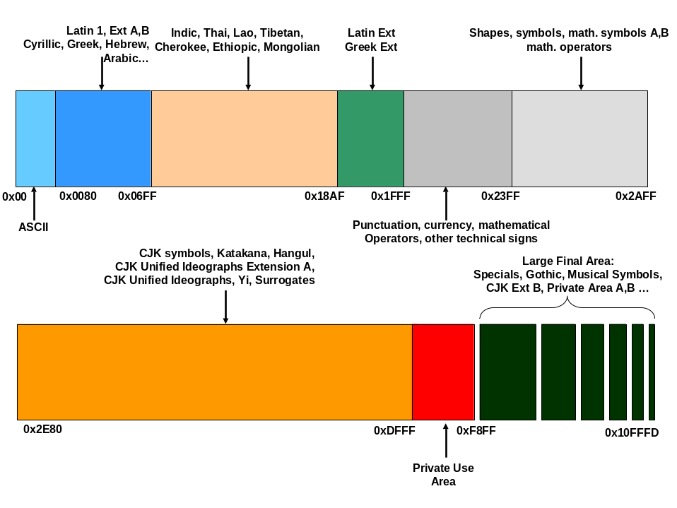
9-1

Class CultureInfo
Class CultureInfo is the most important one when speaking about internationalization, because this class provides culture-specific data, such as currency, numbers, language, country or calendar specifics.

Very important is knowledge about standards implemented in this class like definition of culture names. They are derived from RFC 1766 standard where is defined format as language[-country/region] (language is lowercase two-letter code derived from ISO-639-1 standard and country/region is uppercase two-letter code derived from ISO 3166 standard. This convention is used on CultureInfo class and there can be seen 3 types of different cultures:
- Invariant cultures
Invariant culture is very specific and it should be used just by services or applications that don’t require culture specific data or don’t work with security services working with strings that are culture specific.
Invariant culture is represented by CultureInfo.InvariantCulture property when invariant culture is unique culture associated with English language, but not with any country/region. But what is the meaning? As it was written above, some applications don’t need to work with culture specifics, like system services. The advantage is working with data that are not specific to any culture and any user from any country can work with them without problems (or can easily convert them to culture specific format). InvariantCulture is intended to be used for data that are not directly presented to the user and are stored in culture independent format. As it was written, with this approach data can be easily access from any culture and converted to any culture.
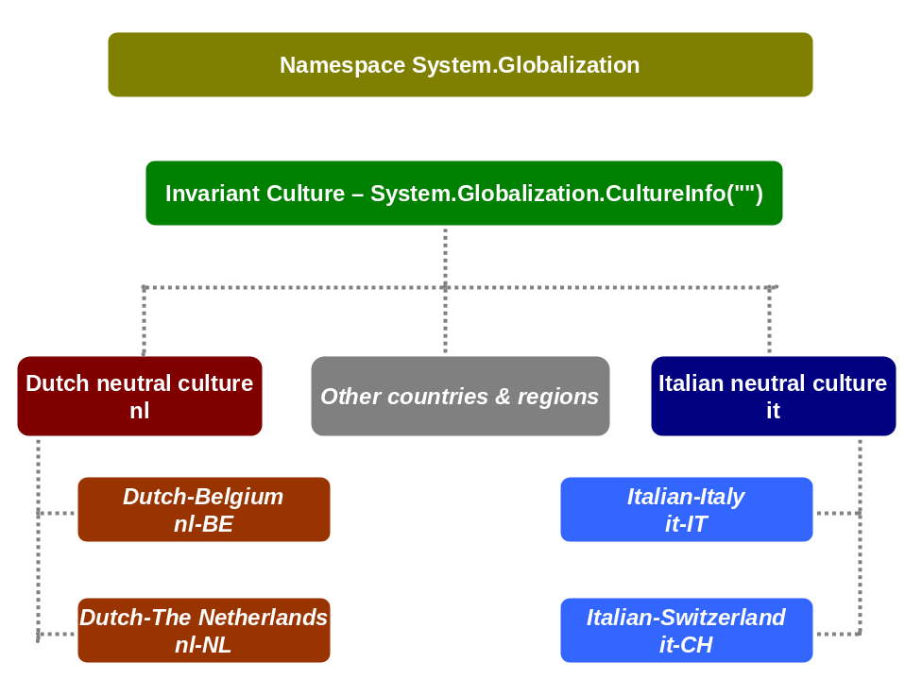
- Neutral cultures
Neutral culture is specified by only two-digit lowercase code like “de” for German or “en” for English and this culture is associated with language like German or English, but it isn’t associated with country/region where can be many other culture specifics. Typically English is shared (in general) by United States and United Kingdom, but there are many differences in other culture specifics like currency etc.
When programmers start to work with class CultureInfo, this is typical error, when this type of culture is used and set to Thred.CurrentThread.CurrentCulture property and exception is fired. Just try following sample:

public static void Main(string[] args)
{
Thread.CurrentThread.CurrentCulture = new CultureInfo("en");
}

When this code is run then it will caused the exception with this message: “Unhandled Exception: System.NotSupportedException: Culture 'en' is a neutral culture. It can not be used in formatting and parsing and therefore can not be setas the thread's current culture.”. This error can be easily solved by using specific culture (see next section).
- Specific cultures
Specific culture is a culture that provides complete information about language and other culture specifics. In previous section was presented sample on “en” culture, where just English language was specified (it was just neutral culture). But this sample presents correct usage of CultureInfo class:

public static void Main(string[] args)
{
// setting of specific culture for United Kingdom
Thread.CurrentThread.CurrentCulture = new CultureInfo("en-GB");
}

This sample will be running without any error or exception.

Collections

ArrayList
Namespaces:
using System;
using System.Collections;

Code:
static void Main(string[] args)
{
// create arraylist instance
ArrayList myList = new ArrayList();

myList.Add("First");
myList.Add("Second");
myList.Add("Third");
myList.Add("Fourth");
myList.Add("Fifth");

// sort array items
myList.Sort();
// remove first two items
myList.RemoveRange(0, 2);

// output final 3 item after sorting
foreach (Object item in myList)
{
Console.WriteLine(item);
}
}

BitArray
Namespaces:
using System;
using System.Collections;

Code:
static void Main(string[] args)
{
// initialize BitArray with boolean values
bool[] values1 = {true, false, true, false, true, false, false};
BitArray myArray = new BitArray(values1);

foreach (Object item in myArray)
{
// output value will the same as declared in array
Console.WriteLine(item);
}

Console.WriteLine("---------------Bits from Int---------------");

// 110000.....0
// first two bits are 1, others 0, first two out value will be true and others false
int[] values2 = {3};
myArray = new BitArray(values2);

foreach (Object item in myArray)
{
Console.Write(item + " ");
}
}

HashTable
Namespaces:
using System;
using System.Collections;

Code:
static void Main(string[] args)
{
Hashtable myHash = new Hashtable();
// add key-pair values
myHash.Add("First", 1);
myHash.Add("Second", 2);
myHash.Add("Third", 3);

// move through hashtable data in cycle
foreach (DictionaryEntry item in myHash)
{
Console.WriteLine(item.Key);
Console.WriteLine(item.Value);
}

// get first item
Console.WriteLine("Get first item: " + myHash["First"]);
// this will not work, name of item is not identical
Console.WriteLine("Get second item: " + myHash["SECOND"]);
}

Queue
Namespaces:
using System;
using System.Collections;

Code:
static void Main(string[] args)
{
// queue works as FIFO
Queue myQueue = new Queue();

// put some values into queue
myQueue.Enqueue(1);
myQueue.Enqueue(2);
myQueue.Enqueue(3);

// get values from queue (first in - first out)
while (myQueue.Count > 0)
{
Console.WriteLine(myQueue.Dequeue());
}
}

SortedList
Namespaces:
using System;
using System.Collections;

Code:
static void Main(string[] args)
{
// values in sorted list are sorted according to key
SortedList myList = new SortedList();

myList.Add(12, "December");
myList.Add(9, "September");
myList.Add(10, "October");
myList.Add(4, "April");
myList.Add(5, "May");
myList.Add(6, "June");
myList.Add(2, "February");
myList.Add(8, "August");
myList.Add(7, "July");
myList.Add(3, "March");
myList.Add(11, "November");
myList.Add(1, "January");

// output values that are sorted according to key
foreach (DictionaryEntry item in myList)
{
Console.WriteLine(item.Value);
}
}

Stack
Namespaces:
using System;
using System.Collections;

Code:
static void Main(string[] args)
{
// stack works as FILO
Stack myStack = new Stack();

myStack.Push(1);
myStack.Push(2);
myStack.Push(3);

// get values from stack (last in - last out)
while (myStack.Count > 0)
{
Console.WriteLine(myStack.Pop());
}
}

Time Operations

Time measuring (TickCount and Ticks property)
Code:
public static void Main(string[] args)
{
// TickCount is less accurate property
int start = Environment.TickCount;
// Ticks are measuring in 100 nanoseconds intervals
long startLong = DateTime.Now.Ticks;

// this is a sample cycle to generate some workload
for (int i = 0; i < 3000000; i++)
{
// here do some operations to measure
}

int end = Environment.TickCount;
long endLong = DateTime.Now.Ticks;
Console.WriteLine("TickCount property:" + (end - start));
Console.WriteLine("Ticks property:" + (endLong - startLong));
}

Accurate time measuring
This sample can be used as a class to make very accurate measurement. Similar code was published by Microsoft: http://support.microsoft.com/default.aspx?scid=kb;en-us;Q306979
Code:
using System;
using System.Runtime.InteropServices;

namespace SampleApp
{
public class CTimeMeasurement
{
private long m_Start;
private long m_Finish;
private long m_Frequency;
// [DllImport("Coredll.dll")] – use it on PocketPC
[DllImport("kernel32.dll")]
extern private static short QueryPerformanceCounter(ref long x);
// [DllImport("Coredll.dll")] – use it on PocketPC
[DllImport("kernel32.dll")]
extern private static short QueryPerformanceFrequency(ref long x);
public CTimeMeasurement()
{
Reset();
}
public void Start()
{
QueryPerformanceFrequency(ref m_Frequency);
QueryPerformanceCounter(ref m_Start);
}
public void Stop()
{
QueryPerformanceCounter(ref m_Finish);
}
public void Reset()
{
m_Start = 0;
m_Finish = 0;
m_Frequency = Int32.MaxValue;
}
public double Duration()
{
return (m_Finish - m_Start) * 1.0 / m_Frequency;
}

public static void Main(string[] args)
{
CTimeMeasurement measure = new CTimeMeasurement();
measure.Start();
Console.WriteLine("Some measured operations.");
measure.Stop();
Console.WriteLine("Duration of mearured operations:" + measure.Duration());
}
}
}

Messaging
Messaging or message queuing is an established term in software industry and presents technology enabling those two primary functionalities:

- Communication between different entities (systems, components, applications)
Entities use agreed standards to exchange messages not depending on platform or product they rely on.
- Connectionless communication
This is the most important functionality feature of messaging enabled systems. This has many advantages and when properly used messaging can significantly improve system performance or application usage.
Typical example of messaging is sending emails. User can be offline and work on his notebook, write his emails but it would be very bad that emails could be written just in case he would be connected. That is why he can do his work offline and when he gets connected emails are sent.
With this point is connected asynchronous communication which means that receiving entity can work with delivered messages without client being involved. Like when sending email, mail-server gets emails from client but client can be offline when server is trying to deliver his emails.
There are many other scenarios when messaging provides the best solution.
- Guaranteed message delivery
Messages must be deliver or sending client must be informed about issues and his message has not been delivered. Again this is how email works, email server provides delivering backend and is responsible for correct communication with other sides. The same functionality provides message queuing in applications.

There are many products providing messaging functionality (like known MQ Series from IBM) and Microsoft offers own solution in its technology called MSMQ.

Windows Management Instrumentation (WMI)
WMI is a very strong feature of Windows systems. But it’s not Microsoft specific because it is based on general OS independent standard defined by Desktop Management Task Force (DMTF - http://www.dmtf.org). WMI unifies two other standards as Common Management Information Protocol (CMIP) and Simple Network Management Protocol (SNMP).
DMTF defines many other standards related to management like Web Based Enterprise Management (WBEM) instead of other companies (BMC Software, Cisco Systems Inc., Compaq, Intel and Microsoft) which passed this specification to DMTF.
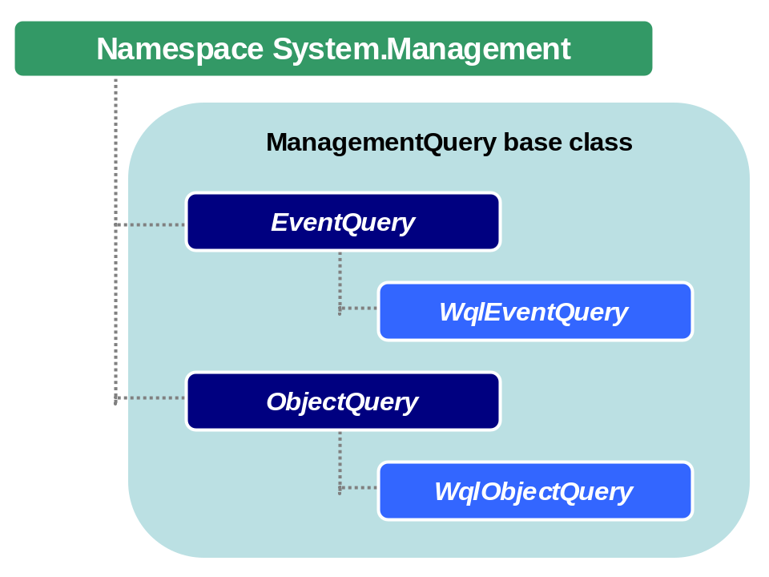

CIM Schema
CIM specification consists of two parts: CIM schema and language for working with this schema and data.
CIM schema is organized as a structure of classes with their methods, properties and qualifiers and this structure defines how classes are organized and rules for them.
Schema is devided into logical and physical domains, logical domains are:
- Application domains – this domain is suitable for applications, to set their installation properties, upgrade specifics, working rules etc.
- Device domains
- Network domains – it is related to protocols, network settings and access etc.
- System domains – this is related to computer settings, environment, processes, services etc.

WMI Architecture
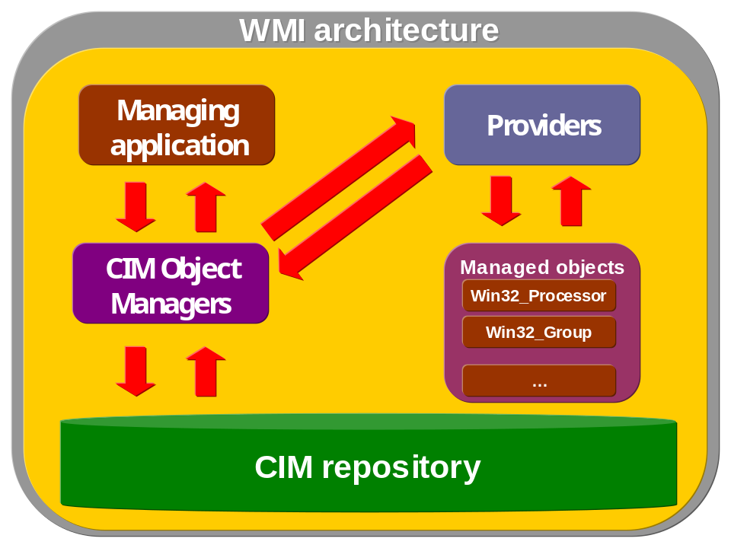

WMI tools
Microsoft provides WMI tools that can be used to test or manage WMI classes and environment. There are four tools available:

- WMI Object Browser
- WMI CIM Studio
- WMI Event Registration Tool
- WMI Even Viewer

Those tools are written using HTML and ActiveX and they provide management environment for WMI for local (“\root\CIMV2”) or remote computers (“\\remotesrv\root\default”) and their usage is easy and intuitive.

WMI Object Browser
WMI Object Browser is primary tool for easy working with CIM classes (primary Win32 ones) organized in hierarchy view. Those classes represent current environment settings and user doesn’t use any WQL to select specific classes or values. Usage of Object Browser is not suitable for any WQL testing but can help to imagine organization of classes in CIM repository and their dependenties and parent classes.

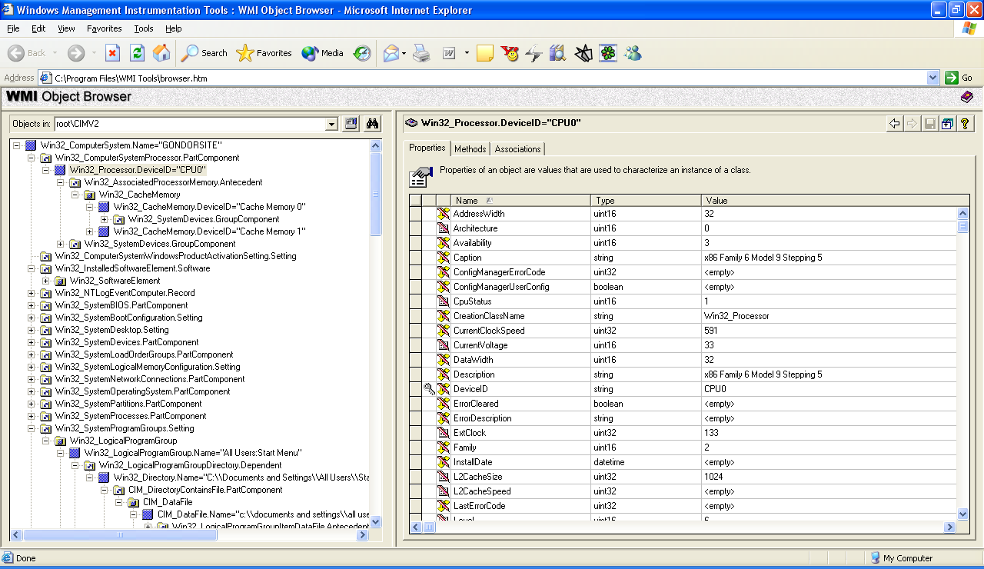

WMI CIM Studio
WMI CIM Studio is great tool for advanced operations like creation of custom MOF files, quering CIM repository using WQL and changing properting and calling methods of classes (like in Object Browser).
CIM Studio is recommended to use when you’re tryting to use some WQL queries in .NET environment with ManagementQuery derived classes (like in samples listed in this chapter).
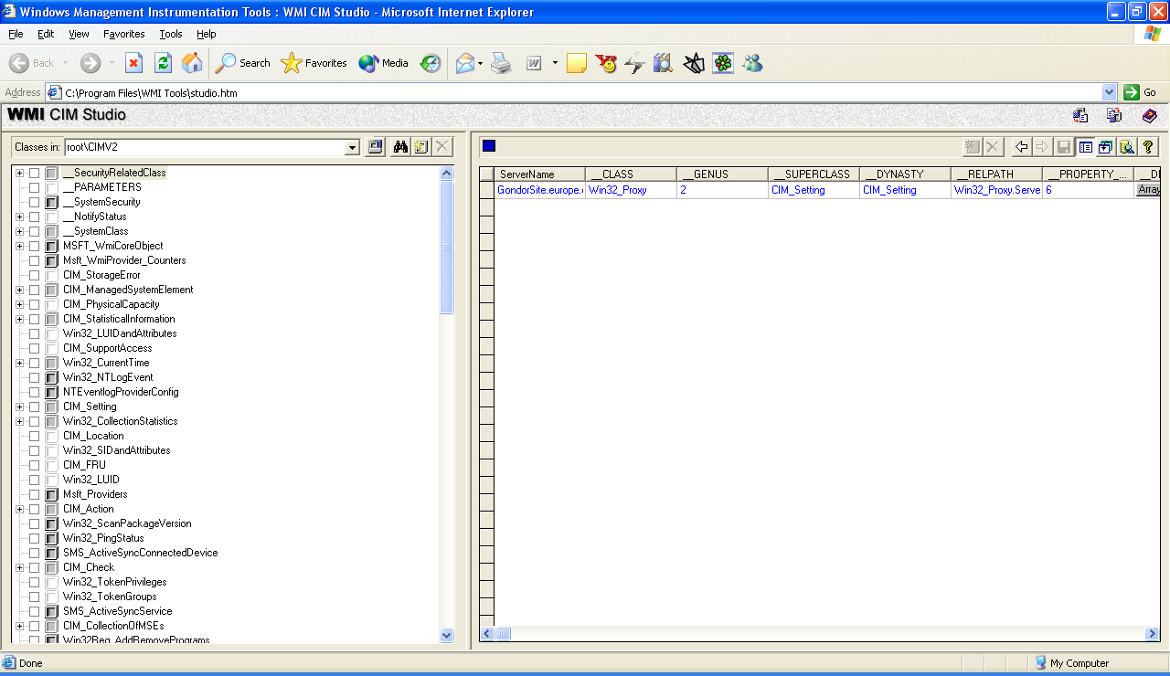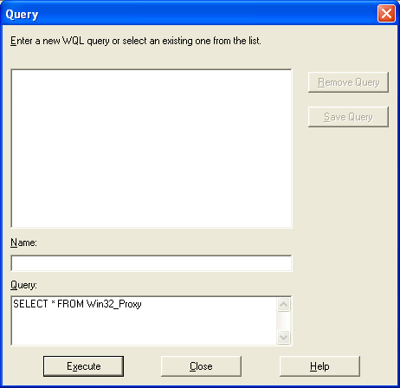
WQL query
editor

WMI Event Registration Tool

WMI Event Viewer
WMI Event Viewer allows to receive any events from WMI infrastructure.

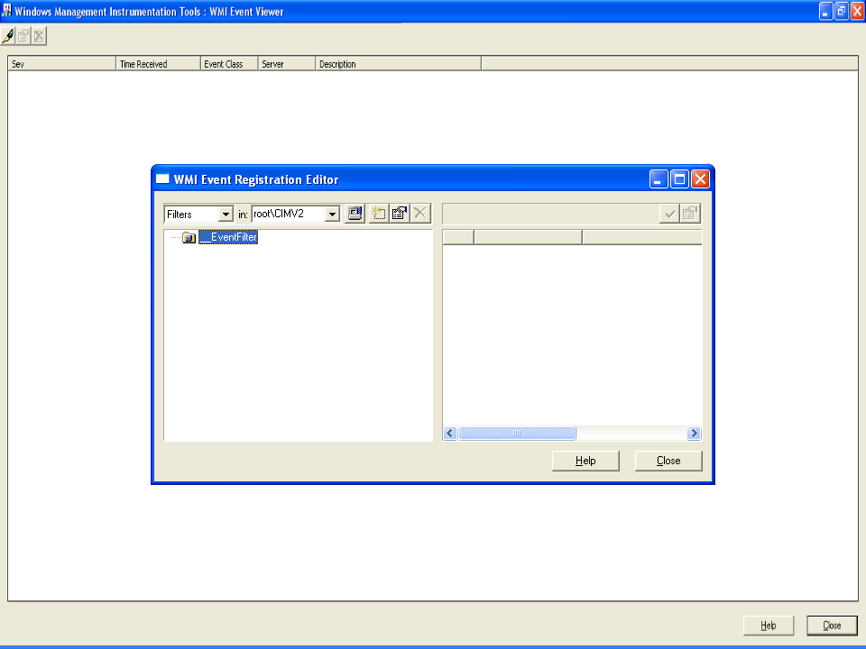

List of WMI Classes

Working with WMI on remote machine
Namespaces:
using System;
using System.Management;

Code:
static void Main(string[] args)
{
ConnectionOptions options = new ConnectionOptions();
options.Username = @"domain\username";
options.Password = "password";
ManagementScope scope = new ManagementScope(@"\\machine_name\root\cimv2", options);

scope.Connect();

try
{
// do some work with WMI
}
catch (Exception e) {}
}

Get computer info (domain, model etc.)
Namespaces:
using System;
using System.Management;

Code:
static void Main(string[] args)
{
WqlObjectQuery query = new WqlObjectQuery("SELECT * FROM Win32_ComputerSystem");
ManagementObjectSearcher find = new ManagementObjectSearcher(query);
foreach (ManagementObject mo in find.Get())
{
Console.WriteLine("Computer belongs to domain................" + mo["Domain"]);
Console.WriteLine("Computer manufacturer....................." + mo["Manufacturer"]);
Console.WriteLine("Model name given by manufacturer.........." + mo["Model"]);
}
}

Get computer info (vendor, UUID, type)
Namespaces:
using System;
using System.Management;

Code:
static void Main(string[] args)
{
WqlObjectQuery query = new WqlObjectQuery("SELECT * FROM Win32_ComputerSystemProduct");
ManagementObjectSearcher find = new ManagementObjectSearcher(query);
foreach (ManagementObject mo in find.Get())
{
Console.WriteLine("Description..........................................." + mo["Description"]);
Console.WriteLine("Identifying number (usually serial number)............" + mo["IdentifyingNumber"]);
Console.WriteLine("Commonly used product name............................" + mo["Name"]);
Console.WriteLine("Universally Unique Identifier of product.............." + mo["UUID"]);
Console.WriteLine("Vendor of product....................................." + mo["Vendor"]);
}
}

Get data about operating system
Namespaces:
using System;
using System.Management;

Code:
class WMIOperatingSystemSample
{
static void Main(string[] args)
{
WqlObjectQuery query = new WqlObjectQuery("SELECT * FROM Win32_OperatingSystem");
ManagementObjectSearcher find = new ManagementObjectSearcher(query);
foreach (ManagementObject mo in find.Get())
{
Console.WriteLine("Boot device name........................." + mo["BootDevice"]);
Console.WriteLine("Build number............................." + mo["BuildNumber"]);
Console.WriteLine("Caption.................................." + mo["Caption"]);
Console.WriteLine("Code page used by OS....................." + mo["CodeSet"]);
Console.WriteLine("Country code............................." + mo["CountryCode"]);
Console.WriteLine("Latest service pack installed............" + mo["CSDVersion"]);
Console.WriteLine("Computer system name....................." + mo["CSName"]);
Console.WriteLine("Time zone (minute offset from GMT........" + mo["CurrentTimeZone"]);
Console.WriteLine("OS is debug build........................" + mo["Debug"]);
Console.WriteLine("OS is distributed across several nodes..." + mo["Distributed"]);
Console.WriteLine("Encryption level of transactions........." + mo["EncryptionLevel"] + " bits");
Console.WriteLine("Priority increase for foreground app....." + GetForeground(mo));
Console.WriteLine("Available physical memory................" + mo["FreePhysicalMemory"] + " kilobytes");
Console.WriteLine("Available virtual memory................." + mo["FreeVirtualMemory"] + " kilobytes");
Console.WriteLine("Free paging-space withou swapping........" + mo["FreeSpaceInPagingFiles"]);
Console.WriteLine("Installation date........................" + ManagementDateTimeConverter.ToDateTime(mo["InstallDate"].ToString()));
Console.WriteLine("What type of memory optimization........." + (Convert.ToInt16(mo["LargeSystemCache"]) == 0 ? "for applications" : "for system performance"));
Console.WriteLine("Time from last boot......................" + mo["LastBootUpTime"]);
Console.WriteLine("Local date and time......................" + ManagementDateTimeConverter.ToDateTime(mo["LocalDateTime"].ToString()));
Console.WriteLine("Language identifier (LANGID)............." + mo["Locale"]);
Console.WriteLine("Local date and time......................" + ManagementDateTimeConverter.ToDateTime(mo["LocalDateTime"].ToString()));
Console.WriteLine("Max# of processes supported by OS........" + mo["MaxNumberOfProcesses"]);
Console.WriteLine("Max memory available for process........." + mo["MaxProcessMemorySize"] + " kilobytes");
Console.WriteLine("Current number of processes.............." + mo["NumberOfProcesses"]);
Console.WriteLine("Currently stored user sessions..........." + mo["NumberOfUsers"]);
Console.WriteLine("OS language version......................" + mo["OSLanguage"]);
Console.WriteLine("OS product suite version................." + GetSuite(mo));
Console.WriteLine("OS type.................................." + GetOSType(mo));
// this is extension to OS addressing space, not available to Windows XP, Windows 2000, and Windows NT 4.0 SP4 and later
// Console.WriteLine("PAE enabled.............................." + mo["PAEEnabled "]);
Console.WriteLine("Number of Windows Plus!.................." + mo["PlusProductID"]);
Console.WriteLine("Version of Windows Plus!................." + mo["PlusVersionNumber"]);
Console.WriteLine("Type of installed OS....................." + GetProductType(mo));
Console.WriteLine("Registered user of OS...................." + mo["RegisteredUser"]);
Console.WriteLine("Serial number of product................." + mo["SerialNumber"]);
Console.WriteLine("Serial number of product................." + mo["SerialNumber"]);
Console.WriteLine("ServicePack major version................" + mo["ServicePackMajorVersion"]);
Console.WriteLine("ServicePack minor version................" + mo["ServicePackMinorVersion"]);
Console.WriteLine("Total number to store in paging files...." + mo["SizeStoredInPagingFiles"] + " kilobytes");
Console.WriteLine("Status..................................." + mo["Status"]);
Console.WriteLine("ServicePack minor version................" + mo["ServicePackMinorVersion"]);
Console.WriteLine("OS suite................................." + GetOSSuite(mo));
Console.WriteLine("Physical disk partition with OS.........." + mo["SystemDevice"]);
Console.WriteLine("System directory........................." + mo["SystemDirectory"]);
Console.WriteLine("Total virtual memory....................." + mo["TotalVirtualMemorySize"] + " kilobytes");
Console.WriteLine("Total physical memory...................." + mo["TotalVisibleMemorySize"] + " kilobytes");
Console.WriteLine("Version number of OS....................." + mo["Version"]);
Console.WriteLine("Windows directory........................" + mo["WindowsDirectory"]);
}
}

private static string GetForeground(ManagementObject mo)
{
int i = Convert.ToInt16(mo["ForegroundApplicationBoost"]);
switch (i)
{
case 0:
return "None";
case 1:
return "Minimum";
case 2:
return "Maximum (defualt value)";
}
return "Boost not defined.";
}

private static string GetSuite(ManagementObject mo)
{
uint i = Convert.ToUInt32(mo["OSProductSuite"]);
switch (i)
{
case 1:
return "Small Business";
case 2:
return "Enterprise";
case 4:
return "BackOffice";
case 8:
return "Communication Server";
case 16:
return "Terminal Server";
case 32:
return "Small Business (Restricted)";
case 64:
return "Embedded NT";
case 128:
return "Data Center";
}
return "OS suite not defined.";
}

// this method covers just some of the Windows systems, not other ones from other vendors as Microsoft
private static string GetOSType(ManagementObject mo)
{
uint i = Convert.ToUInt16(mo["OSType"]);
switch (i)
{
case 16:
return "WIN95";
case 17:
return "WIN98";
case 18:
return "WINNT";
case 19:
return "WINCE";
}
return "Other OS systems aren not covered.";
}

private static string GetProductType(ManagementObject mo)
{
uint i = Convert.ToUInt32(mo["ProductType"]);
switch (i)
{
case 1:
return "Work Station";
case 2:
return "Domain Controller";
case 3:
return "Server";
}
return "Product type not defined.";
}

private static string GetOSSuite(ManagementObject mo)
{
uint i = Convert.ToUInt32(mo["SuiteMask"]);
// OS suite identification - final string
string suite = "";
if ((i & 1) == 1) suite += "Small Business";
if ((i & 2) == 2)
{
if (suite.Length > 0) suite += ", "; suite += "Enterprise";
}
if ((i & 4) == 4)
{
if (suite.Length > 0) suite += ", "; suite += "Back Office";
}
if ((i & 8) == 8)
{
if (suite.Length > 0) suite += ", "; suite += "Communications";
}
if ((i & 16) == 16)
{
if (suite.Length > 0) suite += ", "; suite += "Terminal";
}
if ((i & 32) == 32)
{
if (suite.Length > 0) suite += ", "; suite += "Small Business Restricted";
}
if ((i & 64) == 64)
{
if (suite.Length > 0) suite += ", "; suite += "Embedded NT";
}
if ((i & 128) == 128)
{
if (suite.Length > 0) suite += ", "; suite += "Data Center";
}
if ((i & 256) == 256)
{
if (suite.Length > 0) suite += ", "; suite += "Single User";
}
if ((i & 512) == 512)
{
if (suite.Length > 0) suite += ", "; suite += "Personal";
}
if ((i & 1024) == 1024)
{
if (suite.Length > 0) suite += ", "; suite += "Blade";
}
return suite;
}
}

Logoff, shutdown, reboot computer
Namespaces:
using System;
using System.Management;

Code:
static void Main(string[] args)
{
object[] FLAG_LOGOFF = {0};
object[] FLAG_SHUTDOWN = {1};
object[] FLAG_REBOOT = {2};
object[] FLAG_FORCELOGOFF = {4};
object[] FLAG_FORCESHUTDOWN = {5};
object[] FLAG_FORCEREBOOT = {6};
object[] FLAG_POWEROFF = {8};
object[] FLAG_FORCEPOWEROFF = {12};

SelectQuery query = new SelectQuery("Win32_OperatingSystem");
ManagementObjectSearcher find = new ManagementObjectSearcher(query);

try
{
// convert parameter from command-line to choose appropriate shutdown mode
int mode = Convert.ToInt32(args[0]);

foreach (ManagementObject mo in find.Get())
{
if (mode == (int)FLAG_LOGOFF[0])
mo.InvokeMethod("Win32Shutdown", FLAG_LOGOFF);
else if (mode == (int)FLAG_SHUTDOWN[0])
mo.InvokeMethod("Win32Shutdown", FLAG_SHUTDOWN);
else if (mode == (int)FLAG_REBOOT[0])
mo.InvokeMethod("Win32Shutdown", FLAG_REBOOT);
else if (mode == (int)FLAG_FORCELOGOFF[0])
mo.InvokeMethod("Win32Shutdown", FLAG_FORCELOGOFF);
else if (mode == (int)FLAG_FORCESHUTDOWN[0])
mo.InvokeMethod("Win32Shutdown", FLAG_FORCESHUTDOWN);
else if (mode == (int)FLAG_FORCEREBOOT[0])
mo.InvokeMethod("Win32Shutdown", FLAG_FORCEREBOOT);
else if (mode == (int)FLAG_POWEROFF[0])
mo.InvokeMethod("Win32Shutdown", FLAG_POWEROFF);
else if (mode == (int)FLAG_FORCEPOWEROFF[0])
mo.InvokeMethod("Win32Shutdown", FLAG_FORCEPOWEROFF);
else
Console.WriteLine("This is unknown shutdown mode.");
}
}
catch (Exception e)
{
Console.WriteLine(e.Message);
}
}

Get user’s desktop info
Namespaces:
using System;
using System.Management;

Code:
static void Main(string[] args)
{
// get default desktop settings, where condition should be changed for appropriate user
WqlObjectQuery query = new WqlObjectQuery("SELECT * FROM Win32_Desktop WHERE Name = '.Default'");
ManagementObjectSearcher find = new ManagementObjectSearcher(query);
foreach (ManagementObject mo in find.Get())
{
// values can be changed in registry "HKEY_CURRENT_USER\Control Panel\Desktop"
Console.WriteLine("Width of window borders..............................." + mo["BorderWidth"]);
Console.WriteLine("ALT+TAB task switching allowed........................" + mo["CoolSwitch"]);
// value is in ms
Console.WriteLine("Lenght of time between cursor blincks................." + mo["CursorBlinkRate"]);
Console.WriteLine("Show content of windows when are draged..............." + mo["DragFullWindows"]);
// this indicates spacing of grid cells that windows are bound to
Console.WriteLine("Grid settings for dragging windows...................." + mo["GridGranularity"]);
Console.WriteLine("Grid settings for icon spacing........................" + mo["IconSpacing"]);
Console.WriteLine("Font used for the names of icons......................" + mo["IconTitleFaceName"]);
Console.WriteLine("Icon ront size........................................" + mo["IconTitleSize"]);
Console.WriteLine("Wrapping of icon title................................" + mo["IconTitleWrap"]);
Console.WriteLine("Name of the desktop profile..........................." + mo["Name"]);
Console.WriteLine("Screen saver is active................................" + mo["ScreenSaverActive"]);
Console.WriteLine("Name of the screen saver executable..................." + mo["ScreenSaverExecutable"]);
Console.WriteLine("Is screen saver protected with password..............." + mo["ScreenSaverSecure"]);
Console.WriteLine("Time to pass to activate screen saver................." + mo["ScreenSaverTimeout"]);
Console.WriteLine("File name for desktop background......................" + mo["Wallpaper"]);
Console.WriteLine("Wallpaper fills entire screen........................." + mo["WallpaperStretched"]);
Console.WriteLine("Wallpaper is tiled...................................." + mo["WallpaperTiled"]);
}
}

Determine computer type (workstation, server, controller etc.)
Namespaces:
using System;
using System.Management;

Code:
static void Main(string[] args)
{
WqlObjectQuery query = new WqlObjectQuery("SELECT * FROM Win32_ComputerSystem");
ManagementObjectSearcher find = new ManagementObjectSearcher(query);
foreach (ManagementObject mo in find.Get())
{
switch (Convert.ToInt32(mo["DomainRole"]))
{
case 0:
Console.WriteLine("Standalone Workstation");
break;
case 1:
Console.WriteLine("Member Workstation");
break;
case 2:
Console.WriteLine("Standalone Server");
break;
case 3:
Console.WriteLine("Member Server");
break;
case 4:
Console.WriteLine("Backup Domain Controller");
break;
case 5:
Console.WriteLine("Primary Domain Controller");
break;
}
}
}

Determine physical computer features
Namespaces:
using System;
using System.Management;

Code:
class WMIEncloserSample
{
static void Main(string[] args)
{
// get all processor unit on machine
WqlObjectQuery query = new WqlObjectQuery("SELECT * FROM Win32_SystemEnclosure");
ManagementObjectSearcher find = new ManagementObjectSearcher(query);
int i = 0;
foreach (ManagementObject mo in find.Get())
{
Console.WriteLine("------------------------- Chasis setting #" + i + " -------------------------");
Console.WriteLine("Chasis type..............................." + GetChasisType(mo));
Console.WriteLine("Description..............................." + mo["Description"]);
Console.WriteLine("Depth of physical package (in inches)....." + mo["Depth"]);
Console.WriteLine("Height of physical package (in inches)...." + mo["Height"]);
Console.WriteLine("Width of physical package (in inches)....." + mo["Width"]);
Console.WriteLine("Weight...................................." + mo["Weight"]);
Console.WriteLine("Service philosophy ......................." + GetServicePhilosophy(mo));
Console.WriteLine("Status...................................." + mo["Status"]);
Console.WriteLine("Property includes visible alarm..........." + mo["VisibleAlarm"]);
Console.WriteLine("Property includes visible alarm..........." + mo["VisibleAlarm"]);
Console.WriteLine("--------------------------------------------------");
i++;
}
}

private static string GetChasisType(ManagementObject mo)
{
System.UInt16[] type = (System.UInt16[])mo["ChassisTypes"];
String returnType = "";
for (int i=0; i<type.Length; i++)
{
if (i > 0) returnType += ", ";
switch (type[i])
{
case 1:
returnType += "Other";
break;
case 2:
returnType += "Unknown";
break;
case 3:
returnType += "Desktop";
break;
case 4:
returnType += "Low Profile Desktop";
break;
case 5:
returnType += "Pizza Box";
break;
case 6:
returnType += "Mini Tower";
break;
case 7:
returnType += "Tower";
break;
case 8:
returnType += "Portable";
break;
case 9:
returnType += "Laptop";
break;
case 10:
returnType += "Notebook";
break;
case 11:
returnType += "Hand Held";
break;
case 12:
returnType += "Docking Station";
break;
case 13:
returnType += "All in One";
break;
case 14:
returnType += "Sub Notebook";
break;
case 15:
returnType += "Space-Saving";
break;
case 16:
returnType += "Lunch Box";
break;
case 17:
returnType += "Main System Chassis";
break;
case 18:
returnType += "Expansion Chassis";
break;
case 19:
returnType += "SubChassis";
break;
case 20:
returnType += "Bus Expansion Chassis";
break;
case 21:
returnType += "Peripheral Chassis";
break;
case 22:
returnType += "Storage Chassis";
break;
case 23:
returnType += "Rack Mount Chassis";
break;
case 24:
returnType += "Sealed-Case PC";
break;
}
}
return returnType;
}

private static string GetServicePhilosophy(ManagementObject mo)
{
int i = Convert.ToInt16(mo["ServicePhilosophy"]);
switch (i)
{
case 0:
return "Unknown";
case 1:
return "Other";
case 2:
return "Service From Top";
case 3:
return "Service From Front";
case 4:
return "Service From Back";
case 5:
return "Service From Side";
case 6:
return "Sliding Trays";
case 7:
return "Removable Sides";
case 8:
return "Moveable";
}
return "Service philosophy not defined.";
}
}

Rename computer name
Namespaces:
using System;
using System.Management;

Code:
static void Main(string[] args)
{
WqlObjectQuery query = new WqlObjectQuery("SELECT * FROM Win32_ComputerSystem");
ManagementObjectSearcher find = new ManagementObjectSearcher(query);
// set new computer name
object[] methodArgs = {"Aramir"};
foreach (ManagementObject mo in find.Get())
{
// invoke Rename method on computer object
mo.InvokeMethod("Rename", methodArgs);
}
}

Get processor info
Namespaces:
using System;
using System.Management;

Code:
class WMIProcessorSample
{
static void Main(string[] args)
{
// get all processor unit on machine
WqlObjectQuery query = new WqlObjectQuery("Select * from Win32_Processor");
ManagementObjectSearcher find = new ManagementObjectSearcher(query);
int i = 0;
foreach (ManagementObject mo in find.Get())
{
Console.WriteLine("-------------- Processor #" + i + " --------------");
Console.WriteLine("Processor address width in bits.............." + mo["AddressWidth"]);
Console.WriteLine("Architecture of processor...................." + GetArchitecture(mo));
Console.WriteLine("Availability................................." + GetDeviceState(mo));
Console.WriteLine("Caption......................................" + mo["Caption"]);
Console.WriteLine("Processor address width in bits.............." + mo["AddressWidth"]);
Console.WriteLine("Device configuration........................." + GetConfigError(mo));
Console.WriteLine("Usage status of the processor................" + GetCpuStatus(mo));
Console.WriteLine("Current clock speed (in MHz)................." + mo["CurrentClockSpeed"]);
Console.WriteLine("Processor data width........................." + mo["DataWidth"]);
Console.WriteLine("Unique string identification................." + mo["DeviceID"]);
Console.WriteLine("External clock frequency....................." + mo["ExtClock"]);
Console.WriteLine("Processor data width........................." + mo["DataWidth"]);
Console.WriteLine("Processor family............................." + GetFamily(mo));
Console.WriteLine("L2 cache size................................" + mo["L2CacheSize"]);
Console.WriteLine("L2 cache speed..............................." + mo["L2CacheSpeed"]);
Console.WriteLine("Load percentage (average value for second)..." + mo["LoadPercentage"]);
Console.WriteLine("Manufacturer................................." + mo["Manufacturer"]);
Console.WriteLine("Maximum speed (in MHz)......................." + mo["MaxClockSpeed"]);
Console.WriteLine("Name........................................." + mo["Name"]);
Console.WriteLine("Support for power management................." + mo["PowerManagementSupported"]);
Console.WriteLine("Unique identificator describing processor...." + mo["ProcessorId"]);
Console.WriteLine("Processor type..............................." + GetProcessorType(mo));
Console.WriteLine("Role (CPU/math).............................." + mo["Role"]);
Console.WriteLine("Socket designation..........................." + mo["SocketDesignation"]);
Console.WriteLine("Status......................................." + mo["Status"]);
Console.WriteLine("Status information..........................." + GetStatusInfo(mo));
Console.WriteLine("Method how upgrade processor................." + GetUpgradeMethod(mo));
Console.WriteLine("Processor version............................" + mo["Version"]);
Console.WriteLine("Socket voltage..............................." + mo["VoltageCaps"]);
i++;
}
}

private static string GetArchitecture(ManagementObject mo)
{
int i = Convert.ToInt32(mo["Architecture"]);
switch (i)
{
case 0:
return "x86";
case 1:
return "MIPS";
case 2:
return "Alpha";
case 3:
return "PowerPC";
case 4:
return "ia64";
}

return "Undefined";
}

private static string GetCpuStatus(ManagementObject mo)
{
int i = Convert.ToInt32(mo["CpuStatus"]);
switch(i)
{
case 0:
return "Unknown";
case 1:
return "CPU Enabled";
case 2:
return "CPU Disabled by User via BIOS Setup";
case 3:
return "CPU Disabled By BIOS (POST Error)";
case 4:
return "CPU is Idle";
case 5:
return "This value is reserved.";
case 6:
return "This value is reserved.";
case 7:
return "Other";
}
return "Undefined";
}

private static string GetFamily(ManagementObject mo)
{
int i = Convert.ToInt32(mo["Family"]);
switch (i)
{
case 1:
return "Other";
case 2:
return "Unknown";
case 3:
return "8086";
case 4:
return "80286";
case 5:
return "80386";
case 6:
return "80486";
case 7:
return "8087";
case 8:
return "80287";
case 9:
return "80387";
case 10:
return "80487";
case 11:
return "Pentium® brand";
case 12:
return "Pentium® Pro";
case 13:
return "Pentium® II";
case 14:
return "Pentium® processor with MMX technology";
case 15:
return "Celeron™";
case 16:
return "Pentium® II Xeon";
case 17:
return "Pentium® III";
case 18:
return "M1 Family";
case 19:
return "M2 Family";
case 24:
return "K5 Family";
case 25:
return "K6 Family";
case 26:
return "K6-2";
case 27:
return "K6-3";
case 28:
return "AMD Athlon™ Processor Family";
case 29:
return "AMD® Duron™ Processor";
case 30:
return "AMD2900 Family";
case 31:
return "K6-2+";
case 32:
return "Power PC Family";
case 33:
return "Power PC 601";
case 34:
return "Power PC 603";
case 35:
return "Power PC 603+";
case 36:
return "Power PC 604";
case 37:
return "Power PC 620";
case 38:
return "Power PC X704";
case 39:
return "Power PC 750";
case 48:
return "Alpha Family";
case 49:
return "Alpha 21064";
case 50:
return "Alpha 21066";
case 51:
return "Alpha 21164";
case 52:
return "Alpha 21164PC";
case 53:
return "Alpha 21164a";
case 54:
return "Alpha 21264";
case 55:
return "Alpha 21364";
case 64:
return "MIPS Family";
case 65:
return "MIPS R4000";
case 66:
return "MIPS R4200";
case 67:
return "MIPS R4400";
case 68:
return "MIPS R4600";
case 69:
return "MIPS R10000";
case 80:
return "SPARC Family";
case 81:
return "SuperSPARC";
case 82:
return "microSPARC II";
case 83:
return "microSPARC IIep";
case 84:
return "UltraSPARC";
case 85:
return "UltraSPARC II";
case 86:
return "UltraSPARC IIi";
case 87:
return "UltraSPARC III";
case 88:
return "UltraSPARC IIIi";
case 96:
return "68040";
case 97:
return "68xxx Family";
case 98:
return "68000";
case 99:
return "68010";
case 100:
return "68020";
case 101:
return "68030";
case 112:
return "Hobbit Family";
case 120:
return "Crusoe™ TM5000 Family";
case 121:
return "Crusoe™ TM3000 Family";
case 128:
return "Weitek";
case 130:
return "Itanium™ Processor";
case 144:
return "PA-RISC Family";
case 145:
return "PA-RISC 8500";
case 146:
return "PA-RISC 8000";
case 147:
return "PA-RISC 7300LC";
case 148:
return "PA-RISC 7200";
case 149:
return "PA-RISC 7100LC";
case 150:
return "PA-RISC 7100";
case 160:
return "V30 Family";
case 176:
return "Pentium® III Xeon™";
case 177:
return "Pentium® III Processor with Intel® SpeedStep™ Technology";
case 178:
return "Pentium® 4";
case 179:
return "Intel® Xeon™";
case 180:
return "AS400 Family";
case 181:
return "Intel® Xeon™ processor MP";
case 182:
return "AMD AthlonXP™ Family";
case 183:
return "AMD AthlonMP™ Family";
case 184:
return "Intel® Itanium® 2";
case 185:
return "AMD Opteron™ Family";
case 190:
return "K7";
case 200:
return "IBM390 Family";
case 201:
return "G4";
case 202:
return "G5";
case 250:
return "i860";
case 251:
return "i960";
case 260:
return "SH-3";
case 261:
return "SH-4";
case 280:
return "ARM";
case 281:
return "StrongARM";
case 300:
return "6x86";
case 301:
return "MediaGX";
case 302:
return "MII";
case 320:
return "WinChip";
case 350:
return "DSP";
case 500:
return "Video Processor";
}
return "Undefined processor family";
}

private static string GetProcessorType(ManagementObject mo)
{
int i = Convert.ToInt32(mo["ProcessorType"]);
switch (i)
{
case 1:
return "Other";
case 2:
return "Unknown";
case 3:
return "Central Processor";
case 4:
return "Math Processor";
case 5:
return "DSP Processor";
case 6:
return "Video Processor";
}
return "Undefined type";
}

private static string GetStatusInfo(ManagementObject mo)
{
int i = Convert.ToInt32(mo["StatusInfo"]);
switch (i)
{
case 1:
return "Other";
case 2:
return "Unknown";
case 3:
return "Enabled";
case 4:
return "Disabled";
case 5:
return "Not applicable";
}
return "StatusInfo not defined.";
}

private static string GetUpgradeMethod(ManagementObject mo)
{
int i = Convert.ToInt32(mo["UpgradeMethod"]);
switch (i)
{
case 1:
return "Other";
case 2:
return "Unknown";
case 3:
return "Daughter Board";
case 4:
return "ZIF Socket";
case 5:
return "Replacement/Piggy Back";
case 6:
return "None";
case 7:
return "LIF Socket";
case 8:
return "Slot 1";
case 9:
return "Slot 2";
case 10:
return "370 Pin Socket";
case 11:
return "Slot A";
case 12:
return "Slot M";
}
return "UpgradeMethod not defined.";
}

private static string GetSocketVoltage(ManagementObject mo)
{
int i = Convert.ToInt32(mo["VoltageCaps"]);
switch (i)
{
case 1:
return "5";
case 2:
return "3.3";
case 3:
return "2.9";
}
return "Socket voltage not defined";
}

private static string GetDeviceState(ManagementObject mo)
{
// here call method from sample 'Get CD-ROM/DVD information'
return "";
}

private static string GetConfigError(ManagementObject mo)
{
// here call method from sample 'Get CD-ROM/DVD information'
return "";
}
}

Get memory info
Namespaces:
using System;
using System.Management;

Code:
static void Main(string[] args)
{
WqlObjectQuery query = new WqlObjectQuery("SELECT * FROM Win32_PerfFormattedData_PerfOS_Memory");
ManagementObjectSearcher find = new ManagementObjectSearcher(query);
foreach (ManagementObject mo in find.Get())
{
Console.WriteLine("Available bytes: " + mo["AvailableBytes"]);
Console.WriteLine("Available KBs: " + mo["AvailableKBytes"]);
Console.WriteLine("Available MBs: " + mo["AvailableMBytes"]);
Console.WriteLine("Cache bytes: " + mo["CacheBytes"]);
Console.WriteLine("Cache bytes peak: " + mo["CacheBytesPeak"]);
Console.WriteLine("Cache bytes: " + mo["CacheBytes"]);
Console.WriteLine("Commit limit: " + mo["CommitLimit"]);
Console.WriteLine("Committed bytes: " + mo["CommittedBytes"]);
Console.WriteLine("Free system page table entries: " + mo["FreeSystemPageTableEntries"]);
Console.WriteLine("Pool paged bytes: " + mo["PoolPagedBytes"]);
Console.WriteLine("System code total bytes: " + mo["SystemCodeTotalBytes"]);
Console.WriteLine("System driver total bytes: " + mo["SystemDriverTotalBytes"]);
}
}

Getting list of file shares on local machine
Namespaces:
using System;
using System.Management;

Code:
static void Main(string[] args)
{
WqlObjectQuery query = new WqlObjectQuery("SELECT * FROM Win32_Share");
ManagementObjectSearcher find = new ManagementObjectSearcher(query);
foreach (ManagementObject mo in find.Get())
{
Console.WriteLine("List of shares = " + mo["Name"]);
}
}

Get logical disk info
Namespaces:
using System;
using System.Management;

Code I:
This sample uses CMI path instead of WQL, this is just demonstration on CMI addressing but WQL is more intuitive and will be used in majority of samples.

static void Main(string[] args)
{
string cmiPath = @"\root\cimv2:Win32_LogicalDisk.DeviceID='C:'";
// create managment object for required path in CMI
ManagementObject mo = new ManagementObject(cmiPath);

//output logical disk data
Console.WriteLine("Description: " + mo["Description"]);
Console.WriteLine("File system: " + mo["FileSystem"]);
Console.WriteLine("Free disk space: " + mo["FreeSpace"]);
Console.WriteLine("Size: " + mo["Size"]);
}

Code II:
static void Main(string[] args)
{
WqlObjectQuery query = new WqlObjectQuery("SELECT * FROM Win32_LogicalDisk WHERE DeviceID = 'C:'");
ManagementObjectSearcher find = new ManagementObjectSearcher(query);
foreach (ManagementObject mo in find.Get())
{
//output logical disk data
Console.WriteLine("Description: " + mo["Description"]);
Console.WriteLine("File system: " + mo["FileSystem"]);
Console.WriteLine("Free disk space: " + mo["FreeSpace"]);
Console.WriteLine("Size: " + mo["Size"]);
}
}

Get environment variables
Namespaces:
using System;
using System.Management;

Code:
static void Main(string[] args)
{
WqlObjectQuery query = new WqlObjectQuery("Select * from Win32_Environment");
ManagementObjectSearcher find = new ManagementObjectSearcher(query);
Console.WriteLine("Description - Name - User Name - Value");
Console.WriteLine("----------------------------------------------------------");
foreach (ManagementObject mo in find.Get())
{
Console.WriteLine(mo["Description"] + " - " + mo["Name"] + " - " + mo["UserName"] + " - " + mo["VariableValue"]);
}
}

Get CD-ROM/DVD information
Namespaces:
using System;
using System.Management;

Code:
class CDROMInfo
{
static void Main(string[] args)
{
WqlObjectQuery query = new WqlObjectQuery("SELECT * FROM Win32_CDROMDrive");
ManagementObjectSearcher find = new ManagementObjectSearcher(query);
foreach (ManagementObject mo in find.Get())
{
Console.WriteLine("The availability and status of the device............." + GetDeviceState(mo));
Console.WriteLine("Device configuration state............................" + GetConfigError(mo));
Console.WriteLine("Description..........................................." + mo["Description"]);
Console.WriteLine("Drive................................................." + mo["Drive"]);
Console.WriteLine("Maximum length of a filename.........................." + mo["MaximumComponentLength"]);
Console.WriteLine("Type of media........................................." + mo["MediaType"]);
Console.WriteLine("Size of the disk......................................" + mo["Size"]);
Console.WriteLine("Status of the disk...................................." + mo["Size"]);
Console.WriteLine("Current transfer rate................................." + mo["TransferRate"]);
}
}

// this method returns state of device regarding its power state
private static string GetDeviceState(ManagementObject mo)
{
int i = Convert.ToInt16(mo["Availability"]);
switch (i)
{
case 3:
return "Full Power";
case 4:
return "Warning";
case 5:
return "Test";
case 10:
return "Degraded";
case 13:
return "Power Save - Unknown";
case 14:
return "Power Save - Low Power Mode";
case 15:
return "Power Save - Standby";
case 17:
return "Power Save - Warning";
}
return "Unknown state";
}
// this method returns configuration state of device
private static string GetConfigError(ManagementObject mo)
{
int i = Convert.ToInt16(mo["ConfigManagerErrorCode"]);
switch (i)
{
case 0:
return "This device is working properly.";
case 1:
return "This device is not configured correctly.";
case 2:
return "Windows cannot load the driver for this device.";
case 3:
return "The driver for this device might be corrupted, or your system may be running low on memory or other resources.";
case 4:
return "This device is not working properly. One of its drivers or your registry might be corrupted.";
case 5:
return "The driver for this device needs a resource that Windows cannot manage.";
case 6:
return "The boot configuration for this device conflicts with other devices.";
case 7:
return "Cannot filter.";
case 8:
return "The driver loader for the device is missing.";
case 9:
return "This device is not working properly because the controlling firmware is reporting the resources for the device incorrectly.";
case 10:
return "This device cannot start.";
case 11:
return "This device failed.";
case 12:
return "This device cannot find enough free resources that it can use.";
case 13:
return "Windows cannot verify this device's resources.";
case 14:
return "This device cannot work properly until you restart your computer.";
case 15:
return "This device is not working properly because there is probably a re-enumeration problem.";
case 16:
return "Windows cannot identify all the resources this device uses.";
case 17:
return "This device is asking for an unknown resource type.";
case 18:
return "Reinstall the drivers for this device.";
case 19:
return "Your registry might be corrupted.";
case 20:
return "Failure using the VxD loader.";
case 21:
return "System failure: Try changing the driver for this device. If that does not work, see your hardware documentation. Windows is removing this device.";
case 22:
return "This device is disabled.";
case 23:
return "System failure: Try changing the driver for this device. If that doesn't work, see your hardware documentation.";
case 24:
return "This device is not present, is not working properly, or does not have all its drivers installed.";
case 25:
return "Windows is still setting up this device.";
case 26:
return "Windows is still setting up this device.";
case 27:
return "This device does not have valid log configuration.";
case 28:
return "The drivers for this device are not installed.";
case 29:
return "This device is disabled because the firmware of the device did not give it the required resources.";
case 30:
return "This device is using an Interrupt Request (IRQ) resource that another device is using.";
case 31:
return "This device is not working properly because Windows cannot load the drivers required for this device.";
}
return "Unknown state.";
}
}

Get boot configuration
Namespaces:
using System;
using System.Management;

Code:
static void Main(string[] args)
{
WqlObjectQuery query = new WqlObjectQuery("SELECT * FROM Win32_BootConfiguration");
ManagementObjectSearcher find = new ManagementObjectSearcher(query);
foreach (ManagementObject mo in find.Get())
{
Console.WriteLine("Boot directory with files required for booting........" + mo["BootDirectory"]);
Console.WriteLine("Description..........................................." + mo["Description"]);
Console.WriteLine("Directory with temporary files for booting............" + mo["ScratchDirectory"]);
Console.WriteLine("Directory with temporary files........................" + mo["TempDirectory"]);
}
}

Get list of running/stopped services
Namespaces:
using System;
using System.Management;

Code:
static void Main(string[] args)
{
// change the WSL to 'stopped' to get non-running services
WqlObjectQuery query = new WqlObjectQuery("SELECT * FROM Win32_Service WHERE state='running'");
ManagementObjectSearcher find = new ManagementObjectSearcher(query);

Console.WriteLine("--------------------------------------------------");
foreach (ManagementObject mo in find.Get())
{
// output running services
Console.WriteLine("Service name: " + mo["DisplayName"] + " --- Start mode: " + mo["StartMode"] + "--- Description: " + mo["Description"]);
Console.WriteLine("--------------------------------------------------");
}
}

Getting partition info
Namespaces:
using System;
using System.Management;

Code:
class WMIPartitionSample
{

static void Main(string[] args)
{
WqlObjectQuery query = new WqlObjectQuery("Select * from Win32_DiskPartition");
ManagementObjectSearcher find = new ManagementObjectSearcher(query);
foreach (ManagementObject mo in find.Get())
{
Console.WriteLine("Block size............................................" + mo["BlockSize"] + " Bytes");
Console.WriteLine("Partition is labeled as bootable......................" + mo["Bootable"]);
Console.WriteLine("Boot partition active................................." + mo["BootPartition"]);
Console.WriteLine("Caption..............................................." + mo["Caption"]);
Console.WriteLine("Device configuration state............................" + GetConfigError(mo));
Console.WriteLine("Description..........................................." + mo["Description"]);
Console.WriteLine("Unique identification of partition...................." + mo["DeviceID"]);
Console.WriteLine("Index number of the disk with that partition.........." + mo["DiskIndex"]);
Console.WriteLine("Detailed description of error in LastErrorCode........" + mo["ErrorDescription"]);
Console.WriteLine("Type of error detection and correction................" + mo["ErrorMethodology"]);
Console.WriteLine("Hidden sectors in partition..........................." + mo["HiddenSectors"]);
Console.WriteLine("Index number of the partition........................." + mo["Index"]);
Console.WriteLine("Last error by device.................................." + mo["LastErrorCode"]);
Console.WriteLine("Total number of consecutive blocks...................." + mo["NumberOfBlocks"]);
Console.WriteLine("Partition labeled as primary.........................." + mo["PrimaryPartition"]);
Console.WriteLine("Free description of media purpose....................." + mo["Purpose"]);
Console.WriteLine("Total size of partition..............................." + mo["Size"] + " bytes");
Console.WriteLine("Starting offset of the partition......................" + mo["StartingOffset"]);
Console.WriteLine("Status................................................" + mo["Status"]);
Console.WriteLine("Type of the partition................................." + mo["Type"]);
}
}
// this method returns configuration state of device
private static string GetConfigError(ManagementObject mo)
{
// code here is removed, see sample and copy the same method from “Get CD-ROM/DVD information
}
}

Get list of user’s account from local machine/domain
Namespaces:
using System;
using System.Management;

Code:
class WMIAccountSample
{
class WMIGroupsSample
{

static void Main(string[] args)
{
// select all local groups, not groups from domain
// change this query to change WHERE statement and remove LocalAccount and use Domain = 'domain_name'
WqlObjectQuery query = new WqlObjectQuery("SELECT * FROM Win32_UserAccount WHERE LocalAccount = 'true'");
ManagementObjectSearcher find = new ManagementObjectSearcher(query);
Console.WriteLine("---------------------------------------------------------------------------");
foreach (ManagementObject mo in find.Get())
{
Console.WriteLine("Caption........................................" + mo["Caption"]);
Console.WriteLine("Description...................................." + mo["Description"]);
Console.WriteLine("Domain where account belongs..................." + mo["Domain"]);
Console.WriteLine("Account is defined on local machine............" + mo["LocalAccount"]);
Console.WriteLine("Name of the account............................" + mo["Name"]);
Console.WriteLine("Password can be changed........................" + mo["PasswordChangeable"]);
Console.WriteLine("Password expires..............................." + mo["PasswordExpires"]);
Console.WriteLine("Password is required for this account.........." + mo["PasswordRequired"]);
Console.WriteLine("Security identifier (SID)......................" + mo["SID"]);
Console.WriteLine("Type of security identifier...................." + GetSidType(Convert.ToInt32(mo["SIDType"])));
Console.WriteLine("Status........................................." + mo["Status"]);
Console.WriteLine("---------------------------------------------------------------------------");
}
}

public static string GetSidType(int type)
{
switch (type)
{
case 1:
return "SidTypeUser";
case 2:
return "SidTypeGroup";
case 3:
return "SidTypeDomain";
case 4:
return "SidTypeAlias";
case 5:
return "SidTypeWellKnownGroup";
case 6:
return "SidTypeDeletedAccount";
case 7:
return "SidTypeInvalid";
case 8:
return "SidTypeUnknown";
case 9:
return "SidTypeComputer";
}
return "";
}
}
}

Get list of user groups from local machine/domain
Namespaces:
using System;
using System.Management;

Code:
class WMIGroupsSample
{

static void Main(string[] args)
{
// select all local groups, not groups from domain
// change this query to change WHERE statement and remove LocalAccount and use Domain = 'domain_name'
WqlObjectQuery query = new WqlObjectQuery("Select * from Win32_Group where LocalAccount = 'true'");
ManagementObjectSearcher find = new ManagementObjectSearcher(query);
Console.WriteLine("---------------------------------------------------------------------------");
foreach (ManagementObject mo in find.Get())
{
Console.WriteLine("Caption........................................" + mo["Caption"]);
Console.WriteLine("Description...................................." + mo["Description"]);
Console.WriteLine("Domain where group belongs....................." + mo["Domain"]);
Console.WriteLine("Account is defined on local machine............" + mo["LocalAccount"]);
Console.WriteLine("Name of the group.............................." + mo["Name"]);
Console.WriteLine("Security identifier (SID)......................" + mo["SID"]);
Console.WriteLine("Type of security identifier...................." + GetSidType(Convert.ToInt32(mo["SIDType"])));
Console.WriteLine("Status........................................." + mo["Status"]);
Console.WriteLine("---------------------------------------------------------------------------");
}
}

public static string GetSidType(int type)
{
// code here is the same as in previous sample
}
}

Get list of installed codec files
Namespaces:
using System;
using System.Management;

Code:
static void Main(string[] args)
{
WqlObjectQuery query = new WqlObjectQuery("Select * from Win32_CodecFile");
ManagementObjectSearcher find = new ManagementObjectSearcher(query);
Console.WriteLine("---------------------------------------------------------------------------");
foreach (ManagementObject mo in find.Get())
{
Console.WriteLine("File should be archived..............................." + mo["Archive"]);
Console.WriteLine("Caption (name of codec)..............................." + mo["Caption"]);
Console.WriteLine("Compressed............................................" + mo["Compressed"]);
Console.WriteLine("Compression method...................................." + mo["CompressionMethod"]);
Console.WriteLine("DOS compatible file name.............................." + mo["EightDotThreeFileName"]);
Console.WriteLine("Encrypted............................................." + mo["Encrypted"]);
Console.WriteLine("Encryption method....................................." + mo["EncryptionMethod"]);
Console.WriteLine("Extension............................................." + mo["Extension"]);
Console.WriteLine("File name............................................." + mo["FileName"]);
Console.WriteLine("File size............................................." + mo["FileSize"]);
Console.WriteLine("File type............................................." + mo["FileType"]);
Console.WriteLine("Group (type of codec)................................." + mo["Group"]);
Console.WriteLine("File is hidden........................................" + mo["Hidden"]);
Console.WriteLine("Installation date....................................." + ManagementDateTimeConverter.ToDateTime(mo["InstallDate"].ToString()));
Console.WriteLine("Currently open instances of this file................." + mo["InUseCount"]);
Console.WriteLine("Time when file was last accessed......................" + ManagementDateTimeConverter.ToDateTime(mo["LastAccessed"].ToString()));
Console.WriteLine("Time when file was last modified......................" + ManagementDateTimeConverter.ToDateTime(mo["LastModified"].ToString()));
Console.WriteLine("Manufacturer.........................................." + mo["Manufacturer"]);
Console.WriteLine("Path.................................................." + mo["Path"]);
Console.WriteLine("File can be read......................................" + mo["Readable"]);
Console.WriteLine("Status................................................" + mo["Status"]);
Console.WriteLine("Version..............................................." + mo["Version"]);
Console.WriteLine("File can be written..................................." + mo["Writeable"]);
Console.WriteLine("---------------------------------------------------------------------------");
}
}

XML

Forward-only reading and writing XML
.NET environment provides many classes to work with XML documents and to parse them. The basic one is a XmlReader, which is main class providing many functionality to derived ones.
As it was written, XmlReader parses XML document into list of nodes. Those nodes have names (for some cases), their values or even both. The following table presents the node types you can see in .NET:
Node Type | Name | Value
Attribute
CDATA
Comment
DocumentType
Element
EndElement
EntityReference
ProcessingInstruction
SignificantWhitespace
Text
Whitespace
XmlDeclaration

XmlTextReader
The XmlTextReader is the fastest version of XmlReader class and this class is designed to enable manipulation with strings (from an URL, a stream or from a memory).

XML file “Sample.xml” used in following samples
<?xml version="1.0" encoding="UTF-8"?>
<!DOCTYPE samples [

<!ELEMENT samples ((writer)*, (client)*)>
<!ELEMENT writer (name, address+, email+, book+)>
<!ELEMENT name (#PCDATA)>
<!ELEMENT address (#PCDATA)>
<!ELEMENT email (#PCDATA)>
<!ELEMENT book (#PCDATA)>
<!ATTLIST book price CDATA #REQUIRED>
<!ELEMENT client (#PCDATA)>
<!ATTLIST client name CDATA #REQUIRED
address CDATA #IMPLIED
email CDATA #IMPLIED>

]>

<samples>
<writer>
<name>Jan Seda</name>
<address>Prague, Czech republic</address>
<email>jan.seda@skilldrive.com</email>
<book price="49.9">.NET in Samples</book>
</writer>

<writer>
<name>Jane Gurnet</name>
<address>New Your, USA</address>
<email>jane@hotmail.com</email>
<book price="29">Technical Support in Microsoft</book>
</writer>

<writer>
<name>John Grey</name>
<address />
<email></email>
<book price="39.9">Programmer</book>
</writer>

<client name="Jan Seda" address="Prague, Czech republic" email="jan.seda@skilldrive.com" />
<client name="John Grey" address="" email="" />
</samples>

XSD file “Sample.xsd” used in following samples
Schema file can be easily created using Visual Studio .NET environemt and provided XML file. Programmers using .NET SDK can use following schema file:

<?xml version="1.0"?>
<xs:schema id="samples" targetNamespace="http://tempuri.org/Sample.xsd" xmlns:mstns="http://tempuri.org/Sample.xsd" xmlns="http://tempuri.org/XMLFile23.xsd" xmlns:xs="http://www.w3.org/2001/XMLSchema" xmlns:msdata="urn:schemas-microsoft-com:xml-msdata" attributeFormDefault="qualified" elementFormDefault="qualified">
<xs:element name="samples" msdata:IsDataSet="true" msdata:Locale="cs-CZ" msdata:EnforceConstraints="False">
<xs:complexType>
<xs:choice maxOccurs="unbounded">
<xs:element name="writer">
<xs:complexType>
<xs:sequence>
<xs:element name="name" type="xs:string" minOccurs="0" />
<xs:element name="address" type="xs:string" minOccurs="0" />
<xs:element name="email" type="xs:string" minOccurs="0" />
<xs:element name="book" nillable="true" minOccurs="0" maxOccurs="unbounded">
<xs:complexType>
<xs:simpleContent msdata:ColumnName="book_Text" msdata:Ordinal="1">
<xs:extension base="xs:string">
<xs:attribute name="price" form="unqualified" type="xs:string" />
</xs:extension>
</xs:simpleContent>
</xs:complexType>
</xs:element>
</xs:sequence>
</xs:complexType>
</xs:element>
<xs:element name="client">
<xs:complexType>
<xs:attribute name="name" form="unqualified" type="xs:string" />
<xs:attribute name="address" form="unqualified" type="xs:string" />
<xs:attribute name="email" form="unqualified" type="xs:string" />
</xs:complexType>
</xs:element>
</xs:choice>
</xs:complexType>
</xs:element>
</xs:schema>

Load and read XML from URL
Namespaces:
using System;
using System.Xml;

Code:
static void Main(string[] args)
{
XmlTextReader xmlreader = new XmlTextReader("http://localhost/sample.xml");
while (xmlreader.Read())
{
Console.WriteLine("{0,-10}{1,-10}{2,-10}", xmlreader.NodeType.ToString(),
xmlreader.Name,xmlreader.Value);
}
xmlreader.Close();
}

Load and read XML from file
Namespaces:
using System;
using System.IO;
using System.Xml;

Code:
static void Main(string[] args)
{
FileStream fs = new FileStream("Sample.xml", FileMode.Open);
XmlTextReader xmlreader = new XmlTextReader(fs);
while (xmlreader.Read())
{
Console.WriteLine("{0,-10}{1,-10}{2,-10}", xmlreader.NodeType.ToString(),
xmlreader.Name,xmlreader.Value);
}
xmlreader.Close();
fs.Close();
}

Load and read XML from memory-stored data
Namespaces:
using System;
using System.Xml;
using System.IO;
using System.Text;

Code:
static void Main(string[] args)
{
string xmlData = "<?xml version='1.0' encoding='utf-8' ?><a><b>Some data</b></a>";
UTF8Encoding utf8 = new UTF8Encoding();
byte[] byteData = utf8.GetBytes(xmlData);
MemoryStream ms = new MemoryStream(byteData);
XmlTextReader xmlreader = new XmlTextReader(ms);
while (xmlreader.Read())
{
Console.WriteLine("{0,-20}{1,-10}{2,-10}", xmlreader.NodeType.ToString(),
xmlreader.Name,xmlreader.Value);
}
xmlreader.Close();
ms.Close();
}

Handle whitespaces in XML
Whitespaces in XML: carriage return, line feed characters, space, tab.

Namespaces:
using System;
using System.Xml;
using System.IO;

Code:
static void Main(string[] args)
{
FileStream fs = new FileStream("Sample.xml", FileMode.Open);
XmlTextReader xmlreader = new XmlTextReader(fs);

// see the difference when whitespaces are handled
// xmlreader.WhitespaceHandling = WhitespaceHandling.All;
xmlreader.WhitespaceHandling = WhitespaceHandling.None;
while (xmlreader.Read())
{
Console.WriteLine("{0,-10}{1,-10}{2,-10}", xmlreader.NodeType.ToString(),
xmlreader.Name,xmlreader.Value);
}

xmlreader.Close();
fs.Close();
}

Read specific attribute in XML
Namespaces:
using System;
using System.Xml;
using System.IO;

Code:
static void Main(string[] args)
{
FileStream fs = new FileStream("Sample.xml", FileMode.Open);
XmlTextReader xmlreader = new XmlTextReader(fs);
while (xmlreader.Read())
{
// get name attributes for client elements in xml file
if (xmlreader.Name.Equals("client"))
Console.WriteLine(xmlreader.GetAttribute("name"));
}
xmlreader.Close();
fs.Close();
}

Step over attributes in XML
Namespaces:
using System;
using System.Xml;
using System.IO;

Code:
static void Main(string[] args)
{
FileStream fs = new FileStream("Sample.xml", FileMode.Open);
XmlTextReader xmlreader = new XmlTextReader(fs);
while (xmlreader.Read())
{
// find elements with attributes and step over them
if (xmlreader.NodeType==XmlNodeType.Element && xmlreader.HasAttributes)
{
while(xmlreader.MoveToNextAttribute())
{
Console.WriteLine(xmlreader.Name+": "+xmlreader.Value);
}
}
}
xmlreader.Close();
fs.Close();
}

Write string data to XML file
Namespaces:
using System;
using System.Xml;
using System.IO;

Code:
static void Main(string[] args)
{
XmlTextWriter xmlwriter = new XmlTextWriter("Sample2.xml", null);
// output starting element
xmlwriter.WriteStartElement("start");
// output child element to <start>
xmlwriter.WriteStartElement("some_element");
// output string data
xmlwriter.WriteString("here goes some string data");
xmlwriter.WriteEndElement();
xmlwriter.WriteEndElement();
xmlwriter.Close();
}

Write characters to XML file
Namespaces:
using System;
using System.Xml;
using System.IO;

Code:
static void Main(string[] args)
{
char[] chars = new char[3] {'A', 'B', 'C'};
XmlTextWriter xmlwriter = new XmlTextWriter("Sample2.xml", null);
// starting element
xmlwriter.WriteStartElement("start");
// child element
xmlwriter.WriteStartElement("some_element");
// output characters
xmlwriter.WriteChars(chars, 0, 3);
xmlwriter.WriteEndElement();
xmlwriter.WriteEndElement();
xmlwriter.Close();
}

Write comments to XML file
Namespaces:
using System;
using System.Xml;
using System.IO;

Code:
static void Main(string[] args)
{
XmlTextWriter xmlwriter = new XmlTextWriter("Sample2.xml", null);
xmlwriter.WriteStartElement("start");
xmlwriter.WriteComment("Here goes some comments in xml file");
xmlwriter.WriteEndElement();
xmlwriter.Close();
}

Write processing instructions to XML file
Processing instructions are used when XML document is processed by some application and they can provide additional information, simply application specific.
Procession instructions have following syntax:

<?instruction_name instruction_data?>

Namespaces do not apply to processing instruction and that is why collitions can happen.
Namespaces:
using System;
using System.Xml;
using System.IO;

Code:
static void Main(string[] args)
{
XmlTextWriter xmlwriter = new XmlTextWriter("Sample2.xml", null);
xmlwriter.WriteStartElement("start");
xmlwriter.WriteProcessingInstruction("instruction_name", "instruction_data 1 2 3");
xmlwriter.WriteEndElement();
xmlwriter.Close();
}

Write attributes to XML file
Namespaces:
using System;
using System.Xml;
using System.IO;

Code:
static void Main(string[] args)
{
XmlTextWriter xmlwriter = new XmlTextWriter("Sample2.xml", null);
// starting element
xmlwriter.WriteStartElement("start");
// first attrbite to <start> element
xmlwriter.WriteStartAttribute("first_att", null);
// outputing attribute value
xmlwriter.WriteString("attribute value");
xmlwriter.WriteEndAttribute();
xmlwriter.WriteAttributeString("second_att", "second_value");
xmlwriter.WriteEndElement();
xmlwriter.Close();
}

Write namespace to XML file
Namespaces:
using System;
using System.Xml;
using System.IO;

Code:
static void Main(string[] args)
{
XmlTextWriter xmlwriter = new XmlTextWriter("Sample2.xml", null);
// starting element
xmlwriter.WriteStartElement("start");
// writing namespace to element
xmlwriter.WriteStartElement("some_element", "http://localhost/some_element");
xmlwriter.WriteEndElement();
xmlwriter.WriteEndElement();
xmlwriter.Close();
}

Write namespace with prefix to XML file
Namespaces:
using System;
using System.Xml;
using System.IO;

Code:
static void Main(string[] args)
{
XmlTextWriter xmlwriter = new XmlTextWriter("Sample2.xml", null);
// starting element
xmlwriter.WriteStartElement("start");
// prefixing elements
xmlwriter.WriteStartElement("prefix", "some_element", "http://localhost/some_element");
xmlwriter.WriteElementString("element_Name", "http://localhost/some_element", "Here goes element value");
xmlwriter.WriteEndElement();
xmlwriter.WriteEndElement();
xmlwriter.Close();
}

Set format options when writing to XML file
Namespaces:
using System;
using System.Xml;
using System.IO;

Code:
static void Main(string[] args)
{
XmlTextWriter xmlwriter = new XmlTextWriter("Sample2.xml", null);
// format xml document
xmlwriter.Formatting = Formatting.Indented;
// use tab as indenting character
xmlwriter.IndentChar = '\t';
// just one tab character
xmlwriter.Indentation = 1;
// starting element
xmlwriter.WriteStartElement("start");
xmlwriter.WriteStartElement("some_element");
xmlwriter.WriteString("here goes some string data");
xmlwriter.WriteEndElement();
xmlwriter.WriteEndElement();
xmlwriter.Close();
}

Set a single quote as formatting option for XML file
xmlwriter.QuoteChar = '\'';

Document Object Model (DOM)

Open XML document from URL
Namespaces:
using System;
using System.Xml;

Code:
static void Main(string[] args)
{
XmlDocument xmldoc = new XmlDocument();
xmldoc.Load("https://localhost/sample.xml");
}

Open XML document from file
Namespaces:
using System;
using System.Xml;

Code:
static void Main(string[] args)
{
XmlDocument xmldoc = new XmlDocument();
// opening a file stream with xml source
FileStream fs = new FileStream("Sample.xml", FileMode.Open);
xmldoc.Load(fs);
// output content of DOM to console
Console.Write(xmldoc.InnerXml);
fs.Close();
}

Open XML document with memory-stored data
Namespaces:
using System;
using System.Xml;

Code:
static void Main(string[] args)
{
string xmlData = "<?xml version='1.0' encoding='utf-8' ?><a><b>Some data</b></a>";
XmlDocument xmldoc = new XmlDocument();
xmldoc.LoadXml(xmlData);
// output content of DOM to console
Console.Write(xmldoc.InnerXml);
}

Quering XML using XPath
Namespaces:
using System;
using System.Xml.XPath;

Code:
static void Main(string[] args)
{
// this is a special document proving fast accest to xml document
XPathDocument xDoc = new XPathDocument("Sample.xml");
XPathNavigator nav = xDoc.CreateNavigator();

// find and iterate through the names in xml document
XPathNodeIterator iter = nav.Select("/samples/writer/name");
while (iter.MoveNext())
{
Console.WriteLine("This is value of node 'name': " + iter.Current.Value);
}
}

Sum attribute values using XPath expression
Namespaces:
using System;
using System.Xml.XPath;

Code:
static void Main(string[] args)
{
XPathDocument xDoc = new XPathDocument("sample.xml");
XPathNavigator nav = xDoc.CreateNavigator();

XPathExpression expr = nav.Compile("sum(//book/@price)");
Console.WriteLine("Sum price of the books: " + nav.Evaluate(expr));
}

Validate XML against XSD
Namespaces:
using System;
using System.Xml;
using System.Xml.Schema;

Code:
class SchemaValidationClass
{
static void Main(string[] args)
{

XmlSchema schema = XmlSchema.Read(new XmlTextReader("Sample.xsd"), null);
// define handler for outputing compile errors
ValidationEventHandler handler = new ValidationEventHandler(SchemaValidationClass.CompileErrors);
XmlTextReader reader;
XmlValidatingReader valid;
try
{
// open xml file to be validated
reader = new XmlTextReader("Sample.xml");
valid = new XmlValidatingReader(reader);
// add schema to validate xml file
valid.Schemas.Add(schema);
// set type of validation to schema
valid.ValidationType = ValidationType.Schema;
// read through the xml
while (valid.Read()) {}
Console.WriteLine("XML is ok!");
}
catch (Exception e)
{
Console.WriteLine("XML is wrong!");
}
finally
{
reader = null;
valid = null;
schema = null;
}
}

public static void CompileErrors(object sender, ValidationEventArgs args)
{
Console.WriteLine("Compile error: " + args.Message);
}
}

Validate XML against DTD
Namespaces:
using System;
using System.Xml;
using System.Xml.Schema;

Code:
class DTDValidationClass
{
static void Main(string[] args)
{
// define handler for outputing compile errors
ValidationEventHandler handler = new ValidationEventHandler(DTDValidationClass.CompileErrors);
XmlTextReader reader;
XmlValidatingReader valid;
try
{
// open xml file to be validated
reader = new XmlTextReader("Sample.xml");
valid = new XmlValidatingReader(reader);
// set type of validation to DTD
valid.ValidationType = ValidationType.DTD;
// read through the xml
while (valid.Read()) {}
Console.WriteLine(reader.Name);
Console.WriteLine("XML is ok!");
}
catch (XmlException e)
{
Console.WriteLine("XML is wrong! " + e.Message);
}
finally
{
reader = null;
valid = null;
}
}

public static void CompileErrors(object sender, ValidationEventArgs args)
{
Console.WriteLine("Compile error: " + args.Message);
}
}

Extensible Stylesheet Language for Transformation (XSLT)
XSLT technology is simple but very powerful when appropriately used. Simply said XSLT enables transformation of an one XML document to another with different format like for example XHTML.
.NET Frameworks provides support for XSLT in XslTransform class.

XML Encryption
Details about xml encryption and specifications can be found on http://www.w3.org/TR/xmlenc-core/.
XML encryption is extension to existing security protocols like SSL/TLS and IPSec solving following issues:
- Encryption only partial data, not whole communication
Unlike SSL/TLS encrypted XML solves problem with encryption of only sensitive data, not whole communication and this can improve system performance.
- Encryption of well-formed data stored on device
SSL/TLS is not suitable for data storage, this scenario can be easily solved by encrypted xml.

Computer environment

Local computer environment properties
Functionality | Namespace | Code
Get current application directory. | using System.Net; | Environment.CurrentDirectory;
Get NetBIOS local machine name. | using System.Net; | Environment.MachineName;
Get operating system name & version. | using System.Net; | Environment.OSVersion;
Get number of processors on local machine. | using System.Net; | Environment.ProcessorCount;
Get current stack trace information. | using System.Net; | Environment.StackTrace;
Get system directory path. | using System.Net; | Environment.SystemDirectory;
Get number of milliseconds since system start. | using System.Net; | Environment.TickCount;
Get domain name associated with current user. | using System.Net; | Environment.UserDomainName;
Get current user name. | using System.Net; | Environment.UserName;
Get CLR version number. | using System.Net; | Environment.Version;
Get amount of memory mapped to process context. | using System.Net; | Environment.WorkingSet;

Other features

Creating shortcut in special folders (Desktop, StartMenu, Startup)
This table lists all available special folders provided by WSH. They can be used in sample code and set into variable shortAdr.

Folder identifier | Description
AllUsersDesktop | Desktop shortcuts for all users.
AllUsersStartMenu | Startmenu schortcuts available to all users.
AllUsersPrograms | Programs shortcuts available to all users.
AllUsersStartup | Startup shortcuts set for all users.
Desktop | Desktop shortcuts of current user.
Favorites | Internet favorite shortcuts of current user.
Fonts | Folder with installed system fonts.
MyDocuments | “My Documents” folder of current user.
NetHood | Network shortcuts of current user.
PrintHood | Printer shortcuts of current user.
Programs | Programs shortcuts of current user.
Recent | Shortcuts to recetly opened documents by current user.
SendTo | Shortcuts displayed in “SendTo” menu (right-click on any file).
StartMenu | Startmenu shortcuts of current user.
Startup | Startup shortcuts of current user.
Templates | Application specific templates of current user.

Namespaces:
using System;
// link to this COM must be added in references - component "Windows script host object model"
using IWshRuntimeLibrary;

Code:
static void Main()
{
// create shortcut on desktop
object shortAdr = (object)"Desktop";
// create shortcut in start menu of current user
// object shortAdr = (object)"Startmenu";
// create shortcut to My Documents folder of current user
// object shortAdr = (object)"MyDocuments";

WshShell shell = new WshShell();
// address where to store link
string link = ((string) shell.SpecialFolders.Item(ref shortAdr)) + @"\Calc.lnk";
IWshShortcut shortcut = (IWshShortcut)shell.CreateShortcut(link);
// description of shortcut
shortcut.Description = "Custom shortcut from .NET";
// assing hotkeys for shortcut
shortcut.Hotkey = "CTRL+SHIFT+A";
// set full-path to application
shortcut.TargetPath = Environment.GetFolderPath(Environment.SpecialFolder.System) + @"\Calc.exe";
// create shortcut
shortcut.Save();
}

Determine actual system power status
Namespaces:
using System;
using System.Runtime.InteropServices;

Code:
class Powerstatus
{
[DllImport("Kernel32.dll", CharSet=CharSet.Auto)]
public static extern bool GetSystemPowerStatus(ref SYSTEM_POWER_STATUS sps);

// this structure contains data about power status
public struct SYSTEM_POWER_STATUS
{
public System.Byte ACLineStatus;
public System.Byte BatteryFlag;
public System.Byte BatteryLifePercent;
public System.Byte Reserved1;
public System.Int32 BatteryLifeTime;
public System.Int32 BatteryFullLifeTime;
}

static void Main(string[] args)
{
SYSTEM_POWER_STATUS sps = new SYSTEM_POWER_STATUS();
// get power status from Windows
if (GetSystemPowerStatus(ref sps))
{
// output AC status
Console.Write("AC power status is ");
switch (sps.ACLineStatus)
{
case 0:
Console.Write("'offline'");break;
case 1:
Console.Write("'online'");break;
case 255:
Console.Write("'unknown status'");break;
}

// output battery status
Console.Write("\nBattery charge status is ");
switch (sps.BatteryFlag)
{
case 1:
Console.Write("'high'");break;
case 2:
Console.Write("'low'");break;
case 4:
Console.Write("'critical'");break;
case 8:
Console.Write("'charging'");break;
case 128:
Console.Write("'no system battery'");break;
case 255:
Console.Write("'unknown status'");break;
}

if (sps.BatteryFullLifeTime == -1) Console.WriteLine("\nBattery full lifetime is unknown.");
else Console.WriteLine("\nBattery full lifetime is " + sps.BatteryFullLifeTime + " seconds.");

if (sps.BatteryLifeTime == -1) Console.WriteLine("\nRemaining battery lifetime is unknown.");
else Console.WriteLine("\nRemaining rattery lifetime is " + sps.BatteryLifeTime + " seconds.");

if (sps.BatteryLifePercent == 255) Console.WriteLine("\nBattery percentage charge is unknown.");
else Console.WriteLine("\nBattery percentage charge is " + sps.BatteryLifePercent + "%.");

} else Console.WriteLine("Power status could not be determined.");
}
}

Enumerate installed printers on local machine
Namespaces:
using System;
using IWshRuntimeLibrary;
using System.Collections;

Code:
static void Main()
{
WshNetwork net = new WshNetwork();
foreach (IEnumerable enumer in net.EnumPrinterConnections())
{
Console.WriteLine(enumer.ToString());
}
}

Set default printer on local machine
Namespaces:
using System;
using IWshRuntimeLibrary;

Code:
static void Main()
{
// index specifies number of printer connection to use
object index = (object)"1";
WshNetwork net = new WshNetwork();
IWshCollection enumer = net.EnumPrinterConnections();
if (enumer.Count() > 0)
{
// set first printer connection as default
net.SetDefaultPrinter((string)enumer.Item(ref index));
}
}

Enumerate network drives
Namespaces:
using System;
using IWshRuntimeLibrary;
using System.Collections;

Code:
static void Main()
{
WshNetwork net = new WshNetwork();
foreach (IEnumerable enumer in net.EnumNetworkDrives())
{
Console.WriteLine(enumer.ToString());
}
}

Integration with Windows (Help, Shotdown, Suspend, Control Panels)
Many Windows functions can be integrated into the .NET applications using Shell32 component. It must be added into the project references (find it under COM objects as “Microsoft Shell Controls And Automation”). Here is a list of provided methods with their sample usage.

Method name | Description | Sample
BrowseForFolder | Enables to open specific Windows folder dialog.
CascadeWindows | Re-arrange application Windows to cascade style. | x
ControlPanelItem | Starts Control Panel application according to parameter.
EjectPC | Ejects computer from docking station. | x
Explore | Opens a specific folder according to parameter.
FileRun | Opens “Run” dialog windows (same as Start -> Run). | x
FindComputer | Opens search dialog finding computer. | x
FindFiles | Opens search dialog finding files (same as Start -> Search -> For Files or Folders) | x
Help | Opens Windows help and support center. | x
MinimizeAll | Minimizes all windows on the desktop. | x
PrintHood | Printer shortcuts of current user.
Programs | Programs shortcuts of current user.
Recent | Shortcuts to recetly opened documents by current user.
SendTo | Shortcuts displayed in “SendTo” menu (right-click on any file).
StartMenu | Startmenu shortcuts of current user.
Startup | Startup shortcuts of current user.
Templates | Application specific templates of current user.

Open Control Panel items
This is simple sample on using Shell and some of its methods. Provided code will open many windows that represent Control Panel’s applications (same can be done using Run command or command prompt). It’s just demonstration on shell usage.

Namespaces:
using System;
// this is COM component that can be found under the name "Microsoft Shell Controls And Automation"
// this must be added to project references
using Shell32;
Code:
static void Main()
{
Shell shell = new Shell();
// accessibility options
shell.ControlPanelItem("access.cpl");
// add-remove programs
shell.ControlPanelItem("appwiz.cpl");
// bluetooth configuration
shell.ControlPanelItem("btcpl.cpl");
// desktop settings
shell.ControlPanelItem("desk.cpl");
// directX properties
shell.ControlPanelItem("directx.cpl");
// add hardware wizard
shell.ControlPanelItem("hdwwiz.cpl");
// internet properties
shell.ControlPanelItem("inetcpl.cpl");
// regional and language options
shell.ControlPanelItem("intl.cpl");
// Wireless link
shell.ControlPanelItem("irprops.cpl");
// Game controllers
shell.ControlPanelItem("joy.cpl");
// Mouse properties
shell.ControlPanelItem("main.cpl");
// Sounds and audio devices properties
shell.ControlPanelItem("mmsys.cpl");
// Network connections
shell.ControlPanelItem("ncpa.cpl");
// User accounts
shell.ControlPanelItem("nusrmgr.cpl");
// ODBC datasource administrator
shell.ControlPanelItem("odbccp32.cpl");
// Power options properties
shell.ControlPanelItem("powercfg.cpl");
// System properties
shell.ControlPanelItem("sysdm.cpl");
// Location information - telephone properties
shell.ControlPanelItem("telephon.cpl");
// Date and time properties
shell.ControlPanelItem("timedate.cpl");
// Automatic updates - WindowsUpdate settings
shell.ControlPanelItem("wuaucpl.cpl");
}

Get folder items using Windows folder dialog
This sample list all items in Desktop folder, can be easily customized to other folder types (just see MSDN documentation).

Namespaces:
using System;
using Shell32;

Code:
static void Main()
{
Shell shell = new Shell();
// open dialog for desktop folder
// use appropriate constant for folder type - ShellSpecialFolderConstants
Folder folder = shell.BrowseForFolder(0, "Get some folder from user...", 0, ShellSpecialFolderConstants.ssfDESKTOP);

if (folder != null)
{
foreach (FolderItem fi in folder.Items())
{
Console.WriteLine(fi.Name);
}
}
}

Handle events from other applications
This sample uses mapping of Win32 window’s messages to .NET events. That is why class Form is used to provide this wrapped native functionality. Code can be changed to hide WinForm and work just with called application like “notepad.exe” in this sample.

Namespaces:
using System;
using System.Windows.Forms;
using System.Diagnostics;

Code:
class ProcessSample : System.Windows.Forms.Form
{
static void Main()
{
Application.Run(new ProcessSample());
}

public ProcessSample()
{
this.Load += new System.EventHandler(this.Form_Load);
this.Visible = false;
}

private void Form_Load(object sender, System.EventArgs e)
{
this.Hide();
// create a new process
Process proc = new Process();
// set process's application
proc.StartInfo.FileName = "Notepad.exe";
// proc.StartInfo.UseShellExecute = false;
proc.EnableRaisingEvents = true;
proc.SynchronizingObject = this;
proc.Exited +=new EventHandler(closeHandler);
proc.Start();
}

private void closeHandler(object sender, EventArgs e)
{
this.Close();
Console.WriteLine("Application is finished.");
}
}

Beep in application
Namespaces:
using System;
using System.Runtime.InteropServices;

Code:
class Beep
{
[DllImport("kernel32.dll")]
// frequency of the sound, 37 - 32767, duration in milliseconds
static extern bool Beep (int freq, int duration);

static void Main(string[] args)
{
Beep(1000, 100);
}
}

Beep in application in Whidbey
Whidbey brings an option to beeping in application using .NET Framework classes and not interop. Here is the code.
Code:
Console.Beep();
Console.Beep(1000, 100);

Programming access to attributes
This sample presents how to access attributes defined in AssemblyInfo.cs file. But generally this technique can be used to access any attribute.
For instance programmer want to access attribute:

[assembly: AssemblyCompany("My enterprise company")]

This attribute holds a value with a name of company (in this case “My enterprise company”). To access this attribute from code, use the following code.

Code:
using System;

namespace SampleApp
{
public class SampleClass
{
public SampleClass()
{
System.Reflection.Assembly assembly = this.GetType().Assembly;
// here is defined type of attribute by System.Reflection.AssemblyCompanyAttribute parameter
System.Reflection.AssemblyCompanyAttribute attribute = (System.Reflection.AssemblyCompanyAttribute)System.Attribute.GetCustomAttribute(assembly, typeof(System.Reflection.AssemblyCompanyAttribute));
string company = attribute.Company;
Console.WriteLine(company.ToString());
}

public static void Main(string[] args)
{
new SampleClass();
}
}
}

Get full-path & name of current process
Namespaces:
using System;
using System.Diagnostics;

Code:
static void Main(string[] args)
{
Process curProcess = Process.GetCurrentProcess();
String path = curProcess.MainModule.FileName;
Console.WriteLine(path);
}

Get topmost window title using Win32 API
To get topmost window it is useful to use Win32 API, as it is demonstrated in code below. The sample assumes that programmer doesn’t know anything about the process that owns the topmost windows.

Code:
using System;
using System.Runtime.InteropServices;
using System.Text;

namespace SampleApp
{
public class SampleClass
{
public static void Main(string[] args)
{
StringBuilder title = new StringBuilder();
int strSize = 256;
// get handle to window with focus
int hwnd = GetForegroundWindow();
GetWindowText(hwnd, title, strSize);
Console.WriteLine(title);
}
[DllImport("user32.dll")]
public static extern int GetWindowText(
int hWnd, // Handle to window
[Out, MarshalAs(UnmanagedType.LPStr)] StringBuilder lpString, // string buffer
int nMaxCount //buffer size
);

[DllImport("user32.dll")]
public static extern int GetForegroundWindow();
}
}

ADO.NET

Architecture of ADO.NET
.NET brings a conceptually new data access API providing many enhanced functionalities and primary completely object approach to working with data and data API interfaces when previous ADO was completely redesigned leveraging more then ten years of experience with data services. Next ADO.NET is not based on COM model and uses new one based on OOP approach and newly designed classes.

ADO.NET gives access to source of data through data provider, which is specific to each data source and this provider encapsulates other classes related to working with data from that source.
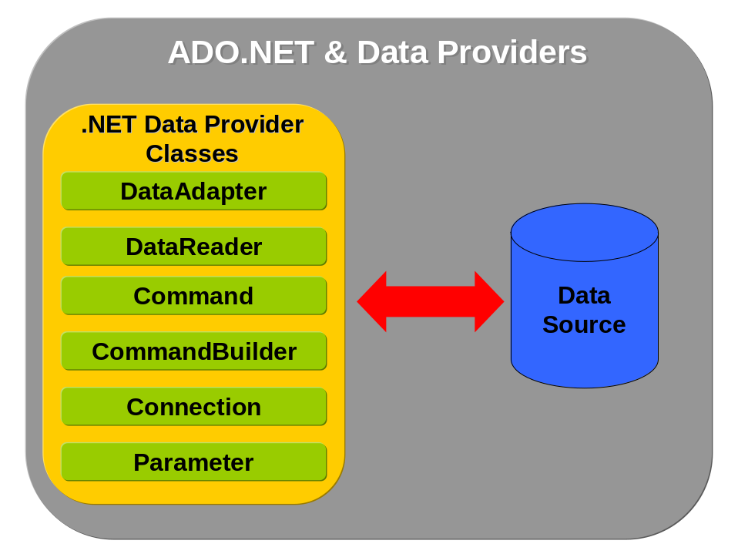
17-2
By default in .NET environment can be found following data providers:

Data provider | Namespace | Description
.NET Framework Data Provider for SQL Server | System.Data.SqlClient | It’s high speed provider for SQL Server version 7.0 or later using optimized TDS communication. Still requires MDAC 2.6 or later.
.NET Framework Data Provider for OLE DB | System.Data.OleDb | OLE DB provider works via COM interop for existing version 2.5 or later. It’s not designed to be used with ODBC.
.NET Framework Data Provider for ODBC | System.Data.ODBC  (old: Microsoft.Data.ODBC) | ODBC provider is about 20% faster than OLE DB. In .NET Framework since version 1.1.
.NET Framework Data Provider for Oracle | System.Data.OracleClient | Oracle data providers supports Oracle client software version 8.1.7 or later. In .NET Framework since version 1.1.
.NET Compact Framework Data Provider for SQL Server CE | System.Data.SqlServerCe | Provides connection to SQL Server CE.

As it was presented in diagram above, data providers encapsulate many other classes. Their functionality will be shortly described in the next sections.
- Connection classes
It’s obvious that connection classes hold information about connection to specific data source. Those classes implement interface IDbConnection when data source is a relational database.
- Command classes
Command classes are used to execute SQL statement or stored procedures and they implement IDbCommand interface (again when we talk about relational data source). A whole SQL command is stored in CommandText property (it can contain SQL statement, the name of stored procedure or finally the name of a table).
Command classes can have a collection of parameters and that is why there can be two types of classes: implementation of IDataParameterCollection and implementation of IDataParameter. Those two classes are holding parameter information and are used by command class.

Connecting to SQL Server, Oracle, MySQL and others
The best resource about connections to data source can be found on http://www.connectionstrings.com, here are just a few samples.
Namespaces:
using System;
// must be added reference to System.Data.OracleClient.dll
using System.Data.OracleClient;
using System.Data.SqlClient;

Code:
static void Main(string[] args)
{
try
{
// ------------- SQL SERVER -------------
// connection to SQL Server 7.x and 2000 using optimized driver
SqlConnection sqlConn = new SqlConnection();
// connect to SQL Server using integrated Windows security, its recommended for higher security
sqlConn.ConnectionString = "Data Source=(local);Initial Catalog=Northwind;Integrated Security=SSPI;";
sqlConn.Open();
Console.WriteLine("Connected to SQL Server: " + sqlConn.State);
sqlConn.Close();

// ------------- Oracle -------------
// Microsoft provides optimized Oracle driver, details on http://msdn.microsoft.com/library/default.asp?url=/library/en-us/dndotnet/html/manprooracperf.asp
// Oracle provides custom .NET driver ODP.NET, http://www.oracle.com/technology/tech/windows/odpnet/index.html
// third party optimized oracle driver, http://crlab.com/oranet/, http://www.crlab.com/oranet/oranet.msi
OracleConnection oraConn = new OracleConnection();
oraConn.ConnectionString = "Data Source=Oracle8i;User Id=user;Password=pass;Integrated Security=yes;";
oraConn.Open();
Console.WriteLine("Connected to Oracle: " + oraConn.State);
oraConn.Close();

// ------------- MySQL -------------
// Direct driver from Core Lab, http://crlab.com/mysqlnet/, http://www.crlab.com/mysqlnet/mysqlnet.msi
// Direct driver from Seven Objects, http://www.sevenobjects.com/MySqlClient.aspx

// ------------- Others -------------
// see http://www.connectionstrings.com/
}
catch (Exception e)
{
Console.WriteLine(e.StackTrace);
}
}

Executing SQL command and reading data in SqlDataReader
Namespaces:
using System;
using System.Data;
using System.Data.SqlClient;

Code:
static void Main(string[] args)
{
SqlConnection conn = new SqlConnection("Integrated Security=yes;Initial Catalog=Northwind;Data Source=(local)");
conn.Open();
// select last names of just 5 top rows from table with employees
SqlCommand command = new SqlCommand("select top 5 lastname from employees", conn);
// this is default setting, SQL text is used to return data
command.CommandType = CommandType.Text;

// use datareader to work with data
SqlDataReader reader = command.ExecuteReader();
while (reader.Read())
{
// output last name
Console.WriteLine(reader.GetString(0));
}

reader.Close();
conn.Close();
}

Executing stored procedure and reading data in SqlDataReader
Namespaces:
using System;
using System.Data;
using System.Data.SqlClient;

Code:
static void Main(string[] args)
{
SqlConnection conn = new SqlConnection("Integrated Security=yes;Initial Catalog=Northwind;Data Source=(local)");
conn.Open();
// command calls stored procedure 'Sales by Yeas' from Northwind database
SqlCommand command = new SqlCommand("Ten Most Expensive Products", conn);
command.CommandType = CommandType.StoredProcedure;

// use datareader to work with data
SqlDataReader reader = command.ExecuteReader();
while (reader.Read())
{
Console.WriteLine(reader.GetString(0));
}

reader.Close();
conn.Close();
}

Executing stored procedure and reading data from multiple result sets in SqlDataReader
DataReader is able to work with multiple results set returned from database. This sample uses custom stored procedure ReaderSampleProc. Its code is available here:

ALTER PROCEDURE ReaderSampleProc AS

SET ROWCOUNT 5

SELECT Employees.LastName FROM Employees
SELECT Products.ProductName FROM Products

Namespaces:
using System;
using System.Data;
using System.Data.SqlClient;

Code:
static void Main(string[] args)
{
SqlConnection conn = new SqlConnection("Integrated Security=yes;Initial Catalog=Northwind;Data Source=(local)");
conn.Open();
// command calls stored procedure 'Sales by Yeas' from Northwind database
SqlCommand command = new SqlCommand("ReaderSampleProc", conn);
command.CommandType = CommandType.StoredProcedure;

// use datareader to work with data
SqlDataReader reader = command.ExecuteReader();
// output data from first result set
Console.WriteLine("-------------- Employees --------------");
while (reader.Read())
{
Console.WriteLine(reader.GetString(0));
}

// !!!! move to next result set !!!!
reader.NextResult();

// output data from second result set
Console.WriteLine("-------------- Products --------------");
while (reader.Read())
{
Console.WriteLine(reader.GetString(0));
}

reader.Close();
conn.Close();
}

Executing stored procedure and getting data in DataSet
Logical schema of this sample is illustrated on the following figure:
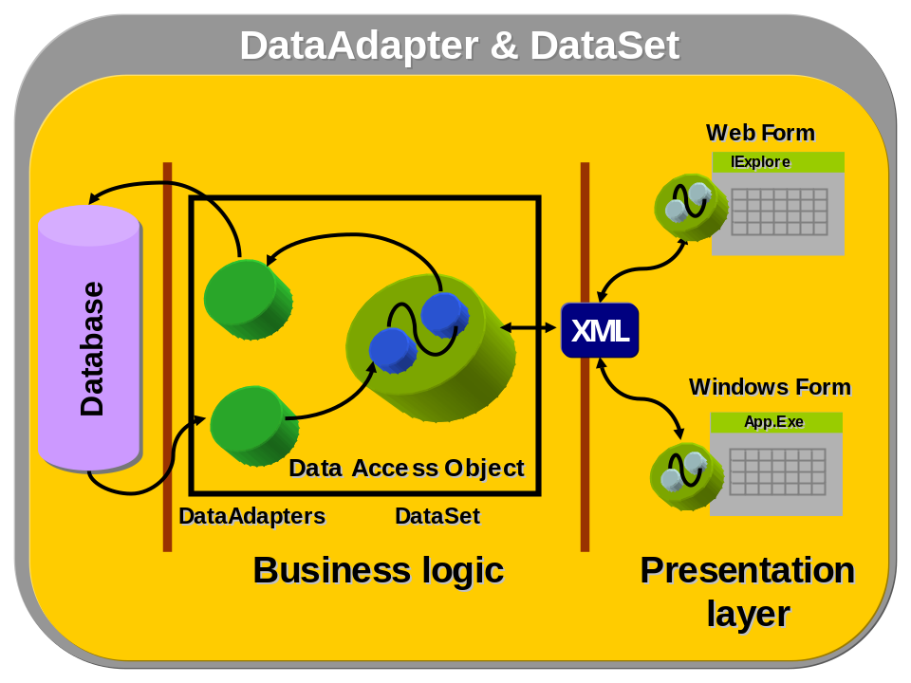
Namespaces:
using System;
using System.Data;
using System.Data.SqlClient;

Code:
static void Main(string[] args)
{
// this is just another option how to work with resources
using (SqlConnection conn = new SqlConnection("Integrated Security=yes;Initial Catalog=Northwind;Data Source=(local)"))
{
// command calls stored procedure 'Sales by Yeas' from Northwind database
SqlCommand command = new SqlCommand("Sales by Year", conn);
command.CommandType = CommandType.StoredProcedure;

// setting parameters for stored procedure
command.Parameters.Add("@Beginning_Date", SqlDbType.DateTime, 8).Value = "01/01/1997";
command.Parameters.Add("@Ending_Date", SqlDbType.DateTime, 8).Value = "31/01/1997";

// use dataadapter to read data
SqlDataAdapter adapter = new SqlDataAdapter(command);
DataSet dataset = new DataSet();

adapter.Fill(dataset);

// output xml data
Console.WriteLine(dataset.GetXml());
}
}

Updating database data with changes in DataSet
Namespaces:
using System;
using System.Data;
using System.Data.SqlClient;

Code:
static void Main(string[] args)
{
// this is just another option how to work with resources
using (SqlConnection conn = new SqlConnection("Integrated Security=yes;Initial Catalog=Northwind;Data Source=(local)"))
{
// command calls stored procedure 'Sales by Yeas' from Northwind database
SqlCommand command = new SqlCommand("select top 5 * from employees order by employeeID", conn);

// use dataadapter to read data
SqlDataAdapter adapter = new SqlDataAdapter(command);
DataSet dataset = new DataSet();

adapter.Fill(dataset);

// do some changes on dataset data - in this sample first row
DataRow row = dataset.Tables[0].Rows[0];
// update last name of employee
row["LastName"] = "Changed name";

// add new row to the table
row = dataset.Tables[0].NewRow();
// row["EmployeeID"] = "";
row["LastName"] = "Seda";
row["FirstName"] = "Jan";
row["Title"] = "Software architect";
row["TitleOfCourtesy"] = "Mr.";
dataset.Tables[0].Rows.Add(row);

// update database using SqlCmdBuilder, which build SQL commands to update table
SqlCommandBuilder builder = new SqlCommandBuilder(adapter);

// it's obvious there are some changes, but this is correct code for real application
if (dataset.HasChanges()) adapter.Update(dataset);
}
}

List available SQL servers
This sample works with SQLDMO and that is why is not appropriate for general client where this COM component is not installed but can be used in backend applications.

Namespaces:
using System;
// COM component 'Microsoft SQLDMO Object Library' must be included in project references
using SQLDMO;

Code:
static void Main(string[] args)
{
ApplicationClass appClass = new ApplicationClass();
// this method provides list of available SQL servers
NameList list = appClass.ListAvailableSQLServers();
for(int i = 0; i < list.Count; i++)
{
// output SQL server list
Console.WriteLine(list.Item(i + 1).ToString());
}
}

ADO.NET & System.Xml 2.0 (Whidbey)

Summary of new features in ADO.NET 2.0
ADO.NET 2.0 (or called by code name ADO.NET Whidbey) brings no model changes, so if it works now, it will work with ADO.NET 2.0.

Asynchronous Data Access
Asynchronous data access brings better performance to client and server applications by non blocking UI or server threads by waiting for source response. This feature provides performance improvement also when combined with MARS.
ADA works fine with SQL Server 7, 2000 and “Yucon”.

Batch Updates
Currently DataAdapter.Update does a round-trip per row, which is not efficient in case of batches.In ADO.NET 2.0 batching is supported by extending framework with a feature adapter.UpdateBatchSize. Also other enhancements are made with respect to batching, see samples.
This feature is available for SqlClient and OracleClient.

DataSet Performance

MARS (Multiple Active Results Sets)
MARS is a technology allowing a connection

Summary of new features in System.Xml

Appendix A - Fast-track to C# language
This is just a very brief introduction to C# programming language giving basic understanding. All details can be found in C# language specification on http://download.microsoft.com/download/0/a/c/0acb3585-3f3f-4169-ad61-efc9f0176788/CSharp.zip.

Basic terms and definitions in .NET & C#
Application – refers to assembly that has an entry point (method Main()). When application is started, a new application domain is created and each application is separated in its own application domain.
Application domain – this is a new term in .NET and application domain brings better management and security when working with .NET applications. An application domain is something like a container with its own libraries and settings. No data or any areas of application domain can be shared between other domains.
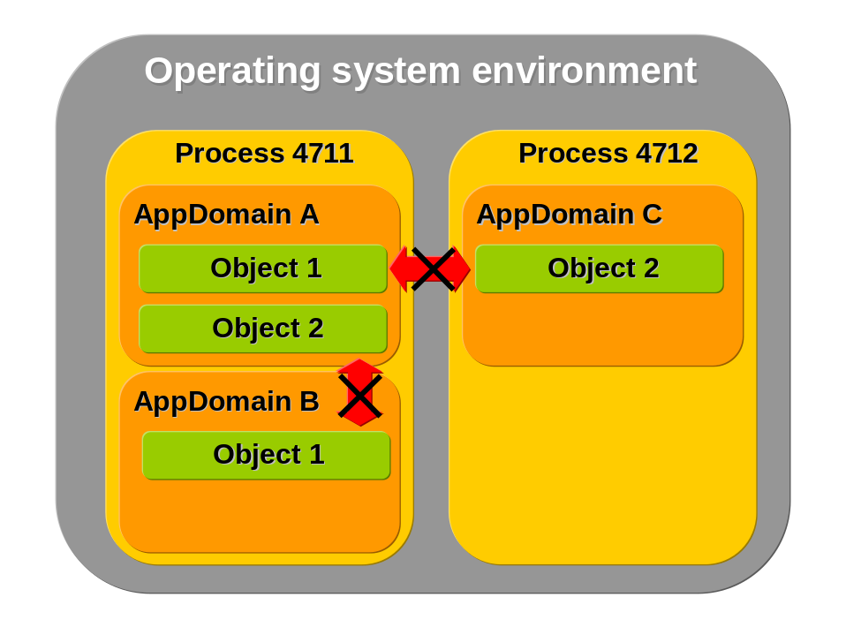
Assembly – assemblies are libraries containing final output from compilation of application. Assemblies have similar format like “.dll” files with some differences (primary metadata section) and may contain executable code, type definitions and other resources.
Class library – this term refers to assembly that can be used by other assemblies. Class library is similar to “.dll” file loaded into the process’s address space (in case of typical Win32 application) when class library is loaded into the application domain (class library is not running in a separate application domain).
Namespace – namespaces provide logical organization system where classes are logically divided into separate “sections”. When compared with Java, namespaces unlike packages in Java are just logical and don’t require to be implemented in physically stored classes in each folders representing logical structure.
Unsafe code – unsafe code is a way how to run low-level operations like direct memory manipulations, pointers, etc. This is a way how to call direct APIs of operation system or optimize performance dependent algorithms (for example game development).

What is C#?
First of all, it’s important to say what C# is and which features aren’t included in this programming language. So here is the list of features which are significant for C# and are the most typical:

- Type-safety
- Garbage collection
- Delegates, properties, events
- Versioning
- Metadata, attributes
- Preprocessor

And here is the list of features that were disposed of C#:

- Macros
- Templates (but this is true till C# 2.0 where generics are introduced)
- Multiple inheritance
- Header files

Hello world
This is the basic skeleton of C# application presenting layout and structure:

using <namespace>
namespace <my own namespace> [{]
public class <class name> {
public static void Main() {
}
}
[}]

It’s typical to start talking about programming language by “Hello world” application:

using System;
namespace Hello {
public class HelloWorld {
public static void Main() {
Console.WriteLine("Hello world application.");
}
}
}

Assemblies
When you compile the “Hello world” sample assembly will be created. But what is assembly? This term is specific to .NET and it defines type of file that encapsulates all application content like compiled code, metadata, resources etc. It can be understood as a “.dll” library (assembly has similar physical layout) but assemblies can only be used in .NET environment and aren’t just a file-storage of application data (assemblies are related with rights, permitions, place of storage etc.) but are improved by many important features (see other chapters).

Locating of assemblies
It’s very important to understand how .NET runtime (Common Language Runtime – CLR) locates assemblies.
The process of locating and binding assemblies can be divided into two types of reference to assemblies:
- Static references
Static references are created when application is being compiled and compiler makes static references to assemblies. Figure below illustrates sample references from the environment of Visual Studio .NET and those references are built as the static ones.
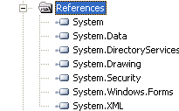
These references are stored in metadata when assembly is built.
- Dynamic references
These references are constructed on the fly by programmer using specific methods such as System.Reflection.Assembly.Load or AppDomain.Load.

Assembly layout
Assemblies encapsulate many types of data and that is why their layout must be defined properly. Here is the list of sections contained inside of assemblies and their short descriptions.

Identifiers
Identifiers are names used by programmers for methods, variables, types, classes, interfaces etc.
- C# identifiers are case-sensitive.
- Identifiers must be a whole word, not divided.
- Identifiers must start with character or with underscore.
- Keywords in C# can’t be used as an identifier.

Types
There could be a long story about types and their representation in CLR. But this book is just a reference giving fast help and introduction to C# and that is why types are covered here just in a basic form.
Generally all data types in .NET are based on strong data typing. This definition says that all variables belong to specific type and all .NET languages must complain on this behavior.
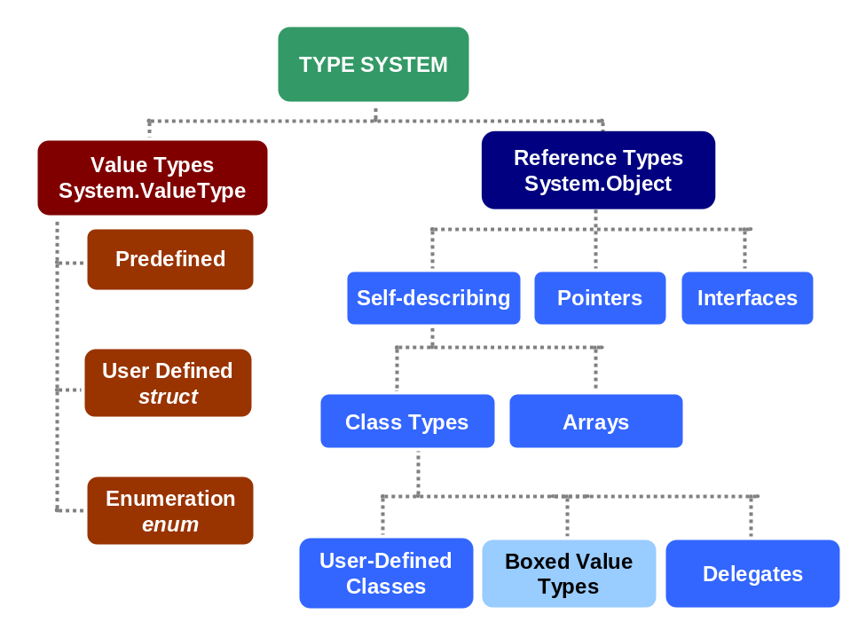

Hierarchy of types
All types in C# are derived from System.Object and can access its methods even the primitive types like int, double etc. (this is done through the boxing/unboxing technique, see chapter 19.6.10).
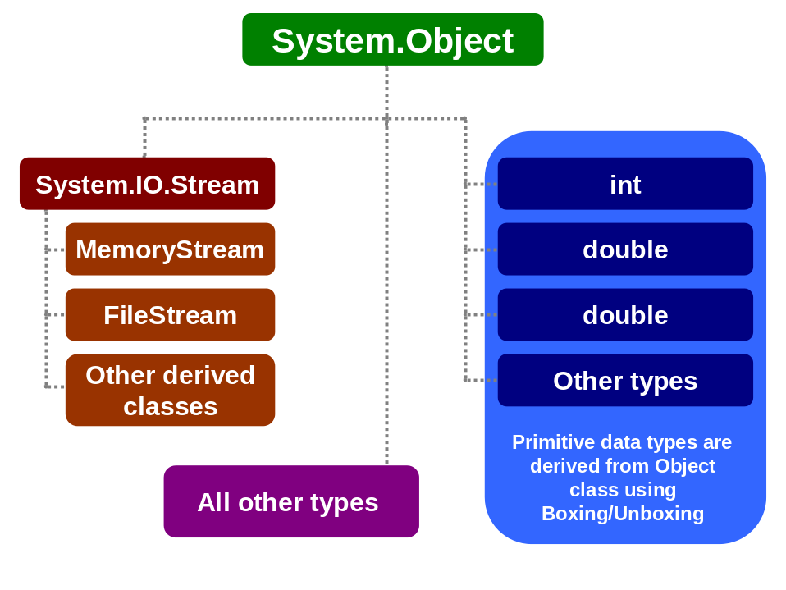

Predefined types
Predefined types are the basic ones and are defined in all .NET environments (ISO compliant, details on ECMA site) and are not dependent on any other libraries, just the basic ones.

Integral types
C# type | .NET type | Size (bytes) | Signed | Range
sbyte | System.Sbyte | 1 | yes | -128 to 127
byte | System.Byte | 2 | no | 0 to 255
char | System.Char | 2 (Unicode) | - | U+0000 to U+ffff
short | System.Int16 | 2 | yes | -32,768 to 32,767
ushort | System.UInt16 | 2 | no | 0 to 65,535
int | System.Int32 | 4 | yes | -2,147,483,648 to 2,147,483,647
uint | System.UInt32 | 4 | no | 0 to 4,294,967,295
long | System.Int64 | 8 | yes | -9,223,372,036,854,775,808 to -9,223,372,036,854,775,807
ulong | System.UInt64 | 8 | no | 0 to 18,446,744,073,709,551,615

Initialization of integral types can be defined in decimal or hexadecimal form:

// decimal initialization
int decimalVar = 12345;
// hexadecimal initialization
int hexadecimalVar = 0xA345;

Values can be filled in by the following suffixes:

U – uint and ulong types

uint four = 15U;
ulong eight = 15U;

L – long and ulong types

long signed_eight = 15L;
ulong eight = 15L;

UL – ulong type

ulong eight = 15UL;

Implicit conversions of integral types must be performed just between types where is not possible loss of data. Here is a list of possible implicit conversions:

// one byte identifiers
byte one = 1;
sbyte signed_one = -1;

// two bytes identifiers
short signed_two;
ushort two;

// four bytes indentifiers
int signed_four;
uint four;

// eight bytes identifiers
long signed_eight;
ulong eight;

// sample implicit conversions
signed_eight = signed_four = signed_two = signed_one;
eight = four = two = one;

The figure presenting implicit conversions can be found in chapter 19.6.9.
Special type of integral type is char type holding Unicode values representing literals or escape character (see table below).

Escape character | Description | Value
\0 | Null | 0x0000
\a | Bell | 0x0007
\b | Backspace | 0x0008
\t | Horizontal tab | 0x0009
\n | New line | 0x000A
\v | Vertical tab | 0x000B
\f | Form feed | 0x000C
\r | Carriage return | 0x000D
\" | Double quote | 0x0022
\' | Single quote | 0x0027
\\ | Backslash | 0x005C

Char type can be converted to any

Floating-point types
C# type | .NET type | Size (bytes) | Signed | Aprox. Range | Precision
float | System.Single | 4 | yes | ±1.5x10⁴⁵ to ±4.5x10³⁸ | 7 digits
double | System.Double | 8 | yes | ±5.0x10³²⁴ to ±1.7x10³⁰⁸ | 15-16 digits

Implicit conversions of floating-point types must value keep data as integral types. That is why conversion from float to double is allowed but not vice versa.
Also int, uint and long can be converted to float and from long to double.

Decimal type
C# type | .NET type | Size (bytes) | Signed | Aprox. Range | Precision
decimal | System.Decimal | 12 | yes | ±1.0x10²⁸ to ±7.9x10²⁸ | 28-29 significant num.

Decimal type has better precision but unlike floating-point type smaller range.
When decimal values are assigned, then they require suffix “m” or “M”:

decimal twelve = 465632.3676m;

Bool type
C# type | .NET type | Size (bytes) | Signed | Value
bool | System.Boolean | 1-2 | no | true, false

In C# Boolean type can be assigned just to true or false values, which are represented by one bit (1 or 0) but because of processor’s addressing space at least one byte is occupied. When Boolean type is used in arrays, it occupies 2 bytes of memory space.
Boolean type can’t be converted to any numeric type or vice versa.

Object type
C# type | .NET type | Size (bytes) | Value
object | System.Object | 0/8

The object type is a base class for all types in .NET Framework. This type is going across other types like value and reference types, when in case of value types object has no overhead (special 8 bytes used to work with object, to address them, synchronize them and monitor by garbage collector).

String type
C# type | .NET type | Size (bytes) | Value
string | System.String | >=20 | Unicode

String object is immutable object which means that instance of string can’t be changed without allocation of new string object. This is a reason why string operations are the most frequent reason for performance problems.

Implicit conversions of numeric values
On the diagram below are shown possible implicit conversions of built-in types in .NET. The
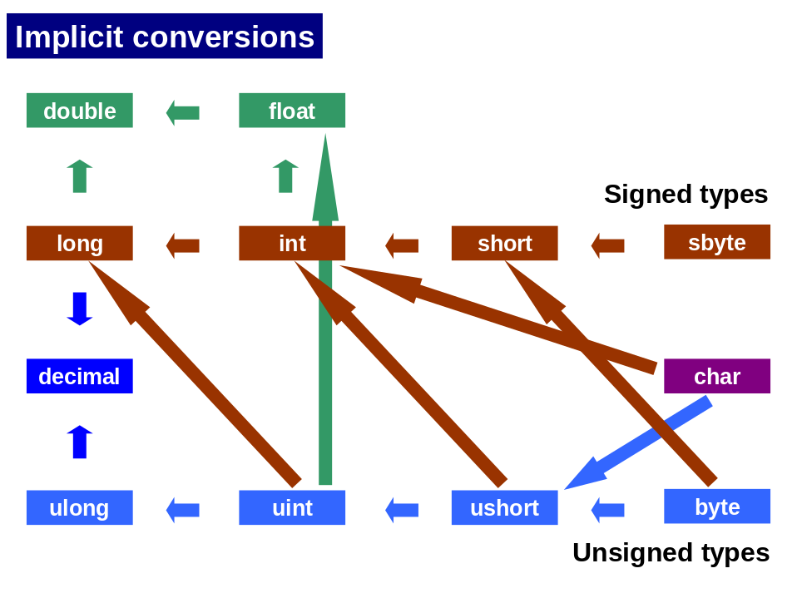
19-3

Boxing and unboxing
Boxing and unboxing is typical part of type system and a nice and very good feature that was copied by other languages like Java (from version 1.5). It provides an easy way how to tread reference types as value types and vice versa. This is a very strong feature because it simplifies development and OOP layout of classes holding data.
Boxing is an implicit conversion of value type to the reference type. When value type is boxed, then memory is allocated on the heap for the reference type, which is boxing a value type.
Unboxing is implicit conversion method how to convert from reference type back to value type.
See the sample bellow:

static void Main(string[] args)
{
int i = 123;
// boxing, this will box the value type '123'
object o = i;
// unboxing
int j = (int)o;

Console.WriteLine(o);

if (o is int)
{
Console.WriteLine("Object is treated as int value.");
}
}
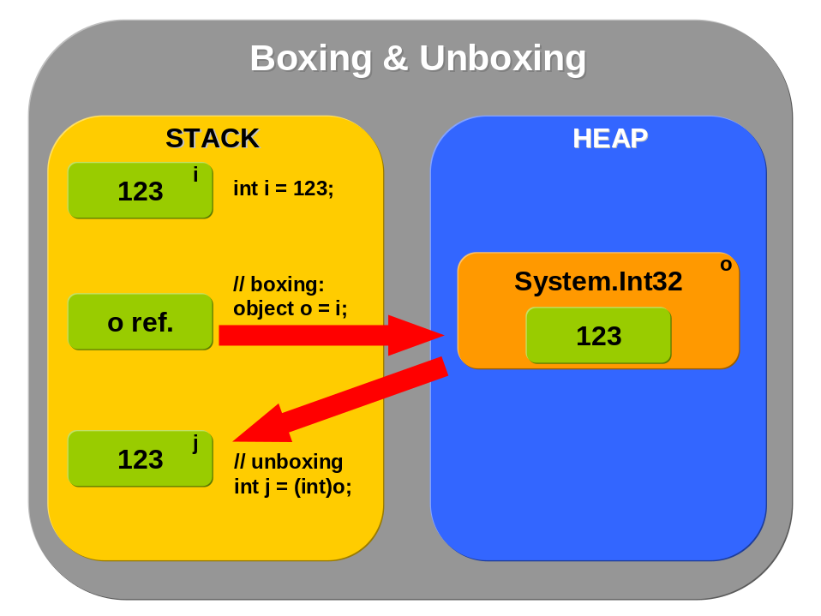

Variables & parameters

Types of variables & parameters
A variable represents memory storage for specific type as variable is defined. In C# specification are defined those types of variables and parameters:
- Local (declared in methods, properties or indexers)

int a;
int b = 1;
int c, d = 1;

Variables in C# must be assigned a value before they are used, otherwise this will cause an error. This part of code will throw an error when compiled:

int a;
int b = 1;
int c = a + b;

- Field (variable that is associated with class or struct
  - Static (field variable defined with keyword static, it is associated with type)
  - Instance (instance variables are associated with class instances)

class Person
{
// static variable, shared accross all instances of type 'Person'
public static string[] sex = {"M", "W"};
// instance variables are tight and specific to each instance of this class
public int weight;
public int height;
}

- Value parameters (are used for ‘in’ parameters, when value is not changed in the passes argument outside of called method)

static void SampleMethod(int p) { . . . // parameter is just passed into the method but never changed outside

- Reference parameters (parameters act like an aliases for caller-provided arguments, modifications of a referenced parameter impact the corresponding argument, reference parameter is defined by ref keyword)

using System;
class ReferenceParameter
{
static void Add(ref int a)
{
// increment value in a
a++;
}
static void Main()
{
int a = 0;

Add(ref a);
// this will output '1'
Console.WriteLine("Value: " + a);
Add(ref a);
// this will output '2'
Console.WriteLine("Value: " + a);
}
}

- Output parameters (they’re similar to reference parameters, except the fact that initial value of passing parameter isn’t important, output parameter is declared by out keyword)

using System;
class OutputParameter
{
static void Sum(int a, int b, out int res)
{
// this will throw an error
// Console.WriteLine("Passed value: " + res);
res = a + b;
}
static void Main()
{
int a = 10, b = 10;
int result = 40;

Sum(a, b, out result);
// this will output value '20'
Console.WriteLine("Result of sum: " + result);
}
}

- Parameter array (This enables to pass variable number of parameters to a method, parameter array is declared by param keyword)

using System;
class ArrayParameter
{
static void F(params int[] args)
{
Console.WriteLine("# of arguments: {0}", args.Length);
for (int i = 0; i < args.Length; i++)
Console.WriteLine("\targs[{0}] = {1}", i, args[i]);
}
static void Main()
{
F();
F(1);
F(1, 2);
F(1, 2, 3);
F(new int[] { 1, 2, 3, 4 });
}
}

Default values
The following categories of types are automatically initialized to their default values (see table below):
- Static variables
- Instance variables
- Array elements
Reference types are initialized by default to null.

Type | Default Value
Numeric | 0
Bool | false
Char | '\0'
Enum | 0
Reference | null

Expressions & Operators

Operators
The following table presents operators in order of precedence (order in which operators are evaluated) from highest to lowest.

Category | Operators
Primary | x.y, f(x), a[x], x++, x--, new, typeof, checked, unchecked
Unary | +, -, !, ~, ++x, (T)x
Multiplicative | *, /, %
Additive | +, -
Shift | <<, >>
Relational and type testing | <, >, <=, >=, is, as
Equality | ==, !=
Logical AND | &
Logical XOR | ^
Logical OR | |
Conditional AND | &&
Conditional OR | ||
Conditional | ?:
Assignment | =, *=, /=, %=, +=, -=, <<=, >>=, &=, ^=, |=

Overflow check operators
C# provides explicit overflow checking capability with specific operators:

checked(expression)
unchecked(expression)

Sample of using those operators follows. The first one presents overflow checking when OverflowException is thrown by CLR and when operator checked controls a block of code:

static void Main(string[] args)
{
int a = 1000000000;
checked
{
// this will pass
a = a + a;
// this throws OverflowException
a = a * a;
}
}

Operator checked can be used even as a one-line command when testing just one expression:

a = checked(a * a);

The second operator unchecked works similarly, but it disables arithmetic checking at compile time.

Operator overloading
C# lets to overload operators, but just some of them. In table is a list of operators that can be overloaded. For that purpose is specified a new keyword operator preceding the operator to be overloaded.

Type of overloadable operators | Overloadable operators
Unary | +, -, !, ~, ++, --, true, false
Binary | +, -, *, /, %, &, |, ^, <<, >>, ==, !=, >, <, >=, <=

Here is a sample on operator overloading when implementing value equality:

using System;
namespace OperatorOverloading
{
class SampleApp
{
static void Main(string[] args)
{
Client c1 = new Client(1000, 20000);
Client c2 = new Client(30000, 10000);

Console.WriteLine("Equals sign: "+(c1 == c2));
Console.WriteLine("Non-equals sign: " + (c1 != c2));
}
}

class Client
{
int credit;
int salary;
public Client(int cre, int sal)
{
credit = cre;
salary = sal;
}
public static bool operator == (Client c1, Client c2)
{
return (c1.credit == c2.credit && c1.salary == c2.salary);
}
public static bool operator !=(Client c1, Client c2)
{
return (c1.credit != c2.credit && c1.salary != c2.salary);
}
public override bool Equals(object o)
{
if (!(o is Client)) return false;
return this == (Client)o;
}
public override int GetHashCode()
{
return base.GetHashCode();
}
}
}

Statements
C# is a programming language from C language family and that is why many statements are similar to C/C++. Table below lists available statements:

Statement | Description | Example
if (expression)  statement1  [else  statement2] | The if statement selects a statement for execution based on the value of a Boolean expression.  Details on MSDN. | if (a == 1) a = 2;  else a = 1;
switch (expression)  {  case constant-expression:  statement  jump-statement  [default:  statement  jump-statement]  } | The switch statement is a control statement that handles multiple selections by passing control to one of the case statements within its body.  The switch statement supports wide range of data types for switch (expression), like enumerations, integer, chars and strings.  The switch statement supports goto statement jumping between case options. Also C# doesn’t allow to multiple case options on one statement call in switch (like in Java) and that is why case blocks aren’t terminated by special keyword (for instance by break).  Details on MSDN. | switch (strValue)  {  case "First":  case "Second":  goto default;  case "Three"  goto case "Second";  case "Four":  strValue = "FOUR";  default:  strValue = "None";  }
while (expression) statement | The while statement executes a statement or a block of statements until a specified expression evaluates to false.  Details on MSDN. | while (a < 10)  {  a = a + 1;  }
do statement while (expression); | The do statement executes a statement or a block of statements repeatedly until a specified expression evaluates to false.  Details on MSDN. | do  {  a = a + 1;  } while (a < 10);
for ([initializers]; [expression]; [iterators]) statement | The for loop executes a statement or a block of statements repeatedly until a specified expression evaluates to false.  Details on MSDN. | for (int a = 0; a < 10; a++)  {  Console.WriteLine("Value a: " + a);  }
foreach (type identifier in expression) statement | The foreach statement repeats a group of embedded statements for each element in an array or an object collection which implements interface System.IEnumerable (or the same pattern).  The type in foreach statement must be the same as the type in collection object (or there must be explicit type-casting).  Details on MSDN. | string[] strValue = {"First", "Second", "Third"};  foreach (string tmpString in strValue)  {  Console.WriteLine(tmpString);  }
break; | The break statement terminates the closest enclosing loop or switch statement in which it appears.  Details on MSDN. | for (int i = 0; i < 10; i++)  {  // break cycle when i==5  if (i == 5) break;  }
continue; | The continue statement passes control to the next iteration of the enclosing iteration statement in which it appears.  Details on MSDN. | for (int i = 0; i < 10; i++)  {  // this skips other code behind continue statement  if (i < 5) continue;  Console.WriteLine(i);  }
labeled-statement:  identifier : statement | Labeled statement identifies a place where jump is performed with keyword goto and label name.  Details on MSDN. | myLabel : a = 0;  if (a == 1) goto myLabel;
goto identifier;  goto case constant-expression;  goto default; | The goto statement transfers the program control directly to a labeled statement.  Details on MSDN. | see switch statement example
return [expression]; | The return statement terminates execution of the method in which it appears and returns control to the calling method.  Details on MSDN. | public static int SampleMethod()  {  return 0;  }
try statement | The try statement provides a mechanism for catching exceptions that occur during execution of a block.  See chapter 19.11.  Details on MSDN. | try  {  // some code  }  catch (Exception e)  {  Console.WriteLine(e.Message);  }
throw [expression]; | The throw statement is used to signal the occurrence of an anomalous situation (exception) during the program execution.  Details on MSDN. | throw (new Exception("Sample exception"));
checked block  unchecked block | The checked and unchecked statements are used to control the overflow checking context for integral-type arithmetic operations and conversions.  Similar behavior can be caused by using the compiler flag /checked.  Details on MSDN. | int a = 1123456789;  // this rises overflow exception  int b = checked (a * 15);  // this supresses overflow check  int c = unchecked(a * 15);
lock(expression) statement_block | The lock keyword marks a statement block as a critical section by obtaining the mutual-exclusion lock for a given object, executing a statement, and then releasing the lock.  Details on MSDN. | lock (this)  {  // code that needs thread synchronization, it's done on 'this' object  }  lock (some_object)  {  // code that needs thread synchronization, this is done on instance of some_object  }
using (expression | type identifier = initializer) statement | The using statement defines a scope at the end of which an object will be disposed.  Object used by this statement must implement System.IDisposable interface.  Details on MSDN. | using (SomeClass usedClass = new SomeClass())  {  // usedClass object is used here and finally dispose method is called  }

C# namespaces
As it was written for the first time in section 19.1 about namespaces, they’re intended to be used to manage classes in logical groups. With this approach .NET Framework can be seen as a group of logical packages with many functionality implementations in each class. Generally, every class belongs to some namespace, even when you consider class definition as follows

class SampleClass
{
}

This class is not assigned to any namespace (as in the example) then class SampleClass becomes part of the global namespace and such a class is globally available to any application.
But this is not a recommended approach, classes should be defined in a specific namespace and the syntax is following

namespace SampleNamespace;
class SampleClass
{
}

and also as

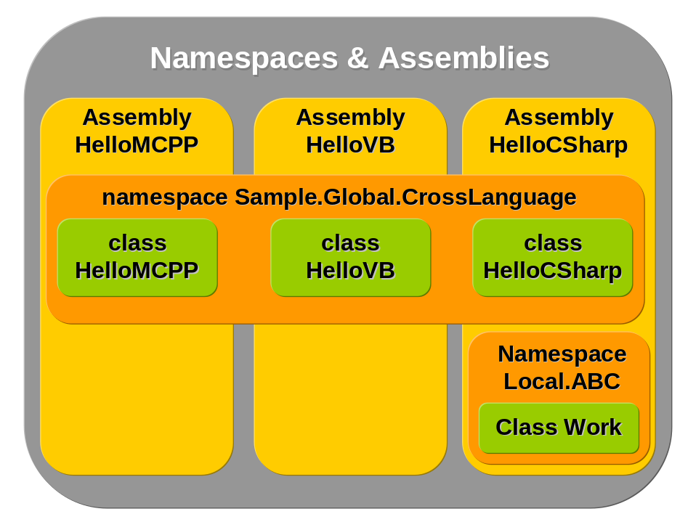

Exceptions & exception handling
Exception handling is one of the main features of today’s modern languages and that is why it can be found in C# too. With this programming approach it’s possible to handle special situations programmatically and to react to specific circumstances. An exception objects physically represent a special event where data related to this event are encapsulated inside of exception object. See figure below presenting sample exception when accessing file which is in use:
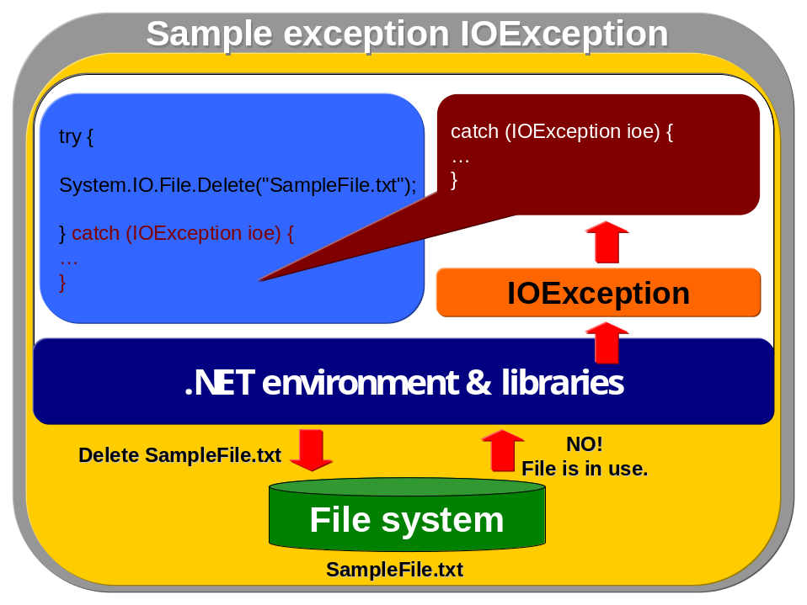
From the figure above can be seen that the exception handling is a straightforward technique. Here you can see a sample try-catch block representing typical usage of handling in C# code:

try
{
// code that needs to be handled
}
// this catches specific class of exception (it's defined by exception type)
catch (SomeExceptionClass ec)
{
}
// this is a typical clause where catch block is handling all exceptions
catch
{
}
// this code block will be run whenever exception has been rised or not
finally
{
}

This is an obvious code and more details about try-catch block syntax can be found on MSDN (regarding other statements and their overview see chapter 19.9). But for general introduction of exception handling and its catching it’s enough to understand the idea of exceptions. But there are more talking points about exceptions and their declaration and throwing.

Throwing exceptions
Exceptions can be thrown by .NET environment but they can be thrown programmatically using keyword throw too. Its syntax is covered in chapter 19.9 and is pretty simple. Generally, exceptions can be re-thrown when they are created outside throw call like in this sample

try
{
// new exception is thrown
throw new Exception();
}
// exception is caught
catch (Exception e)
{
// the same exception is re-thrown
throw e;
}

This code presents two main usages of throw statement:
- Throwing a new exception programmatically
- Re-throwing an already created exception

Exception classes
There are many exception classes defined in runtime environment, but they all share one class System.Exception. This is a primary class which should be used for all other exceptions even when considering declaration of custom ones. Except this base class there are two exception classes (System.SystemException designed for system exceptions and System.ApplicationException is for application exceptions, which are some non-fatal exceptions).
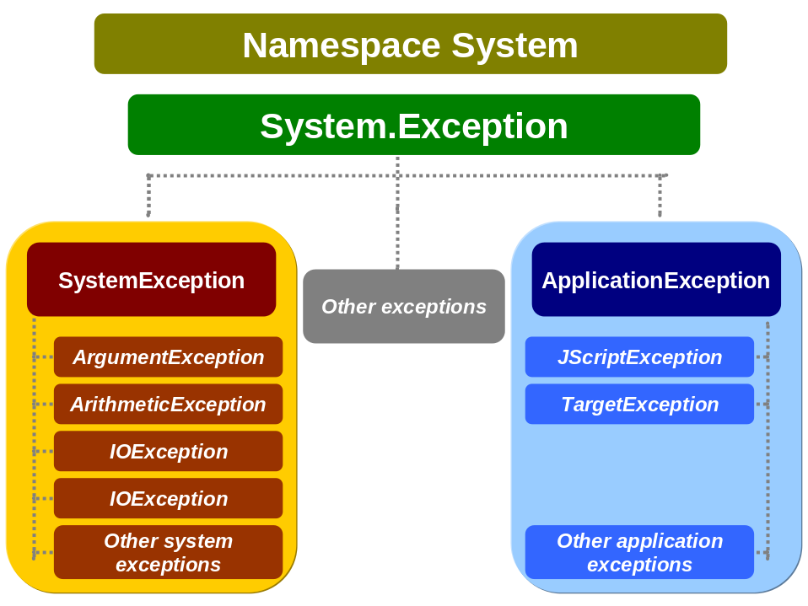

Monitoring of exception performance
When exceptions are overused, significant performance problems will rise. That is why usage of exceptions should be wise and very moderate. Applications with exceptions should always be monitored at least when they are tested. For that purpose it’s possible to use Performance Monitor with its performance object .NET CLR Exceptions and appropriate mode (in figure below is used # of exceptions thrown / sec. and processor time when sample program throwing exceptions had been started).

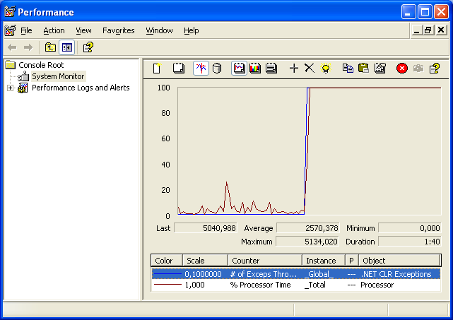

Here is the sample of very primitive code that shows how exceptions can overload the whole system:

static void Main(string[] args)
{
for (; ; )
{
try
{
throw new Exception();
}
catch
{
Console.WriteLine("Catching the exception.");
}
}
}

Checked & unchecked exceptions
What is typical about exception handling in C# is that usage of try-catch blocks is not required even when methods (or classes) are declared as throwing exceptions. For programmers familiar with Java this can seem strange because they’re used to checked exceptions (exceptions must be handled when declared). But C# has the concept of unchecked exceptions which don’t push a programmer to handle them.
Those two concepts have many advantages and disadvantages that have been talked over many times as can be seen here:

- http://discuss.develop.com/archives/wa.exe?A2=ind0101A&L=DOTNET&P=R10490
- http://www.mindview.com/Etc/Discussion/CheckedExceptions

But primary we can see the problem with making general layer for any programming language in .NET (one of the key aspects of .NET architecture). So far Java is the only programming language implementing checked exceptions but the other languages like Eiffel, Smalltalk or Pascal don’t.
Even if I say it myself I consider the idea of checked exceptions as a good one, even though I understand the reasons of .NET designers to remove it. If you’re one of the checked exceptions advocate then I can assure you that this can be solved by using third party products filling in this feature into the .NET or by using of attributes.

Attributes
Attributes are very powerful feature goving .NET programmers provide declarative information about entities in their programs. Attributes are compiled and then final information is kept in metadata in assembly. This is used by CLR when application is started and adequate functionality is provided according to attribute used for an entity.

Multithreading & synchronization
Multithreading is one of the today’s modern and standard techniques of programming. Multithreading is similar to concept of multitasking in operating system when many application processes can run concurrently and user can work simultaneously with them just by switching. The similar approach is with multithreading when user can work on many tasks in one application at once. Typical usage of multithreading would be when application is processing some large file or similar data source but user can work on another task in the same application simultaneously. This is because one thread takes care about processing of file and the other threads react on user interface events or other operations done by user.
So what is a thread? The answer isn’t simple and there could be written a whole book just about thread definition but very simple saying it’s a execution unit within a process that has its own code, data stack, file IO and signal tables and can access the process’s resources and rights and share it with other process’s threads. Still not catching? ☺ No problem, multithreading isn’t easy to understand, but thread can be imagined like a subset of process which behaves unpredictable from execution time perspective (see figure below).
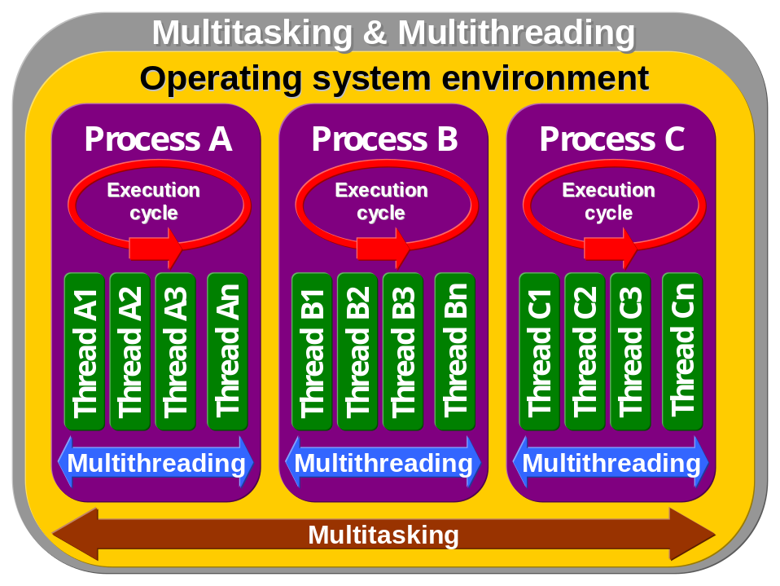
As it’s presented on the figure above, threads can be thought as semi-processes or subsets of process. It’s because they have similar layout like process but on smaller “area”. Threads are just further application of idea of multitasking into the processes where users can do more work when things are done in parallel manner.

Semaphores & mutexes
As was written in previous section, threads are unpredictable from execution point of view. It’s not possible to say when thread will be active and how much work it will do. That is why when many threads access shared resources then it can cause unpredictable behavior of whole application and its results. That is why threads must be synchronized in such situations and this is done through semaphores and mutexes. But this not important for .NET programmers because this work is done behind the scene but at least basic understanding of those terms should be required (it’s important to understand this when dealing with unmanaged applications in interop scenarios).

Semaphores
Semaphores act as an flag signaling where other threads can access some resource or if it’s overloaded. A semaphore keeps a count of threads accessing specific resource and when it reaches some high number of threads (it can be determined programmatically or by some special algorithms in operating system) then it refuses any other threads trying to access a resource.

Mutexes
Mutex is the term standing for mutually exclusive access. And this says all – when mutexes are used then resource is locked for one thread and any other can’t access it. This can create performance problems because with this approach it’s easy to create application bottleneck because resource wouldn’t be accessible to any other thread at the same time.

Thread architecture
When working with threads, then there’re two application designs of thread usage:
- Pipeline model
In this case threads work on different operations in different stages and those threads have a very little in common. Typical sample is a game where rendering operations are assigned to separated thread, next one deals with AI, another works on network communication etc.
- Worker thread model
In this model application has threads that work on the same task in parallel manner. Typically this model is used by web servers (or servers in general) handling HTTP communication when worker threads are assigned to each HTTP session and other related operations. Because thread creation demands many system resources and time, this operation is “cached” in a format of thread pools where worker threads are pooled. For instance when request is sent to a server then available pooled thread is assigned to it. When pool is out of threads the new ones are created continually so server isn’t overloaded and when server detects reducing load then destroys unused threads to minimum.

Multithreading in C#
As a starting point consider following code providing very simple application working with thread:

using System;
using System.Threading;
class ThreadSample
{
public static void Main()
{
Thread t = new Thread(new ThreadStart(TestMethod));
t.Start();
TestMethod();
}

public static void TestMethod()
{
for (int i = 0; i < 30; i++)
{
Console.WriteLine("Value of i: "+i);
}
}
}

The output of this code should be something like this

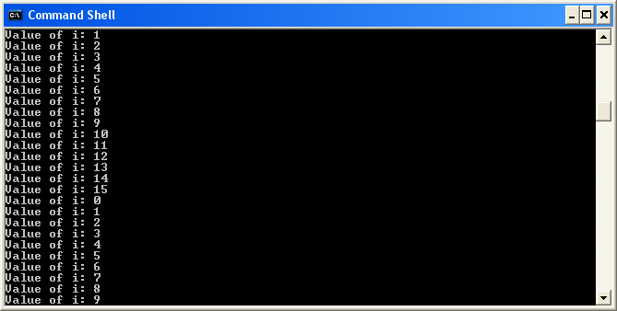

or something similar when number should not be organized in two growing lines like when calling TestMethod method two times stepwise.
So what’s happening in this sample? In this code is defined a new Thread class object which is constructed by passing it the parameter ThreadStart delegate. It represents a reference to method that is encapsulated by this thread and that is running inside of it.
Then there is a call to Start method (defined in Thread class) casing the operating systems starts a new thread (where TestMethod is encapsulated). After that there is a call to method TestMethod when this call is associated with current thread (it runs Main method of the application). So finally there’re two thread running parallelly and calling the same method TestMethod.
As can be seen on this sample, both threads share console as an output device and that is why output results are random and not organized to one queue of growing numbers. You can imagine that this can cause many problems without synchronization of thread. That is why synchronization of threads is basic feature of any language dealing with multithreading.

Lock statement
In the chapter 19.9 has been introduced C# statement including lock with basic syntax and description. Here are some more details.

Garbage Collection
The .NET Framework provides automatic memory management, where allocation and de-allocation of objects is done automatically by the environment. This behavior is limited to managed code; in case of unmanaged code the situation is different.

The concept of garbage collector is allocation of objects on managed heap whenever programmer calls new keyword; de-allocation is down when all reference to the objects are explicitly set to null or gone out of scope. Generally process of garbage collector work can be divided into these steps:

- Memory for an object is allocated on the managed heap whenever new keyword is called.
- The allocated object is used and referenced in application.
- The object is de-allocated when object references are explicitly set to null or gone out of scope and reference counter for the object is zero.
- The object’s memory is marked as not used and that it should be de-allocated. When garbage collector runs a trip around objects, it reclaims not used memory space.

Collection of memory space
Today’s modern garbage collectors are called generation garbage collector because they use the concept of generation. What it means? See the following figure:
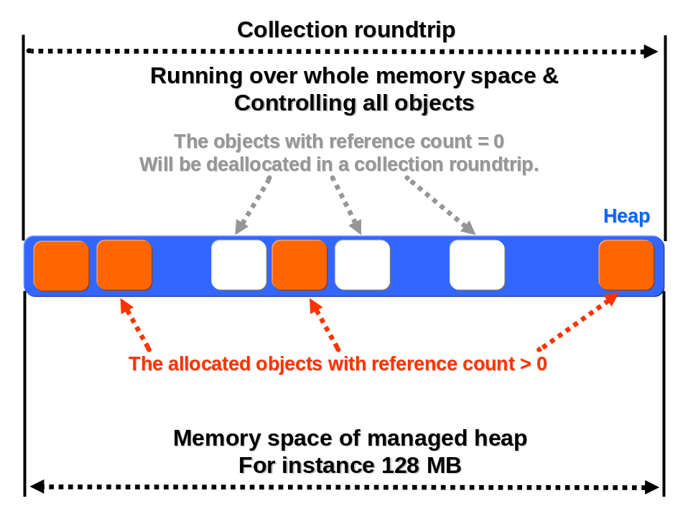
On that figure is garbage collector working with objects through the all memory address space without any organization. Issues of that approach are obvious:

- Memory fragmentation and poor organization. There is no difference between old and young objects.
- Collection roundtrips must run through all memory address space and control all objects repeatedly. When there would be old objects allocated for long time then many operations would be repeated uselessly. Also time needed to run over address space is too long and performance would be poor.

Generation garbage collector works according to following hypothesis, which has been proved by statistical data in virtual environment research:

- Object’s lifetime is shorter as it’s newer and vice versa.
- Management of smaller part of heap is faster then management of whole heap.

And now consider following sequence of figures with heap divided into generations (this is the layout of CLR’s garbage collector):

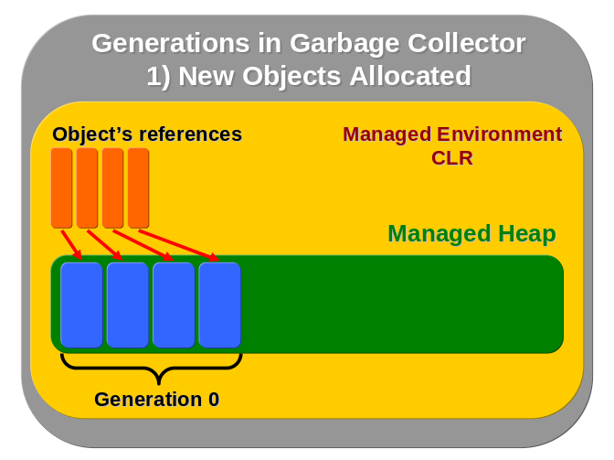  New objects are allocated and first generation is created on managed heap. All object references are valid. | 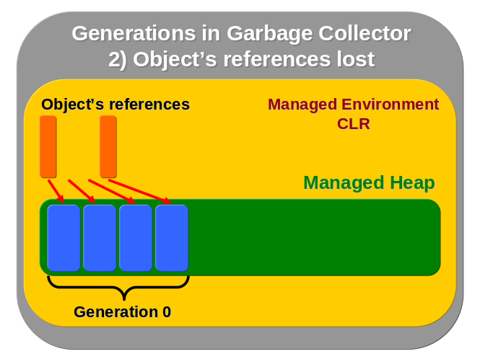  Object’s references are set to null or are out of scope.
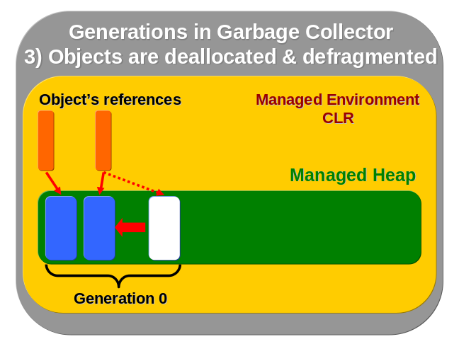  Allocated objects are deallocated when reference count is zero. Memory in generation one is assembled (defragramented). | 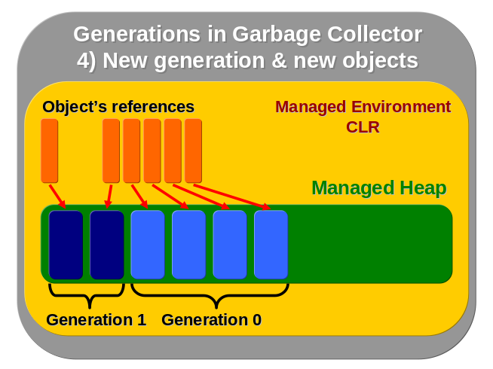  New objects are allocated and then new generation (gen 0) is again created. Older objects are now in generation 1.

As can be seen on these figures, generation garbage collectors have better organization when working with objects according to their age. With this approach memory range, which must be checked, is much smaller and objects are divided according to their age and this makes a possibility for optimization of garbage collector’s algorithms choosing how to treat with each generation.

Garbage Collector’s methods explained
Garbage collector behavior can be controlled through methods in the System.GC class. Here is the list of methods with their description.

Method | Description
System.GC.Collect | This method forces garbage collection, but it should be avoided to use. In some cases programmers can see that memory is not deallocated and this method could possibly help. However garbage collector runs own optimization and monitoring process on each memory generations and objects. More attention should be paid to object references and management of objects.
System.GC.KeepAlive | This method prevents object from collection keeping reference on it. Generally it should not be called from managed code. But in case that object needs to be kept alive for external calls (for instance from Win32 application), this method can be used.
System.GC.SuppressFinalize | It prevent system from calling Finalize method. This scenario can be used when object’s resources are explicitly released through IDisposable interface and Dispose method called by client.
System.GC.WaitForPendingFinalizers | This method suspends the current thread until the thread has emptied the finalization queue. It is called right behind System.GC.Collect method to wait for all finalizers of employed objects.

Hotspot JVM
Virtual machines are used in other platforms and one of the most famous is Java environment. .NET and Java are today’s enterprise standards and that is why knowledge of both systems is going to be essential for system architects. That is why here is mentioned Hotspot JVM layout:
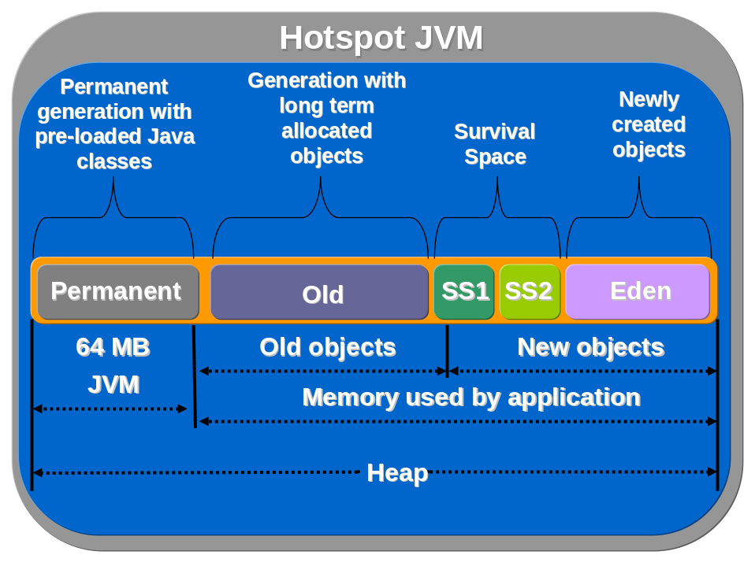

Unsafe code
Unsafe code is very strong but also very dangerous feature of C#. As it was written in previous chapters, .NET environment manages its memory operations by garbage collector and there’re no direct memory accesses (like in C/C++). This is a strong feature of .NET that protects developers from dealing with problems like memory leaks etc. But this takes more system resources and time needed to do this automatic work and that is why performance is lower when compared with native optimized application (even native ugly written application can be much slower then managed one ☺).
Typically there are situations when using unsafe code is necessary; for instance when developing game or some optimized algorithm. Then unsafe code can be very effective and optimization works fine. Just consider following samples when working with array in safe and unsafe mode. First is safe mode version of code:

using System;
class SafeArray
{
public static void Main()
{
// starting time
DateTime start = DateTime.Now;
int i, j, k, n;
int[] x;
int[] y;

// number of itterations
n = 50000;
x = new int[n];
y = new int[n];
for (i = 0; i < n; i++)
x[i] = i + 1;

for (k = 0; k < 1000; k++)
for (j = n - 1; j >= 0; j--)
y[j] += x[j];

// final elapsed time
TimeSpan span = DateTime.Now.Subtract(start);

Console.WriteLine(span);
}
}

Run this sample and you’ll get elapsed time of this small performance test. Then try second version written in unsafe code (compile this code with /unsafe compiler flag):

using System;
class UnsafeArray
{
public static unsafe void Main()
{
DateTime start = DateTime.Now;
int i, j, k, n;

n = 50000;

int *x = stackalloc int[n];
int *y = stackalloc int[n];

for (i = 0; i < n; i++)
x[i] = i + 1;

for (k = 0; k < 1000; k++)
for (j = n - 1; j >= 0; j--)
y[j] += x[j];

TimeSpan span = DateTime.Now.Subtract(start);

Console.WriteLine(span);
}
}

As can be seen in the second sample code there’re arrays allocated by unsafe calls and they’re referenced by pointers. This all makes working with them directly and faster, that is why the results of unsafe code will be better then the managed one in the previous sample.

C# version 2.0
With “Whidbey” Visual Studio and..NET Framework comes many important changes to C# and this chapter will describe them basically.

Partial types
In version C# 1.1 it’s required to use one single file for each class but in C# 2.0 it’s possible to separate the code into many files even when dealing with one class.
This feature is controversial because it’s new and there’re no experiences with it. But there’re situations when partial classes make sence and can be very effective for programmers.
Typically when programmer would use a wizard or RAD tool which generates application code then he will receive a large file with generated code with just a few lines of custom code (for instance when designing WinForm application and generating many code-lines by some RAD environment and writing a fews lines to buttons events as in the figure below).
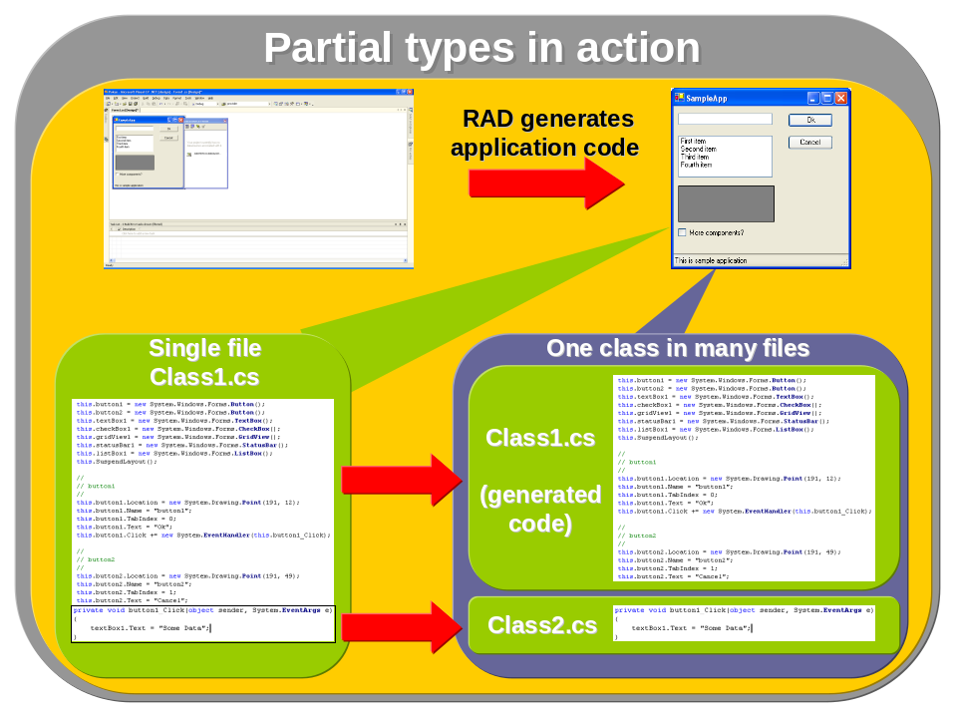

Alphabetical bibliography
These resources are covering in more details appropriate topic as they are listed on and are strongly recommended for further reading (or listening).

Security & Cryptography
- .NET Security And Cryptography, Peter Thorsteinson, G. Gnana Arun Ganesh, www.phptr.com, 2004
- .NET Framework Security, Brian A. LaMacchia, Sebastian Lange, Matthew Lyons, Rudi Martin, Kevin T. Price, Addison-Wesley, 2002
- Applied Cryptography: Protocols, Algorithms, and Source Code in C, Second Edition, Bruce Schneier, John Wiley & Sons, 1995
- ASP.NET Security, Brady Gaster, Dan Kent, Doug Seven, Enrico Sabbadin, Richard Conway, Russ Basiura, Sitaraman Laksminarayanan, Srinivasa Sivakumar, www.wrox.com, 2002
- Cryptography Demystified, John E. Hershey, McGraw-Hill, 2002
- Handbook of Applied Cryptography, Alfred J. Menezes, Paul C. Van Oorschot, Scott A. Vanstone, CRC Press, 1996
- Modern Cryptography: Theory and Practice, Wenbo Mao, Prentice-Hall, 2003
- Network Security PRIVATE Communication in a PUBLIC World, Charlie Kaufman, Radia Perlman, Mike Speciner, Prentice Hall, 1995
- Programming Windows Security, Keith Brown, Addison-Wesley, 2000
- RSA Security’s Official Guide to Cryptography, Steve Burnett, Stephen Paine, McGraw-Hill, 2001
- The Codebreakers: The Comprehensive History of Secret Communication from Ancient Times to the Internet, David Kahn, Scribner, 1996
- Windows 2000 Server Security, Thomas W. Schinder, Stace Cunningham, www.syngress.com, 2000

.NET Environment
- C# Essentials, Ben Albahari, Peter Drayton, Brad Merrill, www.oreilly.com, 2001
- Compiling for the .NET Common Language Runtime (CLR), John Gough, www.phptr.com, 2001
- Indide C#, Tom Archer, Microsoft Press, 2001
- Naučte se ADO.NET za 21 dní, Dan Fox, Computer Press, Prague, Pearson Education, 2002
- Professional C#, Simon Robinson, Ollie Cornes, Jay Glynn, Burton Harvey, Craig McQueen, Jerod Moemeka, Christian Nagel, Morgan Skinner, Karli Watson, www.wrox.com, 2001
- Visual C# .NET Krok za Krokem, John Sharp, Jon Jagger, Mobil Media, Microsoft Press, 2002
- XML v příkladech, Benoit Marchal, Computer Press, Prague, 2000

Interop
- .NET and J2EE Interoperability Toolkit, Simon Guest, Microsoft Press

Others
- Modern Operating Systems, Andrew S. Tanenbaum, Prentice-Hall, 1992

