Configuring Web Services
To suit
Your Own Preferences

Also applies to
Web Services you download
from our class website

Jim Fawcett
CSE681 – Software Modeling and Analysis
Fall 2005
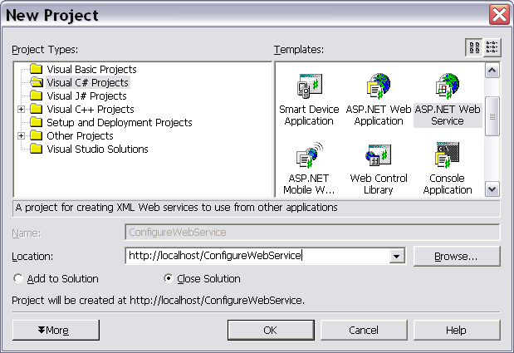

- This will create a web service located in a virtual folder named “ConfigureWebService” in a physical folder: C:\InetPub\wwwroot\ConfigureWebService.
- It will create a project wherever you have elected to put the default source path in Visual Studio. That path is C:\documents and settings\username\My Documents\Visual Studio Projects, unless you change it as shown on the next page.
- 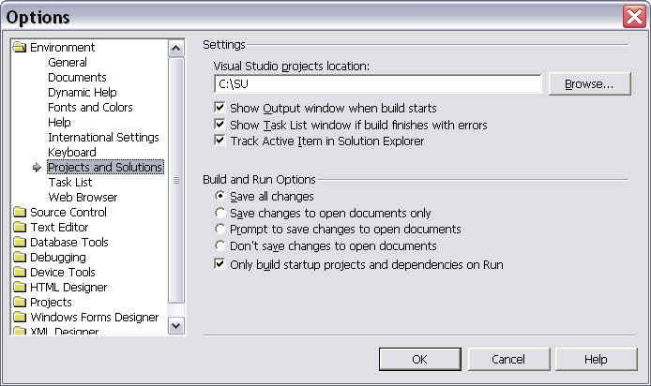

This is how you select a new default path for projects.
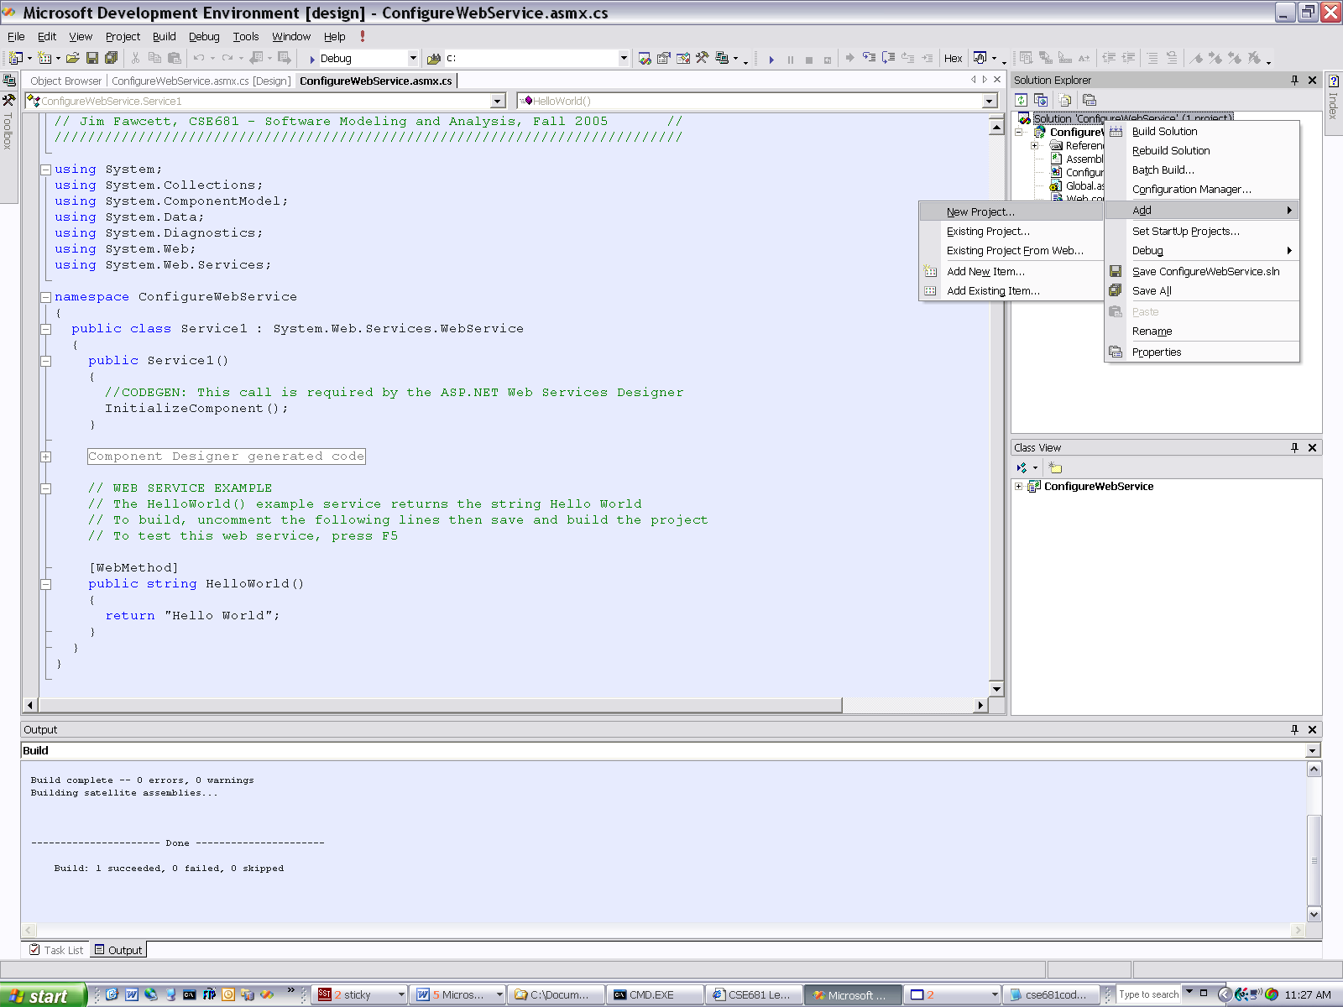
OK, now we are going to create a client.
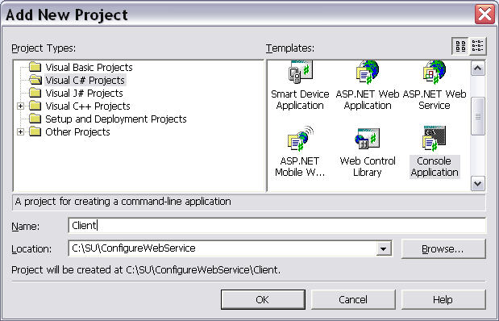

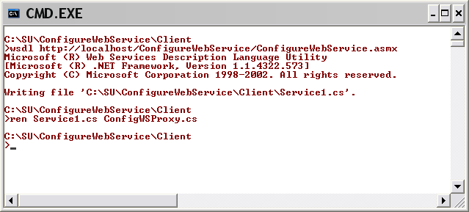
Here we are creating a proxy for the client to use, with the WSDL tool. You can do this as soon as you have built the web service. Note that I used the web address as the argument to WSDL.exe
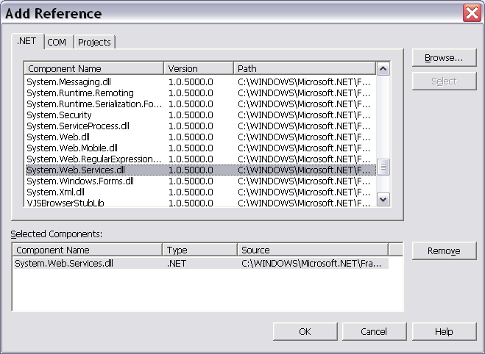
We have to add a reference to the System.Web.Services dll so that the compiler can build our proxy.
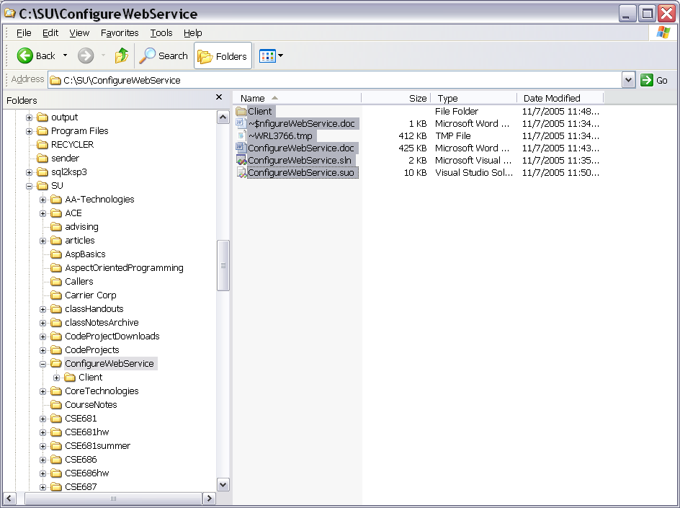
Now, we are copying all the contents of the Project Folder, so that we can combine it with the contents of the WebService folder.
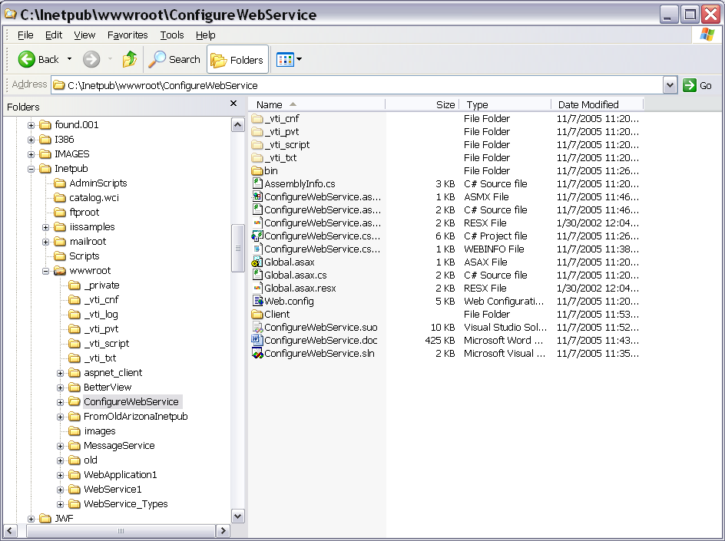
We just copied all those contents into the Web Service Folder in wwwroot, which we are going to move to another location we prefer.
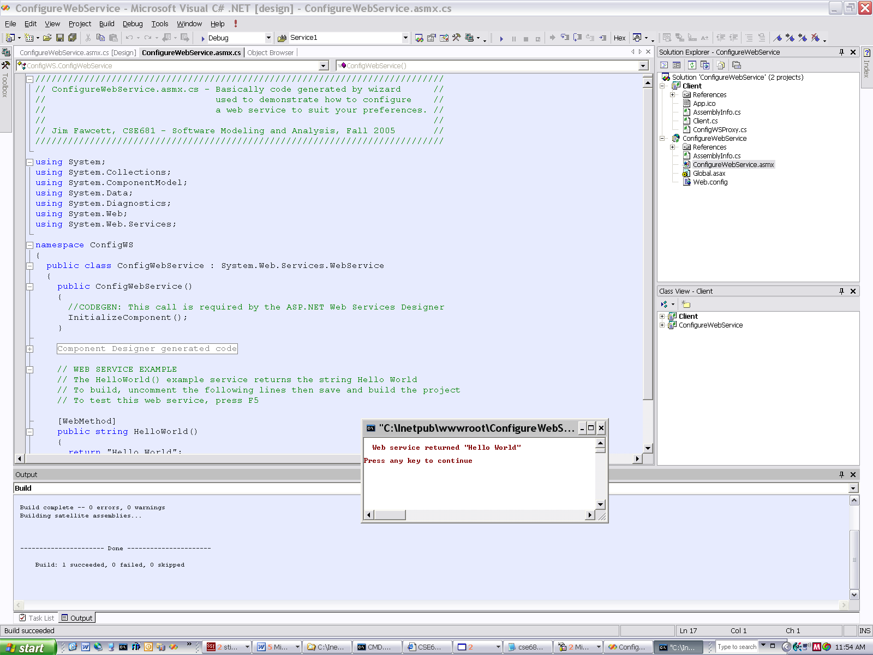
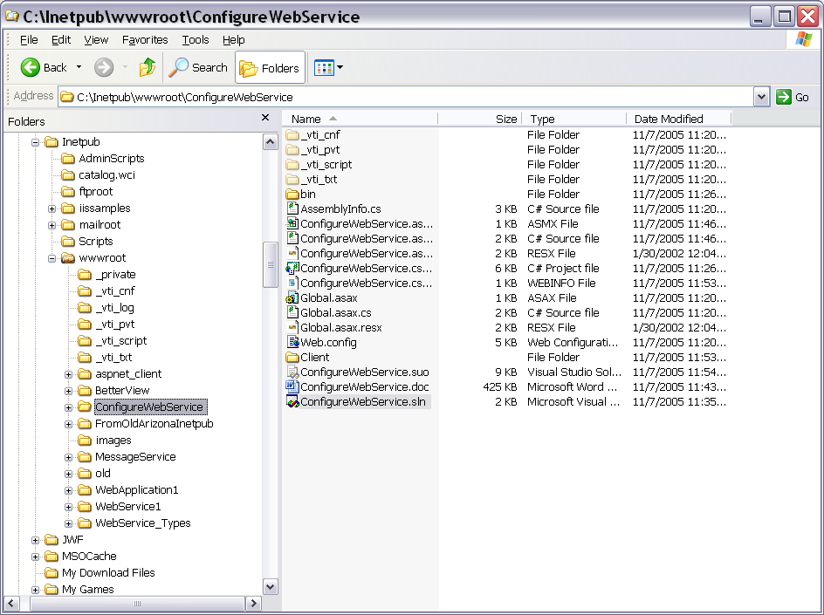
Now, we’re grabbing the entire folder and will copy it to cse681/code.
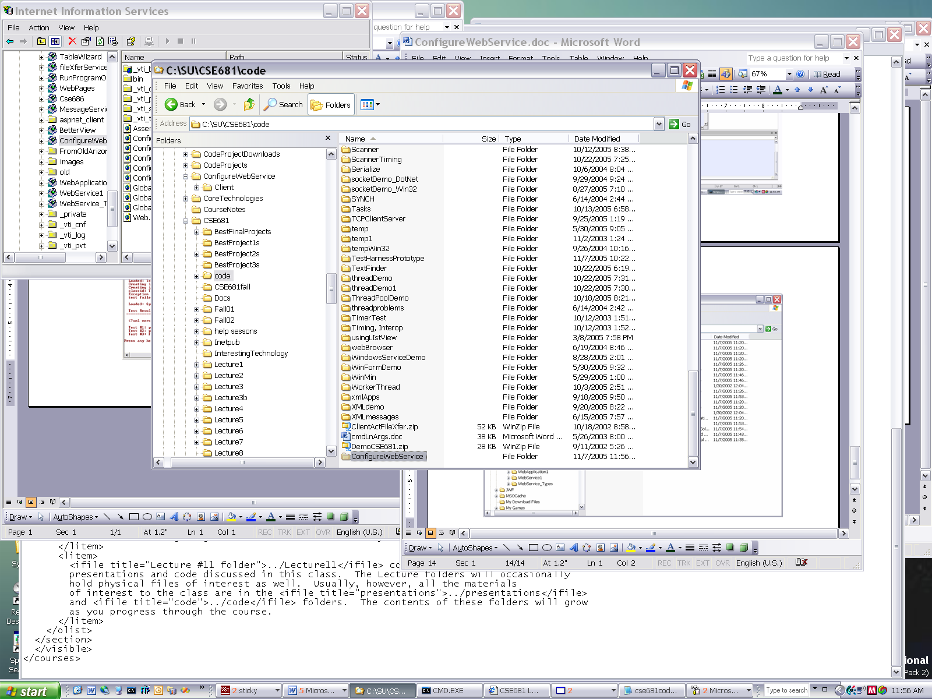
We just copied the folder into cse681/code.
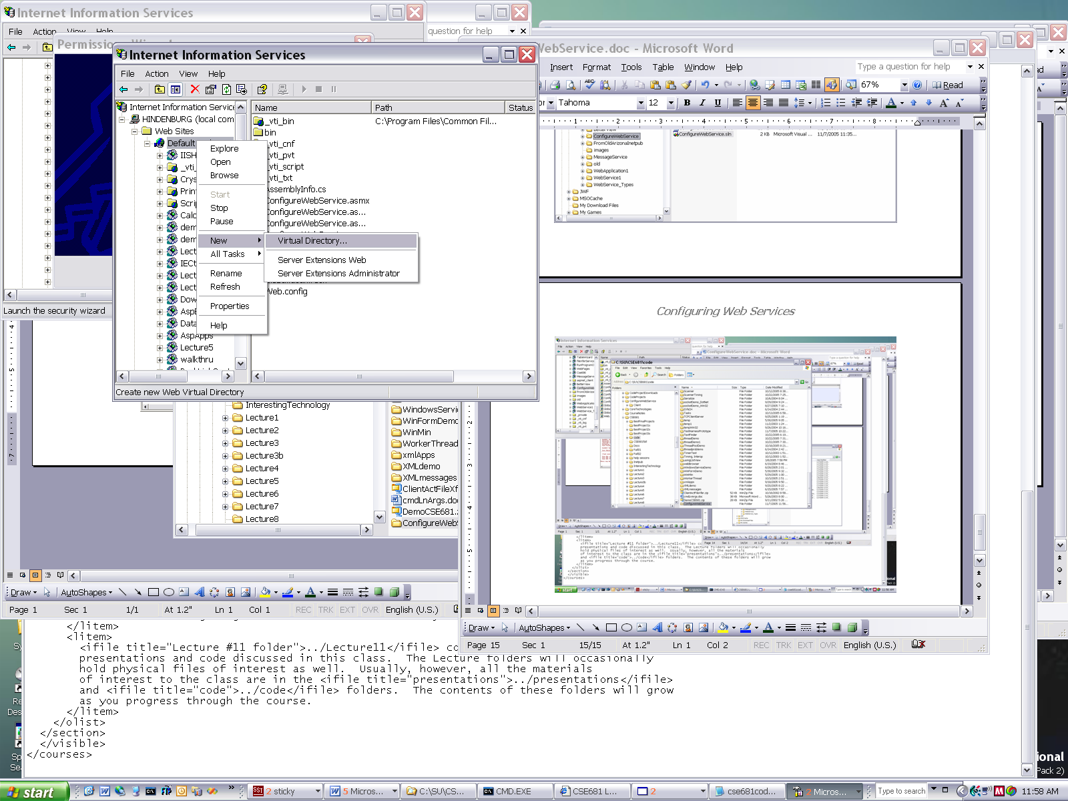
Next, we will make that new folder a virtual directory.
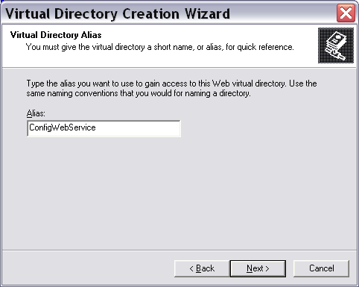
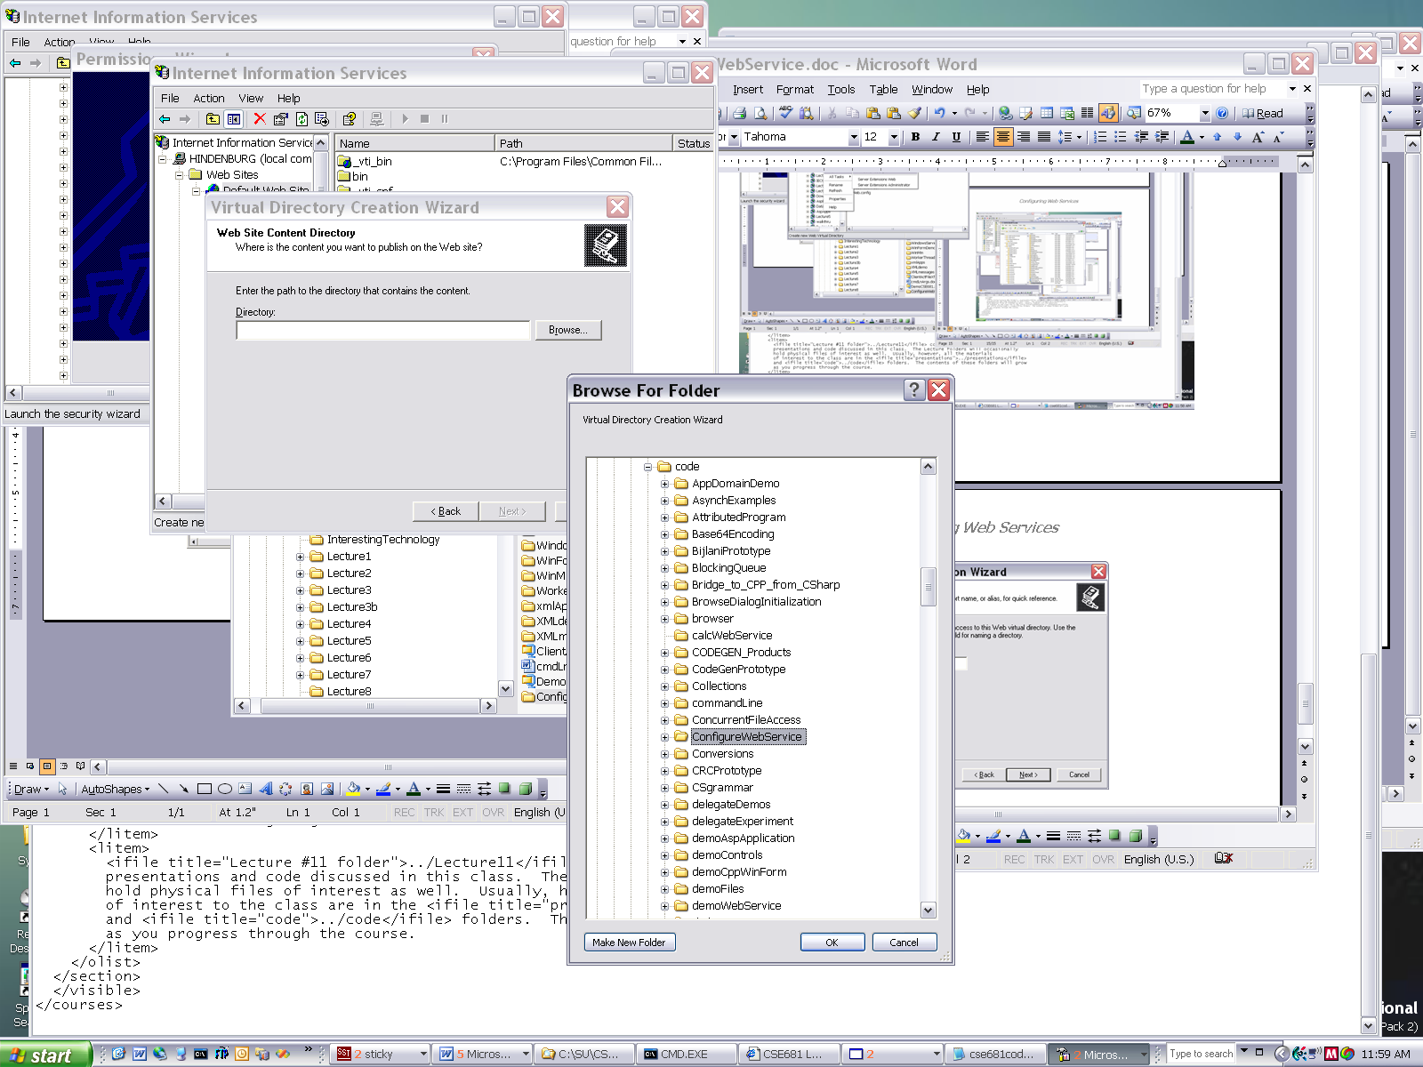
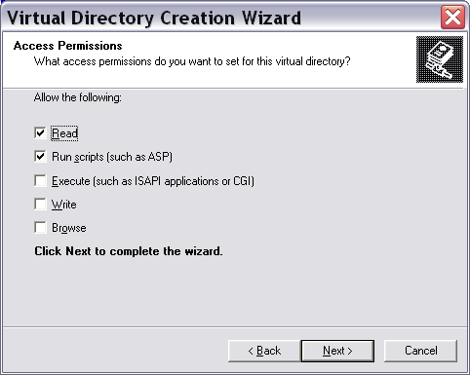
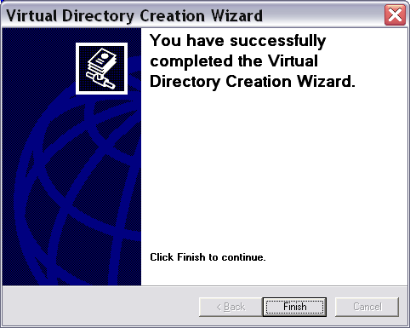
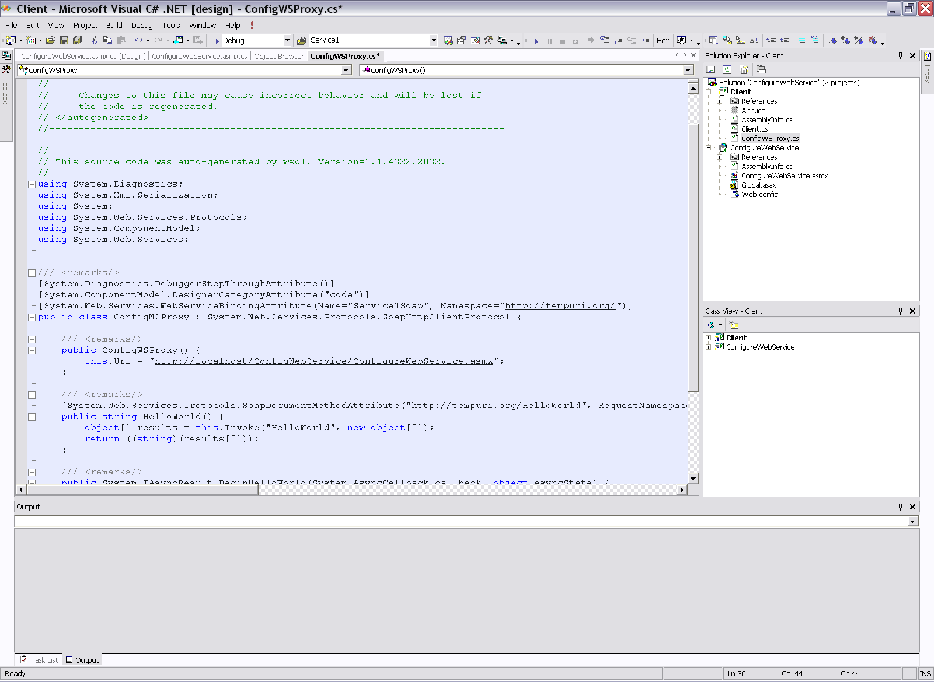
To satisfy my paranoia, I created the new virtual directory before removing the old, and so had to use a different name. Here we give the new name to the proxy.
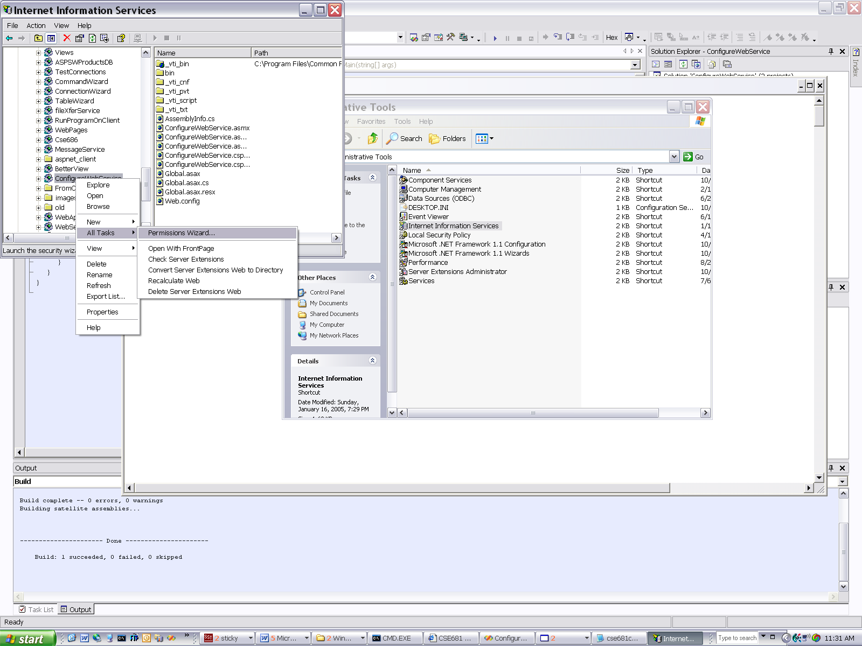
Now we set permissions for the new virtual directory.

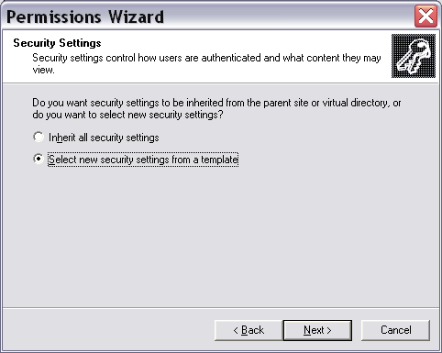
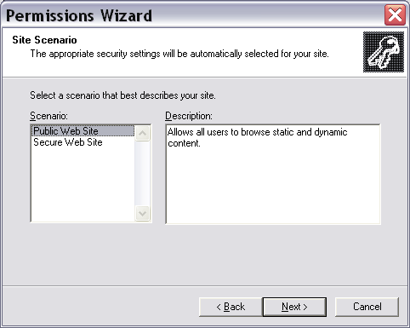
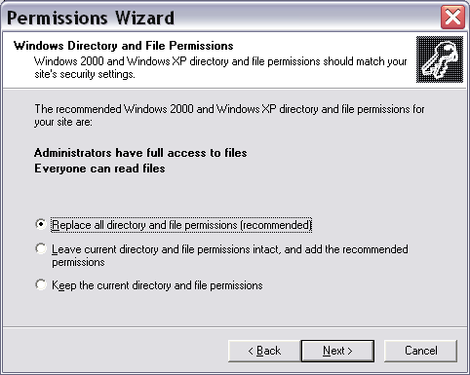
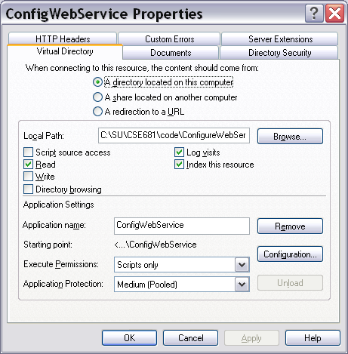
The virtual directory needs to have the correct application to run, and you do that here, by clicking the remove and add – the button gets renamed after removing to add.
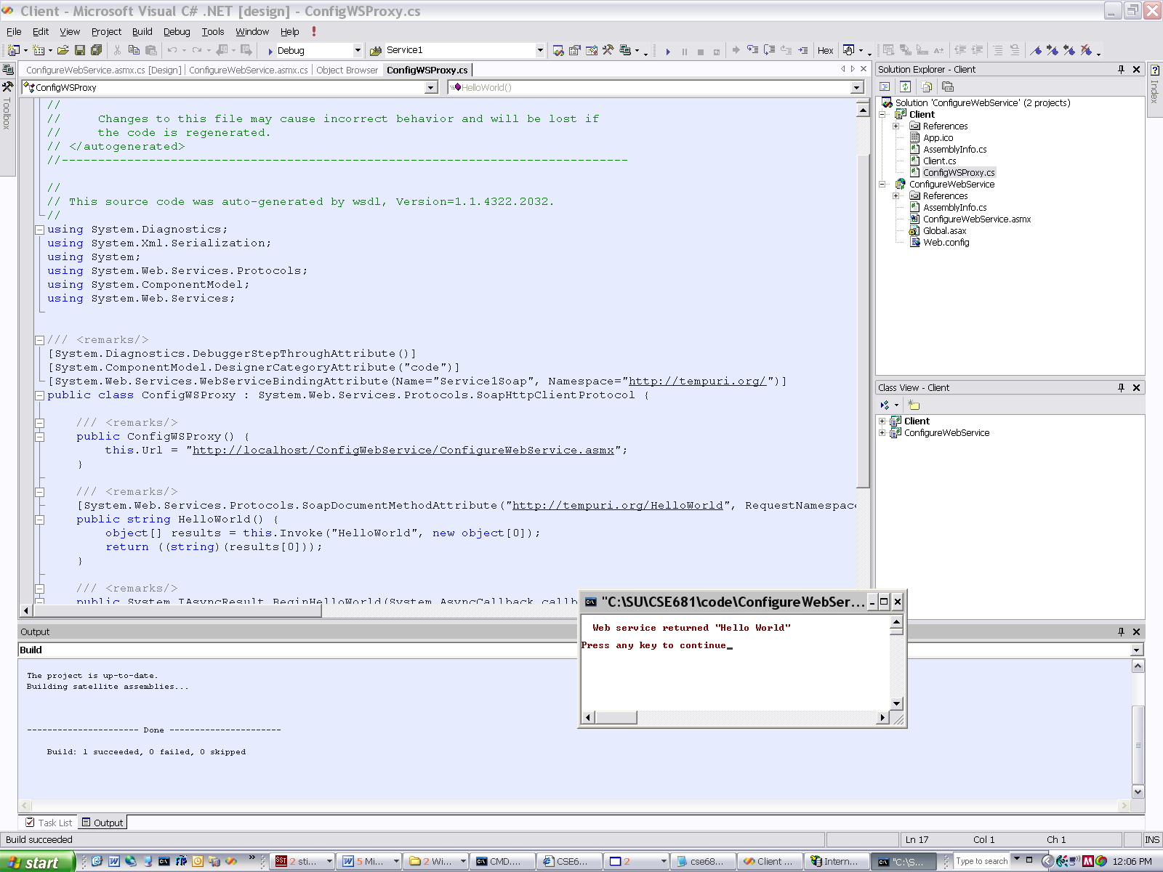
Here is the web service running from the new virtual directory.
You may decide that it is easier to fight than switch, and just let Visual Studio put stuff where it wants to. But, when you download Web Service projects from the class website, you will have to go through these steps to get it to work.

